UNITED STATES
SERVICE ACADEMY NOMINATIONS



Congressman Randy Neugebauer
611 University Avenue
Suite 220
Lubbock, Texas 79401
888-763-1611

GENERAL INFORMATION

Each congressional office uses a selection process for academy nominations designed to meet its own needs and standards. The different procedures are often confusing to applicants who apply to more than one source. Misunderstandings can be avoided by carefully studying and following the instructions of each office. PLEASE NOTE: By signing the application you will have indicated an understanding and acceptance of nomination requirements as set forth by the office of Congressman Randy Neugebauer.

Because of the extreme competition for nominations, you are urged to apply to every nominating authority available to you (both U.S. Senators, your local Congressman, and the Vice President.) Should your eligibility allow, you may also apply to the President. Ideally, students seeking a nomination should begin the congressional and academy process in April of their junior year in high school.

Congressman Randy Neugebauer will have one vacancy each at the U.S. Air Force Academy, U.S. Military Academy at West Point, U.S. Naval Academy, and U.S. Merchant Marine Academy. Included is an informational fact sheet outlining the requirements of Congressman Randy Neugebauer’s Nominating Review Board for each academy.

Contact with the admissions office of the academy of your preference is imperative. The academy will establish a file and forward general information and detailed admissions requirements including a Prospective Candidate Questionnaire.

As outlined on page two, certain information must be provided for you to be considered an applicant. It is YOUR responsibility to submit the required information. The postmark deadline file completion is November 15.

In order that more 19th Congressional applicants have an opportunity to be reviewed by the academies, please let me know immediately if you are nominated by another authority. Additionally, should you change career goals, please notify us. This will offer the opportunity to another student.
1

REQUIREMENTS

Residency: Applicant must be a legal resident of the 19th Congressional District of Texas.

Application Form: The enclosed application should be completed and returned promptly along with a photograph. It is preferred that you send your information as you complete it. Please do not wait to send all required information at one time. This will allow us to help you identify any missing information prior to the postmark deadline.

Academic Recommendation Form: Ask your high school counselor or principal to complete Academic Recommendation Form RF-1. Please ask that the completed form be returned to you in a sealed envelope. It is your responsibility to ensure that all information is provided.

Two Letters of Recommendation: You are required to submit two letters of recommendation. One should be written by your English teacher and the other from your math teacher. Have the teacher sign their name across the seal of the envelope. Only two recommendation letters will be required. Please do not submit additional letters. It is your responsibility to confirm that the materials needed to complete your file have been received by this office.

Transcript: Ask your counselor or principal for an official transcript that includes your course listing and grades, current G.P.A., class rank, and SAT/ACT scores. Your final junior grades must be listed on the official transcript (report card copy is an ineligible substitute). The transcript should be returned to you in a sealed envelope. (Please do not request your transcript before the completion of our junior year).

Numerical Class Rank/Size: Numerical class rank and the approximate size of class are required. This information must be included on the recommendation form completed by your guidance counselor or principal. A few schools have advised they do not rank students. In order to complete all requirements, an accurate estimate of your class standing will have to be made by your guidance counselor or principal.

Standardized Test Results: To have scores forwarded to our office directly from the testing center, please the following codes: SAT – 6079, ACT 7000. You MUST have scores that meet the minimum levels as indicated on the fact sheet in this packet by the postmark deadline. If you have not taken the tests before the post mark deadline, you will NOT be eligible for nomination during this cycle.

Essay: Briefly state why you want to attend the academy of your choice. Please confine your essay to one page.

Deadline: Send the above information to the Lubbock office: 611 University Avenue, Suite 220, Lubbock, TX 79401. All information must be postmarked by November 15.

2
Fact Sheet

The academies provide guidelines for applicants who may be eligible to be considered for an appointment. A candidate must be an American citizen by the date of induction into an academy and of good moral character.

U.S. Air Force, Military, and Naval Academies require you be at least 17, but not have passed your 23rd birthday by July 1 of the year of induction. A candidate must be unmarried with no dependents.

U.S. Merchant Marine Academy requires you be at least 17, but have not passed your 23th birthday by July 1 of the year of induction.

The scores listed below are established and suggested by Congressman Randy Neugebauer’s office and do not necessarily reflect minimums standards of each academy. Minimum SAT or ACT scores must be met by the postmark deadline . It is suggested that you take your exams as early as possible. Some students find it necessary to take the exams more than once to achieve qualifying scores. If you have not taken your tests by the postmark deadline, you will not be eligible for nomination during this nomination cycle.
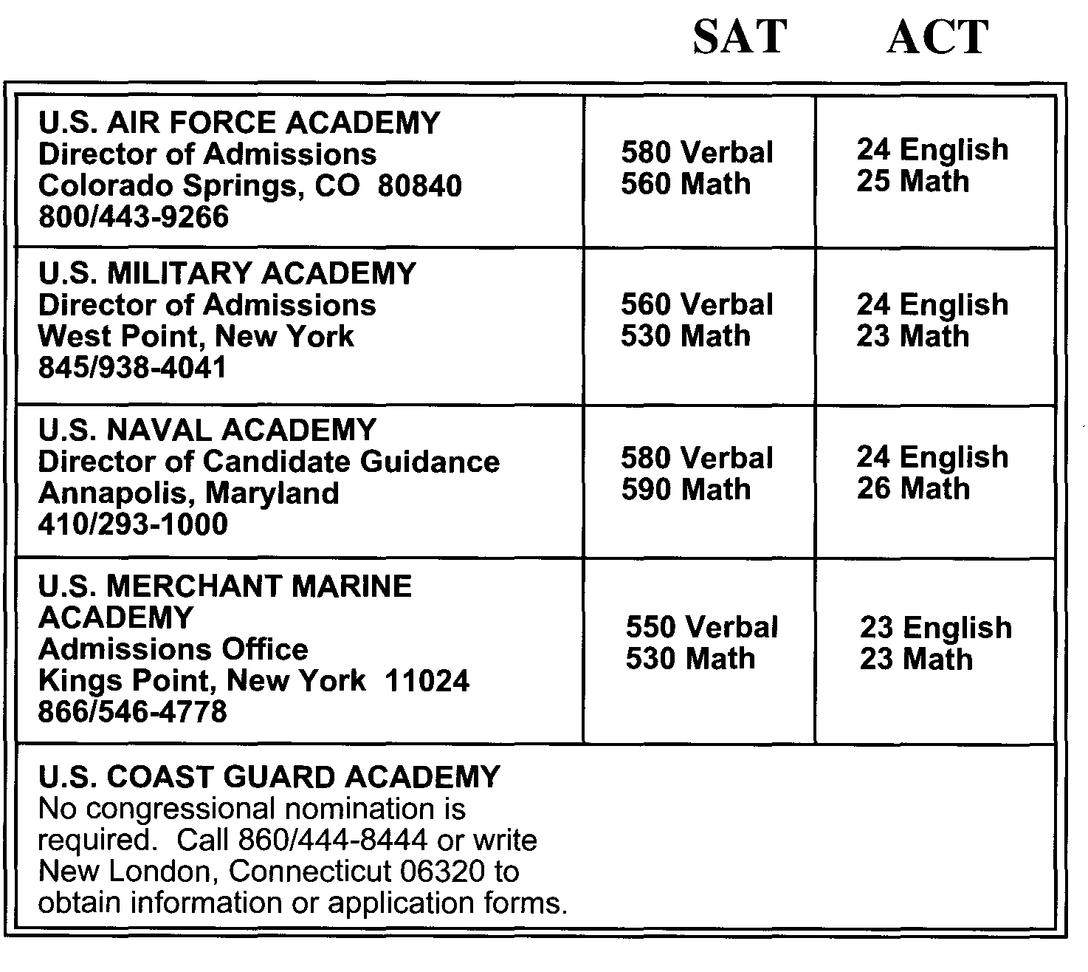

All academies require you to pass a Department of Defense Medical Examination Review Board ((DODMERB). The academy to which you have applied will initiate the scheduling of an examination with the Department of Defense. Once taken, the examination may be used for all service academies and four-year ROTC scholarship programs.

NOTE: Graduation from a United States Service Academy obligates you to serve five years of Active Duty Service.

3

Congressman Randy Neugebauer Staple
611 University Avenue Photograph
Suite 220 Here
Lubbock, Texas 79401
888/763-1611

PLEASE TYPE OR PRINT THE REQUIRED INFORMATION ON BOTH SIDES

1st Choice of Academy:_________________________ 2nd Choice of Academy______________________

PERSONAL DATA

________________________________________________________________________________________Full Legal Name: SS#

Legal Address: City: State: Zip Code

________________________________________________________________________________________
County: Home Phone #: Date of Birth: Email Address

________________________________________________________________________________________
Place of Birth: U.S. Citizen? Height Weight

________________________________________________________________________________________
Father’s Name: Daytime Phone #

Mother’s Name: Daytime Phone #

________________________________________________________________________________________
Name of School: Date of Graduation:

Counselor: School Phone #:

ACADEMIC DATA

SAT: V ___________ M _____________ ACT: ___________

Please circle: Honors classes Y / N AP classes Y / N

4

LEADERSHIP DATA

Please check all applicable:
______Boy’s/Girl’s State or Nation ______ Hours worked per week (after school)
______Eagle Scout/Gold Award ______ Hours worked per week (summer)
______ Boy Scout/Girl Scout ______ Church membership
______ Key/Interact Club ______ Football (#years)
______National Honor Society ______ Baseball/Softball (#years)
______ President or Officer of ______Volleyball (#years)
Class/Student Council ______ Basketball (#years)
______ President or Officer of School Club ______ Swimming (#years)
______ Academic Honors Club ______Track/Cross Country (#years)
______ School Band/Chorus ______Other Sport (#years)
______ Jr. ROTC Officer ______Drama (#years)
______ Debate Club ______ Civil Air Patrol or Navy Sea Cadets

ATTACHMENTS: You MUST attach a brief essay stating why you want to attend the academy of your choice. You are encouraged to attach a resume or list of honors and awards, activities or any information you feel is pertinent to your application.

Please DO NOT attach additional letters of recommendation. Only the letters requested will be reviewed by Congresssman Neugebauer’s Selection Committee.

PLEASE READ CAREFULLY BEFORE SIGNING:

I have read the information sheet explaining Congressman Neugebauer’s nominating procedures and I understand the Congressman’s requirements. I am also aware of the postmark deadline of November 15. I certify that I am a legal resident of the 19th Congressional District of Texas and there is no known reason why I should not be medically qualified to receive an appointment to a service academy, if nominated.

Date: Candidate’s Signature:

In signing this form, you are stating that you understand the nomination requirements for the Office of Congressman Randy Neugebauer and that you will abide by these requirements.

5

Office of Congressman Randy Neugebauer
ACADEMIC RECOMMENDATION FORM
UNITED STATES SERVICE ACADEMY NOMINATIONS
(RF-1)
This form MUST be completed by a high school principal or guidance counselor. Please note that the completion of this form is a requirement. Please type or print and return completed form to the candidate in a sealed envelope with your signature across the seal.

Name of Applicant:_______________________________________________________________________________
First Middle Last
Name of High School______________________________________________________________________

Telephone Number of School: ( ) _______________-____________________________

Unweighted GPA:____________________________Weighted GPA:_______________________________

ACT Score: E M Numerical Class Rank/Size* /___________

SAT Score : V M *If your school does not rank, please provide approximate rank.

Leadership Characteristics:________________________________________________________________

Personality Traits:________________________________________________________________________

Ability to Work Under Pressure:____________________________________________________________

Ability to Get Along with Others:___________________________________________________________

School Activities in Which Applicant Participates:_____________________________________________

General Comments and/or Recommendations (Your additional comments will be very helpful.)

SIGNATURE:____________________________________________DATE: _________________________
TITLE:__________________________________________________

Schedule
U.S. Representative Randy Neugebauer
United States Service Academy Nominations

April 1 Application process opens
November 15 Postmark Deadlines for file completion
December 20 Nominee notification by mail begins

CHECK LIST FOR CANDIDATES:

___________ Application form completed and mailed.

___________Photograph attached to application form

___________ Essay returned

___________ Recommendation form (RF-1) completed by guidance counselor or principal

_____/_____ Letters of Recommendation (2)

___________Official high school transcript, including final junior or senior year grades,
(also, college transcript if applicable).

___________ Class rank and the approximate size of graduating class. NOTE: It is your
responsibility to provide ALL required information. If obtaining this
information is a problem, please call Mary Whistler at 888/763-1611.

____________SAT/ACT scores (Scores reflected on high school transcript will be accepted
in lieu of testing center documentation.

All CORRESPONDENCE REGARDING THE SERVICE ACADEMIES
SHOULD BE SENT TO: Congressman Randy Neugebauer
611 University Avenue, Suite 220
Lubbock, Texas 79401
Attn: Mary Whistler
THE POSTMARK DEADLINE FOR FILE COMPLETION IS
NOVEMBER 15

