The Center for the Book in the Library of Congress
Announces the 21st annual

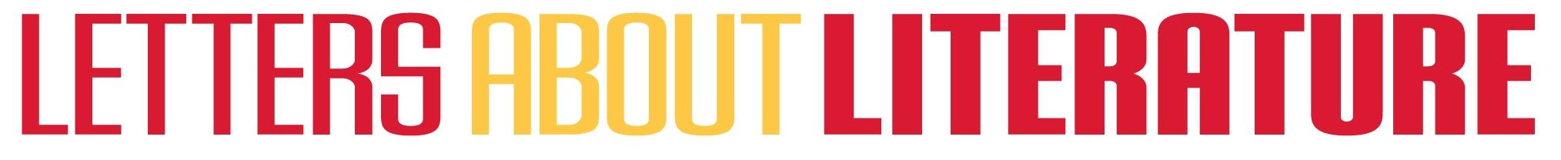
Letter Writing Contest
for Young Readers in grades 4 – 10
from participating states*

- Are you a teacher? Your students can enter!
- Are you a librarian? Your young patrons can enter!
- Are you a home school parent? Your children, too, can enter!

Submission Address:
P.O. Box 5308, Woodbridge, VA 22194

Submission deadline:
Friday, January 11, 2013

Visit www.lettersaboutliterature.org or mail the national office at
programdirector@lettersaboutliterature.org to download free lesson plans, assessment checklists and student writing samples.

Letters About Literature offers awards on
both the state and national level

Eligibilty: Children currently in grades 4 – 10 for the 2012-2013 school year from participating states are eligible to enter.
*Participating states:

AL, AK, AR, AZ, CA, CO, DC, DE, FL, GA, HI, ID, IL, IN, IA, KY, LA, MD, ME, MA, MI, MN, MS, MO, MT, NE, NV, NC, NH, NM, NJ, NY, OH, OK, OR, PA, RI, SC, TN, TX, UT, VA, WV, WA, WI, WY

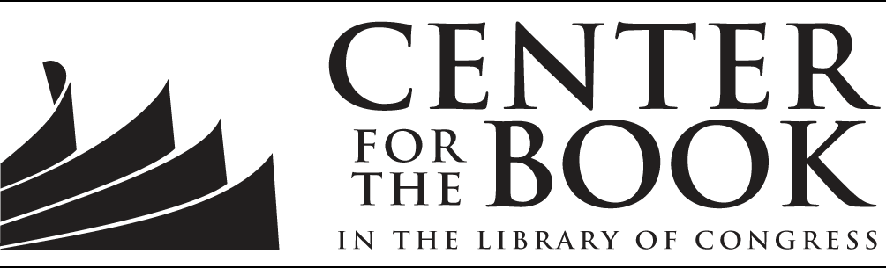
LAL supports national standards for teaching reading and writing as stabled by both the National Reading Association (NRA) and the National Council of Teachers of English (NCTE) and may be a valuable tool for assisting students achieve Common Core State Standards (CCSS) for writing. Please visit our website for more information, including the REQUIRED ENTRY COUPON.

