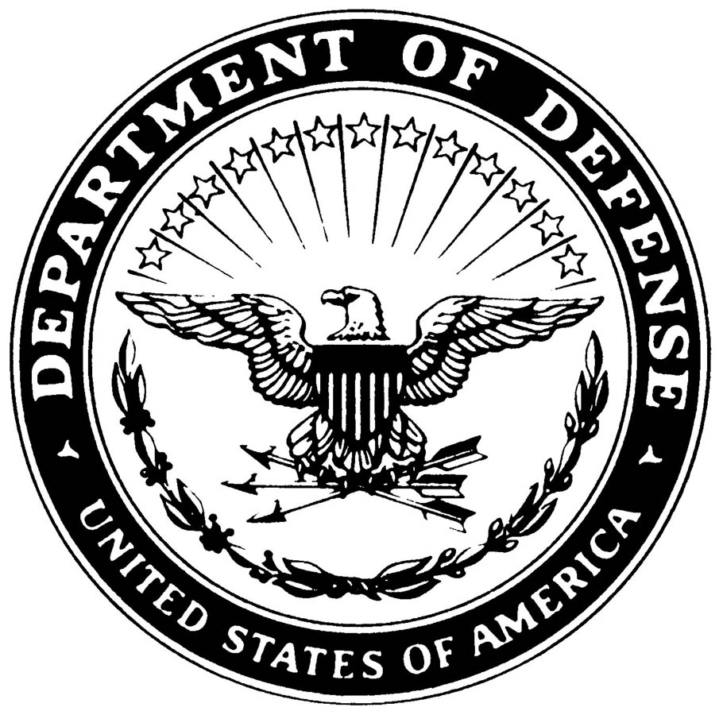

US Department of Defense
. 7, 200DoD Update: March 20, 2006 – MNF-I Fact Sheet OIF
Following is information compiled by the Multi-National Force - Iraq. (Link to the page on the MNF-I web site at www.mnf-iraq.com)
Operation Iraqi Freedom: Three Year Anniversary -- Progress Fact Sheet
In just three years, the people, the government and security forces of Iraq have made tremendous and steady progress: the elimination of a brutal dictator, the democratic election of an Iraqi government, the development of an Iraqi constitution, the restoration of Iraq’s infrastructure beyond pre-war levels and the establishment of an increasingly effective Iraqi Security Force that in time will be able to take over from Multi-National Force-Iraq.
As their march towards a stable democracy continues, the United States Embassy – Iraq and Multi-National Force-Iraq remain committed to the people and government of Iraq while it shapes and seats its new government, a government in which all Iraqis have a voice and their rights are protected and acts as a partner in the war on terror.
WAR ON TERROR
- Before the start of Operation Iraqi Freedom, Iraq, under the control of Saddam, was an enemy of the U.S. and the civilized world; today it is an ally of both as well as a global partner in fighting terror.
- The aim is to defeat the terrorists and their allies at the heart of their power - and Coalition forces are achieving that goal. Coalition and Iraqi Security Force operations in Iraq continue fighting the terrorists and regime remnants in Iraq, who seek to overthrow a democracy, claim a strategic country as a haven of terror, destabilize the Middle East, and strike America and other free nations with ever increasing violence.
- Since 2003, Iraqi forces have fought alongside Coalition forces in Najaf, Samarra, Fallujah, Baghdad, North Babil, Mosul, Al Anbar, and a host of other locations. Although Iraqi forces have endured thousands of casualties, have been attacked multiple times each day, and have suffered losses through brutal intimidation attacks, there remains no shortage of volunteers ready to step up and defend the sovereignty and freedom of their nation.
- Fighting the enemy here in Iraq makes it more difficult for them to strike us in the U.S. We can decisively weaken the ideological extremists, led by bin Laden, Zawahiri and Zarqawi, by stabilizing Iraq, and actively helping Iraq help themselves against this threat.
- Now that the people of Iraq are permitted to choose their own destiny and advance by their own energy the terrorists are being marginalized; last year, tips to Coalition or Iraqi Security Forces regarding terrorist activity or locations only numbered about 400 a month, by year’s end more than 4,500 calls per month provided information on terrorists or resources whereabouts.
- Operations continue to degrade the terrorist network. Since January 2005, we have killed or captured more than 122 key leaders of Al Qaeda in Iraq.
Information compiled from White House reports, 2006 MNF-I press conference transcripts, and MNF-I Report “2005 Year in Review”

IRAQI GOVERNMENT
General Governance
- The Iraqi people took responsibility for their government with the transfer of sovereignty and the establishment of the Interim Iraqi Government on June 28, 2004. In the December 2005 elections more than 300 parties and coalitions were registered, and roughly 11 million voters participated, including many who had opposed the constitution and boycotted elections in January.
- The Council of Representatives (CoR), the parliament elected under the new Iraqi constitution, convened on Thursday, March 16, at the Parliament Center in Baghdad. Two hundred seventy-five representatives were sworn into Iraq’s new four-year government. The formal seating or convening of this CoR symbolizes an important step in Iraq’s pathway to democracy. This representative body will serve as the basis for establishing a broad-based government of national unity for Iraq.
- In 2003, the authoritarian control of Saddam’s regime allowed few of Iraq’s 18 governorates any real authority. Today, those 18 governorate councils, in addition to 90 district councils, 194 city or sub-district councils, and 437 neighborhood councils established since the start of OIF equate to and promote a decentralized governance system that provides more than 19 million people the means to engage in local policy discourse.
- It is unknown if civil society organizations even existed under the totalitarian regime of Saddam; however, now in 2006, there are more than 561 civil society organizations in 18 governorates established as part of a campaign targeting grassroots democracy.
- Today, there are more than 40 countries and international organizations with Embassies and Missions established in Iraq, cementing Iraq’s position in a cooperative, global community.
Information provided by MNF-I, DCS STRATEFF, Policy Division
Ministry of Education
- In 2003, approximately 6.1 million children were enrolled in Iraq’s lower education system. Of these only about 2.96 million were expected to graduate from secondary school. Now, in 2006 nearly 25% of the Iraqi population either attends a school of, or is directly employed by, the Ministry of Education. With a 2006 budget of $1.9 million (up 66% from 2005), the ministry oversees more than 20,000 school sessions in over 14,731 school buildings, administrative offices, and educational facilities nationwide. The MoED provides the oversight and training needed to support 500,000 teachers in their work with 6.28-6.4 million K-12 students a 3-5% increase from 2003.
- In 2003 there were 14,731 kindergarten, elementary and secondary schools, most of which suffered from years of neglect by the Saddam regime, an insurgency intent on intimidating teachers and students, and the damage caused by war. Over the last three years nearly 6,000 of those schools have been renovated or undergone some form of rehabilitation.
- In 2003, the Ministry of Higher Education and Scientific Research (MHESR) consisted of 22 universities, 46 institutes or colleges within the community college system, two commissions and two research centers. Since 2003, MHESR has, in addition to continuous work on its facilities and infrastructure that had been largely destroyed by war and looting, has been able to install nearly a dozen new colleges within its university system.
Information provided by Iraq Reconstruction Management Office

Ministry of Health
- Iraq's Ministry of Health (MoH) on Sept. 4, 2004, initiated the first polio immunization program in the country since the start of the war in March 2003, in an effort to protect 4.7 million children from the infectious disease. After two rounds of National Polio Immunization Days in the summer of 2005, 98% of Iraqi children under five have been vaccinated for polio.
- With support from the United Nations Children's Fund (UNICEF), the World Health Organization (WHO) and the European Union (EU), which contributed over US $2.5 million, the Iraqi authorities succeeded in immunizing the vast majority of children in the first three days of the campaign, UNICEF said. A total of 25 million doses of vaccine were purchased with help from a $3.2 million grant from the United States Agency for International Development (USAID).
Information compiled from the MNF-I Reports “2004/2005 Year in Review” and Iraq Reconstruction Management Office report “Rebuilding Iraq” (Feb 06)
IRAQI SECURITY FORCES
General Security
- Today, ISF independent operations account for more than 36 percent of total operations conducted.
- Since 2003, 34 Forward Operating Bases out of a peak total of 110, have been transferred to the Iraqi Transitional Government, transferred to the ISF or closed.
- Controlling its national borders and preventing infiltration of terrorists and foreign fighters wishing to use Iraq as a safe haven or conduct acts of terror, was possible due to operations in Al Anbar, Tall Afar, and the Western Euphrates River Valley area. These operations, along with the establishment of 258 border forts, resulted in the successful restoration of border control to the people and government of Iraq in late 2005.
- Since 2003, 258 border facilities, 309 police stations, 14 academies and branch schools, 26 unit headquarters, and 67 fire stations have been built or rehabilitated.
Information compiled from 2006 MNF-I press conference transcripts
Ministry of Defense
- After being formally dissolved May 23, 2003, the first 1,000 recruits of Iraq’s new Army began training Aug 2, 2003. Today the Ministry of Defense forces now number 112,900; with 99,500 in the Army, 600 in the Air Force, and 800 in the Navy, and 10,800 in various support force units.
- The Iraqi military was rebuilt from scratch since 2003. The Iraqi Army absorbed the Iraqi National Guard to form 10 Iraqi Army combat divisions. There are now 101 trained and equipped combat battalions in the Iraqi Army – all of them are in the fight. This includes a (Special Operations Forces) Counter-Terrorist battalion, a Commando battalion, and Strategic Infrastructure battalions. Most recently, the Counter-Terrorism battalion rescued a retired Iraqi army brigadier general who had been kidnapped and was going to be killed by his captors. Today, 49 Iraqi Army combat battalions, 13 Brigade headquarters, and two Division headquarters control their own battle space.
- Iraq’s Navy is now operational with a Patrol Boat Squadron with five Predator-class Patrol Craft, an Assault Boat Squadron with 25 Fast Assault Boats (FABs), and a Marine battalion, all of which serve to defend Iraq’s coast, territorial waters, vital ports and offshore assets against both external and internal security threats.
- Iraq’s Air Force has five fully operational squadrons capable of conducting a variety of airlift, utility, intelligence gathering, surveillance, and reconnaissance missions. The squadrons include one C-130 transport squadron, two ISR squadrons with CH2000, Compair, and Seeker aircraft, and two helicopter squadrons with UH-1s and Bell Jet Rangers. The IAF recently purchased 10 Mi17 Hip helicopters which will soon form another helicopter squadron.
- Iraq’s three military academies are committed to professionalizing the Iraqi military. Rustamiyah has graduated 73 from the Sandhurst model course, Zahko has graduated 411, and Qalachoun currently has 188 enrolled. Between the three institutions, 653 have graduated from the three-week newcomer’s course.
- Since 2003, construction on 12 major military training facilities was completed and 10 other projects are ongoing.
Information provided by MNSTC-I Public Affairs
Ministry of Interior
- In 2003, Iraq had a dilapidated internal security force. Today the Ministry of Interior has over 127,845 professionally trained and equipped members. Of those, over 88,962 are trained and equipped regular police officers and the other approximately 38,883 are assigned to National Police Forces, Commandos, Public Order Division, Mechanized Police Brigade and Border Enforcement.
- In November 2003, Iraq’s only formal police training academy opened in Jordan; today, there are 12 police training academies including eight basic police academies that instruct the10-week basic training course, designed to better prepare the police for the challenging environment in which many will serve.
- In 2003, Iraq was unable to independently provide security for its own borders; today 20,391 border enforcement personnel have completed training and 258 border forts have been built, or are currently under construction, to help Iraq’s Border Enforcement officers patrol and secure Iraq’s borders.
- Since 2003, 20 provincial SWAT teams of 32 personnel each have been trained and equipped, and one more is scheduled to complete training by December 2006.
- Since 2003, 277 Iraqi Police construction projects were completed across the 18 provinces and 11 major cities. This included 37 police headquarters, 187 police stations, and seven highway patrol stations.
Information provided by MNF-I/Ministry of Interior Liaison Officer
IRAQI ECONOMY
- When Coalition forces began Operation Iraqi Freedom, they entered a country whose energy infrastructure had deteriorated over many years. The U.S. Embassy and MNF-I set out to help the Iraqi government restore oil facilities, increase production, and improve refining, natural gas production, and pipeline facilities; by year-end 2005, 179 oil projects have been pursued worth $1.16 billion, 42 have been completed worth $110 million. Production is on par with prewar levels at 2.0 million barrels of oil per day (bpd) and exports of 1.3 million bpd. Over 350 pipelines have been repaired and revenues are up to $24.5 billion from postwar levels of $5.1 billion in 2003.
- The U.S. Embassy and the Government of Iraq continue to address the issue of Iraqi unemployment; today, about 1.5 million Iraqis are employed under reconstruction efforts, working on schools, clinic, roads and numerous other infrastructure projects, and the overall national unemployment dropped in 2005 to 28% (as reported by COSIT) or 12-18% (as estimated by MNF-I).
- Since 2003, 32,574 new Iraqi businesses have been registered.
Information provided by MNF-I, DCS STRATEFF, Economics Division
RECONSTRUCTION PROJECTS
- The Iraq Relief & Reconstruction Fund ($2.5 billion) and supplemental appropriations ($18.4 billion) have been committed to the rebuilding of Iraq. As of March 7, 2006, $18.6 billion (of which $11.4 billion is obligated for DoD projects) has been obligated on Iraqi reconstruction.
- Since March 2003, more than 11,600 construction projects have been started. More than 9,340 projects, valued at $9.3 billion, have been completed.
- Since March 2003 $9.6 billion (IRRF 1 - $2.5 billon, IRRF 2 - $7.1 billion) has been focused on providing reliable essential services (electricity, water, transportation, telecommunications, and oil). More than 2,412 essential service projects are either completed or underway.
- Before March 2003, Iraq averaged 4,300 MW of peak electricity generation, supplying Baghdad with 12 to 24 hours of power a day by diverting power from the rest of Iraq, left with four to eight hours of power, however today the average Iraqi citizen has seven hours of electrical service in Baghdad and 10 to 12 hours in the rest of the country. It is expected to be 12 to 14 hours over the next year.
- Before March 2003, only 5.5 million of Iraq’s 25 million citizens had access to a safe and stable water supply. Iraq’s cities suffered from inadequate sewage systems, today 19 potable water treatment facilities have been built or rehabilitated, providing a standard level of service to about 2.7 million more Iraqis. In addition eight centralized sewage treatment facilities have been rehabilitated, adding capacity to benefit 4.9 million Iraqis.
- Health care for some ethnic groups was almost nonexistent under Saddam's regime; today there are over 300 new health care facility projects across Iraq and over 270 projects underway to be completed by mid-year 2007 allowing an additional 7 million Iraqi citizens, regardless of ethnicity, geographic origin, gender, or religious affiliation access to health care that was unavailable under the old regime.
Information complied from U.S. Army Corps of Engineers, Gulf Region Division, Public Affairs and IRMO Feb 06 report “Rebuilding Iraq”

Published by the U.S. Department of Defense Office of Public Affairs

