June 2, 2003
M-03-14
MEMORANDUM FOR THE HEADS OF DEPARTMENTS AND AGENCIES
FROM: Mitchell E. Daniels, Jr.
Director
SUBJECT: Reducing Cost and Improving Quality in Federal Purchases of Commercial
Software

The federal government plans to spend more than $58 billion on information technology (IT) products and services in fiscal year 2003. More than 4 million desktop, laptop, and networked computers serve as essential tools for achieving the missions of federal agencies. Since each computer uses at least one commercial software package, federal agencies engage in thousands of licensing agreements annually. This uncoordinated approach to acquiring common software is wasteful and ineffective.

If the federal government applied a government-wide approach for enterprise licenses on common software, there would be substantial benefits to the taxpayer. Several agencies have negotiated independent department-wide licenses, creating a wide disparity in prices paid by agencies for exactly the same software. As an example, the amount that federal agencies pay for common desktop software varies from under $200 to about $500. If all agencies made joint use of the best priced software licenses, well in excess of $100 million could be saved each year. In addition, the broad mosaic of different software versions installed increases the difficulty and cost of securing federal computers.

There can be no doubt, therefore, that the federal government can become a smarter buyer of commercial software. Pursuant to Section 5112 of the Clinger-Cohen Act of 1996, OMB is responsible for improving the acquisition and use of information technology by the federal government and designating Executive agents for government-wide acquisitions of information technology. To assure that the federal government is leveraging its immense buying power to achieve the maximum cost savings and best quality for commodity software, OMB has created the SmartBUY initiative.

The General Services Administration (GSA) is designated the Executive Agent under Section 5112(e) of the Clinger-Cohen Act for the SmartBUY interagency initiative, and will lead the interagency team in negotiating government-wide enterprise licenses for software. We expect the GSA led team to negotiate these enterprise licenses by the end of fiscal year 2003. The SmartBUY initiative includes commercial off-the-shelf software that is generally acquired using license agreements with terms and prices that vary based on volume. The SmartBUY initiative will include the following types of software licenses: Office Automation; Network Management; Antivirus; Database; Business Modeling Tools; and Open source software support.
Attachment (1)
In view of the benefits from enterprise licensing, each agency is asked to assist and support the SmartBUY initiative. Specifically, agencies must participate in SmartBUY by:
- Providing information and input on existing agreements, current prices, unique terms and conditions, and future needs for relevant software. The SmartBUY team is collecting this information, using a web-based survey, for consideration in an overall acquisition strategy;
- Developing a migration strategy and taking contractual actions as needed to move to the government-wide license agreements as quickly as practicable;
- Integrating agency common desktop and server software licenses under the leadership of the SmartBUY team. This includes refraining, to the maximum extent feasible, from renewing or entering into new license agreements without prior consultation with, and consideration of the views of, the SmartBUY team.
As discussed above agencies should, to the maximum extent practicable, refrain from entering into any new or renewal software licensing agreements pending a review by OMB and the SmartBUY initiative team.

These steps are necessary to better manage information technology resources and save taxpayer dollars. In fulfilling those IT management requirements, OMB will work with the SmartBUY team and agencies to ensure success in this effort, including consistency with the Administration's policies to promote competition and opportunities for small businesses. Please have your agency designate a point of contact for this initiative by June 6, 2003, to Kimberly Nelson of my staff at (202) 395-3787 or by email at KNelson@omb.eop.gov. Your cooperation in making SmartBUY a success is greatly appreciated.
Attachment (1)
Reporting Procedures

For use when acquiring any commercial software products licensed by: IBM and Computer Associates (other than those products currently covered by ESI), Citrix, ESRI, ISS, Manugistics, Veritas, and SAS).

The following figures show how to access and complete the SmartBUY reporting screens from the ESI Web site home page: http://www.don-imit.navy.mil/esi When completing the screens, care should be taken to ensure accuracy of the data and point of contact information. If no reply is received within three business days, the acquisition may proceed as planned:
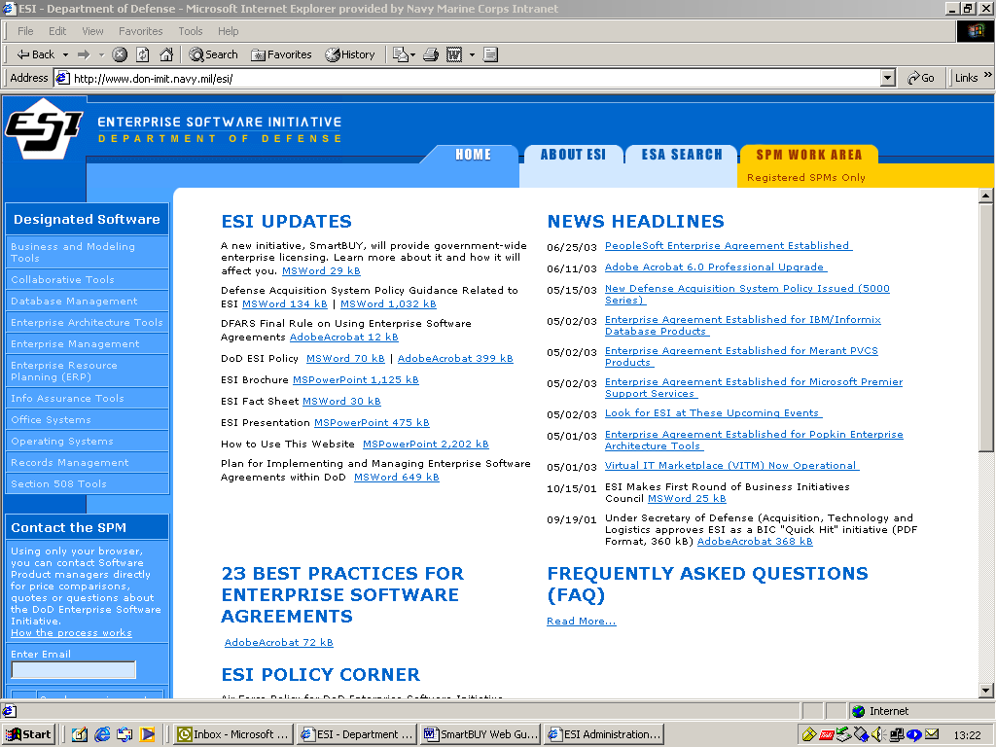
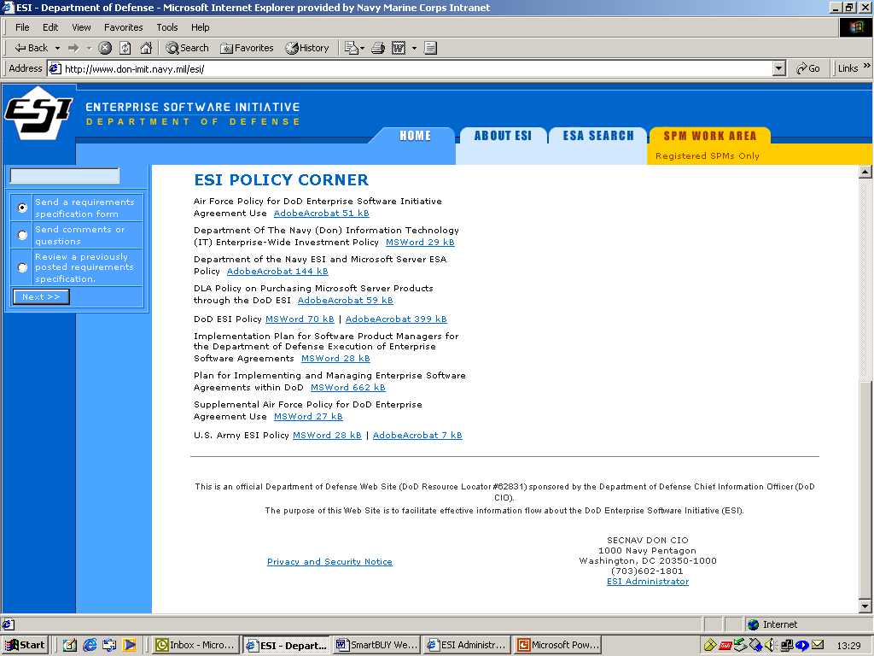
Select
Requirements
Specification Form

Attachment (2)
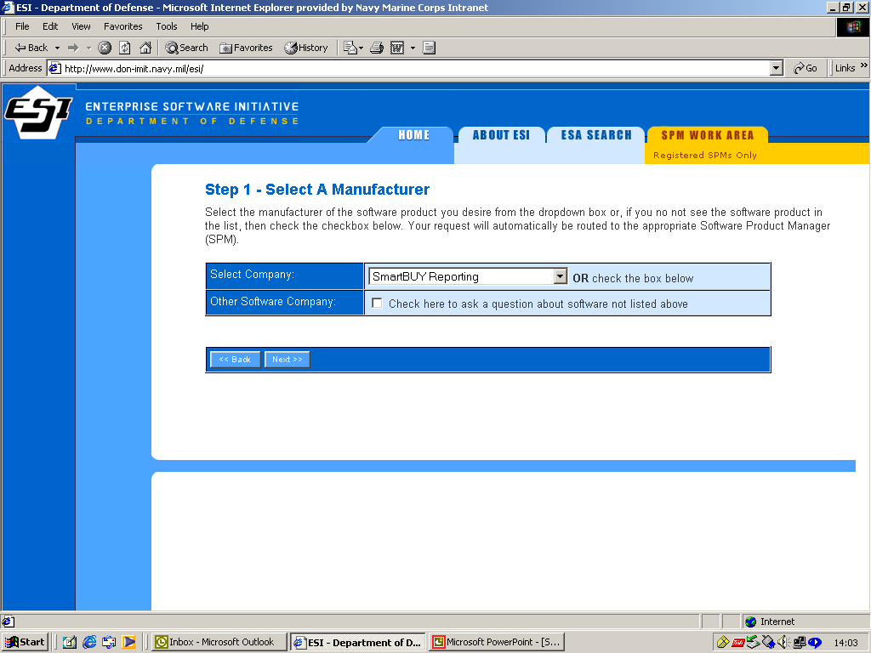
Select
SmartBUY
Reporting

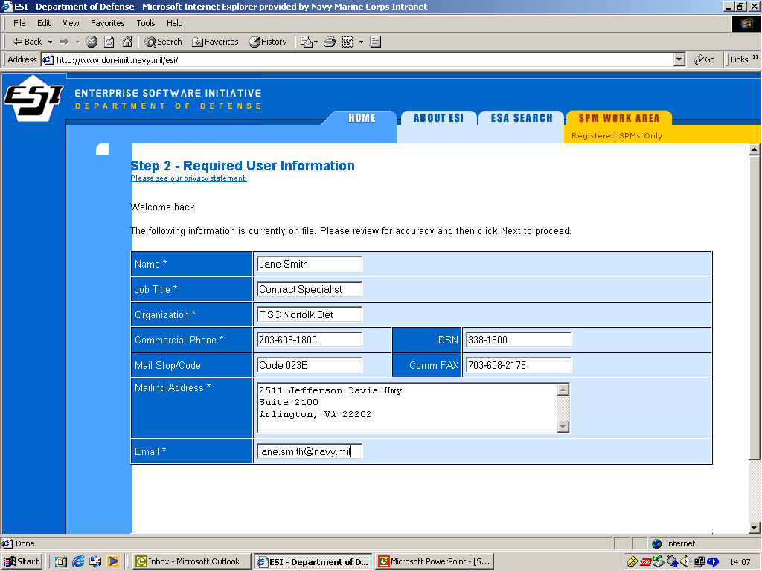
Provide required information
If not already registered.
Attachment (2)

Attachment (2)

