Partners in State and Local Climate Services
State climate offices provide climate services at the state and local level in partnership with NOAA and other federal agencies, including the Regional Climate Centers (RCC), Regionally Integrated Sciences and Assessments (RISA) program, the National Climatic Data Center (NCDC), the National Weather Service (NWS), and the USDA's Natural Resource Conservation Service (NRCS). State climate offices (SCO) have experienced first-hand the increased demand of climate services, driven by the interest in climate change and society's increased sensitivity to climate and weather events.
Many SCOs have a history of successful involvement in climate services. Key factors include:
- Locals trust locals - trusted relationships with state and local entities developed over many years of service. The median length of service of a state climatologist is 8 years and some are lifelong residents of their state.
- Connections - service on a variety of federal, state, or local boards, commissions, task forces, and other groups, providing a direct conduit of information and expertise into planning and operations within the state.
- Outreach – working very closely with the state and local media, talking to diverse groups, writing popular articles and newsletters, working with cooperative extension programs, and operating widely-viewed web sites.
- State focus – administrative, economic, social, and legal connections are best developed within state boundaries, thus a state tailored focus of climate services.
Observations and Monitoring
SCOs have a strong tradition of involvement in both observations and monitoring. As a group, we are passionate about the quality of climate data, which are considered the backbone of all that we do – research, monitoring, and services. As a result, many state climatologists are recognized experts in historical climate records, instrumentation, and the design and operation of climate networks. NOAA has twice recognized state climatologists as Environmental Heroes for their dedication toward obtaining abundant rainfall and snowfall observations of high standards.
SCOs use federal and state networks to monitor the climate and weather conditions in their state. In fact, many SCOs have developed and maintained their own state or local climate networks to address needs within their state. (e.g., the Oklahoma Mesonet).
In addition, SCOs collect information and evaluate the impacts of major climate events such as drought-related crop yield losses or flood damages. For example, SCOs in the Midwest and South worked closely with the NWS in a report on the 2007 April freeze that produced losses of $2 billion in agriculture.
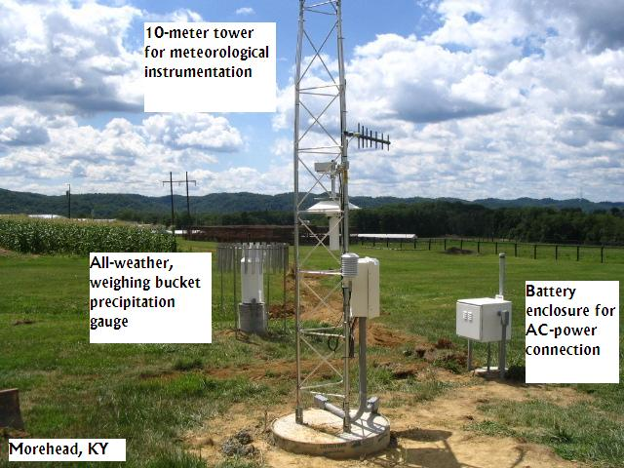
Figure 1. Kentucky Mesonet site in Morehead, KY, operated by the Kentucky Climate Center at Western Kentucky University.
Climate Services Development and Delivery
In some respects, SCOs can be considered as incubators for innovation, like 50 simultaneous pilot projects learning through experience on how to meet the needs of decision-makers covering a wide range of interests. Best practices from this expertise often form the foundation for regional and national products.
Research and Modeling
Because most SCOs are located at universities, and many state climatologists are faculty members, SCO staff can be involved in a wide variety of research activities related to climate variability and climate change. SCOs also established the new refereed on-line Journal of Service Climatology.
Current Level of State Climate Services
Today, 48 states have a designated SCO (three are currently without a state climatologist including Puerto Rico). Of these, 37 qualify for status as an American Association State Climatologists (AASC)-recognized State Climate Office (ARSCO), reflecting an exceptional degree of commitment to climate services in their state.
Limited resources remain a challenge as the demand for climate services continues to increase. As the National Climate Services enterprise evolves, AASC looks forward to exploring avenues to enhance state-level services.
Current Climate Partnership
After the termination of the federal state climatologist program in 1973, SCOs have worked closely with NCDC in a climate services partnership under the auspices of the AASC. In recent years, we have also joined forces with the RCCs, NRCS, and the NWS. In fact, a requirement for becoming an ARSCO includes evidence of cooperative efforts with our partners.
The Future
The need for climate services at local and state levels will continue to increase in coming years. SCOs will play an important and essential role in meeting these needs by continuing to expand our efforts and cooperate with others contributing to the envisioned National Climate Services program.
Contact Information
President, AASC: Nolan Doesken, 970-491-3690, nolan@atmos.colostate.edu
AASC website with links to individual SCOs: http://www.stateclimate.org/

