PATHWAY TO SUCCESS & NEW CONTRACTOR ORIENTATION
TRAININGS ARE NOW AVAILABLE ON-LINE!

GSA FAS Office of Acquisition Management is excited to announce effective October 17, 2011, the Pathway to Success & New Contractor Orientation trainings are available on the Vendor Education Center as web-based on-demand trainings. Both trainings can be found here: https://gsafas.secure.force.com/MASTrainingHome OR under the ‘TRAINING’ tab on the Vendor Support Center (VSC): https://vsc.gsa.gov/.

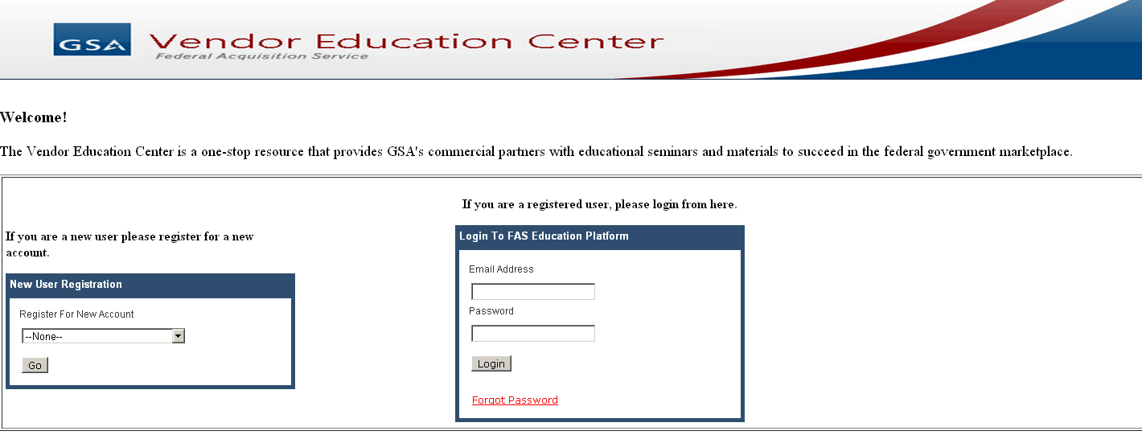
If there are any questions related to the trainings contact pathwaytosuccess@gsa.gov.

