Teacher Satisfaction and Future Plans

Highlights
- If pressed to choose a pathway other than TTT, 33 percent of TTT teachers reported that they would have pursued a traditional teacher education route, and 33 percent said they would seek another alternative teacher preparation program. Without TTT, 20 percent of participants would not have entered teaching at all.
- When presented with a set of areas related to the demands and responsibilities of a teacher, 66 percent of TTT teachers reported that they felt well or very well prepared to teach their subject matter.
- TTT teachers identified workload management as the most challenging aspect of teaching that they encountered in the first three months of teaching.
Individuals have a greater variety of options when they choose to enter teaching than ever before. TTT-sponsored alternate routes coexist in districts and in states with other approaches to recruit various targeted groups into teaching, such as military service members. As data from annual surveys indicate, 48 states and the District of Columbia have some kind of approved alternate route program (Feistritzer, 2006). Teacher education programs in private, public, and for profit IHEs offer many options for those who want to be teachers. Further, in some states, such as Florida, a legislative mandate to offer an alternate route in each school district is currently in place. Therefore, it is of some interest to explore why some individuals choose a TTT project and whether they would select another option or would give up the idea of becoming a teacher if TTT did not exist.
If pressed to choose a pathway other than TTT, 33 percent of TTT teachers reported that they would have pursued a traditional teacher education route, and 33 percent said they would seek another alternative teacher preparation program (see Exhibit 60). Without TTT, 20 percent of participants would not have entered teaching at all. These choices, when examined by teacher characteristics such as age, subject area, and target group show some interesting differences.
Paraprofessionals, among targeted groups, were least likely to say they would not have taught without the TTT alternative (14 percent) compared with recent college graduates (22 percent) and midcareer professionals (24 percent). Teachers who were born in the 1980s were much more likely to say they would have simply not taught if TTT was not available, indicating that those still in their 20s believe they have time to pursue other options. Finally, teachers of social studies and foreign languages reported they were least likely to have expected to find another route and most likely to have simply not taught.
- TTT Teachers’ Choice of
Preparation Pathway Without TTT
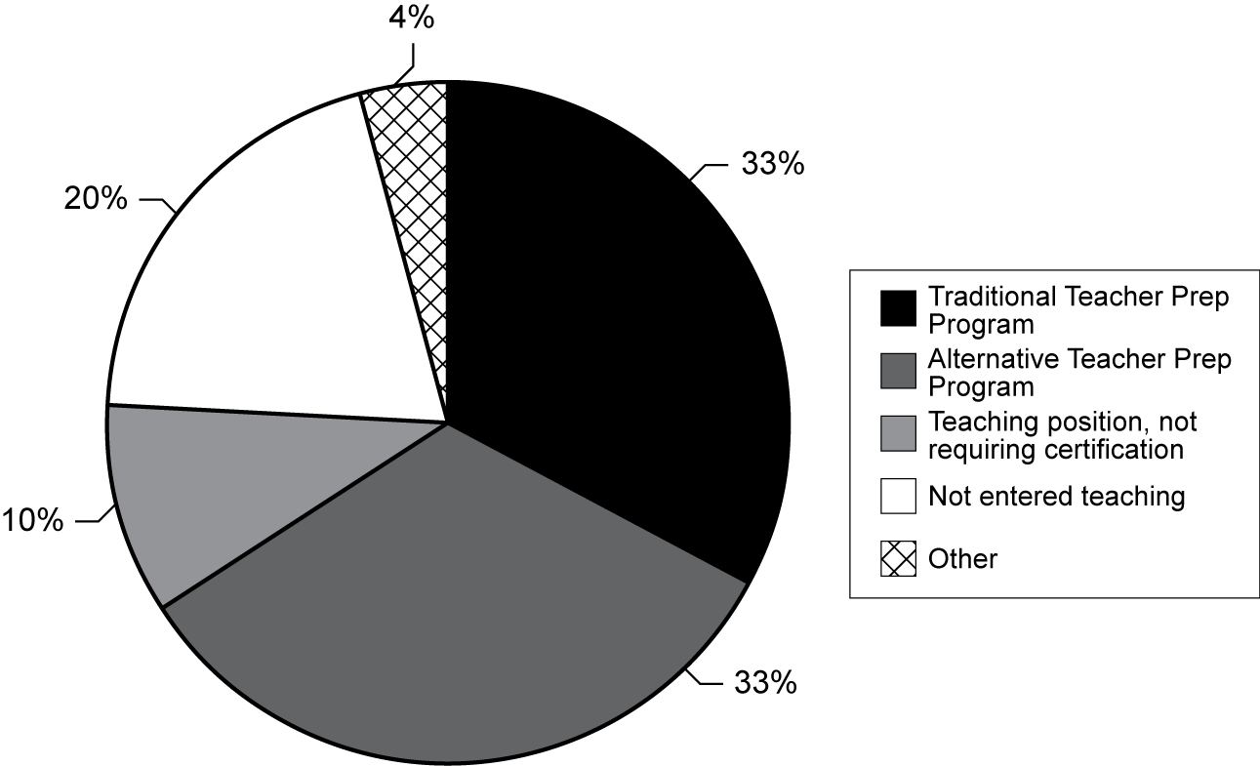

Exhibit reads: Thirty-three percent of TTT teachers reported they would have participated in a traditional teacher preparation program if the TTT project had not been available.
Source: Transition to Teaching TTT teacher survey, 2005–06.

Interest in Teaching and Perspective on Preparedness
To better understand possible influences on retaining teachers who enter through alternate routes to teaching, TTT participants were asked a series of questions about their reasons for entering teaching and their sense of preparedness for teaching. At the top of the list of participants’ reported reasons for becoming a teacher was the desire to work with young people, and the “value” that society places on teaching (see Exhibit 61). Notably, the “only field ever considered” reason was ranked last. This reasoning is implicit in the population that TTT is trying to reach, but it is still important to note that the participants recruited and teaching through the efforts of TTT grantees are individuals who have not always seen themselves as fitting the “teacher” profile. Rather, they have made a specific decision at a point in time to enter the profession.
- Percentage of TTT Teachers Reporting the Extent to Which Specific Reasons Influenced Their Becoming a Teacher
Reason | Extent
Reason | To a great extent  (Percent) | To a moderate/small extent  (Percent) | Not at all  (Percent)
Working with young people | 64 | 35 | 1
Value to society | 54 | 43 | 3
Subject-matter interest | 49 | 45 | 6
Job security | 29 | 51 | 20
Teacher in elementary or secondary school | 29 | 49 | 22
Long summer vacation | 27 | 58 | 15
Family | 24 | 46 | 30
Work schedule | 21 | 65 | 14
Employment mobility | 16 | 49 | 35
College professor/advisor | 13 | 43 | 44
Salary/benefits | 10 | 61 | 29
Preparation program in college | 9 | 30 | 61
Only field ever considered | 3 | 19 | 78
Exhibit reads: Sixty-four percent of TTT teachers reported that “working with young people” influenced their decision to become a teacher “to a great extent.”
Source: Transition to Teaching TTT teacher survey, 2005–06.
Teacher self-efficacy is an area that has been examined in a number of studies of alternate route teachers (Zientek et al., 2006). Of primary concern is whether one’s preparation and content knowledge expertise are commensurate with the demands of the classroom and the school environment. In TTT projects participants experience different sequences and delivery modes, but most are required to demonstrate their content knowledge through teacher assessments. When presented with a set of areas related to the demands and responsibilities of a teacher, 66 percent of TTT teachers reported that they felt well or very well prepared to teach their subject matter (see Exhibit 62). A similar set of challenges was presented to teachers in the most recent SASS, and there appeared to be some differences in the views among these groups of teachers. TTT teachers and teachers entering the profession from alternate routes in the workforce responded very similarly in terms of their perceptions of preparedness. However, teachers prepared in traditional routes already in the workforce reported they felt much better prepared to face these challenges than did TTT teachers. Some challenges for which TTT teachers did not feel as well prepared were “selecting and adapting curriculum materials,” “assessing students,” and “classroom management and discipline.”
- TTT Teachers’ Perceived Level of Preparation to
Face Challenges in Their First Year of Teaching
 | Extent of Being Prepared
Challenges | Well or very well prepared  (Percent) | Somewhat prepared  (Percent) | Not at all prepared  (Percent)
Collaborate with other teachers | 67 | 26 | 7
Teach subject matter | 66 | 27 | 7
Meet state/local standards | 57 | 32 | 11
Communicate with parents | 55 | 32 | 13
Instructional methods | 51 | 39 | 10
Lesson planning | 51 | 40 | 9
Use of computers | 50 | 31 | 19
Non-teaching duties | 50 | 32 | 18
Select and adapt curriculum/materials | 47 | 39 | 14
Assess students | 45 | 44 | 11
Classroom management/discipline | 44 | 44 | 12
Other | 19 | 9 | 72
Note: Respondents did not specify “other” in the survey; they responded to more than one challenge. In other places in the survey, respondents did provide some comments related to level of preparation, indicating that a mismatch of expectations regarding their teaching environment was a likely reasons for feeling unprepared.
Exhibit reads: Sixty-seven percent of TTT teachers felt “well or very well prepared” to “collaborate with other teachers” in their first year of teaching.
Source: Transition to Teaching TTT teacher survey, 2005–06.
Based on the type of grant recipient in which TTT teachers were participating, some differences in feelings of preparedness regarding the teaching of subject matter were reported. Nearly three-quarters (74 percent) of TTT teachers participating in IHE grantees’ projects reported feeling well or very well prepared to teach their subject matter in the first year of teaching. The percentage reporting this sense of preparedness declined to about two thirds for other grantee types, but the differences were not significant (see Exhibit 63).
- Percentage of TTT Teachers Reporting Their Feelings of Preparedness for Teaching Their Subject, by Type of Grant Recipient
Exhibit reads: Seventy-four percent of TTT teachers from IHE-based TTT grants reported being “well prepared” or “very well prepared” to teach their subject during their first year of teaching.
Source: Transition to Teaching Annual Performance Report and TTT teacher survey, 2004–05 and 2005–06.
In addition to describing their sense of preparedness to take on challenges, TTT teachers identified workload as the most challenging aspect of teaching that they encountered in the first three months of teaching (see Exhibit 64).
- Percentage of TTT Teachers Reporting
Extent of Challenges in the First Three Months of Teaching
Teaching Challenges | Extent of Challenge Experienced in the First Three Months
Teaching Challenges | Very challenging  (Percent) | Somewhat/moderately challenging  (Percent) | Not at all challenging  (Percent)
Managing the workload | 38 | 56 | 6
Controlling classroom behavior | 37 | 49 | 14
Scheduling your time | 35 | 59 | 6
Planning lessons | 25 | 64 | 11
Meeting curriculum goals | 24 | 68 | 8
Using technology | 22 | 48 | 30
Student nonacademic problems | 18 | 61 | 21
Applying methods of teaching | 14 | 73 | 13
Communicating with parents | 13 | 59 | 28
Teacher peer relationships | 12 | 45 | 43
Meeting state/local standards | 12 | 69 | 19
Assessing student achievement | 10 | 76 | 14
Other | 10 | 4 | 86
Exhibit reads: Thirty-eight percent of TTT teachers reported that “managing the workload” was “very challenging” during their first three months of teaching.
Source: Transition to Teaching TTT teacher survey, 2005–06.

Future Plans
When considering a series of factors that would cause them to leave teaching related to working conditions, salary and support systems, TTT teachers rated factors similarly regarding their possible impact on such a decision (see Exhibit 65). TTT teachers found moderately challenging the many responsibilities, including general working conditions, they faced in the classroom.
- Percentage of TTT Teachers Reporting
Extent to Which Factors Would Cause Them to Leave Teaching
Factors | Extent
Factors | To a great extent  (Percent) | To a moderate or small extent  (Percent) | Not at all  (Percent)
Other | 29 | 6 | 65
Low Salary | 25 | 59 | 16
Working Conditions | 24 | 61 | 15
Administration-related issues | 21 | 64 | 15
Poor support systems | 21 | 60 | 19
Lack of opportunity for advancement | 14 | 55 | 31
Student-related issues | 9 | 58 | 33
Physical condition of school building | 9 | 57 | 34
Parent/teacher relationship issues | 5 | 55 | 40
Lack of prestige | 3 | 39 | 58
Colleague-related issues | 3 | 46 | 51
Exhibit reads: Twenty-nine percent of TTT teachers reported that “other factors” (e.g., personal issues and mismatch of assignments) would influence them “to a great extent” in making a decision to leave teaching.
Source: Transition to Teaching TTT teacher survey, 2005–06.
When asked about long-term plans for remaining in teaching, nearly 50 percent of TTT teachers reported they would stay as long as they were able; clearly, this implies different amounts of time depending on the age of the participant, but it is similar to other teachers in the workforce. Twenty percent of TTT teachers reported that they were undecided, which was significantly different from the 14 percent of teachers in the workforce trained in traditional programs (see Exhibit 66). This response by TTT teachers may reflect a “wait-and-see” attitude, especially for those in their first year of teaching. The difference between the percentage of TTT teachers (15 percent) and traditionally trained teachers in the workforce (24 percent) who planned on staying until retirement was also significantly different.
- Percentage of TTT Teachers Reporting the Amount of Time They Plan to Remain in Teaching, in Comparison With SASS Data on Alternative Route Teachers and Traditional Route Teachers
Exhibit reads: Forty-nine percent of teachers trained in traditional programs reported they planned to stay in teaching “as long as I am able.”
Source: Transition to Teaching TTT teacher survey, 2005–06; SASS Public School Teacher Survey, 2003–04.

