Archived Information
UNITED STATES DEPARTMENT OF EDUCATION
OFFICE OF ELEMENTARY AND SECONDARY EDUCATION
WASHINGTON, DC 20202-6132

ESEA, TITLE I

PROGRAM GUIDANCE

SUBJECT  Annual Report of Children in Institutions for Neglected or Delinquent Children, Adult Correctional Institutions, and Community Day Programs for Neglected or Delinquent Children Used to Allocate Title I, Part A and Part D, Subpart 1 Funds for School Year 2000-2001 | TYPE AND NUMBER OF DIRECTIVE OR GUIDANCE  FM/ND-9

DATE SIGNED
September 30, 1999

ISSUING OFFICE
CEP

REFERENCE: Part A and Part D, Subpart 1 of Title I of the Elementary and Secondary Education Act of 1965, as amended, Sections 1124 and 1412

TO : State Title I Coordinators

PURPOSE: Transmittal of ED Form 4376, Needed to Collect Information for the Annual Report on Neglected or Delinquent Children

The purpose of the annual report on ED Form 4376 (Attachment 1) is to provide the U.S. Department of Education (ED) with accurate information on (1) the location and number of children who live in local institutions for neglected or delinquent (N or D) children or who are in local adult correctional facilities; and (2) the number of children enrolled in a regular program of instruction in eligible State-operated institutions for N or D children, adult correctional institutions, and community day programs for N or D children. ED needs this information to determine school year (SY) 2000-2001 allocations by local educational agencies (LEAs) for the Grants to LEAs program authorized by Title I, Part A of the Elementary and Secondary Education Act (ESEA) and to determine State allocations for the State agency N or D program authorized by Title I, Part D, Subpart 1 of ESEA.

ED expects to announce final Title I SY 2000-2001allocations in April 2000. In order to meet this schedule, we must receive accurate data on the number of children in State and local N or D institutions by no later than January 17, 2000. The attached ED Form 4376 and the instructions for completing that form are virtually identical to those used last year. Unlike last year, however, you will only need to provide us with information on children in locally operated institutions for neglected or delinquent children by LEA.
To help complete this form, we have provided you with a list of LEAs with Federal district codes for your State. When completing the survey for local N or D counts and submitting them to us, please include the Department’s LEA codes shown on the attached list. This will make it easier for us to process the information you provide. We will also make our list of LEAs available to you electronically.

To assist you in completing this annual report, Attachment 2 provides guidance on how to identify eligible institutions and count children. This guidance is similar to that provided last year.

The information provided in ED Form 4376 is subject to audit and must be certified for completeness and accuracy by the appropriate official in the SEA.

Please submit an original and one copy of the completed survey form no later than January 17, 2000 to:

Mary Jean LeTendre, Director
Compensatory Education Programs
U.S. Department of Education
400 Maryland Avenue, SW (FOB 6, Room 3W200)
Washington, DC 20202-6132

Attention: Sandy Brown

You may also submit this survey in an electronic spreadsheet form to our office at the following E-mail address:

paul_brown@ed.gov

While we encourage you to submit the data as soon as possible, all data must be submitted by January 17, 2000 in order to ensure that we can process these data and announce SY 2000-2001 Title I allocations by early April. We will only accept downward adjustments after that date.

Any questions regarding the completion of this survey should be referred to Mr. Sandy Brown at (202) 260-0976 or Ms. Kim Hicks (202) 260-0973 on my staff.

Mary Jean LeTendre
Director
Compensatory Education Programs

Attachments

Attachment 1 - ED Form 4376 (with individual State list of LEAs)
Attachment 2 - Guidance on how to identify eligible institutions and count children
Attachment 3 - Optional worksheet used to collect enrollment data for the State agency Neglected or Delinquent program

cc: Chief State School Officers

CEP/9/23/99/BROWN/260-0984/PDND9
cc:HUNKIN/State/writer
ATTACHMENT 2

Guidance for Identifying Eligible Institutions and Counting Children

Part I - Local Institutions

1. Identify eligible institutions. In order to be eligible to be counted, a child age 5 through 17 must live in a locally operated facility that meets the definition of an institution for neglected children, an institution for delinquent children, or an adult correctional institution as provided in Section 1432(1), (4), or (5) of Title I. It is not necessary to designate a child as neglected or delinquent because if he or she is between ages 5 and 17 and is in an institution that meets the definitions, that child would be eligible to be counted.

2. Report the October 1999 caseload data for children in eligible institutions. The State educational agency (SEA) must report only the number of children who resided in an eligible institution--and were not counted in the enrollment data for the State agency N or D pro-gram--for at least 30 consecutive days, at least one day of which was in the month of October.

3. Submit a separate count of children for each LEA in the following categories of institutions: (A list of LEAs for your State showing identification codes is attached.)

- Local institutions for neglected children (see the definition in Section 1432(5)).

- Local institutions for delinquent children (Section 1432(4)). In this category also include children in local adult correctional institutions (Section 1432(1)).

Although detailed information for each institution is not required, it may be helpful to provide this guidance to the individual institutions.

Please note that the category of an institution should not change from year to year unless there has been an official change in the purpose for which the institution is operated. For example, if an institution is operated for the care of neglected children, but the majority of the children residing in the institution during October are children adjudicated to be delinquent, the institution should still be reported as an institution for neglected children until its charter or purpose is officially changed to show that it is an institution operated for the care of delinquent children. Consistency in reporting from year to year is necessary because changing the category of an institution from year to year based on the category of the majority of children served affects the hold-harmless allocations and eligibility for Concentration Grants.

4. Count only children ages 5 through 17.

5. Verify the accuracy of the data to be submitted. Compare the October 1999 data to the data that were submitted last year. If there is a large increase or decrease in a county count, the SEA should identify the reason. For example, did a new institution begin operation? Did an
institution close? Do new institutions meet eligibility requirements? Were October caseload data reported correctly? Were only children ages 5 through 17 reported in the count? While it is not necessary to submit documentation to support the accuracy of the data, the SEA should be prepared to respond if questions arise when ED verifies the counts.

Part II - State-Operated or Supported Institutions

1. Identify eligible institutions or community day programs for N or D children to whom a State agency is responsible for providing free public education and is actually providing a regular program of instruction as defined in §200.50(b) of the Title I regulations. Institutions for neglected children and institutions for delinquent children are defined in §200.50(b) of the Title I regulations. The average length of stay in an institution for neglected or delinquent children must be at least 30 days. Adult correctional institutions are defined in Section 1432(1) of Title I and community day programs are defined in Section 1432(3). A child must be in an eligible institution or community day program in order to be counted.

2. Submit data on the number of children enrolled in a regular program of instruction for each eligible institution and community day program for the date specified by the State agency in accordance with §200.51(a)(2). To be counted, a child or youth must be enrolled in a regular program of instruction provided by the State agency for at least--

- 20 hours per week if in an institution for N or D children or a community day program for N or D children; or

- 15 hours per week if in an adult correctional institution.

The SEA must adjust the enrollment data for each institution to account for the relative length of a State agency's annual educational program in such institution in accordance with §200.51(b) of the Title I regulations before submitting the data to ED.

3. Count only children up to age 21 years (through age 20).

4. Verify the accuracy of the data to be submitted. Compare each State agency's enrollment data to the data that were submitted last year. If there is a large increase or decrease in a State agency's count, the SEA should identify the reason. For example, did a new institution begin operation or did an institution close? Were the enrollment data reported correctly and were data reported only for children and youth? Were the enrollment data adjusted correctly? While it is not necessary to submit documentation to support the accuracy of the data, the SEA should be prepared to respond if questions arise when ED verifies the counts.

To assist you in collecting the data needed to complete Part II, we have attached a worksheet (with instructions) that could be used to gather the enrollment data from State-operated programs for N or D children, community day programs, or adult correctional institutions within your State (Attachment 3). States are not required to use this optional worksheet or submit it to ED.
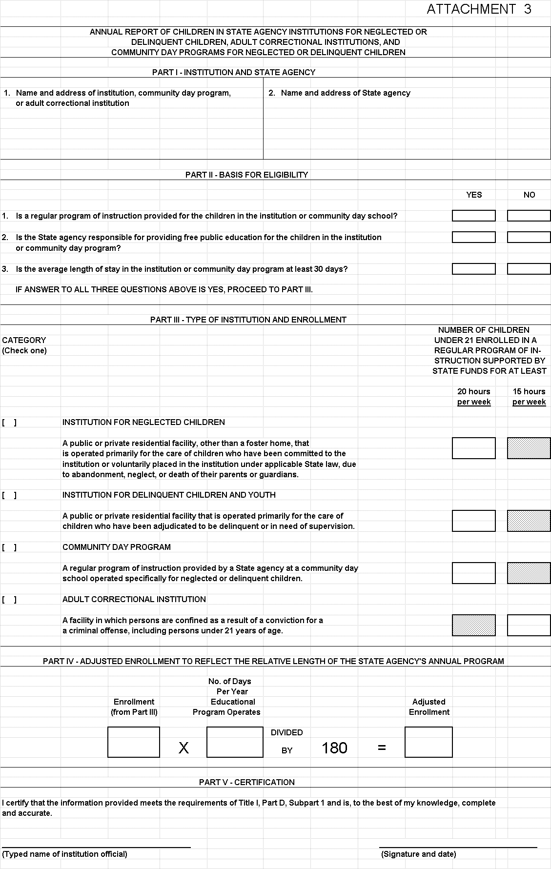
SAMPLE WORKSHEET INSTRUCTIONS

PART I - INSTITUTION AND STATE AGENCY

Enter the names of the institution and State agency. A separate form must be completed for each institution.

PART II - BASIS FOR ELIGIBILITY

Respond “yes” or “no” to each of the three questions. If the answer is no to any one of these questions, the institution or community day program does not qualify.

- In question 1 a “regular program of instruction” means an education program (not beyond grade 12) in an institution or a community day program for neglected or delinquent children that consists of classroom instruction in basic school subjects such as reading, mathematics, and vocationally oriented subjects, and that is supported by non-Federal funds. Neither the manufacture of goods within the institution nor activities related to institutional maintenance are considered classroom instruction.

- In question 2 a “State agency” means an agency of State government responsible for providing free public education for children in institutions for neglected or delinquent children, community day programs for neglected or delinquent children, and adult correctional institutions.

- In question 3 an “average length of stay” is calculated by determining the length of time each child entering the institution stays and dividing that number by the total number of children passing through that institution during a given year. The average length of stay for all children in the institution must equal at least 30 days. An individual child in an institution, however, would not necessarily have to stay for 30 days.

PART III - TYPE OF INSTITUTION AND ENROLLMENT

Category

Check the category that fits the definition of the institution. Do not report institutions that do not meet any of the four definitions.

Enrollment

For the category of institution checked, furnish the number of children under 21, through age 20, enrolled in a State-funded regular program of instruction on a date in calendar year 1999 specified by the State agency. The date specified by the State agency must be consistent for all institutions or community day programs operated by the Sate agency, and the date must represent a school day within calendar year 1999.

In order to be counted as enrolled, a child must be enrolled in a State-funded regular program of instruction for at least:

- 20 hours per week if in an institution for neglected or delinquent children or a community day program for neglected or delinquent children; or

- 15 hours per week if in an adult correctional institution.

PART IV - ADJUSTED ENROLLMENT TO REFLECT THE RELATIVE LENGTH OF THE STATE AGENCY’S ANNUAL PROGRAM

Multiply the enrollment determined in Part III by the number of days in the year that the educational program operates. Divide that number by 180 to determine the adjusted enrollment.

PART V - CERTIFICATION

The appropriate institution and State agency official should sign certifying that the information provided meets the requirements of Title I, Part D, Subpart 1, and is complete and accurate. (Note, because these data will generate Federal funds, they are subject to audit and must be supportable from documented records.)

