OSHA Hispanic Safety Summit
Sunday, June 10, 2012
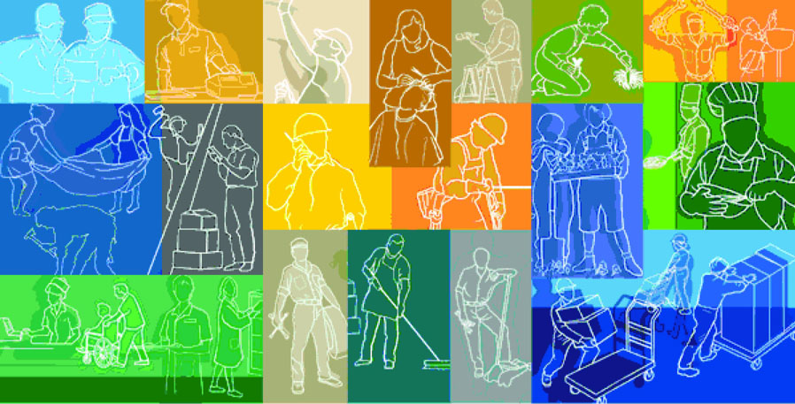
AGENDA

“MAKING A DIFFERENCE”

1:30pm - 2:30pm Registration and Resource Tables

2:30pm - 3:00pm Welcome Remarks –

Pastor Israel Figueroa, Pastor for Iglesia de Dios Maranatha Church
Kurt Petermeyer OSHA Region 3 Deputy Regional Administrator
Mexican Consulate – Speaker not yet named

OSHA’s Mission and Worker Safety and Health Rights
(TBD), OSHA Region 3 Rep (Re-emphasis of OSHA’s National Initiative, Statistical Information, Resources)

2:30pm – 3:30pm Lunch PROVIDED

3:00pm – 3:30pm 1st concurrently running session –

Protecting Workers Rights, how to make a complaint, resources available
Fall protection - PHILAPOSH
Landscaping – Delmarva Safety Association
Poultry – Victoria Mesa, Wylie Hinson

3:30pm – 4:00pm 2nd concurrently running session –

Protecting Workers Rights, how to make a complaint, resources available
Fall protection - PHILAPOSH
Landscaping – Delmarva Safety Association
Poultry – Victoria Mesa, Wylie Hinson

4:00pm – 5:00pm Federal Wage & Hour – Worker Rights
Ivette Vigano
US DOL Wage & Hour Division

5:00pm – 5:30pm Closing Remarks
Kurt Petermeyer, OSHA Region 3 Deputy Regional Administrator
Domenick Salvatore, OSHA Delaware Area Office Area Director
Pastor Israel Figueroa, Pastor for Iglesia de Dios Maranatha Church

5:30pm Adjourn

