
Department of Defense
Legacy Resource Management Program
Natural Selections
Volume 2, Issue 12 December 2006
Legacy Program Update
2007 Sustaining Military Readiness Conference: Last issue, the UPDATE reported that the save-the-date website for the DoD-sponsored Sustaining Military Readiness Conference website would be available 1 December. Due to circumstances beyond our control, the website has not been functional. The website is now functional and available at:
http://www.sustainingmilitaryreadiness2007.com/
Stay tuned to UPDATE and to the website for forthcoming information on the 30 July-3 August conference.
Legacy Program Full Proposals under review by review team: This past month, the Legacy staff met and reviewed the proposals. The proposals continue making their way up the chain. Those applicants whose proposals receive funding will be notified on the Legacy Tracker.
Legacy project highlight of the month
Legacy Project 03-160 Model Invasive Species Control Project: Yellow Starthistle:

Yellow starthistle (Centaurea solstitialis L.) is a non-native invasive plant now commonly found in western states. Yellow starthistle (YST) is California’s most widespread invasive plant, a winter annual widely distributed in the Central Valley and adjacent foothills. YST is believed to originate from Eurasia, where it is native to Balkan-Asia Minor, the Middle East, and south-central Europe. Its introduction to North America probably occurred in California after 1849 as a seed contaminant in Chilean-grown alfalfa seed. Current estimates place YST infestation at 14 million acres.
Yellow starthistle has a major impact on grassland communities, including native plants and wildlife. It also has a significant impact on groundwater consumption and forage quality. Land managers, both public and private, face the need to address these impacts on the land they oversee. DoD’s capability to train has been affected at several western installations, in particular Fort Hunter Liggett, where parachute landing sites were closed due to the thorny nature of the YST.
The DoD needed an effective management guide that would provide installations with the how-to information needed to deal with this invasive thistle.
In 2001 and 2003 the Legacy Program funded the study and evaluation of different methodologies for an integrated approach to YST eradication. This project tested at Fort Hunter Liggett resulted in the Yellow Starthistle Management Guide. This management guide supports effective land management by compiling current information on the biology, impacts, and control of yellow starthistle. Several techniques are highlighted including mechanical tools, chemical treatments, cultural practices, and biological agents.
Mechanical control options for YST include hand pulling, hoeing, tillage, and mowing. Manual removal of YST is most effective for controlling small patches or in maintenance programs where plants are sparsely located in the grassland system. Hand pulling can also be an important tool in steep or uneven terrain where other mechanical tools are impossible to use. The best timing for manual removal is after plants have bolted but before they produce viable seed.
Tillage is more common in agricultural areas than in non-crop areas. Early summer tillage will control YST provided the roots are detached from the shoots. Repeated cultivation can be used in the same season if rainfall stimulates additional germination between tillage practices. This will rapidly deplete the YST seedbanks, but may have the same effect on seedbanks of more desirable species. In order to be effective, this method should be applied before the YST can produce viable seeds.
Success with mowing depends on proper timing and the growth form of the plant. Mowing is most successful at the spiny to early flower stage. Mowing too early, before yellow starthistle seed heads reach the spiny stage, may allow YST to recover and also can suppress competing vegetation grow, thus enhancing light penetration and increasing the starthistle problem.
Cultural control techniques involve manipulation of the environment by non-mechanical means such as grazing management, controlled burning, or revegetation programs. A successful grazing program significantly reduces the population of YST, by manipulating the pattern of defoliation so that the target weed is at a competitive disadvantage relative to other more desirable plants in the community.
The best time for burning is in early to mid-summer (late June to early July in most areas of California), which may not be feasible in some areas. At that time starthistle is in the very early flowering stage (similar to ideal mowing timing) and will not have produced viable seeds, whereas seeds of most desirable species will already have dispersed and grasses will have dried to provide adequate fuel.
Biological control of YST is achieved through establishing self-sustaining populations of biological control agents that will proliferate and attack the target weed throughout its range. Several seed head insects were studied in this project and two of them seem promising as biological control methods for YST. The hairy weevil (Eustenopus villosus) and the false peacock fly (Chaetorellia australis) have proven to consistently build up high numbers and cause a substantial amount of seed destruction. The hairy weevil is the most damaging biological control; it feeds by chewing a small hole in young flower buds and feeding on the soft internal tissues. This feeding damage kills young buds and stops their development. Biological control methods are ideal where application of herbicides is not permitted, such as near stream corridors, or in areas that are not accessible by equipment such as hill sides or ravines.
Herbicides are an appropriate management option for large infestations, in highly productive soils, around the perimeter of infestations (to contain their spread), and for spot treatments of escaped patches or satellite populations. Several compounds used for starthistle control discussed provide postemergence (foliar) activity control of YST, very few of the compounds provide preemergence control. A few of the herbicides provide both excellent postevergence activity control and a significant period of preemergence control, some examples include aminopyralid, clopyralid (the most widely used chemical for YST control) picloram, and imazapyr. The Yellow Starthistle Management Guide will be on DENIX SOON!
In The News
A.P. Hill buffer preserved
Army, conservation groups reach agreement to protect 1,320 acres near the fort from construction in the future By Jenn Rowell, The Free-Lance Star
December 19, 2006
Army officials have reached agreement with several conservation groups to protect 1,320 acres near the post from development.
The agreement, signed December 19, is a first for the Caroline County post. Officials there hailed it as a major step in protecting the fort's training programs.
"From the military standpoint, the people who are really going to benefit from these easements are the fighting men and women training at the installation," A.P. Hill spokesman Ken Perrotte said. "These easements help preserve realistic conditions for training."
A.P. Hill is entering into a partnership with The Trust for Public Land, The Nature Conservancy, The Conservation Fund, Virginia Outdoors Foundation and the U.S. Fish and Wildlife Service to acquire its first conservation easement at A.P. Hill under the Army Compatible Use Buffer Program. The program allows land buffers to be established around Army installations by paying landowners not to develop the land. The landowners are still able to use and live on the land, but it cannot be subdivided for major development.
"We just don't want the land-use pattern to change to where all of a sudden there's 1,000 homes," said Lt. Col. Joe Knott, the Army's buffer program manager.
The Trust for Public Land negotiated the agreement and the Virginia Outdoors Foundation will work with the landowners to ensure the terms are kept.
"[The agreement] stays with the land, it doesn't go with the landowners, so that the Army and the conservation community don't have to worry," said Denise Schlener with the Trust for Public Land.
During the next 10 to 15 years, the coalition will work to acquire more buffers through similar agreements with other landowners, Knott said. "It's like a jigsaw puzzle and this is the first piece," he said.
The coalition partners work only with willing landowners, Schlener said. Eminent domain is not used to acquire land, she said.
The easements were purchased with about $3 million from the Defense Department, $1 million from private groups and about $1 million from the state, said Virginia Secretary of Natural Resources L. Preston Bryant Jr.
The state is concerned that encroachment around military bases could have an impact on the future of those installations, and the impact they have on the state and local economies.
In 2005, the Base Realignment and Closure process cited significant encroachment around the Naval Air Station Oceana in Virginia Beach and recommended moving the East Coast Master Jet Base to Florida, taking more than 11,000 jobs with it.
"We don't want A.P. Hill to find itself in the same position as Oceana," Bryant said. "There are lots of interests at play--conservation and economic."

Inside This Issue
1 | Legacy Program Update
1 | Legacy Project Highlight of the Month
1 | In The News
2 | Announcements and Events of Interest
6 | Recent Natural Resources Documents On DENIX
7 | Did You Know?
7 | Contact Us
See Legacy, page 3
A. P. Hill, page 5

Announcements and Events of Interest
NEW! 2007 Sustaining Military Readiness Conference July 30-August 3, 2007, at the Coronado Springs Resort, Orlando, Florida. The DoD Legacy Resource Management Program (Conservation Office), the Office of Economic Adjustment (OEA), Environmental Readiness and Safety Office, Personnel and Readiness Office, SERDP/ESTCP Office, and Operational Test and Evaluation Directorate (DOT&E) are hosting a conference in 2007 for DoD personnel and invited partners. Look for registration information and other details in the December issue of Natural Selections. Save the date for this conference at www.sustainingmilitaryreadiness2007.com.
NEW! Knotweed Symposium The Western Society of Weed Science (WSWS) is sponsoring an Invasive Knotweed Symposium to take place at the WSWS Annual Meeting in Portland, Oregon. The program will begin on the morning of Thursday, March 15, 2007 and continue through noon on Friday, March 16. International experts John Bailey from the United Kingdom and Petr Pysek from the Czech Republic will be keynote speakers, discussing genetics and ecology of invasive knotweeds. Other experts will discuss biology, physiology, ecological impacts, and management of Japanese knotweed, giant knotweed, Bohemian knotweed, and Himalayan knotweed, a group of species that have become problematic throughout the world. The meeting will be held at Hilton Portland & Executive Tower, 921 SW Sixth Avenue, Portland, OR. A complete agenda will be announced in late January, 2007. The registration fee is $50 if you also attend the 2007 WSWS annual meeting and $75 if only attending the Knotweed Symposium. Registration includes a one-year, complementary membership to the WSWS. Student discounts are available. Log on to the WSWS website http://www.wsweedscience.org/ or mail in the attached form to register. Online pre-registration is available until February 15, 2007.
National Military Fish and Wildlife Association “2007 Department Of Defense Natural Resources Training Workshop” March 19-23, 2007 at the Hilton Portland and Executive Tower Hotel in Portland, Oregon. The workshop will be conducted in conjunction with the North American Wildlife and Natural Resources Conference. NMFWA technical presentations will include sessions on Fire as a Management Tool, Bio-control of Invasive Species, Habitat Restoration Using Native Plants, Herpetology, Bird Conservation, Opportunities in Conservation Training, Wetlands, Invasive Species Issues, New Bird Regulations and INRMPs, and Ecology of Military Training Disturbance. Additional information and registration is available at www.nmfwa.org.
Invasive Plant Management Workshop January 24, 2007 at the US National Arboretum in DC. This will be the first year that this meeting, usually held at Fort Detrick, will be held at the Arboretum. If you have any questions please e-mail or call Steven Manning at stevemanning@mindspring.com or 615-969-1309. For more information and registration materials, visit www.usna.usda.gov/Education/. Once on the site, go to current events and programs, click on January and look for the Invasive Plant Management Workshop. When you click on registration required you will find the registration form, or call 202-245-5898.
2007 National Gap Analysis Conference Featuring the Southeast Regional Gap Analysis Project September 11-13, 2007, at the Renaissance Asheville Hotel, Asheville, North Carolina. The meeting will include presentations and discussions about recent developments and applications from GAP projects across the country. This meeting is sponsored by the U.S. Geological Survey, The Biodiversity and Spatial Information Center at NCSU, Alabama Gap at Auburn University, the Institute of Ecology at the University of Georgia, and the University of Idaho. Attendees will learn about the most important environmental issues in the country, particularly in the Southeast, and to discuss how GAP data sets can be used for resource management and decision-making. A special symposium will focus on conservation issues in the Southeastern U.S. and on the use of the Southeast Regional Gap Analysis Project (SEGAP) data for addressing these issues. This symposium is intended to bring together all interested individuals and agencies to explore the highest priority management needs in this region and to discuss how data resources can be
used to assist managers.

Legacy, continued from page 1

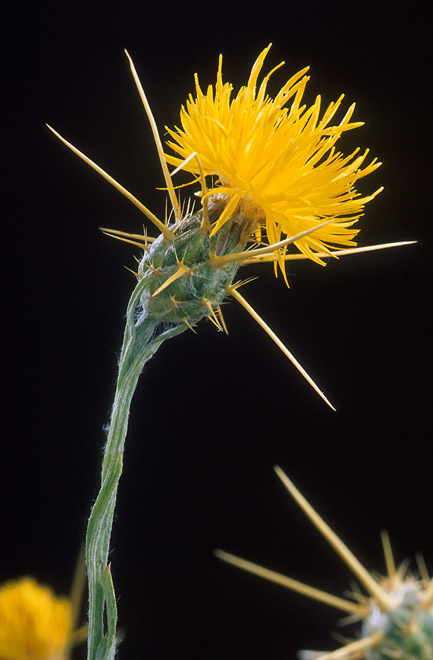
Yellow Starthistle (Centaurea solstitialis L). at full bloom stage.

Check it out!
APWG 2007 Printable Calendar
The Alien Plant Working Group's Invasive Plant Calendar for 2007 is now done and available online for you to download & print. Take a look at:
http://www.nps.gov/plants/alien/pubs/calendar.htm#print

A. P. Hill, continued from page 1
A.P. Hill, continued from page 1

Recent Natural Resources Documents On DENIX
SOON! Yellow Starthistle Management Guide (Legacy 03-160): - This management guide supports effective land management by compiling current information on the biology, impacts, and control of yellow starthistle. Several techniques are highlighted including mechanical tools, chemical treatments, cultural practices, and biological agents. Each technique is discussed in detail to assist land managers decide the best approach after consideration of a particular site parameters.
Migratory Linkages of Burrowing Owls on DoD Installations and Adjacent Lands: where do owls breeding on DoD installations in the southwestern U.S. spend the winter. April 2006 (Legacy 05-243): -This document details the progress made on a project that investigates Burrowing Owls on DoD installations and wintering grounds throughout Mexico. Includes numbers and locations of samples taken on Davis-Monthan AFB AZ, Kirtland AFB NM, and Naval Base Coronado CA, detailed feather and specimen collection methodology and detailed information on wintering grounds, species stressors and threats throughout Mexico.
Fact Sheet: Department of Defense National Public Lands Day 2005 (Legacy # 5-86): This fact sheet summarizes the ongoing National Public Lands Day project accomplishments for 2005.
State Wildlife Action Plan (SWAP) & INRMP Workshop Summary Atlanta GA 05, 09-11, 2006 (Legacy 5-281): These materials summarize the information from the State Wildlife Action Plans (SWAPs) and INMPs Workshop held in Atlanta GA on May 9-10-2006. The purpose of the workshop was to bring state (GA, NC, SC, & FL), military and USFWS personnel together to integrate SWAPs and INRMPs by identifying common problems and goals for the region. Includes the workshop workbook and information templates on follow up efforts being undertaken in the four states. DoD side of Denix only.
Management Strategies for Reversing Declines in Landbirds of Conservation Concern on Military Lands: Enhanced Species-Landscape Models and Avian Demographics. September 2006 (Legacy #5-103): This document reports on enhancements to a species-landscape model that predicts effects of landscape change on a suite of adult and young birds in the eastern and central U.S. Findings will be used as the basis for subsequent management guidelines for installations in that region of the U.S.
Federal Native Plant Conservation Memorandum of Understanding (MOU) (signed 09-01-06): Signed by DoD, FHA, USGS, BLM, NPS, OSMRE, USDA and USFWS, the purpose of this MOU is to establish and describe a Federal Native Plant Conservation Committee. The Committee will identify and recommend, as appropriate, priority conservation needs for native plants and their habitats and coordinate implementation of programs for addressing those needs. A native plant species is one that occurs naturally in a particular habitat, ecosystem, or region of the United States and its Territories or Possessions, without direct or indirect human actions.
Memorandum of Understanding (MOU) between DoD and Bat Conservation International (BCI) (signed 10-11-06): The purpose of this MOU is to establish procedures for planning and conducting cooperative efforts by BCI and DoD on DoD lands. It also establishes policies and procedures for BCI to provide technical assistance to DoD to maintain or increase the productivity of bats and their habitats on DoD lands; to keep once-common bat species from being Federally-listed as threatened or endangered; and to work to recover presently listed species of bats and prevent species extinction.
Wintering Ecology of Shrubland Birds: Linking Landscape and Habitat: Annual Progress Report September 2006 (Legacy 5-241): Summarizes the data collected during the first field season of winter 2005-2006 on 8 western installations that will help gain insight to Shrubland birds with regards to habitat associations on wintering grounds, climate influences and breeding-wintering ground connectivity. Contains detailed species counts and information. Also included is a discussion of the benefits this study will have to the military. Information is preliminary and will be incorporated into a subsequent report and management plan.

Did You Know?
Ohh! BATS! The majority of North American bat species are insectivorous and extremely beneficial because they consume large quantities of moths, flies, mosquitoes, beetles, and other insects. Bats typically consume more than 50 percent of their body weight in insects each night, and nursing females have been reported to eat enough insects to equal their body weight. Bats amount to approximately a quarter of all mammal species. They are found everywhere in the world except in the most extreme desert and polar regions. Most bats navigate with high-frequency sounds. Using sound alone, they can detect obstacles as fine as a human hair in total darkness. The sophistication of their unique echolocation system surpasses current scientific knowledge!
Bats carefully groom themselves. Bats are among the cleanest of animals and are also exceptionally resistant to disease. Bats, for their size, are the slowest reproducing mammals on earth. This is one reason why many bat species are in decline. On average mother bats rear only one young per year. Some do not give birth until they are two or more years old. Like humans, bats give birth to poorly developed young and nurse them from a pair of pectoral breasts. Mother bats have been known to adopt each other's young. Bats are exceptionally long-lived, some species can live up to 34 years! Bats always turn left when exiting a cave. Bats are the only mammals that are able to fly.
Contact Us
For further information about the Legacy Resource Management Program please contact:

L. Peter Boice | Pedro Morales
Conservation Team Leader | Natural Resource Management Specialist
 | 703-604-1933
Jane Mallory | Hillori Schenker
Natural Resource Management Specialist | Cultural Resource Management Specialist
703-604-1774 | 703-604-1724

Disclaimer
Every effort is made to provide accurate and complete information. However, with the hundreds of documents available online, often uploaded within short deadlines, we cannot guarantee that there will be no errors. With respect to documents and information referenced by means of hyperlinks on this publication, neither the U.S. Government, the U.S. Department of Defense (DoD), Plexus Scientific (website contractor) nor their employees and contractors make any warranty, expressed or implied, including the warranties of merchantability and fitness for a particular purpose with respect to documents available from Department of Defense websites, or from independent parties outside of DoD. Additionally, the U.S. Government, DoD, nor Plexus Scientific assume no legal liability for the accuracy, completeness, or usefulness of any information, product, or process disclosed herein and do not represent that use of such information, product, or process would not infringe on privately owned rights.
Requests to be added or removed to the Natural Selections distribution list may be sent to Pedro.Morales.ctr@osd.mil.

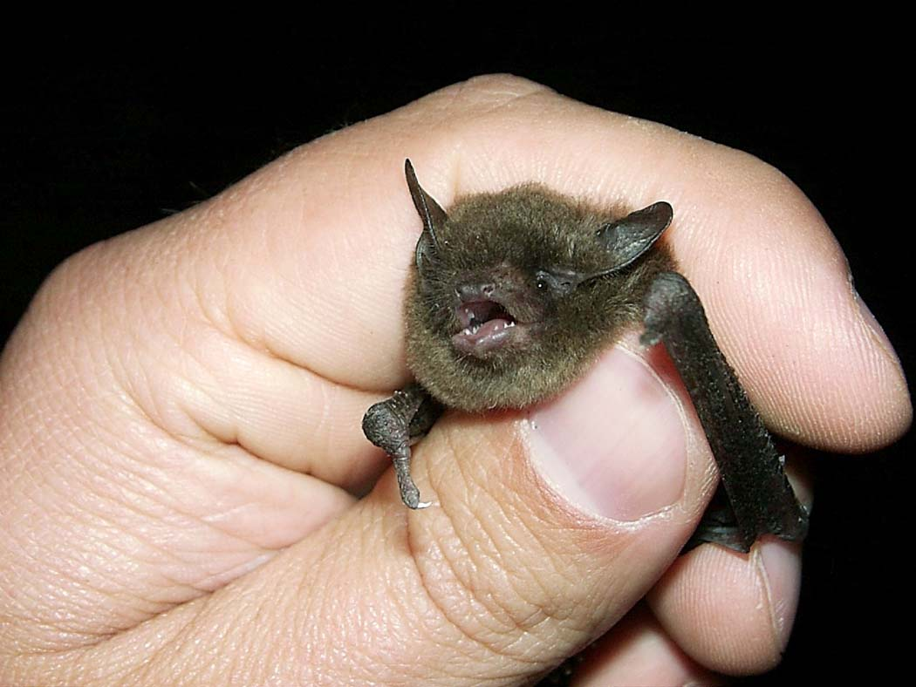
Indiana Bat (Myotis sodalis). Photo by USFWS

