Tropical Cyclone Report
Tropical Storm Edouard
(AL052008)
3-6 August 2008

James L. Franklin
National Hurricane Center
14 November 2008

Edouard was a short-lived tropical storm that made landfall along the upper Texas coast.

- Synoptic History

The remnants of a front moved southward into the northern Gulf of Mexico on 2 August, in the form of a weak surface trough of low pressure. Shower activity became more concentrated along the trough south of the Florida panhandle during the day, and by early on 3 August a small area of low pressure had formed. By 1200 UTC that day the low had developed a well-defined circulation with sufficient convective organization to be designated a tropical depression. At this time the center was located about 140 n mi south of Pensacola, Florida.

The “best track” chart of the tropical cyclone’s path is given in Fig. 1, with the wind and pressure histories shown in Figs. 2 and 3, respectively. The best track positions and intensities are listed in Table 1. A reconnaissance aircraft found only relatively light winds and a minimum pressure of 1007 mb on its first pass through the center of the depression around 1930 UTC 3 August. However, a burst of convection developed over the center about that time, and within an hour and a half the pressure had fallen to 1002 mb and flight-level winds had increased to 54 kt, indicating that the depression had strengthened to a tropical storm. This period of development was short-lived, however, as northerly shear and mid-level dry air appeared to prevent the cyclone from maintaining convection over the center, and little change in strength occurred over the next 24 h as Edouard moved westward around the periphery of mid- to upper-level high pressure over the south-central United States.

While the center of Edouard was passing around 50 n mi to the south of the coast of Louisiana late on 4 August, northerly shear abated and the cyclone’s outflow began to increase in the northwestern quadrant. Turning to the west-northwest around the periphery of the mid- to upper-level high, Eduard began to strengthen. As it approached the upper Texas coast early on 5 August, spiral banding features became better defined and the cyclone’s peak winds reached 55 kt at 0600 UTC. Edouard maintained this intensity and made landfall at the McFaddin National Wildlife Refuge, between High Island and Sabine Pass, at 1200 UTC that day.

Edouard quickly began to weaken as it moved inland to the west-northwest, becoming a depression near 0000 UTC 6 August and degenerating to a remnant low 6 h later when deep convection diminished. The remnant circulation of Edouard continued across central Texas accompanied by intermittent convection before dissipating later that day.

- Meteorological Statistics

Observations in Edouard (Figs. 2 and 3) include satellite-based Dvorak technique intensity estimates from the Tropical Analysis and Forecast Branch (TAFB) and the Satellite Analysis Branch (SAB), as well as flight-level, stepped frequency microwave radiometer (SFMR), and dropwindsonde observations from flights of the 53rd Weather Reconnaissance Squadron of the U. S. Air Force Reserve Command. Data from NWS Doppler radars were also useful in tracking Edouard.

Edouard’s estimated peak intensity of 55 kt is based largely on a flight-level wind observation of 68 kt from 850 mb at 0704 UTC 5 August. While there was an SFMR report of 63 kt observed shortly before landfall about 10 n mi offshore, this instrument sometimes performs erratically in rainy areas where winds are below hurricane force. In addition, waters in this area were sufficiently shallow to suspect that shoaling might have compromised the data. This SFMR observation, and an earlier observation near 0000 UTC 4 August, have no support from the flight-level data and are judged to be either incorrect or unrepresentative.

Surface observations of note are presented in Table 2. There were no reports from ships of winds of tropical storm force. Along the coast, sustained winds of 49 and 47 kt were observed at Texas Point, TX and Calcasieu Pass, LA, respectively. Reported storm surge values did not exceed 4 ft. The largest storm total rainfall report of 6.48 inches came from the Baytown, Texas EOC. In Louisiana, the maximum reported amount was 3.81 inches in Hackberry. An analysis of storm-total rainfall is given in Figure 4, where it is seen that only a small area close to the path of the center received significant rains.

No tornadoes were reported in association with Edouard.

- Casualty and Damage Statistics

Damage associated with Edouard was relatively light. In Texas, inland flooding closed a portion of Interstate 10 in Chambers County, with additional road closures reported in Harris County. Near Baytown, water entered a few garages, while flooding from the storm tide affected approximately 25 homes in Gilchrist. In Louisiana, some tidal flooding was reported in Lake Charles, the roofs of several mobile homes were damaged in Cameron County, and there were downed trees and power lines. In Jefferson County up to 30,000 customers lost power.

Oil and gas production platforms in the Gulf of Mexico, as well as some coastal refineries, were briefly shut down as Edouard approached.

There was one death reported in association with Edouard – an adult male who fell overboard from a shrimping vessel in rough seas near the mouth of the Mississippi River.

- Forecast and Warning Critique

The development of Edouard was not well anticipated. The precursor disturbance moved offshore into the Gulf of Mexico the day prior to genesis, and was introduced into the Tropical Weather Outlook only 18 h prior to the best track’s genesis time. Even at the time of (best track) genesis, the experimental genesis forecast probability was only at 50%. Northerly shear and dry continental air were considered to be inhibiting factors for development.

A verification of official and guidance model track forecasts is given in Table 3. Edouard was a short-lived event, and the number of cases is very small. Average official track errors for Edouard (with the number of cases in parentheses) were 29 (8), 31 (6), 49 (4), and 67 (2) n mi for the 12, 24, 36, and 48 h forecasts, respectively. These errors are well below the 5-yr mean official track errors (Table 3), and mostly close to the track consensus model TVCN.

A verification of official and guidance model intensity forecasts is given in Table 4. Average official intensity errors were 6.3 (8), 7.5 (6), 7.5 (4), and 5.0 (2) kt for the 12, 24, 36, and 48 h forecasts, respectively. For comparison, the 5-yr mean official intensity errors are 7, 10, 12, and 14 kt, respectively. In addition to being well below the long-term means, the official intensity errors were well below the decay-SHIFOR5 skill benchmark (OCD5). The errors, while small, had a systematic high bias.

Watches and warnings associated with Edouard are given in Table 5. The tropical storm warning for the landfall area was issued 27 h prior to landfall.

Acknowledgements.

Appreciation is expressed to WFO Houston/Galveston, WFO Lake Charles, and WFO New Orleans for their comprehensive reports on observations and impacts in their respective areas. Rex Hervey at the National Data Buoy Center provided additional surface observations. David Roth at the Hydrometeorological Prediction Center constructed the rainfall analysis.
Table 1. Best track for Tropical Storm Edouard, 3-6 August 2008.

Date/Time  (UTC) | Latitude  (°N) | Longitude  (°W) | Pressure  (mb) | Wind Speed  (kt) | Stage
03 / 1200 | 28.1 | 87.4 | 1010 | 25 | tropical depression
03 / 1800 | 28.1 | 87.8 | 1009 | 30 | "
04 / 0000 | 28.1 | 88.5 | 1002 | 45 | tropical storm
04 / 0600 | 28.1 | 89.6 | 1005 | 40 | "
04 / 1200 | 28.1 | 90.3 | 1002 | 40 | "
04 / 1800 | 28.3 | 91.0 | 1001 | 40 | "
05 / 0000 | 28.5 | 91.7 | 999 | 50 | "
05 / 0600 | 29.0 | 92.9 | 997 | 55 | "
05 / 1200 | 29.6 | 94.2 | 996 | 55 | "
05 / 1800 | 30.0 | 94.8 | 999 | 40 | "
06 / 0000 | 30.6 | 95.7 | 1003 | 30 | tropical depression
06 / 0600 | 31.4 | 97.0 | 1008 | 25 | low
06 / 1200 | 32.0 | 98.0 | 1011 | 20 | "
06 / 1800 | 32.7 | 98.7 | 1012 | 20 | "
07 / 0000 |  |  |  |  | dissipated
05 / 1200 | 29.6 | 94.2 | 996 | 55 | Landfall at McFaddin National Wildlife Refuge, TX
05 / 1200 | 29.6 | 94.2 | 996 | 55 | minimum pressure

Table 2. Selected surface observations for Tropical Storm Edouard, 3-6 August 2008.

Location | Minimum Sea Level Pressure |  | Maximum Surface  Wind Speed |  |  | Storm surge  (ft)^{c} | Storm  tide  (ft)^{c} | Total  rain  (in)
Location | Date/  time  (UTC) | Press.  (mb) | Date/  time  (UTC)ª | Sustained  (kt)^{b} | Gust  (kt) | Storm surge  (ft)^{c} | Storm  tide  (ft)^{c} | Total  rain  (in)
Texas
International Civil Aviation Organization (ICAO) Sites
Galveston Scholes Field (KGLS) | 05/1152 | 1009.0 | 05/1517 | 27 | 39
Beaumont - Southeast Texas Regional Airport (KBPT) | 05/1225 | 1000.0 | 05/1422 | 39 | 49
Coastal-Marine Automated Network (C-MAN) Sites
SRST2 | 05/1200 | 996.5 | 05/1400 | 47 | 56
National Ocean Service (NOS) Sites
Galveston Ship Channel North Jetty (GSJT2) |  |  | 05/1518 | 43 | 52
Sabine Pass North (SBPT2, 6 min average) |  |  | 05/1324 | 42 | 60
University Networks
Texas Point (TCOON, 29.68N 93.84W) | 05/1048 | 996.2 | 05/1324 | 49 | 62
Public/Other
Moody Gardens Inc  (GLVST, 29.27N 94.85W) |  |  | 05/1429 | 41 | 60
Jamaica Beach  (JBHT2, 29.20N 94.98W) |  |  | 05/1626 | 35 | 40
Rollover Pass |  |  | 05/1300 | 36 | 49 | 3.92 | 4.85
Baytown EOC |  |  |  |  |  |  |  | 6.48
Sheldon (458H) |  |  |  |  |  |  |  | 5.91
Pasadena (579F) |  |  |  |  |  |  |  | 5.75
La Porte (580F) |  |  |  |  |  |  |  | 4.49
Houston (496H) |  |  |  |  |  |  |  | 4.41
Wallisville (457V) |  |  |  |  |  |  |  | 4.41
Kemah (620P) |  |  |  |  |  |  |  | 2.67
Louisiana
ICAO Sites
Lake Charles (KLCH) | 05/0836 | 1007.8 | 05/0829 | 33 | 43 |  |  | 1.86
South Timbalier (KS58) |  |  | 04/1645 | 40 | 45
RAWS
Hackberry 8 SSW |  |  |  |  |  |  |  | 3.81
Lake Charles 6 SE |  |  |  |  |  |  |  | 2.56
NOS Sites
Calcasieu Pass (CAPL1, 6 min average) | 05/0848 | 1001.0 | 05/0848 | 47 | 54 | 2.44 | 4.31
University Networks
Marsh Island (MRSL1, 23 m anemometer height, 8 min average) |  |  | 05/0400 | 42 | 54
Tambour Bay (TAML1) |  |  | 05/0551 | 34 | 38
South Timbalier Blk 52 (SPLL1, 40 m anemometer height) |  |  | 04/1800 | 41
Public/Other
Grand Chenier 9 ESE (GCHL1) |  |  |  |  |  |  |  | 2.95
Freshwater Locks |  |  |  |  |  | 3.60 | 5.09
Buoys
42035 | 05/1150 | 1005.3 | 05/1350 | 35 | 45

ª Date/time is for sustained wind when both sustained and gust are listed.
^{b} Except as noted, sustained wind averaging periods for C-MAN and land-based ASOS reports are 2 min; buoy averaging periods are 8 min.
^{c} Storm surge and tide values referenced to mean lower low water.

Table 3. Track forecast evaluation (heterogeneous sample) for Tropical Storm Edouard, 3-6 August 2008. Forecast errors (n mi) are followed by the number of forecasts in parentheses. Errors smaller than the NHC official forecast are shown in boldface type.

Forecast Technique | Forecast Period (h)
Forecast Technique | 12 | 24 | 36 | 48 | 72 | 96 | 120
CLP5 | 44 (9) | 99 (7) | 156 (5) | 287 (3)
GFNI | 21 (2)
GFDI | 30 (9) | 33 (7) | 41 (5) | 38 (3)
HWFI | 29 (9) | 50 (7) | 85 (5) | 100 (3)
GFSI | 30 (9) | 44 (7) | 61 (5) | 48 (3)
AEMI | 54 (8) | 110 (4) | 157 (4) | 133 (2)
NGPI | 28 (9) | 34 (7) | 44 (5) | 35 (3)
UKMI | 29 (6) | 38 (4) | 15 (2)
EGRI | 31 (6) | 38 (2) | 88 (2)
EMXI | 34 (5) | 32 (4) | 59 (3) | 59 (1)
BAMD | 26 (9) | 30 (7) | 47 (5) | 49 (3)
BAMM | 30 (9) | 49 (7) | 67 (5) | 66 (3)
BAMS | 26 (9) | 24 (7) | 33 (5) | 36 (3)
LBAR | 30 (9) | 43 (7) | 56 (5) | 63 (3)
TVCN | 25 (9) | 30 (7) | 49 (5) | 40 (3)
GUNA | 31 (6) | 43 (2) | 69 (2)
FSSE | 30 (7) | 40 (5) | 60 (3) | 63 (1)
OFCL | 29 (8) | 31 (6) | 49 (4) | 67 (2)
NHC Official  (2003-2007 mean) | 34.0 (1742) | 58.2 (1574) | 82.2 (1407) | 106.2 (1254) | 154.2 (996) | 207.5 (787) | 272.5 (627)

Table 4. Intensity forecast evaluation (heterogeneous sample) for Tropical Storm Edouard, 3-6 August 2008. Forecast errors (kt) are followed by the number of forecasts in parentheses. Errors smaller than the NHC official forecast are shown in boldface type.

Forecast Technique | Forecast Period (h)
Forecast Technique | 12 | 24 | 36 | 48 | 72 | 96 | 120
OCD5 | 9.3 (9) | 12.4 (7) | 13.2 (5) | 9.7 (3)
GHMI | 10.1 (9) | 5.9 (7) | 3.4 (5) | 7.3 (3)
HWFI | 11.3 (9) | 13.7 (7) | 19.8 (5) | 19.7 (3)
LGEM | 10.6 (9) | 9.3 (7) | 10.0 (5) | 10.7 (3)
DSHP | 9.0 (9) | 7.6 (7) | 6.6 (5) | 10.0 (3)
FSSE | 7.1 (7) | 9.2 (5) | 7.7 (3) | 18.0 (1)
ICON | 10.1 (9) | 6.3 (7) | 6.0 (5) | 10.7 (3)
OFCL | 6.3 (8) | 7.5 (6) | 7.5 (4) | 5.0 (2)
NHC Official  (2003-2007 mean) | 6.7 (1742) | 10.0 (1574) | 12.3 (1407) | 14.3 (1254) | 18.2 (996) | 19.7 (787) | 21.8 (627)

Table 5. Watch and warning summary for Tropical Storm Edouard, 3-6 August 2008.

Date/Time (UTC) | Action | Location
3 / 2100 | Tropical Storm Watch issued | Intracoastal City to Port O’Connor
3 / 2100 | Tropical Storm Warning issued | Mississippi River to Intracoastal City
4 / 0300 | Tropical Storm Watch changed to Hurricane Watch | Intracoastal City to Port O’Connor
4 / 0300 | Tropical Storm Warning modified to | Mississippi River to Cameron
4 / 0900 | Tropical Storm Warning modified to | Mississippi River to San Luis Pass
4 / 1500 | Tropical Storm Warning modified to | Mississippi River to  Port O’Connor
5 / 0300 | Tropical Storm Warning modified to | Grand Isle to Port O’Connor
5 / 0900 | Tropical Storm Warning modified to | Grand Isle to Sargent
5 / 0900 | Hurricane Watch modified to | Intracoastal City to Sargent
5 / 1500 | Tropical Storm Warning modified to | San Luis Pass to Cameron
5 / 1500 | Hurricane Watch discontinued | All
5 / 2100 | Tropical Storm Warning discontinued | All

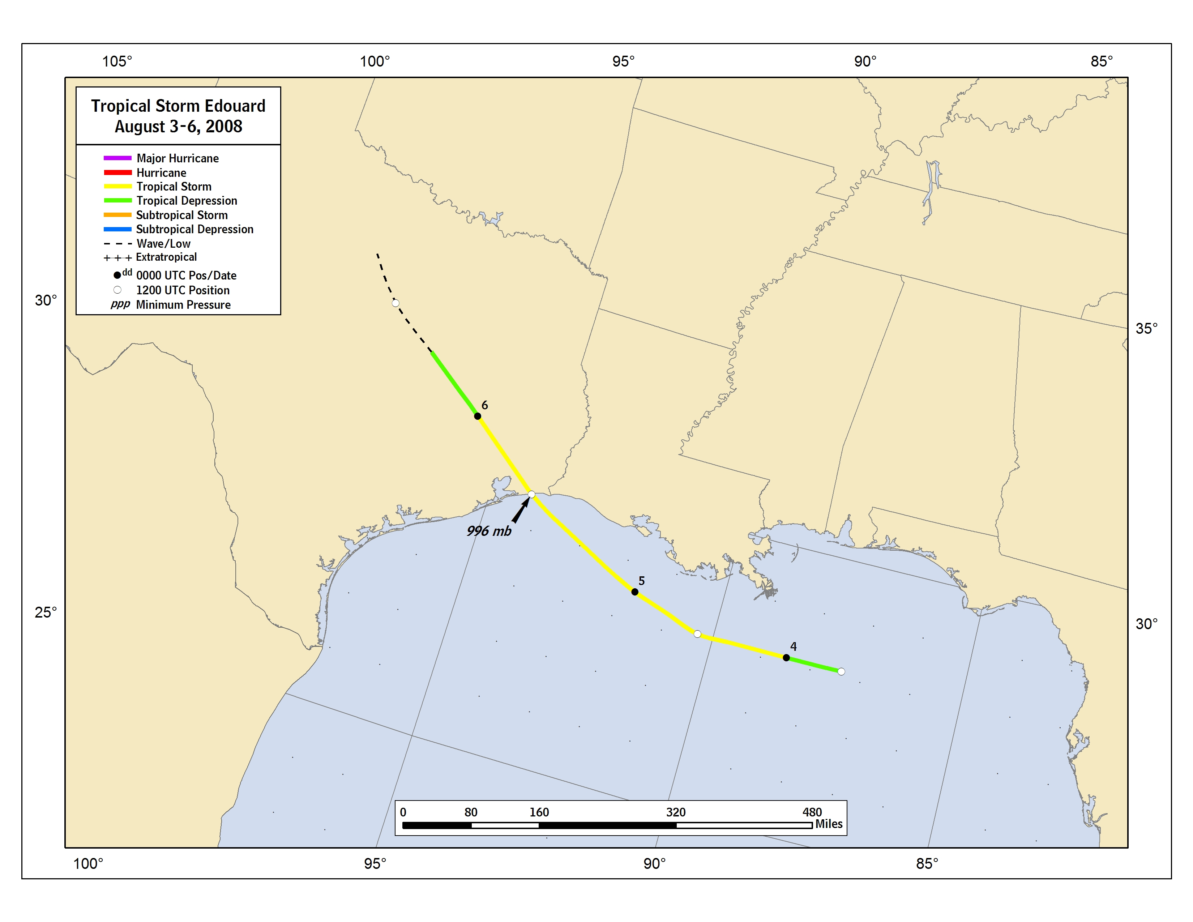
Figure 1. Best track positions for Tropical Storm Edouard, 3-6 August 2008.
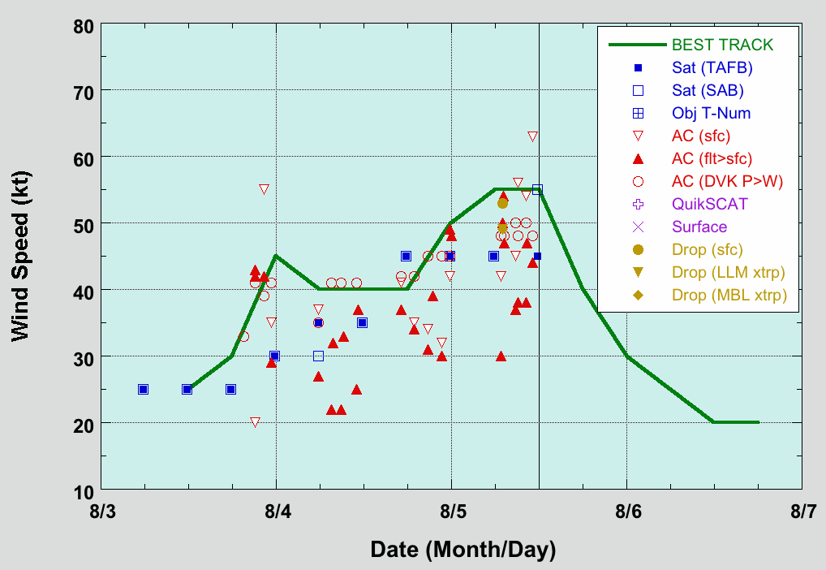
Figure 2. Selected wind observations and best track maximum sustained surface wind speed curve for Tropical Storm Edouard, 3-6 August 2008. Flight-level aircraft observations have been adjusted for elevation using 90%, 80%, and 80% reduction factors for observations from 700 mb, 850 mb, and 1500 ft, respectively. Landfall in Texas is denoted by the thin solid vertical line.
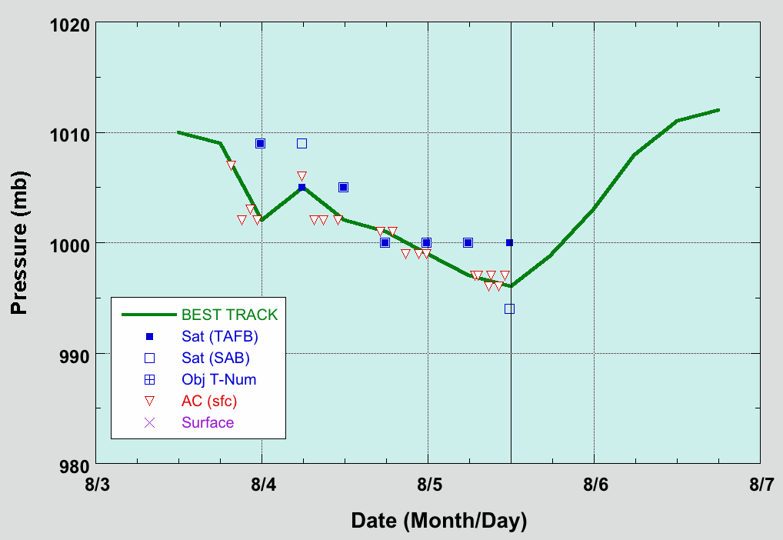
Figure 3. Selected pressure observations and best track minimum central pressure curve for Tropical Storm Edouard, 3-6 August 2008. Landfall in Texas is denoted by the thin solid vertical line.

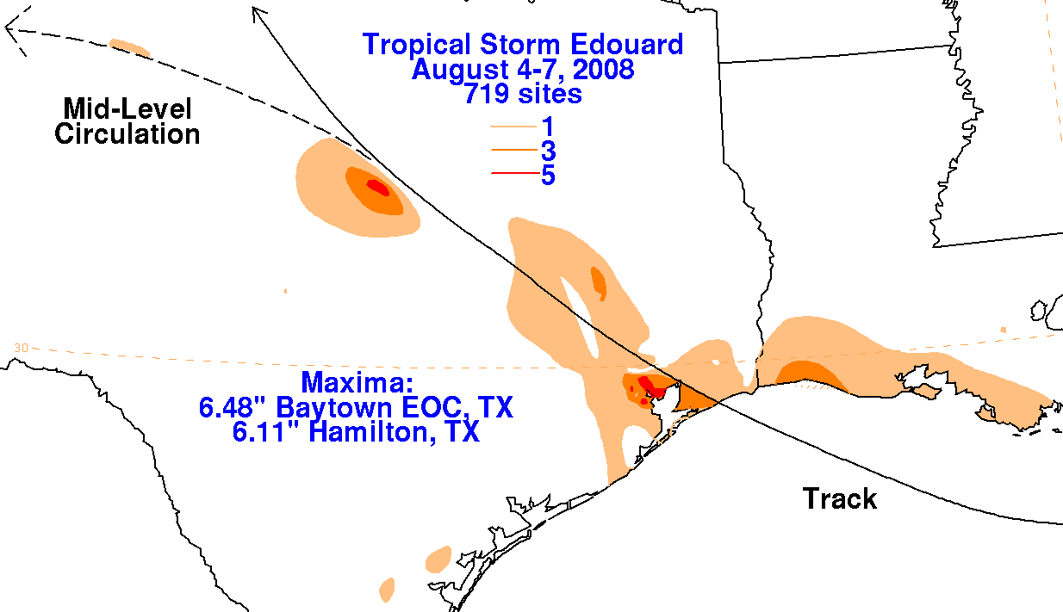

Figure 4. Storm-total rainfall analysis for Tropical Storm Edouard, courtesy David Roth, NOAA/NWS/Hydrometeorological Prediction Center.

A digital record of the complete best track, including wind radii, can be found on line at ftp://ftp.nhc.noaa.gov/atcf. Data for the current year’s storms are located in the btk directory, while previous years’ data are located in the archive directory.

