Tropical Cyclone Report
Hurricane Boris
(EP022008)
27 June- 4 July 2008

Eric S. Blake
National Hurricane Center
17 October 2008

Boris was a category one hurricane that followed a typical early summer path far offshore of southwestern Mexico.

- Synoptic History

The easterly wave that spawned Boris left the African coast on 14 June. The wave moved across the Atlantic basin in about a week, showing few signs of development before it entered the eastern Pacific on 22 June. A broad surface low formed the next day south of the Gulf of Tehuantepec as the convective organization increased. Thunderstorms consolidated near the center of the low late on 26 June, and the system acquired enough organization to become a tropical depression around 0600 UTC 27 June, centered about 525 n mi south-southwest of Manzanillo, Mexico. The “best track” chart of the tropical cyclone’s path is given in Fig. 1, with the wind and pressure histories shown in Figs. 2 and 3, respectively. The best track positions and intensities are listed in Table 1.

High pressure to the north of the tropical cyclone initially steered the system to the west-northwest, then more to the west as the high strengthened. Moderate easterly wind shear was light enough to allow the depression to become a tropical storm six hours after formation. The moderate shear, however, prevented much intensification of Boris for the next day or so. The shear lessened early on 29 June, and Boris slowly strengthened. The tropical cyclone was near hurricane strength on 30 June when a ragged eye feature became apparent in satellite imagery, and it became a hurricane on the next day. The hurricane briefly weakened late on 1 July, but it restrengthened on 2 July, turned to the west-northwest and reached a peak intensity of about 70 kt. However, cold water and a relatively stable atmosphere contributed to a fast demise of Boris. Convection rapidly diminished near the system on 3 July and the system weakened to a tropical depression early on 4 July, becoming a remnant low later that day about 1270 n mi west-southwest of the southern tip of Baja California. The low moved west to west-southwest for a couple of days, eventually dissipating on 6 July just before entering the central Pacific Ocean.

- Meteorological Statistics

Observations in Boris (Figs. 2 and 3) include satellite-based Dvorak technique intensity estimates from the Tropical Analysis and Forecast Branch (TAFB) and the Satellite Analysis Branch (SAB). Microwave satellite imagery from NOAA polar-orbiting satellites, the NASA Tropical Rainfall Measuring Mission (TRMM), the NASA QuikSCAT, and Defense Meteorological Satellite Program (DMSP) satellites, among others, were also useful in tracking the storm. The peak intensity of 70 kt is based on a blend of satellite estimates from TAFB and SAB. The intensity of Boris after peak intensity was based on a blend of Dvorak T/CI numbers from TAFB and SAB. There were no reports of tropical-storm force winds received from ships.

- Casualty and Damage Statistics

There were no reports of damages or deaths related to Boris.

- Forecast and Warning Critique

The genesis of Boris was well-anticipated. The system was first mentioned in the Tropical Weather Outlook products almost 60 hours before it developed, and the possibility of the system becoming a tropical depression was explicitly included about 18 hours before formation.

The average official track errors for Boris were 28, 52, 73, 100, 152, 170 and 158 n mi for the 12, 24, 36, 48, 72, 96, 120 h forecasts, respectively. The number of forecasts ranged from 27 at 12 h to 9 at 120 h. These forecast errors were near the five-year average official track errors through 72 h (Table 2), and little smaller than that average thereafter. The official forecast was an improvement on most of the guidance except for the variable consensus models (TVCN, TVCC) through 72 hr.

Average official intensity errors were 7, 9, 13, 16, 22, 23, and 19 kt for the 12, 24, 36, 48, 72, 96, 120 h forecasts, respectively. These errors are generally a little larger than the long-term average, especially at 72 and 96 h. In sharp contrast to the track forecast errors, almost all of the available guidance was better than the official NHC forecast, which had a pronounced low bias. The system intensified much more than anticipated in NHC forecasts, which were based on the expectation that the shear would be too strong to allow significant intensification. The best guidance at long-range was the climatology and persistence model (SHF5).

Table 1. Best track for Hurricane Boris, 27 June- 4 July 2008.

Date/Time  (UTC) | Latitude  (°N) | Longitude  (°W) | Pressure  (mb) | Wind Speed  (kt) | Stage
27 / 0600 | 12.2 | 107.9 | 1006 | 30 | tropical depression
27 / 1200 | 12.6 | 108.7 | 1005 | 35 | tropical storm
27 / 1800 | 13.0 | 109.5 | 1000 | 45 | "
28 / 0000 | 13.5 | 110.5 | 997 | 50 | "
28 / 0600 | 14.0 | 111.5 | 997 | 50 | "
28 / 1200 | 14.4 | 112.5 | 1000 | 45 | "
28 / 1800 | 14.7 | 113.4 | 1000 | 45 | "
29 / 0000 | 14.9 | 114.2 | 1000 | 45 | "
29 / 0600 | 15.0 | 115.0 | 1000 | 45 | "
29 / 1200 | 14.9 | 115.8 | 997 | 50 | "
29 / 1800 | 14.8 | 116.8 | 995 | 55 | "
30 / 0000 | 14.8 | 117.9 | 992 | 60 | "
30 / 0600 | 14.9 | 119.0 | 992 | 60 | "
30 / 1200 | 14.9 | 120.2 | 992 | 60 | "
30 / 1800 | 14.8 | 121.4 | 992 | 60 | "
01 / 0000 | 14.7 | 122.5 | 989 | 65 | hurricane
01 / 0600 | 14.6 | 123.5 | 989 | 65 | "
01 / 1200 | 14.7 | 124.3 | 989 | 65 | "
01 / 1800 | 14.9 | 125.0 | 991 | 60 | tropical storm
02 / 0000 | 15.3 | 125.6 | 988 | 65 | hurricane
02 / 0600 | 15.7 | 126.2 | 985 | 70 | "
02 / 1200 | 16.2 | 126.9 | 988 | 65 | "
02 / 1800 | 16.6 | 127.4 | 992 | 55 | tropical storm
03 / 0000 | 16.9 | 127.9 | 995 | 50 | "
03 / 0600 | 17.2 | 128.4 | 995 | 50 | "
03 / 1200 | 17.3 | 129.0 | 1000 | 40 | "
03 / 1800 | 17.3 | 129.6 | 1002 | 35 | "
04 / 0000 | 17.2 | 130.2 | 1003 | 30 | tropical depression
04 / 0600 | 17.1 | 130.8 | 1005 | 25 | "
04 / 1200 | 17.0 | 131.5 | 1006 | 20 | low
04 / 1800 | 16.8 | 132.4 | 1007 | 20 | "
05 / 0000 | 16.5 | 133.2 | 1007 | 20 | "
05 / 0600 | 16.2 | 134.1 | 1007 | 20 | "
05 / 1200 | 16.0 | 135.0 | 1007 | 20 | "
05 / 1800 | 16.0 | 136.2 | 1007 | 20 | "
06 / 0000 | 15.9 | 137.2 | 1007 | 20 | "
06 / 0600 | 15.8 | 138.0 | 1008 | 20 | "
06 / 1200 | - | - | - | - | dissipated
02 / 0600 | 15.7 | 126.2 | 985 | 70 | minimum pressure

Table 2. Track forecast evaluation (heterogeneous sample) for Hurricane Boris, 27 June- 4 July 2008. Forecast errors (n mi) are followed by the number of forecasts in parentheses. Errors smaller than the NHC official forecast are shown in boldface type.

Forecast Technique | Forecast Period (h)
Forecast Technique | 12 | 24 | 36 | 48 | 72 | 96 | 120
CLP5 | 35 (27) | 70 (25) | 103 (23) | 132 (21) | 189 (17) | 163 (13) | 173 ( 9)
GFNI | 34 (25) | 77 (23) | 121 (21) | 150 (18) | 223 (14) | 319 (10) | 550 ( 6)
GFDI | 32 (27) | 61 (25) | 87 (23) | 115 (21) | 201 (17) | 353 (13) | 448 ( 9)
HWFI | 30 (27) | 57 (25) | 83 (23) | 107 (21) | 161 (17) | 175 (13) | 254 ( 9)
GFSI | 40 (27) | 79 (25) | 132 (23) | 206 (20) | 350 (15) | 488 ( 6) | 573 ( 5)
AEMI | 40 (27) | 82 (25) | 138 (23) | 202 (21) | 335 (16)
NGPI | 30 (25) | 57 (23) | 90 (21) | 127 (19) | 203 (15) | 315 (11) | 410 ( 6)
UKMI | 34 (25) | 62 (23) | 86 (21) | 115 (19) | 202 (11) | 245 ( 5) | 1380 ( 2)
EMXI | 33 (17) | 55 (16) | 82 (14) | 109 (12) | 190 ( 8) | 358 ( 5) | 565 ( 2)
BAMD | 36 (27) | 62 (25) | 86 (23) | 121 (21) | 205 (17) | 280 (13) | 386 ( 9)
BAMM | 32 (27) | 50 (25) | 72 (23) | 108 (21) | 205 (17) | 360 (13) | 464 ( 9)
BAMS | 34 (27) | 58 (25) | 77 (23) | 100 (21) | 171 (17) | 251 (13) | 333 ( 9)
TVCN | 27 (27) | 48 (25) | 70 (23) | 91 (21) | 147 (17) | 213 (13) | 300 ( 9)
TVCC | 30 (27) | 48 (25) | 68 (23) | 91 (21) | 116 (17) | 221 (13) | 266 (9)
GUNA | 26 (25) | 47 (23) | 71 (21) | 106 (18) | 203 ( 7) | 534 ( 1)
FSSE | 29 (25) | 54 (23) | 78 (21) | 101 (20) | 166 (15) | 235 (10) | 288 ( 4)
OFCL | 28 (27) | 52 (25) | 73 (23) | 100 (21) | 152 (17) | 170 (13) | 158 ( 9)
NHC Official  (2003-2007 mean) | 31.9 (1282) | 55.1 (1129) | 77.4 (979) | 97.9 (849) | 136.2 (620) | 180.1 (439) | 226.1 (293)

Table 3. Intensity forecast evaluation (heterogeneous sample) for Hurricane Boris, 27 June- 4 July 2008. Forecast errors (kt) are followed by the number of forecasts in parentheses. Errors smaller than the NHC official forecast are shown in boldface type.

Forecast Technique | Forecast Period (h)
Forecast Technique | 12 | 24 | 36 | 48 | 72 | 96 | 120
SHF5 | 7.3 (27) | 9.2 (25) | 11.3 (23) | 12.5 (21) | 12.4 (17) | 12.5 (13) | 10.2 ( 9)
GHMI | 6.6 (27) | 8.4 (25) | 11.5 (23) | 11.9 (21) | 15.6 (17) | 19.8 (13) | 16.4 ( 9)
HWFI | 7.6 (27) | 8.7 (25) | 10.4 (23) | 14.6 (21) | 18.6 (17) | 21.5 (13) | 17.6 ( 9)
SHIP | 7.2 (27) | 9.3 (25) | 12.7 (23) | 14.5 (21) | 20.8 (17) | 22.0 (13) | 12.0 ( 9)
DSHP | 7.2 (27) | 9.3 (25) | 12.7 (23) | 14.5 (21) | 20.8 (17) | 22.0 (13) | 12.0 ( 9)
LGEM | 7.6 (27) | 10.8 (25) | 14.0 (23) | 17.5 (21) | 22.9 (17) | 25.0 (13) | 18.0 ( 9)
FSSE | 6.4 (25) | 9.6 (23) | 12.8 (21) | 13.4 (20) | 15.1 (15) | 19.6 (10) | 21.8 ( 4)
ICON | 6.8 (26) | 8.1 (24) | 11.0 (23) | 13.6 (21) | 19.1 (17) | 21.1 (13) | 13.2 ( 9)
OFCL | 7.2 (27) | 9.4 (25) | 13.3 (23) | 16.0 (21) | 21.5 (17) | 22.7 (13) | 18.9 ( 9)
NHC Official  (2003-2007 mean) | 6.2 (1282) | 10.4  (1129) | 13.9  (979) | 16.3  (848) | 18.7 (620) | 19.2 (439) | 19.1 (293)

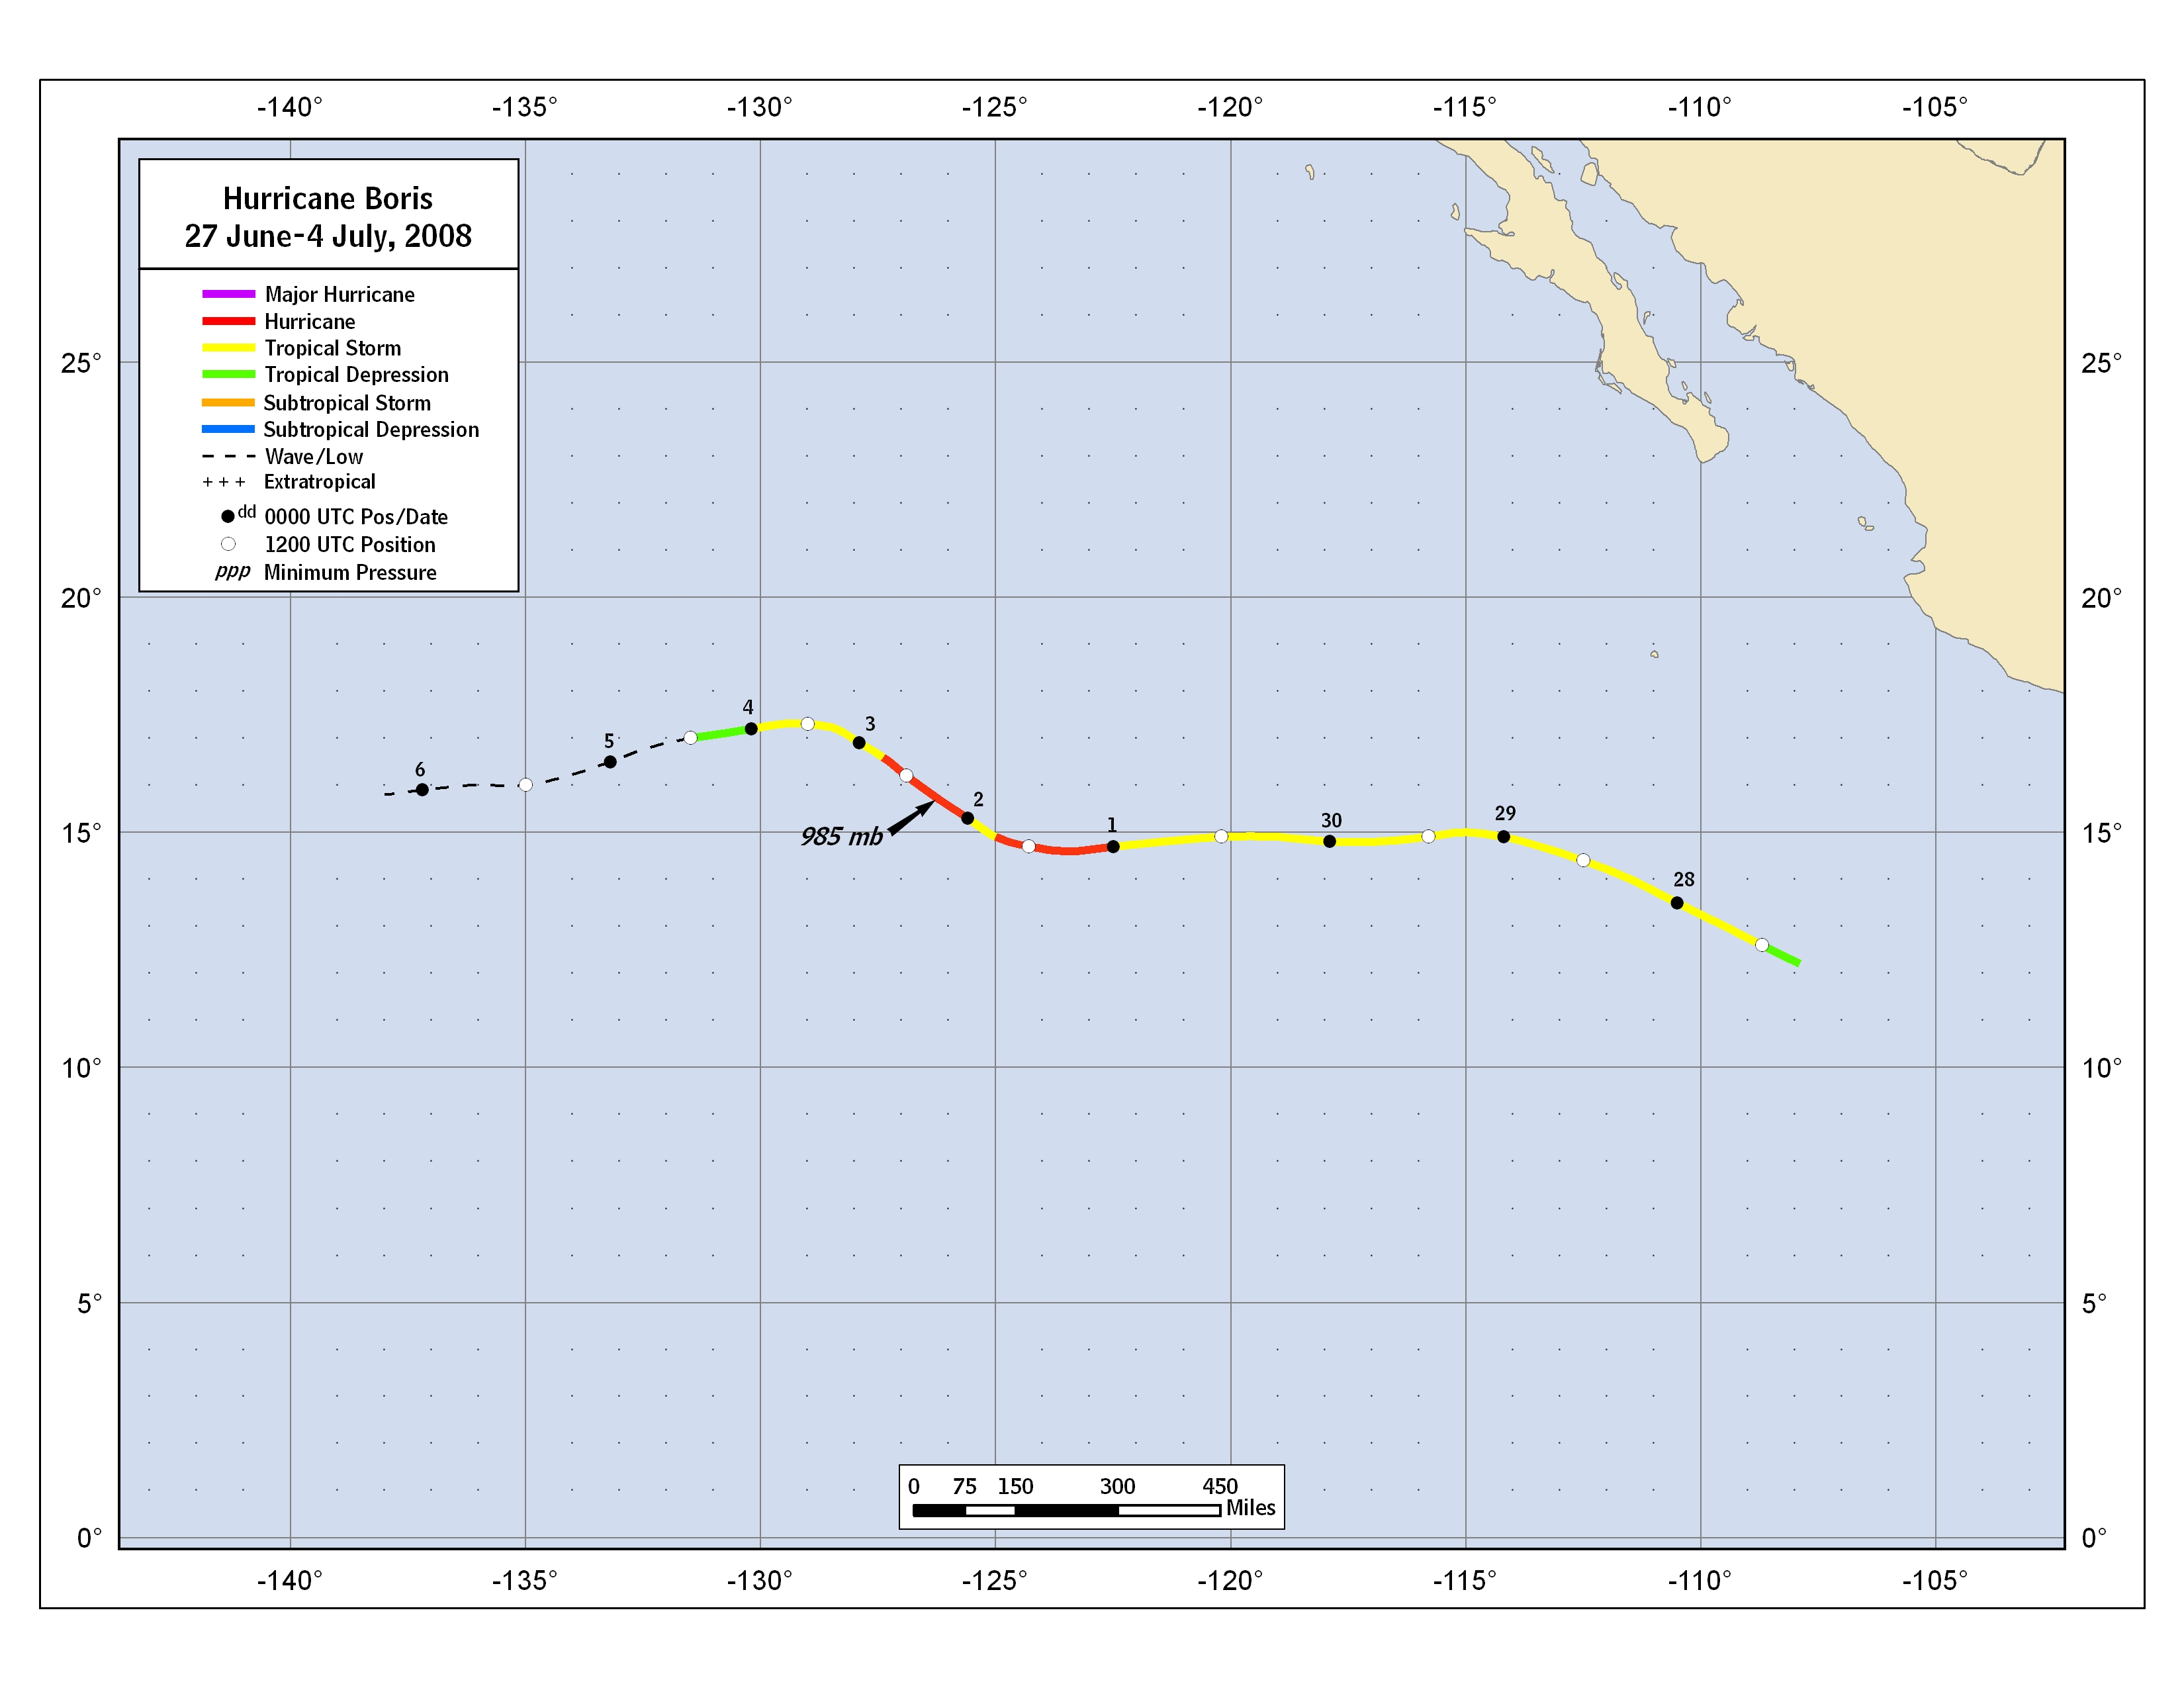

Figure 1. Best track positions for Hurricane Boris, 27 June- 4 July 2008.
Figure 2. Selected wind observations and best track maximum sustained surface wind speed curve for Hurricane Boris, 27 June- 4 July 2008.

Figure 3. Selected pressure observations and best track minimum central pressure curve for Hurricane Boris, 27 June- 4 July 2008.

