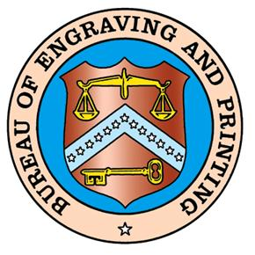

GROUP RESERVATION REQUEST FORM
(Group Tours can be requested up to 1 year in advance)

 Tour Operator
- School
- Other _____________

Group requests are accepted by mail, e-mail or fax only. DO NOT RE-FAX! To cancel a tour, call (202) 874-2330 or toll free 1-866-874-2330. The tour must be re-booked if ten or more individuals are added to the original request.

Name of Group: _______________________________ FAX Number: ______________________________________
(Confirmation will be faxed back to this number)

Mailing Address: _______________________________ E-Mail address: ____________________________________

City, State, Zip: ________________________________________________________________________________________

Primary Contact Name and Phone Number: ___________________________________________________________

Total Number in Group: ________________ (not to exceed 50 guests per tour)

Special Needs: (i.e. wheel chairs, hearing impediments, etc.): _____________________________________________

Group Tour Schedule

Monday through Friday, excluding federal holidays and the week between Christmas and New Year’s Day
DAILY  Jan – Dec | 11:00 a.m. | 11:15 a.m. | 11:30 a.m. | 11:45 a.m. | 12:00 p.m. | 12:15 p.m.

1st choice

_______________ __________________ _______________
Day of week Date Time

2nd Choice

_______________ __________________ _______________
Day of week Date Time

TourScheduler@bep.gov
14th and C. Streets, SW – Room 151-M
Washington, DC 20228
www.moneyfactory.gov
PHONE: (202) 874-2330 Toll Free: 1 (866) 874-2330  FAX #: (202) 874-6331
TLP 1/08

