Dear Texas 18th Congressional District Constituents:

The United States Congress has agreed to continue the current moratorium on earmarks as defined by clause 9(e) of Rule XXI of the Rules of the House.

Over the past year, many of my colleagues and I have learned the hard way that being forced to request essential funding for their respective Districts puts them at a distinct disadvantage, and in many cases leaves them open to unseemly bargaining with the Executive branch. In the end, the United States Congress will have to choose between an open and transparent method for allocating targeted funding.

For 2013, the programmatic requests for which I am supporting are principally for National programs that provide the funding supported by the President of the United States for by non-profit organizations and institutions located in the communities I represent in Congress.

These programmatic requests would provide valuable benefits in the local area, with a focus on economic development and job creation, transportation, health care, community and social services, environmental remediation, and education.

Rest assured that I will continuously work with my colleagues in Congress and the President’s Administration to direct investments to the 18th Congressional District of Houston, Texas.

I welcome your questions and comments regarding the appropriations and budgeting process in Congress. Please call my staff or me at 713.655.0050 in Houston, or 202.225.3816.

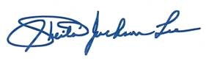

Sincerely,

              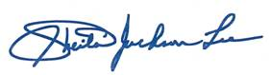

Sheila Jackson Lee
Member of Congress

