Hurricanes and Coastal Storms

Instructor guidance | Content
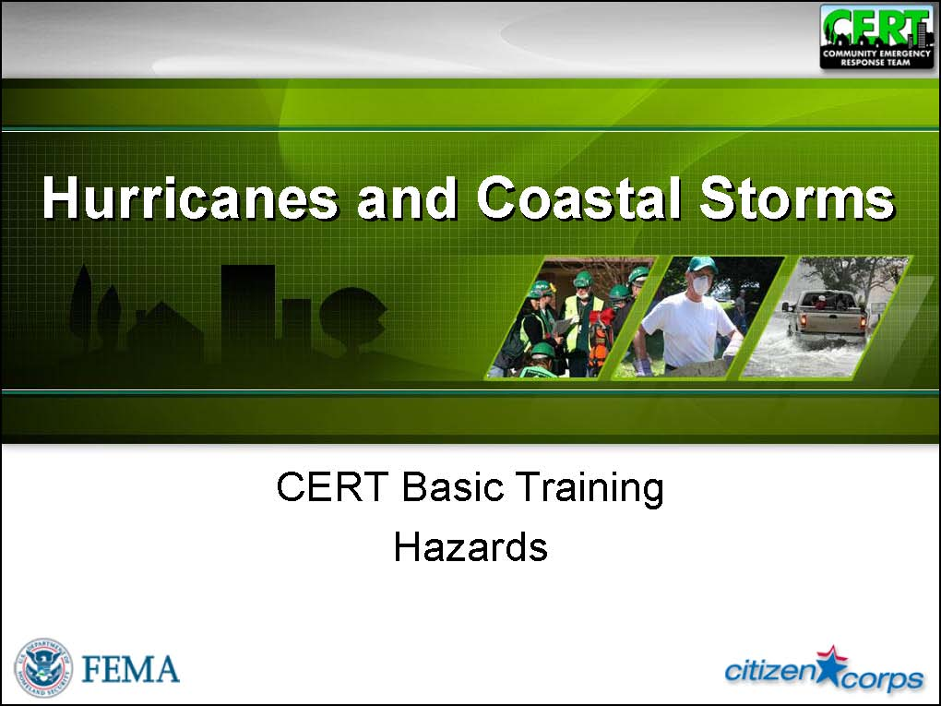  Display Slide Hu-0 | Hurricanes and Coastal Storms
  Allow the participants time to respond before displaying the slide. | What is the difference between a hurricane and a coastal storm?
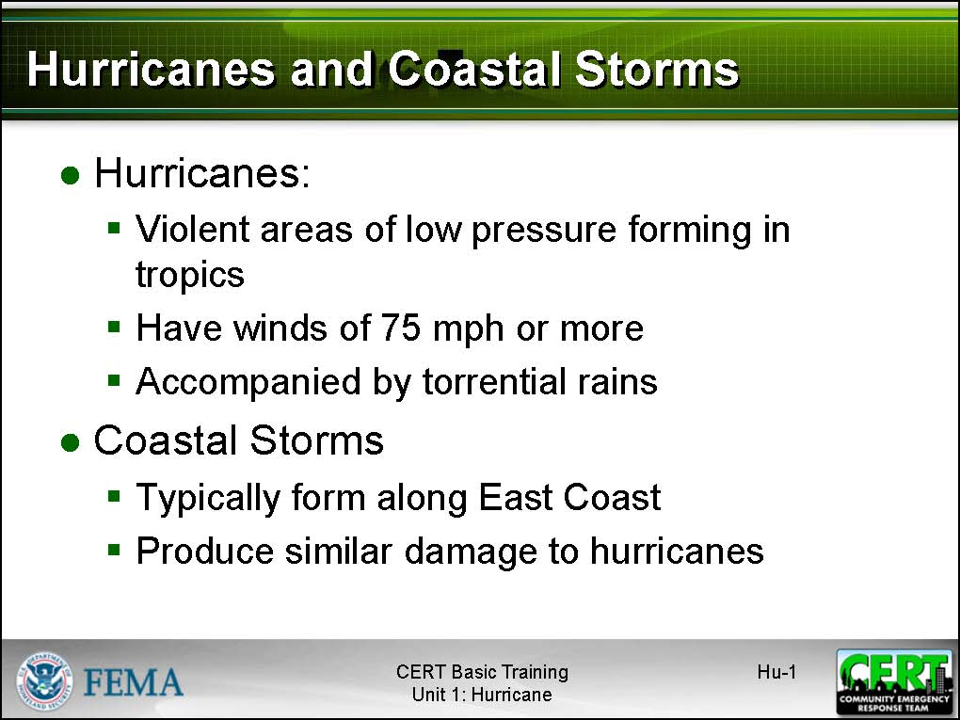  Display Slide Hu-1 | Hurricanes  A hurricane is a violent area of low pressure forming in the tropical Atlantic Ocean from June to November. August and September are peak months. (Similar Western Pacific Ocean storms are called typhoons.) Hurricanes have winds of 75 miles per hour or more and are accompanied by torrential rains and – along coastal areas – a storm surge.  Tell the participants that, although coastal storms may have hurricane-force winds and may cause similar kinds and amounts of damage, they are not classified as hurricanes because they do not originate in the tropics. Coastal storms typically form along the east coast from December through March.
Instructor guidance | Content
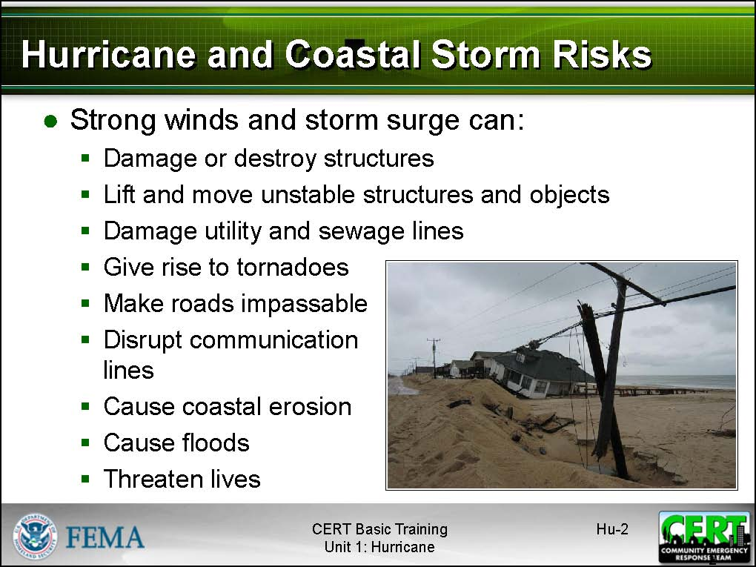  Display Slide Hu-2 | Hurricane and Coastal Storm Risks  Explain that hurricanes and coastal storms pose a risk because powerful winds and storm surges can:  - Damage or destroy structures  - Lift and move unstable structures and objects  - Damage utility and sewage lines  - Give rise to tornadoes  - Cause coastal erosion  - Cause floods  - Threaten lives  - Make roads impassable  - Disrupt communication lines, including 911  - Overwhelm first responders  The accompanying heavy rains can inundate coastal areas and inland communities, presenting another risk to life and property.
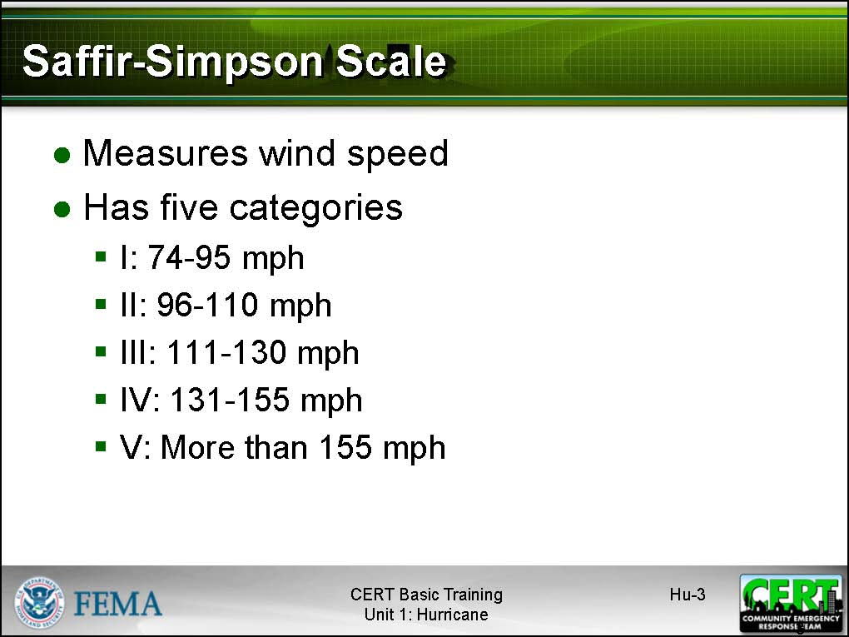  Display Slide Hu-3  PM, P. Hu-2 | Saffir-Simpson Hurricane Scale  Refer the participants to the chart titled Hurricane Classifications in the Participant Manual. Explain that hurricanes are classified according to the Saffir-Simpson Hurricane Scale, which measures wind speed.  Point out that the chart in the Participant Manual also includes the anticipated barometric pressure (in inches) and storm surge for each category of storm.

Instructor guidance | Content
PM, P. Hu-2 | Hurricane Classifications

Category | Barometric  Pressure (Inches) | Windspeed  (Miles Per Hour) | Storm  Surge (Feet)
I - Minimal | Above 28.94 | 74-95 | 4-5
II - Moderate | 28.50-28.91 | 96-110 | 6-8
III - Extensive | 27.91-28.47 | 111-130 | 9-12
IV - Extreme | 27.17-27.88 | 131-155 | 13-18
V - Catastrophic | Less Than 27.17 | More Than 155 | More than 18

Instructor Guidance | Content
Frequency of Hurricanes

Point out that the greatest likelihood of a hurricane striking land is along the Gulf Coast and the southeastern seaboard. However, hurricanes also have hit central Pennsylvania and the coasts of New Jersey, New York, and New England.

Explain that each year an average of 11 storm-strength weather disturbances develop over the Atlantic Ocean, Caribbean Sea, and Gulf of Mexico. Of these, half may grow to hurricane proportion. Two hurricanes are likely to strike the U.S. coast each year.
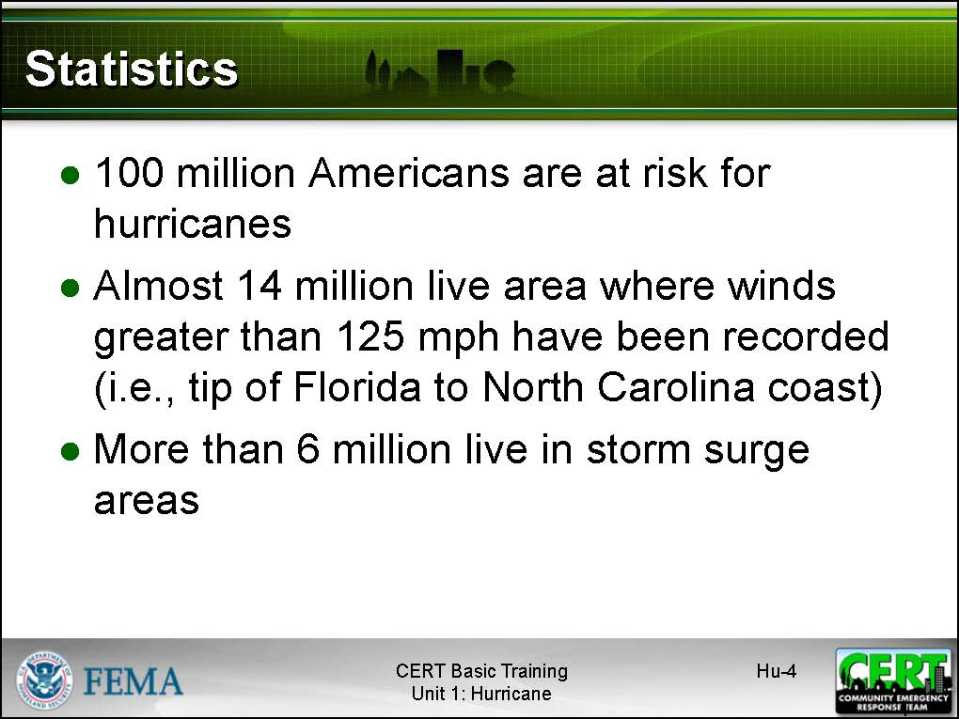  Display Slide Hu-4 | Statistics  Stress that nearly 100 million Americans are at risk from hurricanes. Specifically:  - Almost 14 million live in the area where winds greater than 125 mph have been recorded (i.e., the tip of Florida to the North Carolina coast).  - More than 6 million live in storm surge areas.  Emphasize that, although deaths from hurricanes are decreasing as hurricane warning systems improve, property damage is on the rise.
 | Preparing for a Hurricane or Coastal Storm
Allow the group time to respond. | How can you prepare for a hurricane or coastal storm?
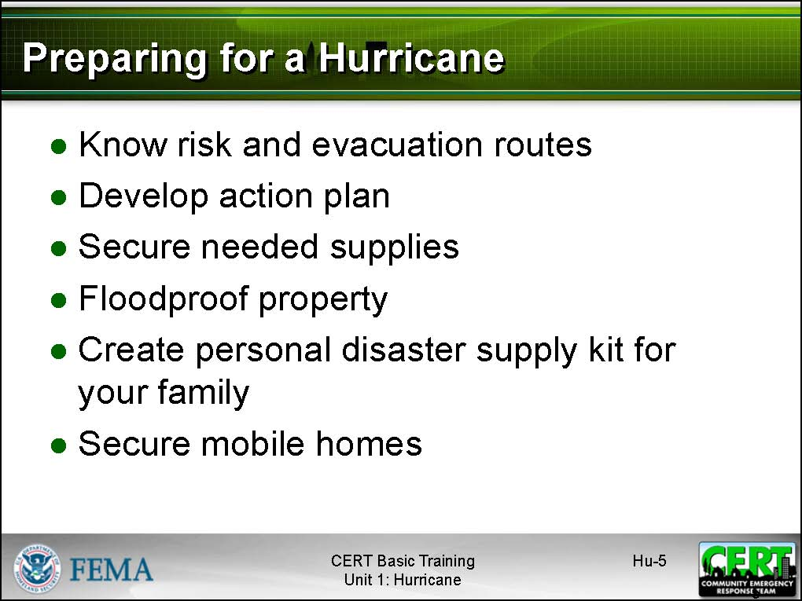  Display Slide Hu-5 | Point out that many people do not realize the threat that hurricanes can present – even if they live in hurricane-prone areas – because they have not experienced a major hurricane.  Stress that there are certain preparations that people who live in high-risk areas should take to prepare for a hurricane or coastal storm before one occurs.  Describe for the group the following preparations:  - Know the risk and evacuation routes. Being aware of the risk and how to get out of the area as quickly as possible should an evacuation order be issued is one of the key preparedness steps to take. Driving the evacuation routes to ensure familiarity before a storm and identifying shelter locations will make an evacuation smoother.  - Develop an action plan. When will you begin preparing your home for possible high winds and storm surge? How much time will it take you to evacuate, if necessary? Does your evacuation route change based on the direction of the storm? Will you go to a shelter or a hotel? These are all questions that anyone who lives in a high-risk area should answer as part of hurricane or coastal storm planning. While creating this plan, keep in mind any provisions that might be necessary to accommodate the elderly, those with special needs, and pets.  - Secure needed supplies. If you assemble your disaster supply kits as suggested in this unit, you will have everything that you need for hurricane and coastal storm preparedness.
Review the techniques for floodproofing properties that are included in the Flood Hazard section of this Instructor Guide. | - Floodproof property. Floodproofing can range from using a water sealer in areas that have basements to sandbagging to elevating utilities to moving furniture to the second floor.  - Create a personal disaster supply kit for your family. Keep in mind the needs of the elderly, those with special needs, and your pets. Include up to 2 weeks of non-perishable food.  - Secure mobile homes and any outdoor items that could be picked up by the wind or washed away.
Solicit other suggestions from the group. Additional suggestions may include keeping the car’s gas tank filled and verifying insurance coverage.

Advise participants that they should have flood insurance, even if they’re not in a flood zone. It might also be beneficial to have insurance for windstorms and homeowner’s insurance for internal belongings.

Participants should know the details of their insurance plans, including deductibles and what is and is not included. Take photos and videos of your property at least once a year.
Allow the group to respond before displaying the next slide. | After a hurricane watch has been issued, what should you do to prepare?
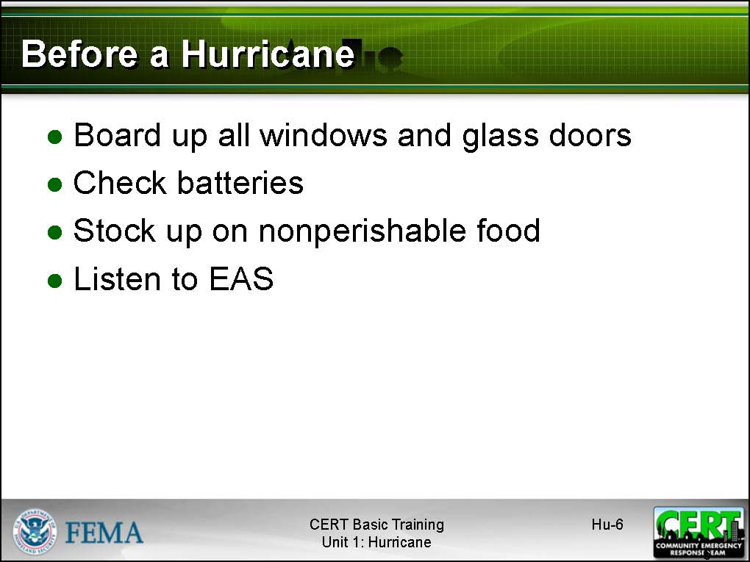  Display Slide Hu-6 | Before a Hurricane  Summarize for the group the steps that everyone who is at risk should take before a hurricane strikes:  - Board up all windows and glass doors. Studies have shown that if the wind can be kept out of a structure, the structure will withstand high winds relatively well. If wind is allowed inside, however, additional structural and nonstructural damage will occur very quickly. The best way to prevent wind from getting into a structure is to cover all windows and glass doors with plywood or to close hurricane shutters. Have tarps available for temporary roof repairs.
- Check batteries. Often electricity is disrupted by hurricanes (and coastal storms) and, depending on the extent of damage, may not be restored immediately. Check batteries for flashlights and portable radios to ensure that they are fresh. Replace old batteries, and have extra on hand.
- Stock up on nonperishable food. A 3-day supply of food and water for each family member is a must.
- Listen to the Emergency Alert System (EAS) for local emergency information. Local officials will have the most current emergency information about the storm (including watch and warning information from the National Weather Service) and will provide information and instructions via EAS.
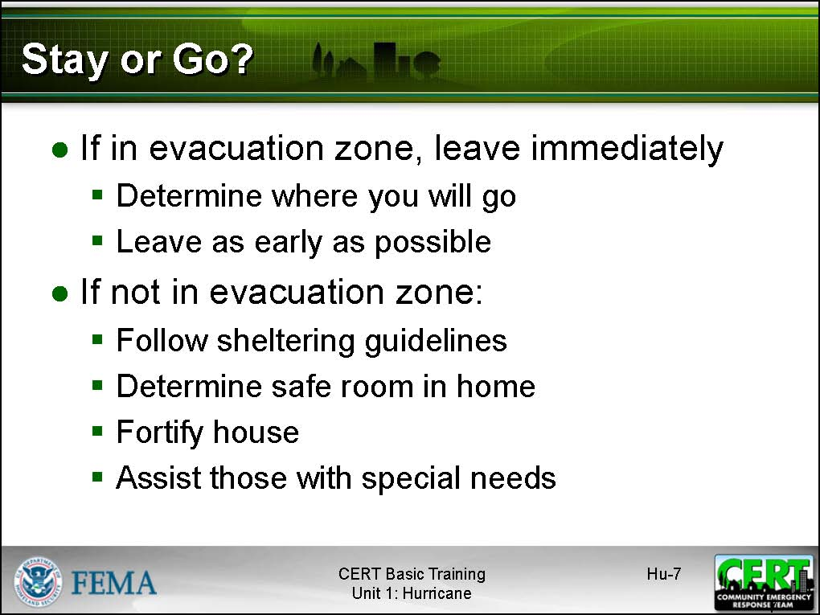  Display Slide Hu-7 | Deciding to Stay or Go  If you are in an evacuation zone, LEAVE IMMEDIATELY. As CERT members, you set the example for your community.  If you are evacuating:  - Determine where you will go. Identify a family member’s or friend’s house, or a public shelter, where you will go if you evacuate. Keep in mind those with special needs, including the elderly, and pets. Preregistration and approval at shelters is often required. Check with the shelter to determine what supplies you should bring.  - Leave as early as possible.
If you are NOT in an evacuation zone and decide to stay:
- Follow the sheltering guidelines.
- Determine a safe room in your home.
- Fortify your house. Consult www.flash.org for information on window protection, garage door protection, roof protection, and door protection. Secure outdoor items that could be blown away and cause damage.
- Assist those with special needs. A wheelchair dependent person who lives in a high rise, for instance, might be “shut-in” if the electricity goes out and the building’s elevator is inoperable. He/she will require food, water, and possibly medicine.
Allow the group to respond before displaying the next slide. | What should you do during a hurricane?
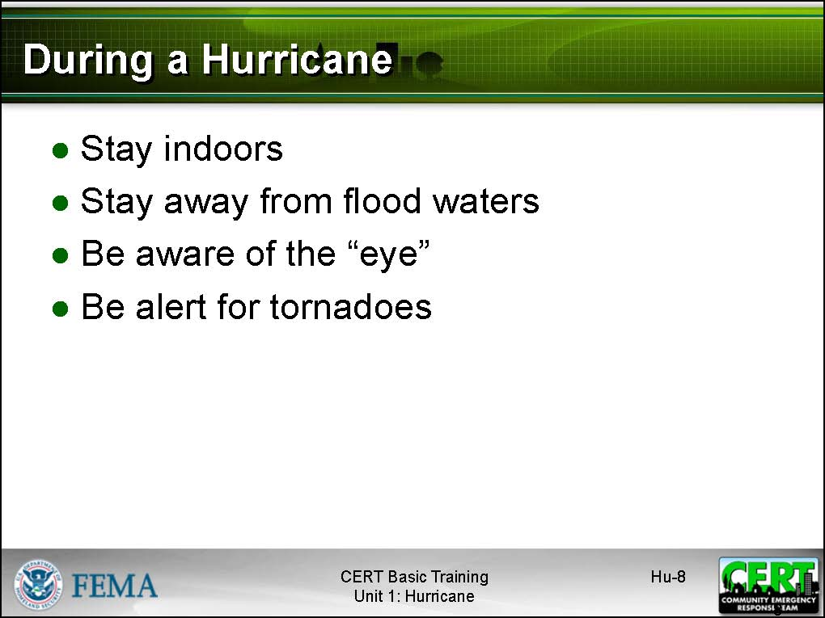  Display Slide Hu-8  If you live in an area that is away from the coast but subject to inland flooding, you should include some discussion on inland flooding that accompanies decaying hurricanes and tropical storms and the risk of cascading events, such as landslides and mudflows. You should also emphasize that hurricane- and tropical storm-force winds can extend well inland from the coast, and that the strongest sustained winds from a hurricane usually occur in the right front quadrant of the storm. | During a Hurricane  Allow the group time to respond. Then, summarize their responses using the slide.  Be sure to make these points:  - Stay indoors. If advised to evacuate, do so. However, do not assume that because an evacuation order is not issued that the situation is safe. Even Category 1 hurricanes are dangerous. Stay indoors and listen to EAS for up-to-date information.  - If advised to take shelter:  - Take the family disaster supply kit.  - Go to an interior “safe” room without windows, if possible.  - Stay in the safe room and listen to EAS for additional instructions.  - Stay away from flood waters. If the home begins to flood, go to a higher level, if possible.  - Be aware of the “eye.” The “eye” of a hurricane is typically 20 to 30 miles wide in relation to the storm, which may have a diameter of 400 miles. During the “eye,” there are very few clouds, but it is important to remember that the storm is not over.  - Be alert for tornadoes. Tornadoes are frequently associated with hurricanes, and are most common in the right-front quadrant of the storm.
Allow the group to respond before displaying the next slide. | What precautions should you take after a hurricane or coastal storm?
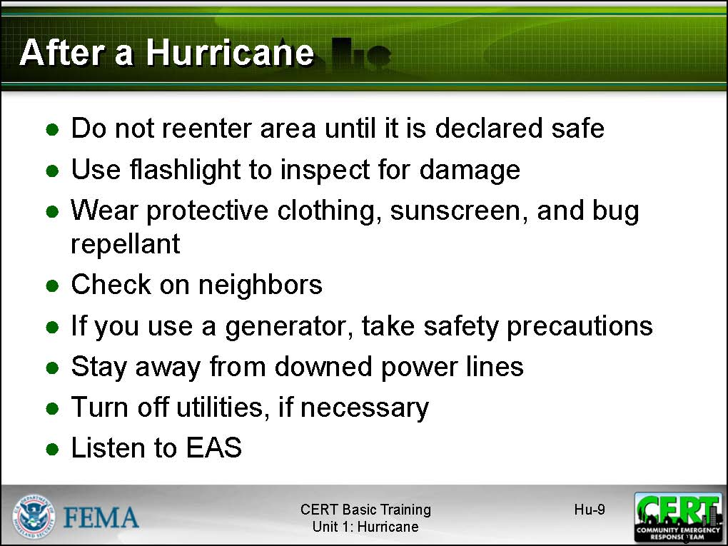  Display Slide Hu-9 | After a Hurricane  Be sure to make these points:  - Do not reenter the area until it is declared safe. Reentry to the area too soon may cause unnecessary risk—and may keep first responders and utility workers from doing their jobs.  - Use a flashlight to inspect for damage. Do not assume that utilities are undamaged following a hurricane or coastal storm. Checking for damage with a flashlight reduces the risk of injury, especially from a damaged electric supply.  - Wear protective clothing, sunscreen, and bug repellant.  - Be aware that lost pets may be scared and more inclined to bite.  - Be aware of traffic hazards. Do not drive through flooded areas. Watch for traffic signals that may be out of service.  - Check on neighbors.  - If you use a generator, take safety precautions. Follow proper directions for use and never use a generator indoors, including garages. Keep the generator at least 10 feet from any opening of anyone’s home or business. Consult your local fire marshal for more information.  - Stay away from downed power lines. The only sure way to limit risk from downed power lines is to avoid them completely.

Instructor guidance | Content
Remind the group that if they turn off the gas valve, only the gas company can restore the service. | - Turn off utilities, if necessary. If there is a gas smell or a fire, turn off the gas valve. If there is damage to electric lines or supply, shut off the electricity by turning off small circuit breakers (or unscrewing fuses) first, then turning off the main breaker (or fuse).
- Reserve the telephone for emergency use. Telephone lines are invariably overloaded following a disaster or emergency. Reserving telephone use (both landline and cellular) for emergency use helps to ensure that those calls that must go through do so.
- Listen to EAS for updated information. Local officials will use EAS extensively to provide emergency information and instructions. Be sure to tune in often for updates.
 | Does anyone have additional questions, comments, or concerns about hurricanes or coastal storms?

[This page intentionally left blank]

