
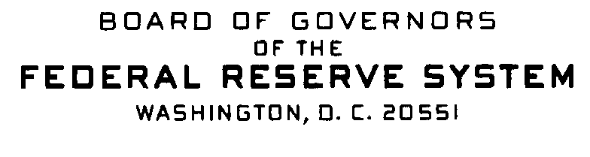


Correspondence Date: December 23, 2009

Dear Sir or Madam:

This notice serves as a reminder of previously announced information that relates to Home Mortgage Disclosure Act (HMDA) data collection for calendar year 2010 that will be reported in 2011.

Exemption threshold:

• The 2010 exemption threshold for depository institutions will remain $39 million based on the annual percentage change in the Consumer Price Index for Urban Wage Earners and Clerical Workers for twelve-month period ending in November 2009. Thus, depository institutions with assets of $39 million or less as of 12/31/2009 are exempt from 2010 data collection. The exemption thresholds for nondepository institutions have not changed.

Geographic Changes in the 2010 FFIEC Census file:

- Three Metropolitan Statistical Area (MSA) code changes:
  - Bradenton-Sarasota-Venice, FL (MSA 14600) was changed to North Port-Bradenton-Sarasota, FL (MSA 35840). The two counties in MSA 35840 are Manatee (code 081) and Sarasota (code 115).
  - Fort Walton Beach-Crestview-Destin, FL (MSA 23020) was changed to Crestview-Fort Walton Beach-Destin, FL (MSA 18880) consisting of Okaloosa County (code 091).
  - Weirton-Steubenville, WV-OH (MSA 48260) was changed to Steubenville-Weirton, OH-WV (MSA 44600) consisting of Jefferson County, OH (code 081); Brooke County, WV (code 009); and Hancock County, WV (code 029).

The 2010 A Guide to HMDA Reporting: Getting it Right! will include the above MSA code changes; the Guide will be posted in the second quarter of 2010 to the Web only.

Any questions or requests for additional information should be directed to:

Assistance Line: Internet E-Mail Address:
(202) 452-2016 hmdahelp@frb.gov

