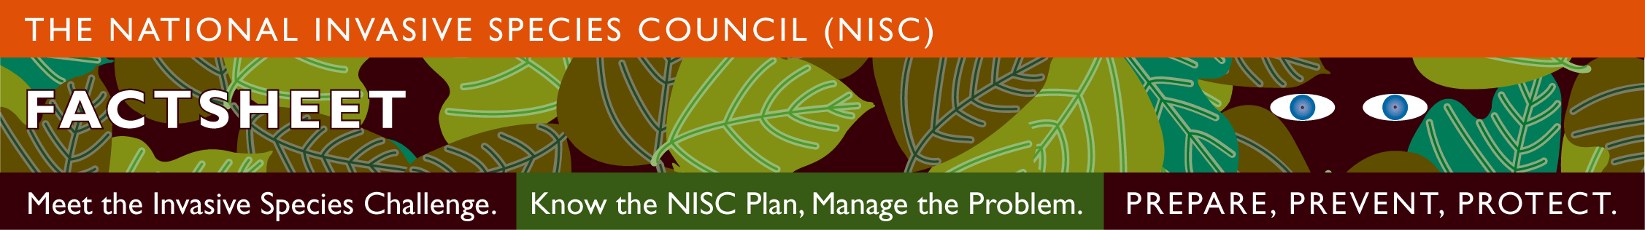

What Can I do about Invasive Species?

What are Invasive Species? Invasive species are plants, animals, or pathogens that are non-native and cause harm. EO 13112 charged all federal departments and agencies to prevent and control invasive species and created the National Invasive Species Council (NISC).

How do they harm the environment? Some invasive species feed directly on or make ill fish and wildlife. Invasive plant pathogens can kill forest trees. Invasive plants shade out other plants. Indirectly, invasive species compete for food and space with other species and interfere with their growth, reproduction, and development. Invasive species place other species at increased risk of extinction.

Do invasive species harm humans?
Giant hogweed causes blistering and severe skin reactions. Invasive plant pollen causes allergic reactions. Imported Red Fire Ants cause painful stings. “Zoonotic” pathogens and parasites infect both humans and wildlife and livestock. Additionally, pathogens are spread by ticks, insects, and other animal vectors. West Nile Virus is spread by mosquitoes and has caused over 1,000 deaths in the U.S.

Where are invasive species found?
Invasive species can be found in every type of habitat. They are in oceans, lakes, streams, and wetlands. On land, they can be in croplands, rangelands, backcountry areas, parks, and forests. Some invasive species inhabit homes and urban environments. While invasive species are in many habitats, vast areas continue to need protection.

For more information see NISC’s website
Invasivespecies.gov.

Where can I find specific information?
Your County’s Extension Office is supported by the State Land Grant University System and the USDA. They can help. (www.csrees.usda.gov/Extension/index.html)

What can I do about invasive species?
- Learn what invasive species are in your area and what is being done about them.

- Report new invasive species and range expansions.

- Share your knowledge.

- Clean hiking boots, waders, boats and trailers, off-road vehicles, and other pathways of spread to stop hitchhiking invasive species.

- Use certified “weed-free” forage, firewood, hay, mulch, and soil.

- Don’t dump live bait into waterways.

- Remove invasive plants from your land.

- Plant non-invasive plants in your garden.

- Volunteer for organized efforts to remove invasive species from natural areas.

- Care for aquarium fish and other pets properly so that they don’t become invasive.

- Ask your political representatives to support invasive species efforts.

- Write a letter about invasive species to your newspaper.

- Support non-profit organizations that work with invasive species.

see Invasive Species Definition Clarification White Paper (www.invasivespeciesinfo.gov/docs/council/isacdef.pdf)

