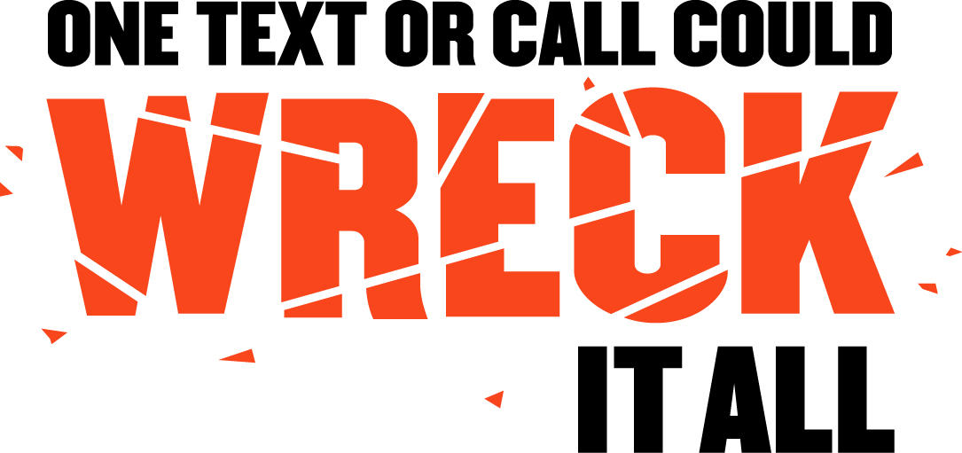

SAMPLE LAW TO PROHIBIT

TEXTING WHILE DRIVING

February 2010

The purpose of this sample legislation is to provide a framework for state legislatures to use to prohibit texting while driving. While there are many sources of driver distraction, there is heightened concern regarding the risks of texting-while-driving. The act of composing, sending or reading text messages interrupts drivers’ cognitive attention, causes vision to be directed away from the road, and compromises manual control of the vehicle.

While evidence is accumulating on the effects of other sources of driver distraction, a number of states have enacted laws addressing cell phone use and/or texting while driving. Although laws alone will not fully resolve the problem, this sample language is offered as an important step in addressing the growing concern about driver distraction. In 2009, more than 135 billion text messages were sent or received in a one-month period in the U.S., an 80 percent increase over the rate in 2008.

The U.S. Department of Transportation held a Distracted Driving Summit on September 30 - October 1, 2009 in Washington, D.C. to examine the full spectrum of distracted driving across transportation modes: passenger vehicles, large trucks, trains and transit. More than 250 leading traffic safety experts, safety advocates and government officials gathered to define the problem and discuss how best to address it. The summit generated broad agreement among public and private sector organizations and policymakers about the need for texting-while-driving laws. Public surveys also confirm widespread community support for texting bans.

In further recognition of the serious risk posed by texting-while-driving and to demonstrate Federal leadership, President Obama issued an Executive Order on October 1, 2009. The Order prohibits Federal employees from texting while driving Government owned vehicles or privately owned vehicles while on official Government business or from texting-while-driving using wireless electronic devices supplied by the Government.

By the end of 2009, 19 states and the District of Columbia had enacted legislation banning texting-while-driving for all drivers, while a number of other states had laws covering specific types of drivers, such as novice drivers or school bus drivers. However, these laws vary in their design and scope. In 2009 alone, more than 200 driver distraction bills were considered and analysts expect that state legislatures will remain active in coming years as evidence accumulates and the call to take action on this issue becomes yet more urgent.

Texting laws are relatively new and have not been thoroughly evaluated. However, considering the rapid emergence of the problem and the growing evidence showing the threat to the safety of all road users, safety advocates and state legislatures are compelled to move forward, basing texting legislation on the broad foundation of principles learned from seat belt laws, impaired driving statutes and similar legislative initiatives, while more specific scientific evidence is gathered. This sample law reflects current circumstances and state of knowledge, but may be revised in the future to incorporate new research findings, address evolving technologies, or to harmonize with other legislation.

In addition to enacting a texting-while-driving law, states may consider other steps to address the issue, including enhanced public awareness and law enforcement programs and improved police crash reports that document specific distractions involved in crashes. Since the prevalence of texting is particularly high among teens, legislatures may also choose to include specific consequences under their graduated drivers licensing law for texting violations by novice drivers, such as delayed full licensure.

The following organizations participated in the development of this sample law: Advocates for Highway and Auto Safety, Alliance of Automobile Manufacturers, American Association of Motor Vehicle Administrators, American Association of State Highway and Transportation Officials, AAA, Centers for Disease Control and Prevention, CTIA- The Wireless Association, Governors Highway Safety Association, ITS America, International Association of Chiefs of Police, National Conference of State Legislatures, National Safety Council, The National Traffic Law Center of the National District Attorneys Association, Safe Kids USA, and the U.S. Department of Transportation. The sample law – either in its entirety or in its individual provisions - does not necessarily reflect the positions of any of the individual participating organizations.



SAMPLE TEXTING WHILE DRIVING LAW

§ 1 Short title
This act may be cited as the [State] Ban on Texting While Driving Law

§ 2 Purpose
The purpose of this subchapter is to:
- Improve roadway safety for all vehicle operators, passengers, bicyclists, pedestrians and other road users;
- Prevent crashes related to the act of text messaging while driving a motor vehicle;
- Reduce injuries, death, property damage, health care costs, health insurance and automobile insurance rates related to motor vehicle crashes; and
- Authorize law enforcement officers to stop vehicles and issue citations to persons texting while driving as a standard offense.

§ 3 Application
Except as provided in Section 4, this subchapter applies to all drivers during operation of a motor vehicle on the travel portion of public streets, roads and highways [Option: States may elect to cover only motor vehicles in motion]. This subchapter amends [insert state code] to make it unlawful to manually type or enter multiple letters, numbers, symbols or other text in a wireless communication device, or send or read data in the device, for the purpose of non-voice interpersonal communication, including texting, emailing and instant messaging.

§ 4 Exemptions
This subchapter does not apply to a driver who is:
- A law enforcement, fire service, or emergency medical services professional performing official duties.
- Reporting an emergency, or criminal or suspicious activity to law enforcement authorities.
- Receiving messages related to the operation or navigation of a motor vehicle; safety-related information including emergency, traffic, or weather alerts; data used primarily by the motor vehicle; or radio broadcasts.
- Using a device or system for navigation purposes.
- Conducting wireless interpersonal communication that does not require manual entry of multiple letters, numbers, or symbols or reading text messages, except to activate, deactivate, or initiate a feature or function.

§ 5 Penalties
A driver violating this subchapter shall be subject to a penalty of:
- For the 1st offense – traffic infraction or violation including a minimum fine of $75 and action against driving privileges.
- For a subsequent offense – penalties should escalate in accordance with the state’s motor vehicle and traffic laws.
- For any offense that results in a death or serious injury – the infraction should increase to a felony (criminal offense) with penalties consistent with state sentencing guidelines.

See www.archives.gov/federal-register/executive-orders/2009-obama.html and click on Executive Order 13513 for more information.

