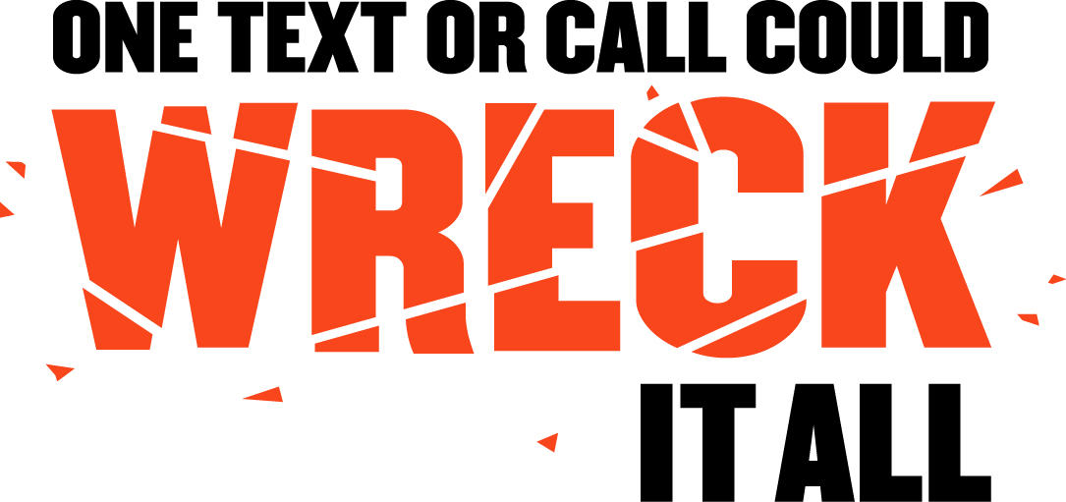

SAMPLE DROP-IN
NEWS ARTICLE

With ever increasing demands on our personal and professional time in today’s busy society, learning to juggle multiple tasks at once is something we all face daily. As a result, a new traffic safety epidemic has emerged on America’s roadways that demands immediate attention: distracted driving.

In 2010, 3,092 people were killed in crashes involving a distracted driver. One of the most alarming and widespread forms of distracted driving is cell phone usage. According to a Carnegie Mellon study, driving while using a cell phone reduces the amount of brain activity associated with driving by 37 percent. And a report from the National Safety Council found that more than one out of every four traffic accidents is caused by people talking on cell phones or sending text messages.

“Distracted driving is an epidemic on America’s roadways, and we’re doing our part to help put an end to it,” said U.S. Secretary of Transportation Ray LaHood. “Texting and cell phone use while driving is extremely dangerous, and we know simply getting drivers to turn their phones off when they get behind the wheel will make our roads significantly safer.”

Text messaging is of heightened concern because it combines three types of distraction – visual, manual and cognitive. In other words, texting involves taking your eyes off the road, your hands off the wheel, and your mind off the task of driving.

To tackle this ever-increasing problem, NHTSA is focusing on ways to change the behavior of drivers through legislation, enforcement, public awareness and education—the same tactics that have curbed drinking and driving and increased seat belt use.

“Decades of experience with drunk driving and getting people to buckle up has taught us it takes a consistent combination of public education, effective enforcement, a committed judiciary, and the collective efforts of local, state, and national advocates to put a dent in the problem,” said LaHood.

NHTSA’s message is simple – “One Text or Call Could Wreck it All.” With supporters ranging from President Obama to Oprah and legislation being passed across the nation to discourage distracted driving, we hope drivers get the message loud and clear.

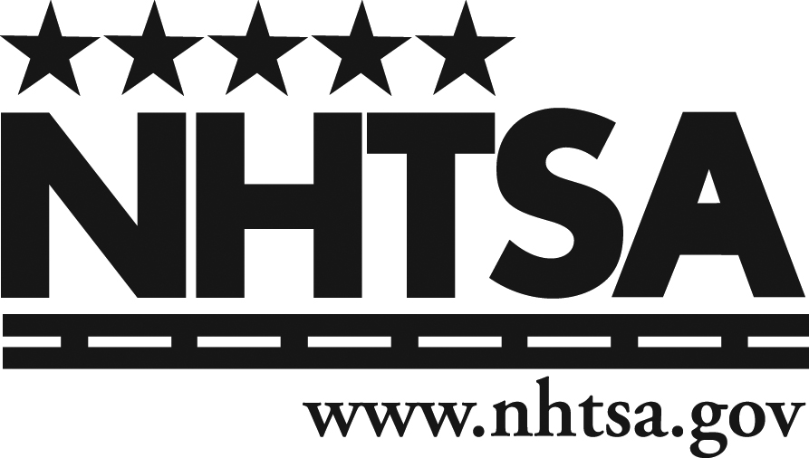
So the next time you are pressed for time, and it seems like multitasking in the car is the best decision, remember those 3,092 lives that were taken because someone decided they could do two things at once. A text or call is not worth your life, or anyone else’s.

