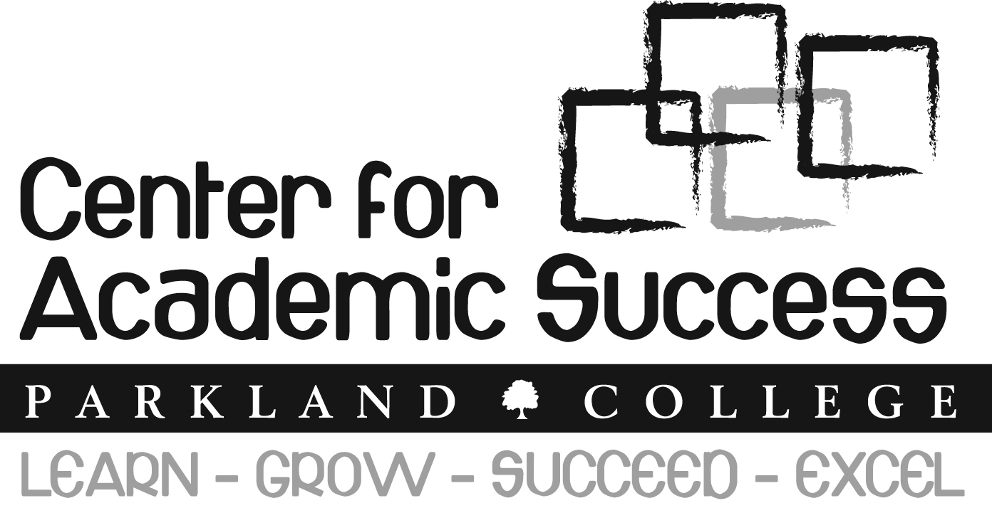

The Center for Academic Success (CAS) is Parkland’s one-stop learning center for all students. It is located in D-120. The mission of the CAS is to provide academic support services to help you learn well, grow as a student, succeed in your academic goals, and excel in your classes. There are four kinds of academic support services.
- Walk-in Tutoring and Learning Assistance: The CAS faculty and staff provide free tutoring and learning assistance services.
  - Writing faculty help students with all kinds of writing assignments and projects in the Writing Lab. These writing assignments can be from any class, not just ENG classes. You can ask for help at any stage of the writing process from brainstorming, learning how to proofread a paper, improving a thesis statement to developing supporting details.
  - Math faculty guide students in understanding the math concepts in and completing homework for MAT 094, 095, 097, and 098. Come and do your math homework here: you can get immediate help from Math Faculty Tutoring when you encounter difficulties.
  - Academic Development Specialists work with students in CCS 098 and 099, ENG 098 and 099, MAT 094, 095, 097, and 098. They also help students use technology, as needed, to overcome learning challenges to succeed in the college classes.
  - Peer Tutors are students who have excelled in their classes. They provide tutoring in Math (all levels), Chemistry, Physics, Accounting, Computer Science, Business, Economics, and more.
  - Assistance with technology. We can help you access your student email, use Angel, log into the student portal (my.parkland.edu), or use the computer.

- For-credit Tutorials and Modules:
  - Tutorials: You can take one-credit hour tutorials to supplement what you learn in the classroom. These tutorials are “guided independent study” courses, customized to meet your specific learning challenges. Tutorials in math, reading, writing, study skills, and chemistry are available.
  - Modules: You can take one or two-credit hour modules to complete the following foundational course requirements: CCS 098 and 099, ENG 098 and 099, MAT 094, 095, 097, and 098.

- Academic Advising and Personal Planning:
- Academic Advising: Our team of advisors and advocates will help you plan a class schedule, choose classes that fit your academic needs, and discuss your academic goals.
- Personal Planning: Students often have to deal with non-academic issues. Our advisor/advocate team can talk with you about your concerns (ex. work, childcare, housing, relationships, and time management), identify possible solutions, and/or refer you to resources.

- First Year Experience Program:
- Early Alert: Our team of advisors and advocates respond to faculty alerts by providing you with information and referrals to the resources you need to succeed.
- Learning Communities: Cohorts of students who share a common major or background take courses together and receive support from staff & faculty mentors as well as each other.
- New Student Orientation: A hybrid orientation model is used to welcome you from the point of application and guide you during the initial enrollment process and throughout your first year.
Check us out online at http://www.parkland.edu/resources/cas

