 | PubMed for Experts  http://pubmed.gov



National Network of Libraries of Medicine
South Central Region
NLM Contract No: HHSN-276-2011-00007-C

July 2011

Introduction to the U.S. National Library of Medicine

The United States National Library of Medicine (NLM), part of the National Institutes of Health (NIH), is the world's largest medical library. The collections of the National Library of Medicine include more than seven million books, journals, technical reports, manuscripts, microfilms, photographs, and images on medicine and related sciences, including some of the world's oldest and rarest works.

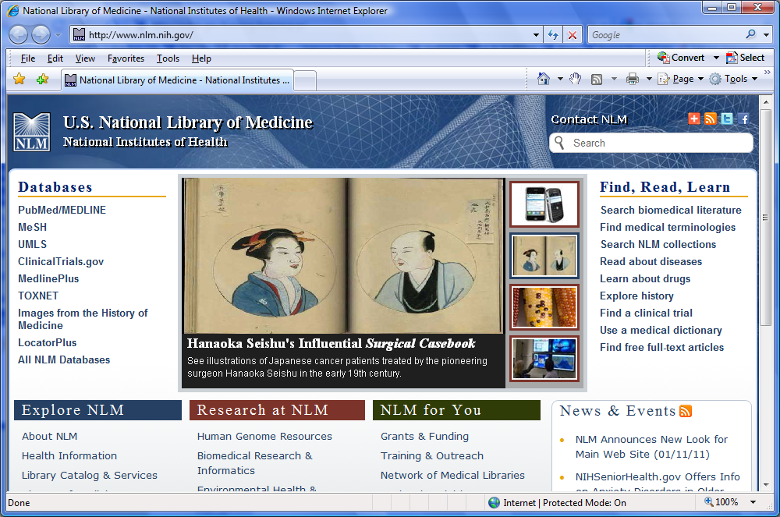

A redesigned version of the NLM homepage debuted January 11, 2011. NLM databases are located at the top right corner of the page. A link to the NLM Technical Bulletin is located at the bottom page. Information in the Technical Bullet includes, PubMed revisions, new MeSH Terms and updates on other NLM databases.


PubMed® (pubmed.gov)

- NLM has been indexing the biomedical literature since 1879, to help provide health professionals access to information necessary for research, health care, and education.
- What was once a printed index to articles, the Index Medicus, became a database now known as MEDLINE®. MEDLINE contains journal citations and abstracts for biomedical literature from around the world.
- Since 1996, free access to MEDLINE has been available to the public online via PubMed.

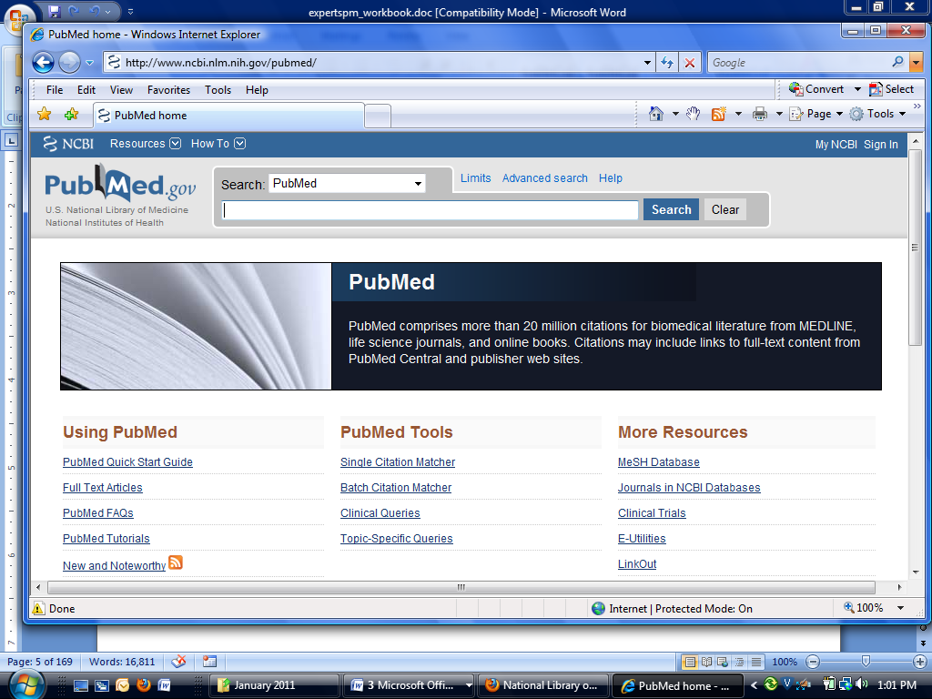

- PubMed currently includes more than 20 million bibliographic citations.
- PubMed also has links to the full-text of articles at participating publishers’ Web sites, as well as biological data, sequence data, and more from other Entrez Databases and from third parties.
- Over 70 million PubMed searches are conducted every month.

Interrelationships between Entrez Databases

- PubMed provides links to the integrated molecular biology databases maintained by NCBI. These databases contain: DNA and protein sequences, genome mapping data, and 3-D protein structures, aligned sequences from populations, and the Online Mendelian Inheritance in Man (OMIM). Links between MEDLINE records and sequence records make it easy to find MEDLINE abstracts associated with sequence records and vice versa.

- PubMed also provides links to chemical information in PubChem Substance, PubChem Compound and PubChem Bioassay databases.

- The following diagram illustrates the relationships between some of the information resources in Entrez:

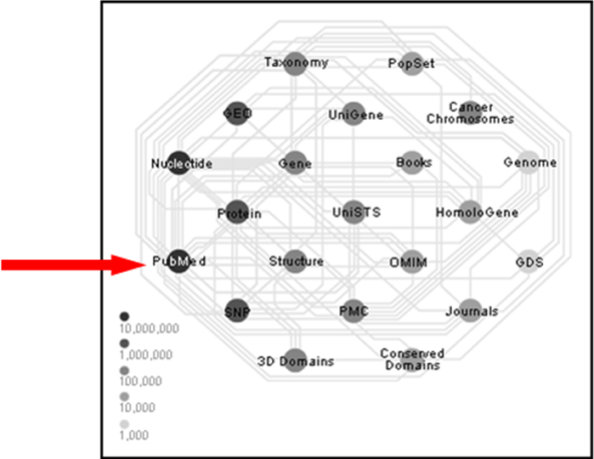
See an interactive view of Entrez links at http://www.ncbi.nlm.nih.gov/Database/

What’s in PubMed

- Most PubMed records are MEDLINE citations.
- Other records include those in different stages of processing (including records provided directly from the journal publisher) but destined to be MEDLINE citations.
- A relatively small number of records are included in PubMed but not selected for MEDLINE.

MEDLINE Citations

PubMed provides access to MEDLINE, the National Library of Medicine’s premier bibliographic database containing citations and author abstracts from approximately 5,400 biomedical journals published in the United States and in other countries.

The scope of MEDLINE includes such diverse topics as microbiology, delivery of health care, nutrition, pharmacology and environmental health. The categories covered in MEDLINE include everything from anatomy, organisms, diseases, psychiatry, and psychology to the physical sciences.

- MEDLINE currently contains over 18 million references dating back to 1946.
- New material is added Tuesday through Saturday.
- Coverage is worldwide, but most recently added records (about 92%) are from English-language sources or have English abstracts.
- Approximately 82% of the citations are included with the published abstract.

MEDLINE Journal Selection

- The Literature Selection Technical Review Committee (LSTRC) meets three times a year and considers approximately 140 titles for MEDLINE at each meeting.
- Final approval is made by the Director of the National Library of Medicine.
- Titles are considered for scope and coverage, quality of content, quality of editorial work, production quality, audience, and type of content.
- For more details, see the NLM Fact Sheet, MEDLINE Journal Selection, at http://www.nlm.nih.gov/pubs/factsheets/jsel.html.

How Citations Get Into PubMed
- Records are either supplied electronically by publishers or created using scanning and Optical Character Recognition (OCR) at NLM.
- Citations are immediately made available via PubMed. All citations go through a quality control process, and citations from MEDLINE journals are indexed.
- All citations display a status tag, which indicates their stage of processing.

Publisher Supplied Citations
- These are citations that are supplied electronically by publishers directly to PubMed. The citations are then forwarded to NLM’s Index Section to be processed. (Not all citations are supplied electronically).

- Citations received electronically have the status tag: [PubMed - as supplied by publisher].

Sample PubMed citation that was submitted electronically but processing has not yet begun:

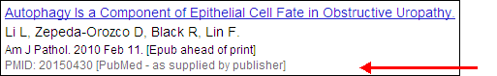
Notice the [PubMed – as supplied by publisher] status tag.

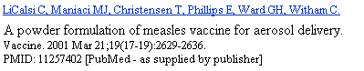

In Process
- These citations are being reviewed for inclusion in MEDLINE and, if in scope, subsequently are indexed with MeSH® vocabulary. In addition the bibliographic data in these records is being checked for accuracy.

- In process records carry the status tag: [PubMed – in process].

- In process records are added to PubMed Tuesday-Saturday.

Sample In Process citation in PubMed:

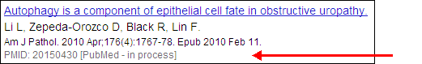

Notice the [PubMed – in process] status tag.
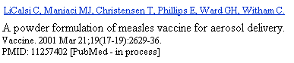

MEDLINE Citations

- After Medical Subject Headings (NLM’s controlled vocabulary terms) and other indexing terms are added, the in process citations graduate to MEDLINE records. These “completed” records have also been checked for bibliographic accuracy.

- Fully indexed MEDLINE records carry the status tag [PubMed – indexed for MEDLINE].

- MEDLINE records are added to PubMed Tuesday-Saturday.

Sample MEDLINE citation in PubMed:

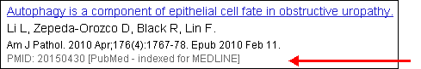
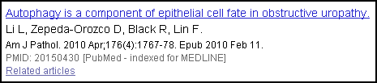

Notice the [PubMed – indexed for MEDLINE] status tag.

OLDMEDLINE Citations

- About 2 million citations (most with no abstracts) are from two printed indexes: Cumulated Index Medicus (CIM) and the Current List of Medical Literature (CLML) published from 1946 to 1965.

- The citations are from international biomedical journals covering the fields of medicine, preclinical sciences, and allied health sciences.

- OLDMEDLINE citations have been created using standards that are different from the data entry standards for MEDLINE records. There are also variations among OLDMEDLINE citations in the data fields present as well as in their format, depending on the original source from which the citations were obtained.

- Beginning in 2005, the original subject terms applied to the citations in the printed indexes are being mapped to current Medical Subject Headings (MeSH).

- OLDMEDLINE records carry the status tag [PubMed – OLDMEDLINE] until all original subject terms are mapped to current MeSH. Once all terms are mapped, the records are promoted to status [PubMed – indexed for MEDLINE].

Sample OLDMEDLINE citations in PubMed:
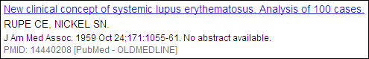

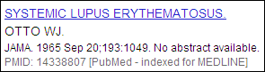

Non-MeSH Indexed Citations

- Some citations never become MEDLINE citations.
- These records are not indexed with MeSH terms.
- These records have either the status tag [PubMed] or [PubMed – as supplied by publisher].

There are four sources of these types of records:

1. Out-of-scope articles from selectively indexed MEDLINE journals

This may occur when a particular article in a selectively indexed journal is out-of-scope for MEDLINE (such as a geology article in a general scientific journal like Science or Nature).
These citations have been reviewed for accurate bibliographic data.
The status tag [PubMed] appears on these citations.

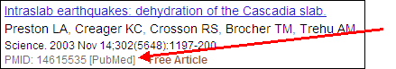
Sample citation for an article that is out of scope for MEDLINE:

Notice the [PubMed] status tag.

Sample citation for an article from the same journal issue that is indexed for MEDLINE:

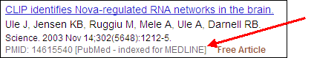
Notice the [PubMed – indexed for MEDLINE] status tag. 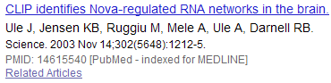

2. Articles from issues of journals published prior to selection for MEDLINE indexing

These earlier citations will not be indexed with MeSH headings.
- Prior to late 2003:
► the citations were not reviewed for accurate bibliographic data
► the status tag of [PubMed – as supplied by publisher] appears
- Beginning in late 2003:
► the citations have been reviewed for accurate bibliographic data
► the status tag of [PubMed] appears.

Example: NLM began indexing the journal, The Neurologist with v. 9, no. 1, 2003. However, the publisher electronically supplied NLM with citations from earlier volumes. The citations from back volumes were entered into PubMed but will not be indexed with MeSH.

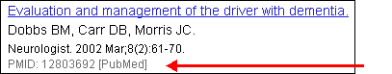

Notice the [PubMed] status tag from an item from vol. 8, 2002.

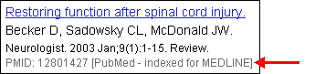

Notice the [PubMed – indexed for MEDLINE] status tag on an item from volume 9, 2003.

Indexing information for a particular journal can be found in the “Current Indexing Status” field in the Journals Database.

3. Articles from non-MEDLINE journals

- Beginning in July 2005:
► the citations have been reviewed for accurate bibliographic data
► the status tag of [PubMed] appears



- Author manuscripts in PubMed Central (PMC) that would not normally be in PubMed.

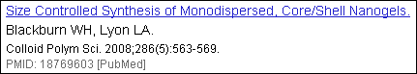

4. Books and book chapters from the NCBI Books database

- Selected books are cited by title and by chapter in PubMed
- The status tag of [PubMed] appears
- To search for book citations in PubMed, enter pmcbook in the PubMed search box.
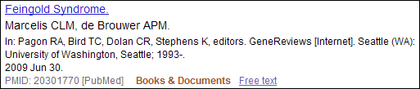

PubMed Citation Status Tags Summary Table
Citation Status Tag Value | Condition(s) | MeSH-indexed? | Biblio-graphic data checked? | How to search
PubMed - as supplied by publisher
 | - Citations supplied electronically when first received.  - Citations from issues of journals published before journal selected for MEDLINE indexing (records received prior to late 2003).  - Citations from non-MEDLINE journals (records received prior to June 2005). | No | No | publisher [sb] NOT pubstatusnihms NOT pubstatuspmcsd NOT pmcbook
PubMed - in process
 | - Citations in review for inclusion in MEDLINE. | No | No | in process [sb]
PubMed - indexed for MEDLINE
 | - Fully indexed citations. | Yes | Yes | medline [sb]
PubMed – OLDMEDLINE
 | - Citations originally printed in hardcopy indexes published from 1946 through 1965 that have not had all of their original subject terms mapped to current MeSH. | Partial | Yes | oldmedline [sb]
PubMed
 | - Out-of-scope articles from selectively indexed MEDLINE journals.  - Since late 2003, citations from issues of journals published prior to selection for MEDLINE indexing.  - Since June 2005, citations from non-MEDLINE journals.  - Citations for articles with full-text in PubMed Central (PMC) that would not normally be in PubMed.  - Citations for selected books and book chapters in the NCBI Books database. | No | Yes | pubmednotmedline [sb] OR pmcbook OR (publisher [sb] AND (pubstatusnihms OR pubstatuspmcsd))

Review of Basic Skills

Basic Searching

Search: Find citations to articles about indigestion and abdominal pain.

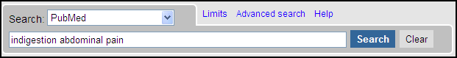

Entering Search Terms
- Enter significant terms in the search box (e.g., indigestion abdominal pain).
- Click on the Search button (or hit Enter).

Automatic Term Mapping (ATM)

Search Details
You can see how PubMed processes your search by viewing Search details from the right column of your search results page:
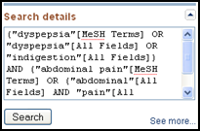

Click See more… to open the Search details page

The Search Details page shows how your terms are translated or mapped to terms indexed in the database.

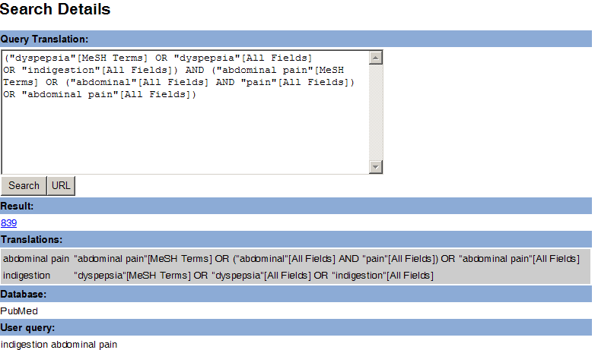

Translations are shown in the grey box towards the bottom of the screen.

A link to the Details screen is also available from the Advanced Search screen. Click on Advanced Search, adjacent to the search box buttons,
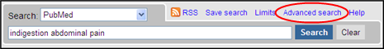

then click on Details:
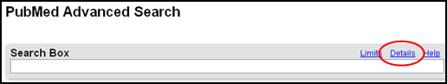

Terms entered in the search box without a search tag, e.g., [au] are matched against:
- Subjects, using the
  - MeSH (Medical Subject Headings) Translation Table
- Journals, using the
  - Journals Translation Table
- Authors and Investigators, using the
  - Full Author Translation Table
  - Author Index
  - Full Investigator Translation Table
  - Investigator Index

1. MeSH Translation Table contains:
- MeSH Headings
- Subheadings
- Publication Types
- Entry Term mappings (also known as synonyms) for MeSH terms
- Mappings derived from the Unified Medical Language System (UMLS)
- Supplementary Concepts and synonyms to the Supplementary Concepts

If a match is found in this translation table:
- the term will be mapped to the appropriate MeSH term and searched as MeSH
- the searcher’s term and the mapped MeSH term will be searched in All Fields

Example: 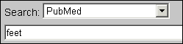

PubMed’s Translation:
"foot"[MeSH Terms] OR "foot"[All Fields] OR "feet"[All Fields]

- Feet is an Entry Term for the MeSH term, Foot.

When a term is searched as a MeSH Heading, PubMed automatically searches that heading and the more specific headings underneath in the hierarchy. This is called exploding a term.

For example, when searched as a MeSH Term, PubMed will search the heading Foot as well as the more specific term(s) in the hierarchy:
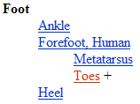

Matching phrases are searched in All Fields as a phrase and broken into individual words, with the exception of phrases mapping to Supplementary Concepts (substances) or MeSH Headings that include a standalone number or single character. These are searched only as phrases in All Fields.
Example: 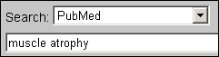

PubMed’s Translation:
"muscular atrophy"[MeSH Terms] OR ("muscular"[All Fields] AND "atrophy"[All Fields]) OR "muscular atrophy"[All Fields] OR ("muscle"[All Fields] AND "atrophy"[All Fields]) OR "muscle atrophy"[All Fields]

Example: 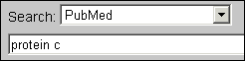

PubMed’s Translation:
"protein c"[MeSH Terms] OR "protein c"[All Fields]

2. Journals Translation Table contains:

- Full journal title
- MEDLINE abbreviation
- International Standard Serial Number (ISSN)

Example: 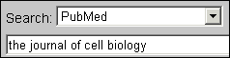

PubMed Translation:
"J Cell Biol"[Journal] OR "the journal of cell biology"[All Fields]
If a name of a journal also happens to be a MeSH term or a one-word title, PubMed will search the term as a MeSH heading and in All Fields. For example, the search for Science untagged will search: "science"[MeSH Terms] OR "science"[All Fields]. To limit your search to a journal title, use the Limits page or use the tag [ta], e.g., science [ta]

3. Full Author Translation Table includes:

- Full author names for articles published from 2002 forward and to journals that publish using the full names of authors.

- Full author searching can be entered in natural or inverted order:

julia s wong
wong julia s
- When searching a full name using the inverted order, a comma following the last name is generally optional, omit periods after initials, and put all suffixes, e.g., Jr, at the end. For example, to search for the author Bruce J. Herron, you may use any of the following formats:

herron, bruce j
herron bruce j
bruce j herron

- For some names, however, it is necessary to distinguish which name is the last name by using the comma following the last name:

ryan, james
james, ryan

4. Author Index

- Author’s names, for all years of publication, are included in the form of Last Name (space) Initials. Use this format for searching.

Examples: o’brien jm

- If only the first initial is used, PubMed automatically truncates the author’s name to account for varying initials.

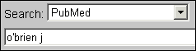
Example:

This search retrieves citations to articles written by o’brien j, o’brien ja, o’brien jz, etc.

If only an author’s last name is entered, PubMed will search that name in All Fields (Author field plus all other searchable fields). It will not default to the Author Index because the last name is not followed by an initial. When the last name is the same as a MeSH term, PubMed will search the term in MeSH as well as in All Fields. To limit a search to an author’s name, use Limits or use the tag [au], e.g., o’brien [au].

5. Full Investigator Translation Table and Investigator Index

- Investigators are individuals who contributed to the research, but may not have participated in writing the article.
- The names in the Full Investigator Translation Table and the Investigator Index are formatted and searchable in the same way as the Full Author Name Table and Author Index (see above).

If no match is found?

- PubMed breaks apart the phrase and repeats the automatic term mapping process until a match is found.

- Terms that don’t make a match will be searched in “All Fields.” Individual terms will be combined (ANDed) together.

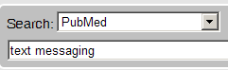
Example:

PubMed Translation:

text[All Fields] AND messaging[All Fields]

- PubMed breaks apart a long phrase from right to left:
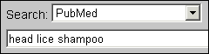
Example:

Searches for: | Results: | Action:
head lice shampoo | No match found | Removes term on right to re-run Automatic Term Mapping process.
head lice | Match found in MeSH Translation Table | head lice will be searched as "pediculus"[MeSH Terms] OR "pediculus"[All Fields] OR ("head"[All Fields] AND "lice"[All Fields]) OR "head lice"[All Fields]
shampoo | No match found in Translation Tables | shampoo will be searched as  shampoo[All Fields]

PubMed then combines (ANDs) the terms to produce a single search strategy:

"pediculus"[MeSH Terms] OR "pediculus"[All Fields] OR ("head"[All Fields] AND "lice"[All Fields]) OR "head lice"[All Fields]
AND
shampoo[All Fields]

Phrase Searching

PubMed searches for phrases under these conditions:

- The phrase is found in the MeSH, journal, author or investigator tables or indexes during the automatic term mapping process
- The phrase is entered with a search tag:
kidney allograft [tw]
- The phrase is enclosed in double quotes: (The absence of a search tag indicates the search should be conducted in All Fields.)
“kidney allograft”
- The term is hyphenated:
first-line
- The term is truncated:
kidney allograft*

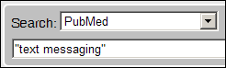
Example:

PubMed Translation: "text messaging"[All Fields]

- The above formats for phrase searching instruct PubMed to bypass automatic term mapping. Instead PubMed looks for the phrase in its Index of searchable terms. If the phrase is in the Index, PubMed will retrieve citations that contain the phrase.

- PubMed may fail to find a phrase because it is not in the Index.

When you enclose a phrase in double quotes, PubMed will not perform automatic term mapping which includes explosions of MeSH terms. For example, “health planning” will include citations that have the MeSH heading, Health Planning, but will not include the more specific indentations (e.g., Health Care Rationing, Health Care Reform) that are included with automatic MeSH mapping and explosion.

Limits

Limits allow you to set commonly used parameters for your query, which may result in more relevant retrieval.
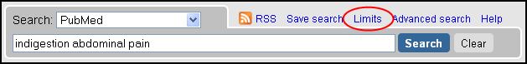
lick on the Advanced Search link displayed to right of the search box.

Details screen link

Click Limits above the search box on any PubMed screen to bring up the Limits feature. Multiple selections are allowed.
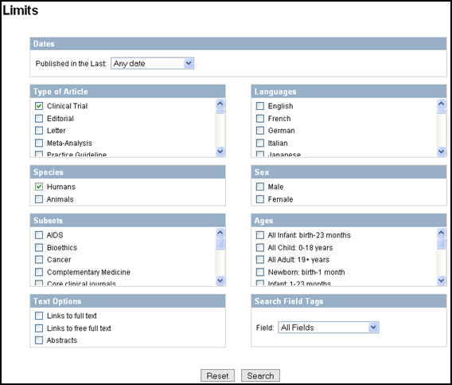

Note that active Limits appear above your search results.
To return to the Limits page to change your selections, click Change.
To clear your Limits selections, click Remove.

The following pages explain more about each type of limit.
Dates:

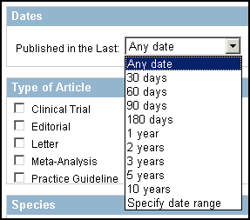
PubMed contains citations published back to 1948. New citations are generally added Tuesday through Saturday.

Limit your search to articles Published in the Last pre-set date range, or specify a date range using yyyy/mm/dd format. Month and days are optional.

Note that PubMed will search both electronic and print publication dates when searching a range of dates. If using a single date, PubMed will search only the earliest publication date.

PubMed displays search results in descending date of entry order, i.e., last in, first out.

Limiting by Type of Article (Publication Type)

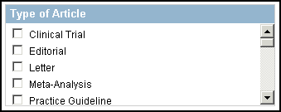
- Use to limit your retrieval based on the type of material the citation represents.
- The selections at the top are frequently searched publication types.
- Scroll down to find an alphabetic list of more publication types.
- Multiple selections are allowed (ORed together).

Limiting by Languages
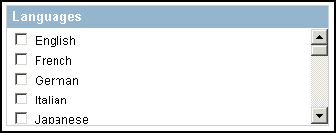
- Journals published in approximately forty languages are indexed.
- The selections at the top are frequently searched languages.
- Scroll down to find a complete alphabetic list of more languages.
- Multiple selections are allowed (ORed together).

Limiting by Species (Humans or Animals)

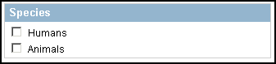

- Use to limit to a specific group.
- If both options are checked, they are ANDed together.

Limiting by Sex

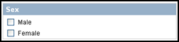

- Use to limit by sex.
- If both options are checked, they are ANDed together.

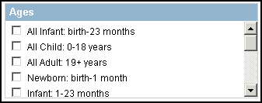
Limiting by Ages

Use to search for a specific age group or multiple age groups (ORed together).

Text Options
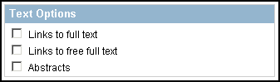
Click the appropriate checkboxes to limit to those records that link to full text, link to free full text or contain abstracts.

Advanced Search Screen

History

- History available from the Advanced Search screen.
- Temporarily holds up to 100 searches and links to results.
- The History screen displays:
  - Your search query
  - Most recent 5 searches are displayed
  - The time of the search
  - The number of citations in your search results
  - Search statement numbers menu for combining searches

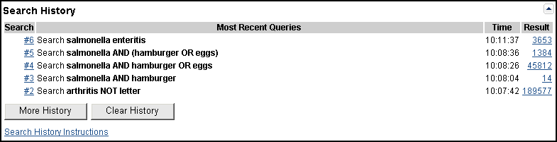

Using History

- You can use the search statement numbers shown in History in search strategies.

Example: 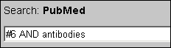



Type Boolean operators in all caps as shown in the example above.

Other examples: #8 AND #10
#7 OR #14

Search Statement Number Menu

- Click on the search statement number to open an Options menu:

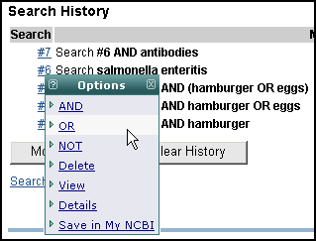

Options Menu includes:
- Boolean operators AND, OR or NOT to add the search to the search box
- Delete the individual search from History
- View the results
- Display the search Details
- Save in My NCBI

History Tips:

- Maximum number of searches that can be held in History is 100.
- The search history will be deleted after 8 hours of inactivity.
- If a search is repeated, its original number is moved to the top.
- A separate Search History will be kept for each of the Entrez databases although the search statement numbers will be assigned sequentially for all databases.

History displays the last five searches. When there are more than five, click the More History button to see the full display. Click Less History to revert to the shorter display.

Click on the Clear History button available at the bottom of the History screen to remove all searches from the History.

Medical Subject Headings (MeSH® Vocabulary)

For a video introduction to MeSH, see Branching Out: The MeSH Vocabulary at http://www.nlm.nih.gov/bsd/disted/video/

MeSH Tree Structure

- MeSH vocabulary is organized by 16 main branches:

- Anatomy
- Organisms
- Diseases
- Chemical and Drugs
- Analytical, Diagnostic and Therapeutic Techniques and Equipment
- Psychiatry and Psychology
- Phenomena and Processes
- Disciplines and Occupations
- Anthropology, Education, Sociology and Social Phenomena
- Technology, Industry, Agriculture
- Humanities
- Information Science
- Named Groups
- Health Care
V. Publication Characteristics
Z. Geographic Locations

- Each Descriptor has a tree number that positions the term in the hierarchy.

Eye [A01.456.505.420]
Eyebrows [A01.456.505.420.338]
Eyelids [A01.456.505.420.504]
Eyelashes [A01.456.505.420.504.421]

- Some terms have multiple tree numbers because they appear in more than one place in the hierarchy.

- By having narrower terms indented under broader terms, a search of a broad term can automatically include the narrower terms. This is known as an EXPLODE.

MeSH Database

- MeSH is the name of an Entrez database that assists PubMed users in locating appropriate terms for searches. This database provides information about MeSH terms including:

  - Definitions
  - Synonyms for the concept
  - Related terms
  - The position of the headings in the MeSH hierarchy

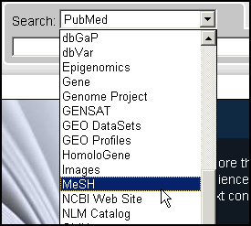
- We can use the MeSH database to look at the type of information associated with each MeSH term:

Click on MeSH Database on the homepage or select MeSH from the database selection box and click Search:

Enter cell proliferation and click Search:
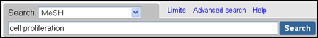

In the retrieval, click on Cell Proliferation:
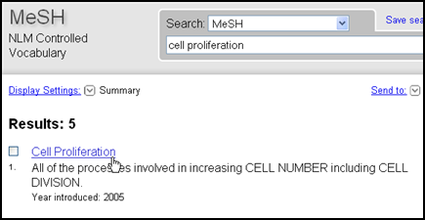

This displays the full record for Cell Proliferation:
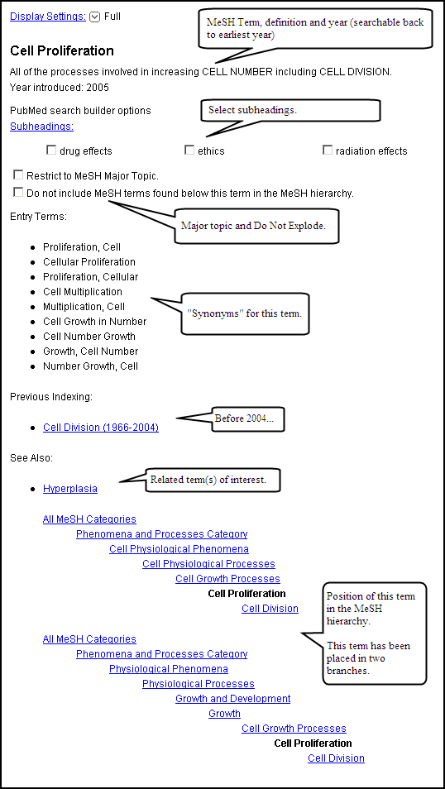

Use the links menu in the right column to go to the NLM MeSH Browser for additional information:

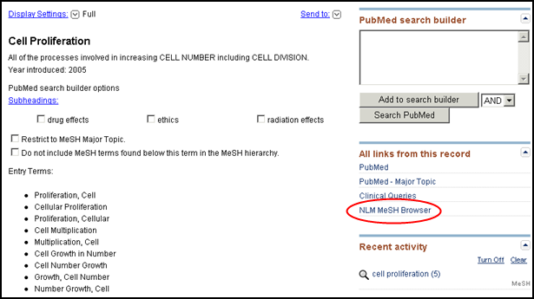

The NLM MeSH Browser is the tool used by MEDLINE indexers and catalogers.

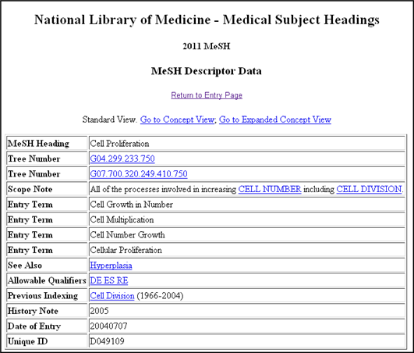

Indexing with MeSH Headings

- NLM MEDLINE indexers examine articles and assign the most specific MeSH heading(s) appropriate to describe the main concepts discussed.
- When there is no single specific MeSH heading for a concept, the indexer will use the closest, more general MeSH heading available.
- The indexer will assign as many MeSH headings as appropriate to cover the topics of the article (generally 5 to 15).
- The MeSH terms that reflect the major points of the article are marked with an asterisk (*) by indexers.
- Information the indexer provides includes:
topic of article
age group of population studied
human vs. animal studies
male vs. female studies
type of article (e.g., review article)

Article Title:
Hormone therapy in perimenopausal and postmenopausal women: examining the evidence on cardiovascular disease risks.

Abstract:
Women may live for 30 years or longer after menopause with cardiovascular disease as their highest mortality risk. Menopause may correspond to health alterations for women, yet the use of estrogen during and after this transition has been controversial for the past four decades. The evidence from recent scientific studies does not support the use of hormone therapy for the prevention or treatment of cardiovascular disease, which has resulted in its removal from national guideline recommendations. However, because of concerns related to specific aspects of the research, there are gaps in the evidence. Studies are under way to evaluate alternate methods for hormone delivery, low-dose hormone therapy, and selective estrogen receptor modulators (SERMs) in reducing cardiovascular risks in perimenopausal and postmenopausal women. Implications for clinical nursing practice include education as well as assessment and counseling related to individual risk factors.

Publication Types:
Review

MeSH Terms:
Aged
Cardiovascular Diseases/chemically induced*
Estrogen Replacement Therapy/adverse effects*
Evidence-Based Medicine
Female
Humans
Middle Aged
Perimenopause*
Postmenopause*
Risk Factors

Subheadings
- Subheadings further describe a particular aspect of a MeSH heading.

The entire list of subheadings follows:
Abnormalities | ab | Isolation & purification | ip
Administration & dosage | ad | Legislation & jurisprudence | lj
Adverse effects | ae | Manpower | ma
Agonists | ag | Metabolism | me
Analogs & derivatives | aa | Methods | my
Analysis | an | Microbiology | mi
Anatomy & histology | ah | Mortality | mo
Antagonists & inhibitors | ai | Nursing | nu
Biosynthesis | bi | Organization & administration | og
Blood | bl | Parasitology | ps
Blood supply | bs | Pathogenicity | py
Cerebrospinal fluid | cf | Pathology | pa
Chemical synthesis | cs | Pharmacokinetics | pk
Chemically induced | ci | Pharmacology | pd
Chemistry | ch | Physiology | ph
Classification | cl | Physiopathology | pp
Complications | co | Poisoning | po
Congenital | cn | Prevention & control | pc
Contraindications | ct | Psychology | px
Cytology | cy | Radiation effects | re
Deficiency | df | Radiography | ra
Diagnosis | di | Radionuclide imaging | ri
Diagnostic use | du | Radiotherapy | rt
Diet therapy | dh | Rehabilitation | rh
Drug effects | de | Secondary | sc
Drug therapy | dt | Secretion | se
Economics | ec | Standards | st
Education | ed | Statistics & numerical data | sn
Embryology | em | Supply & distribution | sd
Enzymology | en | Surgery | su
Epidemiology | ep | Therapeutic use | tu
Ethics | es | Therapy | th
Ethnology | eh | Toxicity | to
Etiology | et | Transmission | tm
Genetics | ge | Transplantation | tr
Growth & development | gd | Trends | td
History | hi | Ultrasonography | us
Immunology | im | Ultrastructure | ul
Injuries | in | Urine | ur
Innervation | ir | Utilization | ut
Instrumentation | is | Veterinary | ve
 |  | Virology | vi

Subheading Groupings

- Related subheadings have been grouped to allow for additional, relevant retrieval.
- Not all subheadings have been placed in these groupings – some do not logically fit.

Families of Subheading Explosions

adverse effects
poisoning
toxicity

analysis
blood
cerebrospinal fluid
isolation & purification
urine

anatomy & histology
blood supply
cytology
pathology
ultrastructure
embryology
abnormalities
innervation

chemistry
agonists
analogs & derivatives
antagonists & inhibitors
chemical synthesis

complications
secondary

cytology
pathology
ultrastructure

diagnosis
pathology
radiography
radionuclide imaging
ultrasonography

embryology
abnormalities

epidemiology
ethnology
mortality
etiology
chemically induced
complications
secondary
congenital
embryology
genetics
immunology
microbiology
virology
parasitology
transmission

metabolism
biosynthesis
blood
cerebrospinal fluid
deficiency
enzymology
pharmacokinetics
urine

microbiology
virology

organization & admin
economics
legislation & jurisprudence
manpower
standards
supply & distribution
trends
utilization

pharmacology
administration & dosage
adverse effects
poisoning
toxicity
agonists
antagonists & inhibitors
contraindications
diagnostic use
pharmacokinetics
physiology
genetics
growth & development
immunology
metabolism
biosynthesis
blood
cerebrospinal fluid
deficiency
enzymology
pharmacokinetics
urine
physiopathology
secretion

statistics & numerical data
epidemiology
ethnology
mortality
supply & distribution
utilization

surgery
transplantation

therapeutic use
administration & dosage
adverse effects
contraindications
poisoning

therapy
diet therapy
drug therapy
nursing
prevention & control
radiotherapy
rehabilitation
surgery
transplantation

Pharmacologic Action Terms

Every drug and chemical MeSH heading has been assigned one or more headings that describe known pharmacological actions (PA).

- Since 1996, NLM indexers add the appropriate pharmacological action MeSH heading as well as the specific chemical MeSH heading to a citation when the action of the chemical is discussed in the article.

Example:

The pharmacological actions established for the MeSH Heading, Aspirin:

Pharmacological Action
Pharmacological Action
Pharmacological Action
Pharmacological Action

Anti-Inflammatory Agents, Non-Steroidal
Cyclooxygenase Inhibitors
Fibrinolytic Agents
Platelet Aggregation Inhibitors

- A citation to an article that discusses aspirin used as an anti-inflammatory agent will be assigned:

Aspirin
Anti-Inflammatory Agents, Non-Steroidal

- A citation to an article that discusses aspirin used to inhibit blood clotting will be assigned:

Aspirin
Platelet Aggregation Inhibitors

See “The Basics of MeSH in MEDLINE/PubMed” (http://www.nlm.nih.gov/bsd/disted/mesh/), linked from Tutorials on the PubMed home page for information on searching with pharmacologic action terms.

Other Types of MeSH Vocabulary

Supplementary Concepts
- Over 186,000 terms.
- Primarily substances, but also include some protocols and rare diseases.
- Display in RN field on MEDLINE record and under Substances or Supplementary Concepts in Abstract view of PubMed.

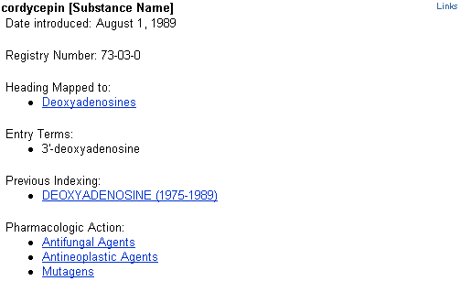

The data in a Supplemental Concept MeSH Database record may include:
- Name of substance: For example: cordycepin
- Date Introduced: The date the record was added to the vocabulary
- Registry Number: For example: 73-03-0. A unique number assigned to chemicals by the Chemical Abstract Service, or a code for enzymes assigned by the Commission on Biological Nomenclature. May display as zero (0), generally for terms for a group or class of compounds.
- Heading Mapped to: The MeSH term used for indexing the concept in MEDLINE
- Entry Term: Synonyms that can be used for searching this concept
- Previous Indexing: MeSH terms used before the current term became available
- Pharmacologic Action: An action of a drug or chemical as reported in the literature, e.g., Antifungal Agents or Antineoplastic Agents

Age Group MeSH Headings

These are MeSH headings which indicate the age of human subjects discussed in the article:

Infant, Newborn Birth to 1 month
Infant 1 to 23 months
Child, Preschool 2 to 5 years
Child 6 to 12 years
Adolescent 13 to 18 years
Young Adult 19 to 24 years
Adult 19 to 44 years
Middle aged 45 to 64 years
Aged 65 to 79 years
80 and over 80+

Publication Types

- Publication Types describe the type of material being indexed.
- The most common type is Journal Article. Other Publication Types include:

Clinical Trial
Retraction of Publication
Comment
Review
Practice Guideline
Twin Study
Retracted Publication

- Publication Types may be searched in the MeSH Database. Definitions are provided.
- They are part of the MeSH hierarchy (V category).

Finding a Specific Citation

Using the Search box
- PubMed looks for combinations of search terms that are characteristic of citation searching, e.g., volume/issue numbers, author names, journal titles, article titles, publication dates, using a feature called the Citation Sensor.
- Simply type the available information into the Search box:

Example 2: Article title words
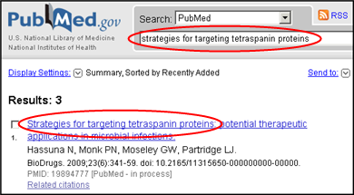

- If multiple citation matches are retrieved by the Citation Sensor, you will see a yellow area above the default retrieval with links to one or more citations for your consideration:

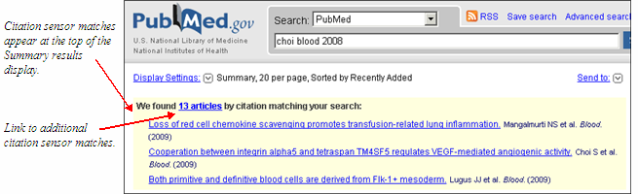

Single Citation Matcher

The Single Citation Matcher, available from the PubMed Home page and the Advanced Search page, allows you to fill in the information you have about a citation (e.g., author, title, journal, volume, issue, page number) by field.
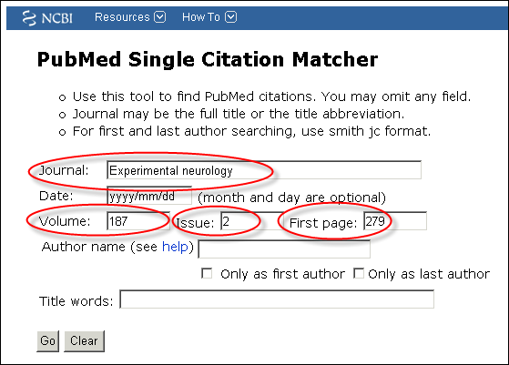

Autocomplete feature available for Journal and Author name

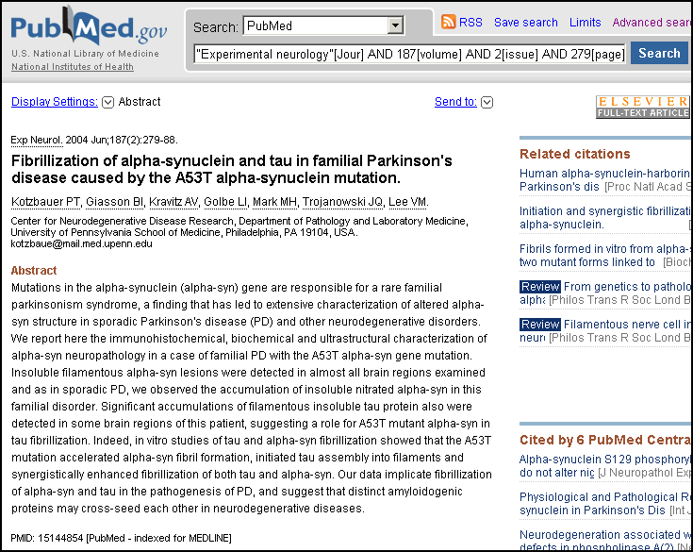

NLM Catalog Journal Search

The NLM Catalog has a special tool that allows you to look up information about a PubMed journal. You can search for a journal using:

- journal title
- MEDLINE/PubMed title abbreviation
- print and electronic International Standard Serial Numbers (pISSNs and eISSNs)
- subject terms

How to get there:

- Click Journals in NCBI Databases from the More Resources menu on the PubMed homepage:

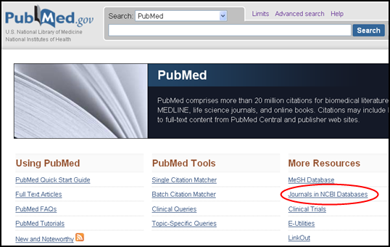
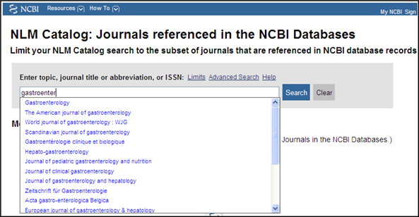

Enter your term.

You can select journal titles from the autocomplete feature which appears as you type.

Results:
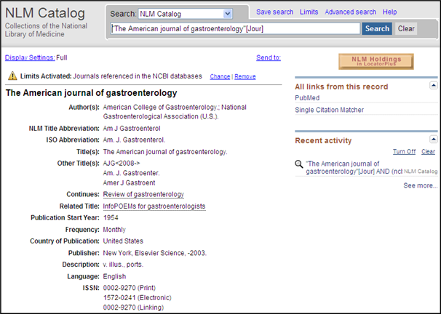
Click PubMed to retrieve all PubMed citations from this journal.

Click Single Citation Matcher to add author, article title, date or other criteria to find citations from this journal in PubMed.

Broad Subject Terms

- Subject terms are assigned by NLM to describe the overall scope of MEDLINE-indexed journals.
- Subject terms will display in the Full display format.
- Use link from the NLM Catalog homepage.

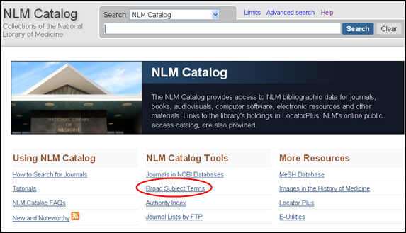
Example: pediatrics [st]

Searching for non-tagged terms, e.g., pediatrics in the NLM Catalog will retrieve all books and journals that include the word pediatrics or narrow terms in the MeSH, the title or other fields, as well as journals with the Subject Term, Pediatrics
The complete list of terms is available at the Journal Subject Terms Web page (http://wwwcf.nlm.nih.gov/serials/journals/).

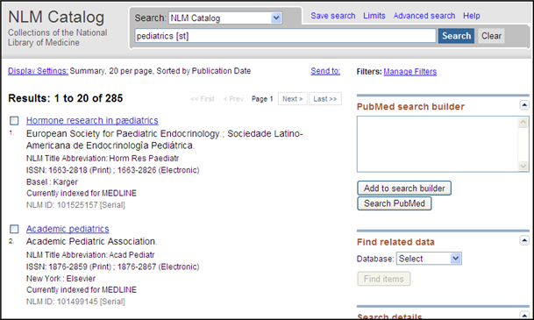
Click on the hyperlinked journal title or choose the Full display format to see more information about the title.

Limit to currently indexed titles, by language or by subset

Click on Limits link.
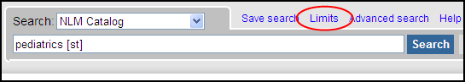

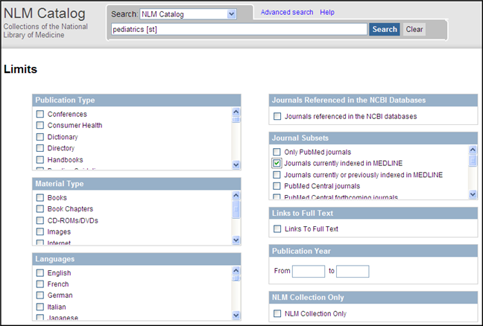
Use the checkbox to limit your search to currently indexed MEDLINE journal titles or other criteria.

Use the Only PubMed journals option on the Limits page to limit to journals in PubMed.

Building a PubMed query for multiple journals using the NLM Catalog
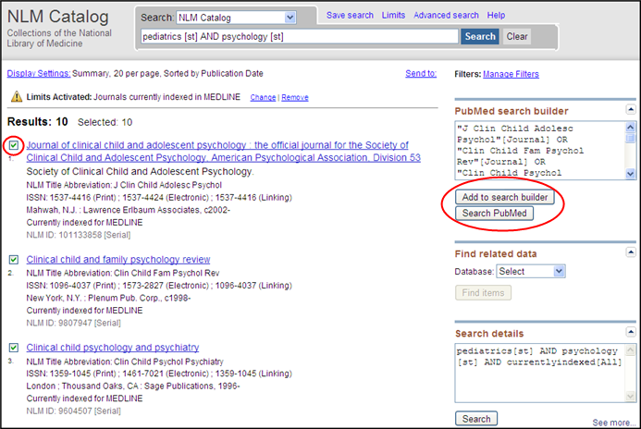
On the Summary display of results,
click in the checkbox to the left of desired journal title(s).

In the right column under PubMed search builder, choose Add to search builder .

Once finished building your search, click Search PubMed button.

Use Save Search and My NCBI to facilitate the task of limiting searches to a specific group of journals.

Using the Search Builder to Search by Field
There are several ways to search using a specific field (e.g., author, title, journal name). The Search Builder on the Advanced Search page is one convenient method.

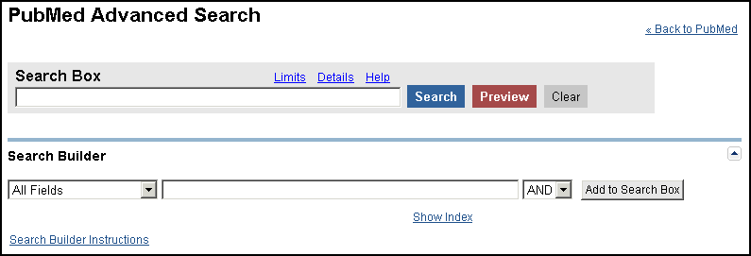
- Use to search for terms within selected fields
  - Use the pull-down menu to change the search field(s)
  - Select AND, OR or NOT
  - Click Add to Search Box
- Auto-complete feature available for Author, First Author, Last Author, and Journal
- Click Search Builder Instructions for help

Author and Journal Search Example:
Step 1:
Select Author from field selection.

Type the last name of author and select using the auto-complete feature.

Click Add to Search box.

Step 2:
Select Journal from field selection.

Type the journal title and select using the auto-complete feature.

Leave AND as the Boolean operator.

Click Add to Search Box.

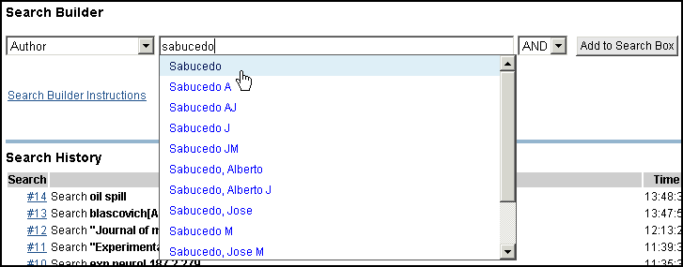
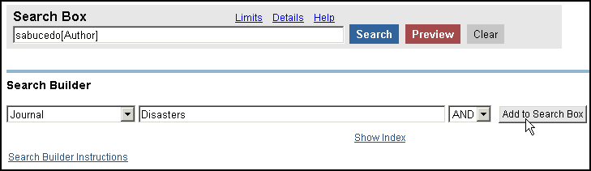

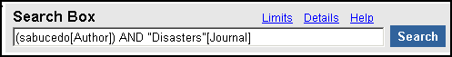
Step 3: When you’ve completed entering your terms, click the Search button.

Using the Index feature

- Click on the Show Index link below the Search Builder text box to display the index of searchable terms for the selected search field
- View and select terms from the Index to add them to your search strategy.
- Use the <ctrl> key (PC) or <Command> key (Mac) to select more than one term from one index to combine with OR.

Selecting a field and entering a term to look up in the Index

Example 1: Use the Index function on the Search Builder to find citations to articles about gene expression where the first author’s affiliation is listed as Princeton University.

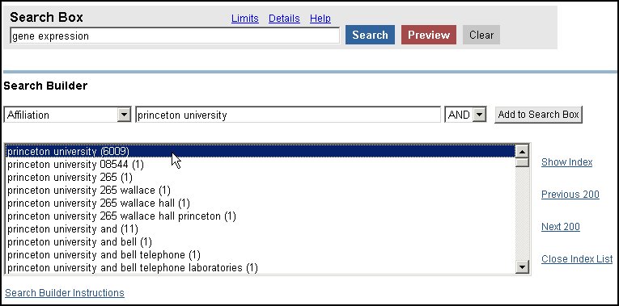
Subject term entered in the Advanced Search search box.

Select affiliation from the pull-down menu.

PubMed displays a portion of the alphabetical list of available terms for the selected search field.

- Scroll up and down this window using the scroll bar.
- The number of citations that contain the term appears in parentheses to the right of the term.
- To scroll up or down the entire Index for the field, click the Previous or Next links.
- Click on the term to highlight it.
- Click on the Close Index List link to collapse the Index display if desired.
- Continue selecting fields and adding search terms until your strategy is complete. Then click the Search button at the top of screen.

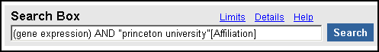
Search box shows the search term and the search field.

Example 2: Find articles where the major topic discussed is treating obesity hypoventilation syndrome with diet or drug therapy.

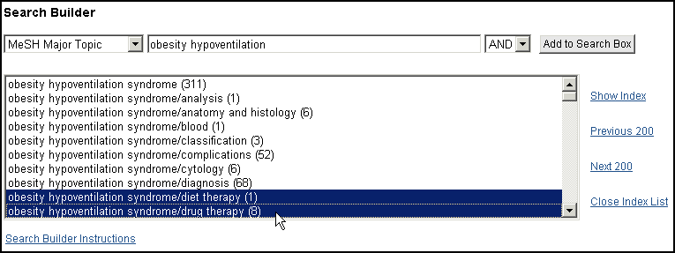

- Select Search field from drop-down menu.
- Type in search term(s)
- Click Show Index.
- Use the Ctrl-key (PC) or the Command-key (Mac) to OR together multiple terms.
- Select the desired Boolean connector to add terms (OR’ed together) to the query.
- Click Add to Search Box

See the next section for more on searching by fields using search field tags.
Using Search Tags -- Search Field Descriptions

- Search fields can be specified using PubMed’s search field tags. A list of the field names and searching information is found in PubMed Help: Search Field Descriptions and Tags (http://www.ncbi.nlm.nih.gov/books/bv.fcgi?rid=helppubmed.section.pubmedhelp.Search_Field_Descrip). Not all searchable fields are included in this workbook section.

- For further information on the data found in the fields found on the MEDLINE display format, see MEDLINE®/PubMed® Data Element (Field) Descriptions (http://www.nlm.nih.gov/bsd/mms/medlineelements.html)

Rules
- Each search term should be followed with the appropriate search field tag, which indicates which field will be searched. The search field tag must follow the term.
Correct entry: aromatherapy [mh]
Incorrect entry: [mh] aromatherapy
- Search field tags must be enclosed in square brackets.
- Case and spacing do not matter: ice [mh] = Ice[mh] = ICE [MH]
Terms entered with a search tag (e.g., [mh]; [majr]; [tw]) will not generate the “Did you mean” message (PubMed’s spell check feature).

MeSH headings [mh]

- MeSH headings can be searched using two search field tags:
[mh] to search a MeSH heading
[majr] to search a MeSH heading that is a major topic of an article

- PubMed automatically searches the MeSH heading as well as the more specific terms beneath that heading in the MeSH hierarchy; i.e., the term is exploded.

- To turn off automatic explosion of MeSH headings, use one of the following tags:
[mh:noexp] or [majr:noexp]

Example: thromboembolism [majr:noexp]
Alternatively, consider using the “Do not explode” selection from the Detailed Display in the MeSH Database.

Searching with MeSH headings will exclude in process and publisher-supplied citations, as they are not indexed with MeSH.

Subheadings [sh]

- You can directly attach subheadings to MeSH headings using the format MeSH heading/subheading.

- Two letter abbreviations for subheadings or the full subheading name may be used.

Examples: thromboembolism/pc
thromboembolism/prevention and control
toes/in [majr]
toes/injuries [majr]

- Only one subheading may be attached to a MeSH heading at a time. To attach multiple subheadings, combine each MeSH/subheading combination with the OR connector or use the MeSH Browser.

Example: thromboembolism/pc [majr] OR thromboembolism/di [majr]

- For a MeSH/subheading combination, PubMed always explodes the MeSH term and also searches the subheading and its grouping if there is one.

In the example below, the subheading therapy or members of the therapy grouping (e.g., diet therapy) will be attached to the MeSH term (hypertension) or one of its indentions (e.g., hypertension, malignant).

Example: hypertension/th

Hypertension with its indentions:
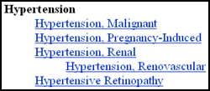

Subheading grouping for therapy:
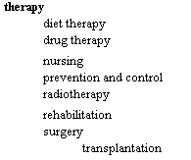

A list of subheadings and subheading groupings appears in PubMed’s Help.

To turn off both the MeSH heading explosion and subheading groupings, you would enter:
hypertension/th [mh:noexp]
hypertension/th [majr:noexp]

These search for only the subheading therapy attached to only the MeSH term hypertension (with “majr,” only as the main point).

- You may also choose to “free-float” a subheading with a MeSH heading using the Boolean AND and the subheading field tag of [sh]. This is typically done when you want to search for a subheading that cannot be applied to the MeSH heading you are also searching.

Example: hypertension [mh] AND toxicity [sh]

To turn off the subheading grouping, use the tag [sh:noexp]. You may only do this when “free-floating” a subheading.

Text Words [tw]

Terms or numbers that are searched with the Text Words [tw] field tag will be searched in the following fields:

- Title
- Abstract
- MeSH headings, Subheadings, Publication Types (includes single words and phrases)
- Other Terms field
- Chemical Names of Substances
- Secondary Source Identifier (The SI field identifies other data sources, databanks and accession numbers of molecular sequences discussed in MEDLINE articles.)
- Personal Name as Subject

Corporate Author [cn]

- Use the [cn] tag to search for corporate authorship of an article. Search the whole name or individual words from the name.

Examples: american dental association [cn]
american [cn] AND dental [cn] AND association [cn]
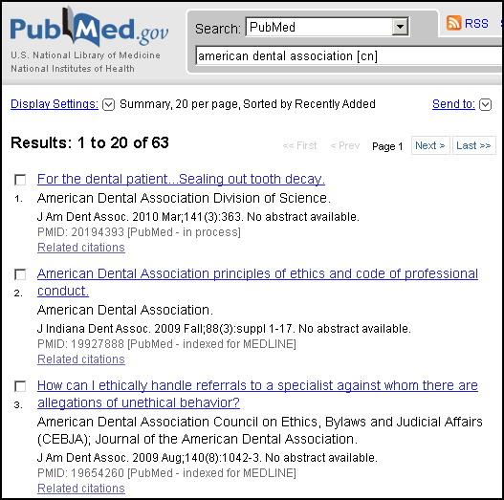

Example: american dental association [cn] OR
american dental association [ti]

Personal Name as Subject [ps]

- Use the [ps] tag to search for citations to articles about a named individual. The name is searched in the conventional author searching format: lastname + initial(s)

The Personal Name as Subject field is not available from the Search Builder on the Advanced Search screen.

Example: lincoln a [ps]

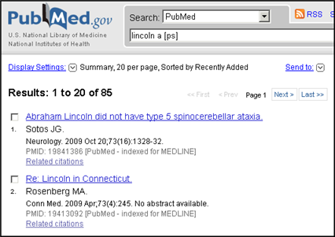

Date Ranging

- The colon (:) is used between ranging values.
- To search on Publication Date from 1993 to 1997, enter:

1993:1997 [dp]

- To search on a date, use the format YYYY/MM/DD

Use the Single Citation Matcher for a fill-in-the-blank Date searching option.

Place of Publication [pl]

- This field indicates the cited journal’s country of publication.
- Use the [pl] tag.

Example: aids AND nigeria [pl]

Geographic Place of Publication regions are not searchable. In order to retrieve records for all countries in a region (e.g., North America), it is necessary to OR together the countries of interest.

Secondary Source Identifier [si]

- Identifies a secondary source that supplies information, e.g., other data sources, databanks and accession numbers of molecular sequences

Examples of Data Sources:
GenBank
GEO (NLM’s Gene Expression Omnibus) – beginning in February 2006
ClinicalTrials.gov identifier numbers – beginning in July 2005
International Standard Randomised Controlled Trial Number (ISRCTN) – beginning in mid-2006)
Reference Sequence (RefSeq) collection accession numbers
PubChem databases identifiers – beginning in January 2007

- The field is composed of a source followed by a slash followed by an accession number.

- Use the [si] search tag.

Examples:

genbank/af113832 [si]
clinicaltrials.gov/nct00000419 [si]
clinicaltrials.gov [si]
clinicaltrials.gov [si]

Unique Identifier Searching [pmid]

- To search using the PubMed Unique Identifier (PMID), type in the number with or without the search field tag [pmid].

Example: 11073054

- You can search for several Unique Identifier numbers by entering each number in the search box separated by a space. PubMed will OR them together. Do not enter the OR connector.

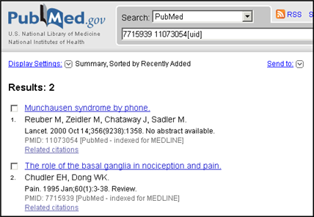
Example: 7715939 11073054

Unique Identifiers
as entered in the
search box.

PubMed finds the 2 citations.

To find the PubMed Central unique identifier (PMCID), see the MEDLINE or Abstract format for the record in PubMed, or use the PMID: PMCID Converter at http://www.ncbi.nlm.nih.gov/sites/pmctopmid

Affiliation [ad]

- May include the institutional affiliation and address (including e-mail address) of the first author of the article as it appears in the journal.
- Use the [ad] search tag.
- This field can be used to search for work done at specific institutions.
- The data is how it appears in the original journal article. It is not standardized, therefore the same institution may appear in variant forms.

Example: cleveland [ad] AND clinic [ad]

Grant Number [gr]
- Research grant numbers, contract numbers, or both that designates financial support by:
  - an agency of the US PHS (Public Health Service)
  - the Howard Hughes Medical Institute,
  - eight funding sources from the United Kingdom,
  - Canadian Institutes of Health Research,
  - Other funding organizations from the European Union.

- For Public Health Services agencies, the number is followed by the Institute acronym; followed by the agency’s hierarchical structure from lower to higher entity, when known; and then followed by the country name.

Examples: LM05545/LM/NLM NIH HHS/United States
CA47147/CA/NCI NIH HHS/United States

- For other funding organizations, the number is followed by the name of the organization; followed by the country name.

Examples: GR072308/Wellcome Trust/United Kingdom
066866/Wellcome Trust/United Kingdom
Howard Hughes Medical Institute/United States

- Use the [gr] search tag.

Example: lm05545/lm/nlm nih hhs/united states [gr]

The four pieces of the grant number (e.g., LM05545 – number; LM – acronym; NLM NIH HHS – parts of, or the entire string of the agency’s hierarchical structure; and funding country) are each individually searchable using the [gr] tag.

Examples: lm05545 [gr] wellcome trust [gr]
nlm [gr] united kingdom [gr]
PubMed’s online Help links to a Web page detailing Grant Number Information Found in the GR Field in MEDLINE/PubMed (http://www.nlm.nih.gov/bsd/grant_acronym.html).

Subsets

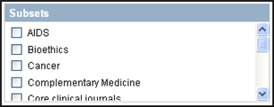
Allows you to limit your retrieval to topic, journal set, or other groupings of records:

- AIDS
- Bioethics
- Cancer
- Complementary Medicine
- Core clinical journals: 120 English-language journals from the formerly published Abridged Index Medicus
- Dental journals
- Dietary Supplements
- History of Medicine
- MEDLINE
- Nursing journals
- Systematic Reviews
- Toxicology
- Veterinary Science

  - Multiple selections are allowed (ORed together).

Each topic Subset uses its own specialized search strategy to aid in the retrieval of citations on these topics. You may view these strategies at http://www.nlm.nih.gov/bsd/pubmed_subsets.html.

Journal Subsets
Limiting to published journal indexes

The following values are available:
Core clinical journals | jsubsetaim
Dental journals | jsubsetd
Bioethics journals | jsubsete
Health administration journals, non-Index Medicus | jsubseth
Index Medicus journals | jsubsetim
Consumer health journals, non-Index Medicus | jsubsetk
Nursing journals | jsubsetn
History of medicine journals and selected citations from other journals | Jsubsetq
Citations from non-Index Medicus journals in the field of history of medicine | jsubsetqis
Citations from space life sciences journals and selected space life sciences citations from other journals | jsubsets
Health technology assessment journals, non-Index Medicus | jsubsett
AIDS/HIV journals (selected citations from other journals 1980 – 2000) | jsubsetx

Topic Specific Queries:

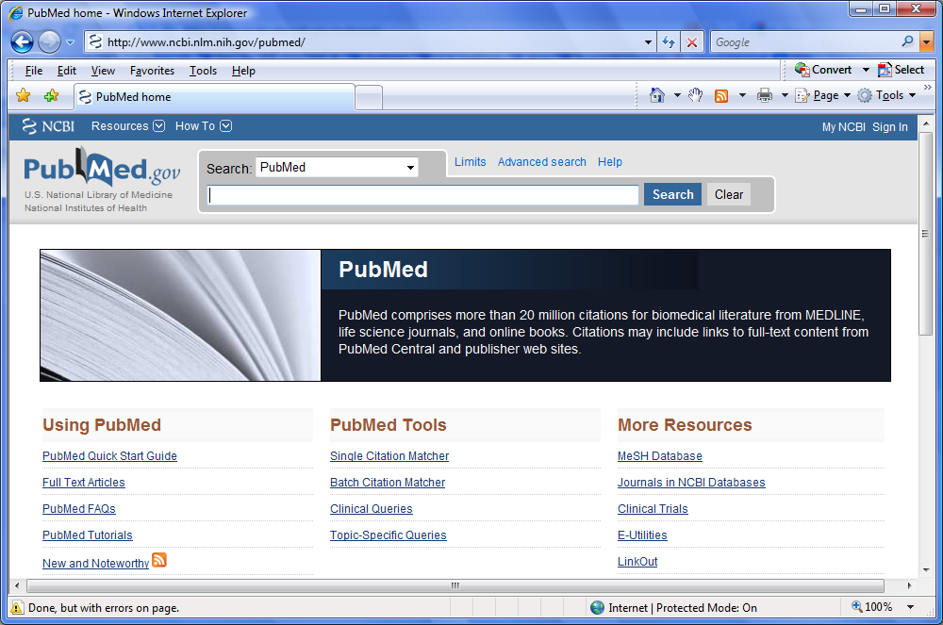

- Includes:

Queries Targeted for Clinicians and Health Services Researchers
  - Subjects
  - Additional Search Queries/Interfaces
  - Journal Collections
- Links to search parameters may be available.


My NCBI

Getting to My NCBI
- The NCBI banner will display links to My NCBI.
- The My NCBI link goes to the My NCBI home page.
- Sign In links to the Sign In page and to registration.

Registering for My NCBI
- To use My NCBI you need to register for an account or sign in through a partner organization.
- If you choose to include an e-mail address, you will receive a confirmation e-mail
(see page 109 for details).

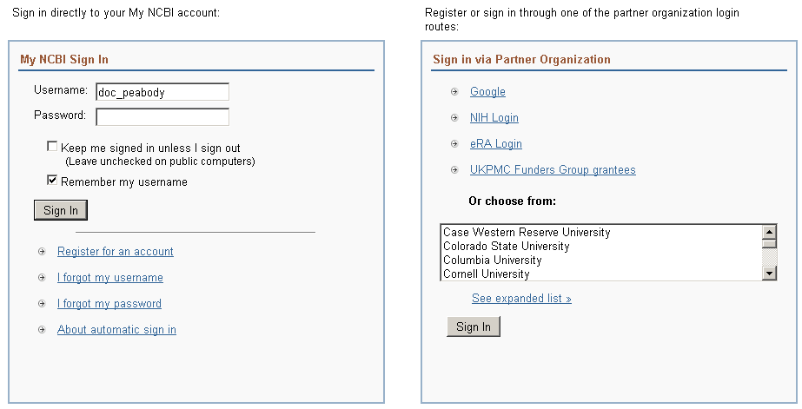
Sign In:

My NCBI Sign In
Sign in directly to your My NCBI account.

Check the “Keep me signed in” if you are using your own computer to access My NCBI.

Click About automatic sign in for more information.

Sign in via Partner Organization
Use your NIH, eRA Commons, Google or other credentials to register and sign into My NCBI. Click See expanded list for the full list of partner organizations.
Saving the Search

Saving Search Strategies with My NCBI

- Run your PubMed search.
- From the Results page, click on the Save Search link above the search box.

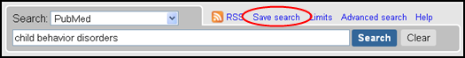

- PubMed will open a separate window in your browser to start the saving process. (If you are not already signed into My NCBI, you will be prompted to do so).

- Be aware that the default search name does not include any Boolean operators, search statement numbers or search tags, if entered. This name does not affect the strategy, so it is advisable to edit it to something short, yet meaningful.

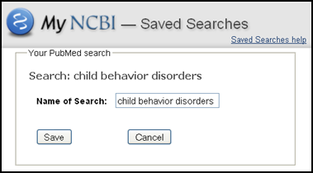
- You can edit the name of the search.

- This name will be part of the Subject line of automatic e-mail updates.

- Click Save.

Your search strategy is saved and the Saved Search Settings Window is displayed (see next page).

Setting Up Automatic Updating

Set up your updates using the Saved Search Settings page:

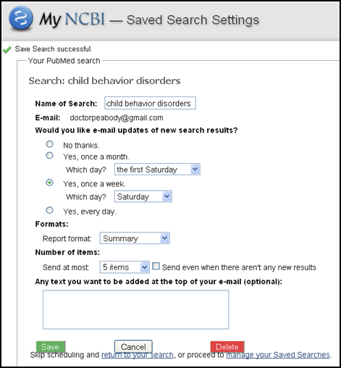

- Modify the name of the search, if desired.

- Enter an e-mail address for the account if you haven’t already.

- Select how often you want to get updates - monthly, weekly, or daily.

- Select the format (Summary, Abstract, etc.).

- Select the Number of items to be sent with each update. A link in the e-mail will take you to the total update results in PubMed.

- If you want to know when an update retrieved no citations, select Send even when there aren’t any new results.

- The text box is a place to add a note. This text will display on each e-mail update as “Sender’s message.”

- Click Save.

Partial e-mail update results:

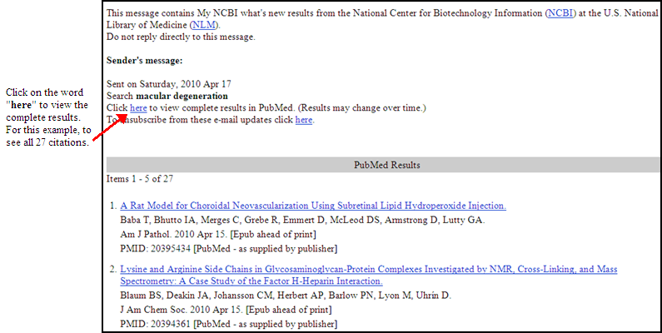

Important Facts about the E-mail for My NCBI Account
- Each My NCBI account can have only one e-mail address that will be used for all automatic e-mail updates saved in that account.
- To change the e-mail address on an account, go to NCBI Site Preferences on the My NCBI home page:

- If you change the e-mail address for your account, the new e-mail address will be used for all automatic updates following confirmation.
The address for PubMed’s Send to E-mail feature can be changed for individual e-mails on the Send to E-mail page without affecting the e-mail address used for the My NCBI account.

The Confirmation E-mail
- The first time an automatic e-mail update is created for an account, or if the e-mail is changed in User Preferences, a confirmation e-mail will be sent to that address.
- No automatic updates will be sent to an address until it has been confirmed.

Manually Updating Searches
- To manually update a search, go to your Saved Searches portlet in My NCBI. The number of new citations for each search is displayed in the “What’s New” column. Click the number to view the citations
- If you link to the results, i.e., complete the update, your saved search list will reflect the date and time of the update.

About the Updates
- The update strategies used for My NCBI are detailed in PubMed’s Help.
- New or modified searches can be generated no sooner than the next day. For example, this morning, you changed the frequency for an update from Monthly to Daily. The first update will be sent tomorrow.

Additional Functions available from the Saved Searches portlet

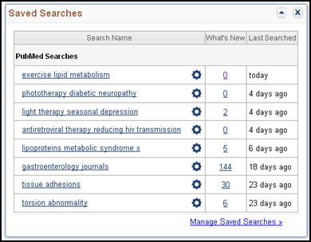

Click the search name to retrieve total results for the search in PubMed. This will not affect future updates.

Click the gear icon () to change your settings (your e-mail frequency and format) for your search.

Click the number in the What’s New column to view new results for your search since the Last Searched date.

Hold your cursor over the data in the Last Searched column to show the date the last e-mail update was sent or manually updated.

Click Manage Saved Searches to delete searches or run multiple searches manually.

Modifying a Strategy: Save a New One and Delete the Old

- Saved search strategies cannot be edited. To modify a strategy, re-save it with your changes.
- To delete a search, go to Manage Saved Searches. Select the search using the check box and click on Delete Selected Item(s).

Collections

- Use Collections to save search results within My NCBI.

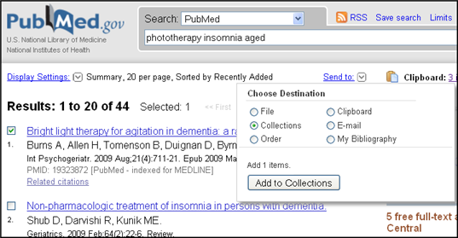
Create a Collection

Step 1: Select search result items you wish to save

Step 2: Choose Collections from the Send to menu.

Step 3: Click Add to Collections

If you are not already signed into My NCBI, you will be prompted to do so.

If you do not select items, all items (up to 5000) will be saved to the collection you are creating.
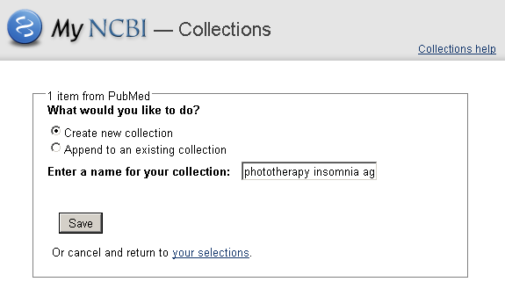

Step 4: Choose to create a new collection.

Rename your collection.

Click Save.

The maximum number of items in a collection was increased to 5,000 from 500. If you have saved any Collections prior to February 2009, then these will remain with 500 as the maximum number unless you recreate the Collection again.
Append to a collection

- Choose Append to an existing collection from the Save Collection pop-up window.
- Choose the collection to which you want to add items and click Save.
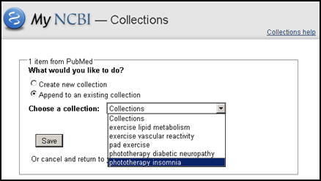

Accessing your collections

- Access My NCBI by clicking on My NCBI in the upper right of any PubMed page:
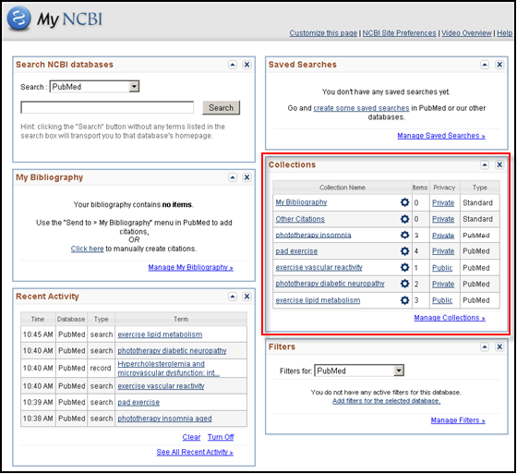

The Collections portlet appears by default on the right hand side.

Move portlets by clicking and dragging the title bar to the preferred location.

Hide portlets by using the up arrow ().
Collapse portlets using the X ().

Use the Customize this page link at the top of the page to select and deselect portlets.

Edit a collection
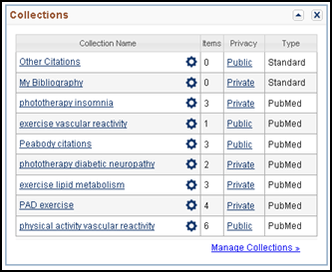
From the Collections portlet on the My NCBI home page you may:
- view the Collection in PubMed by clicking on the collection name,
- edit, change settings for or export a collection by selecting the gear icon (),
- change the collection to Public or Private, or
- merge or delete collections by selecting Manage Collections.

From the individual collection page you may:

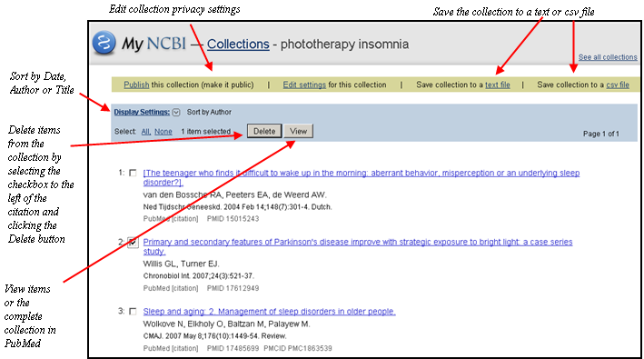

My Bibliography
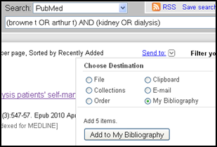
My Bibliography is designed to make it easier for authors to search and collect citations for their publications from PubMed. Citations not found in PubMed (other journal articles, books, presentations, etc.) may also be manually added.

Create Your Bibliography

- Select your works from your PubMed search results and click on Send to: My Bibliography
or

- In the My Bibliography portlet on the My NCBI home page, select Click here to manually create citations:
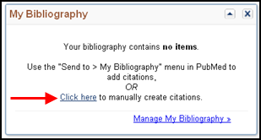

You are brought to the My Bibliography screen with a special Add citation Window open:

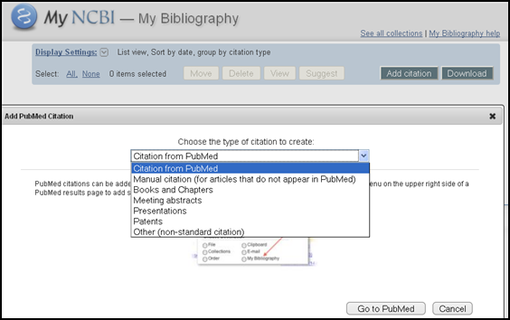

Select the type of citation you want to create.

A form will appear for you to enter your citation data.

You can add items to the bibliography by using the Send to: Menu on any PubMed results screen, or by returning to the My Bibliography portlet and clicking the number of items link or Manage My Bibliography:

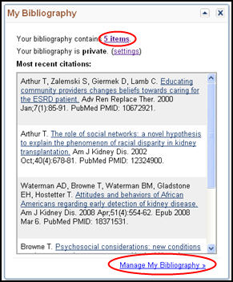

On the My Bibliography page, click the Add citation link.

Additional Functions available from the My Bibliography page

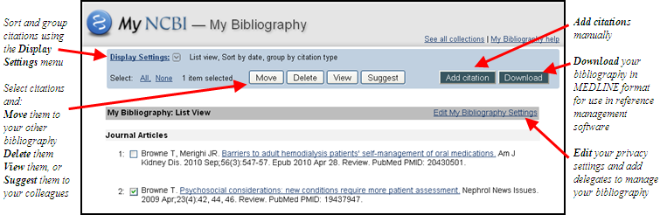

Additional Tools

Filters
- My NCBI includes a Filters feature which groups search results by areas of interest.
- Filters are available from the right hand column of your search results
- You can have up to fifteen active filters using My NCBI.

Default Filters
- “All” shows the total retrieval for the search. “Review” shows the total retrieval for review articles. “Free full text” shows those citations that link without charge to the full text.
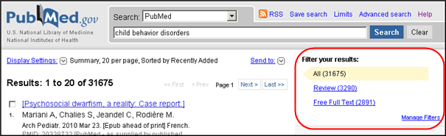

Adding Filters
- Use the Manage Filters link to the My PubMed Filters menu (you must sign in to My NCBI if not already signed in)
- This page displays the filters currently applied to PubMed, and provides links to the Frequently Requested Filters, and the Browse and Search options:

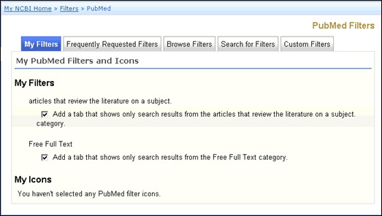

- Click on Frequently Requested Filters to add common filters to your display:

Click in the checkboxes to select or deselect filters.
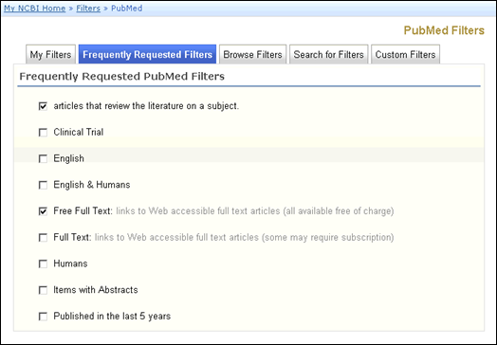

Browse
- Click on Browse to see additional options for PubMed filters.
- On the Browse page there are three categories:
- LinkOut
- Links
- Properties
- Users interested in subject-related filters for their searches should look at Properties.

There are over 70 filter options under Properties.
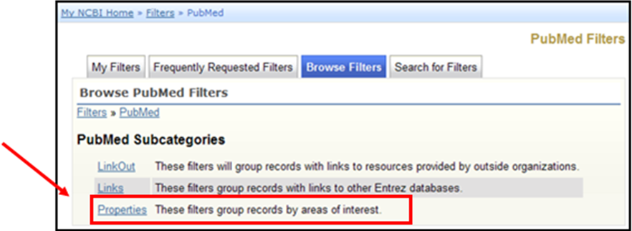

Under Properties, use the links to see the available filters for each sub-category. Here’s the one for Publication Types:

Click in the checkbox to select the filter.

A confirmation message will display. 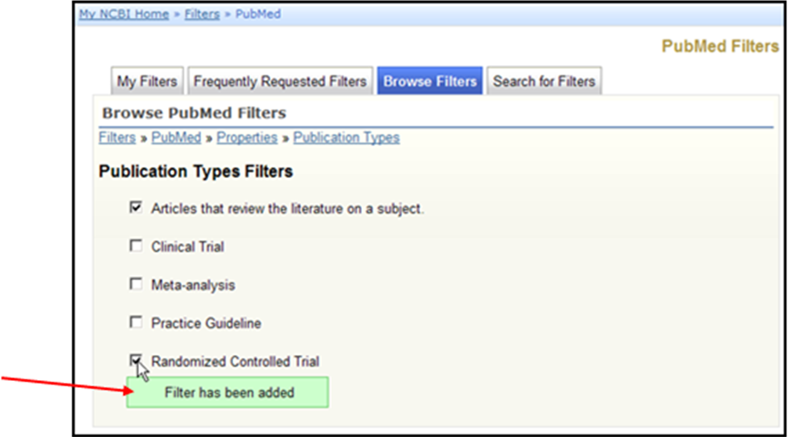

LinkOut Filters
- Filters in this category group results by full text providers, libraries, and other outside resources.

Adding your library’s holdings as a filter

- From the PubMed “Browse” filters page:

Click on LinkOut

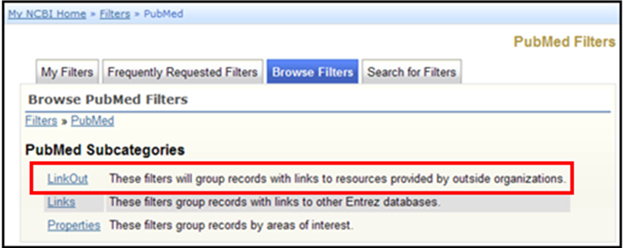

Click on Libraries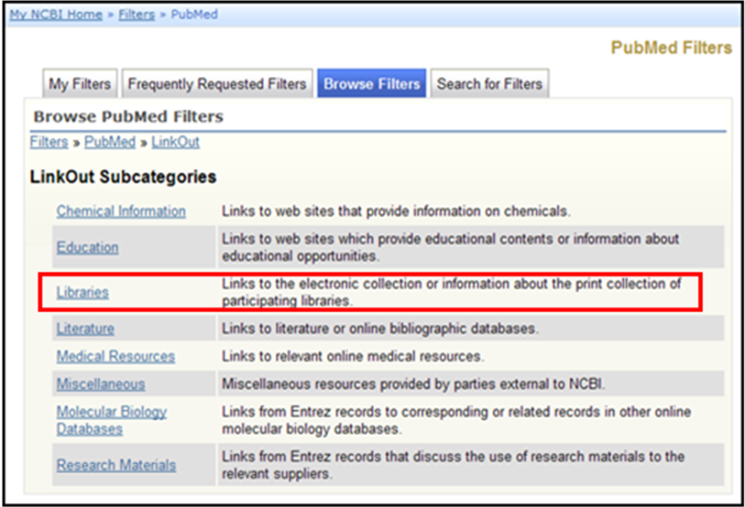

This will bring up a page with all of the LinkOut-participating libraries.
- Use your browser’s Find feature to locate your library.
- Click on the desired library link.
- Then click on the checkboxes to add a result tab and/or display the library’s icon:

Notice the use of “breadcumbs” on the Filters pages.

Each breadcrumb for a higher level is a link to that page.

Click in the checkboxes to add these selections.

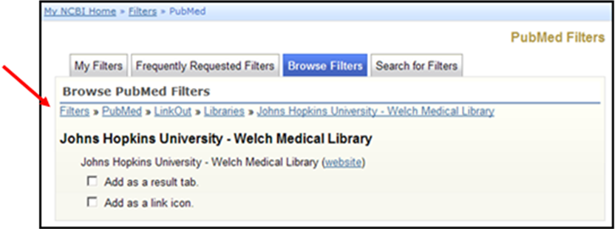

- Filter links for LinkOut providers display the LinkOut user name.
- Place your cursor over this ID to see the name of the provider.
- Users who connect to PubMed with a URL that includes a library's holdings parameter will continue to see their library icon even if they do not select their library in My NCBI. Users should select their library filter if they want to see a filter link for their library in the search results.

Using the Filter Links

- Click on a filter name to go to the citations for a particular filter. Select any display format you wish.
- When you click on the filter name to see the results for a filter, a (+) symbol will appear in the menu:

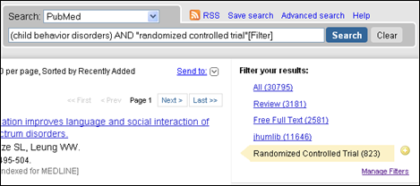

Clicking on the + icon adds that filter to the search box.

- Filters added using the (+) icon will display in the search box with the [Filter] tag.
- If you want to save this search, click on Save Search.
- Many filter topics can be added to the search via the Limits page. Either way will yield the same results.

My NCBI User Preferences

- Available from My NCBI sidebar.
- In effect when you are signed in to My NCBI.

Common Preferences (for all NCBI databases):
- Save an e-mail address for e-mail updates.
- Highlight search words in retrieval.

PubMed Preferences:
- Open the supplemental data in the Abstract display by default.
- Set your document delivery and/or Outside Tool preferences.
- Turn off the Auto Suggest feature, which displays suggested searches as you type in the PubMed search box.
- Select your default result display settings (format, number per page and sort order).
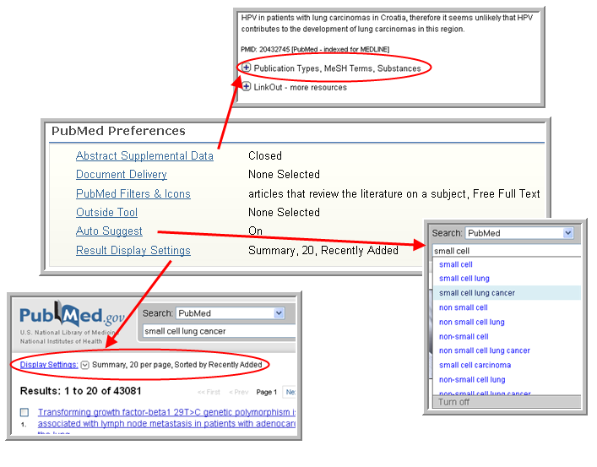
See demos on various My NCBI features. Click on PubMed Tutorials under More Resources from the PubMed homepage or go directly to: http://www.nlm.nih.gov/bsd/disted/pubmed.html

