

**T**

**H**

**U**

**R**

**M**

**A**

**N**

**S**

**E**

**N**

**D**

**S**

**#**

**5**

12 January 2012

**Hazing, Bullying, and Maltreatment**

1. Commanders and Leaders; you are likely aware that the Army is investigating several allegations of hazing within its ranks that recently occurred in Afghanistan. These incidents appear to be isolated and are not indicative of a broader problem. However, I want to reiterate to you that any form of hazing, bullying, or maltreatment of a Soldier, Sailor, Airman, or Marine is unacceptable and directly countermands my command philosophy.

2. Hazing and bullying involves conduct where one person causes another person to suffer or be exposed to an action that is cruel, abusive, oppressive, or harmful. Hazing and bullying can include physical assaults, forced consumption of alcohol/food, abusive verbal taunts, or forcing someone to engage in demeaning, embarrassing, or dangerous acts. All these actions are inexcusable and can be punished under the Uniform Code of Military Justice.

3. Commanders and Leaders; you will ensure that all subordinates are treated with respect, fairness, and dignity and that you inform your subordinates that all forms of hazing or bullying are unacceptable. Every leader is expected to set the standard for leadership by living our military core values and is accountable for the health and performance of his or her subordinates. Every leader is expected to foster a culture of accountability where swift, decisive, and appropriate action is taken when any form of hazing or bullying is witnessed or discovered.

4. I want to be clear on this: In my organization it is 100% unacceptable for any military personnel to engage in hazing or bullying or to stand by and do nothing when he or she has knowledge of hazing, bullying, or any behavior that runs contrary to our military core values. We all joined the military because we believe in living our lives in accordance with a higher moral standard. Honor, Respect, Discipline. These are not just empty words, they are words that we must live by every day, on or off-duty.

5. Thank you for your attention to this subject, I know you will continue to strive to do what is right each and every day.

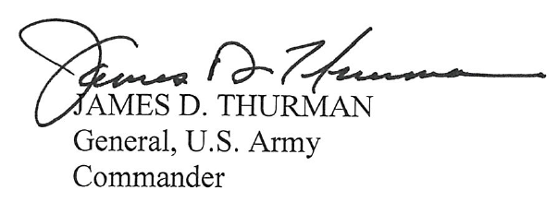

## FREEDOM’S FRONTIER!