 |  | Advisory Circular
U.S. Department  of Transportation  Federal Aviation  Administration |  | Advisory Circular

Subject: FIRST RESPONDERS’ RESPONSIBILITY FOR PROTECTING EVIDENCE AT THE SCENE OF AN AIRCRAFT ACCIDENT/INCIDENT | Date: 9/28/2009  Initiated by: AAS-300 | AC No.: 150/5200-12C  Change:
- PURPOSE. This advisory circular (AC) furnishes general guidance for airport employees, airport management, and other personnel responsible for aircraft rescue and firefighting (ARFF) operations at the scene of an aircraft accident on the proper preservation of evidence. It explains the need for preservation of evidence and details operational actions which may be permitted if performed in the interest of preserving life.
- CANCELLATION. AC 150/5200-12B, Fire Department Responsibility in Protecting Evidence at the Scene of an Aircraft Accident, dated September 3, 1999, is cancelled.
- APPLICATION. The material contained in this AC is applicable for use on all civil airports. The Federal Aviation Administration (FAA) recommends the guidance and specifications in this Advisory Circular be used by First Responders responsible for protecting evidence at the scene of an aircraft accident/incident. In general, use of this AC is not mandatory. However, use of this AC is mandatory for all projects funded with federal grant monies through the Airport Improvement Program (AIP) and with revenue from the Passenger Facility Charges (PFC) Program. See Grant Assistance No. 34, Policies, Standards, and Specifications, and PFC Assurances No.9, Standards and Specifications.
- PRINCIPLE CHANGES.
  - Title change: replaced Fire Department with First Responders.
  - Section 4: added new Related Reading Material.
  - Section 6: added figures showing representative Flight Data Recorders and Cockpit Voice Recorders.
- RELATED READING MATERIAL.
  - International Civil Aviation Organization (ICAO), Annex 13.
  - International Fire Service Training Association (IFSTA), Aircraft Rescue and Fire Fighting, Fifth Edition CHAPTER 10.
  - National Fire Equipment System (NFES) 2659, Interagency Aviation Mishap Response Guide and Checklist.
  - International Fire Service Training Association ARFF Fifth Edition, Chapter 4, Personnel Decontamination.
  - Internationl Fire Service Training Association ARFF Chapter 11, Str Tac Operations.
  - National Fire Protection Association (NFPA) 424, Guide for Airport/Community Emergency Planning.
  - National Fire Protection Association 472, Standard for Competencies of Responders to Hazardous Material and WMD Incidents.
  - National Fire Protection Association 473, Standards for Competencies for EMS Personnel Responding to Hazardous Materials Incidents and WMD Incidents.
  - National Fire Protection Association 1003, Standard for Airport Firefighter Professional Qualifications 2005, Chapter 6, Airport Firefighter.
  - National Transportation Safety Board Regulation, Title 49 CFR, Part 830, Paragraph 830.10(b).
  - National Transportation Safety Board (NTSB) brochure, Responding to an Aircraft Accident, How to Support the NTSB, A Guide for Police and Public Safety Personnel.
  - U.S. Air Force Fire Emergency Service Technical Order 00-105E-9, Aerospace Emergency Rescue and Mishap Repsonse Information.
- GENERAL.
Today, investigators are increasingly suspicious of acts of sabotage, willful or egregious reckless conduct, intentional and specific acts of terrorism.
The cause of an aircraft accident has often been determined from a detailed analysis of the wreckage including the actual location of the wreckage and where the remains from the wreckage fell. Therefore, it is essential that wreckage be protected during rescue operations. This is not to imply that during fire fighter operations wreckage may not be disturbed; it should be kept to a minimum.
NTSB Regulation, Title 49 CFR, Part 830, §830.10(b) pertaining to the preservation of aircraft wreckage allows for the removal of aircraft components to the extent necessary to:
- Remove persons injured or trapped;
- Protect the aircraft from futher damage; or
- Protect the public from injury.
It further states that, at §830.10(c):
“Where it is necessary to disturb or move aircraft wreckage, mail or cargo, sketches, descriptive notes, and photographs shall be made, if possible, of the original position and condition of the wreckage and any significant impact marks.”
Fire fighting operations should not be delayed in order to prepare such sketches or photographs. Firefighters or rescue personnel should attempt to remember the original location of anything that was moved during fire fighting and rescue operations.
As soon as practical, all personnel should document in writing all of their actions and activities during their involvement in the accident/incident. All documentation should be made available to appropriate investigative agencies.
Typical activities of first responders and authorities at an accident scene include the following:
  - Setting up security to limit access to the wreckage area other than first responders and law enforcement authorities.
  - After the fire(s) has been extinguished all personnel inside the secured area should be cautioned to keep their activities around the wreckage to a minimum to prevent unnecessary disturbance and eradication of valuable evidence, such as ground scars.
  - During operations at an accident/incident potentially caused by an intentional act, limiting the activities will also reduce the risk of disturbing any unexploded or secondary devices.
- OPERATIONS.
  - Saving of aircraft occupants’ lives is the primary objective. All other considerations, such as preservation of wreckage, must be secondary to rescue operations. Therefore, fire fighters in the performance of their primary mission of rescue through fire control or extinguishment should not be hampered or restrained by restrictions governing the preservation of evidence. However, during the final stages of salvage and overhaul, care should be taken to avoid unduly disturbing any evidence that may aid in determining the cause of the aircraft accident. Careful preservation of cockpit instruments, controls, areas of primary structural failure or damage, etc., in their original position is important. Any changes made in after-action documentation should be noted.
  - To assure complete fire extinguishment and accountability of all persons, firefighters make a thorough examination of the aircraft cabin and storage compartments. During salvage and overhaul operations documentation of any items is essential for preservation of evidence for follow-on investigations.
  - Airport fire and security departments should establish procedures whereby:
    - Photographic coverage of the accident scene must be accomplished. This may require a camera be made available by the airport operator.
    - Security of the accident scene is the responsibility of the airport operator until it is released to appropriate agency custody.
    - When Cockpit Voice Recorders (CVRs) and Flight Data Recorders (FDRs) are located, they need to be protected. They are of vital importance to accident/incident investigations. If attached to the aircraft, their location should be carefully noted but not disturbed. If attached to the aircraft, they should not be removed except to preserve them from any further damage. As a general rule, the voice and flight data recorders are located in the rear of the fuselage. Once located and secured, the recorders must not be tampered with or opened.
      - Firefighters should be trained in the identification of FDRs and CVRs. FDRs and CVRs need to be located and protected.
      - There are several types of FDRs. They are International Orange in color and measure approximately 5 x 8 x 21 inches. They have a “pinger” to facilitate under water location. See Figure 1.
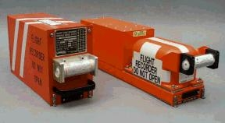
Figure 1. Representative Flight Data Recorders

      - There are several types of CVRs. They are International Orange in color and measure approximately 5 x 8 x 13 inches. See Figure 2.
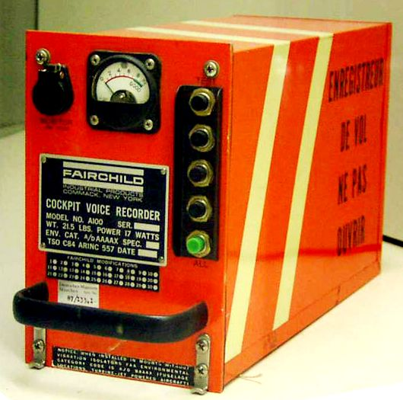
Figure 2. Representative Cockpit Voice Recorder
  - Airport management should ensure that all first responders are thoroughly familiar with the relevant reference material, such as the Airport Certification manual and 14 CFR, Part 139. In addition, the principles in this AC should be reflected in departmental operating instructions and included in fire fighters personnel training programs, and the Emergency Plan elements of the Airport Certification Manual.


Michael J. O’Donnell
Director of Airport Safety and Standards

This page intentionally left blank.

