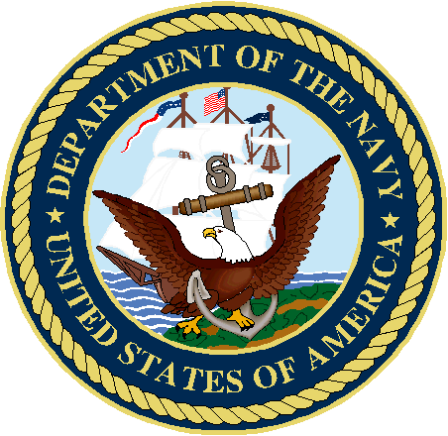
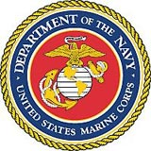

Mentor-Protégé Program
Procedure Manual



Revised December 2008
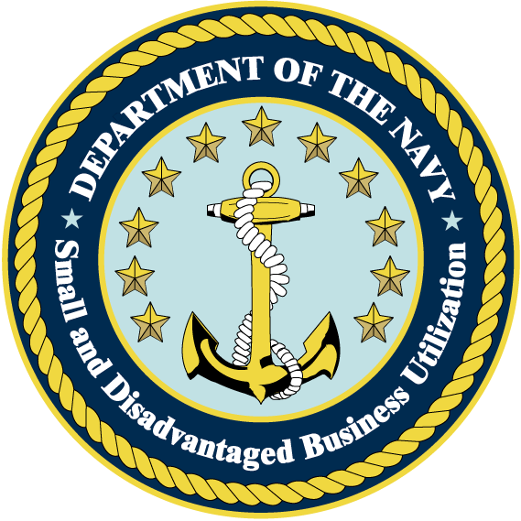
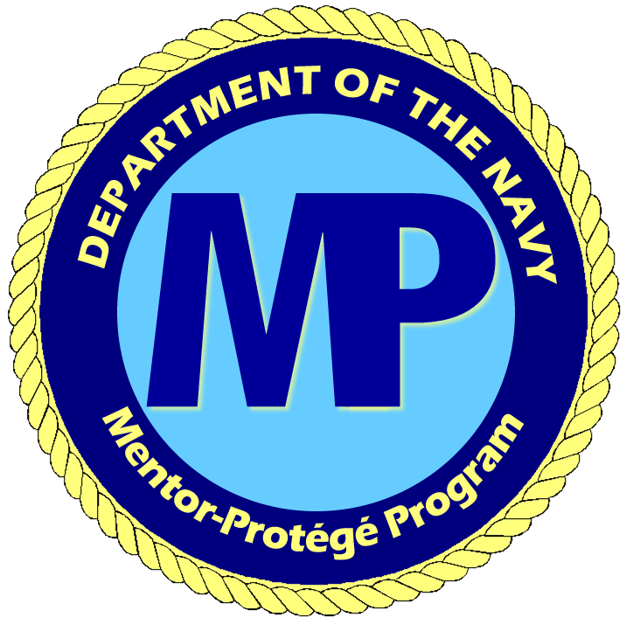
TABLE OF CONTENTS
1. Purpose 2
2. Background 2
3. Responsibilities 3
4. Eligibility to Participate 3
5. General Procedures 4
6. Evaluation Process for Mentor-Protégé Agreements 8
7. Procedures for Processing New Agreements 9
8. Procedures for Annual Funding 10
9. Procedures for Processing Agreement Extensions/Realignment of Milestones 10
10. Procedures for Cancellation/Termination of Agreements 11
11. Reporting and Reviews 11

APPENDICES
APPENDIX - A A-1
NAVY MENTOR-PROTÉGÉ NEW AGREEMENT CHECKLIST A-1
APPENDIX - B B-1
AGREEMENT INFORMATION SHEET B-1
APPENDIX - C C-1
NAVY MENTOR-PROTÉGÉ INCREMENTAL FUNDING CHECKLIST C-1
APPENDIX - D D-1
NAVY MONTHLY EXPENDITURE REPORT TEMPLATE D-1

Department of the Navy’s
Mentor-Protégé Program Procedures

Purpose

The procedures contained in this manual are for guidance in developing, submitting, processing, and administering the Department of the Navy’s (DoN) reimbursable Mentor-Protégé agreements in accordance with Defense Federal Acquisition Regulation Supplement (DFARS) 219.71 and DFARS Appendix I. These procedures cover new agreements, incremental funding of agreements, extensions/realignment of milestones of current agreements, and reporting requirements.

Credit agreements allow a mentor to receive credit toward subcontracting goals for costs incurred, see DFARS Appendix I-110. Mentors interested in initiating credit agreements should contact Defense Contract Management Agency (DCMA) Office of Small and Disadvantaged Business Utilization Office (SADBU) directly as all credit agreements are sponsored by DCMA SADBU. For the DCMA homepage, go to http://www.dcma.mil. The Point of Contact (POC) for credit Mentor-Protégé agreements is:

Mentor-Protégé Division
Ms. Elaine Howell, Division Chief
DCMA Small Business Operation Center
2300 Lake Park Drive, Suite 240
Smyrna, GA 30080
Phone: (800) 932-3561 Email: elaine.howell@dcma.mil

Background

The Department of Defense (DoD) Pilot Mentor-Protégé Program was established under Section 831 of Public Law 101-510, the National Defense Authorization Act for Fiscal Year 1991 (10 U.S.C. 2302 note). The purpose of the Program is to provide incentives for DoD contractors to assist small businesses, as defined in DFARS 219.71, in enhancing their capabilities and to increase participation of such firms in Government and Commercial contracts.

Mentors receive compensation for their costs associated with Mentor-Protégé agreements in the form of credit or direct reimbursement. A reimbursable agreement provides monetary reimbursement only for the cost of developmental assistance incurred by the mentor firm and provided to a protégé firm in accordance with the approved agreement.

For more information about the DoD Mentor-Protégé Program, visit their home page at http://www.acq.osd.mil/osbp/mentor_protege/index.htm

Responsibilities

- The Head Contracting Activity (HCA) Small Business Office is responsible for the overall administration and management of their Mentor-Protégé Program. The HCA Small Business Office will coordinate with other departments within the activity to ensure the requirements of DFARS 219.7103 and DFARS Appendix I are met, and coordinated with the Office of the Secretary of the Navy; Office of Small Business Programs (OSBP)

- The contracting officer’s responsibilities are detailed at DFARS 219.7103-2. These responsibilities include adding Mentor-Protégé agreements to existing contracts by contract modification, issuing modifications for funding, extensions, and deobligation of unused funds, and other responsibilities identified in sections 5(c) and 7(h) of this Procedure Manual.

- Program Managers are responsible for sponsoring Mentor-Protégé agreements. An endorsement letter acknowledging the agreement is to be added to an existing contract, under their program cognizance, which will acknowledge sponsorship.

- In accordance with Appendix I-113, the DCMA will conduct annual performance reviews of the progress and accomplishments realized under approved Mentor-Protégé agreements.

Eligibility to Participate

Both the mentor and the protégé must meet the established eligibility requirements to participate in the program. These requirements are provided at DFARS 219.7102 http://www.acq.osd.mil/osbp/mentor_protege/participate/dfars21971.htm and DFARS Appendix I http://farsite.hill.af.mil/reghtml/regs/far2afmcfars/fardfars/dfars/dfarsapxI.htm

- The Mentor. Prior to participation, mentor firms must complete and submit a mentor application to either the DoD OSBP Director or the OSN OSBP Director for approval as a mentor firm under the Program.

Agreements should be structured only after completion of a Needs Assessment of the Protégé in accordance with DFARS Appendix I-106 (b). Prior to the OSN OSBP Director approving the Mentor-Protégé agreement, the Navy Mentor-Protégé Program Manager may elect to have an outside firm perform an on-site needs assessment at the Protégé’s facility. The results of the needs assessment will be compared to the one completed by the Mentor.

The mentor is required to obtain sponsorship of the agreement from the cognizant program office after coordination with the cognizant Small Business Office. The Mentor Application and Mentor-Protégé agreement templates may be accessed electronically from the DoD Mentor-Protégé website at http://www.acq.osd.mil/osbp/mentor_protege/downloads/index.htm
- The Protégé. Prior to processing a Mentor-Protégé agreement, the mentor and sponsoring activity must ensure the protégé is eligible to participate as a protégé. To be eligible to participate, the protégé must meet one of the eligibility requirements as defined in DFARS 219.7102 (b) and DFARS Appendix I-102 (b) and maintain that status for the life of the agreement. If the protégé self-certifies that it meets the eligibility requirements, a separate written self-certification of their small business status must be provided with the Mentor-Protégé agreement. (Note: If the SBA SDB certification expires prior to the end of the agreement period, the agreement and contract modification may still be written for the entire agreement period with conditions stating funding is subject to the protégé’s SDB recertification.

General Procedures

- The mentor is solely responsible for selecting a protégé that they believe will result in a successful relationship. Mentors shall consider the following when selecting a protégé:

  - A previous, established relationship must exist between the mentor and protégé,
  - Protégé’s geographic proximity to the mentor,
  - How the assistance aligns with the protégé strategic vision,
  - Protégé’s attitude regarding being mentored,
  - Commitment to the relationship by both parties,
  - Capabilities of the protégé and how they interface with the mentor,
  - Stability of the protégé’s management and financial status,
  - Protégé’s past performance,
  - Results of any contract/subcontract work between the mentor and protégé, and
  - Subcontracting expectations.

- A mentor may have several DoD mentor-protégé relationships; however, a protégé may have only one DoD mentor at any given time. A separate Mentor-Protégé agreement must be submitted for each Mentor-Protégé relationship.

- Mentor-Protégé agreements are formalized contractually by adding a separately priced cost reimbursable contract line item number (CLIN) to an existing Navy contract for the developmental assistance cost approved by the OSN OSBP Director. Generally, the mentor identifies one of their existing DoN prime contracts and conducts discussions with the cognizant Small Business Office, Program Manager, and Contracting Officer about developing the Mentor-Protégé Agreement. Guidance for selection of the appropriate contractual vehicle includes:

- Mentor-Protégé agreement must be added:
- as a no fee line item to an existing contractual instrument or
- as a task order to a negotiated Indefinite Delivery type contract (not Blanket Purchase Agreement (BPA) or Basic Ordering Agreement (BOA))

- Agreements may be added to a contractual instrument that does not have adequate period of performance remaining to cover the entire period of the Mentor-Protégé agreement. In this case, it is permissible for the contracting officer to move the Mentor-Protégé agreement to another contractual instrument so that the expired contract file may be closed. Such action must be coordinated with the cognizant Small Business Office and Program Office.

- Agreements cannot exceed three (3) years from the date of the issuance of the task order or contract modification that incorporated the approved Mentor-Protégé agreement as a separate cost reimbursable line item on a DoN prime contract.

- It is strongly recommended that the proposed agreement period be established for 60 – 90 days less than a full 3-year period to allow for an extension in the event the milestones cited in the agreement are not met.

- Agreements cannot exceed the protégé’s SDB certification period. If a protégé’s certification expires prior to the end of the agreement period, the mentor may submit the cost proposal for the entire period; however, the contracting officer must include a condition in the contract stating that any cost extension of the agreement or annual funding is subject to the protégé’s SDB recertification by SBA.

- Based upon processing and approval cycles required, soft dates such as “30 days after contract modification” should be utilized throughout the agreement.

- As cited in DFARS 219.7103-2 (f) and DFARS Appendix I-109 (d), the total amount that may be reimbursed to a mentor per year may not exceed $1,000,000. The amounts listed in the Proposal Amounts and Not-To-Exceed Amounts columns below are considered “customary” for the Navy Mentor-Protégé Program.

 | Proposal Amounts | Not-To-Exceed Amounts
Non-Manufacturing Per Year | $175K - $250K | $500K
Non-Manufacturing Per Agreement | $750K | $1.5M
Manufacturing Per Year | $750K | $950K
Manufacturing Per Agreement | $2.25M | $2.85M

Non-Manufacturing agreements are agreements where a hardware end product is not produced or delivered by the Protégé.

Manufacturing agreements are agreements where a hardware end product is produced or delivered by the Protégé.

- All Navy Mentor-Protégé agreements must contain the following four sections with each one separately identified:

- The Mentor-Protégé agreement as defined in DFARS Appendix I, Section I-107

(a) All elements of Section I-107 (b) MUST be addressed separately.

- A separate statement citing the benefits of this agreement and/or the Return On Investment of this agreement to the DoN and/or DoD must be submitted on a separate page, which is clearly identified.

- A technical proposal that details the developmental program described in the Mentor-Protégé agreement DFARS Appendix I, Section I-107 (f).

  - The technical proposal should be constructed so it easily tracks to the cost proposal. The hours associated with each task described in the technical proposal should be visible in the cost proposal. A very strong technical proposal is imperative. Hours and dollar values associated with technology transfer should be approximately 70% of the proposed hours and cost. The remaining 30% may be related to business development tasks. Technology transfer is the most important element of the proposed agreement and will be used as an evaluation criteria in accordance with section (6) (d) of this manual, entitled Evaluation Process for Mentor-Protégé Agreements.

Examples of technology transfer and business development include, but are not limited to:

Technology Transfer:
Accounting Systems, ISO Certifications, Software Certifications, Office Automation, Program Management associated with technology transfer, Manufacturing Processes, and Quality Process Improvements

Business Development:
Marketing, processes related to Human Resources, and Company Policies and Procedures and Administration

  - For additional examples, see Section 12 of the DoD Mentor-Protégé agreement template for examples of technical and business development assistance at http://www.acq.osd.mil/osbp/mentor_protege/downloads/AgreeAppTempFY08.pdf

  - The technical proposal shall include: a milestone chart (with soft dates) to track the proposed technical assistance. Metrics shall also be included to measure progress and completion of each of the major developmental tasks.

- A detailed cost proposal of the technical proposal presented in 12-month increments as cited in DFARS Appendix I, Section I-108 (a) (4). Cost proposals must comply with the following:

    - The cost proposal shall be constructed with a base year and priced options for any additional years of effort proposed, not to exceed 3 years in accordance with section 5(c)(4) of this manual.

    - A separate cost summary page broken out in 12-month periods.

    - Labor/salary reimbursement must be for employees on the mentor’s payroll only. Protégé salaries and consultant costs are unallowable.

  - Do not include any type of fee or profit.

  - Incidental costs or other direct costs (ODCs) cannot exceed 10% of the total cost of the proposal. Incidental costs include all costs other than direct labor, overhead, and general and administrative (G&A) costs associated with direct labor. Examples of incidental costs include travel, training, equipment and software, etc. To calculate the 10%: divide the incidental costs into the total proposal costs (total proposal cost includes labor, overhead, G&A, and incidental costs).

- No capital equipment is allowed to be purchased under this Mentor-Protégé agreement. Any equipment that would normally be depreciated will be considered as capital equipment.

  - Tasks to be completed by Historically Black Colleges or Universities or Minority Institutions (HBCUs/MIs), Procurement Technical Assistance Centers (PTACs), or Small Business Development Centers (SBDCs) are allowable and are not included in incidental costs. The use of these resources for training is strongly encouraged. The total HBCU/MIs, PTACs, or SBDCs cost should not exceed 30% of the total cost of the proposal.

Websites:

HBCUs: http://www.acq.osd.mil/sadbu/programs/hbcumi/Home.htm
PTACs: http://www.aptac-us.org/new/
SBDCs: http://sbdcnet.utsa.edu/

  - The percentages for incidental costs and HBCU/MIs, PTACs, or SBDCs are to be clearly displayed per year as well as the total for all years.

  - The only protégé expenses to be reimbursed by the government are for travel expenses relating to training, not marketing.

  - All proposed costs must track to each developmental assistance category proposed in the technical proposal.

Evaluation Process for Mentor-Protégé Agreements

- Proposed Mentor-Protégé agreements should first be forwarded by the mentor to the cognizant HCA Small Business Office for review and endorsement. Although mentors should anticipate this initial review to take approximately 30-45 days, be sure to check with the cognizant HCA Small Business Office for their deadlines. The HCA Small Business Office should forward endorsed Mentor-Protégé agreements for evaluation to the Navy Mentor-Protégé Program Manager by close of business on the following cut off dates:

August 30th
November 30th
February 28th
May 31st

Proposed Mentor-Protégé agreements submitted late will be held for evaluation at the next cut off date. It is anticipated that up to one-fourth of the DoN Mentor-Protégé Program funding available for a fiscal year will be allocated for the highest rated new agreements received at each cut off date.

- Proposed Mentor-Protégé agreements will be evaluated and forwarded to the OSN OSBP Director for approval and funding or rejected within 60 days after the above cut off dates. Notification of rejection will be sent to the mentor and the cognizant HCA Small Business Office.

- Unsuccessful agreements may be revised and resubmitted a maximum of two times.

- Proposed agreements will be evaluated based on the following criteria in descending order of importance:

- Merit of the technology transfer to the protégé firm;
- Perceived benefit/value of the agreement to Navy and/or DoD;
- Percentage of hours associated with technology transfer;
- Subcontracting opportunities available to the protégé;
- Utilization of HBCUs/MIs, PTACs, SBDCs; and
- Proposed cost.

- A panel of DoN small business specialists and other acquisition personnel will evaluate the proposed agreements.

Procedures for Processing New Agreements

    - Ensure that the Mentor is an approved DoD Mentor prior to proposal submission.

    - Mentor has completed a preliminary assessment of the developmental needs of the protégé firm in accordance with DFARS Appendix I, Section I-106 (b).

    - Mentor coordinates with the cognizant HCA Small Business Office and received preliminary approval from the sponsoring Program Office to add a line item to an existing Navy prime contract.

    - Mentor and protégé develop the agreement in accordance with DFARS Appendix I, Section I-107. The Mentor-Protégé Program Agreement Template may be accessed electronically from the DoD Mentor-Protégé website at http://farsite.hill.af.mil/reghtml/regs/far2afmcfars/fardfars/dfars/dfarsapxI.htm

    - Mentor submits agreement to the cognizant Small Business Office for review, which will then be forwarded for review by the cognizant HCA Small Business Office.

    - Upon completion of the cognizant HCA Small Business Office review, the proposed agreement is forwarded to OSN OSBP Office with the following attachments:

- Endorsement letter from the Program Manager
- Endorsement letter from the cognizant HCA Small Business Office
- New agreement checklist
- Agreement information sheet

    - If the agreement is approved and funded by OSN OSBP Director, funding will be sent to the sponsoring activity. OSN OSBBP will forward a copy of the approval letter and advise the cognizant HCA Small Business Office when funds have been provided.

    - Once the funding is received at the HCA, the contracting officer should issue a modification to the contract adding the funding and the Contract Data Requirements List (CDRL) for the reporting requirements. The agreement will be added as a separately priced cost reimbursable line item to the appropriate existing Navy contract. The Mentor-Protégé Agreement and the Technical Proposal portions excluding the Cost Proposal should be added to the contract as an attachment. A special contract clause should be added stating all GFE purchased under this CLIN shall be abandoned in place at the Protégé’s facility upon completion of the agreement.

    - All approved agreements will have the base year funded and will contain priced options for any additional years of effort proposed.

Procedures for Annual Funding

- To be considered for funding of the priced options both the mentor and protégé must be satisfied with the progress of the agreement and agree to continue the agreement for an additional year. The mentor must submit a letter signed by both the mentor and protégé requesting the agreement be continued for an additional year. The letter must include:

(1) Explanation of what milestones were met with the previous funding, what milestones were not met, and why, corrective action planned, and what accomplishments are planned with the next increment of funding;
(2) Funding expended to date;
(3) The most recent DoD Mentor Protégé Agreement Semi-Annual Report; and
(4) Updated agreement, developmental assistance, milestones, metrics, and revised cost proposal, if applicable.

- Mentors must submit the request for incremental funding when 75% of funds have been expended.

- The letter must be submitted to the cognizant HCA Small Business Office for review.

- Upon completion of the cognizant HCA Small Business Office review, the Incremental Funding Request is forwarded to the OSN OSBP Office with the following attachments:

- Endorsement letter from the cognizant HCA Small Business Office
- Mentor-Protégé Agreement Incremental Funding Checklist with all attachments required by the checklist (located on the DoD OSBP website at http://www.acq.osd.mil/osbp/mentor_protege/downloads/index.htm
- Current self-certification of business status if not certified by SBA.

  - After approval and funding is provided to the sponsoring activity, OSN OSBP will forward a copy of the approval letter and advise the cognizant HCA Small Business Office. The cognizant contracting officer should issue a contract modification to add the additional funding to the contract.

Procedures for Processing Agreement Extensions/Realignment of Milestones

The mentor must submit a formal request to extend the agreement if the milestones established in the Mentor-Protégé agreement cannot be met within the period of performance and/or if the mentor needs to realign or add milestones upon re-evaluation of the protégé needs assessment. The request shall be submitted to the OSN OSBP through the cognizant HCA Small Business Office. Requests may be either at cost or no additional cost; but in either case, the total agreement period cannot exceed 3 years.

    - To avoid a gap in the agreement period of performance, a mentor must submit extension requests as soon as they suspect an extension will be necessary to meet the agreed upon milestones. The mentor must include a letter signed by both the mentor and protégé requesting the extension and/or realignment/addition of milestones with a justification explaining why it is necessary. The letter must include:

  - Funding expended to date;
  - Milestones accomplished;
  - Milestones not accomplished with explanation;
  - Any new milestones proposed;
  - Formal modification/addendum to the agreement signed by both parties (include updates to developmental assistance, milestones, metrics, and cost proposal, if applicable); and
  - Justification for additional cost, if any.

    - The extension and/or realignment/addition of milestones request must be submitted to the cognizant HCA Small Business Office for review.

    - The cognizant HCA Small Business Office shall endorse and forward the request to the Navy Mentor-Protégé Program Manager for OSN OSBP approval.

    - After OSN OSBP approval is provided to the cognizant HCA Small Business Office, the cognizant contracting officer should issue a contract modification to incorporate the changes and/or extend the agreement.

Procedures for Cancellation/Termination of Agreements

If the agreement is terminated prior to the scheduled completion date, a formal notification must be submitted IAW the procedures described in DFARS Appendix I, Section I-111.

- A letter signed by both parties must be submitted to the cognizant HCA Small Business Office with copies to the OSN OSBP, DCMA, and contracting officer.

Reporting and Reviews

- Reporting requirements for each mentor and protégé are described in DFARS Appendix I, Section I-112.

- Monthly expenditure reports are required to be submitted to the Navy Mentor-Protégé Program Manager with a copy to the cognizant HCA Small Business Office by the 20th of each month. This report will be included as a CDRL requirement when issuing the contract modification for the Mentor-Protégé agreement. Repeated failure to provide this report may result in denial of the next funding option.

- Extra emphasis is placed on the semi-annual reports that are required in paragraph (a) above. These reports are reviewed and will be used in the decision-making process to determine if the option year funding will be approved. Inaccurate and late reports will have a negative impact on the decision to approve funding.

- Annual performance reviews are conducted by the DCMA as described at DFARS Appendix I, Section I-113. Post program reviews of the protégé firms are conducted for 2 fiscal years after expiration of agreements. These reviews will be used in the decision-making process to determine if option year funding will be approved.
APPENDIX
A - D

APPENDIX - A

NAVY MENTOR-PROTÉGÉ NEW AGREEMENT CHECKLIST

Mentor:
Protégé:
HCA:
PCO:
 | Name:
 | Address:
 | Phone:
 | Email:
Mentor’s Cognizant DCMA ACO:
 | Name:
 | Address:
 | Phone:
 | Email:
Protégé’s Cognizant DCMA ACO:
 | Name:
 | Address:
 | Phone:
 | Email:
Mentor Cage Code:
Total Cost of Agreement:
 |  | FY-06
 |  | FY-07
 |  | FY-08
Contract Number:
Package Complete:
Signed Mentor-Protégé Agreement |  |  |  | Page #
PM Endorsement Letter |  |  |  | Page #
HCA SADBU Endorsement Letter |  |  |  | Page #
Funding POC Identified |  |  |  | Page #

Mentor Eligibility: |  |  |  |  |  |  |  | YES | NO
- Previously Approved Mentor:

Semi-annual reports submitted?

DCMA reviews conducted:

Past performance issues?

If so, please specify:
- New Mentor – Date of Approval
Protégé Eligibility: |  |  |  |  |  |  |  | YES | NO
SDB Pro-Net Certification:

SDB Expire Date:

8(a) Expire Date:

Employ severely disabled:

WOSB:
Service-Disabled Veteran-Owned:
HubZone:
Agreement Approval: |  |  |  |  |  |  |  | YES | NO
Firm Name/Address/Phone #/POC Mentor & Protégé
Description of Developmental Assistance
Milestones for Developmental Assistance Plan
Past and Estimated $ Subcontracts to Protégé(s)
NAICS/SIC Codes for Protégé
Estimate of Cost
Total Incidental Cost (do not include costs for HBCU/MIs, PTACs, or SBDCs) |  |  |  |  |  | $ & % (not to exceed 10%)
Total HBCU/MI, PTAC, or SBDC Cost |  |  |  |  |  | $ & %
Period of Performance
Termination Procedures for Both Parties
Agreement Signed by Both Parties
Protégé agrees to comply with reporting/review requirements
Mentor agrees to comply with reporting/review requirements
Previously Participated as a Protégé: |  |  |  |  |  |  |  | YES | NO
Previous Mentor
Term of previous agreement
Semi-annual reports received/rebutted
DCMA reviews conducted
Past Performance Issues:

Approval |  | Disapproval |  | Initials |  | Date

APPENDIX - B

AGREEMENT INFORMATION SHEET

APPENDIX - C

NAVY MENTOR-PROTÉGÉ INCREMENTAL FUNDING CHECKLIST

Mentor:
Protégé:
HCA:
PCO:
 | Name:
 | Address:
 | Phone:
 | Email:
Mentor’s Cognizant DCMA ACO:
 | Name:
 | Address:
 | Phone:
 | Email:
Protégé’s Cognizant DCMA ACO:
 | Name:
 | Address:
 | Phone:
 | Email:
Mentor Cage Code:
Contract Number:
Package Complete:
Signed Incremental Request Letter by Mentor and Protégé |  |  |  |  | Page #
HCA Small Business Office Endorsement Letter |  |  |  |  | Page #
Incremental funding ($ amount) |  |  |  |  | Page #
Developmental Assistance Accomplishments: |  |  |  |  |  | YES |  | NO
Modifications (if any) to:
Metrics
Milestones
Protégé is determined not to be a SDB
Reporting Requirements:
Monthly expenditure reports submitted
Semi-annual reports submitted
DCMA reviews conducted
Performance Issues:
Funding:
Total dollars obligated to date |  |  |  |  |  | $
Total voucher submitted to date |  |  |  |  |  | $
Total expended to date |  |  |  |  |  | $

Approval |  | Disapproval |  | Initials |  | Date

APPENDIX - D

MONTHLY EXPENDITURE REPORT TEMPLATE

