BSO Tutorial for Tax Year 2011

W-2 Online

Contains the following lessons:

- Lesson 1: Create/Resume Forms W-2 Online
- Lesson 2: Download Submitted Reports
- Appendix: Other Pages

Lesson 1: Create/resume Forms W-2 Online
Follow the instructions below to create up to fifty reports with fifty Forms W-2 online in each report.
Step 1: Point your browser to the Business Services Online (BSO) “Welcome to Business Services Online” page: www.socialsecurity.gov/bso/bsowelcome.htm.
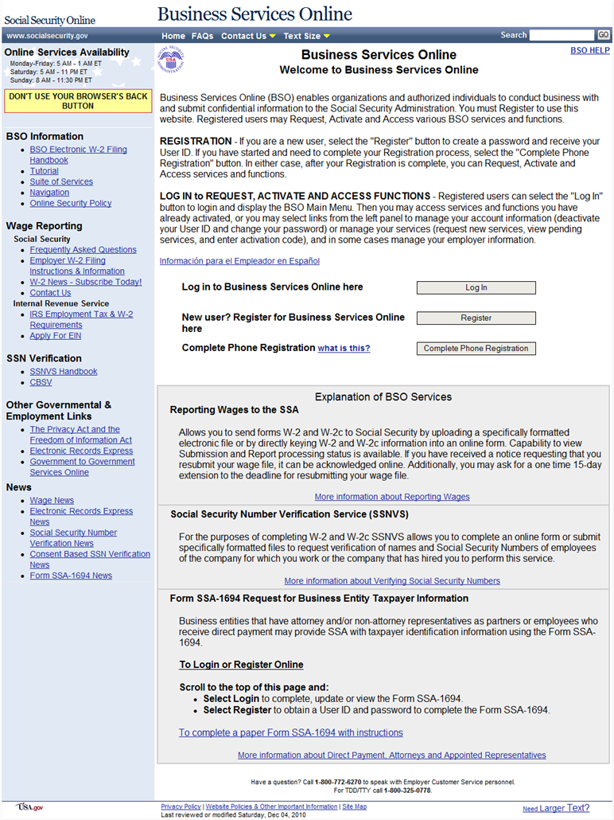

Step 2: Select the Log In button on the BSO “Welcome to Business Services Online” page. The system displays the “Log In to Online Services” page.
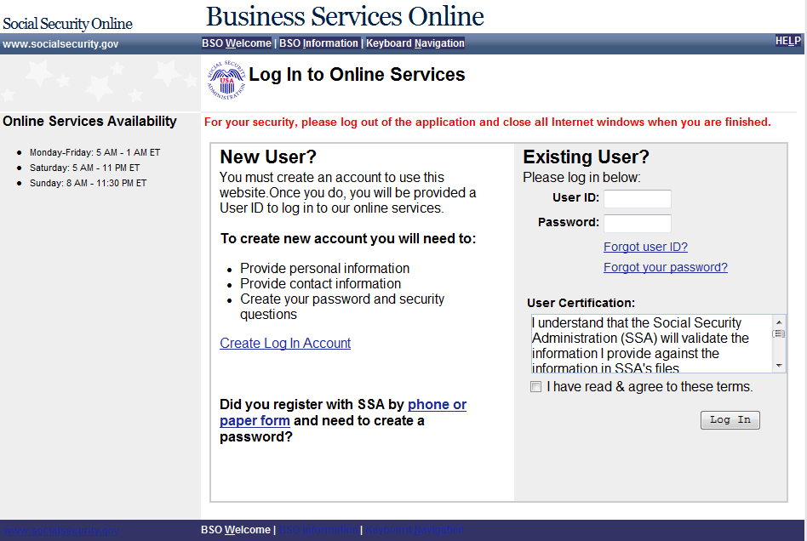

Step 3: Enter your User ID and Password.
Step 4: Select the I have read & agree to these terms check box on the “Log In to Online Services” page.
Select the Log In button to display the “BSO Main Menu” page.
To return to the BSO “Welcome to Business Services Online” page, select the BSO Welcome link at the top or bottom of the page.

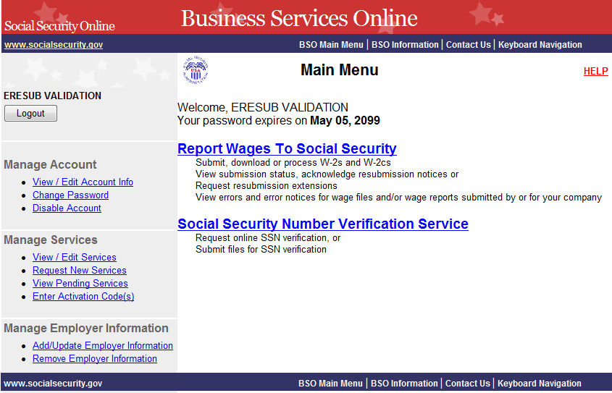

Step 5: Select the Report Wages To Social Security link on the “BSO Main Menu” page. The system displays the “Wage Reporting Attestation” page.
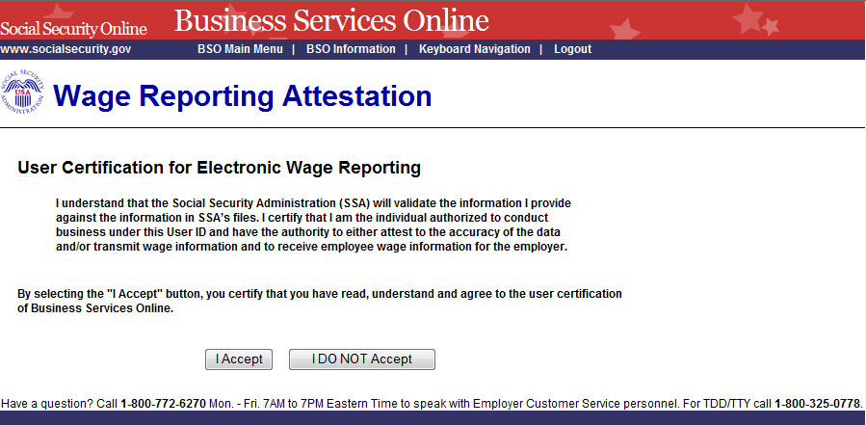

Step 6: Select the I Accept button on the “Wage Reporting Attestation” page to go to the EWR home page.
To return to the “BSO Main Menu” page, select the I DO NOT Accept button.
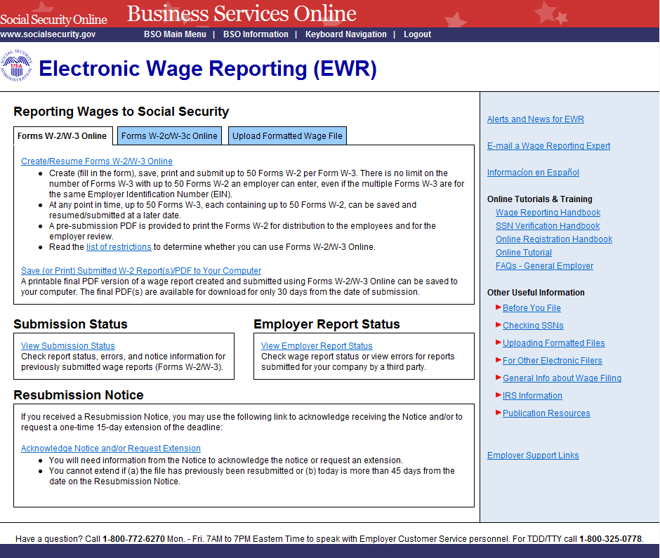

Step 7: On the EWR home page:
Forms W-2/W-3 Online tab is default.
Select the Create/Resume Forms W-2/W-3 Online link. If there are no unsubmitted reports, the system displays the “Before You Create Your Form(s) W-2/W-3” page. If there are unsubmitted Forms W-2/W-3, the system displays the Forms W-2/W-3 Online “Unsubmitted Reports” page.
You may have a maximum of fifty unsubmitted reports at one time. When you have reached the fifty “saved” report limit, you must first submit at least one of the unsubmitted reports in order to be able to start a new report. If there are forty-nine or fewer reports, you may continue without submitting the existing reports.
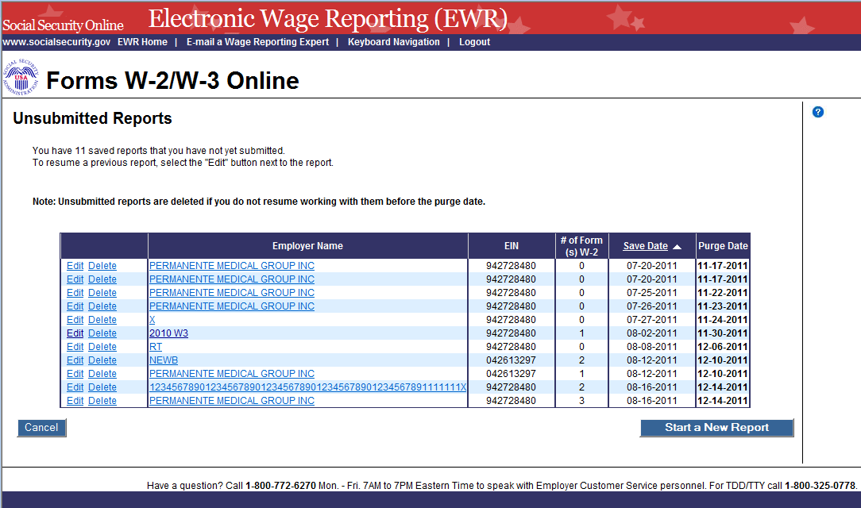
Step 8: Select the Start a New Report button on the “Unsubmitted Reports” page. The system displays the “Before You Create Your Form(s) W-2/W-3” page.
Select the Delete link to delete an unsubmitted report. The “Are you sure you want to delete the unsubmitted report?” page will be displayed.
Select the Cancel button to return to the EWR home page.

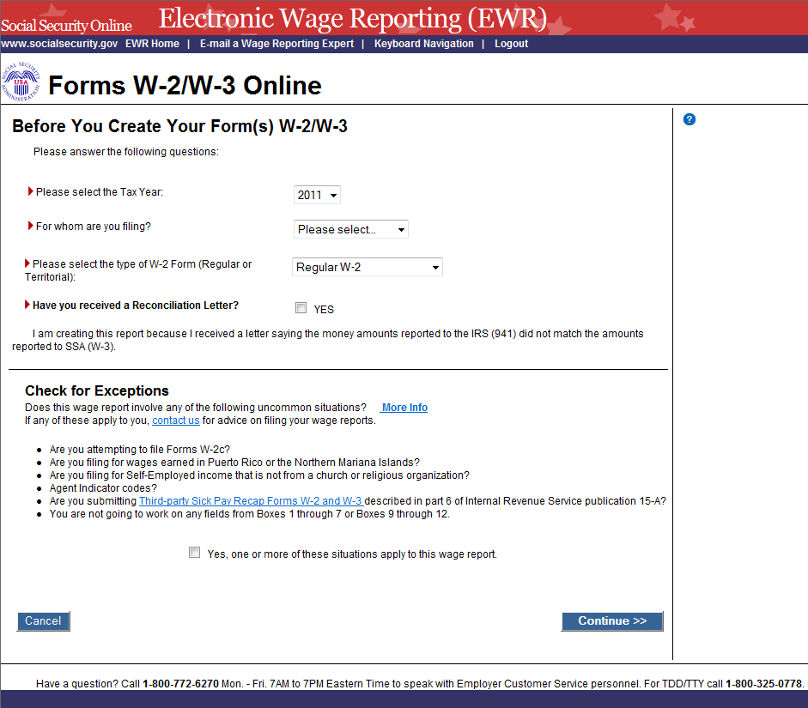

Step 9: On the Before You Create Your Form(s) W-2/W-3 page:
Select a Tax Year, select a company name and the type of W-2 Form you are creating. If you received a Reconciliation Letter, select the check box.
If none of the situations listed in the Check for Exceptions section apply, select the Continue button to go to the “Employer Information for this Wage Report” page.
If any of the situations listed in the Check for Exception section apply, select the check box and the Continue button to go to the “W-2 Online Restrictions” page.
Select the Cancel button to return to the EWR home page.

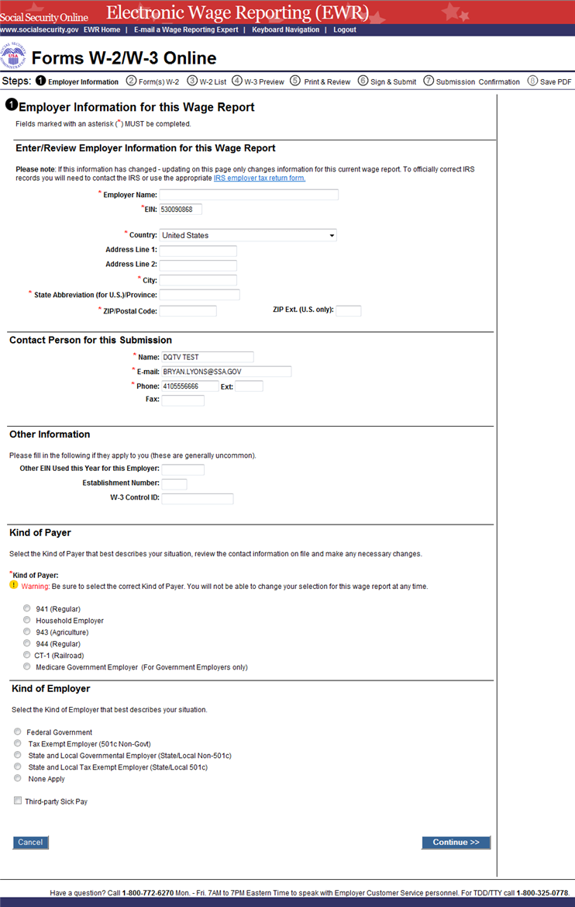

Step 10: On the “Employer Information for this Wage Report” page:
Enter or review Employer Information, Contact Person information, Other Information and select the Kind of Payer and the Kind of Employer, then select the Continue button to go to the “Enter W-2 Information” page.
Select the Cancel button to return to the EWR home page.
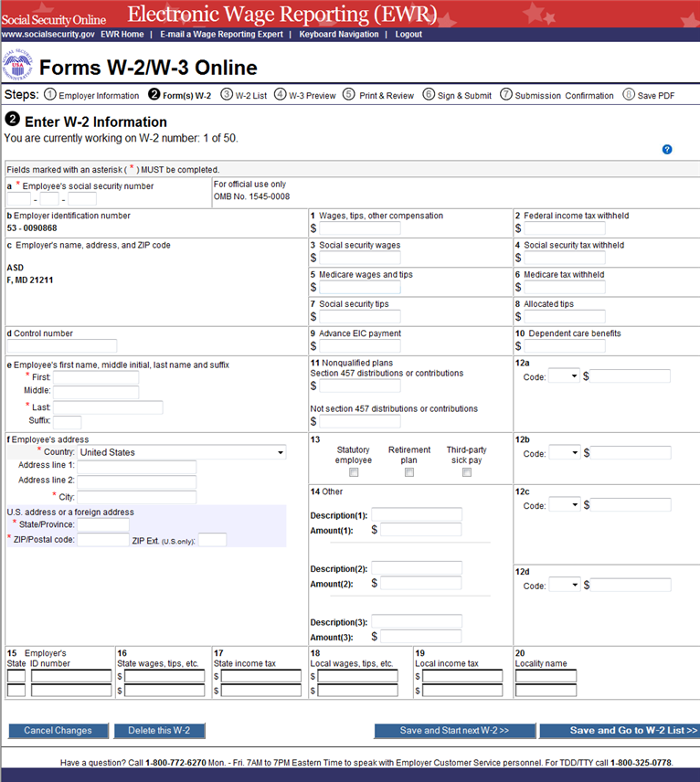
Step 11: Enter the W-2 data in the appropriate boxes on the “Enter W-2 Information” page. Select the Save and Start next W-2 button to save this W-2 information and create another W-2. The system may display some alerts. If an alert is displayed, you may proceed by making corrections to the W-2 or by selecting the override checkbox.
Select the Save and Go to W-2 List button when you finish creating W-2 to go to the “W-2 List for this Submission” page.
You can enter a maximum of fifty W-2s The number of the current W-2 is displayed at the top of the “Enter W-2 Information” page. When entering your fiftieth W-2, the system will no longer display the Save and Start Next W-2 button.
Select the Cancel Changes button to discard changes made to this W-2 and go to “W-2 List for this Submission” page.
Select the Delete this W-2 button: If the form has been saved previously, the system will display the “Are you sure you want to delete this W-2” page; If the form has not been saved previously, the system will display the “W-2 List for this Submission” page.
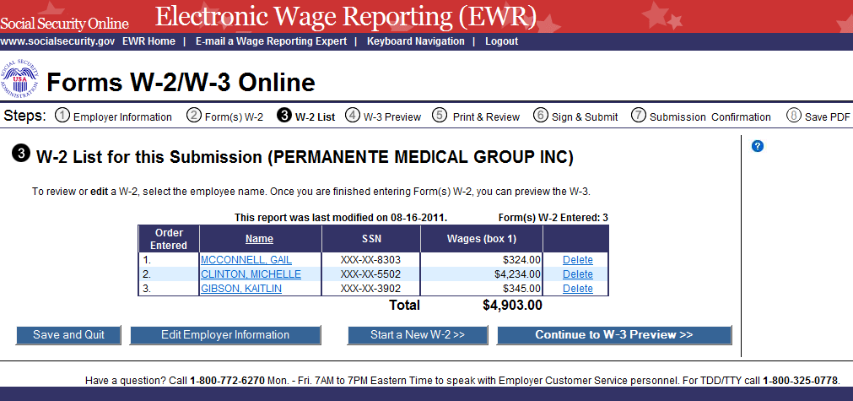
Step 12: The following options are available on the “W-2 List for this Submission” page:
Select a name to view and edit the W-2 data.
Select the Delete link to delete the W-2. When you select the delete link, “Are you sure you want to delete this W-2” page will be displayed for your assistance.
Select the Save and Quit button to exit W-2 Online without submitting your wage report to the Social Security Administration (SSA). When you select this button, “Are you sure you want to save and exit W-2 Online without submitting your annual wage report to SSA” page will be displayed for your assistance.
Select the Edit Employer Information button to change previously entered employer information.
Select the Start a New W-2 button to create another W-2.
Select the Continue to W-3 Preview button to view the “W-3 Preview for this Submission” page.
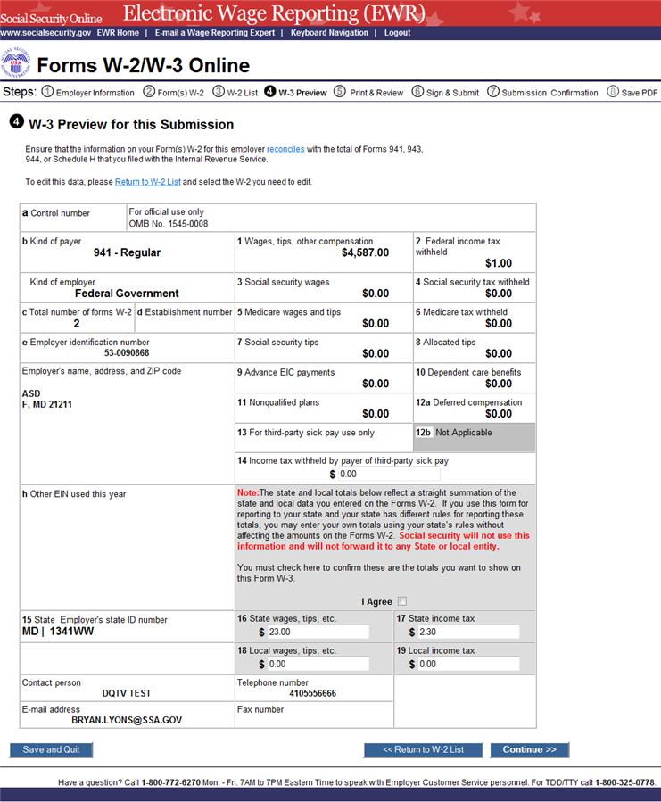
Step 13: The totals displayed in Boxes 16, 17, 18, and 19 on the “W-3 Preview for this Submission” page are straight summations of state tax information entered on the Forms W-2. If you intend to use this form for reporting to your state and your state has different rules for reporting those totals, you may enter your own totals and select the I Agree check box to continue. This information will not be used by Social Security, nor will it be forwarded to any state or local entity.
Select the Continue button to go to the “Print Unsubmitted Form(s) W-2/W-3 for Review” page.
Select the Return to W-2 List button to return to the “W-2 List for this Submission” page.
Select the Save and Quit button to exit W-2 Online without submitting your wage report to SSA. When you select this button, “Are you sure you want to save and exit W-2 Online without submitting your annual wage report to SSA” page will be displayed for your assistance.
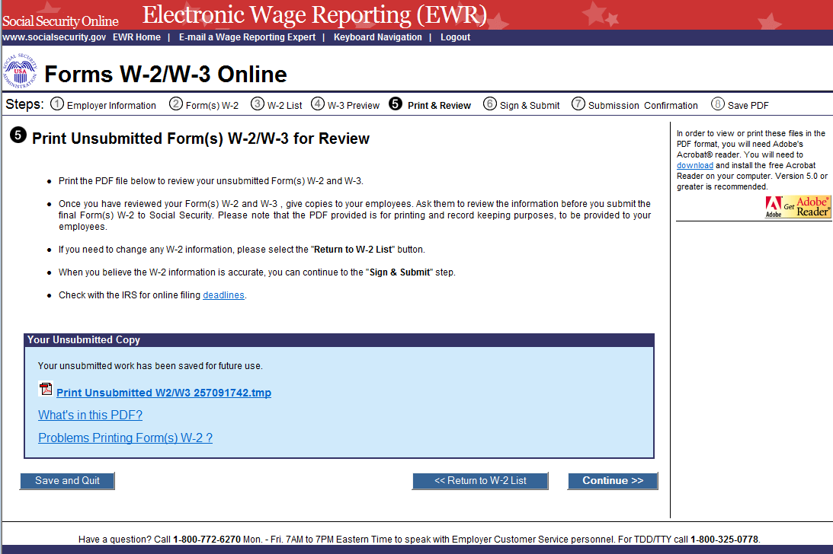
Step 14: The following options are available on the “Print Unsubmitted Form(s) W-2/W-3 for Review” page:
Select the Continue button to go to the “Sign and Submit” page.
Select the Return to W-2 List button to return to the “W-2 List for this Submission” page.
Select the Save and Quit button to exit W-2 Online without submitting your wage report to SSA. When you select this button, “Are you sure you want to save and exit W-2 Online without submitting your annual wage report to SSA” page will be displayed for your assistance.
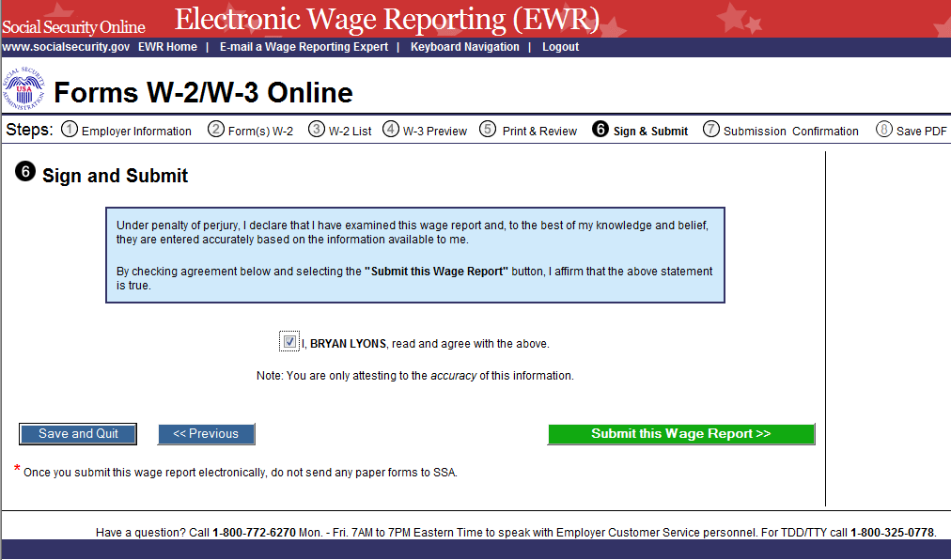
Step 15: Select the check box on the “Sign and Submit” page to attest to the accuracy of the report and select the Submit This Wage Report Correction button to submit your wage report correction. The system will display the “Confirmation Receipt - Your File Was Received” page with a pop up window on the top.
Select the Save and Quit button to exit W-2 Online without submitting your wage report correction to SSA. When you select this button, “Are you sure you want to save and exit W-2 Online without submitting your annual wage report to SSA” page will be displayed for your assistance.
Select the Previous button to return to the “Print Unsubmitted Form(s) W-2 for Review” page.

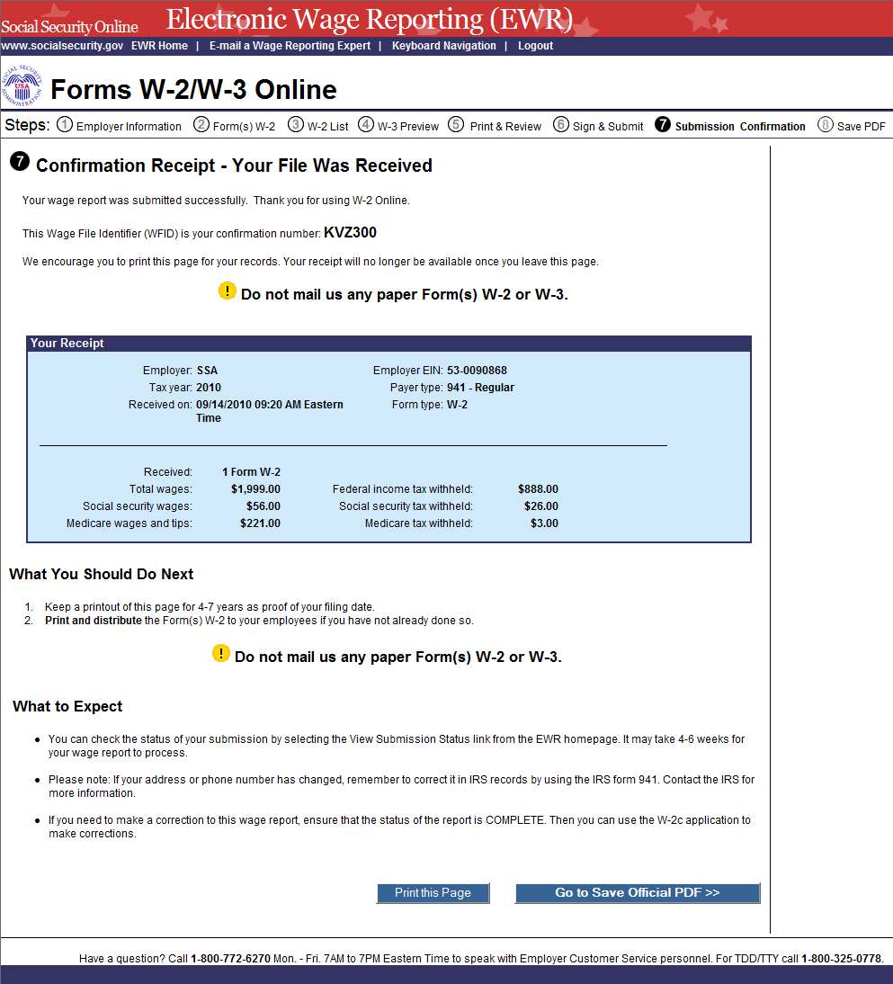
Step 16: A print pop-up window will be displayed on top of the “Confirmation Receipt - Your File Was Received” page. From the print pop-up window you may select one of the following options:
Select the OK button to print the “Confirmation Receipt - Your File Was Received” page.
Select the Cancel button to close the pop-up window.
Step 17: From the “Confirmation Receipt – Your File Was Received” page, you may select one of the following options:
Select the Print this Page button to print the confirmation page.
Select the Go to Save Official PDF button to go to the Save PDF page.
Your wage file will be available for you to review under your BSO account until the date displayed on your “Save PDF” page.
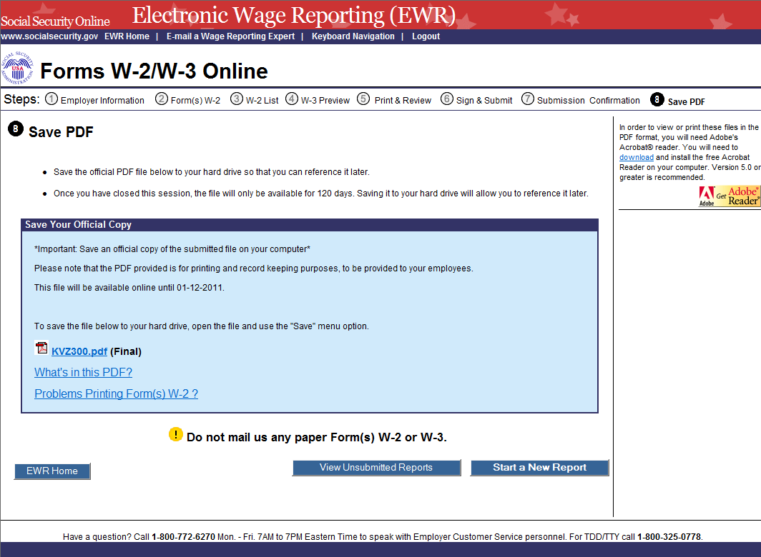
Step 18: Right click the file name (<filename.pdf>) on the “Save PDF” page to view or save the submitted report.
Select the Start a New Report button to return to the “Before You Create Your Form(s) W-2/W-3” page.
Select the View Unsubmitted Reports button to go to the “Unsubmitted Reports” page.
Select the EWR Home button to go to the EWR home page.

Lesson 2: Download Submitted Reports
Follow the instructions below to download an Adobe file containing Forms W-2 and W-3 for a W-2 Online report submitted within the last 30 days.
Submitted wage report files are available for 30 days or until December 31, whichever comes first.
Step 1: Select the Save (or Print) Submitted W-2 Report(s)/PDF to Your Computer link under the Forms W-2/W-3 Online tab on EWR home page. The system displays the “Download Submitted Reports” page.
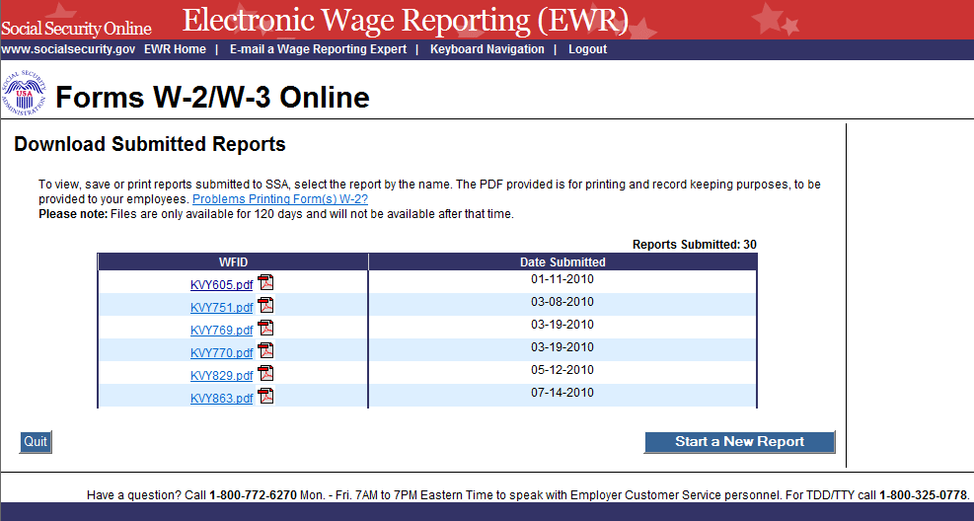
Step 2: Right-click the WFID link on the “Download Submitted Reports” page to display a menu including the following options:
  - Select Save Target As to download the file onto your computer.
  - Select Open in New Window to view the file.
Note: Adobe Acrobat Reader is required to view your downloaded wage file. If you do not have Adobe Acrobat Reader on your computer, you can download it at http://www.adobe.com.
Select the Quit button to return to the EWR home page.
Select the Start a New Report button to proceed to the “Before You Create Your Form(s) W-2/W-3” page.

Appendix: Other Pages

Are You Sure You Want to Delete this W-2 Page
If a user selects the “Delete This W-2” button on the “Enter W-2 Information” page, the system shall display the “Are you sure you want to delete this W-2” Page.
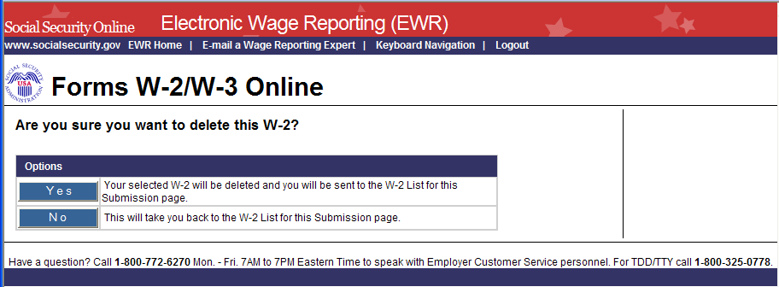

Are You Sure You Want to Save and Exit W-2 Online Without Submitting Your Annual Wage Report to SSA Page
If a user selects the “Save and Quit” button on the “W-2 List for this Submission (ABC Limited)” page, “W-3 Preview for this Submission” page, the “Print Unsubmitted Form(s) W-2/W-3 for Review” page or on the “Sign and Submit” page, the system shall display the “Are you sure you want to save and exit W-2 Online without submitting your annual wage report to SSA” Page.
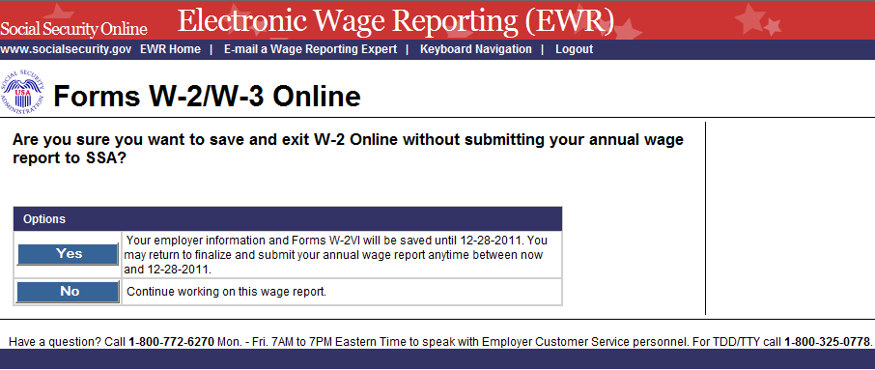

Are You Sure You Want to Delete the Unsubmitted Report Page
If a user selects the “Delete” button on the “Unsubmitted Reports” page, the system shall display the “Are you sure you want to delete the unsubmitted report” page.
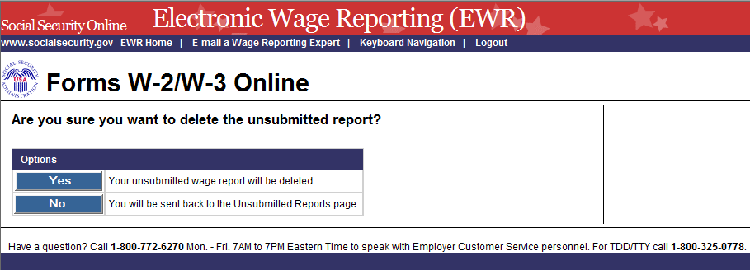

W-2 Online Restrictions Page
Users can access “W-2 Online Restrictions” page by selecting the “Continue” button on the “Before Your Create Your Form(s) W-2/W-3” page when the radio button “No” and/or the check box “Yes, one or more of these situations apply to this wage report” is selected.
