BSO Tutorial for Tax Year 2011

Acknowledge Resubmission Notice and/or Request Extension

Step 1: Point your browser to the Business Services Online (BSO) “Welcome to Business Services Online” page: www.socialsecurity.gov/bso/bsowelcome.htm.
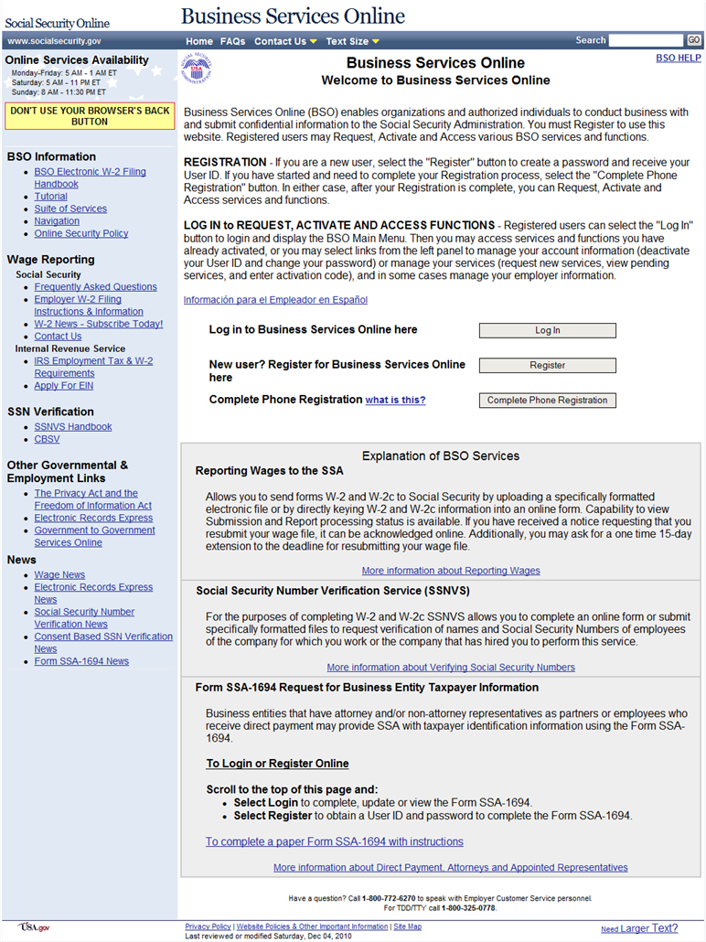
Step 2: Select the Log In button on the BSO “Welcome to Business Services Online” page. The system displays the “Log In to Online Services” page.
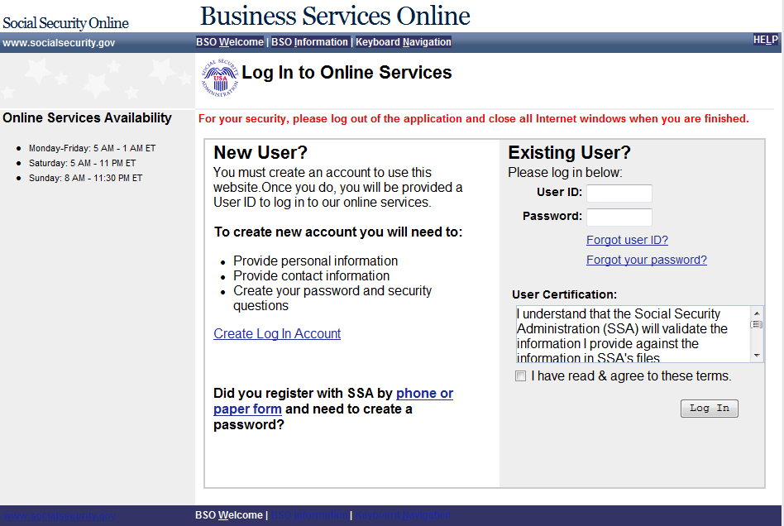
Step 3: Enter your User ID and Password.
Step 4: Select the I have read & agree to these terms check box on the “Log In to Online Services” page.
Select the Log In button to display the “BSO Main Menu” page.
To return to the BSO “Welcome to Business Services Online” page, select the BSO Welcome link at the top or bottom of the page.

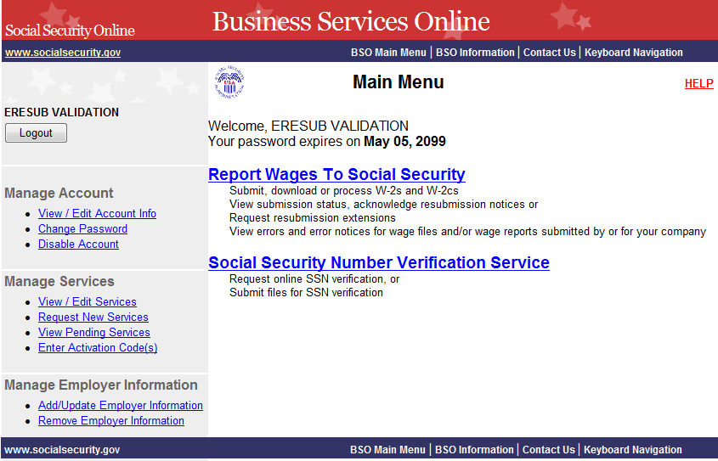
Step 5: Select the Report Wages to Social Security link on the “BSO Main Menu” page, the system displays the “Wage Reporting Attestation” page.
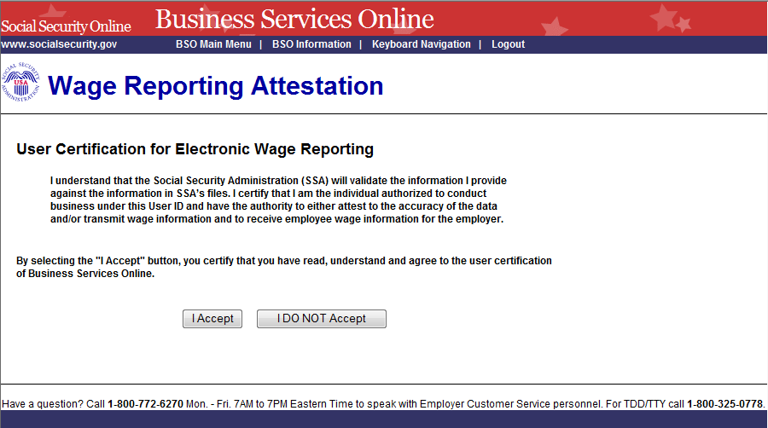

Step 6: Select the I Accept button on the “Wage Reporting Attestation” page to go to the EWR home page.
To return to the “BSO Main Menu” page, select the I DO NOT Accept button.
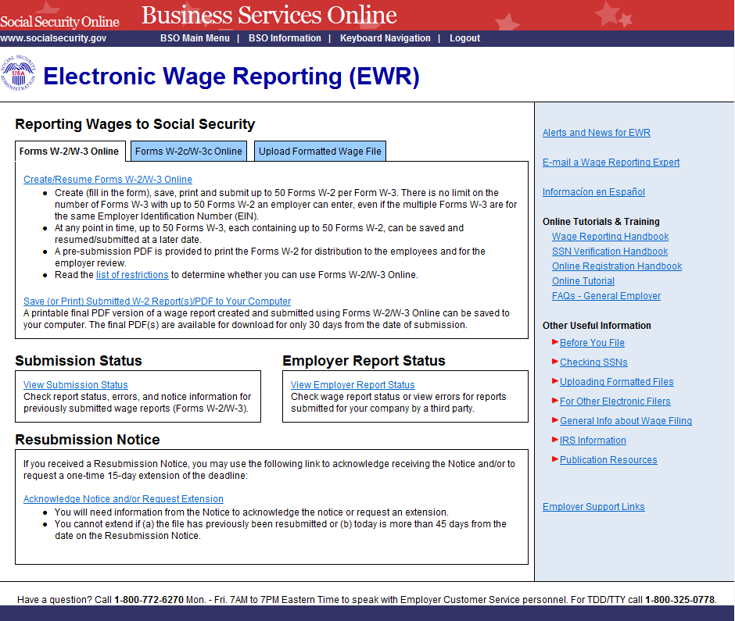
Step 7: Select the Acknowledge Notice and/or Request Extension link on the EWR home page. The system displays the “Acknowledge Notice and/or Request Extension” page.
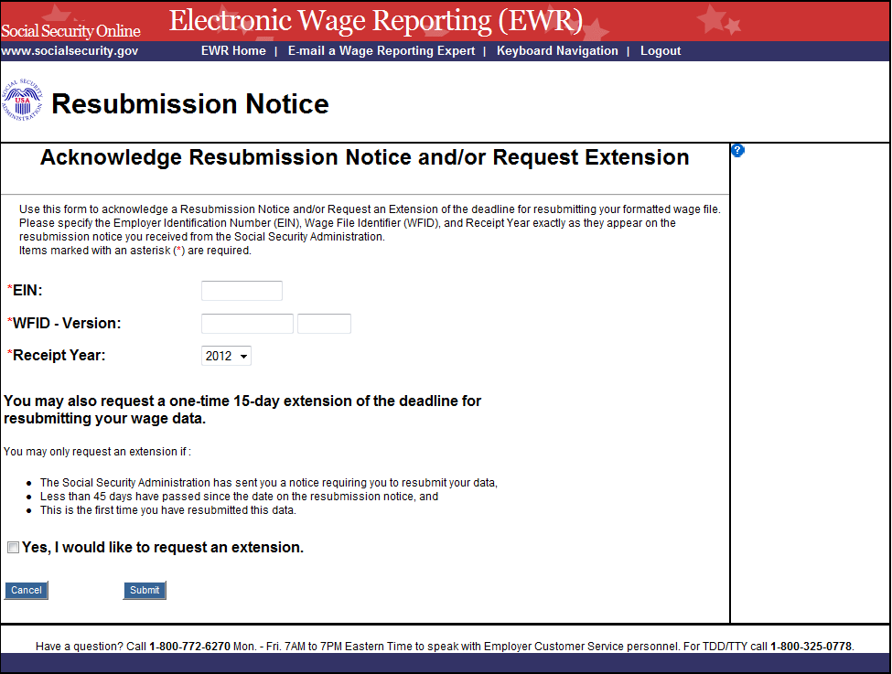
Step 8: Enter your Employer Identification Number (EIN), Wage File Identifier (WFID), Version, and Receipt Year (exactly as they appear on the resubmission notice you received from SSA.)
If you would like to request an extension on the deadline for resubmitting your formatted wage file, select the check box.
Select the Submit button to go to the “acknowledgement and/or request an extension receipt” page.
To return to the EWR home page, select the Cancel button.

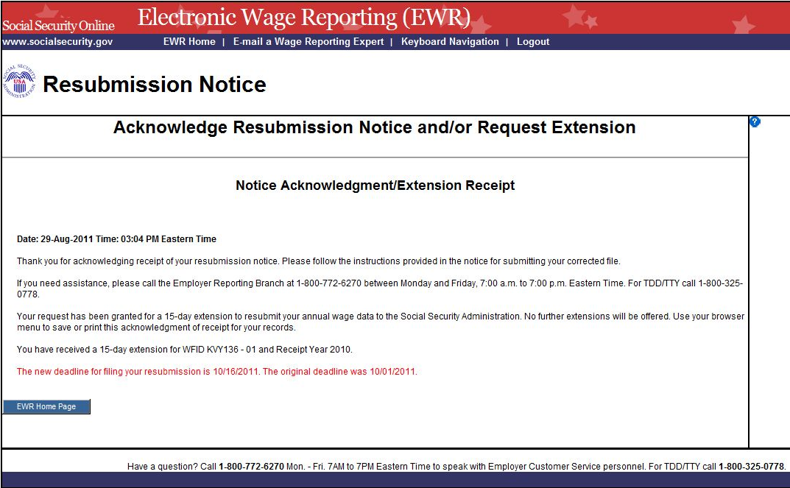

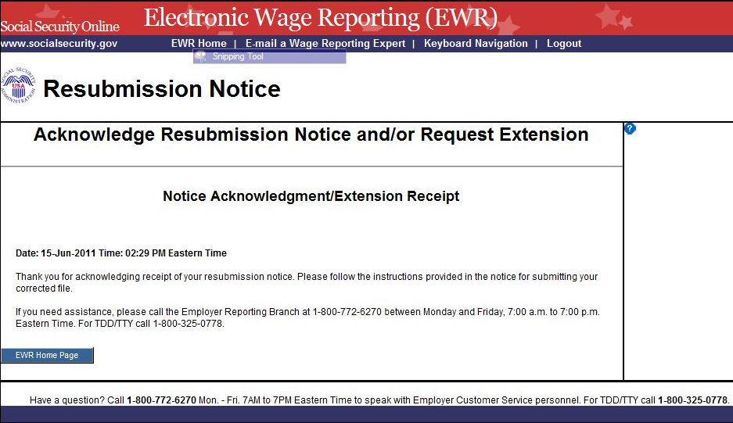

Step 9: “The Notice Acknowledgment/Extension Receipt” page displays acknowledgement and extension confirmation. If the “Yes, I would like to request an extension” check box on the “Acknowledge Notice and/or Request Extension” page was not selected, the system displays the “Notice Acknowledgement/Extension Receipt” page without a confirmation of extension.
Select the EWR Home page button to return to the EWR home page.

