Using the Manual PVA Spreadsheet

General Guidance:
The manual PVA spreadsheet is comprised of multiple worksheets, four of which are used to capture input (always noted in green cells). Most formulas can be viewed by clicking on cells; however, certain calculations such as amortization are hidden from view. Pink cells contain the SFO-specified discount and escalation rates used for the analysis. The final PV result appears in the yellow cell.

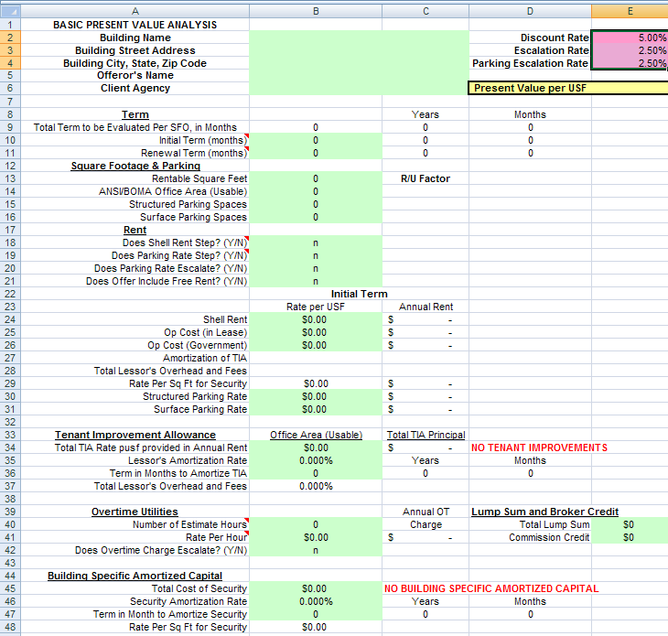

eLease contains a PVA spreadsheet without the cells locked. To prevent data entry mistakes, lock all cells prior to inputting any information.

The attached PVA version is preferred to be used as it locks all cells except those requiring data entry (green blocks), preventing accidental overwriting of formulas. To unlock cells, click on the "Review" tab at the top of the Excel window. Then click on "Unprotect Sheet" to unlock the cells. When you're all done, click on "Protect Sheet" to turn protection back on for the locked cells. When prompted for a password, don't enter anything. Just click the "OK" button.

1
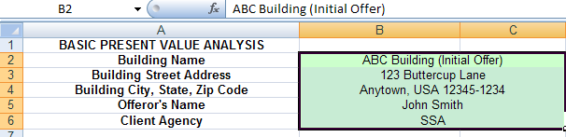Step 1: Start at “Input” worksheet. Insert Information about the offeror. This is fairly self-explanatory. Fill in offered building name and address, the offeror’s name, and the client agency. Information is free text, and does not feed into any other spreadsheet calculations. Tip: If you are doing PVA sheets over several offer iterations (initial proposal, revised proposal, FPR, etc.), you may want to note this here (for example “XYZ Bldg – FPR”)
2
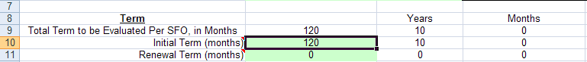Step 2: Input the initial (full) lease term, in months, excluding renewal options. Sheet will convert # of months to # of years.

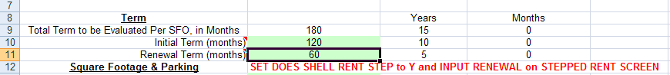Step 3: Input renewal term(s), in months, only when renewal options are required under the SFO. Do not include unrequested “deal sweetening” options offered on the Form 1364.” (Also do not confuse this with the requirement to always include options for scoring analysis). If input, sheet will direct you to do the following: click “y” for cell B18, “Does shell rent step?” (discussed under step 6 below) AND input rates in column F on Stepped Rent worksheet (discussed under step 9 below).
3
4
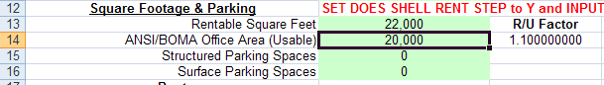Step 4: Input amount of rentable space and ANSI BOMA Office Area (usable) space from offer. Spreadsheet will calculate R/U or Common Area Factor (CAF). Note that amount of RSF must always be at least equal to or higher than amount of ABOA SF. If the amount of ABOA space offered is more than the maximum required by the SFO, do not input the amount of offered space; instead, recalculate the rates per ABOA by dividing the annual amounts by the SFO maximum SF, and input the maximum SFO figure here.
4
5
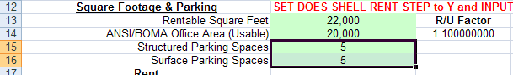Step 5: Input number of parking spaces, structured and surface.

6
Step 6: Choose either “Y” or “n”. If answer to “Does shell rent step?” is “n”, sheet will read shell rent listed on this worksheet, under cell B24. If answered as “y”, sheet will direct you to input rates on “Stepped Rent” worksheet and will NOT read shell rate information input on this worksheet under cell B24. Note that if an offeror wants to keep total rent constant after TI amortization period, you need to reflect this as a stepped shell rent increase.
7
Step 7: Choose either “y” or “n”. If answer to “Does parking rent step?” is “n” , sheet will read parking rates listed on this worksheet under cells B30 and B31 (see step 12 ). If answered as “y”, sheet will direct you to input rates on “Stepped Rent” worksheet and will NOT read parking rate information on this worksheet under cells B30 and B31.
8
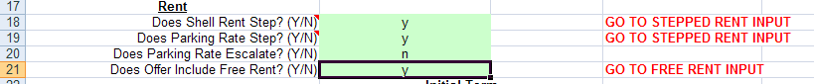Step 8: Choose either “y” or “n.” If answer to “Does Offer Include Free Rent?” is “y”, sheet will direct you to input on “Free Rent” worksheet (see step 10).

9
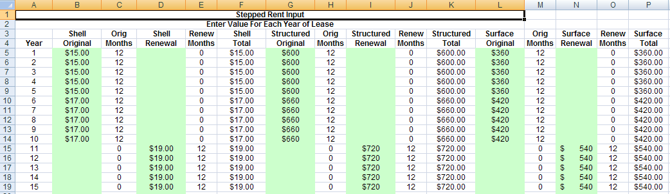Step 9: On the stepped rent worksheet, if applicable, input stepped shell and parking rates for each year, inputting any (evaluated) renewal rates in separate columns shown. Note that this information will not be read unless responses on first worksheet indicate “y.”
100
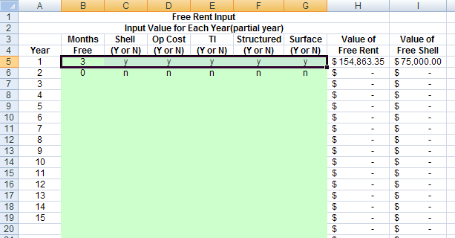Step 10: On the “Free Rent” worksheet, if applicable, input the number of months of free rent for each year in which offered. Also indicate whether free rent applies to each rental component by indicating “y” or “n.” Spreadsheet calculates total annual value of free rent and shell rent.
110
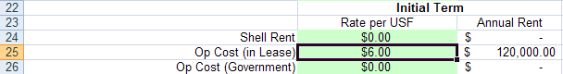Step 11: Go back to “Input” worksheet. Input offeror’s shell rate (unless stepped shell rent was inserted on “Stepped Rent Input” worksheet; input operating cost rate. Annual amounts will be calculated. “Op Cost (Government”), used to compare less-than-fully-serviced offers with fully serviced ones, is usually left blank, unless we are allowing non-fully serviced offers in the SFO. Under this scenario, input an estimated rate for government’s share of operating rent (for example, electric) for “net” offers, so that the PVA assumes escalation on the fully-serviced amount (lease + government).
120
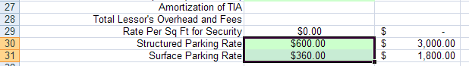Step 12: Input parking rates. If indicated as stepped, sheet will override this information and read “Stepped Rent” worksheet instead. Sheet calculates annual parking rent.

130
130
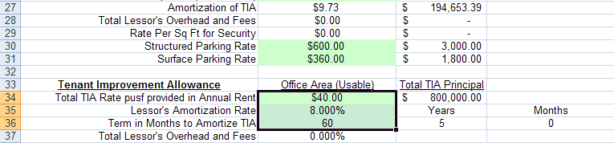Step 13: Input the tenant improvement allowance, on a per ABOA SF basis, which is specified in the SFO. The total principal to be amortized is calculated. Input the amortization rate. Input the amortization term, in months (this is usually equivalent to the firm term). The spreadsheet calculates the amortized rent per BOAF and per annum and populates each under cells B27 and C27, respectively. Note that Total lessor’s overhead and profit are not an input cell, but are calculated from information input under “Fee Schedule” worksheet (see steps 18 a-d).

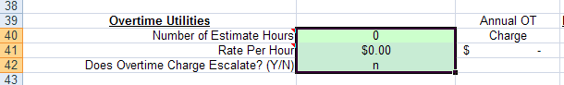
140
Step 14: The overtime rate is usually evaluated on its own, and not as part of the PVA. Fill this out only when the SFO indicates that overtime will be evaluated as part of PVA; the SFO must also specify the estimated annual number of hours to be assumed for the PVA. Once an hourly OT rate and estimated annual number of hours are input, sheet calculates annual OT rent, which is included in the discounted rental stream. If applicable, answer whether OT rate escalates. If answered “y” sheet assumes an annual escalation equal to that shown as the “Escalation Rate” in Cell E3 on “Input” worksheet.
150
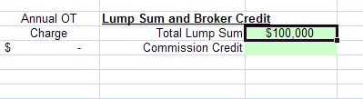Step 15: Input evaluated lump sums. Usually, this reflects relocation costs, applied to offers other than current lessor. This can also reflect items identified to be paid via RWA (such as security). These costs are annualized, calculated as a per ABOA rate, and are not discounted.
160
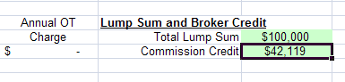Step 16: If NBC project, input broker’s commission credit to be credited back to the government (this is not the commission, which is included in shell rate). To calculate this figure, first determine the amount of commission by multiplying the total aggregate rent for the firm term by the commission percentage negotiated between the broker and the offeror. Take the total commission and multiply it by the credit percentage established in the NBC contract for that particular NBC firm and the year that task order was issued. Free rent is not subject to commission (or credit). Please note that instructions for step # 16 relate to NBC and commission credit for NBC 2 will be calculated differently.
170
170
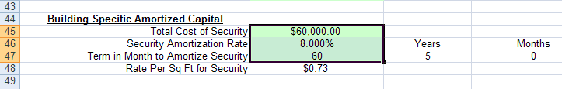Step 17: Input offeror’s total principal amount for Building Specific Amortized Capital (aka Building Specific security), amortization rate, and term in months (term may or may not be equivalent to firm term), as indicated on GSA Form 1364 (costs should also be listed on separate SecUP Form). Spreadsheet calculates the amortized rent and populates in cell B48.
180
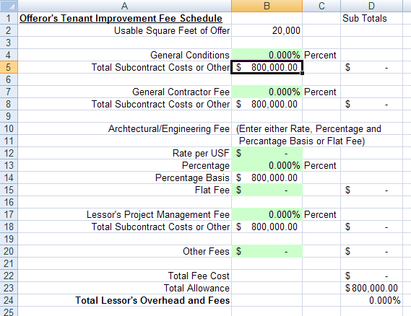Step 18: Go to the “Fee Schedule” worksheet, which captures the effect of the TI overhead tiers. Policy dictates that we obtain all four fees for projects 20,000 sf and higher (steps 18 a-d). Region 3 direction is to capture the Lessor’s PM (overhead/profit) fee in all instances (step 18d). The sheet will take these fees and convert them to an overall percentage of TI (cell D24) that will carry over to Cell B37 on “Input” worksheet. This percentage will be applied against annual TI rent and added to rental stream for PVA purposes. Note that, prior to filling out, sheet shows a construction cost base equal to TI principal (cell C34 from “Input” sheet). This figure will change as fees from GSA Form 1364A are input into the sheet, since sheet follows the following “order of precedence”:
1) A/E fees are taken from total TI principal
2) GC fees are applied to the residual TI left after A/E fees are taken
3) GC general conditions are applied to the residual TI after A/E and GC fees are taken
4) Lessor PM fees are applied to the total TI principal
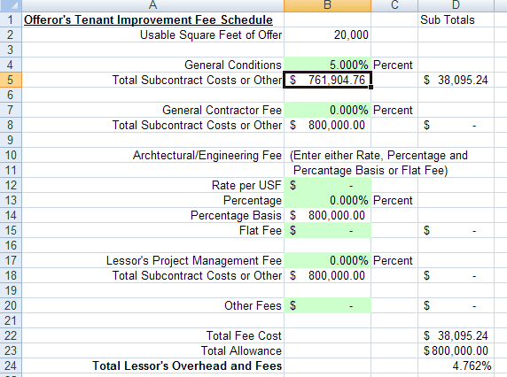a) Input GC’s general conditions percentage. While this figure is input first, sheet’s logic assumes that general conditions are applied to the TI amount left over after A/E fees, and GC fees are applied. Sheet calculates the residual amount of subcontractor construction costs available to apply against the gen cond fee (so that results equal full TI amount), and calculates the amount of fee. Sheet adds up all fee subtotals under cell D22 (Total Fee Costs) and converts to an overall TI fee percentage (“Total Lessor’s Overhead and Fees” Cell D24) by dividing by total TI allowance.
18a

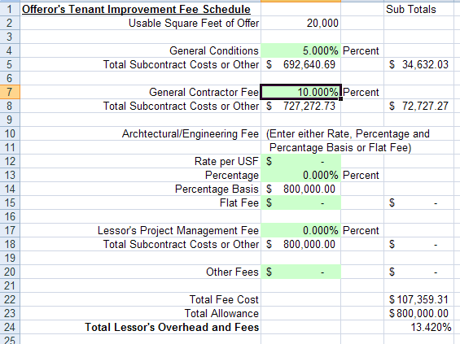b) Input GC’s fee percentage. This figure is input second; sheet’s logic assumes that fees are applied to the TI amount left over after A/E fees are applied. Sheet re-calculates the residual amount of subcontractor construction costs available to apply against the GC fee, so that results equal full TI amount. Sheet also recalculates the residual available for general conditions and the amount of fee. Sheet re-calculates Total Fee Cost under cell D 22 and re-calculates the overall TI fee percentage.
18b

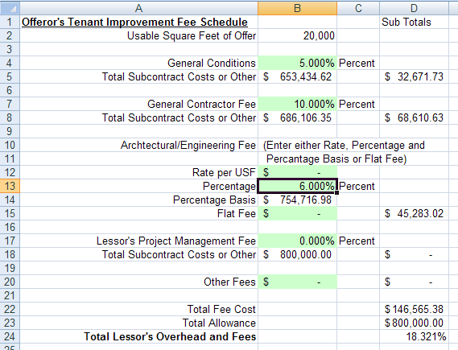c) Input A/E fees as either a rate per usf/ABOA sf, percentage, or flat fee. Sheet’s order of precedence assumes that A/E fees are applied against TI first, then recalculates residual amounts for GC fee and gen cond, affecting each fee’s subtotal. Sheet re-calculates Total Fee Cost under cell D22 and re-calculates the overall TI percentage.
18c
18d
18d
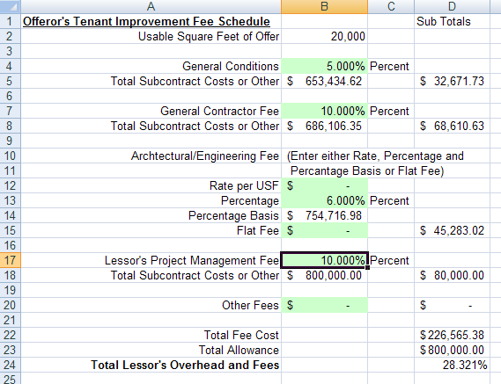d) Regardless of whether the other three fees are included, the Lessor’s PM (OH/P) fee should be captured for all of region 3 projects. Sheet’s logic assumes that lessor’s fee is on top of entire TI allowance amount when calculating subtotal fee amount. If other fees are present, sheet re-calculates Total Fee Cost and re-calculates overall TI percentage. Note that cumulative effect of tiering is not a strict addition of fees (5%+10%+6%+10%) due to sheet’s logic that backs the first three fees out of the allowance using an order of precedence (first A/E, then GC fee, then general conditions). The Total Lessor’s Overhead and Fees (Cell D24) repopulates under “Input” worksheet Cell B37, shown below.
190
Step 19. Once all information has been input, go to “Input” worksheet, to find final PVA figure calculated under Cell E6. (Note that Total Lessor ‘s Overhead and Fees from other worksheet are carried over onto Cell B37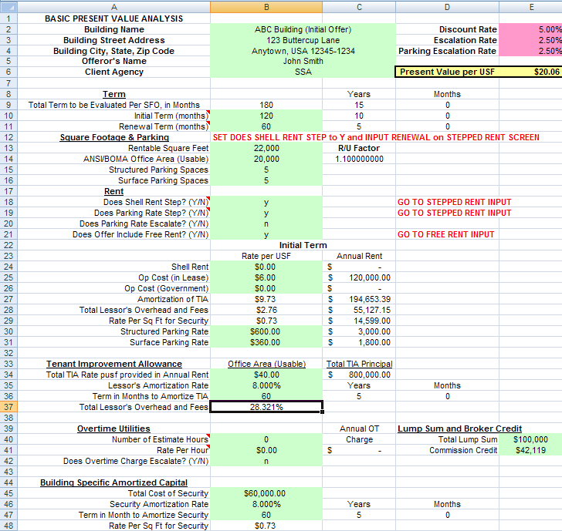).

Step 20: Think you are done? Think again! Go to the “PVA Calculation” worksheet (below). This is the sheet where the PVA calculation is performed. All information input elsewhere is carried over to this sheet. The information on this sheet (plus the annualized lump sum on the “Input” worksheet) is used for the actual PVA calculation under Cell E2. Therefore, any information that is either missing or incorrectly captured on this sheet will result in an incorrect PVA calculation. It is always a good practice to check such items as:
- Number of years: should show rental for each year of the entire lease term, including required renewals.
- Shell rent: should be static except for step increases.
- Operating cost in lease: should be increasing over time at 2.5% compound interest.
- Operating cost by gov’t: usually blank. used to compare a less-than-fully serviced offer.
- TI: should appear for each year of amortization (usually the firm term); figure should drop off afterwards.
- Building Specific Amortized Capital: should appear for each year of amortization, depending upon offer (usually the firm term); should drop off afterwards.
- Lessor TI OH: should always appear for the full term of the TI amortization; should drop off afterwards.
- Overtime utilities: usually should be blank unless evaluated per SFO.
- Parking: should reflect parking space rate, converted to ABOA rates, and should apply over entire term, including options. Check for steps.
- Annual rent: This column includes the effect of the TI overhead for PVA purposes and is not the actual offered total annual rent that would be used in the lease agreement.
- Free rent: usually shows up at the beginning lease years or at the end of full term.
- Commission credit: Shows up during year 1 of the lease.
200
