Precipitation Post-Analysis
Operations Guide

December 21, 2005
AWIPS Build OB6
Office of Hydrologic Development (OHD)
Hydrologic Software Engineering Branch (HSEB)

TABLE OF CONTENTS

- Introduction

- Application Control
  - Application Defaults Tokens
  - Post Analysis Start Script
- File Directories
  - Post Analysis Executables Directory
  - Post Analysis Data Input Directories
  - Post Analysis Data Output Directories
- Database Tables
  - Input Tables
  - Output Tables
- Log File
- Application Operation
  - Choose date/hour Window
  - Main Window
    - Summed Hourly MPE Field
    - Gage Only Field
    - Legend
  - Control Menu
6.3.1 Merged Data
  - Options Menu
    - Zooming
    - Gage Table
    - Remove Ap Option
  - Overlay Menu
  - Help Menu
  - Popup Displays
    - Locator Popup
    - 7x7 Summed Hourly MPE Field Popup

Appendix A. Gage Only Field Generation Algorithm
Appendix B. Merged Field Generation Algorithm
1.0 Introduction

The Post Analysis application analyzes precipitation data in a “post event” mode. It allows previously computed gridded hourly Quantitative Precipitation Estimates (QPE) to be compared with gage data that may arrive many hours after the hourly QPE grids were initially generated. By comparing the summation of the hourly grids into durations and time periods which match 6- and 24-hour gage data, both the multi-hour gage data and the gridded hourly grids can be quality controlled and adjusted as appropriate.

To assist in the comparisons, Post Analysis generates and displays a summed hourly Multi-sensor Precipitation Estimator (MPE) precipitation field based on the hourly best estimate QPE fields. The summation duration can be for 6 or 24 hours and is chosen by the user. Post Analysis also generates and displays a gage-only field based on 6- hour or 24-hour gage data. It has options to merge these two fields and to "time distribute" gage precipitation not found in the summed hourly MPE field back onto the individual hourly fields. The adjusted individual hourly MPE fields can be stored either separately from the existing best estimate grids or they can overwrite the existing best estimate grids.

Post Analysis has the option to overlay the gage identifiers or gage values of reporting gages on the summed hourly MPE field and gage only field displays. A popup window showing a 7x7 grid of the summed hourly MPE field centered on the location of the gage is available when the gage identifiers or gage values are displayed.

Post Analysis also has the capability to display and edit gage values through a gage table window. If edits to the gage values are made, the "Recompute gage-only" option may be selected to recompute the gage only field, update the display and update the database with the new gage value.

Post Analysis has the capability to display assorted supporting information. Location information can be displayed using a locator popup. This popup displays the HRAP coordinates, latitude/longitude, basin name, county name, summed hourly MPE field value and gage only field value at the location of the cursor. This display is generated by right mouse clicking on a point in any display (summed hourly MPE display, gage only display or merged field display). Post Analysis has the capability to display geographic overlays such as states, counties, cities/towns, rivers and basin boundaries. The Geographic overlays appear on both the summed hourly MPE field display and gage only field display.

This document provides information on Post Analysis operations. It begins by discussing the application controls, and the input and output data accessed. The user interface of the application is described, with sample screen images supporting the discussion. The appendices detail the algorithm for computing the gage only field and the merged field.
2.0 Application Control

Certain key operational characteristics of Post Analysis are controlled by application default “tokens” and the start script used to initiate the application

2.1 Application Defaults Tokens

The tokens read by Post Analysis are listed below, with a brief description and default value listed.

$(db_name) - name of the IHFS database to read from. (e.g. hd_ob6tir)

$(geo_data) – base directory containing geographic overlay data. (e.g. /awips/hydroapps/geo_data)

$(st3_rfc) - site identifier. (e.g. marfc)

$(rfcwide_help_dir) – directory which contains the help files /awips/hydroapps/precip_proc/local/data/app/mpe/help/

$(rfcwide_xmrg_dir) – directory containing the hourly QPE files. Files are read from this directory and, if the user selects to overwrite them, the grids will be written to this directory. /awips/hydroapps/precip_proc/local/data/mpe/qpe

$(mpe_post_output) - directory where updated hourly QPE files are written to if the "Save/Separate" option is chosen. /awips/hydroapps/precip_proc/local/data/app/postanalysis

$(rfcwide_logs_dir) – directory where the post_analysis.log file is written. /awips/hydroapps/precip_proc/local/data/log/mpe_fieldgen

$(st3_date_form) – date format. mdY (default) or Ymd for name of QPE files

$(rfcwide_prism_dir) – directory containing the PRISM data (files are named as PRISM_mm, where mm is the month number). /awips/hydroapps/precip_proc/local/data/app/mpe/prism .

2.2 Post Analysis Start Script

The run_post_analysis script executes the Post Analysis process. It is located in /awips/hydroapps/precip_proc/bin.

This script “sources” the file /awips/hydroapps/set_hydro_env to set up environment variables for the application. The script generates a log file named post_analysis.log which contains detailed information related to the execution of the process.

The script executes the post_analysis.LX executable with the following optional command line arguments:

post_analysis.LX [-d] [-t<date time>]

The -d option prints detailed debug-style information to the log. The -t option requires a specified date/hour in GMT time using the YYYYMMDDHH format. Using this option causes the specified date/hour to be the first date/hour in the “Choose date/hour” window.

If the “-d” and “-t” options are not specified, then the default command in the run_post_analysis script will print out only the general, less verbose, information and will use the current GMT top-of-the-hour time as the chosen date/hour.

3.0 File Directories

The Post Analysis program uses the following directories for execution control scripts, and to read, write data files and log files. The referenced tokens were presented in the previous section.

3.1 Post Analysis Executables Directory

The executable files post_analysis.LX and run_post_analysis are to be placed in this directory.

/awips/hydroapps/precip_proc/bin

3.2 Post Analysis Data Input Directories

Geographic Data Directory
- Defined as $(geo_data)/$(st3_rfc)/ascii
- Post Analysis reads coordinate data from file coord_$(st3_rfc).dat in this directory.

Overlay Data Directory
- Defined as $(geo_data)/$(st3_rfc)/binary
- Post Analysis reads overlay data from this directory

Hourly QPE Field Directory
- Defined as $(rfcwide_xmrg_dir)
- Post Analysis reads the hourly QPE fields from this directory. Sample filenames are xmrgmmddyyyhhz

Help File Directory
- Defined as $(rfcwide_help_dir)
- Post Analysis reads the help information from files in this directory. This information is displayed by selecting the "Help" option in the main window. This directory contains topics on main display, date selection, gage table, editing gage data, single site.

PRISM Data Directory
- Defined in $(rfcwide_prism_dir)
- Post Aanalysis reads PRISM files for the appropriate month.

Resource File Directory
- resource file S3Post_res is located at /awips/hydroapps/precip_proc/bin. It defines the geometry of the main window, fonts and some colors used by the GUI.

3.3 Post Analysis Data Output Directories

Hourly QPE Field Directory
- Defined as $(rfcwide_xmrg_dir)
- directory written to if the “Save/Overwrite” option is chosen

Post Analysis QPE Field Directory
- Defined as $(mpe_post_output)
- directory written to if the “Save/Separate” option is chosen.

Post Analysis Log Directory
- Defined as $(rfcwide_logs_dir)
- directory in which post_analysis.log is stored

4.0 Database Tables

Post Analysis accesses the following tables from the IHFS database.

4.1 Input Tables

CurPP
- Read the 6 hour or 24 hour total precipitation data.

RadarLoc
- Get the number of radars and the location of each radar within the required geographic area.

ColorValue
- Get color and value for the legend. If not found, a default hard coded set of colors/values is used.

S3PostAnalPrefs
- Read the initial setting (on or off) of various overlays such as state, city, river, basin and radar overlay. Read value for num_hours_wind which is the number of hours allowed to be displayed by the “Choose date/hour” window.

S3PostAnalParams
- Read values for gg_min_gage_val, gg_min_dist, gg_weighting, kernel_est_scale and rhat used by gage only field generation and the merge field generation (see Appendices A and B)

4.2 Output Tables

CurPP
- Edited gage values are written to this table. Editing the gage value in the gage table, followed by selecting "Recompute_GageOnly" submenu, updates the value field in the CurPP table with the edited data for the particular location. If "M" or "m" (missing) is entered in the edited column, it updates the value in the CurPP table with -9999.0.
5.0 Log File

Below is a sample log file without the debug option.

---------------------------------------------------------------
Invoking /awips/hydroapps/precip_proc/bin/post_analysis.LX at Thu Nov 22 17:29:15 UTC 2005
Current system: lx1-nhdr
Current database: hd_ob6rhax
Welcome to Post Analysis
version number = OB6
no record for user in S3PostAnalPrefs table
minimum gage value (used by gage only analysis)=5.000000
minimum distance (used by gage only analysis)=15
weight parameter (used by gage only analysis)=2
weight scale parameter (used by merge)=1.000000
rhat (used by merge)=0.950000
default overlay colors used
The selected date/hour is 2005-11-22 12:00:00
13 radars defined
HRAP coordinates of radar locations:
AKQ x,y = 985.381531 501.475037
BGM x,y = 937.646484 633.660339
BUF x,y = 881.883179 626.422791
CCX x,y = 918.437073 585.472351
DIX x,y = 994.056030 597.797180
DOX x,y = 990.654419 561.330811
ENX x,y = 965.490906 661.157654
FCX x,y = 921.454041 471.010559
LWX x,y = 951.416626 544.559753
OKX x,y = 1008.037476 634.798279
PBZ x,y = 883.020569 556.854553
RAX x,y = 972.787292 454.673065
RLX x,y = 878.904907 490.249756
total gage number within the required area and time interval is 176
default precip levels,colors used
default precip levels,colors used
Completed post_analysis at Thu Nov 22 17:30:14 UTC 2005

6.0 Application Operation

6.1 Choose date/hour Window

The first window displayed by Post Analysis shows a table of allowable ending date/hours that may be selected for processing. The 6- or 24- hour mode is selected by clicking in the radio button diamond next to the appropriate value. The default selection is 24 hour. A sample window is shown in Figure 1.

By default, the first date/hour listed in the table is the current hour in GMT. This can be changed by specifying the date/hour as an argument on the command line. In this manner, Post Analysis can be run for historical cases.

To select a date/hour, move the cursor to the desired row and click with the LEFT mouse button.
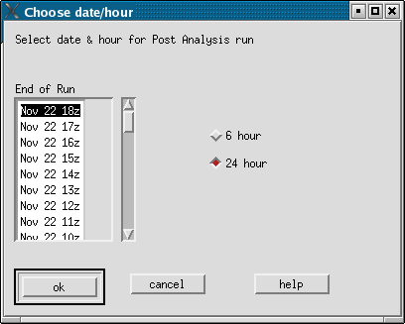

Figure 1 Post Analysis Choose date/hour Display

This row will be highlighted and the selection may be changed by clicking on another row.

Three buttons appear at the bottom of this window - "OK", "Cancel", and "Help". The "OK" button initiates Post Analysis processing for the selected date and hour. The "Cancel" button will exit Post Analysis without doing anything. Choosing the "Help" button pops up a window showing help text.

Many COOP observers stations report data around 12z with a duration of 24 hours. Selecting a date with hour = 12z and a 24 hour processing duration will often provide the most data rich case. METAR and/or other data may be available with 6 hour durations at hours 0z, 6z, 12z and 18z. Choosing other hours will generally result in no gage data since no data matches the specified end time and duration.

6.2 Main Window

An example of the main window for MARFC is shown in Figure 2. The main window consists of three parts: two geographic window displays and a legend bar. The upper window displays the summed hourly MPE field and the lower window displays the gage only field.

6.2.1 Summed Hourly MPE Field

This window displays a grid created by adding up the precipitation values for each grid bin from each previously saved hourly best estimate QPE file. The summation duration is 6 or 24-hour depending on the user’s selection in the “Choose date/hour” window. If there is an error reading any of the QPE files, an error message will be written to the post_analysis.log.

It should be noted that although MPE generates many precipitation fields (RMOSAIC, BMOSAIC, LMOSAIC, etc), Post Analysis reads only the field designated as the best estimate QPE field.

Post Analysis expects the best estimate gridded fields to be stored in the xmrg file format.

6.2.2 Gage Only Field

This window displays a gage only analysis grid based on the point precip data values. The point data is read from CurPP table. Only data with physical element = “PP” area are used. All gage values for gages located within the geographic area which have an observed time and duration that match the specified ending time and duration (6 hr or 24 hr) from the “Choose date/hour” window are considered. Note that the Post Analysis gage only field does not consider precip values with physical element = “PC”.

Appendix A details the algorithm for calculating the gage only field.

6.2.3 Legend

The legend shows the accumulation intervals in inches. The first color in the legend signifies missing data. The second color signifies a value of zero. The third color is for the interval greater than zero and less than the first non-zero value. All colors except the last are for values within the specified interval (greater than or equal to lower value and less than higher value). The last color corresponds to all values greater than the lower value.

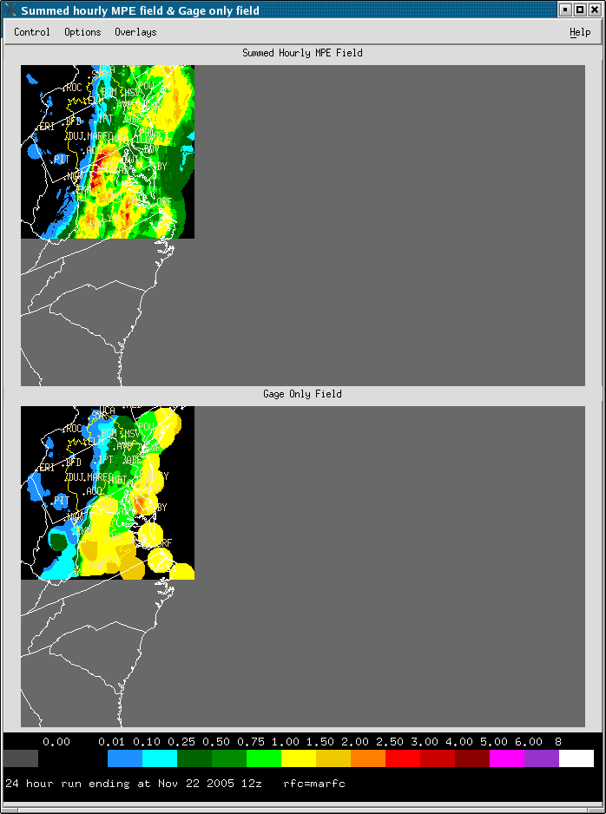

Figure 2 Summed Hourly MPE field and Gage Only Field

6.3 Control Menu

The Post Analysis “Control” menu contains two options: “Merge Data” and “Quit”. The Quit option simply terminates the application.

6.3.1 Merged Data

Selecting this option results in the display of a grid which is created by merging the summed hourly best estimate field with the gage only field. This merged field can be used to generate new best estimate fields or to update previously generated best estimate fields using a time distribution method. A sample merged field is displayed as Figure 3. Appendix B describes the algorithm for calculating the merged field and for updating previously generated fields.

The merge data window has a menubar with two options: Control and Overlays. The “Overlays” option allows various overlays to be displayed on the window. The Control menu option has three sub-options: Quit and Save→Save/separate, Quit and Save→Save/overwite and Close Window.

Selecting “Save/separate” causes the new time distributed hourly MPE fields generated from merged field to be saved in a separate directory. Selecting “Save/overwrite” causes the new time distributed hourly MPE fields to overwrite the previous best estimate fields.

Note if there is at least one error occurring when reading the best estimate files to generate the merged field, no individual hourly MPE fields will be generated and saved since not enough accurate data can be used to calculate the time distributed hourly MPE fields.

.

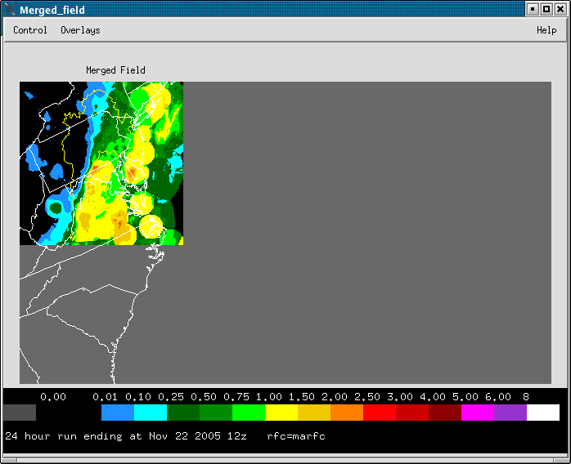

Figure 3 Post Analysis Merged Field Display

6.4 Options Menu

The “Options” menu includes the following options: “Zoom”, “Gage Table” and “Remove AP” submenus. Each is explained below.

6.4.1 Zooming

To activate the Zoom option, the user must first define the region to zoom. This is
done as follows:

- Press and hold the LEFT mouse button at starting point of the zoomed region in either display (this point will become the top left point of the zoom region).
- Drag the cursor until the desired area is enclosed within the rectangle
- Release the button
- Click on the "Zoom" option under "Options"

The rectangle can be defined on either display. Both displays are redrawn at the same zoom level. Selecting the "Zoom" option again will return the displays to the default unzoomed mode.
An example of a zoomed window with precipitation gages display is shown in Figure 4.

Certain features are available only in zoom mode. The “Gage Identifiers” and “Gage Values” under the “Overlay” menu and the 7x7 popup can be activated only in zoomed mode.

6.4.2 Gage Table

The gage table option presents a table with the following columns:

- Gage identifier
- Gage Value (units = inches)
- Closest Summed Hourly Best Estimate value of 9 nearest neighbor bins to the gage value
- Lowest Summed Hourly Best Estimate value of 9 nearest neighbor bins to gage location
- Highest Summed Hourly Best Estimate value of 9 nearest neighbor bins to gage location
- Edit Column

Gage values are for gages with duration chosen in the “Choose date/hour” window. The gage table for the sample case is shown in Figure 5.

The gage table allows the user to enter new gage values for particular gages, and then update the value in the CurPP database table and redisplay the gage only field by selecting “Recompute Gage Only”. This option recomputes the gage only field with the new gage value(s) and redisplays it. Zoomed displays are not refreshed. Therefore, the display must be "unzoomed" to see the result.

The information in the gage table window can be ordered by 4 sort options:

- Gage value - display values in descending order
- Gage ID - display values alphabetically by gage identifier
- Ratio – display values in descending order. The value is the ratio of gage value to the best summed hourly MPE value (if gage value > best summed hourly MPE value), or the ratio of best summed hourly MPE value to the gage value (if gage value < best summed hourly MPE value)
- Difference - difference between the gage value and the closest gage value.

The sort option is for display purposes only. The edit gage value option is available with all sorting options.

6.4.3 Remove Ap option

This option replaces areas of the summed hourly MPE field deemed to be bad with missing values. To remove an area, click with the left mouse button and hold to create a rectangle as for the zoom option and then choose the "Remove Ap" option. This will cause the summed hourly MPE field to be recalculated with missing values substituted in the area removed. The merged field will replace these missing bins with the appropriate values from the gage only field.

More than one area may be removed. However, after each area is selected, the "Remove Ap" option must be chosen. This option is not available from zoomed mode.

6.5 Overlays Menu

Geographic data such as states, counties, cities/towns, river, and basin boundaries can be overlayed (if data is available) on the summed hourly MPE field display, gage only field display and merged field display whether in zoomed mode or not. Any already displayed overlay can be toggled off by re-selecting the overlay.

Note that the "Gage Identifiers" and “Gage Values” options under the "Overlays" menu pulldown are activated only in zoom mode and only if precipitation gage reports are available for the chosen duration and ending hour. When selected, this option displays the locations of all reporting precipitation gages by gage identifier. The actual location of the gage is at the lower left hand corner of the text. This overlay cannot be toggled on and off. It can be removed by toggling another overlay option.

6.6 Help Menu

Post Analysis supports the display of help popup windows, including an overview of the application and other topics include editing the bias table and editing radar coverage information.

6.7 Popup Displays

Two other types of popup windows for displaying information are available and are discussed in the following sections.

6.7.1 Locator Popup

Post Analysis has a capability to display a locator popup window by pressing and holding the right mouse button. This locator popup displays the HRAP coordinates, latitude/longitude, county name, MAP basin name, summed hourly MPE precipitation value and the gage only precipitation value at the location of the cursor.

The locator popup can be activated from summed hourly MPE field display, gage only field display, merged field display, and from displays in zoomed mode.

6.7.2 7x7 Summed Hourly MPE Field Popup

While the displays are in zoomed mode, and when “Gage Identifiers” or “Gage Values” are activated, Post Analysis can display a 7x7 grid popup by clicking the left mouse button anywhere in a zoomed window. This window shows the values of the 7x7 nearest neighbor summed hourly grid bins centered on the gage closest to the cursor location. The gage is chosen automatically and may be inside or outside of the zoomed window. The gage ID is given on the left column along with the 6 or 24-hour gage precipitation value.

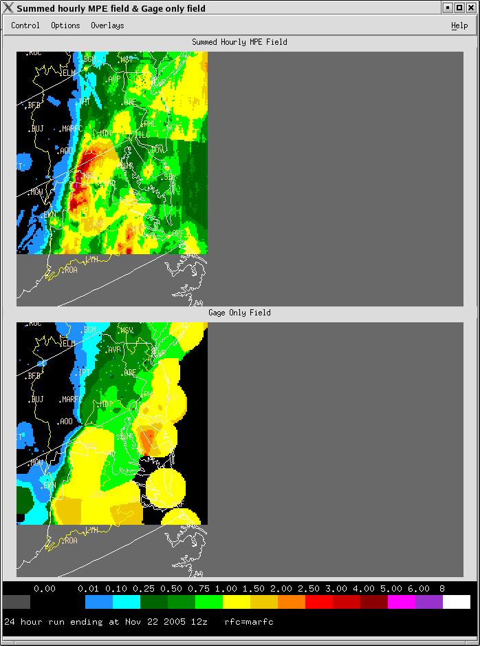

Figure 4 Post Analysis Main Window (Zoom Mode)

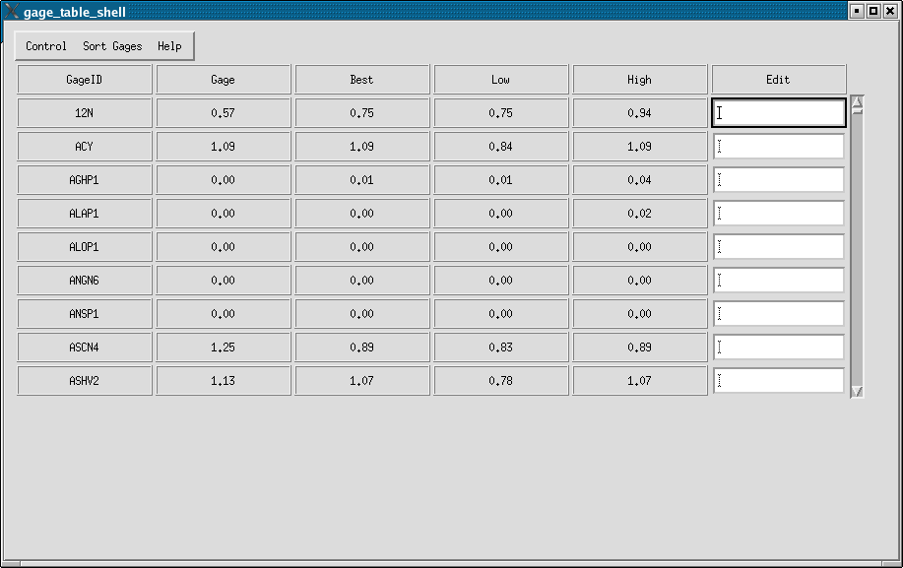

Figure 5 Post Analysis Gage Table (sorted by gage value)

Appendix A. Gage Only Field Generation Algorithm

The following parameters are read from the S3PostAnalParams table:
MINVAL = minimum precipitation value threshold
MINDIST = minimum distance value threshold
IWIND = distance weighting factor

Define the following variables:
PRECIP = the Summed Hourly QPE field
DISTANCE = the distance from point i, j to gage ig
gage_value(ig) = the gage value of gage ig
gageonly_value(i,j) = the gage only field value at location (i,j)
allzero = TRUE or FALSE
lowgage = TRUE or FALSE
dist(ig) = distance between point i,j and gage ig
WEIGHT(ig) = weighting factor from gage ig.
DENWT = variable used in calculating WEIGHT(i,j)
weighted_value(i,j)= sum of weighted gage values on point(i,j). It considers all reporting
gages’ weights. Also weighted by the PRISM value.

Calculate allzero:
If (all 8 surrounding bins from to bin i,j have PRECIP = 0)
allzero = TRUE
else
allzero = FALSE

Calculate lowgage:
If (allzero = TRUE and any DISTANCE < MINDIST and gage_value(ig) > MINVAL)
lowgage = TRUE
else
lowgage = FALSE

Calculate the gage only value at each bin i,j :
If (lowgage = TRUE or allzero = FALSE)
gageonly_value(i,j) = weighted_value(i,j) (see below)
else
gageonly_value(i,j) = 0.0

Note that the “allzero” parameter above “shapes” the gage-only field according to the Summed Hourly QPE field. The gage-only field for a bin is set to 0.0 if all 8 surrounding bins from the Summed Hourly QPE field are 0.0. This algorithm for calculating the gage-only field was originally used by the StageII application. It has been replaced by a different algorithm in MPE.

Weighted Value Computation Scheme:

a) Calculate dist(ig)

b) For all gages with dist(ig) < MINDIST, compute
DENWT = DENWT + exp(-dist(ig) / IWIND)

c) If (no gages have dist(ig) < MINDIST) then
WEIGHT(ig) = 0.0
else
WEIGHT(ig) = exp(-DISTANCE / IWIND) / DENWT

d)Calculate weighted_value(i,j)
weighted_value(i,j) = sum of weighted gage values from all reporting gages, where each weighted gage value is also weighted by the PRISM normals:

weighted_value(i,j)= WEIGHT(ig)*gage_value(i,j)* [xmptim(i,j) / xmptim(at gage)]

where xmptim = PRISM value (historical mean accumulation)

Appendix B. Merged Field Generation Algorithm

Use the following constants:
rhat = sample lag-1 spatial correlation of precipitation estimates; currently set to 0.95.; (read from S3PostAnalParams table)
misbin(i,j) = MISBIN data value for HRAP bin i, j .

Define the following variables:
gg(i,j) = the gage only field at bin i,j
shs(i,j) = the summed hourly value at bin i,j; considered missing if < 0.0
merge(i,j) = the merged field value at bin i,j
obw = observed weight for i,j
num = number of hours chosen for Post Analysis calculation (= 6 or 24)
precip1(i,j) = the hourly MPE field at bin i, j

a) For each HRAP bin i,j, compute merge field value:

if (gg(i,j)=0 and shs(i,j)=0) then
merge(i,j) = 0
else if (misbin(i,j) = 0) then
merge(i,j) = gg(i,j)
else if (number of reporting gages = 0) then
merge(i,j) = shs(i,j)
else
calculate obw (see below)
merge(i,j) = obw*gg(i,j) + (1-obw)*shs(i,j)

The observed weight is calculated as follows:
sc = scale constant, currently set to 1.0
lnrhat = ln(rhat) = ln(0.95) = -0.0513
dnear = distance in HRAP bins from i,j to closest gage
obw = exp(sc*lnrhat*dnear)

b) Compute ratio value:

if (shs(i,j) > 0.0) then
then ratio(i,j) = merge(i,j) / shs(i,j)
else
ratio(i,j) = -1*merge(i,j)

c) Perform time distribution:

if (ratio(i,j) < 0 ) then
precip1(i,j) = -ratio(i,j) / num
else
precip1(i,j) = precip1(i,j)*ratio(i,j)

