Guidelines for the Transition from FLDWAV to HEC-RAS; Forecast Implications and Transition Tools

Seann Reed, Fekadu Moreda, Angelica Gutierrez, Cécile Aschwanden

TABLE OF CONTENTS
1 Executive Summary 6
2 Overview 8
2.1 Intended Audience and Scope 10
2.2 Organization of this Document 11
3 Models 11
3.1 FLDWAV 11
3.2 HEC-RAS 12
3.3 Differences Between FLDWAV and HEC-RAS 13
3.3.1 Cross-section Geometry Representation 20
3.3.2 Manning’s n, Conveyance, and the Momentum Coefficient (β) 21
3.3.3 Ineffective Flow Areas 23
3.3.4 The FLDWAV AS Parameter 24
3.3.5 Blend Functionality within DWOPER and FLDWAV 25
4 Model Transition Approaches 26
4.1 Converting FLDWAV or DWOPER Models to HEC-RAS 26
4.1.1 The fld2ras Program Features 26
4.1.2 How to Use the fld2ras Program 27
4.1.3 Lateral Inflows 38
4.2 Converting OHD Calibration Time Series to DSS Format (Using oh2dss) 39
4.2.1 FLDWAV Time Series Data 39
4.2.2 The oh2dss and oh2dss_bat Scripts 39
4.2.3 How to Use the oh2ds Time Series Converter 40
4.2.4 How to Use the oh2dss_bat.py Time Series Convertor. 43
4.3 Obtaining and Using Existing HEC-RAS Models 44
5 Case Studies: Evaluating Converted Models 45
5.1 Study Areas 45
5.1.1 Tar River 45
5.1.2 Columbia River 48
5.1.3 Lower Mississippi, Ohio, Cumberland, Tennessee Model 51
5.2 FLDWAV to HEC-RAS Geometry and Manning’s n Conversions 52
5.3 Comparing Simulations from Symmetric and Detailed Cross-Section Models 54
5.3.1 Tar River Results 54
5.3.2 Lower Columbia River Results 56
5.4 Choice of Bank Station Locations for Converted Models 59
5.5 A Rating Curve as an Internal Boundary for the Lower Columbia 66
5.6 Verifying the AS Representation on the Lower Columbia 66
5.7 Ineffective Areas 67
5.7.1 Mississippi River Model 67
5.7.2 Lower Columbia River Model 69
5.8 Impacts of Using 4 Digits for Manning’s n Specifications 74
6 Model Calibration Procedures 74
7 Python Statistics Script (eventstats_bat.py) 75
8 Summary and Conclusions 77
9 Recommendations for Future Work 79
10 Acknowledgements 80
11 References 81

FIGURES

Figure 3-1. Symmetric representation of a cross-section. 21
Figure 3-2. Illustration of the FLDWAV BSS parameter and our HEC-RAS approximation. The cross-section defined by the black line represents the full channel width from FLDWAV including BSS (total top width at each elevation is BS + BSS). The cross-section depicted with the pink line is the FLDWAV active channel (BS only). The green lines are the multiple blocked ineffective areas generated by the fld2ras program. 24
Figure 3-3 Representing the FLDWAV AS parameter in HEC-RAS. 25
Figure 4-1. Example of clipped river mile (red block) and cross-section data (green block) for input to the fld2ras program. 28
Figure 4-2. Example output file from the fld2ras program. This file is in HEC-RAS geometry file format. 29
Figure 4-3. Creating a new folder and a project. Once the project file name is setup, HEC-RAS will use this name with additional pre-specified extension to save all other files related to this project. For example, in the case of MissRiver, the project file is saved as MissRiver.prj, the geometry file is saved as MissRiver.g01, and the unsteady flow condition will be MissRiver.u01. If there is a second geometry file, it is saved as MissRiver.g02. 30
Figure 4-4. Geometry data editor. 31
Figure 4-5. Cross-section data editor 32
Figure 4-6. Saving the Geometry Data file. 32
Figure 4-7. Geometry data file. 33
Figure 4-8 Example of Ineffective Flow Area Specifications for a Cross-Section. 34
Figure 4-9. All cross-section data populated along the reach 34
Figure 4-10 Cross-section configuration at a junction. Adapted from Figure 4-3 in the HEC-RAS Hydraulic Reference Manual Version 4.0 35
Figure 4-11. Junction Data Editor. 37
Figure 4-12. Roughness factors entered from the plan menu. 38
Figure 4-13. HEC-DSSVue main window 41
Figure 4-14 . Browsing the script. 43
Figure 5-1. Location map for the lower Tar River 47
Figure 5-2. Profile from Tarboro to Washington 47
Figure 5-3. XYZ – plot of cross-section geometry from Tarboro to Washington 48
Figure 5-4 Location map for the lower Columbia model 50
Figure 5-5 Schematics for the two lower Columbia models: the (a) converted DWOPER (symmetric) model, and the (b) detailed, modified USACE model. 51
Figure 5-6 Schematic of the lower Mississippi model including the Ohio, Cumberland, and Tennessee tributaries. 52
Figure 5-7. A symmetric and detailed representation of a Tar River Cross-section. While the detailed cross-section is obtained from 105 survey points, the symmetric cross-section is represented by only 16 points, which were derived from FLDWAV (eight pairs of top widths (BS) and elevations (HS)). 53
Figure 5-8. Variation of Manning’s n versus flow for five cross-section reaches that are designated by the calibration gauges for the Tar River 54
Figure 5-9 FLDWAV and converted model (SYM) simulations at the Greenville station compared to observed stages. 55
Figure 5-10 FLDWAV and converted model (SYM) simulations at the Rock Springs station compared to observed stages. 55
Figure 5-11 Detailed model with Manning’s n from the steady state model(DET_RAW_n) and the detailed model after some manual calibration (DET_CAL_n) at the Greenville station compared to observed stages. 56
Figure 5-12 Detailed model with Manning’s n from the steady state model(DET_RAW_n) and the detailed model after some manual calibration (DET_CAL_n) at the Rock Springs station compared to observed stages. 56
Figure 5-13. Example of simulated and observed hydrographs for Columbia River at Vancouver with symmetric cross-section models. 58
Figure 5-14. Example of simulated and observed hydrographs for Columbia River at Wauna with symmetric cross-section models. 58
Figure 5-15. Example of simulated and observed hydrographs for Columbia River at Vancouver with FLDWAV and observed data compared to two detailed cross-section models (DET_FLDWAV_n, DET_CAL_n). 59
Figure 5-16. Example of simulated and observed hydrographs for Columbia River at Wauna with FLDWAV and observed data compared to two detailed cross-section models (DET_FLDWAV_n, DET_CAL_n). 59
Figure 5-17. (a) Cross-section geometry and (b) pre-computed elevation-conveyance curves for ‘Wide’ and ‘Regular’ stationing at cross-section 792242. 60
Figure 5-18(a) Cross-section geometry and (b) pre-computed elevation-conveyance curves for wide and regular stationing at cross-section 826927 61
Figure 5-19 Hydrographs for HEC-RAS models with ‘Regular’ and ‘Wide’ stationing compared to results from the simplified FLDWAV model at Rock Springs, NC. 62
Figure 5-20 Hydrographs for HEC-RAS models with ‘Regular’ and ‘Wide’ stationing compared to results from the simplified FLDWAV model at Grimesland, NC. 62
Figure 5-21 Cross-section 1000.40 on the Ohio River tributary with ‘Regular’ and ‘Wide’ cross-sections. 64
Figure 5-22 Example elevation-conveyance curve for the Ohio River cross-section 1000.40 without any flow-roughness factors applied. 65
Figure 5-23 Simulations from models with wide stationing and regular stationing at one location on the Ohio River. The effects of lower conveyance in the case of wide stationing are apparent. 65
Figure 5-24. Geometric representations in HEC-RAS to approximate the FLDWAV BSS parameterization for cross-section 953.0 on the lower Mississippi segment. The cross-section defined by the black line represents the full channel width from FLDWAV including BSS (total top width at each elevation is BS + BSS). The cross-section depicted with the pink line is the FLDWAV active channel (BS only). The green lines are the multiple- blocked ineffective areas generated by the fld2ras program. 67
Figure 5-25 Same as Figure 5-24 but zoomed in to show more details of the multiple-blocked ineffective areas that are defined. 68
Figure 5-26. Elevation-storage relation for cross-section 953.0. 68
Figure 5-27 Simulations with and without inactive storages from FLDWAV and HEC-RAS. 69
Figure 5-28 The ‘cave-in-bank’ concept is used to represent a spike in storage that occurs over a given elevation range (e.g. the height of the levee). Only water behind the levee is treated as inactive. Water in the off-channel area that is higher than the levee is treated as active. This is Figure 8.2 from Fread and Lewis (1998). 70
Figure 5-29 FLDWAV cross-section 20.7 from the Willamette River. 71
Figure 5-30 Cross-section 20.7 on the Willamette tributary from the UNET model. 72
Figure 5-31 Area-elevation relationships for the FLDWAV and HEC-RAS representations of cross-section 20.7. 73
Figure 7-1. Example input file for eventstats_bat.py 76
Figure 7-2. Example eventstats_bat.py output file. 76

TABLES

Table 3-1. NWS FLDWAV and DWOPER Model Inventory 18
Table 3-2. Representation of cross-section in FLDWAV and the equivalent in HEC-RAS 20
Table 5-1 Stage and flow data along the Tar River. 47
Table 5-2 Stage and flow locations in the lower Columbia system. All data used span the period February 1, 1995 – February 28, 1996. 50
Table 5-3. Bias and (RMSE) both in feet (ft) for the Tar River for the Period July 1, 1999 to August 31, 2005 54
Table 5-4. Bias and (RMSE) both in (ft) for the Columbia River 57
Table 5-5. Differences between simulations measured in terms of RMSE (ft) at four different validation points along the Tar River, NC. Analysis period is July 1, 1999 to August 31, 2005. 61
Table 5-6 Differences between simulations measured in terms of Bias (ft) at four different validation points along the Tar River, NC. 63
Table 5-7 Differences in FLDWAV-G relative to FLDWAV-AS for the main stem of the lower Columbia model. 66
Table 5-8 Effects of inactive storage areas on simulations at several stations along the Ohio and Mississippi River. Effects are measured by assuming the models including storage are the truth and computing the change after removing the storage. Values reported are RMSE in ft. For example, the ‘errors’ are for a FLDWAV model without storage relative to a FLDWAV model with storage. 69
Table 5-9. Difference between FLDWAV simulations with and without BSS for the lower Columbia River System 71
Table 5-10 RMSE and maximum difference of a FLDWAV simulation with four Digits of Manning’s n precision compared to a FLDWAV simulation with three digits of Manning’s n precision for four validation points in the Mississippi River System. 74
Table 8-1. Summary of steps to create a HEC-RAS model from an existing FLDWAV or DWOPER model 77

Executive Summary

NOAAs National Weather Service (NWS) is integrating the US Army Corps of Engineers (USACE) Hydrologic Engineering Center’s River Analysis System (HEC-RAS) software into the NWS Community Hydrologic Prediction System (CHPS). CHPS is the next generation software infrastructure intended to replace the NWS River Forecast System (NWSRFS). HEC-RAS will replace the Flood Wave Dynamic Model (FLDWAV) and Dynamic Wave Operation (DWOPER) and become the main 1-D hydraulic model for NWS river forecasting. By doing this, the NWS can take advantage of HEC-RAS features that are not available within FLDWAV or DWOPER and eliminate duplication of effort required in maintaining two similar 1-D hydraulic models at two US federal agencies. Because the NWS has defined an aggressive schedule to transition from NWSRFS to CHPS, River Forecast Centers (RFCs) need simple and inexpensive procedures to convert or replace DWOPER and FLDWAV models with HEC-RAS models. The NWS Office of Hydrologic Development (OHD) is currently investigating two approaches to meet this need: (1) transform existing FLDWAV and DWOPER models into HEC-RAS and (2) modify and calibrate existing HEC-RAS models created for a purpose other than operational forecasting (e.g. HEC-RAS models for flood insurance studies).

OHD evaluated these two approaches in the lower part of the Tar River, NC, and the lower Columbia River, OR. We compared FLDWAV and HEC-RAS results to each other and observed data. During the evaluation, we also developed recommended procedures and utility programs to assist with model conversions. Some model conversion challenges include determining equivalent hydraulic representations for cross-section geometry, ineffective flow areas, bridges, and channel roughness factors. While some FLDWAV features can be easily converted (e.g. basic cross-section geometry and Manning’s n roughness specifications), reproducing the effects of other FLDWAV model features such as the FLDWAV AS parameter (AS is the active flow area below the lowest defined cross-section elevation) and FLDWAV ineffective areas is more challenging. We provide tools and procedures to address these challenges.

In the Lower Columbia case study, converting the existing DWOPER model was more complex than the Tar River case and requires some manual steps. This is in part because the Lower Columbia is a four-reach model while the Tar River model includes only a one reach. In addition, FLDWAV ‘cave-in-bank’ inactive storage areas in the lower Columbia tributaries pose a unique challenge. We describe a solution to the ‘cave-in-bank’ storage difficulty that was developed in conjunction with NWRFC.

We also analyzed both FLDWAV and HEC-RAS versions of a Mississippi, Ohio, Tennessee, and Cumberland River model to develop better guidance on how to model ineffective areas, how to place bank stations, and how much precision is needed in Manning’s n roughness specifications.

To meet the short-term goal of implementing the equivalent of existing FLDWAV/DWOPER models in HEC-RAS, we recommend the direct conversion of FLDWAV models to HEC-RAS as a first cut. Both approaches considered produce comparable results and the model conversion approach requires substantially less work. This is in part because FLDWAV models have already been calibrated and they are designed to be simple and robust for operational forecasting. Because there are substantial differences between FLDWAV and HEC-RAS in how model geometry and parameterizations are defined, a converted model cannot produce the exact same results. However, our case studies indicate converted models can produce close results to FLDWAV. This approach should allow relatively quick model conversions while retaining most of the skill from existing FLDWAV models. Some refinement to converted models is recommended and can be accomplished through manual adjustment of Manning’s n values in HEC-RAS with relatively little effort. Regardless of whether one is working with a model converted from FLDWAV or modifying a HEC-RAS model from another source, we recommend developing an automatic calibration capability for HEC-RAS similar to the existing capability in FLDWAV.

This document describes key differences between FLDWAV (and DWOPER) and HEC-RAS and procedures to convert FLDWAV models to HEC-RAS. It also summarizes existing FLDWAV models and provides a detailed explanation of which features can be converted, which features can be overlooked in the conversion process and why. We analyzed a number of model variants to understand the relative importance of different model features. This helped to guide development of the conversion tools. To assist in efforts to check converted models in simulation mode and refine calibrations, we also describe scripts that can be used to convert existing flow and stage time series to HEC-RAS compatible format and compute statistics on simulated time series.

Overview

In 2007, a team of National Weather Service (NWS) hydrologists reviewed several well-known hydraulic models to identify methods to improve hydraulic modeling capabilities for NWS operational forecasting. The NWS report “Evaluation of Hydraulic Models in Support of NWS Operations” recommends integrating the United States Army Corps of Engineers (USACE) Hydrologic Engineering Center’s River Analysis System (HEC-RAS) into the NWS operational forecasting environment (NWS Hydraulic Model Evaluation Report, 2007; USACE, 2008a and b). NWS forecasters currently use Flood Wave Dynamic Model (FLDWAV) and Dynamic Wave Operation (DWOPER) (Fread and Lewis, 1998; Fread, 1978) for operational hydraulic modeling. The NWS Hydraulic Model Evaluation Report (2007) also recommends testing FLDWAV and HEC-RAS on identical data sets and developing methods to transform FLDWAV models to HEC-RAS. This report follows those recommendations.

This document describes guidelines and procedures to assist National Weather Service River Forecast Centers (RFCs) in developing and calibrating HEC-RAS models for operational forecasting. Software engineering efforts are ongoing to include HEC-RAS in the Community Hydrologic Prediction System (CHPS). Soon after the NWS Hydraulic Model Evaluation Report was released, OHD management set a goal to fully transition away from Flood Wave Dynamic Model (FLDWAV) and Dynamic Wave Operation (DWOPER) and only include HEC-RAS in the first release of CHPS. The assumptions behind this decision were that (1) HEC-RAS can provide equivalent functionality capable of replacing existing FLDWAV and DWOPER models (with relatively minor HEC-RAS enhancements), and (2) through collaboration with HEC, it will be more economical to maintain and enhance HEC-RAS alone, rather than independently maintaining HEC-RAS, DWOPER, and FLDWAV. In addition to reducing duplication of effort, the transition to HEC-RAS will allow the NWS to take advantage of features not available or not as well developed within FLDWAV (e.g. a more advanced Graphical User Interface, additional modeling functionality, better documentation, and more readily available training).

Although the basic one-dimensional model equations solved by FLDWAV and HEC-RAS are the same, there are substantial differences in the model parameterization and solution methods. Unlike the hydrology models that are being ported from the National Weather Service River Forecast System (NWSRFS) into CHPS, which will require no model or parameterization changes, implementing acceptable hydraulic models using HEC-RAS will require new model development. The substantial differences between FLDWAV and HEC-RAS, combined with the aggressive CHPS implementation schedule, make this transition a big challenge. This report describes scientific methods and guidance that the OHD Hydraulics Group has developed to address this challenge.

Three possible approaches to develop acceptable HEC-RAS models are to:

(1) convert existing DWOPER or FLDWAV models to HEC-RAS
(2) obtain an existing HEC-RAS model developed for other purposes and modify it to meet RFC needs
(3) create new HEC-RAS models from scratch using HEC Geo-RAS or other tools

The effort required to develop acceptable models will increase from the first to second to third approaches. Either of the first two approaches can save time over building a new model from scratch because they take advantage of schematization, cross-section geometry data, and hydraulic feature data developed by others. The first approach can take advantage of calibrated roughness values from FLDWAV that provide a useful starting point for HEC-RAS modeling. The second approach requires more effort than the first because the available model domain and boundary conditions may not exactly match RFC needs, the roughness values assigned for other applications are not likely to be suitable for continuous modeling over a wide range of flows, and the model may not be stable under all flow conditions of interest.

To take advantage of the information in existing FLDWAV and HEC-RAS models and attempt to meet the CHPS project schedule, we only address the first and second approaches in this document. The third approach is well documented elsewhere (e.g. HEC-RAS User’s Manual, HEC-RAS Hydraulics Reference Manual, and HEC-RAS Training Classes).

To evaluate the first two approaches, we developed and compared HEC-RAS models for the lower part of the Tar River, NC, and the lower Columbia River between Washington and Oregon. For both rivers, we compared FLDWAV and multiple HEC-RAS simulations to observed stage data at multiple points, statistically and graphically. In addition, multiple scenarios of interest were compared within each modeling approach, e.g. cases with and without calibration.

In addition to the case studies to convert the Tar and Columbia River models, we studied 28 additional RFC operational FLDWAV decks to understand which FLDWAV features are used and which must be converted to HEC-RAS. This inventory indicated that some FLDWAV features are not used and therefore we did not spend time in developing methods to replicate these features in HEC-RAS.

We developed utility programs to assist RFCs in converting their FLDWAV and DWOPER models to HEC-RAS. The main utilities include a model conversion program (fld2ras), a time-series conversion program (oh2dss.py), and a statistical analysis program (eventstats_bat.py) that automatically converts several major model features. The fld2ras program has the ability to (1) replicate FLDWAV symmetric geometry in HEC-RAS, (2) approximately convert FLDWAV ineffective flow areas into HEC-RAS, and (3) account for the FLDWAV option to specify active flow area below the channel cross-section (AS, an option not available in HEC-RAS).

Intended Audience and Scope

This document is primarily intended as training material for NWS forecasters to help them develop HEC-RAS models to replace existing FLDWAV models. The document provides specific instruction on how to convert models and time series (Section 4), and describes case studies illustrating the effectiveness and limitations of model conversion procedures (Section 5). A secondary purpose of the modeling experiments described in this document is to identify future enhancements needed to our hydraulic modeling software.

Customized unsteady modeling and model conversion lectures and workshops will be developed based on the information included in this document. Some information provided here (e.g. descriptions of calibration approaches and methods to convert time series to DSS format) will also be helpful for developing new models for rivers that were not modeled using FLDWAV. The document assumes knowledge of hydraulic modeling principles and the HEC-RAS software. To fully understand model conversion issues, the user must also have basic knowledge of FLDWAV and/or DWOPER. This document is intended to supplement information in the existing HEC-RAS User’s Manuals (USACE, 2008), the FLDWAV User’s Manual (Fread and Lewis, 1998), and standard HEC-RAS Steady and Unsteady Flow Training Courses. We draw upon information found in these manuals to emphasize points that are particularly important for operational forecasting with HEC-RAS.

Some procedures described here also require the use of the HEC Data Storage System Visual Utility Engine (HEC-DSSVue) software and Python scripts that call HEC-DSSVue functions. Step-by-step instructions are provided on how to execute the procedures so in-depth knowledge of HEC-DSSVue is not required (Section 4.2). However, readers are strongly encouraged to download and read the HEC-DSSVue user documentation to enhance their understanding (USACE, 2005).

This document covers only development and calibration of HEC-RAS models. Information on how to set up HEC-RAS for operational runs within CHPS will be provided through separate documentation and training. In addition, this document focuses on runoff-generated flood waves as opposed to dam break generated flood waves. Conversion of NWS dam break models to HEC-RAS requires additional considerations and we will address this issue in a separate project with separate documentation.

The first version of this document focuses on the needs of the four front-runner RFCs in the CHPS transition process (referred to as CHPS Acceleration Team or CAT - RFCs). Due to this, our case studies did not include converting a FLDWAV model with the lock and dam feature. As we begin to work with non-CAT RFCs, we will add any material necessary to complete the guidance for model transition.

Organization of this Document

Section 3 summarizes the basic features of FLDWAV and HEC-RAS and highlights key differences. It also describes an inventory of RFC FLDWAV models that helps to focus the remainder of the document on the most critical topics. Section 4 describes recommended procedures for model transition. In addition to procedures for creating HEC-RAS models, Section 4 also describes procedures for converting NWS calibration time-series data into the HEC-DSS format used by HEC-RAS. Transitioned models will likely require some level of model refinement through adjustment to Manning’s n values. Section 5 describes case studies evaluating converted models. Section 6 provides information on where to look for model calibration guidance. Section 7 describes DSSVue-based Python scripts for statistical calculations that are useful for evaluating model results. Section 8 summarizes the document and provides conclusions and Section 9 gives recommendations for future work.

Models

FLDWAV

DWOPER is the initial dynamic wave model developed by Fread (1978). Later, in an effort to combine DWOPER with a stand-alone NWS dam break program (DAMBRK; Fread, 1988), FLDWAV emerged as a comprehensive dynamic hydraulic model that can be used to simulate river networks with several hydraulic structures including an option to simulate dam failure or series of dam failures. FLDWAV is being used in day-to-day forecasting on over two dozen large rivers in the United States and several rivers elsewhere in the world. The model is based on the implicit finite difference solution of the complete one-dimensional Saint-Venant equations of unsteady flow.

The two basic equations are the continuity and momentum equations, 3-1 and 3-2, respectively.

$\frac{∂Q}{∂x}+\frac{∂s_{\text{co}}(A+A_{o})}{∂x}−q=0$ 3-1

$\frac{∂(S_{m}Q)}{∂t}+\frac{∂({{βQ}^{2}}/A)}{∂x}+\text{gA}\left(\frac{∂h}{∂x}+S_{f}+S_{e}+S_{i}\right)+L−W_{f}B=0$ 3-2

Where Q is the flow, h is the water-surface elevation, A is the active cross-sectional area of flow, A_{o} is the inactive off channel storage area, S_{co} and S_{m} are sinuosity factors, x is longitudinal distance along the rive channel, t is the time, q is the lateral inflow or outflow, β is the momentum coefficient for velocity distribution, g is the acceleration due to gravity, S_{f} is the channel flood-plain boundary friction slope, S_{e} is the expansion-contraction slope, S_{i} is additional friction slope for viscous fluids and debris flow, B is that active top width and W_{f} is the effect of wind resistance on the surface of flow.

For flow with negligible wind effect, negligible eddy losses due to expansion and no mud flows, Equation 3-2 can be simplified as follows.

3-3

In the derivation of the Saint-Venant equations, it is assumed that the water surface normal to the direction of flow is horizontal. Chow et al. (1988), Chapter 9, summarize other assumptions required to derive these equations. Although the accuracy of these equations is limited by the inherent assumptions of 1-D modeling, both FLDWAV and HEC-RAS provide additional provisions for modeling off-channel storage, resulting in a quasi-2D representation.

Among the slope terms that are listed in the above equation, it is important to describe the S_{f} as it is central to the model parameterization.

$S_{f}=\frac{n^{2}\left|Q\right|Q}{μ^{2}A^{2}R^{43}}=\frac{\left|Q\right|Q}{K^{2}}$ 3-4

3-5

In Equations 3-4 and 3-5, n is the Manning’s n coefficient of frictional resistance, μ is a unit conversion factor, 1.49 for English units and 1.0 for SI units, R is the hydraulic radius and K is the conveyance. The equations are solved using the well-known four-point implicit box finite difference schemes (Fread, 1985, describes this implicit scheme and its applications).

HEC-RAS

HEC-RAS is an integrated system of software comprised of a graphical user interface (GUI), separate hydraulic analysis component, and data storage management (USACE, 2008). Though the system has several modules, in this paper we focus only on the unsteady flow simulation capability.

The unsteady flow model solves essentially the same equations as FLDWAV (Equations 3-1 and 3-2), except that HEC-RAS 4.0.1 does not include the wind effects term, the expansion and contraction slope term (S_{e}), or the viscous fluid term (S_{i}) (most similar to Equation 3-3). Similar to FLDWAV, HEC-RAS uses a four-point implicit finite difference scheme to generate a set of finite difference equations. However, HEC-RAS solves the finite difference equations using linearization and a sparse matrix linear algebra solver while FLDWAV applies Newton-Raphson iteration and a quad-diagonal, Gaussian elimination algorithm to solve the nonlinear equations.

The HEC-RAS 4.0.1 GUI and computational engines only run on Windows; however, the computational engines are being ported to Linux to work within the NWS CHPS environment.

Differences between FLDWAV and HEC-RAS

Numerous differences exist between FLDWAV and HEC-RAS with respect to both parameterization and optional functionality. Some of these differences must be addressed in converting FLDWAV models to HEC-RAS, while others may be overlooked. For example, some FLDWAV functions are not used by any of the RFCs as discussed below; therefore, we are not spending time in this project to try to replicate these model features in HEC-RAS.

To help focus efforts for this transition project, we studied 28 RFC FLDWAV and or DWOPER input decks and the options used. Table 3-1 summarizes this model inventory. Succinct descriptions of noteworthy differences are provided here, complementing the information in Table 3-1. Some of the most important differences are described in more detail in the subsections that follow. This information is based on the description of FLDWAV given by Fread and Lewis (1998), the HEC-RAS 4.0 User’s Manual, the HEC-RAS 4.0 Hydraulic Reference Manual and the authors’ experiences.

Because the focus here is on transitioning from FLDWAV to HEC-RAS, this list of differences does not include all HEC-RAS options that are not available within FLDWAV. RFCs will likely want to take advantage HEC-RAS features such as ice jam and sediment transport modeling not available in FLDWAV, but detailed discussion of these topics is beyond the scope of this document.

- FLDWAV represents cross-section geometry using elevation-top width pairs. In all applications we have examined, cross-sections in FLDWAV are symmetric. There is an option to define left and right overbank areas of different widths in FLDWAV (causing asymmetry) but we have not seen this option used. HEC-RAS represents cross-section geometry using distance-elevation pairs. HEC-RAS cross-sections can be symmetric but are most often irregular to match the natural landscape. Section 3.3.1 discusses this difference in more detail.

- FLDWAV and HEC-RAS differ in the methods available to calculate the friction slope (S_{f}). Both FLDWAV and HEC-RAS compute a composite conveyance (K) in each cross-section to solve for S_{f} (See Equations 3-4 and 3-5); however, the available methods to calculate the composite K differ. Differences in how Manning’s n values are specified and differences in the definitions of left and right overbanks result in conveyance differences. Section 3.3.2 provides a more detailed discussion of these differences and Section 5 demonstrates the implications when converting models.

- HEC-RAS also computes the weighted velocity distribution factor (β) in Equation 3-3 based on independent calculations of velocity in the overbank sections and main channel. FLDWAV would compute this weighting factor as well, if the floodplain option were turned on. When the floodplain option is off in FLDWAV, the velocity distribution factor (β) for the momentum equation is set to 1.06. Section 3.3.2 describes the implications of this difference.

- The geometric representation of ineffective flow areas used in FLDWAV cannot be exactly reproduced in HEC-RAS. In FLDWAV, the BSS parameter is used to define ineffective flow areas. Sixteen of the decks summarized in Table 3-1 use BSS. Section 3.3.3 describes an approximate approach for translating this information from FLDWAV to HEC-RAS and Section 5 discusses the expected impacts.

- FLDWAV allows the user to specify an active cross-sectional area below the lowest elevation specified for a cross-section (AS parameter). This option is not available in HEC-RAS. Section 3.3.4 describes an approximate approach for translating AS information into HEC-RAS. Five of the decks in our inventory use the AS parameter.

- Five of the RFC models in our inventory use dams and five use lock and dam elements. HEC-RAS has dam and lock and dam modeling capabilities. This version of the document does not cover converting dam and lock and dam elements to HEC-RAS since there were none in our case studies. As we begin to assist non-CAT RFCs in model conversions, we will analyze any differences in FLDWAV and HEC-RAS lock and dam capabilities and add any necessary guidance.

- FLDWAV offers a bridge modeling option; however, the bridge geometry representations in FLDWAV tend to be simpler than those in HEC-RAS. It can be seen from Table 3-1 that only two of the FLDWAV decks we examined explicitly define bridge geometry; therefore, we did not develop an automatic conversion tool for bridge data. For the Tar River model, we manually recreated the HEC-RAS bridges within FLDWAV. HEC-RAS provides an extensive set of bridge modeling options that are not available in FLDWAV. The NWS must learn how and when to take advantage of these options to develop new and improved operational forecast models. Our experience with HEC-RAS on the Tar River is that creating stable unsteady flow models that include bridges is much more challenging than creating models without bridges.

- FLDWAV explicitly includes an expansion and contraction slope term S_{e} in Equation 3-2 while HEC-RAS 4.0.1 does not. This term accounts for head losses due to the formation of large scale eddies where channel geometry changes rapidly (Fread, 1978). Table 3-1 indicates that only one FLDWAV deck (for the Tar River) used the expansion-contraction slope (FKEC) option. An experiment running the Tar River deck with and without the FKEC option showed very small simulation differences at validation points and at cross-sections just upstream of the FKEC instances. Therefore, this parameter is not important in transitioning our existing FLDWAV models. This term may be important for future applications of HEC-RAS, but further study will be needed to determine how important. HEC would be willing to add the S_{e} term into HEC-RAS if we find it to be a high enough priority in the future and provided funding for this enhancement.

- In FLDWAV, users can choose to calculate the hydraulic radius (R) with the expression R = A/B or with R = A/P where A is cross-section area, B is top width, and P is wetted perimeter. In HEC-RAS, hydraulic radius is always calculated using R = A/P. Table 3-1 shows that all FLDWAV decks we examined used the option A/B. Comparisons of FLDWAV simulations on the Tar River (a relatively narrow river among the FLDWAV models) using both A/B and A/P showed practically no difference in simulations. Therefore, we are not concerned with this difference in the transition process.

- FLDWAV allows users to input Manning’s n values with up to four decimals of precision. Table 3-1 shows that it is common to use four decimal points of precision in FLDWAV. Specification of flow roughness factors in HEC-RAS is limited to three decimal points. Thus, our approach for duplicating FLDWAV Q-n values is limited to three decimal points of precision. In general, we cannot justify four decimals of precision using physical data to define Manning’s n parameters; however, the example presented in Section 5.8 shows that even the difference between three and four decimals of precision affect simulations on the Mississippi River by up to 0.75 ft during a large event.

- In FLDWAV, the user can specify a sinuosity factor as a function of elevation to account for differences in flow path lengths between low flows that are constrained to the channel and high, overbank, flows, which may take a more direct path between two points. In HEC-RAS, the user can account for this effect by specifying different lengths for the main channel, left overbank, and right overbank. There were no user specified sinuosity factors in any of the FLDWAV input decks we examined (As indicated by KFLP = 0 in Table 3-1). Therefore, we did not develop techniques to convert FLDWAV sinuosity information into HEC-RAS format.

- FLDWAV does include a wind term in Equation 3-2 (albeit a limited functionality that only allows for unidirectional and constant wind) while HEC-RAS 4.0.1 does not. Because none of the FLDWAV decks we examined used the wind option (Table 3-1), we can move forward with the transition without having a wind effects term available in HEC-RAS. However, NWS (2007) describe wind effects modeling as a ‘vital’ need for RFCs. Therefore, we have initiated a separate project to provide wind effects modeling capabilities to RFCs.

- FLDWAV provides an automatic calibration feature described by Fread (1985) and Fread and Smith (1978). HEC-RAS 4.0.1 does not have an equivalent capability. Results from our case studies described below highlight the need for this capability as discussed in Section 9.
- FLDWAV and HEC-RAS provide different tools to address hydraulic situations that can cause non-convergence in the finite difference solution or other computational problems. For example, if a hydrograph is rising rapidly, a smaller time step may be required. In this case, FLDWAV provides an automatic, global, time step adjustment capability. HEC-RAS also provides some automatic time step adjustment capabilities but implementing these capabilities requires some additional user setup. For specific boundary points, the HEC-RAS user can choose to monitor rapid flow changes at boundary points and have the program adjust the time step if a user specified change threshold is exceeded. FLDWAV also provides the capability for dynamic, automatic cross-section interpolation in certain situations. HEC-RAS offers a tool for cross-section interpolation but requires the user to decide when and how to use this tool prior to calculations. FLDWAV also automatically adjusts the weighting factor (‘theta’) that controls the degree of implicitness in the numerical solution scheme during calculations while HEC-RAS does not. Generally, HEC-RAS offers more user control over parameters that can affect model stability while FLDWAV provides more automatic adjustments to prevent non-convergence. The latter philosophy stems from a focus on emergencies in which the forecaster will not have time to diagnose non-convergence problems. The former approach provides the benefit that the user is forced to understand more about how the model works. The HEC-RAS approach should be acceptable for forecasting if adequate testing of the model is done prior to implementation. The amount of effort required to prove that this is true and do adequate model testing is not yet known, and therefore contains risks within the aggressive CHPS transition timeline. In this document, we do not provide any new knowledge about instability considerations beyond what is provided by HEC documentation and training. However, as part of the overall FLDWAV to HEC-RAS transition projects, training on HEC-RAS model, stability, accuracy, and sensitivity will be provided.

- In application of any hydraulic model, it is often necessary to adjust input and output stage data to match the datum of the cross-sectional geometry data. In NWSRFS operations, gauge data correction factors are often applied within the FLDWAV operation. HEC-RAS does not make these adjustments internally; however, the solution to this problem is simple. When running HEC-RAS within CHPS, any necessary gauge datum adjustments to stage time series will be made using other CHPS functions external to HEC-RAS. For preparing data for model calibration, we provide a simple datum adjustment option in the oh2dss script described in Section 4.2.

- The operational versions of FLDWAV and DWOPER have an option to internally blend observed and forecast tide time series to generate a downstream boundary condition. This data pre-processing is independent of the hydraulic model calculations. An equivalent functionality will be provided within CHPS, but outside of HEC-RAS. See Section 3.3.5 for further discussion.

Table 3-1. NWS FLDWAV and DWOPER Model Inventory

AS: FLDWAV parameter that indicates an amount of active flow area below the lowest defined point in the cross-section geometry.

BSS: FLDWAV parameters defining inactive flow areas.

FKEC: FLDWAV expansion and contraction coefficients.

KFLP: A FLDWAV parameter that controls whether the friction slope S_{f} is calculated using a composite channel or using separate calculations for the main channel, left and right floodplains. If KFLP=0, then a composite channel is used and no left or right floodplains are defined. Note that a composite channel is used for all the decks we examined. DWOPER does not have this option.

MIXF: If this value is 5, users have chosen to use the Local Partial Inertia (LPI) technique (Fread et al. 1996) designed to maintain computational stability during mixed flow (supercritical-subcritical) situations. The LPI technique is also available within HEC-RAS. Users should simply be aware of when this option needs to be turned on.

KPRES: A FLDWAV parameter that controls how the hydraulic radius (R) is calculated. If KPRES = 0, R = A/B, and if KPRES = 1, R = A/P where A = cross-section area, B = top width, and P = wetted perimeter.

Cross-section Geometry Representation

In FLDWAV, surveyed river cross-sections are most often approximated by symmetric cross-sections with the lowest tip point at the middle. These symmetric cross-sections are represented by predefined number of pairs of top width (BS) and elevation (HS). The total number of pairs in FLDWAV is designated by the NB parameter. Typically, five to eight pairs are required to define a cross-section. For a given FLDWAV river model, the definition of the number of pairs is a fixed value for all the cross-sections. Table 3-2 and Figure 3-1 describe a typical FLDWAV cross-section. In this example, the cross-section is represented with eight pairs of BS and HS. The first entry in the FLDWAV representation is the lowest point for a cross-section with a V-shaped bottom.

Another example of cross-section representation in FLDWAV is when there is a width (BS) specified for the bottom of the channel. In this case, the channel bottom is represented by two stations with the same elevation. The major difference between the two representations is that the number of station-elevation pairs is 2*NB-1 for v-shaped and 2*NB for the flat-bottom cross-section. Both bottom types, v-shaped or flat, can be translated to the HEC-RAS cross-sections.

In order to represent the symmetric cross-section of FLDWAV in HEC-RAS, the BS versus HS pairs are translated to X, Z (station versus elevation). The station coordinates start from the left-most station and the deepest point is at the center of the cross-section.

Table 3-2. Representation of cross-section in FLDWAV and the equivalent in HEC-RAS

FLDWAV |  |  | HEC-RAS
BS | HS |  | X | Z(Elevation)
(FT) | (ft) |  | (ft) | (ft)
0 | 7.3 |  | 0 | 60.0
200 | 12.6 |  | 1 | 48.5
234 | 18.4 |  | 666.5 | 48.0
419 | 29.6 |  | 677.5 | 38.1
480 | 38.1 |  | 708 | 29.6
502 | 48.0 |  | 800.5 | 18.4
1833 | 48.5.0 |  | 817.5 | 12.6
1835 | 60.0 |  | 917.5 | 7.3
 |  |  | 1017.5 | 12.6
 |  |  | 1034.5 | 18.4
 |  |  | 1127 | 29.6
 |  |  | 1157.5 | 38.1
 |  |  | 1168.5 | 48.0
 |  |  | 1834 | 48.5
 |  |  | 1835 | 60.0

Figure 3-1. Symmetric representation of a cross-section.

Manning’s n, Conveyance, and the Momentum Coefficient (β)

Manning’s n is a key parameter required for conveyance calculations (Equation 3-5). Although Manning’s n values can be approximated using a combination of look-up tables and engineering judgment or site measurements, Manning’s n is often used as a model calibration parameter. Manning’s n values change with water level and values in look-up tables do not typically define the depth associated with reported Manning’s n values. Within the main channel, the Manning’s n tends to decrease as the water depth increases (Chow, 1959). Most FLDWAV implementations use a composite n value for both the main channel and floodplain. With this approach, the composite Manning’s n may decrease with depth in the main channel and then show an increasing trend with flow above bank full. This is because flow oftentimes will encounter greater frictional resistance in floodplains due to brush and trees (Figure 5-25).

To account for variations with water level, FLDWAV has the option to define Manning’s n as a function of stage or flow for user defined reaches. In nearly all FLDWAV applications, flow-Manning’s n relationships are used rather than stage-Manning’s n relationships. Although it may be easier to relate stage to Manning’s n at individual cross-sections by examining physical features such as vegetation, the flow-Manning’s n approach is more practical for calibration. A practical calibration approach applies the same flow-Manning’s n relationship across many cross-sections in a reach. This inherently assumes that the breaks in Manning’s n occur at a similar flow level in different cross-sections. The geomorphology literature tying channel form to flow level supports this assumption (e.g. Leopold, 1994). On the other hand, one would expect the stages associated with breaks in Manning’s n to vary more than the flows from cross-section to cross-section. Calibration of Manning’s n values for different flow levels is relatively straightforward. In addition, if calibration causes Manning’s n values to depart from published ranges, the modeler knows to check other parts of the model for errors.

In typical HEC-RAS applications, Manning’s n values vary horizontally along a cross-section with higher values typically assigned in the floodplain. This can produce a similar effect to the typical FLDWAV application of defining composite Manning’s n values that tend to increase when high flows reach the floodplain, reflecting the physical presence of brush, trees, or man-made structures in the floodplain. Assigning fixed Manning’s n values that do not vary with depth or flow can be reasonable for design applications (e.g. when models are calibrated against only single events using high water marks or rating curves); however, this approach cannot properly represent the physics for unsteady modeling across a range of flows. Therefore, HEC-RAS also provides the option to specify flow roughness factors as a function of flow. Using this feature, we can reproduce FLDWAV Manning’s n parameterizations within HEC-RAS as discussed in more detail in Section.4.1.2.

Note that HEC-RAS 4.0 limits specification of flow roughness factors to uniform flow increments. However, it is common in FLDWAV applications to specify Manning’s n-flow tables using non-uniform flow increments. Therefore, through a Memorandum of Agreement between HEC and NWS, HEC has added the option to define flow roughness factors on non-uniform flow increments and has made this capability available for this study through HEC-RAS 4.0.1 Beta.

Although there are good physical reasons for defining separate roughness properties in the floodplain, Table 3-1 indicates that all FLDWAV decks in operational use define properties only for a composite channel. DWOPER does not allow separately modeling of the floodplain. Therefore, in this study we only developed a tool for model conversions where no floodplain is defined in FLDWAV.

Although it is relatively straightforward to reproduce geometry for a FLDWAV channel in HEC-RAS, HEC-RAS requires left and right channel bank stations to be defined while FLDWAV does not. Using the bank station information, HEC-RAS normally computes conveyances separately for the left overbank, main channel, and right overbank and then determines a composite conveyance by summing the values. The composite conveyance is used to calculate S_{f} using Equation 3-4. To match FLDWAV conveyance calculations, in theory, bank stations in HEC-RAS should be set at the ends of the cross-sections and the same Manning’s n values specified across the channel (replicating the composite treatment of the channel and floodplain from FLDWAV). If the channel is not forced to be composite, the total conveyance will almost never precisely equal that from FLDWAV. This is because, in general, computing the geometry term in the conveyance equation (AR^{2/3}) using the sum of individual areas and perimeters (left side of Equation 3-6) will yield a different result than computing the term independently for channel subsections and summing the results (right side of Equation 3-6):

$\left(\sum{A_{i}}\right){\left(\frac{\sum{A_{i}}}{\sum{P_{i}}}\right)}^{2/3}≠\sum{(A_{i}{\left(\frac{A_{i}}{P_{i}}\right)}^{2/3}})$ 3-6

The selection of bank stations also affects the value of the weighted velocity distribution factor (β) in HEC-RAS (See Equation 3-3). HEC-RAS computes a composite β based on independent calculations of mean velocity in the overbank sections and the main channel. FLDWAV would compute this weighting factor as well, if the floodplain option were turned on. When the floodplain option is off, as in the applications of interest here, FLDWAV sets β to 1.06. Therefore, even if we try to reproduce FLDWAV conveyance calculations by positioning the bank stations at the ends of the cross-section, the HEC-RAS β value will be 1.00 and therefore, different from FLDWAV. Generally, this difference will have the most impact during rapidly varying flows when the 2nd term in Equation 3-3 becomes more important.

In this project, our approach is to recreate FLDWAV models in HEC-RAS as closely as possible with minimal effort, evaluate the results, and make any additional adjustments within existing HEC-RAS capabilities to produce acceptable results. Following this approach, Section 5 describes experiments that we have done to test model geometry, Manning’s n, and bank stationing conversions from FLDWAV to HEC-RAS.

Ineffective Flow Areas

In FLDWAV, there is a parameter called BSS which can be used to account for ‘off-channel’ or inactive storage areas. A BSS value can be specified at each elevation in the channel cross-section definition. Figure 3-2 illustrates how the BSS relates to the elevation (HS) and top-width (BS) pairs in FLDWAV. The cross-section defined by the black line represents the full channel width from FLDWAV including the inactive area (BS+BSS). The cross-section depicted with the pink line is the FLDWAV active channel (BS only). FLDWAV models the area bounded by the pink and black cross-sections a storage area with no velocity. Sixteen of the FLDWAV models in our inventory use BSS.

HEC-RAS also provides tools to account for inactive (or ‘ineffective’) areas within the cross-section definition. The HEC-RAS options are more flexible in general; however, it is difficult to precisely reproduce the storage area-elevation relationship defined in FLDWAV. The green lines in Figure 3-2 show how the ‘multiple blocked ineffective areas’ option in HEC-RAS can be used to block off approximately the same area that is blocked off in FLDWAV. Water to the right of the green lines is stored with zero velocity. Ineffective areas in HEC-RAS can only be specified with straight vertical lines; hence, it is necessary to specify multiple blocks to approximate the FLDWAV elevation-storage relationship. Our fld2ras conversion program described below has the option to automatically generate multiple blocked ineffective areas for use in HEC-RAS.

Figure 3-2. Illustration of the FLDWAV BSS parameter and our HEC-RAS approximation. The cross-section defined by the black line represents the full channel width from FLDWAV including BSS (total top width at each elevation is BS + BSS). The cross-section depicted with the pink line is the FLDWAV active channel (BS only). The green lines are the multiple blocked ineffective areas generated by the fld2ras program.

The FLDWAV AS Parameter

In FLDWAV, the AS parameter represents the active channel cross-sectional area below the lowest top width-elevation pair. This parameter defines the area subject to the deposition and scour processes at the bottom of the river, in lieu of using the exact cross-section geometry. In HEC-RAS, this AS parameter is not available.

Therefore, to account for AS in our model conversions, an additional active area is added to each cross-section by assuming a rectangular bottom with same width as the lowest HS value. The depth of the additional area is calculated using Depth = AS/BS(1). The elevation of the lowest point is then calculated as Lowest Elevation= HS(1) - Depth (Figure 3-3). Hydrograph analyses described in Section 5 show that this is a reasonable way to replicate the effects of AS in the lower Columbia.

Area added with assumed rectangular geometry.
Figure 3-3 Representing the FLDWAV AS parameter in HEC-RAS.

Blend Functionality within DWOPER and FLDWAV

DWOPER and FLDWAV provide functionality internally to blend observed and simulated tide data at the downstream boundary. This functionality is not in HEC-RAS; however, this functionality is independent of the hydraulic calculations and therefore, will be handled outside of HEC-RAS within CHPS. Here we provide a summary of how the blending codes within DWOPER work since this information is not provided in the NWSRFS documentation. The description is specific to blending routines used at NWRFC.

- Blends the NOS astronomical tide time series (often called STID, ‘simulated tide’) and observed tide data (often called TID) to get an adjusted tide time series (TIDE), which is used as a downstream boundary for coastal river models.

- The algorithm keeps track of nearest tidal extremums for use in the blending. Extremums are the elevation values often referred to as High-High, Low-Low, Low-High, and High-Low (HH, LL, LH, HL), occurring on a daily basis in the Pacific Northwest. The program computes differences (‘balances’) between observed and simulated extremums. To fill missing values at a selected time, the algorithm uses balances from nearest extremums of the correct type (HH, LL, LH, or HL), linearly interpolates the balance between the two bounding extremums and adds this difference to each missing hour in between the bounding extremums.

- The algorithm fills missing data before and after the observed data ends. During the future periods it degrades the ‘balances’ (sometimes referred to as anomalies) by a factor 0.8 for each tide cycle before constructing the TIDE product as a sum of STID and the balances.

- Note that this functionality for adjusting future simulated tides is very similar to that of the combination of the TIDEREV and ADJUST-T NWSRFS operations; however, this algorithm uses a slightly different interpolation approach and TIDEREV cannot handle any missing data.

An alternative to this blending algorithm worthy of consideration in the future is the NWS Meteorological Development Laboratory (MDL) (http://www.weather.gov/mdl/etsurge/) extra-tropical forecast product. This blended product explicitly includes a storm surge factor and an anomaly adjustment on a continuous basis. Use of a storm surge model offers a more physically based approach compared to the empirical blending the NWRFC currently uses. However, the approach for projecting anomalies into the future differs from that currently used by NWRFC and NWRFC is not comfortable switching to direct use of the MDL product or other new products without further research (Don Laurine, personal communication).

Model Transition Approaches

Converting FLDWAV or DWOPER Models to HEC-RAS

Direct conversion of FLDWAV models to HEC-RAS takes advantage of cross-section geometry and hydraulic feature data from existing FLDWAV or DWOPER models. We have developed simple techniques to convert FLDWAV geometry and Manning’s n parameters from FLDWAV to HEC-RAS models.

In order to represent the symmetric cross-sections of FLDWAV in HEC-RAS, the BS versus HS pairs are translated to station versus elevation. We developed a program called fld2ras to convert FLDWAV cross-sections to HEC-RAS.

The fld2ras Program Features

The fld2ras program features include:

- The program reads an input file that consists of a list of river miles followed by FLDWAV cross-sections.
- In FLDWAV, the river miles may either increase or decrease from upstream to downstream. HEC-RAS requires a river station name (e.g. mile) to decrease from upstream to downstream. Fld2ras ensures that river miles decrease from upstream to downstream
- The program converts the ∆x distance between each cross-section from miles to feet. The same ∆x is used for the main channel as well as both river banks (more details will be discussed later).
- The program reads each of the BS and HS values for each cross-section and converts them into HEC-RAS station-elevation pairs. Up to 1000 cross-sections can be converted at one time
- For each of the cross-sections the left-most and right-most stations are assigned as bank stations (see more discussion in Section 5.4).
- The output file from the program is a text file, which contains the cross-sections in a format that can be imported into HEC-RAS.
- A default value for Manning’s n is set for each cross-section (0.04).
- The program has an option to read the inactive areas (BSS) and convert them to approximate inactive areas in HEC-RAS using the permanent, multiple-blocked ineffective area option.
- For cross-sections with additional active storage represented using the FLDWAV AS parameter, the program computes an equivalent rectangular area beneath the lowest elevation for each the cross-section.

Limitations of the current version of fld2ras are:

- Fld2ras converts only one reach at a time; however, simple manual procedures described below can be followed for applications with multiple reaches.
- Fld2ras does not convert inline structure geometry (e.g. bridges, dams, and lock and dam features). These structures can be manually recreated within HEC-RAS.

How to Use the fld2ras Program

This section describes nine steps required to convert a FLDWAV model to HEC-RAS. One sub-section is written for each step. The steps described here assume prior knowledge of FLDWAV and at least basic knowledge of the HEC-RAS GUI.

- Clip the river mile data from FLDWAV input deck into a text file.

As shown in the red block in Figure 4-4, the river miles are typically written in eight columns and separated by spaces. Fld2ras can handle any number of columns. The difference between the two consecutive river miles represents the distance between two consecutive cross-sections that are located at the two river miles. These distances are used as the length between cross-sections for main channel, left over bank, and right over bank.

- Clip all cross-section data for one reach and append that to the river mile data.

The green block in Figure 4-4 contains data for one cross-section. In each cross-section block, there are usually three lines just before the first HS value in a FLDWAV deck (295.00 in this example). The first of the three lines is the description of the cross-section. The second line is information on flood water level and other data. In some decks the second line contains the AS parameter defined either in the second, third, fourth column. The user should note in which column that the AS parameter is provided because fld2ras requires the user to specify this column number in order to read AS values properly. For example, in Figure 4-4, the AS parameter is provided in column 4. The third line is a description of the elevation data.

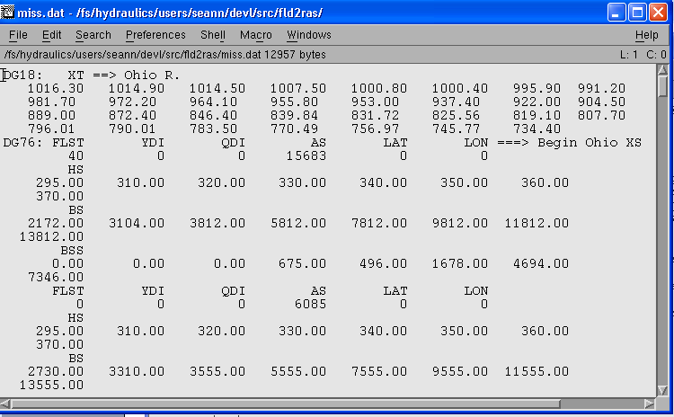
Figure 4-4. Example of clipped river mile (red block) and cross-section data (green block) for input to the fld2ras program.

- Run the fld2ras Program

The fld2ras program is written in FORTRAN and can be compiled in either a Windows PC or Linux environment. When run, fld2ras will interactively ask the following:
- The number of top widths (NB) that the model uses. For example, in Figure 4-4, NB=8 (i.e. there are eight pairs of top width and elevation).
- The total number of cross-sections. For example, in Figure 4-4 there are 31 cross-sections (number of entries in the red box). The total number of river mile entries and total number of cross-section blocks in the text file should be equal as in FLDWAV.
- The input file name (e.g. “miss.dat” in this example).
- The output file name (any file name allowed by your operating system).
- Option to convert BSS inactive areas. "Convert BSS? (1=yes;2=no)"?
- Column number for the AS parameter. You must provide the column at which AS is defined even if the AS=0.0.

- Visually inspect the output file

For example, check for the highest and lowest elevation if they match with the FLDWAV cross-section representation. Also, verify if all values are reasonably converted.
HEC-RAS representation for Cross-section #1

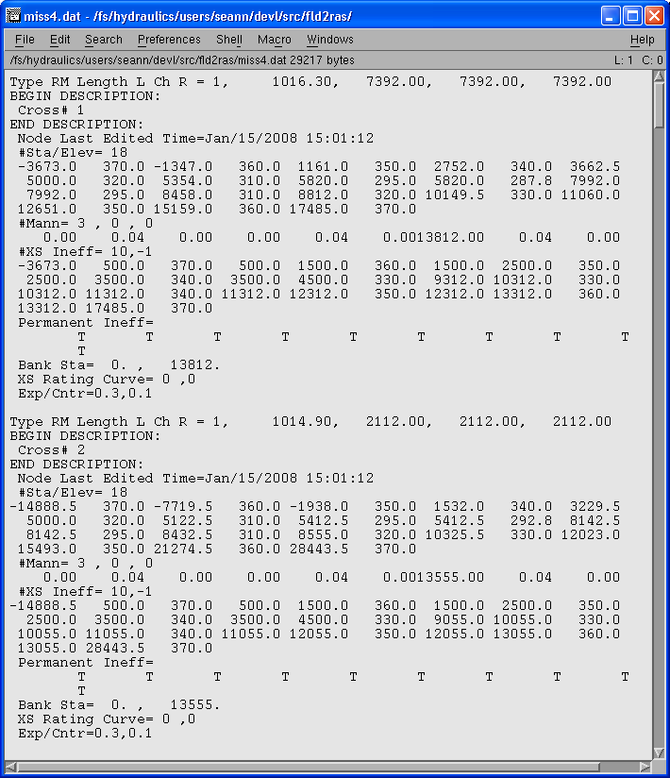

Figure 4-5. Example output file from the fld2ras program. This file is in HEC-RAS geometry file format.

Data shown in the blue box of Figure 4-5 will only exist if the BSS values are converted. If BSS values are converted, the user should examine all cross-sections to be sure that the number of ineffective areas to be defined is less than or equal to 10. This is because there is a limit of 10 blocked ineffective areas for a single HEC-RAS cross-section. In this example, there are 10 multiple blocks defined as indicated by the text “#XS Ineff = 10”. The fld2ras program may recommend more than 10 ineffective blocks in some instances. If this is the case, the user must manually modify the text file to reduce the number of blocked areas.

- Create a project file in HEC-RAS

In this step, we show how to create a new project, create a river reach, and create a geometry file.
- Start HEC-RAS
- From File menu select New Project
- It is recommended to create a new folder for the project – ‘Miss River’ in this example.
- Give a title for the project. Example “Miss River”

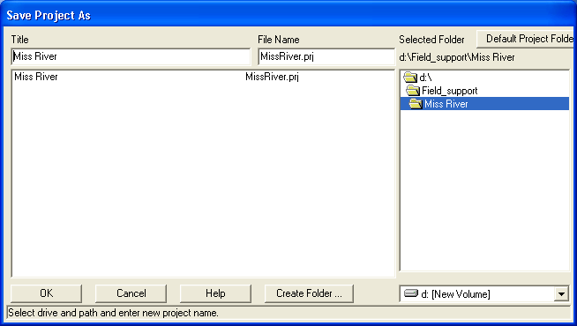
Use this Button to create new
Folder
Project title and file name

Figure 4-6. Creating a new folder and a project. Once the project file name is setup, HEC-RAS will use this name with additional pre-specified extension to save all other files related to this project. For example, in the case of MissRiver, the project file is saved as MissRiver.prj, the geometry file is saved as MissRiver.g01, and the unsteady flow condition will be MissRiver.u01. If there is a second geometry file, it is saved as MissRiver.g02.

- Create a River Reach: Open a Geometric Data Window (e.g. from Edit → Geometric Data). The best way to create a river reach is to have a map of the river reach saved in graphical format (e.g. JPEG) so that you can trace over the map when drawing your schematic. Please refer to the HEC-RAS user manual to learn more options. In this example, we describe a simple method to create a reach and type in two cross-sections at the upstream and downstream points. These cross-sections are created just to hold space in the geometry data file.
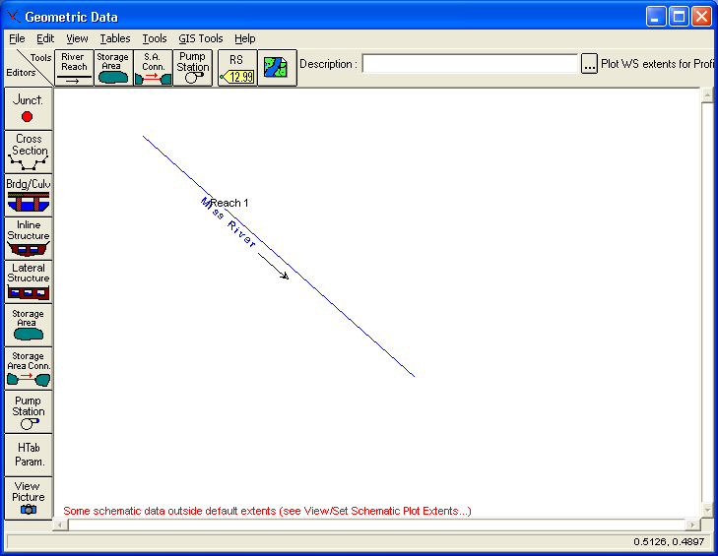
Click On this Button
And draw a straight line on the open space. After drawing the line you will be prompted to provide : River : Miss River
Reach : Reach1
Figure 4-7. Geometry data editor.

- Create one cross-section (Use Cross-Section Editor) and give a River Station name 10. Enter as shown in Figure 4-8: Station elevation, downstream lengths, Manning’s n Values and Main Channel bank stations. Click on the button “Apply Data” to save the data. The actual values are not critical, as they will be replaced in a later step.
- Create one more cross-section with the River Station name 0. You can use “Copy Current Cross-section” from the “Options” menu. Click on the button “Apply Data” to save the data.
- Now from File Menu, save the geometry data. As shown in Figure 4-9, the file name is automatically assigned MissRiver.g01. Provide only the Title for the cross-section data.
- Save the project and exit HEC-RAS

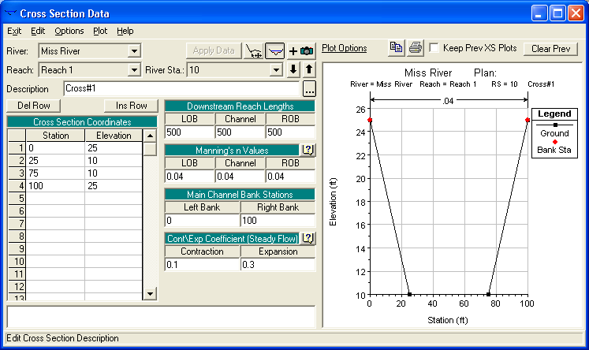

Figure 4-8. Cross-section data editor

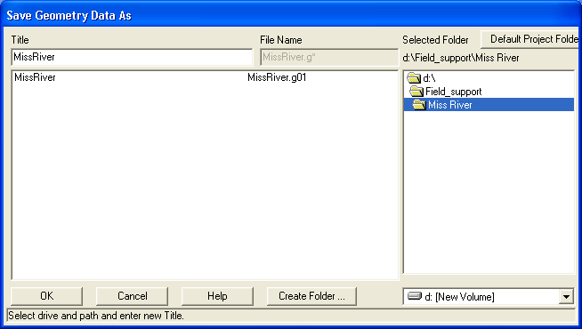

Figure 4-9. Saving the Geometry Data file.
- Copy the contents of the text file created in Step 4 to this Geometry file

- Use any text editor (for example WordPad) and open the geometry file “mass_river.g01”.
- In another instance of a text editor, open the text file you created in Step 4. Select all and copy the contents.
- Switch the window to the text editor where “MissRiver.g01” is opened. Now select the shaded region as shown in Figure 4-10 and paste what you have copied from the other file. This action will replace the two cross-sections created in the HEC-RAS by all the cross-sections imported from FLDWAV.
- Save the MissRiver.g01. Note if you are using window based text editors, the application may automatically add .txt extension. To avoid this, put the file name in quotation marks, e.g. “MissRiver.g01”. This forces the editor to save it with the desired .g01 extension.

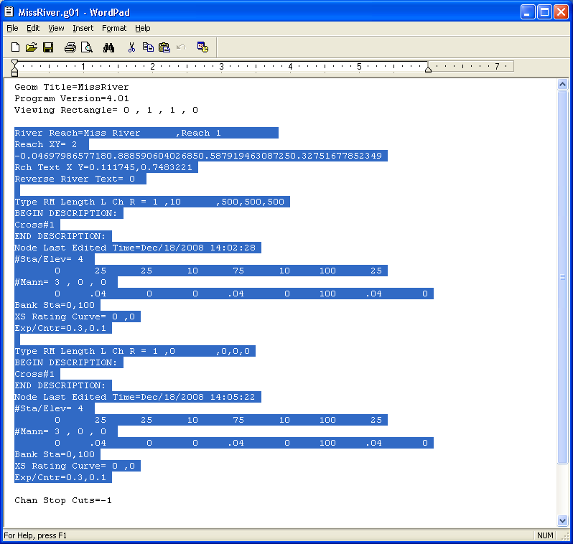
Replace the Selected region by the data from the processed FLDWAV cross-sections
Figure 4-10. Geometry data file.

- Restart HEC-RAS
- Open the project MissRiver.prj
- Open the Geometry Data Editor. If all steps are correctly done, all the cross-sections will be populated to the river reach as shown in Figure 4-12.
- If BSS values are converted, you should manually inspect the ineffective flow areas defined for each cross-section to be sure that all ineffective areas are defined as permanent (e.g. Figure 4-11 -- this window is accessible from the Cross-section Data Editor by double-clicking on the text “Multiple (blocked) Ineffective Flow Areas” that appears only when these areas are defined). We have found that HEC-RAS may set the permanent status of the first block to ‘n’ rather than ‘y’ when importing a geometry file created by fld2ras. All blocks should be made permanent.

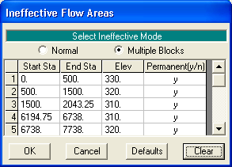
Figure 4-11 Example of Ineffective Flow Area Specifications for a Cross-Section.

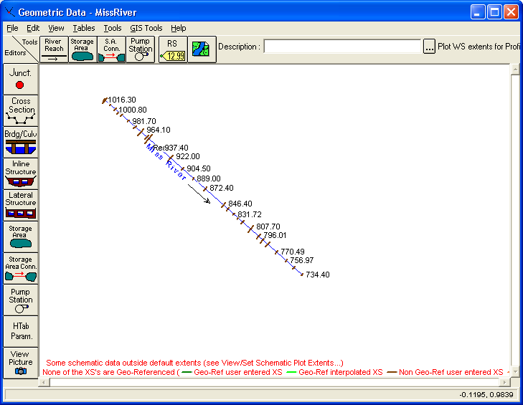
Figure 4-12. All cross-section data populated along the reach

- Adding Tributaries

At junctions where a tributary enters the main channel, both FLDWAV and HEC-RAS should contain cross-sections along the main channel, which closely bound the incoming channel as shown in Figure 4-13. We have found that this was not the case in one of the FLDWAV models we have looked at; however, users can easily correct this problem using HEC-RAS tools as described in the procedures below.

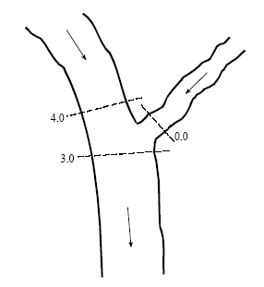
Tributary
Main Stem
Reach 1
Main Stem
Reach 2
Figure 4-13 Cross-section configuration at a junction. Adapted from Figure 4-3 in the HEC-RAS Hydraulic Reference Manual Version 4.0

To convert and add tributary cross-sections:

  - Follow steps 1, 2, 3, and 4. The conversion program assumes that the geographic end of the tributary river is the last cross-section. However, this may not be the case in some FLDWAV decks where the last cross-section of the tributary is actually a short distance upstream of the main river confluence. The downstream distance from this cross-section to the next is not used by HEC-RAS, but this distance is accounted for in the junction definition. If the remaining distance is less than one mile, apply the remaining distance as a junction length using “Junction editor” (Figure 4-14).
  - Open the project MissRiver.prj
  - Click on the “Edit/enter geometric data” button.
  - Determine the location in your reach where the tributary should enter the main channel based on your FLDWAV model. The FLDWAV NJUN parameter defines the number of the cross-section just upstream of the tributary. The FLDWAV model should contain another cross-section just downstream (as shown in Figure 4-13). If this is not the case, add a cross-section just downstream of where the junction should be. If there is no surveyed cross-section data available, a reasonable first guess is simply to copy the same geometry from the cross-section on the upstream side of the junction. Provide reasonable spacing between these two cross-sections (e.g. 4.0 and 3.0 in Figure 4-13). The spacing should be greater than the width of the tributary river at the junction.
  - Select the “River Reach” button and begin drawing a line clicking between the two cross-sections that bound the junction. When finishing the line by double clicking a window opens up.
  - Choose a new name for the tributary (e.g. White) and add a new reach name (e.g. Reach1).
  - A window pops-up asking if you wish to split the existing reach on the main river (e.g. Reach1).
  - Confirm with yes and a new window opens up. Give the newly created reach on the Miss. River a new name, e.g. Reach2.
  - Finally enter a junction name (e.g. White Trib).
  - Save your geometry file and proceed with the instructions beginning from Step 5.f to import the cross-section geometry for the tributary.
  - If you have the missing cross-section larger than one mile at the end of your tributary (as described in Step8.a) issue, fix it as follows:
    - With the cursor point at the last cross-section on the tributary, select “Edit Cross section”.
    - From the “Options” menu, choose “Rename River Station.” Assign the missing distance as its new name.
    - In the Downstream Reach Lengths box of the current river station, enter the missing distance in feet (e.g. 5000) in the “LOB”, “Channel”, and “ROB” space. Hit the “Apply Data” button.
    - From the “Options”, menu select “Copy current cross section” and enter “0.00” as River Station name.
    - In the newly created cross-section change the “Downstream Reach Lengths” values to 0 for “LOB”, “Channel” and “ROB” and hit the “Apply Data” button.
    - Exit the cross-section editor. In the “Geometric Data Editor”, the newly created cross-section will be visible.
  - Use the junction editor accessible from the Geometric Data Editor window to make sure that reasonable lengths are defined across the junction. The lengths across junction (shown in Figure 4-14) are measured from the first cross-section of the lower reach of the main river.

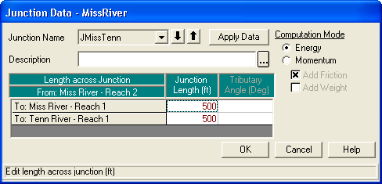

Figure 4-14. Junction Data Editor.

- Setting Manning’s n versus Flow

In order to specify flow roughness factors that correspond to the FLDWAV flow-Manning’s n relationships, initially the Manning’s n values of all cross-sections should be set to 1.0. This can be achieved from Geometry Editor, select – “Tables” –“Manning’s n or k”. For all rivers and reaches, set value of n to 1. Then follow the steps below to set up the roughness factors.

- Click on the “Perform an unsteady flow simulation” button and open the “Unsteady Flow Analysis” window
- Under the “Options” menu select “Flow Roughness Factors”
- Fill in the flows and the roughness factors in the “Plan – Roughness Change Factors” window. As show in Figure 4-15, add new roughness factor data sets by hitting “Add” and selecting the river, the reach, the upstream river station and the downstream river station. Continue for all the reaches in the main river and the tributary according to the FLDWAV model you are converting. It is often helpful to put your FLDWAV Q-n values in a spreadsheet and then copy and paste them into the HEC-RAS Flow Roughness Factors GUI. When specifying roughness factors, do not specify roughness factors on overlapping reaches. For example, specify roughness factors for cross-sections 1 to 5 and 6 to 10. Do not specify the factors for reaches 1 to 5 and 5 to 10. HEC-RAS 4.0.1 allows you to do this but it should not.

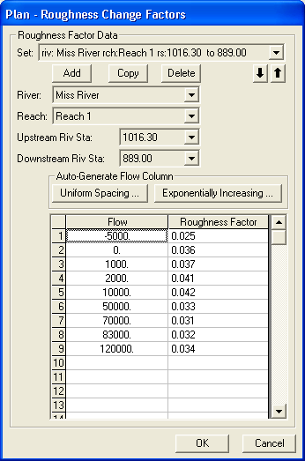
Figure 4-15. Roughness factors entered from the plan menu.

Alternatively, the roughness factors can also be entered from Geometry File (Tools --> Flow Roughness Factors from the Geometry data window). However, there is a difference between entering the roughness factor though Plan File and Geometry file. Roughness factors in the Plan File do not affect the HTab curves that describe bridges while roughness factors in Geometry File do. Therefore, if you want to adjust roughness values (at different flow levels) along a reach, but do not want to modify your bridge tables in these reaches, you should apply the factors through the Plan File. This is the approach we have been using here and seems to work well. The Geometry Preprocessor does not have to be re-run if you change the roughness factors through the Plan File.

If you define roughness factors in the Geometry File, you will get different results from a Plan File implementation if you have bridges in your model. In this case, the HTab curves that describe bridge properties (flow versus headwater depth) are re-computed before run-time using modified flow-roughness information based on the user supplied factors and the prescribed n-values at cross-sections that bound the bridges. If your model has no bridges, then you should get identical results when specifying flow roughness factors through the Geometry File and Plan File.

Lateral Inflows

In HEC-RAS, the lateral inflows are read as a binary file using a DSS format. The user must convert FLDWAV lateral inflow files into DSS format (See Section 4.2) and associate them with a cross-section in the corresponding HEC-RAS model using standard HEC-RAS functionality (HEC-RAS User’s Manual, Chapter 8).

Converting OHD Calibration Time Series to DSS Format (Using oh2dss)

Transitioning existing FLDWAV or DWOPER models to HEC-RAS requires conversion of the FLDWAV cross-sections to HEC-RAS geometry files and conversion of stage and flow time-series data into DSS format. Preparing the time series to check the converted models in simulation mode and for calibration requires several steps including the use of the oh2dss program. This section describes how to convert flow and stage time series data from typical FLDWAV formats into DSS format.

FLDWAV Time Series Data

From a number of existing input files for FLDWAV or DWOPER, the time series of the boundary conditions as well as observed stages for calibration are usually available in one of two formats. If calibration was done using the NWSRFS FLDWAV operation, the time series are saved in the standard OHD data card format (http://www.nws.noaa.gov/oh/hrl/nwsrfs/users_manual/part7/_pdf/72datacard.pdf). If done using a stand-alone version of FLDWAV or DWOPER, all the boundary and other calibration time-series data are most likely saved within the FLDWAV/DWOPER input deck. In either case, the data need to be converted to DSS format in order to use them in HEC-RAS.

For data embedded in the input decks, additional steps are required to extract each time series data set from the FLDWAV or DWOPER deck, put each time-series in its own text file, and add header information including start and end date and hour. The embedded data in DWOPER and FLDWAV decks may not have time stamps unless the model developer has provided them in the comment lines. Therefore, one may have to do research to find the exact period of the data.

The oh2dss and oh2dss_bat Scripts

We have developed Python scripts to convert files in OHD data card format to DSS format. The available scripts are named oh2dss and oh2dss_bat. Both use libraries delivered with the HEC-DSSVue application. The oh2dss version must be run from the DSSVue GUI, while the oh2dss_bat program can be run from either a DOS or cygwin command line. David Welch (LMRFC) developed an early version of this script (manual_import_calb_card_v3) which was subsequently enhanced by OHD to create oh2dss and oh2dss_bat.

Enhancements to the original script include the ability to convert both one column and six column data cards, a change to allow the user to correct the datum for stage time series, and a more robust procedure for locating the two-line header information in the input file.

Features of the two scripts are as follows:

- The scripts convert OHD data card formatted time series into DSS file format, creating one or more new files. The input data format can either be one or six columns.
- The scripts can also convert non-OHD format data of one or more columns. The key step in converting such data is that the user must specify a header, which is same as OH data header. This header specifies the data type, data period and time steps. An example is provided below.
- The scripts convert flow and stage variables that are either observed or simulated.
- Units of flow and stage are converted into English units if the OHD data are in SI units.
- The scripts adjust stage data, if a datum correction is provided. Note that datum corrections are often specified internally within FLDWAV and DWOPER but these corrections must be applied externally for time series that are used as input to HEC-RAS. HEC-RAS expects stage data in the same datum as the cross-section geometry elevations.
- Oh2dss processes only one time series per run, while oh2dss_bat can process multiple time series per run.
- Both scripts use HEC-DSSVue Jython libraries, so HEC-DSSVue must be installed.
- Oh2dss must be run from the HEC-DSSVue GUI, while oh2dss_bat must be run from a command line (e.g. DOS or cygwin). Note that oh2dss_bat can be easily modified to run from the GUI. This may be an easier way for folks not familiar with DOS or cygwin to process multiple time series at once.
- Oh2dss requires the user to edit input data and options within the script (e.g. the input data file name and gage corrections). Input information for oh2dss_bat is provided in a text file.
- Comments within the scripts explain the user input requirements.
- Both scripts specify information in the six standard parts of a DSS formatted time series file: A, B, C, D, E & F. These paths are set using variables defined in the scripts as described in the next section. A summary is provided here:

#DSS PATH A = Watershed
#DSS PATH B = Station ID
#DSS PATH C = Types of data (Either stage or flow or ELV)
#DSS PATH D = Start and end time period
#DSS PATH E = Time interval
#DSS PATH F = Type of data (OH data type e.g. SQIN, QIN, etc.)

How to Use the oh2ds Time Series Converter

- Install HEC-DSSvue

HEC-DSSVue is a Java-based visual utilities program that allows users to plot, tabulate, edit, and manipulate data in a HEC-DSS database file. HEC-DSSVue can be downloaded from http://www.hec.usace.army.mil/software/hec-dss/hecdssvue-dssvue.htm

Follow the documentation provided with the software to install HEC-DSSVue. The scripts provided have been tested using version 1.2.10.

- Copy oh2dss.spy to the DSSVue script folder

To access the scripts directly from HEC-DSSVue, you need to copy the script into a pre-defined folder where all scripts accessible to the DSSVue GUI are saved. The location of this folder will depend on where you install DSSVue.

A typical location for the default scripts folder is:

C:/Program Files/HEC/HEC-DSSVue/HecDssVue/scripts/

- Start HEC-DSSVue

The scripts that are saved in the appropriate folder will automatically show up in the DSSVue tool bar as shown in Figure 4-16.

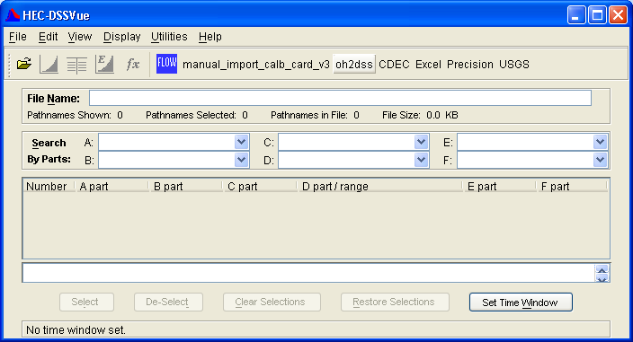
oh2dss
script

Figure 4-16. HEC-DSSVue main window

- Browse and Edit the Script

- To browse from Menu select “Utilities “ and “Script Browser”
- Select the oh2dss script
- To edit the script right click on the script name as shown in Figure 4-17 and select edit script. You could also use any text editor of your choice (the IDLE editor that comes with Python 2.5 has some nice features).
- Change the input blocks numbered from #1 to #8 as appropriate and save the script.
- Comments:
For #1, Make sure the path is not too long and that it does not contain empty spaces such as ‘C:\Documents and Settings\aschwandenc\My Documents\FLDWAVtoRAS\fldwv2rasscross\DSSVueWS’

The following are the inputs filled by users

#1. working directory
workDir='D:/WORKSPACE/test'

#2. input file name
fIn='RCKSP.ohd'

#3. Datum correction - only used for stage data
datm_corrc=0.0

#4. Watershed name: used for the PATH A part of the DSSVue output file name.
watershed='TAR RIVER'

#5. Segment ID: used for the PATH B part of the DSSVue output file
ID = ‘RCKSP’

#6. ohd_format='yes', use 0hd_format='no' for any other format of columns of numbers
# User must provide a header for non OHD format similar to the following on top of the data
# $ FLOW (QINE, QIN, SQIN)
# DATACARD QIN L3/T CFS 1 COLL7
# 02 1995 2 1996 1 F13.2 FLOW
# or
# $ STAGE (STG, PWEL, TWEL, TID)
# DATACARD STG L3/T FT 1 DLAF1
# 07 2006 10 2006 6 F10.2 STAGE
ohd_format='no'

#7. start day
start_day='01'

#8. start hour
start_hour='0000'

- Run the script

- Click oh2dss on the tool bar menu.
- The output file is a DSS file, which will be written to the user defined “working directory.”
- The name of the file will be automatically defined to include the user specified ID (#5 above). An example output file name: RCKSP.SSTG.dss.

- Import the data, and plot the data using HEC-DSSVue to check results.

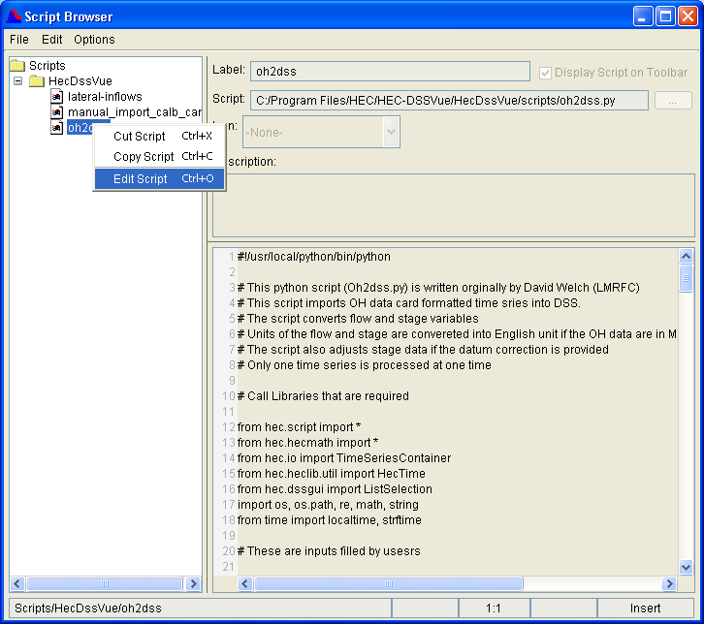

Figure 4-17 . Browsing the script.

How to Use the oh2dss_bat.py Time Series Convertor.

This script is written to be called as an argument to the program HEC-DSSVue.cmd, which is installed with HEC-DSSVue. The default location to find HEC-DSSVue.cmd is under c:\Program Files\HEC\HEC-DSSVue.

To run oh2dss_bat.py, move to the location of your HEC-DSSVue install and type:

C:\Program Files\HEC\HEC-DSSVue> HEC-DSSVue.cmd script_name working_directory control_file_name

There are three arguments. The first is the script name, the second is the directory containing all input files (and where output files will be created), and the third is the name of the control file specifying user options. Full path names should be used for the working directory and control file names. Example:

C:\Program Files\HEC\HEC-DSSVue> HEC-DSSVue.cmd c:\scripts\oh2dss_bat.py c:\working_dir c:\working_dir\todss.cntl

The contents of the control file are as follows:

- One line for each file to be converted.
- Each line contains comma-separated input information:
  - Input file name
  - Datum correction in feet (can be positive or negative)
  - Name for river basin
  - Name for segment
  - Are data in OHD card format? ‘yes’ or ‘no’
  - Two digit starting day
  - Four digit starting hour/minute
- Example control file contents:

UPSTR.SSTG.1HR.CARD,9.32,TAR_RIVER,UPSTR,yes,01,0000
RCKSP.SSTG.1HR.CARD,0.0,TAR_RIVER,RCKSP,yes,01,0000
GRNVL.SSTG.1HR.CARD,-3.54,TAR_RIVER,GRNVL,yes,01,0000
GRIME.SSTG.1HR.CARD,0.00,TAR_RIVER,GRIME,yes,01,0000
WASH.SSTG.1HR.CARD,-1.00,TAR_RIVER,WASH,yes,01,0000

The main difference in this script compared to oh2dss.bat is the ability to process multiple files at once. This capability can also be attained through an interactive run (e.g. Figure 4-17) if that is preferable to the command line. For an interactive run, the user simply modifies the two lines in the script that assign the names of the working directory (“workDir”) and the control file name (“cntlfileName”).

Obtaining and Using Existing HEC-RAS Models

To build hydraulic models for operational implementation more efficiently, we would like to take advantage of the information available in models developed for other applications. Specifically, cross-section geometry data, often already in HEC-RAS format, may be available from FEMA, USACE district offices, or state USGS offices. FEMA’s National Flood Hazard Map Layer provides an inventory of hydraulic model cross-sections that have been used for flood hazard mapping (http://www.gismaps.fema.gov/, http://www.fema.gov/library/viewRecord.do?id=3286).

Searching for and acquiring existing HEC-RAS models will be an excellent starting point for building new hydraulic models. We have also looked at this as an alternative to converting existing FLDWAV models into HEC-RAS, as described in the Tar River and lower Columbia case studies. Generally, acquiring and modifying existing HEC-RAS models developed for purposes other than operational river forecasting saves work compared with building a model from scratch, but requires more work than converting a FLDWAV model. In most cases, existing HEC-RAS models were developed for flood insurance rate mapping or engineering design studies. For these applications, modelers often use steady state models and only calibrate the models to a few flow levels of interest. Therefore, to use these models, the hydrologist must convert steady flow models to unsteady flow models, test stability over a wide range of flow conditions, and calibrate the model for a wide range of flow conditions. Cross-sections may not be spaced appropriately for operational forecasting. In addition, the available model domain and boundary locations may not exactly match RFC needs and may need to be re-defined.

Case Studies: Evaluating Converted Models

Study Areas

We used three river system models to evaluate our FLDWAV to HEC-RAS conversion procedures. For two of the river systems, we also compared the symmetric models converted from FLDWAV to existing, detailed, HEC-RAS models that we modified to match operational forecasting requirements. We analyzed both symmetric and detailed models for the lower Tar River in North Carolina and the lower Columbia River, which forms the border between Oregon and Washington (with three tributaries). We analyzed only symmetric model results for a Mississippi River model, which includes three tributaries (Tennessee, Cumberland, and Ohio).

Initially this project was focused on the Tar River and Columbia River models, but the Mississippi River model was added later, primarily to understand differences on a river with a large floodplain and to look more carefully into the issue of ineffective flow areas. Table 3-1 indicates that ineffective flow areas are widely used in existing FLDWAV models.

Tar River

Tides influence water levels in the lower Tar River starting form its inlet at Pamlico Sound upstream to USGS Gauge 02083893 at Rock Springs, NC (approximately 30 miles) (Figure 5-18). Because of the tidal influence, the NWS needs to run dynamic hydraulic models to provide accurate water level forecasts at locations such as Washington and Greenville, NC. Use of a dynamic hydraulic model is also a pre-requisite for eventually providing dynamic flood mapping services.

In this study, we modeled a single reach of the Tar River between Tarboro and Washington, NC. Riverside Technology (RTi) set up and calibrated a FLDWAV model for this reach (RTi, 2007). The simulated reach covers 48 miles with 102 cross-sections spaced at about 0.5 miles on average. RTi derived cross-sections for FLDWAV using cross-section data obtained from the North Carolina Floodplain Mapping Program and originally derived by the North Carolina US Geological Survey (USGS). The model accounts for the impacts of ten bridges. Four of these are modeled explicitly using bridge geometry while the other six are modeled approximately using constricted cross-sections along with expansion and contraction coefficients. The parameters used in FLDWAV for the four bridges were used directly in HEC-RAS. However, for those bridges approximated by the expansion and constriction coefficients, we used the constricted cross-sections without coefficients since HEC-RAS does not use these coefficients in the unsteady flow model. Lateral inflows for the model were originally generated using a distributed hydrologic model (Koren et al., 2004) on 4-km grid cells, but later aggregated into seven inflows. We converted this FLDWAV model to HEC-RAS using the fld2ras program. The converted channel bottom profile and cross-section geometry are shown in Figure 5-19 and Figure 5-20.

We also took the steady flow HEC-RAS model with more detailed channel geometry developed by the NC USGS and converted it to an unsteady flow model. To cover the same domain as the FLDWAV model, the detailed model was modified to include five additional cross-sections from Grimesland to Washington. The channel geometry for these five sections was duplicated from FLDWAV and the overbank elevations derived from LiDAR elevation data.

The boundary condition and internal calibration/validation points on the Tar River are plotted in Figure 5-18 and listed in Table 5-3. The discharge record at the Tarboro site is used as the upstream boundary condition, while the stage record at the Washington gauge is used as the downstream boundary condition. Tar River simulations are run from July 1, 1999, to August 31, 2005. This period includes a wide range of hydrological conditions, with noticeably high stage cases during Hurricanes Floyd (Sept 1999) and Isabel (Sept 2003). All simulations were run at an hourly time step using hourly input data.

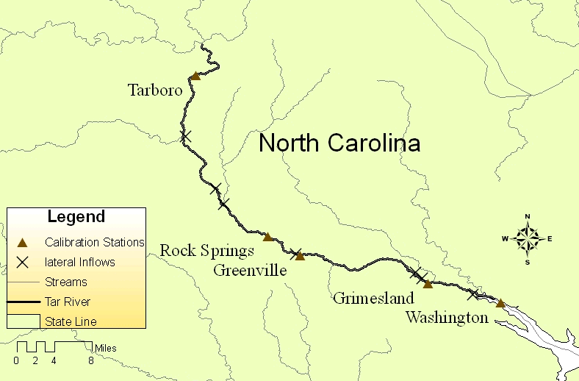

Figure 5-18. Location map for the lower Tar River

Table 5-3 Stage and flow data along the Tar River.
River | Data, used as | River mile | Data Available
Tar River at
Tarboro | Flow, Upstream BC | 48.2 | 1985 – 2005
Rock Spring | Flow, Lateral | 26.7 | 2003-2005
Greenville | Stage, Validation | 21.4 | 1997 – 2005
Grimesland | Stage, Validation | 7.4 | 2003 – 2005
Washington | Stage, Downstream BC | 0.0 | 1999 - 2005

Figure 5-19. Profile from Tarboro to Washington

Figure 5-20. XYZ – plot of cross-section geometry from Tarboro to Washington

Columbia River

In 1985, the NWS Northwest River Forecast Center developed a two-river DWOPER model for the lower Columbia, which was later revised in 1998 to include two additional tributaries. This model has been operational since 1985. The main channel of the lower Columbia model extends from Bonneville Dam to Astoria, OR (Figure 5-21). The model includes three major tributaries: the Willamette River, the Cowlitz River, and the Lewis River. The main channel of the lower Columbia River covers 127.5 miles, while the Willamette, Cowlitz, and Lewis segments cover 32 miles, 23 miles, and 19 miles respectively.

Although NWRFC uses DWOPER for operational runs, we created a nearly identical FLDWAV model of the lower Columbia model as a reference to facilitate study over our one-year calibration period. This is because the NWSRFS version of DWOPER only runs in forecast mode (not calibration mode). The only difference in the FLDWAV model is how it represents a 50 ft dam near the upstream end of the Willamette tributary. An experiment showed that substantially different representations of this boundary condition showed some minor effects at a nearby validation point (Oregon City) but no discernable effects at the next downstream validation point (Portland) or any other validation points in the river system (See Table 5-4). Therefore, if we exclude Oregon City as a validation point, we consider this FLDWAV model a valid surrogate for the operational DWOPER model for the purposes of this study. Note that Section 5.5 discusses how this 50 ft fall is represented using a rating curve in HEC-RAS.

Initially we focused on two different HEC-RAS models for the lower Columbia. A basic symmetric model was created using the fld2ras program. The second model uses cross-sections that are more detailed and was adapted from an existing HEC-RAS model. Later, we worked with Joanne Salerno of NWRFC to develop a model of intermediate complexity to more properly represent inactive flow areas on tributaries relative to the basic symmetric model, but still not including all of the additional complication of the detailed model. The reasoning for this is described in Section 5.7.

The HEC-RAS model with more detailed channel geometry for the Columbia River system was obtained from the Hydrologic Engineering Center (HEC). The model was originally developed by the USACE Portland District and later modified by HEC. The initial model contains 604 cross-sections of which 330 describe the lower Columbia River from Bonneville to Astoria, 86 the Willamette River, and 3 the Cowlitz tributary; the remaining 185 are located in distribution channels along the river. There are no bridges specified in the model; however, ineffective areas are specified in 61 river cross-sections. The model also includes 17 storage areas, 22 lateral structures, and 258 of the cross-section definitions include levees.

The detailed HEC-RAS model was modified to cover the exact same domain as the DWOPER and symmetric HEC-RAS model. To do this, we extended the Cowlitz tributary and added the Lewis tributary. The schematization in the symmetric model is much simpler. In the symmetric model, the main channel contains 22 cross-sections, and the Willamette, Cowlitz, and Lewis have 35, 26, and 20 respectively for a total of 103 cross-sections. Figure 5-22 shows schematic diagrams for both models.

For the Columbia River, discharge records from Bonneville dam define the upstream boundary condition and tide observations at Astoria, OR, define the downstream condition. Discharge records or simulations are also used at the upstream boundaries for the three simulated tributaries. A lateral inflow is applied at the river-mile 114.7 on the Columbia River and a second lateral inflow is applied at the river-mile 25.3 on the Willamette River. These two lateral flows are applied to represent tributaries, which are not hydraulically modeled as rivers. An internal boundary condition represented as a rating curve on the Willamette River at Oregon City is used to represent a 50-foot fall. The simulation runs are from Feb 1, 1995 to Feb 28, 1996.

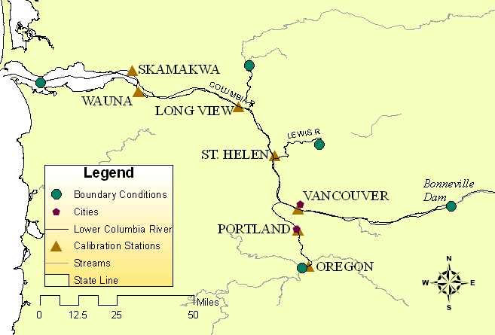
Figure 5-21 Location map for the lower Columbia model

Table 5-4 Stage and flow locations in the lower Columbia system. All data used span the period February 1, 1995 – February 28, 1996.
River | Data, used as | River mile
Columbia River
Bonneville | Flow, Upstream BC | 145
Col_later_flow | Flow, Lateral
Vancouver | Stage, Validation | 106.5
St. Helen | Stage, Validation | 86.1
Longview | Stage, Validation | 66.1
Wauna | Stage, Validation | 41.6
Skamakwa | Stage, Validation | 33.7
Astoria | Stage, Downstream BC | 17.5
Willamette River
Oregon City | Flow, Upstream BC | 26.68
Oregon City | Stage, Validation | 26.4
Willam_later | Flow. Lateral | 25.3
Portland | Stage, Validation | 12.6
Cowlitz River
Cowlitz | Flow, Upstream BC | 19.0
Lewis River
Lewis | Flow, Upstream BC | 15.5

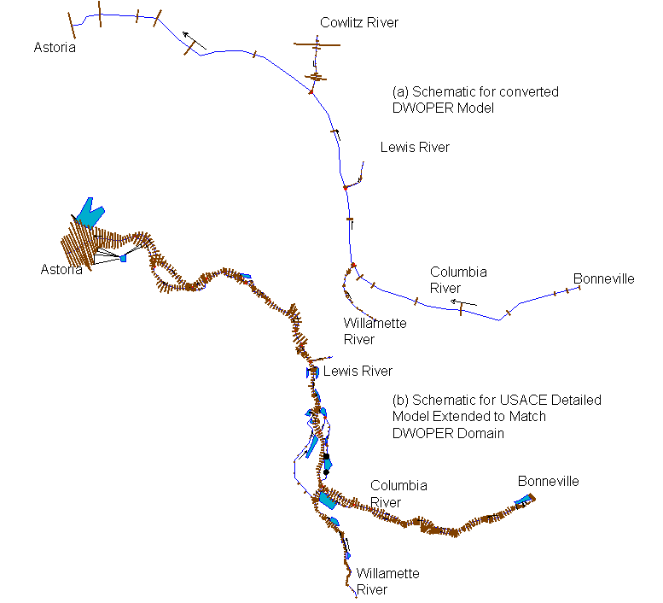
Figure 5-22 Schematics for the two lower Columbia models: the (a) converted DWOPER (symmetric) model, and the (b) detailed, modified USACE model.

Lower Mississippi, Ohio, Cumberland, Tennessee Model

Although initial plans for this study only included the Tar River and lower Columbia models, we have done some additional analyses on a lower Mississippi-Ohio-Cumberland-Tennessee River model to better understand issues that may arise when modeling a river with a very large floodplain. The Lower Mississippi River Forecast Center provided a FLDWAV model spanning 110 Mississippi River miles from Chester, Illinois to the junction with the Ohio River and then 222 additional miles from the Ohio junction to Memphis, Tennessee. The model also includes a 60-mile reach of the Ohio River from Smithland Dam to the Mississippi junction as well as two tributaries to the Ohio, a 31-mile reach of the Cumberland River and a 22-mile reach of the Tennessee River (Figure 5-23).

Figure 5-23 Schematic of the lower Mississippi model including the Ohio, Cumberland, and Tennessee tributaries.

FLDWAV to HEC-RAS Geometry and Manning’s n Conversions

Figure 5-24 shows a FLDWAV and HEC-RAS representation of the same cross-section from the Tar River model. The validity of using simplified cross-sections for large river routing has been established (Fread, 1998; Hicks, 1996). The complexity of the channel is fully represented in the detailed cross-section, which may be advantageous in areas where there are flood-mapping needs. We compare simulations from the symmetric and detailed cross-section models to assess the benefit of having detailed cross-sections for modeling at NWS river forecast points.

Figure 5-24. A symmetric and detailed representation of a Tar River Cross-section. While the detailed cross-section is obtained from 105 survey points, the symmetric cross-section is represented by only 16 points, which were derived from FLDWAV (eight pairs of top widths (BS) and elevations (HS)).

Section 4.1.2 describes the mechanics of implementing Q-n relationships from FLDWAV in HEC-RAS. As an example, Figure 5-25 shows Q-n values developed by RTi (2007) for five sub-reaches of the Tar River. RTi (2007) describes the calibration strategy used to subdivide the reaches and change Manning’s n values.

Figure 5-25. Variation of Manning’s n versus flow for five cross-section reaches that are designated by the calibration gauges for the Tar River

Comparing Simulations from Symmetric and Detailed Cross-Section Models

Tar River Results

For the Tar River we simulated five sets of stages using 1) the FLDWAV model, 2) the HEC-RAS symmetric model with FLDWAV Manning’s n-flow parameters (SYM), 3) the HEC-RAS detailed model with raw Manning’s n values from the USGS steady flow analysis (DET_RAW_n), 4) the HEC-RAS detailed model with Manning’s n-flow parameters from FLDWAV (DET_FLDWAV_n), and 5) the detailed model with calibrated Manning’s n values (DET_CAL_n).

Table 5-5 summarizes statistical results for four validation stations on the Tar River. The FLDWAV and symmetric HEC-RAS model (SYM) exhibit similar overall bias and RMSE and examination of the hydrographs shows similar results over a wide range of flows (Figure 5-26 and Figure 5-27). These results were achieved through direct conversion of model geometry and FLDWAV Manning’s n parameters and no further calibration. We did not attempt further calibration of the HEC-RAS symmetric model, although this additional fine-tuning can be easily done within HEC-RAS.

In contrast, the detailed HEC-RAS model with raw Manning’s n values specified for steady state applications (DET_RAW_n) produced much higher RMSE statistics compared to the other two models. It therefore requires more additional work to achieve a reasonable result. We first replaced the Manning’s n values with those from FLDWAV (DET_FLDWAV_n). This yielded some improvements, but additional calibration was necessary to produce acceptable results comparable to those from FLDWAV (DET_CAL_n). Table 5-5 summarizes the statistical improvement after calibration while Figure 5-28 and Figure 5-29 illustrates the improvements in hydrographs at Greenville and Rock Springs after calibration. It appears that the calibrated hydrographs at Rock Springs could be improved further (most likely with additional Manning’s n adjustments for high flows). Note, however, that the calibration work done in this study looked at the whole data period available and did not specifically focus calibration on the events shown here.

Table 5-5. Bias and (RMSE) both in feet (ft) for the Tar River for the Period July 1, 1999 to August 31, 2005
Stations | FLDWAV | HEC-RAS
Stations | FLDWAV | SYM | DET_RAW_n | DET_FLDWAV_n | DET_CAL_n
Tarboro | .03 (.32) | .04 (.34) | 1.71 (2.03) | -0.15 (0.60 | 0.19 (0.39)
Rcksp | .12 (.51) | .16 (.63) | 0.88 (1.20) | -1.13 (1.45) | -0.43 (0.68
Grnvl | .00 (.90) | .36 (1.11) | 1.86 (2.30) | -0.55 (1.05) | -0.40 (0.86)
Grim | .16 (.28) | .00 (.22) | 1.96 (2.25) | 0.00 (0.22) | 0.11 (0.24)
Note that the period for statistical evaluation is shorter for Rock Springs and Grimesland due to a more limited duration of observed data.

Figure 5-26 FLDWAV and converted model (SYM) simulations at the Greenville station compared to observed stages.
Figure 5-27 FLDWAV and converted model (SYM) simulations at the Rock Springs station compared to observed stages.
Figure 5-28 Detailed model with Manning’s n from the steady state model(DET_RAW_n) and the detailed model after some manual calibration (DET_CAL_n) at the Greenville station compared to observed stages.

Figure 5-29 Detailed model with Manning’s n from the steady state model(DET_RAW_n) and the detailed model after some manual calibration (DET_CAL_n) at the Rock Springs station compared to observed stages.

Lower Columbia River Results

Similarly, for the Columbia River, we simulated four sets of stages using 1) the FLDWAV model, 2) the HEC-RAS symmetric model with FLDWAV Manning’s n-flow parameters (SYM), 3) the HEC-RAS detailed model with FLDWAV Manning’s n-flow parameters (DET_FLDWAV_n), and 4) the HEC-RAS detailed model with some additional calibration (DET_CAL_n). In both the Tar and lower Columbia, the calibrated Manning’s n values were determined through manual calibration by comparing observed and simulated stages and flows at several points along the rivers and adjusting the flow roughness factors.

Table 5-6 summarizes statistical results for the validation stations on the lower Columbia River system. The SYM model (direct conversion of model geometry and DWOPER Manning’s n values to HEC-RAS) produced comparable statistical results to those from FLDWAV (both relative to observed data). The RMSE values actually improved slightly at four stations but disimproved slightly at two stations.

For the Columbia detailed model, no initial estimates of Manning’s n from steady-state analysis were available. Therefore, our first run with the detailed model used Manning’s n values from the FLDWAV model (DET_FLDWAV_n). This approach produces results noticeably worse than FLDWAV, particularly at the Portland and Longview stations. Using the DET_FLDWAV_n model as a starting point, some modest manual calibration effort produces substantial improvements (DET_CAL_n). This manual calibration involved adjusting the flow roughness factors corresponding to different flow levels along different reaches.

Consistent with the statistical results, Figure 5-30 and Figure 5-31 show that the FLDWAV and SYM models track each other very well. Figure 5-32 and Figure 5-33 highlight the improvements in moving from an uncalibrated to a calibrated model for two stations in the lower Columbia. The improvements from DET-FLDWAV_n to DET_CAL_n, clearly show that the flow-n values from FLDWAV are tied to the model geometry and are not directly translatable to a model with different geometry without additional calibration. Like the FLDWAV and SYM models, the DET-CAL_n model needs a little more work to accurately model the low tide values at Wauna.

Table 5-6. Bias and (RMSE) both in (ft) for the Columbia River
Stations | FLDWAV
Stations | FLDWAV | SYM | DET_FLDWAV_n | DET_CAL_n
Vancouver | 0.72 (1.03) | -0.59 (0.96) | -054 (1.17) | -0.17 (0.79)
St. Helen | 1.12 (1.37) | 1.05 (1.32) | -0.31 (1.11) | 0.76 (1.27)
Long View | 0.48 (0.87) | 0.37 (0.78) | -2.21 (2.53) | 0.04 (0.85)
Wauna | 0.19 (0.85) | 0.22 (0.89) | -0.61 (1.01) | -0.51 (1.00)
Skamakawa | 0.35 (0.77) | 0.42 (0.82) | 0.03 (0.69) | -0.00 (0.80)
Portland | 0.57 (0.94) | 0.47 (0.88) | -0.51 (1.09) | -025 (0.82)

Figure 5-30. Example of simulated and observed hydrographs for Columbia River at Vancouver with symmetric cross-section models.

Figure 5-31. Example of simulated and observed hydrographs for Columbia River at Wauna with symmetric cross-section models.

Figure 5-32. Example of simulated and observed hydrographs for Columbia River at Vancouver with FLDWAV and observed data compared to two detailed cross-section models (DET_FLDWAV_n, DET_CAL_n).

Figure 5-33. Example of simulated and observed hydrographs for Columbia River at Wauna with FLDWAV and observed data compared to two detailed cross-section models (DET_FLDWAV_n, DET_CAL_n).

Choice of Bank Station Locations for Converted Models

In this section, we describe experiments to assess the sensitivity of conveyance curves and simulated stages to the choice of bank station location. As discussed in Section 3.3.2, the FLDWAV models we are converting do not have bank stations defined and it is not straightforward to determine how bank stations should be defined after models are converted to HEC-RAS.

The first experiment is on the Tar River in North Carolina. We first eliminate complications such as bridges and ineffective flow areas from the model to better isolate the impacts of bank station locations. We run the FLDWAV model without these complications as a reference model (referred to as Simplified - FLDWAV or S-FLDWAV). We converted the FLDWAV geometry and Manning’s n-flow factors into HEC-RAS using the procedures described above. Note that the initial Manning’s n =1 is set for channel and overbanks. We then created two different versions of the HEC-RAS model. In one version, we force a composite channel by placing the bank stations at the ends of the cross-section (HEC-RAS Wide). For the second version, we place the left and right banks stations at more physically realistic locations, based on visual inspection of each cross-section (HEC-RAS Regular) (See Figure 5-34a and Figure 5-35a).

Figure 5-34. (a) Cross-section geometry and (b) pre-computed elevation-conveyance curves for ‘Wide’ and ‘Regular’ stationing at cross-section 792242.

Figure 5-35(a) Cross-section geometry and (b) pre-computed elevation-conveyance curves for wide and regular stationing at cross-section 826927

We then compare simulations from the two HEC-RAS models to the FLDWAV model and to each other. In Table 5-7, Row 1 shows the ‘error’ in the HEC-RAS Wide stationing simulation when treating the S-FLDWAV model as the truth. Row 2 shows the same ‘error’ in the HEC-RAS Regular stationing simulation, and Row 3 shows the ‘error’ in HEC-RAS Wide simulations when treating HEC-RAS Regular simulations as the truth.

Table 5-7. Differences between simulations measured in terms of RMSE (ft) at four different validation points along the Tar River, NC. Analysis period is July 1, 1999 to August 31, 2005.

It is clear from Table 5-7 that although the choice of bank stations causes some simulation differences in the Tar River, differences caused by bank stationing settings (wide vs. regular) are much smaller than the overall difference caused by moving from FLDWAV to HEC-RAS (e.g. Regular vs. S-FLDWAV).

Figure 5-36 Hydrographs for HEC-RAS models with ‘Regular’ and ‘Wide’ stationing compared to results from the simplified FLDWAV model at Rock Springs, NC.
Figure 5-37 Hydrographs for HEC-RAS models with ‘Regular’ and ‘Wide’ stationing compared to results from the simplified FLDWAV model at Grimesland, NC.

The hydrographs in Figure 5-37 show that greater differences due to choice of stationing occur during large flow events.

On average, Wide stationing simulations produce slightly higher stages than Regular stationing simulations as reflected in Figure 5-37 and the slightly higher bias statistics in Table 5-8. The reason for this can be understood by looking at differences in elevation-conveyance relationships. Figure 5-34b and Figure 5-35b shows elevation-conveyance relationships for two cross-sections in HEC-RAS prior to the application of flow roughness factors. In both cases, the wider channels tend to have smaller conveyance at higher stages. Generally, this lower conveyance will result in higher simulated stages.

Table 5-8 Differences between simulations measured in terms of Bias (ft) at four different validation points along the Tar River, NC.
 | Tarboro | Rock Springs | Greenville | Grimesland
Wide vs. S-FLDWAV | 0.19 | 0.06 | 0.38 | 0.02
Regular vs. S-FLDWAV | 0.17 | 0.05 | 0.38 | 0.00
Wide vs. Regular | 0.02 | 0.01 | 0.01 | 0.02

Figure 5-35b illustrates a problem with treating the channel and floodplain as a composite section (i.e. wide stationing). With this approach, there is an elevation at which the channel suddenly becomes very wide, resulting in a rapid increase in the wetted perimeter and only a small increase in the cross-sectional area. This reduces the hydraulic radius to the extent that it causes a drop in total conveyance even as water level increases, a physically unrealistic situation. Separate calculations of channel and floodplain conveyance provide a more plausible solution (Figure 5-35b, Regular).

The experiment described here is an idealized case where we have tried to eliminate as many differences as possible in converting a FLDWAV to a HEC-RAS model. Still, the results show an inexact match. As one might expect, the differences between FLDWAV and HEC-RAS are greater for the two validation stations farthest from the prescribed boundary conditions (Rock Springs and Greenville) (Table 5-7). There are a number of possible reasons for the inexact match between S-FLDWAV and the HEC-RAS models. We have determined that choice of bank station location contributes relatively little to the overall difference in the Tar River. However, a similar experiment on the Mississippi River system produces a different conclusion.

Figure 5-38 illustrates an example of wide versus regular stationing for cross-section 1000.40 on the Ohio River tributary of the Mississippi River model. The accompanying tabular data illustrates how different conveyance values are computed depending on the stationing location. The highlighted conveyance values for a composite (wide) channel at the selected elevation (148 million cfs) is about 15% lower than the conveyance that would be calculated with regular stationing (175 million cfs). Figure 5-39 illustrates the fact that the divergence in conveyance occurs where the left and right bank stations are defined in the case of regular stationing. Figure 5-40 shows that choice of bank station location can cause a large impact on simulated hydrographs in the Mississippi River system.

Figure 5-38 Cross-section 1000.40 on the Ohio River tributary with ‘Regular’ and ‘Wide’ cross-sections.
Figure 5-39 Example elevation-conveyance curve for the Ohio River cross-section 1000.40 without any flow-roughness factors applied.

Figure 5-40 Simulations from models with wide stationing and regular stationing at one location on the Ohio River. The effects of lower conveyance in the case of wide stationing are apparent.

Given the potentially large impact the stationing has on simulations for some rivers (Mississippi) but not others (Tar River), we recommend trying different stationing options in any converted model to understand the impacts for that specific model. It is preferable to provide physically realistic stationing (e.g. Figure 5-34), but there is no guarantee that this choice will produce the best match with FLDWAV, given that our FLDWAV models use a composite channel. Therefore, a decision about stationing must be made on a case-by-case basis. This choice will affect how much post-conversion calibration is required. Modifying bank station locations is very easy using the HEC-RAS Graphical Cross-Section Editor.

A Rating Curve as an Internal Boundary for the Lower Columbia
HEC-RAS allows use of rating curve as downstream boundary condition as well as internal boundary condition. In our case study of the lower Columbia River, the DWOPER model has an internal rating curve on the Willamette Tributary representing a river fall at Oregon City. In HEC-RAS, the rating curve is entered from Geometry Editor →Cross-section Data→Options → Add Rating Curve. Including the rating curve at a cross-section that forces HEC-RAS to specify the stages at the cross-section using the rating curve rather than the St. Venant Equations. Brunner (2002) recommends use of rating curves to represent structures or particular outlets that cannot be modeled with HEC-RAS.

Verifying the AS Representation on the Lower Columbia

The FLDWAV documentation does not provide precise details on how AS is incorporated into the calculations. Therefore, we ran an experiment on the lower Columbia River to be sure that the AS approximation described in Section 3.3.4 gives reasonable results. We first created a FLDWAV model for the main stem of the Columbia without the AS parameterization, but modified the cross-sections to embed the same additional cross-sectional area in the geometry by deepening the channel (the same way we do in HEC-RAS, e.g. Figure 3-3). For the experiment, we compared the FLDWAV with AS (FLDWAV-AS) to the FLDWAV model with geometric representation of the additional area (FLDWAV-G). Table 5-9 describes the statistical differences.

Table 5-9 Differences in FLDWAV-G relative to FLDWAV-AS for the main stem of the lower Columbia model.
01FEB1995-29FEB1996
 | RMSE | Max Diff (ft)
Vancouver (VANW1) | 0.179 | 0.5
St. Helens (SHNO3) | 0.044 | 0.2
Longview (LOPW1) | 0.032 | 0.17
Skamokawa (SKAWX) | 0.015 | 0.07
Wauna (WAUOX) | 0.018 | 0.1

Although not large relative to other differences, the geometric representation of AS causes some differences. These differences can be accounted for within HEC-RAS by adjusting the Manning’s n versus flow relationships. Generally, larger differences occur at higher flows where FLDWAV-G produces slightly lower stages.

Ineffective Areas

Here, we assess the accuracy of our ineffective area approximation described in Section 3.3.3. For the Tar River model, the BSS parameter was only used in conjunction with bridges and did not appreciably affect simulations. Therefore, we only present examples from the Mississippi River and Columbia River models.

Mississippi River Model

Figure 5-41 and Figure 5-42 show a single cross-section from the Mississippi River model with our HEC-RAS inactive area approximation.

Figure 5-41. Geometric representations in HEC-RAS to approximate the FLDWAV BSS parameterization for cross-section 953.0 on the lower Mississippi segment. The cross-section defined by the black line represents the full channel width from FLDWAV including BSS (total top width at each elevation is BS + BSS). The cross-section depicted with the pink line is the FLDWAV active channel (BS only). The green lines are the multiple- blocked ineffective areas generated by the fld2ras program.

Figure 5-42 Same as Figure 5-41 but zoomed in to show more details of the multiple-blocked ineffective areas that are defined.

The HEC-RAS approximation reproduces the FLDWAV elevation-storage relation very well (Figure 5-43).
Figure 5-43. Elevation-storage relation for cross-section 953.0.

Figure 5-44 illustrates the typical impact that inactive storages in the model will have on the stage hydrographs. FLDWAV simulations run with and without inactive storage areas are shown in the blue and blue dashed lines respectively. HEC-RAS simulations run with and without inactive storage are shown with the black and black-dashed lines respectively. As expected, the impacts of the inactive storage are to lower and delay flood peaks. These effects are seen in both the FLDWAV and HEC-RAS results with a similar pattern. A direct match between FLDWAV and HEC-RAS is difficult due to other issues such as the decisions about model stationing described in Section 5.4.

Figure 5-44 Simulations with and without inactive storages from FLDWAV and HEC-RAS.

Table 5-10 reports statistics at four observation stations giving a sense of how well our HEC-RAS ineffective areas mimicked the effects of FLDWAV ineffective areas at different points in the river system. Generally, the effects of including approximate ineffective areas in the HEC-RAS model are similar in magnitude to the effects of including the BSS storages in FLDWAV.

Table 5-10 Effects of inactive storage areas on simulations at several stations along the Ohio and Mississippi River. Effects are measured by assuming the models including storage are the truth and computing the change after removing the storage. Values reported are RMSE in ft. For example, the ‘errors’ are for a FLDWAV model without storage relative to a FLDWAV model with storage.

Lower Columbia River Model

In the Willamette, Lewis, and Cowlitz tributaries of the Columbia River system DWOPER/FLDWAV model, there are several cross-sections that contain inactive storage areas represented by the BSS parameter. For some cross-sections, these inactive areas are different from those in the lower Mississippi River model because they represent the situation referred to as ‘cave-in-bank’ by Fread and Lewis (1998). Figure 5-45 illustrates the ‘cave-in-bank’ concept.

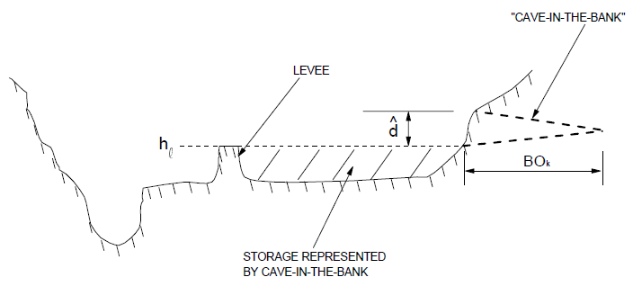
Figure 5-45 The ‘cave-in-bank’ concept is used to represent a spike in storage that occurs over a given elevation range (e.g. the height of the levee). Only water behind the levee is treated as inactive. Water in the off-channel area that is higher than the levee is treated as active. This is Figure 8.2 from Fread and Lewis (1998).

Figure 5-46 shows the FLDWAV cave-in-bank representation for a cross-section at river mile 20.7 of the Willamette River. There is a large BSS values specified at an elevation 45.5, which provides a spike in the storage available.

Figure 5-46 FLDWAV cross-section 20.7 from the Willamette River.

Our HEC-RAS approximation using multiple-blocked ineffective areas cannot represent this type of situation. The algorithm only works if the (BSS+BS) at elevation j is higher than the (BSS+BS) at elevation j-1. To further understand this problem, we ran FLDWAV simulations with and without BSS to understand the impact of these off-channel storage areas on stage simulations. A statistical summary of results shown in Table 5-11 indicates that the effect on the overall RMSE is negligible at all stations. However, there are some noteworthy differences in the maximum simulated stages, particularly the 0.78 ft difference on the selected point on the Lewis tributary (LRWW1).

Table 5-11. Difference between FLDWAV simulations with and without BSS for the lower Columbia River System

01FEB1995-29FEB1996
 | RMSE | Max Diff (ft)
Vancouver (VANW1) | 0.009 | 0.07
Longview (LOPW1) | 0.01 | 0.33
St. Helens (SHNO3) | 0.009 | 0.29
Lewis (LRWW1) | 0.035 | 0.78
Beaver Army Terminal (CBAO3) | 0.008 | 0.2
Skamokawa (SKAWX) | 0.005 | 0.16
Portland (PRTO3) | 0.009 | 0.09
Oregono City (OREGL) | 0.008 | 0.1

Working with Joanne Salerno at NWRFC in an attempt to better represent these ‘cave-in-bank’ storages, we looked back at the original UNET cross-section data used to derive the FLDWAV cross-sections. A FORTRAN program referred to as FLDEC3.FOR (author unknown) was originally used to convert UNET cross-sections to FLDWAV. For this study, we imported the UNET cross-sections into HEC-RAS for display, comparison, and analysis. Figure 5-47 shows the UNET data for cross-section 20.7 on the Willamette (same cross-section as Figure 5-46). Examination of Figure 5-47 suggests that the storage spike in the FLDWAV parameterization is intended to represent the side channel on the right side of the cross-section. This storage spike can be reproduced in HEC-RAS by (1) replacing the FLDWAV cross-section with the UNET cross-section, and (2) defining a permanent ineffective area and levee as shown in Figure 5-47. If only ineffective area is defined without the levee, the side channel will begin to fill with water at an elevation of 23.7 ft rather than 45.5 ft as occurs within FLDWAV.

Figure 5-47 Cross-section 20.7 on the Willamette tributary from the UNET model.

Figure 5-48 Area-elevation relationships for the FLDWAV and HEC-RAS representations of cross-section 20.7.

Figure 5-48 shows that the HEC-RAS approximation accurately describes the storage spike from FLDWAV. However, although the total area of the cross-section in the FLDWAV representation matches the original UNET, the total cross-sectional area of the two models only converges at high elevations on the cross-section. At lower elevations, the FLDWAV representation substantially departs from the original UNET.

For the Columbia River, the initial strategy has been to replace only selected symmetric cross-sections with UNET geometry, where off-channel storage representation is needed. This creates a model of intermediate complexity, but a model still much simpler than the detailed USACE model described in Section 5.1.2. This additional effort moving back towards a more detailed model raises the question of whether it makes more sense to simply replace all of the FLDWAV symmetric cross-sections with UNET cross-sections. The cons of this approach would be (1) the potential to increase the effort required to re-calibrate Manning’s n values, and (2) NWRFC also expressed concern that the UNET geometry may not adequately represent the channel bathymetry currently represented by the AS parameter in the operational DWOPER model. An automatic calibration capability would alleviate the first concern.

Impacts of Using 4 Digits for Manning’s n Specifications

As discussed in Section 3.3, we have no physical basis to specify Manning’s n values to four decimals of precision. However, this level of precision has been used in FLDWAV models, and it is useful to understand the sensitivity of models to the hundredths and thousandths decimal points of precision.

Table 5-12 RMSE and maximum difference of a FLDWAV simulation with four Digits of Manning’s n precision compared to a FLDWAV simulation with three digits of Manning’s n precision for four validation points in the Mississippi River System.

These statistics show that while the precision issue is relatively less important than proper specification of the bank stationing and ineffective area in the Mississippi River model described in earlier sections, it can affect results.

Model Calibration Procedures

Numerous sources of information describing model development and calibration procedures already exist. For example, the HEC-RAS Users Manual Chapter 8 provides several pages of discussion on model calibration. Fread and Lewis (1998), Fread and Lewis (1986) and RTi (2007) also discuss model calibration procedures. Historically, the NWS has also provided training on hydraulic model calibration. However, during the course of this study, the need for a more complete and consolidated set of training materials focused on calibrating models for operational forecasting became apparent. Developing more comprehensive documentation of this type is beyond the scope of this study, but should be given a high priority in future work. There is also a need to develop automatic Manning’s n calibration procedures for use with HEC-RAS. Fread and Smith (1978) describe suitable methods. LMRFC found the automatic calibration option in FLDWAV to be useful for their lower Mississippi River model.

Python Statistics Script (eventstats_bat.py)

HEC-RAS offers several visualization tools for evaluating model results including time series display, river profile display and comparisons of numerous variables, animated river profiles, 3D views of water levels, tabular summaries of variables at each cross-section, and more. However, HEC-RAS does not offer the tools we would like to have to calculate time series statistics during model calibration and validation.

Eventstats_bat.py computes statistical differences between observed and simulated time series stored in DSS format. The user provides:

(1) groups of stage time-series for one or more selected locations
(2) a list of events (start and end dates) for statistical calculations

The groups of time series should include a reference time series (e.g. observed data) followed by a list of time series from other simulation runs for the same location. The program will output statistics for each time series compared to the observed for each station and for each event. Bias, RMSE, and maximum difference are computed relative to the reference time series.

Similar to oh2dss_bat.py, eventstats_bat.py calls DSSVue Jython libraries and therefore requires that DSSVue be installed on your machine. Run in batch mode, the script must be called as an argument to the program HEC-DSSVue.cmd, which is installed with HEC-DSSVue. The default location to find HEC-DSSVue.cmd is under c:\Program Files\HEC\HEC-DSSVue.

To run eventstats_bat.py, at the DOS or cygwin prompt, move to the location of your HEC-DSSVue install and type:

C:\Program Files\HEC\HEC-DSSVue> HEC-DSSVue.cmd eventstats_bat.py inputfilename eventfilename outputfilename

The contents of an example input file are:

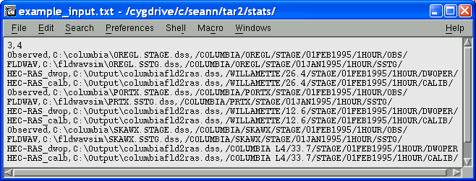

Figure 7-49. Example input file for eventstats_bat.py

The first line indicates the number of points (3) and the number of time series for each point (4).

In this example, there are four lines for each point with three comma-separated entries per line:
- A time series label (e.g. observed)
- The DSS file Name
- The DSS Path Name (all DSS files have a six part file name)

An events input file will have one line with the starting and ending time for each event to be considered in the calculations. A comma should separate the start and end times. The date-time format to use is as follows:

01FEB1995 0000,28FEB1996 1200

An example output file from the program looks like the following.

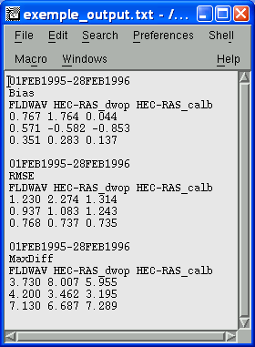
One row of output for each point
One column of output for each time series

Figure 7-50. Example eventstats_bat.py output file.

This script can also be run from the HEC-DSSVue GUI (e.g. Figure 4-17) with minor modifications. For an interactive run, the user simply modifies the three lines in the script that assign the names of the input file (“infileS”), the events file (“evfileS”) and the output file name (“outfilestr”).

Summary and Conclusions

NWS River Forecast Centers need to replace their FLDWAV and DWOPER models with HEC-RAS models during the transition from NWSRFS to CHPS. Unlike other NWSRFS models (e.g. Sacramento, Snow-17), there will be no exact equivalent to FLDWAV and DWOPER in CHPS. Therefore, new HEC-RAS models must be developed rather quickly to meet the CHPS implementation schedule. We investigated two approaches for replacing FLDWAV models with HEC-RAS models for use in operational forecasting. The first is conversion of existing FLDWAV models and the second is acquisition and modification of HEC-RAS models originally developed for other purposes. Both approaches can save time over building a new model from scratch because they take advantage of cross-section geometry and hydraulic feature data developed by others.

To facilitate the first approach, we have developed a fld2ras program to convert FLDWAV geometry to HEC-RAS geometry. This document provides detailed instructions on how to use fld2ras to convert models for single and multiple reach river systems. In addition to converting model geometry and parameters, we also provide a script (oh2dss.py) and detailed instructions for converting historical time series formatted for use with FLDWAV to the DSS format used by HEC-RAS. Historical time series conversion is necessary for validating converted models and developing new models in simulation mode. CHPS will take care of time series management in operational forecast mode.

Table 8-13 summarizes our recommended procedures for model conversion. Some of the more tedious steps are automated, while others require manual work. We concluded that it was not worth the extra resource expenditure to automate conversion of all model features because some (e.g. bridges) are not commonly used.

Table 8-13. Summary of steps to create a HEC-RAS model from an existing FLDWAV or DWOPER model
Step | Method
- Recreate river schematic in HEC-RAS | See Section 4.1
- Convert basic cross-section geometry, AS, and basic ineffective areas | Fld2ras program
- Transfer converted geometric data into HEC-RAS | See Section 4.1.
- Modify geometry for special cases (e.g. ‘cave-in-bank’ storage) | See Section 5.7.2.
- Examine elevation-conveyance curves and modify bank stationing if needed | HEC-RAS Graphical Cross-section Editor; HEC-RAS Conveyance-elevation plotting tool
- Duplicate roughness coefficient factors in the HEC-RAS Plan file | HEC-RAS Standard Tools. See Section 4.1.2.
- Convert calibration time-series to HEC-DSS (e.g. boundary conditions and lateral inflows) | Oh2dss.py, oh2dss_bat.py
- Specify boundary conditions and lateral inflows in HEC-RAS | HEC-RAS standard procedures
- Check results for calibration period graphically and statistically. Adjust roughness coefficients in the Plan file as needed. | HEC-RAS standard tools and eventstats_bat.py (Section 7)
- Test model stability over a wide range of flow conditions. | HEC-RAS standard tools

Because there are many differences between FLDWAV and HEC-RAS, successful completion of these steps requires sound engineering judgment.

Case studies on the Tar River, the lower Columbia River, and the lower Mississippi show that there is considerable value in transferring both the FLDWAV geometry and Manning’s n parameters into HEC-RAS. After this transfer, minimal or no Manning’s n adjustments are required to attain statistically similar results to FLDWAV in the Tar River and lower Columbia River models. With straight conversion and no additional adjustments, three of four validation stations on the Tar River had only slightly worse RMSE results compared to observed data and the other had slightly better results. On the Columbia River, only two stations had slightly worse RMSE results and four stations had slightly improved RMSE. Although we did not do the same comparisons with the Mississippi River model, it is clear that more engineering judgment and model adjustments will be required to successfully convert this model. This is mostly because the choice of bank stationing locations for HEC-RAS has a greater impact on this model and there is no way to precisely emulate the FLDWAV parameterization, which does not use bank stations (see Section 5.4). Ineffective areas also play a greater role in the Mississippi model, but experiments described in Section 5.7 show that our approximate conversions of FLDWAV ineffective areas to HEC-RAS yield the proper effects on simulations.

For the Tar River and Columbia River systems, we also developed more detailed unsteady HEC-RAS models based on previously existing steady-state HEC-RAS models. It is clear that the roughness values from the original steady-state models are not suitable for unsteady modeling and operational forecasting. To determine better Manning’s n values, one option we tested was to use the FLDWAV Manning’s n versus flow relationships in combination with the more detailed cross-sectional geometry. Although this option improves upon steady-state roughness values and may provide a useful starting point, it is clear that calibration is required on these Manning’s n when used with detailed cross-section geometry to meet or exceed the FLDWAV performance. This is true even if the detailed and symmetric models were originally derived from the same elevation data.

We have found that the second approach (modifying a steady-state HEC-RAS model) requires more effort than the first (direct conversion from FLDWAV) because the available model domain and boundary conditions from a steady-state model may not exactly match RFC needs, the roughness values assigned for other applications may not be suitable for continuous modeling over a wide range of flows, and the model may not be stable under all flow conditions of interest. Therefore, we recommend first attempting the direct conversion approach because of the relatively low effort required. Given more time and resources, the second approach may make more sense because it allows one to take full advantage of HEC-RAS features not available in FLDWAV. For example, more detailed bridge representations or more explicit modeling of off-channel ponds could be added. For building models that cover new areas or extending the domain of existing models, acquiring cross-section geometry from existing HEC-RAS models also makes the most sense. Ideally, these cross-sections will be geo-referenced, but this is not always the case.

Recommendations for Future Work

This document describes tools to assist RFCs in transitioning models from FLDWAV to HEC-RAS. There is still much work to be done in supporting the use of these transition tools, particularly for the non-CAT RFCS. It may be necessary to adapt the methods and recommendations described here as we assist RFCs in converting more models. For the transition to be successfully completed, we must also follow through with training on several hydraulic modeling topics including basic (steady state) HEC-RAS modeling, unsteady-state HEC-RAS modeling, FLDWAV model conversions based on information in this document, and use of HEC-RAS within CHPS. Although much of the focus here has been on model conversions, other RFCs may need help in getting new, geo-referenced HEC-RAS models calibrated and stable for operational purposes. For example, OHRFC has been developing HEC-RAS models for the Ohio River.

Since all of the analyses described here have focused on model simulations rather than forecasts, we also will need to fully-test the converted models within CHPS using operational data. This is particularly important for models such as the lower Columbia where processing of the boundary condition data and data post-processing play a major role in the forecast result. CHPS performs these data handling functions, not HEC-RAS.

Section 6 of this document identifies the need for a more complete and consolidated set of training materials focused on calibrating hydraulic models for operational forecasting.
Initial unsteady HEC-RAS modeling training scheduled for April 28, 2009 will cover the topic of calibration using HEC training materials. Follow on work should integrate unpublished NWS training materials and HEC training materials to provide more comprehensive calibration training. Work should also be done to develop automatic Manning’s n calibration procedures similar to those described by Fread and Smith (1978) for use in HEC-RAS. LMRFC and NWRFC have successfully used this capability in the past and this capability should not be lost.

We will also need to follow up with LMRFC, other RFCs, and HEC to determine whether it is necessary to increase the acceptable precision in HEC-RAS Flow Roughness factor specifications. As we work with additional RFCs, we will identify and prioritize any additional desired enhancements to HEC-RAS.

We did not explicitly address time-step and stability considerations in this document. Training for RFCs will include lectures and workshops designed to build knowledge in how to build stable HEC-RAS models and diagnose stability problems. HEC-RAS puts more responsibility on the model user to be sure the appropriate model time steps and cross-section spacing are prescribed, so this must be an emphasis in training.

Acknowledgements

We greatly appreciate the assistance of several colleagues in helping us to complete this work. David Welch (LMRFC) provided Python scripts, data for the Mississippi River model, and other information on hydraulic modeling at LMRFC. Joanne Salerno (NWRFC) provided data on the lower Columbia system and worked closely with us to improve the lower Columbia River component of this study. Gary Brunner (USACE-HEC) provided HEC-RAS 4.01 beta and helped answer HEC-RAS technical questions. NERFC, MARFC, NCRFC, and SERFC provided the model input files used to create Table 3-1. Hassan Mashriqui (OHD) provided a peer review of the document.

References
Chow, V.T., 1959, Open Channel Hydraulics, McGraw-Hill Book Company, NY.
Fread, D.L., 1985. Channel Routing, Chapter 14 in Hydrological Forecasting, Anderson, M.G., and T.P. Burt Editors, John Wiley and Sons Ltd., p. 437 – 503.
Fread, D. L., 1978. National Weather Service Operational Dynamic Wave Model, Theoretical Development and Software Documentation. http://www.weather.gov/oh/hrl/hsmb/docs/hydraulics/papers_before_2009/hl_111.pdf, 64 pp.
Fread, D. and G. Smith, 1978. Calibration Technique for 1-d Unsteady Flow Models. Journal of the Hydraulics Division, ASCE, Vol. 104 No. HY7.
Fread, D.L., 1988, The NWS DAMBRK Model: Theoretical Background/User Documentation, HRL-256, Hydrologic Research Laboratory, National Weather Service, Silver Spring, Md., 315 pp.
Fread D.L., and J.M. Lewis, Nov. 28 1998. NWS FLDWAV model: Theoretical Description and User Documentation, Hydrologic research Laboratory, Office of Hydrology, National Weather Service, NOAA, 335 pp.
Fread, D. L., and J.M. Lewis, 1986. Parameter Optimization of Dynamic Routing models. Proceedings of ASCE Conference /H.Y. EE. WW Divis. Long Beach, CA.
Gee, Michael D. and G. W. Brunner, 2005. Dam break flood routing using HEC-RAS and NWS-FLDWAV, ASCE/EWRI, 2005.
Hicks, F.E, 1996. Hydraulic flood routing with minimal channel data: Peace River Canada. Can.Civ Eng. 23:524-535
Koren, V., Reed, S., Smith, M., Zhang, Z., Seo, D.-J., 2004. Hydrology laboratory research modeling system (HL-RMS) of the US national weather Service. Journal of Hydrology, Vol. 291, 297-318.
Leopold, L.B., 1994. A View of the River, 298 pp.
National Weather Service, Evaluation of Different Hydraulic Models in Support of National Weather Service Operations, Final Report of the Hydraulic Model Evaluation Team, http://www.weather.gov/oh/rfcdev/docs/Final_Report_EvaluationHydraulicModels.pdf, 2007.
Riverside Technology, Inc., RTi, Calibration for the Lower Tar River Basin, Phase II Task Completion Report, Task 6-0016, submitted to NOAA/NWS/OHD, May 2007.
USACE HEC, March 2008. HEC-RAS River Analysis System User’s Manual Version 4.0, 747 pp., Downloadable http://www.hec.usace.army.mil/software/hec-ras/hecras-download.html.
USACE HEC, March 2008. HEC-RAS River Analysis System Hydraulic Reference Manual Version 4.0, 411 pp., Downloadable http://www.hec.usace.army.mil/software/hec-ras/hecras-download.html.
USACE HEC, May 2005, HEC-DSSVue: HEC Data Storage System Visual Utility Engine User’s Manual, version 1.2, 233pp.

For simplicity, throughout the remainder of this document we will often refer only to differences between FLDWAV and HEC-RAS. In most cases, the same statements apply to DWOPER. Differences between FLDWAV and DWOPER are noted only where important.

