Tropical Cyclone Report
Tropical Storm Erin
(AL052007)
15-17 August 2007

Richard D. Knabb
National Hurricane Center
7 April 2008

Erin was a tropical storm that formed in the Gulf of Mexico and made landfall along the Texas coast as a tropical depression. The tropical cyclone directly caused nine fatalities and its remnants caused seven more, mostly as a result of inland flooding due to heavy rainfall. Erin will also be remembered for its unusual, brief strengthening, although not as a tropical cyclone, over Oklahoma.

- Synoptic History

Erin formed in association with a tropical wave that departed the west coast of Africa on 3 August. The wave moved uneventfully across the tropical Atlantic and eastern Caribbean Sea during the following week or so. Eventually a broad surface low formed in the western Caribbean in association with the wave on 12 August. Development was limited in the Caribbean, as the low was influenced by vertical wind shear south of an upper-level low centered over the eastern Gulf of Mexico. The upper-level low moved quickly westward during 13-14 August, allowing vertical wind shear to decrease over the southeastern Gulf as the surface low moved into that area. Thunderstorm activity associated with the surface low increased, and Dvorak classifications were initiated at 1800 UTC 13 August. The system gradually gained some organization over the warm waters of the Gulf, and it became a tropical depression at about 0000 UTC 15 August while centered roughly 375 n mi east-southeast of Brownsville, Texas. The “best track” chart of the tropical cyclone’s path is given in Fig. 1, with the wind and pressure histories shown in Figs. 2 and 3, respectively. The best track positions and intensities are listed in Table 1.

Moving northwestward to the south of a large deep-layer ridge over the southern United States, the cyclone became a tropical storm with maximum winds of 35 kt by 1800 UTC 15 August while centered about 180 n mi east of Brownsville. Bands of heavy rain began moving ashore along nearly the entire coast of Texas at about that time. Sprawling and not very well organized, however, Erin did not strengthen any further over the Gulf, and it barely maintained tropical storm status early on 16 August. The center of Erin made landfall at about 1030 UTC that day on San Jose Island, Texas (just north of Port Aransas and about 30 n mi east-northeast of Corpus Christi). By that time Erin had weakened to a tropical depression with maximum winds of 30 kt. The depression continued northwestward and inland, and degenerated to a remnant low by 1200 UTC 17 August when it was centered about 50 n mi south of San Angelo, Texas. The remnant low turned northward over extreme western Texas on 18 August around the western periphery of the ridge over the southeastern United States. Upon reaching the northwestern extent of the ridge, the system turned northeastward and entered southwestern Oklahoma shortly after 0000 UTC 19 August. The remnant low had occasionally produced some heavy rainfall over Texas during the preceding 36 hours, but the convection was not sufficiently persistent and organized to designate the system as a tropical depression during that period.

As the surface low moved generally east-northeastward over Oklahoma early on 19 August, the associated thunderstorm activity abruptly increased as the low interacted with an eastward-moving upper-level shortwave trough. During an approximately six-hour period that morning, sustained surface winds as strong as about 50 kt were observed at several locations in western and central Oklahoma, with isolated gusts as strong as about 70 kt. The system’s organization also became dramatically enhanced, with an eye-like feature readily discernible in WSR-88D radar imagery between about 0800 and 1300 UTC as the center of the low passed just north of downtown Oklahoma City (Fig. 4 shows a radar image at 1200 UTC). This episode was short-lived, however, and the eye-like feature quickly dissipated after 1300 UTC. The thunderstorm activity and strong winds had already begun to weaken by that time, as the upper-level shortwave trough proceeded eastward and away from the surface low. The surface circulation dissipated shortly after 1800 UTC 19 August over northeastern Oklahoma, but remnant moisture continued northeastward into Missouri.

While the system's structure, particularly its convective organization as seen on radar, resembled and had some characteristics of a tropical storm for a few hours on 19 August, the prevailing view from the Hurricane Specialists at the National Hurricane Center (NHC) is that the system was not a tropical cyclone over Oklahoma. The phrase “organized deep convection” in the NHC tropical cyclone definition has both spatial and temporal components, meaning that a tropical cyclone must produce deep convection over some period of time. While it is a subjective determination, in this case the deep convection is judged to have lasted an insufficient period of time to classify the system as a tropical cyclone. The limited duration of the convection also appears to be indicative of the physical mechanisms that caused the low to briefly strengthen. It is speculated that the upper-level shortwave trough forced the deep convection to increase via upper-level difluence, while briefly superimposed above the surface low that provided a focus for low-level confluence. The upper-level forcing was apparently a dominant mechanism, which is in contrast to tropical cyclones that are maintained primarily by extraction of heat energy from the ocean. Since the system was clearly non-frontal, designating it as an extratropical cyclone is also not the most appropriate solution. In addition, the prevailing view among the NHC’s Hurricane Specialists is that the system’s duration over Oklahoma on 19 August was also too short to classify it as a subtropical cyclone. Given all of the considerations described above, the system is simply designated as a “low” by NHC on 19 August.

- Meteorological Statistics

Observations in Erin (Figs. 2 and 3) include satellite-based Dvorak technique intensity estimates from the Tropical Analysis and Forecast Branch (TAFB) and the Satellite Analysis Branch (SAB), as well as observations from two flights of the 53rd Weather Reconnaissance Squadron of the U. S. Air Force Reserve Command, and one flight of a NOAA WP-3D aircraft. Data and imagery from NOAA polar-orbiting satellites, the NASA Tropical Rainfall Measuring Mission (TRMM), the NASA QuikSCAT, and Defense Meteorological Satellite Program (DMSP) satellites, among others, were also useful in tracking Erin. WSR-88D radar data from sites in Texas and Oklahoma were very useful for analyzing the system at landfall and thereafter, as were numerous surface observations including those collected by the Oklahoma Mesonet. Selected, significant surface observations from land stations and data buoys are given in Table 2, including data in Oklahoma from 19 August when Erin was no longer a tropical cyclone. No ship reports of winds of tropical storm force were received in association with Erin.

Erin’s maximum intensity of 35 kt as a tropical cyclone is supported by aircraft reconnaissance data and Dvorak estimates. The NOAA aircraft at an altitude of about 1500 ft measured a flight-level wind of 44 kt, corresponding to about 35 kt at the surface, at 1445 UTC 15 August. The Air Force aircraft later measured winds of 43 kt at the same flight level at about 0100 UTC 16 August. Dvorak intensity estimates were at least 35 kt, occasionally reaching 45 kt, between 1800 UTC 15 August and 0600 UTC the next day, which is the period during which Erin has been designated as a tropical storm in the best track.

The maximum intensity of the low over Oklahoma is set to 50 kt at 0600 UTC 19 August based on surface observations. An Oklahoma Mesonet site located seven miles west of Watonga (about 50 n mi northwest of Oklahoma City), reported sustained winds (5-minute average) of 47 kt near 0725 UTC, with sustained winds of gale force occurring there much of the time between 0600 and 0800 UTC. Also, at 0725 UTC, this station measured a surface pressure estimated to be equivalent to 999 mb at sea level, so the minimum central pressure was likely lower than that observation and is set to 995 mb at 0600 UTC in the best track. Nearby, a sustained wind of 42 kt, with a gust to 71 kt, was measured at Watonga Airport (an AWOS site) at 0754 UTC, and the station stopped reporting after that time. A little earlier, the Oklahoma Mesonet site at Fort Cobb (about 50 n mi west-southwest of Oklahoma City) reported a sustained wind of 43 kt (also a 5-minute average). Several other observing sites in the eastern semicircle of the circulation, within about 45 n mi of the center, measured sustained winds of 35-40 kt at times between about 0500 UTC until almost 1200 UTC; the strongest winds at selected sites are listed in Table 2.

Erin and its remnants brought heavy rains to portions of southeastern, south-central, and western Texas, portions of Oklahoma, and portions of southern Missouri. Storm-total rainfall amounts of 3-7 in were common in these areas, with some locations receiving more than 10 in (Table 2 and Fig. 5). Erin added to the effects of the flooding that had already occurred within the two prior weeks in the Nueces River basin south and west of San Antonio, Texas.

Approximately three feet of storm surge occurred in the Galveston area on the day of Erin’s landfall.

A weak tornado was observed in the Houston area on 16 August. Following Erin’s tropical cyclone phase, six tornadoes were reported in Oklahoma on 18-19 August.

- Casualty and Damage Statistics

Erin directly caused nine fatalities in parts of southern and western Texas while the system was still a tropical cyclone. Thereafter, the remnants of Erin directly caused seven additional fatalities (six in Oklahoma, and one in Missouri). Most of the 16 total fatalities were due to inland flooding induced by heavy rains, with several of these occurring when occupants drowned in automobiles swept away by floodwaters. On the day of landfall in the Houston, Texas area, several bayous reached flood stage, numerous roads were flooded, and more than 400 homes and 40 businesses were inundated. Minor beach erosion occurred in Galveston and Freeport, Texas. Significant damages occurred on 19 August in some communities northwest of Oklahoma City, where several homes were flooded, and strong winds damaged some mobile homes and downed several trees and power lines. The Property Claim Services of the Insurance Services Office did not provide damage cost estimates for the United States for Erin, since the estimates did not surpass their threshold of $25 million.

- Forecast and Warning Critique

The genesis of Erin was anticipated rather well. The system that eventually became Erin was first mentioned in the NHC Tropical Weather Outlook a little more than three days prior to genesis. During the next couple of days, while the incipient system was over the Caribbean Sea, the Outlooks correctly indicated that conditions were not favorable for development at the time but were expected to become more favorable over the Gulf of Mexico. The potential for the formation of a tropical depression was then mentioned explicitly beginning about 32 hours before the depression formed over the Gulf.

A verification of official and guidance model track forecasts is given in Table 3. Very few forecasts can be verified since Erin was a tropical cyclone for only about 54 hours, with the number of forecasts ranging from seven at 12 h to just two at 48 h. Average official track errors for Erin were generally a little greater than the average long-term official track errors, but they were smaller than the errors from most of the objective models including the consensus guidance. The official forecasts were biased slow and at times slightly south of the actual track. Among the individual dynamical models that were available, the GFDL and HWRF had the smallest errors.

As for the track forecasts, very few intensity forecasts could be verified. Average official intensity errors for these forecasts were generally smaller than the long-term average errors, but were noticeably larger than the errors for the intensity consensus ICON (Table 4). The official intensity forecasts were biased high, in part since the official track forecasts were biased slow and implied that Erin would have more time over water to strengthen.

Table 5 summarizes the coastal watches and warnings issued for Erin.

- Acknowledgments

Oklahoma Mesonet data are provided courtesy of the Oklahoma Mesonet, “a cooperative venture between Oklahoma State University and The University of Oklahoma and supported by the taxpayers of Oklahoma.” Appreciation is also extended to Doug Speheger at the National Weather Service Forecast Office in Norman, Oklahoma for providing radar and surface observations and for his analysis of this event.

Table 1. Best track for Tropical Storm Erin, 15-17 August 2007.

Date/Time  (UTC) | Latitude  (°N) | Longitude  (°W) | Pressure  (mb) | Wind Speed  (kt) | Stage
15 / 0000 | 23.7 | 90.7 | 1006 | 25 | tropical depression
15 / 0600 | 24.5 | 91.8 | 1006 | 25 | "
15 / 1200 | 25.2 | 92.9 | 1005 | 30 | "
15 / 1800 | 25.8 | 94.0 | 1004 | 35 | tropical storm
16 / 0000 | 26.3 | 95.2 | 1003 | 35 | "
16 / 0600 | 27.2 | 96.2 | 1005 | 35 | "
16 / 1200 | 28.1 | 97.1 | 1006 | 30 | tropical depression
16 / 1800 | 28.8 | 97.8 | 1006 | 25 | "
17 / 0000 | 29.4 | 98.6 | 1006 | 25 | "
17 / 0600 | 30.0 | 99.5 | 1007 | 25 | "
17 / 1200 | 30.5 | 100.6 | 1008 | 20 | remnant low
17 / 1800 | 31.1 | 101.4 | 1008 | 20 | "
18 / 0000 | 31.8 | 101.8 | 1008 | 20 | "
18 / 0600 | 32.5 | 101.8 | 1008 | 20 | "
18 / 1200 | 33.2 | 101.5 | 1008 | 20 | "
18 / 1800 | 34.0 | 101.0 | 1007 | 20 | "
19 / 0000 | 34.8 | 100.1 | 1004 | 25 | low
19 / 0600 | 35.6 | 98.8 | 995 | 50 | "
19 / 1200 | 35.6 | 97.7 | 1002 | 35 | "
19 / 1800 | 35.9 | 96.5 | 1007 | 20 | "
20 / 0000 |  |  |  |  | dissipated
16 / 0000 | 26.3 | 95.2 | 1003 | 35 | minimum pressure and maximum winds as a tropical cyclone
16 / 1030 | 28.0 | 96.9 | 1006 | 30 | landfall at San Jose Island, Texas

Table 2. Selected surface observations for Tropical Storm Erin, 15-17 August 2007. Observations in Oklahoma are included for 19 August when Erin was no longer a tropical cyclone.

Location | Minimum Sea Level Pressure |  | Maximum Surface  Wind Speed |  |  | Storm surge  (ft)^{c} | Storm  tide  (ft)^{d} | Total  rain  (in)
Location | Date/  time  (UTC) | Press.  (mb) | Date/  time  (UTC)ª | Sustained  (kt)^{b} | Gust  (kt) | Storm surge  (ft)^{c} | Storm  tide  (ft)^{d} | Total  rain  (in)
Buoys/C-MAN/NOS Sites
Buoy 42019 (60 n mi S of Freeport, TX at 27.91°N 95.36°W) | 16/0850 | 1006.9 | 16/0450 | 27 | 37
Port O’Connor TCOON (PCNT2) |  |  | 16/1000 | 28 | 34
Port Aransas NWR RAWS |  |  | unknown |  | 40 |  |  | 2.81
Texas
Official
Bush-Intercontinental Airport (KIAH) |  |  |  |  |  |  |  | 2.59
Palacios (KPSX) |  |  |  |  |  |  |  | 3.88
Pearland (KLVJ) |  |  |  |  |  |  |  | 3.18
Wharton (KARM) |  |  |  |  |  |  |  | 2.78
Unofficial
Jamaica Beach (western Galveston Island) | 16/0859 | 1009.7 | 16/1523 | 26 | 34 | 3.10
USCG Freeport |  |  | 16/2136 | 30 | 35
Hunting Bayou @ Lockwood (Houston area) |  |  |  |  |  |  |  | 9.65
FO1 @ Sens Road (Houston area) |  |  |  |  |  |  |  | 9.25
Little Cedar Bayou @ 8th St (Houston area) |  |  |  |  |  |  |  | 8.35
Buffalo Bayou @ Turning Basin (Houston area) |  |  |  |  |  |  |  | 7.99
Beltway 8 @ I-45 (Houston area) |  |  |  |  |  |  |  | 7.01
Beamer Ditch @ Hughes (Houston area) |  |  |  |  |  |  |  | 6.02
Mary’s Creek @ Melodywood (Houston) |  |  |  |  |  |  |  | 5.00
Houston Heights |  |  |  |  |  |  |  | 5.02
Matagorda |  |  |  |  |  |  |  | 4.14
Columbus |  |  |  |  |  |  |  | 3.85
Wharton |  |  |  |  |  |  |  | 3.51
Houston Westbury |  |  |  |  |  |  |  | 3.44
Alvin |  |  |  |  |  |  |  | 3.40
Katy |  |  |  |  |  |  |  | 3.35
Aransas Wildlife Refuge (ARNT2) |  |  |  |  |  |  |  | 2.91
Victoria (VICT2) |  |  |  |  |  |  |  | 2.81
Port Lavaca (PVAT2) |  |  |  |  |  |  |  | 3.25
Matagorda Island RAWS (MIRT2) |  |  |  |  |  |  |  | 4.19
Port O’Connor |  |  |  |  |  |  |  | 3.26
Oklahoma
Official
Watonga Regional Airport (KJWG) |  |  | 19/0754 | 42 | 71
7 mi W of Watonga (Mesonet WATO) | 19/0725 | 999.1 | 19/0725 | 47 | 63
4 mi NNW of Fort Cobb (Mesonet FTCB) | 19/0525 | 1003.9 | 19/0525 | 43 | 65 |  |  | 9.30
Wiley Post Airport (Oklahoma City/Bethany) (KPWA) | 19/1153 | 1004.2 | 19/0919 | 39 | 49
2 mi NE of Kingfisher (Mesonet KING) | 19/1140 | 1004.2 | 19/0925 | 38 | 52 |  |  | 5.68
Will Rogers World Airport, Oklahoma City (KOKC) | 19/1152 | 1006 | 19/0925 | 38 | 49 |  |  | 5.38
Guthrie-Edmond Regional Airport (KGOK) | 19/1253 | 1006.6 | 19/0829 | 37 | 48
El Reno Regional Airport (KRQO) |  |  | 19/0741 | 37 | 48
2 mi SSW of Minco (Mesonet MINC) | 19/0720 | 1004.7 | 19/0815 | 37 | 50 |  |  | 6.80
7 mi W of Hinton (Mesonet HINT) | 19/0800 | 1002.3 | 19/0625 | 37 | 56
5 mi WNW of El Reno (Mesonet ELRE) | 19/1050 | 1003.6 | 19/0745 | 37 | 47 |  |  | 8.45
3 mi W of Medicine Park (Mesonet MEDI) | 19/0435 | 1002.4 | 19/0420 | 36 | 46
4 mi WSW of Weatherford (Mesonet WEAT) | 19/0630 | 1000.9 | 19/0505 | 36 | 48 |  |  | 6.53
Norman NWS |  |  |  |  |  |  |  | 7.67
4 mi WNW of Rush Springs (Mesonet ACME) | 19/0740 | 1005.4 | 19/0710 | 27 | 40 |  |  | 6.44
Shawnee (Mesonet SHAW) | 19/1335 | 1007.7 | 19/1220 | 27 | 38 |  |  | 5.14
Unofficial
9.8 mi NNW of Geary |  |  |  |  |  |  |  | 11.03
Watonga |  |  |  |  |  |  |  | 9.11
Sedan |  |  |  |  |  |  |  | 8.84
7.9 mi ESE of Norman |  |  |  |  |  |  |  | 8.68
Walters |  |  |  |  |  |  |  | 8.50
Lookeba |  |  |  |  |  |  |  | 8.15
Shawnee |  |  |  |  |  |  |  | 7.11
Chickasha |  |  |  |  |  |  |  | 6.18
2 mi W of Lindsay |  |  |  |  |  |  |  | 5.12

ª Date/time is for sustained wind when both sustained and gust are listed.
^{b} Except as noted, sustained wind averaging periods for C-MAN and land-based ASOS reports are 2 min; buoy averaging periods are 8 min; wind averaging period for Oklahoma Mesonet sites is 5 min.
^{c} Storm surge is water height above normal astronomical tide level.
^{d} Storm tide is water height above National Geodetic Vertical Datum (1929 mean sea level).

Table 3. Preliminary track forecast evaluation (heterogeneous sample) for Tropical Storm Erin, 15-17 August 2007. Forecast errors (n mi) are followed by the number of forecasts in parentheses. Errors smaller than the NHC official forecast are shown in bold-face type. Verification includes the depression stage.

Forecast Technique | Forecast Period (h)
Forecast Technique | 12 | 24 | 36 | 48 | 72 | 96 | 120
CLP5 | 55 ( 7) | 112 ( 6) | 182 ( 4) | 323 ( 2)
GFNI | 69 ( 3) | 123 ( 2)
GFDI | 36 ( 7) | 66 ( 6) | 99 ( 4) | 161 ( 2)
HWFI | 38 ( 7) | 63 ( 6) | 99 ( 4) | 128 ( 2)
GFSI | 54 ( 6) | 102 ( 5) | 170 ( 3) | 312 ( 1)
AEMI | 73 ( 7) | 127 ( 5) | 177 ( 4) | 208 ( 2)
NGPI | 51 ( 6) | 81 ( 5) | 128 ( 3) | 168 ( 2)
BAMD | 43 ( 7) | 76 ( 6) | 94 ( 4) | 106 ( 2)
BAMM | 44 ( 7) | 78 ( 6) | 92 ( 4) | 95 ( 2)
BAMS | 49 ( 7) | 85 ( 6) | 103 ( 4) | 106 ( 2)
CONU | 43 ( 7) | 79 ( 6) | 121 ( 4) | 177 ( 2)
GUNA | 41 ( 3) | 70 ( 2)
FSSE | 57 ( 3) | 85 ( 3) | 105 ( 1)
OFCL | 42 ( 7) | 70 ( 6) | 97 ( 4) | 110 ( 2)
NHC Official  (2002-2006 mean) | 35 (1852) | 61 (1686) | 86 (1519) | 112 (1362) | 162 (1100) | 221 (885) | 290 (723)

Table 4. Preliminary intensity forecast evaluation (heterogeneous sample) for Tropical Storm Erin, 15-17 August 2007. Forecast errors (kt) are followed by the number of forecasts in parentheses. Errors smaller than the NHC official forecast are shown in bold-face type. Verification includes the depression stage.

Forecast Technique | Forecast Period (h)
Forecast Technique | 12 | 24 | 36 | 48 | 72 | 96 | 120
SHF5 | 7.9 ( 7) | 14.3 ( 6) | 22.8 ( 4) | 23.5 ( 2)
GHMI | 4.3 ( 7) | 3.2 ( 6) | 1.8 ( 4) | 1.5 ( 2)
HWFI | 5.3 ( 7) | 6.5 ( 6) | 3.5 ( 4) | 6.5 ( 2)
SHIP | 8.1 ( 7) | 13.3 ( 6) | 20.8 ( 4) | 24.5 ( 2)
DSHP | 6.7 ( 7) | 5.7 ( 6) | 6.3 ( 4) | 4.5 ( 2)
FSSE | 6.7 ( 3) | 8.0 ( 3) | 2.0 ( 1)
ICON | 4.1 ( 7) | 3.7 ( 6) | 2.5 ( 4) | 1.0 ( 2)
OFCL | 5.7 ( 7) | 5.0 ( 6) | 7.5 ( 4) | 2.5 ( 2)
NHC Official  (2002-2006 mean) | 6.4  (1852) | 9.8  (1686) | 12.0  (1519) | 14.1  (1362) | 18.3  (1100) | 19.8  (885) | 21.8  (723)

Table 5. Coastal watch and warning summary for Tropical Storm Erin, 15-17 August 2007.

Date/Time (UTC) | Action | Location
15 / 0300 | Tropical Storm Watch issued | Brownsville to Freeport
15 / 0300 | Tropical Storm Watch issued | Rio San Fernando to Texas/Mexico Border
15 / 1500 | Tropical Storm Watch changed to Tropical Storm Warning | Brownsville to Freeport
15 / 2100 | Tropical Storm Watch discontinued | All
15 / 2100 | Tropical Storm Warning modified to | Brownsville to San Luis Pass
16 / 0900 | Tropical Storm Warning modified to | Port Mansfield to San Luis Pass
16 / 1200 | Tropical Storm Warning discontinued | All

Figure 1. Best track positions for Tropical Storm Erin, 15-17 August 2007.

Figure 2. Selected wind observations and best track maximum sustained surface wind speed curve for Tropical Storm Erin, 15-17 August 2007. Solid vertical line indicates time of landfall of the center on the Texas coast. Aircraft observations have been adjusted for elevation using 90%, 80%, and 80% reduction factors for observations from 700 mb, 850 mb, and 1500 ft, respectively.
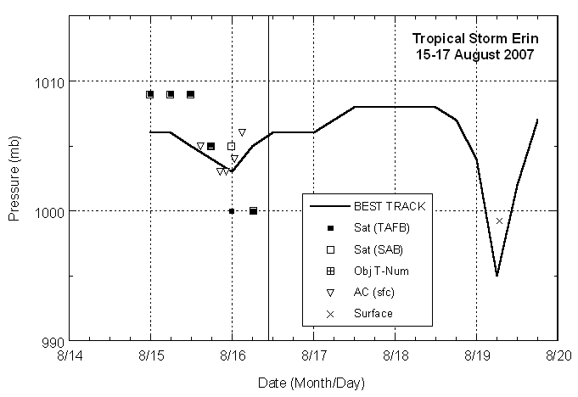

Figure 3. Selected pressure observations and best track minimum central pressure curve for Tropical Storm Erin, 15-17 August 2007. Solid vertical line indicates time of landfall of the center on the Texas coast.
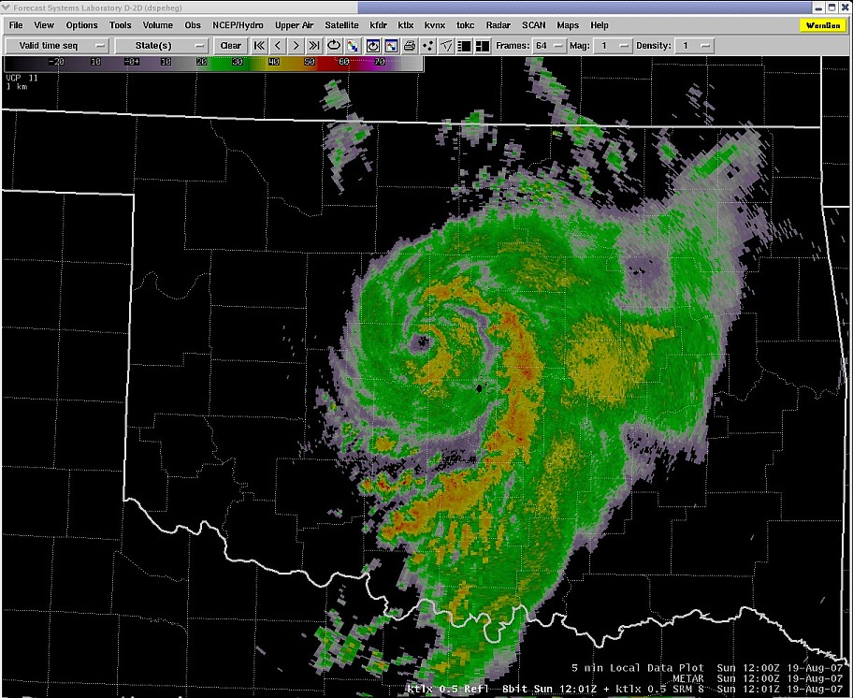

Figure 4. WSR-88D radar reflectivity image over Oklahoma at 1200 UTC 19 August 2007. Graphic courtesy of the National Weather Service Forecast Office in Norman, Oklahoma.
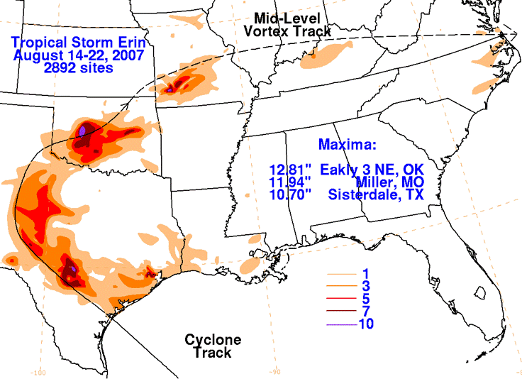

Figure 5. Storm-total rainfall accumulations (inches) from Tropical Storm Erin and its remnants. Graphic courtesy of the Hydrometeorological Prediction Center.

A tropical cyclone is defined by NHC as “a warm-core, non-frontal, synoptic-scale cyclone, originating over tropical or subtropical waters, with organized deep convection and a closed surface wind circulation about a well-defined center.”
An extratropical cyclone is defined by NHC as “a synoptic-scale low pressure system whose primary energy source is baroclinic.”
A subtropical cyclone is defined by NHC as “a non-frontal low pressure system that has characteristics of both tropical and extratropical cyclones.”

