Tropical Cyclone Report

Hurricane Dean

(AL042007)

13-23 August 2007

James L. Franklin

National Hurricane Center

31 January 2008

Revised 19 February 2008

(for damage statistics in Martinique and Guadeloupe and to add acknowledgments)

Revised 7 April 2008

(corrected wind speeds in Table 1 between 16/1200 UTC and 17/0600 UTC)

Dean was a classic Cape Verde cyclone that moved through the Caribbean as a major hurricane, passing very close to Jamaica and later making landfall on the east coast of the Yucatan Peninsula as a category 5 hurricane. Dean, the first Atlantic hurricane since Andrew of 1992 to reach land at category 5 strength, was responsible for 32 deaths.

- Synoptic History

Dean originated from a well-defined tropical wave that crossed the west coast of Africa on 11 August. The wave was associated with a closed surface low even before entering the Atlantic, but strong easterly shear kept the system’s convection displaced from an elongated circulation center for a couple of days. By about 0600 UTC 13 August, however, the circulation became better defined and sufficiently connected to the deep convection to consider the low a tropical depression about 350 n mi west-southwest of Praia in the Cape Verde Islands. The “best track” chart of the tropical cyclone’s path is given in Fig. 1, with the wind and pressure histories shown in Figs. 2 and 3, respectively. The best track positions and intensities are listed in Table 1.

Embedded in a strong easterly current, the depression initially moved westward at about 20 kt. The environment was still characterized by easterly shear, and the depression took 30 h to reach storm strength; this occurred at 1200 UTC 14 August, when the system was centered about 1250 n mi east of Barbados. Although the cyclone’s satellite presentation remained ragged, Dean strengthened early the next day as it turned to the west-northwest, still moving briskly. Dean would continue on this heading, to the south of a deep-layer ridge of high pressure, for the next seven days.

The easterly shear gradually abated, and by late on 15 August well-defined convective banding had developed around the center and microwave data showed the formation of a partial eyewall. Shortly thereafter, infrared satellite imagery began to show an eye, and Dean became a hurricane early on 16 August about 480 n mi east of Barbados. As upper-level outflow became more pronounced, Dean reached an intensity of 80 kt by 1200 UTC that day, but the eyewall then disappeared and the strengthening trend temporarily halted.

Dean entered the Caribbean Sea on 17 August, its center passing between Martinique and St. Lucia around 0930 UTC (Fig. 4). The northern eyewall, accompanied by sustained winds of about 85 kt, passed directly over Martinique. With upper-level outflow increasing in all quadrants, Dean then began to strengthen rapidly in the eastern Caribbean Sea, its winds increasing from 80 to 145 kt (category 1 to category 5 on the Saffir-Simpson Hurricane Scale) in the 24 h ending at 0600 UTC 18 August. At 1200 UTC that day, Dean’s minimum central pressure was 923 mb.

During this period of rapid deepening Dean’s forward motion slowed to about 15 kt; its heading, however, remained remarkably constant throughout the Caribbean as high pressure was maintained to the north of the hurricane, while a mid- to upper-level low over south Florida on 18 August retreated westward in tandem with the tropical cyclone. The center of Dean passed about 180 n mi south of Puerto Rico early on 18 August, and continued west-northwestward in the direction of Jamaica.

By 1200 UTC that day, microwave imagery showed a concentric eyewall structure (Fig. 5). As the inner eyewall eroded over the next 12 h, Dean’s maximum sustained winds decreased from 145 kt to 120 kt (Category 4). Interestingly, the central pressure fell slightly during this time, dropping below 920 mb for a short period early on 19 August (Fig 3). Dean remained a Category 4 hurricane as its center passed within about 80 n mi of the south coast of Haiti during the morning of 19 August, and within about 20 n mi of the south coast of Jamaica that evening. Dean’s intensity as it passed Jamaica is estimated to be 125 kt, although reconnaissance data suggest that Dean’s strongest winds remained just offshore.

On 20 August Dean moved away from Jamaica over the deep warm waters of the northwestern Caribbean. The convective structure that day was dominated by a single eyewall, and under light shear Dean began to strengthen as it approached the Yucatan Peninsula. As the eyewall contracted, Dean regained Category 5 status near 0000 UTC 21 August, and was still deepening when the center made landfall near the town of Majahual in the Costa Maya tourist region of the Yucatan near 0830 UTC that day. At the time of landfall, Dean is estimated to have had a minimum central pressure of 905 mb and maximum sustained winds of 150 kt, making it the first land-falling Category 5 hurricane in the Atlantic basin since Andrew of 1992.

Dean weakened as it moved across the Yucatan Peninsula, emerging into the Bay of Campeche around 1900 UTC. Although Dean maintained hurricane strength throughout its 10-h passage over land, its inner core convective structure was largely disrupted. Aircraft reconnaissance data in the Bay of Campeche showed that the cyclone’s radius of maximum wind had expanded to roughly 55 n mi, and Dean was only able to recapture a small fraction of its former strength. Deep-layer high pressure along the northern coast of the Gulf of Mexico kept Dean on its west-northwestward track until 1200 UTC 22 August, when the cyclone turned to the west. Dean made landfall at 1630 UTC that day near the town of Tecolutla, Mexico, about 90 n mi northeast of Veracruz, as a Category 2 hurricane with winds of 85 kt.

Dean weakened rapidly after landfall, becoming a depression by 0000 UTC 23 August, and dissipating over the mountains of central Mexico shortly thereafter.

- Meteorological Statistics

Observations in Dean (Figs. 2 and 3) include satellite-based Dvorak technique intensity estimates from the Tropical Analysis and Forecast Branch (TAFB) and the Satellite Analysis Branch (SAB), as well as flight-level, Stepped Frequency Microwave Radiometer (SFMR) and dropwindsonde observations from flights of the 53rd Weather Reconnaissance Squadron of the U. S. Air Force Reserve Command (AFRC). Microwave satellite imagery from NOAA polar-orbiting satellites, the NASA Tropical Rainfall Measuring Mission (TRMM), the NASA QuikSCAT, and Defense Meteorological Satellite Program (DMSP) satellites, among others, were also useful in tracking Dean and analyzing its structure.

AFRC reconnaissance aircraft conducted 17 missions into Dean over a period of seven days. Unfortunately, communications issues with the aircraft prevented receipt of a substantial quantity of reconnaissance data operationally. In addition, the very strong radial gradients of wind speed across the eyewall of Dean incorrectly triggered SFMR data-blanking algorithms, causing the loss of additional data. A substantial effort was made to reconstruct/reprocess these data to assist in the preparation of this report. Raw SFMR data were reprocessed after the event by of ProSensing, Inc., using their latest retrieval algorithm with improved quality-control thresholds. Only 10-s means from the reprocessed SFMR profiles were considered in the post-storm analysis; this is the same spatial averaging that is applied to AFRC flight-level observations. Complete flight-level data records were obtained for selected missions, as well as raw dropsonde observations from the eyewall of Dean, which were then reprocessed by the author.

There were a number of notable reconnaissance observations obtained during Dean, including an SFMR surface wind estimate of 150 kt at 0504 UTC 18 August (Fig. 2). Examination of the SFMR wind profile across the eyewall reveals that this was a broad maximum that is difficult to dismiss as unrepresentative, although the peak flight-level (700 mb) wind observed around this time was 154 kt, which would correspond only to 139 kt at the surface using the standard 90% adjustment factor for this flight level. There were two dropsondes early on 18 August that reported instantaneous surface winds of 144 and 149 kt, but in both cases the profile shapes strongly suggest that these particular estimates were unrepresentative of a sustained wind. The best track intensity for 0600 UTC 18 August is set at 145 kt, and represents a compromise between the SFMR and flight-level estimates.

It is worth noting that Dean’s minimum sea-level pressure at this time was only 929 mb, and that the pressure fell another 10 mb or so over the next 18-24 h. During the time of this pressure fall, however, important structural changes were occurring: Dean’s inner eyewall eroded, resulting in a re-distribution of the pressure gradient. There were 30-40 kt reductions in both peak SFMR and dropsonde winds observed during this period, and the peak flight-level winds concurrently fell by over 20 kt. Accordingly, the best track shows a decrease in winds from 145 kt to 120 kt (Fig. 2). This well-monitored hurricane illustrates some of the pitfalls of using central pressure as a proxy or measure of tropical cyclone intensity.

Dean is estimated to have made landfall near Majahual as a Category 5 hurricane on 21 August with maximum sustained winds of 150 kt and a minimum pressure of 905 mb, the latter estimate being based on a dropsonde report of 906 mb at 0814 UTC, accompanied by a surface wind speed of 15 kt. At 905 mb, Dean ties Camille (1969) and Mitch (1998) for the seventh-lowest central pressure on record in the Atlantic basin, and the third-lowest landfall pressure, behind only Gilbert and the 1935 Labor Day hurricane.

The maximum winds at landfall are harder to estimate, as there is a considerable spread among the various observations taken around this time. The most extreme of these is a dropsonde surface report of 177 kt at 0728 UTC. This was associated with a very thin layer of strong winds immediately at and just above the surface, which because of friction is an impossible steady-state configuration; consequently this observation is rejected as unrepresentative of a sustained wind. Several hours prior to landfall, around 0000 UTC, there was good agreement between the SFMR and surface-adjusted flight-level winds on an intensity of 145 kt. Subsequently, the pressure fell from 914 mb to 905 mb, while the flight-level winds increased slightly: at 0653 UTC and 0819 UTC, flight level winds of 165 and 164 kt were recorded, respectively, corresponding to surface winds of 149 and 148 kt. Interestingly, the SFMR did not encounter surface winds higher than 136 kt around the time of landfall, further complicating the analysis. Given the eyewall/convective structure, however, greater weight is placed on the flight-level observations, resulting in a landfall intensity estimate of 150 kt.

Ship and buoy reports of winds of tropical storm force associated with Dean are given in Table 2, and selected surface observations from land stations are given in Table 3. In Martinique, a sustained (1-min mean) wind of 81 kt was observed at Vauclin, a site along the southeast coast of the island but outside of Dean’s eyewall. A gust to 101 kt was reported at Sainte-Anne; this site did experience the eyewall but has a more sheltered exposure. The highest storm-total rainfall in Martinique was 13.07 inches at Fort de France-Colson.

There are few authoritative observations from Dean’s passage over Jamaica, as many instruments did not survive the storm. At Norman Manley International Airport in Kingston (MKJP), the weather station tower was blown over around 1800 UTC 19 August, causing a loss of data. Numerous rain gauges were blown or washed away. There was a ham radio report of an 89 kt sustained wind in Munro, St. Elizabeth, before the instrument was disabled. The highest rainfall report was 13.50 inches at Ingleside, Manchester.

No official wind observations of significance were received in association with either of Dean’s landfalls in Mexico, which occurred in relatively-sparsely populated areas. The maximum rainfall report was 15.39 inches at Requetemu, San Luis Potosi in central mainland Mexico. In Sabancuy, Campeche, 10.87 inches of rain was recorded.

- Casualty and Damage Statistics

Based largely on reports provided by the meteorological services of the affected countries, the number of direct deaths associated with Dean is estimated to be 32, with 14 occurring in Haiti, 12 in Mexico, 3 in Jamaica, 2 in Dominica, and 1 in St. Lucia. Remarkably, the deaths in Mexico occurred in the states of Hidalgo, Puebla, Veracruz, and San Luis Potosi, in association with Dean’s second (weaker) landfall.

Dean is estimated to have been a Category 2 hurricane when its northern eyewall passed over Martinique. Flooding was reported throughout the island. Approximately 1300 homes were destroyed and another 7500 experienced severe damage. Media and government reports indicate the complete destruction of the island’s banana crop, and a 70% loss of the sugar cane crop. Damage has been estimated at 400 million Euros. Although there were no direct deaths, there were at least three indirect deaths, including one from a heart attack and one suicide. Over 200 post-storm injuries were reported during the cleanup after the event. In Guadeloupe, damage has been estimated at 100 million Euros, with about 75% of the banana plantations destroyed. The fishing industry also suffered significant losses, and resorts along the south coast of the island reported damage.

Strong winds and heavy seas caused extensive damage along the north and west coasts of St. Lucia, including damage to bridges, roofs, and utility poles. Damage there was estimated at $18 million. In St. Vincent, some homes lost their roofs, and roof damage was also reported in Dominica. There was a complete loss of banana crop in Dominica. In Barbados, storm surge flooding described as serious was reported along the south coast.

The center of Dean passed about 90 n mi south of the Dominican Republic. Rainfall associated with outer bands there was relatively light, although very heavy surf was reported along the south coast that media reports indicate destroyed several homes. Landslides reportedly destroyed several hundred homes in Haiti, and were responsible for most of the fatalities there.

In Jamaica, the most severe impacts were reported in the southeastern parishes of Clarendon, St. Catherine, and Kingston/St. Andrew, where it is estimated that roughly two-thirds of the homes were completely destroyed or would require major repairs. Flooding in Jamaica was not generally significant, although some occurred in eastern parishes where grounds had become saturated by rains the previous week. Agriculture, particularly the banana crop, was severely impacted.

Dean made its initial landfall in Mexico in a relatively uninhabited area, sparing the popular tourist destinations of Cancun and Cozumel, and consequently the damage was relatively light. Majahual was the only town to experience the full force of the hurricane, where hundreds of buildings were destroyed and steel girders were crumpled. Puerto Costa Maya, the nearby cruise port, was severely damaged and was expected to be closed for many months. Farther to the south, the government of Belize reported about $100 million in damage in that country. At its second landfall near Tecalutla, Mexico, extensive roof damage was reported, along with downed trees and power lines.

- Forecast and Warning Critique

The genesis of Dean was well anticipated in Tropical Weather Outlook (TWO) products. The wave from which Dean formed was introduced into the TWO as a tropical cyclone candidate as it emerged from the African continent into the Atlantic. The National Weather Service Global Forecast System (GFS) model was consistently calling for development of this wave well before it entered the Atlantic basin.

A verification of official and guidance model track forecasts is given in Table 4. Average official track errors for Dean were 21, 39, 58, 82, 141, 198, and 274 n mi for the 12, 24, 36, 48, 72, 96, and 120 h forecasts, respectively. The number of forecasts ranged from 37 at 12 h to 19 at 120 h. These errors are lower than the average long-term official track errors at all time periods (Table 4), and significantly lower than the long-term averages out to 48 h. As can be seen in Fig. 6, the official forecasts had relatively low cross-track errors; although it is difficult to determine from the diagram, the official forecasts primarily had a slow bias, as did many of the guidance models. Among the models, the GFS performed exceptionally well, while the GFDL did unusually poorly, taking Dean too far to the north on many occasions. Several of the guidance models outperformed the official forecast at the longer intervals.

A verification of official and guidance model intensity forecasts is given in Table 5. Average official intensity errors were 10, 12, 13, 14, 21, 33, and 32 kt for the 12, 24, 36, 48, 72, 96, and 120 h forecasts, respectively. For comparison, the average long-term official intensity errors are 6, 10, 12, 14, 18, 20, and 22 kt, respectively. As is often the case with intense hurricanes, official intensity errors for Dean were above the long-term means, and particularly so at the longer ranges. However, the official forecasts were generally superior to the objective guidance. The official forecasts had a modest low bias.

Watches and warnings associated with Dean are given in Table 6.

Acknowledgements.

Radar imagery, as well as information on conditions and impacts in Martinique and Guadeloupe was provided by of Meteo-France. The meteorological services of St. Lucia, Jamaica, and Mexico also provided some of the quantitative information included in this report.

Table 1. Best track for Hurricane Dean, 13-23 August 2007.

Date/Time  (UTC) | Latitude  (°N) | Longitude  (°W) | Pressure  (mb) | Wind Speed  (kt) | Stage
13 / 0600 | 12.2 | 28.9 | 1006 | 30 | tropical depression
13 / 1200 | 12.1 | 30.7 | 1005 | 30 | "
13 / 1800 | 12.0 | 32.4 | 1005 | 30 | "
14 / 0000 | 11.9 | 34.5 | 1005 | 30 | "
14 / 0600 | 11.8 | 36.5 | 1005 | 30 | "
14 / 1200 | 11.8 | 38.3 | 1004 | 35 | tropical storm
14 / 1800 | 11.8 | 40.1 | 1002 | 40 | "
15 / 0000 | 11.9 | 41.7 | 997 | 50 | "
15 / 0600 | 12.0 | 43.4 | 997 | 50 | "
15 / 1200 | 12.3 | 45.1 | 997 | 50 | "
15 / 1800 | 12.8 | 47.0 | 994 | 55 | "
16 / 0000 | 13.0 | 49.2 | 991 | 60 | "
16 / 0600 | 13.2 | 51.3 | 984 | 70 | hurricane
16 / 1200 | 13.5 | 53.3 | 970 | 80 | "
16 / 1800 | 13.8 | 55.5 | 972 | 80 | "
17 / 0000 | 14.0 | 57.7 | 976 | 80 | "
17 / 0600 | 14.2 | 59.8 | 975 | 80 | "
17 / 1200 | 14.4 | 61.7 | 967 | 90 | "
17 / 1800 | 14.8 | 63.5 | 961 | 110 | "
18 / 0000 | 14.9 | 65.1 | 944 | 125 | "
18 / 0600 | 15.0 | 66.6 | 929 | 145 | "
18 / 1200 | 15.4 | 68.0 | 923 | 145 | "
18 / 1800 | 15.9 | 69.5 | 930 | 130 | "
19 / 0000 | 16.1 | 71.0 | 920 | 120 | "
19 / 0600 | 16.4 | 72.6 | 921 | 120 | "
19 / 1200 | 16.8 | 74.3 | 923 | 125 | "
19 / 1800 | 17.1 | 76.0 | 930 | 125 | "
20 / 0000 | 17.5 | 77.8 | 926 | 125 | "
20 / 0600 | 17.6 | 79.8 | 926 | 130 | "
20 / 1200 | 17.8 | 81.5 | 926 | 130 | "
20 / 1800 | 18.0 | 83.3 | 924 | 135 | "
21 / 0000 | 18.2 | 85.1 | 914 | 145 | "
21 / 0600 | 18.6 | 86.9 | 907 | 150 | "
21 / 1200 | 18.9 | 88.7 | 935 | 110 | "
21 / 1800 | 19.2 | 90.5 | 960 | 75 | "
22 / 0000 | 19.7 | 92.2 | 979 | 65 | "
22 / 0600 | 20.1 | 94.0 | 979 | 70 | "
22 / 1200 | 20.5 | 95.5 | 976 | 80 | "
22 / 1800 | 20.5 | 97.3 | 974 | 75 | "
23 / 0000 | 20.5 | 99.0 | 998 | 30 | tropical depression
23 / 0600 |  |  |  |  | dissipated
21 / 0830 | 18.7 | 87.7 | 905 | 150 | minimum pressure
21 / 0830 | 18.7 | 87.7 | 905 | 150 | Landfall near Majahual, Mexico
22 / 1630 | 20.5 | 97.0 | 974 | 85 | Landfall near Tecolutla, Mexico

Table 2. Selected ship and fixed buoy reports with winds of at least 34 kt for Hurricane Dean, 13-23 August 2007.

Date/Time (UTC) | Ship/Buoy ID | Latitude  (°N) | Longitude  (°W) | Wind  dir/speed (kt) | Pressure  (mb)
13 / 0000 | VRBL4 | 14.2 | 27.0 | 040 / 35 | 1010.0
16 / 1250 | 41040 | 14.5 | 53.0 | 120 / 41 | 1008.3
16 / 1900 | 41101 | 14.6 | 56.2 | 070 / 50 | 1003.0
17 / 0100 | 41100 | 15.9 | 57.9 | 080 / 35 | 1011.6
17 / 0600 | J8PB | 17.9 | 64.1 | 080 / 37 | 1015.0
18 / 0600 | C6FN4 | 18.0 | 64.8 | 100 / 39 | 1011.0
18 / 0941 | 42059 | 15.0 | 67.5 | 306 / 57 | 974.2
18 / 1800 | ELUC5 | 16.7 | 66.1 | 130 / 45 | 1010.2
20 / 0000 | DHER | 16.4 | 76.0 | 170 / 35 | 1006.0
20 / 0300 | C6FZ7 | 21.4 | 74.0 | 090 / 39 | 1015.0
20 / 0600 | DHER | 18.2 | 74.9 | 120 / 45 | 1010.8
20 / 2250 | 42056 | 19.9 | 85.1 | 071 / 52 | 1001.3
22 / 0931 | 42055 | 22.0 | 94.0 | 118 / 55 | 1001.2

Table 3. Selected surface observations for Hurricane Dean, 13-23 August 2007.

Location | Minimum Sea Level Pressure |  | Maximum Surface  Wind Speed |  |  | Storm surge  (ft)^{c} | Storm  tide  (ft)^{d} | Total  rain  (in)
Location | Date/  time  (UTC) | Press.  (mb) | Date/  time  (UTC)ª | Sustained  (kt)^{b} | Gust  (kt) | Storm surge  (ft)^{c} | Storm  tide  (ft)^{d} | Total  rain  (in)
Martinique
Caravelle (elev 38 m) |  |  | 17/1000 | 68 | 78
Diamant^{e} (elev 353 m) |  |  | 17/0800 | 55 | 82
Sainte-Anne^{e} (elev 13 m) |  |  | 17/1100 | 66 | 101
Vauclin^{e} (elev 19 m) |  |  | 17/1100 | 81 | 93
Lamentin Airport  (elev 8 m) |  |  | 17/1000 | 54 | 82
Fort de France Desaix  (elev 140 m) |  |  | 17/1100 | 73 | 99
Fonds st Denis  (elev 510 m) |  |  | 17/1100 | 73 | 113
Fort de France Colson |  |  |  |  |  |  |  | 13.07
Bellefontaine Verrier |  |  |  |  |  |  |  | 11.97
Marin Usine |  |  |  |  |  |  |  | 10.79
Sainte Anne Salines |  |  |  |  |  |  |  | 10.24
Fort de France DDST |  |  |  |  |  |  |  | 10.24
Saint Pierre Galère |  |  |  |  |  |  |  | 8.86
Fonds St Denis Cadets |  |  |  |  |  |  |  | 8.19
Sainte Marie Pérou |  |  |  |  |  |  |  | 7.13
Robert Villarson |  |  |  |  |  |  |  | 6.38
Trinité Réservoir |  |  |  |  |  |  |  | 4.65
St. Lucia
Charles Airport (TLPC) | 17/1000 | 991.3 |  | 45 | 58 |  |  | 3.63
Hewanorra | 17/0900 | 997.9 | 17/1000 | 38 | 58 |  |  | 2.10
Dominica
Canefield Airport |  |  | 17/1140 |  | 68
Barbados
Grantley Adams (78954) | 17/0500 | 1004.2 | 17/0623 | 39 | 48 |  |  | 1.13
Dominican Republic
Barahona (MDBH) |  |  | 19/1200 | 45
Punta Cana |  |  |  | 33 | 40
Juma Bonao |  |  |  |  |  |  |  | 2.53
Jamaica
Norman Manley Intl. Airpt. | 19/1930 | 991 |  |  |  |  |  | 5.13
Folly Point (Portland) | 19/2058 | 1000 | 19/1928 | 44^{f} |  |  |  | 4.17
Morant Point (St. Thomas) | 19/2047 | 999.1 | 19/1747 | 54^{f}
Ingleside, Manchester |  |  |  |  |  |  |  | 13.50
Morant Bay, St. Thomas |  |  |  |  |  |  |  | 13.05
Norris, St. Thomas |  |  |  |  |  |  |  | 8.27
Jamaica
(Ham Radio Reports)
Stony Hill, St. Andrew |  | 992 | 19/2219 | 65
Portmore, St. Catherine |  |  | 19/2030 | 85
Munro, St. Elizabeth |  |  | 20/0000 | 89e
Lionel Town, Clarendon |  |  | 19/2156 | 87
Mexico
Chetumal (MMCM) |  |  | 21/1200 | 50 | 70 |  |  | 6.65
Isla Lobos, Veracruz |  |  | 22/1730 | 44 | 57 |  |  | 2.47
Cayo Arcas, Campeche |  |  | 22/0230 | 62 | 75 |  |  | 1.15
Tuxpan | 22/1800 | 974.2
Sabancuy, Campeche |  |  |  |  |  |  |  | 10.87
Escarcega, Campeche |  |  |  |  |  |  |  | 6.42
Requetemu, San Luis Potosi |  |  |  |  |  |  |  | 15.39
Zaqualtipan, Hildago |  |  |  |  |  |  |  | 7.87

ª Date/time is for sustained wind when both sustained and gust are listed.
^{b} Except as noted, sustained wind averaging periods for C-MAN and land-based ASOS reports are 2 min; buoy averaging periods are 8 min.
^{c} Storm surge is water height above normal astronomical tide level.
^{d} Storm tide is water height above National Geodetic Vertical Datum (1929 mean sea level).
^{e} Record incomplete.
^{f} 10-min mean.
Table 4. Preliminary track forecast evaluation (heterogeneous sample) for Hurricane Dean, 13-23 August 2007. Forecast errors (n mi) are followed by the number of forecasts in parentheses. Errors smaller than the NHC official forecast are shown in bold-face type.

Forecast Technique | Forecast Period (h)
Forecast Technique | 12 | 24 | 36 | 48 | 72 | 96 | 120
CLP5 | 32 (38) | 67 (36) | 106 (34) | 149 (32) | 257 (28) | 401 (24) | 578 (20)
GFNI | 39 (35) | 69 (32) | 106 (30) | 117 (24) | 91 (17) | 117 (13) | 180 ( 9)
GFDI | 31 (38) | 50 (36) | 79 (34) | 115 (32) | 210 (28) | 323 (24) | 428 (20)
HWFI | 29 (38) | 46 (36) | 62 (34) | 81 (32) | 141 (28) | 214 (24) | 326 (20)
GFSI | 23 (38) | 37 (36) | 51 (34) | 64 (32) | 103 (28) | 150 (24) | 188 (20)
AEMI | 30 (38) | 58 (36) | 81 (34) | 107 (32) | 169 (28) | 240 (21) | 306 (10)
NGPI | 40 (36) | 84 (34) | 131 (32) | 147 (29) | 229 (25) | 322 (21) | 440 (17)
UKMI | 28 (36) | 46 (34) | 59 (32) | 80 (30) | 133 (26) | 152 (20) | 219 (16)
BAMD | 27 (38) | 48 (36) | 63 (34) | 83 (32) | 130 (28) | 184 (24) | 256 (20)
BAMM | 30 (38) | 46 (36) | 60 (34) | 74 (32) | 121 (28) | 180 (24) | 239 (20)
BAMS | 50 (38) | 90 (36) | 122 (34) | 146 (32) | 181 (28) | 216 (24) | 261 (20)
CONU | 27 (38) | 51 (36) | 77 (34) | 90 (32) | 133 (28) | 206 (24) | 280 (20)
GUNA | 21 (35) | 39 (33) | 59 (31) | 85 (29) | 127 (25) | 180 (19) | 257 (15)
FSSE | 18 (32) | 31 (30) | 50 (28) | 66 (26) | 100 (22) | 145 (18) | 240 (14)
OFCL | 21 (37) | 39 (35) | 58 (33) | 82 (31) | 141 (27) | 198 (23) | 274 (19)
NHC Official  (2002-2006 mean) | 35 (1852) | 61 (1686) | 86 (1519) | 112 (1362) | 162 (1100) | 221 (885) | 290 (723)

Table 5. Preliminary intensity forecast evaluation (heterogeneous sample) for Hurricane Dean, 13-23 August 2007. Forecast errors (kt) are followed by the number of forecasts in parentheses. Errors smaller than the NHC official forecast are shown in bold-face type.

Forecast Technique | Forecast Period (h)
Forecast Technique | 12 | 24 | 36 | 48 | 72 | 96 | 120
OCD5 | 9.4 (38) | 12.1 (36) | 16.2 (34) | 19.5 (32) | 33.6 (28) | 49.8 (24) | 48.8 (20)
GHMI | 11.1 (38) | 15.3 (36) | 16.4 (34) | 18.8 (32) | 26.4 (28) | 35.5 (24) | 40.0 (20)
HWFI | 9.7 (38) | 12.9 (36) | 17.3 (34) | 19.2 (32) | 25.1 (28) | 35.3 (24) | 47.2 (20)
SHIP | 12.7 (37) | 17.6 (35) | 21.3 (33) | 24.5 (31) | 31.6 (28) | 37.0 (24) | 43.0 (20)
DSHP | 9.8 (37) | 12.5 (35) | 12.9 (33) | 13.2 (31) | 20.9 (28) | 27.9 (24) | 35.0 (20)
FSSE | 12.4 (32) | 16.1 (30) | 21.2 (28) | 25.8 (26) | 32.4 (22) | 35.1 (18) | 40.7 (14)
ICON | 9.7 (38) | 12.8 (36) | 13.6 (34) | 16.4 (32) | 22.2 (28) | 33.0 (24) | 37.5 (20)
OFCL | 9.6 (37) | 12.0 (35) | 13.5 (33) | 13.7 (31) | 21.5 (27) | 32.6 (23) | 32.1 (19)
NHC Official  (2002-2006 mean) | 6.4 (1852) | 9.8 (1686) | 12.0 (1519) | 14.1 (1362) | 18.3 (1100) | 19.8 (885) | 21.8 (723)

Table 6. Watch and warning summary for Hurricane Dean, 13-23 August 2007.

Date/Time (UTC) | Action | Location
16 / 0300 | Tropical Storm Watch issued | St. Maarten
16 / 0300 | Hurricane Watch issued | St. Lucia
16 / 0300 | Hurricane Watch issued | Martinique/Guadeloupe
16 / 0300 | Hurricane Watch issued | Saba/St. Eustatius
16 / 0900 | Hurricane Watch changed to Hurricane Warning | St. Lucia
16 / 0900 | Hurricane Warning issued | Dominica
16 / 1200 | Tropical Storm Watch issued | St. Vincent
16 / 1200 | Tropical Storm Watch issued | Montserrat/Antigua/St. Kitts/Nevis/Barbuda
16 / 1200 | Tropical Storm Watch issued | Grenada
16 / 1200 | Tropical Storm Warning issued | Barbados
16 / 1500 | Tropical Storm Watch changed to Tropical Storm Warning | Montserrat/Antigua/St. Kitts/Nevis/Barbuda
16 / 1500 | Tropical Storm Watch changed to Tropical Storm Warning | Grenada
16 / 1500 | Tropical Storm Watch discontinued | All
16 / 1500 | Tropical Storm Warning discontinued | Barbados
16 / 1500 | Tropical Storm Warning issued | Barbados/St. Vincent/Grenadines
16 / 1500 | Tropical Storm Warning issued | St. Maarten/Saba/St. Eustatius
16 / 1500 | Hurricane Watch discontinued | Saba/St. Eustatius
16 / 2100 | Hurricane Watch changed to Hurricane Warning | Martinique/Guadeloupe
16 / 2100 | Tropical Storm Watch issued | Puerto Rico to U. S. Virgin Islands
17 / 0000 | Tropical Storm Warning issued | Anguilla
17 / 0300 | Tropical Storm Watch changed to Tropical Storm Warning | Puerto Rico to U. S. Virgin Islands
17 / 0300 | Tropical Storm Watch issued | Cabo Engano to Haiti/Dominican Republic border
17 / 0600 | Tropical Storm Watch modified to | Cabo Engano to Port-Au-Prince
17 / 0600 | Tropical Storm Warning issued | British Virgin Islands
17 / 1500 | Tropical Storm Watch changed to Tropical Storm Warning | Cabo Engano to Port-Au-Prince
17 / 1500 | Hurricane Warning changed to Tropical Storm Warning | St. Lucia
17 / 1500 | Tropical Storm Warning discontinued | Barbados/St. Vincent/Grenadines
17 / 1500 | Tropical Storm Warning discontinued | Grenada
17 / 1500 | Hurricane Watch issued | Cabo Beata to Port-Au-Prince
17 / 2100 | Tropical Storm Watch issued | Camaguey to Guantanamo
17 / 2100 | Tropical Storm Warning discontinued | St. Lucia
17 / 2100 | Tropical Storm Warning discontinued | St. Maarten/Saba/St. Eustatius
17 / 2100 | Hurricane Watch issued | Jamaica
17 / 2100 | Hurricane Warning discontinued | Dominica
17 / 2100 | Hurricane Warning discontinued | Martinique
18 / 0000 | Tropical Storm Warning modified to | Cabo Engano to Barahona
18 / 0000 | Hurricane Watch modified to | S Border Haiti/Dominican Republic to Port-Au-Prince
18 / 0000 | Hurricane Warning issued | Barahona to S Border Haiti/Dominican Republic
18 / 0300 | Tropical Storm Warning discontinued | Montserrat/Antigua/St. Kitts/Nevis/Barbuda
18 / 0300 | Tropical Storm Warning discontinued | Anguilla
18 / 0300 | Tropical Storm Warning modified to | Port-Au-Prince to N Border Haiti/Dominican Republic
18 / 0300 | Hurricane Watch discontinued | S Border Haiti/Dominican Republic to Port-Au-Prince
18 / 0300 | Hurricane Warning discontinued | Guadeloupe
18 / 0300 | Hurricane Warning modified to | Barahona to Port-Au-Prince
18 / 1500 | Hurricane Watch changed to Hurricane Warning | Jamaica
18 / 1500 | Tropical Storm Warning discontinued | Puerto Rico to U. S. Virgin Islands
18 / 1500 | Tropical Storm Warning discontinued | British Virgin Islands
18 / 1500 | Hurricane Watch issued | Cayman Islands
18 / 1800 | Tropical Storm Watch changed to Tropical Storm Warning | Camaguey to Guantanamo
19 / 0300 | Hurricane Watch changed to Hurricane Warning | Cayman Islands
19 / 0300 | Tropical Storm Watch issued | Ciego de Avila to Isla de la Juventud
19 / 0600 | Tropical Storm Warning discontinued | Cabo Engano to Barahona
19 / 0600 | Tropical Storm Warning issued | Cabo Caucedo to Haiti/Dominican Republic Border
19 / 0600 | Hurricane Warning modified to | S Border Haiti/Dominican Republic to Port-Au-Prince
19 / 0900 | Tropical Storm Warning discontinued | Cabo Caucedo to Haiti/Dominican Republic Border
19 / 1200 | Hurricane Warning modified to | S Border Haiti/Dominican Republic to Port-Au-Prince
19 / 1500 | Tropical Storm Watch issued | Pinar del Rio to La Habana
19 / 1500 | Hurricane Watch issued | Chetumal to San Felipe
19 / 1500 | Hurricane Warning modified to | S Border Haiti/Dominican Republic to Port-Au-Prince
19 / 2100 | Hurricane Warning changed to Tropical Storm Warning | S Border Haiti/Dominican Republic to Port-Au-Prince
19 / 2100 | Tropical Storm Watch issued | Dangriega to Belize/Mexico border
19 / 2100 | Tropical Storm Warning modified to | S Border Haiti/Dominican Republic to Port-Au-Prince
20 / 0000 | Tropical Storm Watch discontinued | Dangriega to Belize/Mexico border
20 / 0000 | Tropical Storm Watch issued | Belize City to Belize/Guatemala border
20 / 0000 | Hurricane Watch modified to | Belize City to San Felipe
20 / 0300 | Hurricane Watch discontinued | Belize City to San Felipe
20 / 0300 | Hurricane Watch issued | Cancun to Ciudad del Carmen
20 / 0300 | Hurricane Warning issued | Belize City to Cancun
20 / 0600 | Tropical Storm Warning discontinued | S Border Haiti/Dominican Republic to Port-Au-Prince
20 / 0900 | Tropical Storm Watch changed to Tropical Storm Warning | Belize City to Belize/Guatemala border
20 / 1500 | Hurricane Warning changed to Tropical Storm Warning | Jamaica
20 / 1500 | Tropical Storm Warning discontinued | Belize City to Belize/Guatemala border
20 / 1500 | Tropical Storm Warning issued | Cancun to Progresso
20 / 1500 | Hurricane Watch discontinued | All
20 / 1500 | Hurricane Warning modified to | Belize/Guatemala border to Cancun
20 / 1500 | Hurricane Warning issued | Progresso to Ciudad del Carmen
20 / 1800 | Tropical Storm Warning discontinued | Jamaica
20 / 2100 | Tropical Storm Watch discontinued | Ciego de Avila to Isla de la Juventud
20 / 2100 | Tropical Storm Watch issued | Isle of Youth
20 / 2100 | Tropical Storm Watch issued | Ciudad del Carmen to Veracruz
20 / 2100 | Tropical Storm Warning discontinued | Camaguey to Guantanamo
20 / 2100 | Hurricane Warning discontinued | Cayman Islands
21 / 0300 | Tropical Storm Watch discontinued | Ciudad del Carmen to Veracruz
21 / 0300 | Tropical Storm Warning issued | Chilitepec to Veracruz
21 / 0300 | Hurricane Watch issued | Chilitepec to Tampico
21 / 0300 | Hurricane Warning modified to | Progresso to Chilitepec
21 / 0900 | Tropical Storm Warning discontinued | Chilitepec to Veracruz
21 / 0900 | Hurricane Watch modified to | Veracruz to Tampico
21 / 0900 | Hurricane Warning modified to | Progresso to Veracruz
21 / 1500 | Tropical Storm Watch discontinued | All
21 / 1500 | Tropical Storm Warning issued | Belize/Mexico border to Belize/Guatemala border
21 / 1500 | Tropical Storm Warning issued | Tampico to La Pesca
21 / 1500 | Hurricane Watch discontinued | All
21 / 1500 | Hurricane Warning modified to | Belize/Mexico border to Cancun
21 / 1500 | Hurricane Warning modified to | Progresso to Tampico
21 / 1800 | Tropical Storm Warning discontinued | Cancun to Progresso
21 / 1800 | Tropical Storm Warning discontinued | Belize/Mexico border to Belize/Guatemala border
21 / 1800 | Hurricane Warning discontinued | Belize/Mexico border to Cancun
22 / 0300 | Tropical Storm Warning modified to | Tampico to Bahia Algodones
22 / 0300 | Hurricane Warning modified to | Campeche to Tampico
22 / 0900 | Tropical Storm Warning modified to | La Cruz to Bahia Algodones
22 / 0900 | Hurricane Warning modified to | Campeche to La Cruz
22 / 1500 | Hurricane Warning modified to | Coatzacoalcos to La Cruz
22 / 2100 | Tropical Storm Warning modified to | La Cruz to Palma Sola
22 / 2100 | Hurricane Warning discontinued | All
23 / 0000 | Tropical Storm Warning discontinued | All

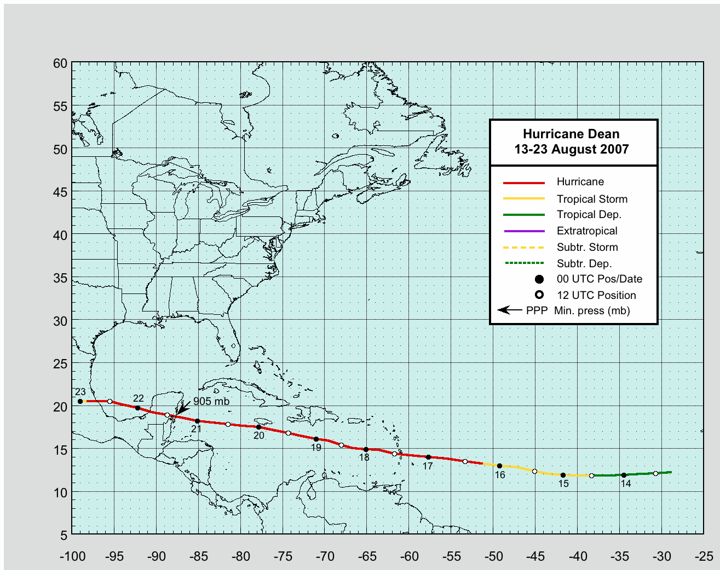
Figure 1. Best track positions for Hurricane Dean, 13-23 August 2007.
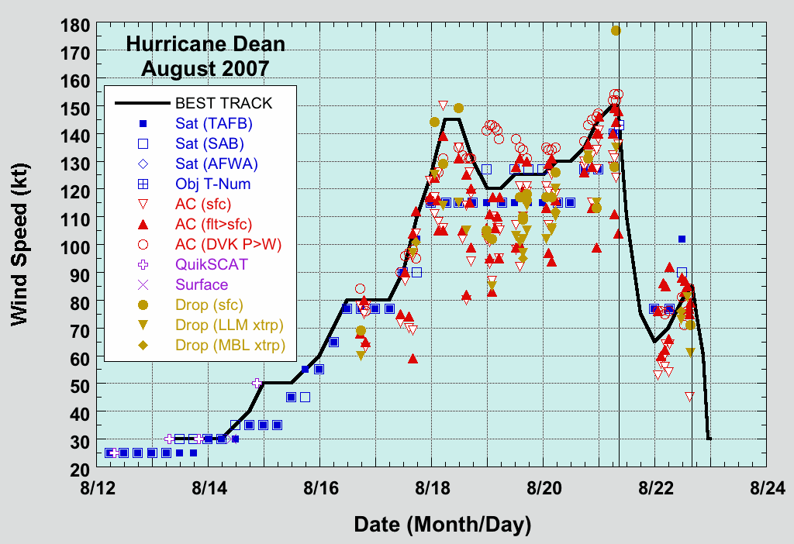
Figure 2. Selected wind observations and best track maximum sustained surface wind speed curve for Hurricane Dean, 13-23 August 2007. Aircraft observations have been adjusted for elevation using 90%, 80%, and 80% reduction factors for observations from 700 mb, 850 mb, and 1500 ft, respectively. Dropwindsonde observations include actual 10 m winds (sfc), as well as surface estimates derived from the mean wind over the lowest 150 m of the wind sounding (LLM), and from the sounding boundary layer mean (MBL). Dashed vertical lines correspond to 0000 UTC. Solid vertical lines indicate times of landfall.
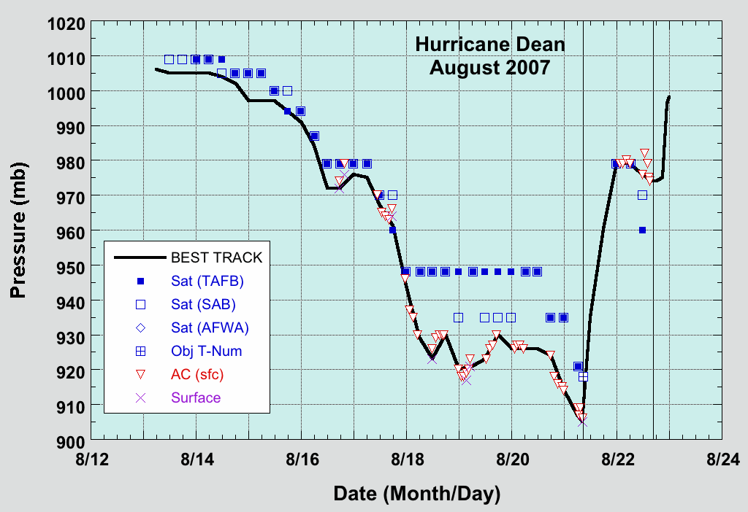
Figure 3. Selected pressure observations and best track minimum central pressure curve for Hurricane Dean, 13-23 August 2007. Dashed vertical lines correspond to 0000 UTC. Solid vertical lines indicate times of landfall.

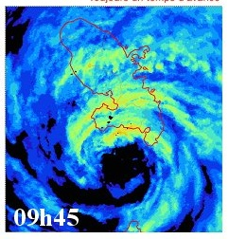

Figure 4. 0945 UTC 17 August radar image of Hurricane Dean passing between Martinique (top) and St. Lucia, from the Meteo-France radar at Martinique (image courtesy , Meteo-France).
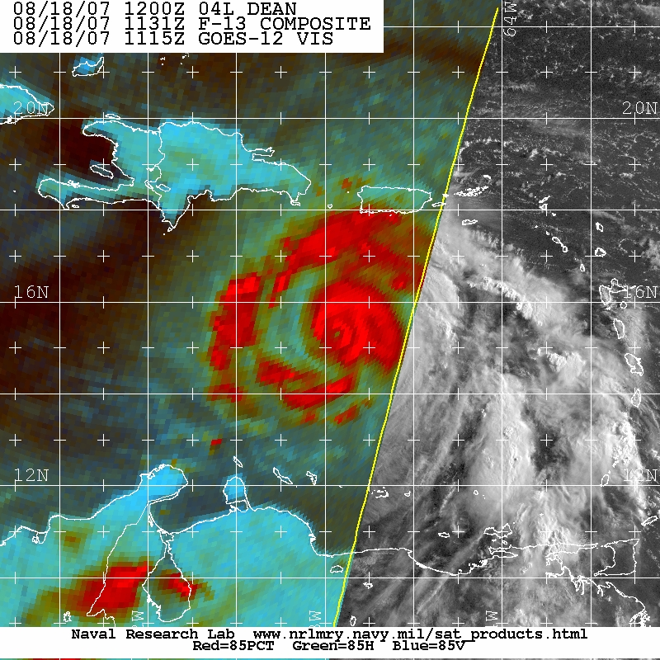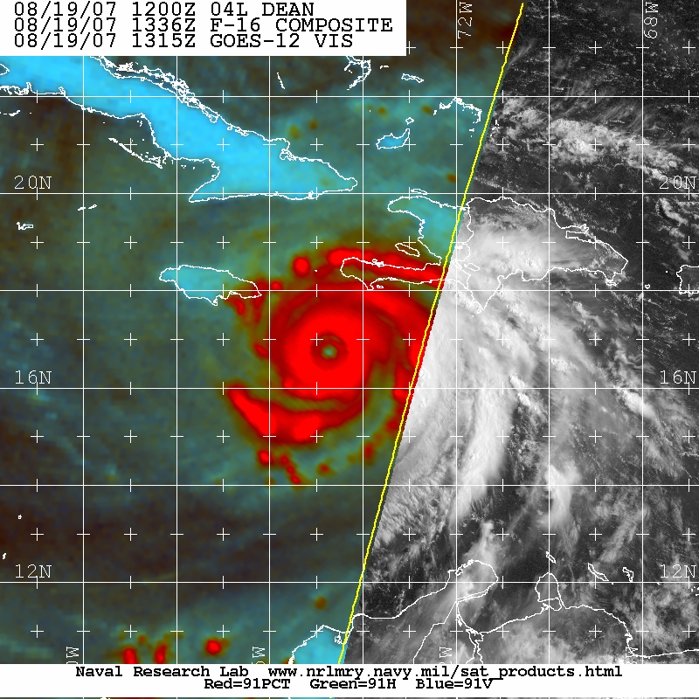

Figure 5. Microwave images of Hurricane Dean at 1131 UTC 18 August (left) and 1336 UTC 19 August (right). In the first image, Dean has an inner 25 n mi diameter eyewall that is just beginning to erode; the intensity at this time is 145 kt. Roughly 24 h later, the inner eyewall has almost completely disappeared, with the predominant eyewall now 55 n mi in diameter; over this interval the intensity decreased to 125 kt. (Images obtained from NRL Monterey Tropical Cyclone Homepage archive, accessible from http://www.nrlmry.navy.mil/tc_pages/tc_home.html)
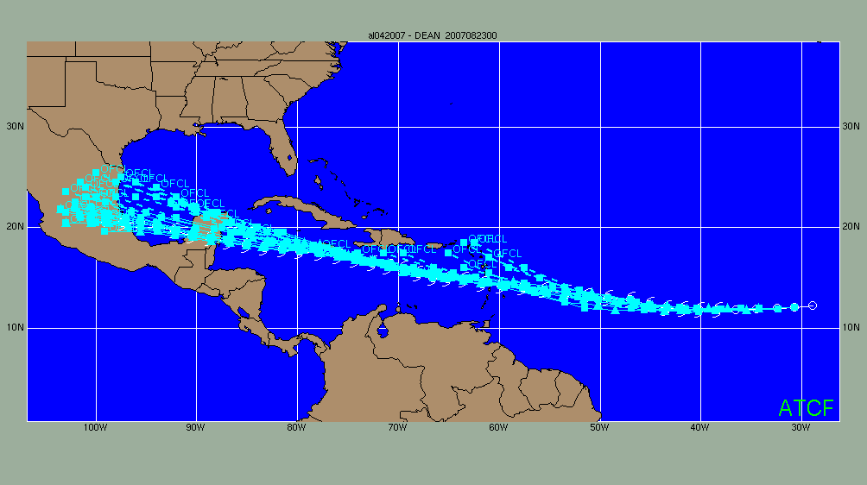
Figure 6. Sequence of official track forecasts for Hurricane Dean, 13-23 August 2007. The actual track of the cyclone is given by the white tropical cyclone symbols.

