Tropical Cyclone Report
Subtropical Storm Andrea
(AL012007)
9-11 May 2007

Jamie R. Rhome, Jack Beven, and Mark Willis
National Hurricane Center
1 June 2007

Andrea formed off the southeast coast of the United States. It was the eighth earliest cyclone since 1851 and the first May cyclone since 1981.

- Synoptic History

Andrea formed from a large extratropical cyclone that originated just offshore the mid-Atlantic United States coast on 6 May. This pre-Andrea cyclone deepened steadily that day, with the central pressure falling 16 mb in the 24-hour period ending at 0600 UTC 7 May. The cyclone initially possessed the classic signature of a fully mature extratropical system, with the associated cold front pushing through Florida and reaching as far south as Cuba on 7 May. By late on 7 May, the extratropical cyclone lost most of its baroclinic support and development ended. However, interaction of the low and strong high pressure to the north produced hurricane-force winds. The resulting large area of high winds, along with the slow motion of the extratropical low, generated large waves that impacted much of the coast of the southeastern United States and the Bahamas Islands. On 8 May, the low weakened and began drifting westward over progressively warmer waters in the western Atlantic. Along this track, vertical shear also decreased allowing for the generation of deeper convection around the center. By early on 9 May, convection had become symmetric about the low-level circulation center, the cyclone had lost all of its frontal and cold core structure, and the wind field had contracted. It is estimated that the system transformed into a subtropical cyclone by 0600 UTC 9 May while centered about 150 n mi east of Jacksonville, Florida. The “best track” chart of the subtropical cyclone’s path is given in Fig. 1, with the wind and pressure histories shown in Figs. 2 and 3, respectively. The best track positions and intensities are listed in Table 1.

The cyclone’s weakening continued during the subtropical phase, so Andrea’s peak intensity of 50 kt occurred at 0600 UTC 9 May. Initially, Andrea was trapped within the retrograding middle-to-upper-tropospheric cutoff low that had caused the pre-Andrea extratratropical cyclogenesis. This pattern resulted in relatively weak shear and a slow westward drift of the cyclone. By late on 9 May, Andrea came under the influence of strong northerly flow aloft on the western side of the upper-level low, resulting in increasing vertical shear and a slow southward motion. The increase in vertical shear displaced the strongest convection southeast of the low-level center, and Andrea weakened to a depression by 1200 UTC 10 May while centered about 95 n mi east-southeast of Jacksonville, Florida. Lacking significant deep convection, Andrea degenerated into a remnant low by 0000 UTC 11 May. The remnants of Andrea produced intermittent bursts of deep convection on 11 May while drifting southward just off the central coast of Florida. However, this activity was transient and never acquired sufficient organization for advisories to be re-initiated. The remnant low accelerated northeastward on 12-13 May ahead of an advancing cold front and later became absorbed within the frontal boundary by 14 May.

- Meteorological Statistics

Observations in Andrea (Figs. 2 and 3) include satellite-based Herbert-Poteat and Dvorak technique intensity estimates from the Tropical Analysis and Forecast Branch (TAFB) and the Satellite Analysis Branch (SAB), as well as flight-level and dropwindsonde observations from two flights of the 53rd Weather Reconnaissance Squadron of the U. S. Air Force Reserve Command. Microwave satellite imagery from NOAA polar-orbiting satellites, the NASA Tropical Rainfall Measuring Mission (TRMM), the NASA QuikSCAT, and Defense Meteorological Satellite Program (DMSP) satellites were also useful in tracking Andrea. Ship reports of winds of tropical storm force associated with Andrea are given in Table 2, and selected surface observations from land stations and data buoys are given in Table 3. Andrea’s estimated peak intensity of 50 kt as a subtropical cyclone near 0600 UTC 9 May is based mainly on QuikSCAT data. The peak wind of 65 kt during the extratropical phase is based on buoy 41001 located, approximate 150 n mi east of Cape Hatteras, which reported a maximum sustained wind of 55 kt with a gust to 70 kt at 0500 UTC 7 May.

The basis for Andrea’s designation as a subtropical cyclone beginning 0600 UTC 9 May includes conventional satellite imagery, nearby ship observations, and remotely-sensed ocean surface vector winds from QuikSCAT. Dropwindsondes obtained from the Air Force Hurricane Hunter aircraft flown on the morning of 9 May indicate that Andrea had no appreciable horizontal thermal gradients (Figure 4a) and was beginning to acquire warm core characteristics. Specifically, the vertical wind profiles displayed in Figure 4a show winds decreasing with height east of the center, a pattern indicative of a warm core cyclone, with winds increasing with height west of the center, a pattern indicative of a cold core cyclone. Conventional satellite infrared satellite imagery showed convection had become symmetric about the circulation center (Figure 4b), and surface observations and ocean surface vector winds from QuikSCAT showed that the radius of strongest winds had contracted to within 60 n mi of the center (Figure 5).

Rainfall totals over the southeastern United States were generally less than 1 inch and no flooding was reported.

- Casualty and Damage Statistics

There were no reports of deaths directly attributable to Andrea as a subtropical storm. However, the pre-Andrea extratropical cyclone was directly responsible for 6 deaths including all four crew members of the 54-foot sailing vessel Flying Colours whose last known location was off the coast of North Carolina on 7 May, a kayaker who died after being pulled out to sea near Seabrook Island, South Carolina on 8 May, and a surfer who drowned after being overtaken by a large wave near New Smyrna Beach, Florida on 9 May. Even though the drowning on 9 May occurred a few hours after the designation of Andrea as subtropical cyclone, most of the wave energy responsible for this death was generated during the pre-Andrea extratropical phase. Additionally, the U.S. Coast Guard rescued 9 people from three sailboats off the coast of North Carolina on 7 May.

Since Andrea never made landfall, most of the resulting damage was associated with the generation of large waves, higher than normal astronomical tides and associated coastal flooding, and associated beach erosion. Most of the significant damage occurred from North Carolina through Florida on 6-8 May as a result of very strong winds and waves associated with the pre-Andrea extratropical cyclone. A storm surge of 2-3 ft was reported in St. Johns and Flagler Counties in northeastern Florida.

The vessel Paris Express encountered high seas in the Atlantic late on 6 May while en route from Savannah to Norfolk, resulting in the loss of 21 containers overboard. The resulting debris washed ashore from Cape Lookout, North Carolina northward to the Virginia border during the following days.

- Forecast and Warning Critique

Since Tropical Weather Outlooks are not issued by the National Hurricane Center prior to June 1 (the “official” start of the Atlantic hurricane season), an assessment of genesis forecasts within that product is not possible. However, the pre-Andrea extratropical cyclone, including its associated hazards, was discussed by the National Hurricane Center within several Special Tropical Disturbance Statements beginning with the first issuance on the morning of 8 May.

A verification of official and guidance model track forecasts is given in Table 4. Average official track errors for Andrea were 22, 46, and 67 n mi for the 12, 24, and 36 h forecasts, respectively. For comparison, the average long-term official track errors are 35, 61, and 86 n mi for the 12, 24, and 36 h forecasts, respectively. A verification of official and guidance model intensity forecasts is given in Table 5. Average official intensity errors were 1, 5, and 1 kt for the 12, 24, and 36 h forecasts, respectively. For comparison, the average long-term official intensity errors are 6, 10, and 12 kt, respectively. Both the official track and intensity forecasts were below the average long-term errors.

A summary of watches and warnings issued during Andrea is given in Table 6.

- Acknowledgements

Ethan Gibney is acknowledged for creating the best track map.
Table 1. Best track for Subtropical Storm Andrea 9-11 May 2007.

Date/Time  (UTC) | Latitude  (°N) | Longitude  (°W) | Pressure  (mb) | Wind Speed  (kt) | Stage
06 / 1200 | 35.5 | 74.0 | 1012 | 35 | extratropical
06 / 1800 | 35.0 | 73.0 | 1009 | 40 | "
07 / 0000 | 34.3 | 71.7 | 1005 | 50 | "
07 / 0600 | 33.3 | 72.3 | 998 | 65 | "
07 / 1200 | 32.3 | 73.1 | 998 | 65 | "
07 / 1800 | 31.5 | 74.0 | 998 | 65 | "
08 / 0000 | 31.0 | 74.9 | 1000 | 55 | "
08 / 0600 | 30.7 | 76.0 | 1001 | 50 | "
08 / 1200 | 30.4 | 77.2 | 1001 | 50 | "
08 / 1800 | 30.4 | 77.9 | 1001 | 50 | "
09 / 0000 | 30.6 | 78.3 | 1001 | 50 | "
09 / 0600 | 30.8 | 78.7 | 1001 | 50 | subtropical storm
09 / 1200 | 30.9 | 79.2 | 1002 | 45 | "
09 / 1800 | 30.9 | 79.6 | 1003 | 40 | "
10 / 0000 | 30.7 | 79.8 | 1003 | 40 | "
10 / 0600 | 30.5 | 79.9 | 1003 | 35 | "
10 / 1200 | 30.1 | 79.9 | 1003 | 30 | subtropical depression
10 / 1800 | 29.7 | 79.8 | 1003 | 30 | "
11 / 0000 | 29.4 | 79.8 | 1004 | 30 | "
11 / 0600 | 29.1 | 79.8 | 1004 | 30 | remnant low
11 / 1200 | 28.8 | 79.7 | 1006 | 25 | "
11 / 1800 | 28.5 | 79.5 | 1007 | 25 | "
12 / 0000 | 28.5 | 79.1 | 1007 | 25 | "
12 / 0600 | 28.8 | 78.8 | 1006 | 25 | "
12 / 1200 | 29.1 | 78.5 | 1005 | 25 | "
12 / 1800 | 29.4 | 78.0 | 1006 | 25 | "
13 / 0000 | 29.7 | 77.2 | 1006 | 25 | "
13 / 0600 | 30.1 | 76.0 | 1006 | 25 | "
13 / 1200 | 30.8 | 74.2 | 1007 | 25 | "
13 / 1800 | 31.4 | 71.9 | 1007 | 25 | "
14 / 0000 | 31.8 | 69.4 | 1007 | 25 | "
14 / 0600 |  |  |  |  | absorbed by front
09 / 0600 | 30.8 | 78.7 | 1001 | 50 | minimum pressure

Table 2. Selected ship reports with winds of at least 34 kt for Subtropical Storm Andrea 9-11 May 2007.

Date/Time (UTC) | Ship call sign | Latitude  (°N) | Longitude  (°W) | Wind  dir/speed (kt) | Pressure  (mb)
09 / 0631 | SPAG1 | 31.4 | 80.6 | 350 / 39
09 / 0700 | WFJN | 32.7 | 75.8 | 140 / 35 | 1013.0
09 / 1800 | WBVY | 32.1 | 79.5 | 090 / 37 | 1005.5

Table 3. Selected surface observations for Subtropical Storm Andrea, 9-11 May, 2007.

Location | Minimum Sea Level Pressure |  | Maximum Surface  Wind Speed |  |  | Storm surge  (ft)^{c} | Storm  tide  (ft)^{d} | Total  rain  (in)
Location | Date/  time  (UTC) | Press.  (mb) | Date/  time  (UTC)ª | Sustained  (kt)^{b} | Gust  (kt) | Storm surge  (ft)^{c} | Storm  tide  (ft)^{d} | Total  rain  (in)
Florida
Official
Jacksonville (KJAX) | 09/2258 | 1007.9 | 10/1328 | 22 | 37 |  |  | 0.17
Craig Municipal Airport (KCRG) | 09/2253 | 1007.8 | 09/2044 |  | 26 |  |  | 0.32
Mayport Naval Base (KNRB) | 09/2249 | 1007.8 | 10/1416 |  | 33 |  |  | 0.36
St. Augustine (KSGJ) | 09/2250 | 1008.1 | 10/1450 |  | 30 |  |  | 0.15
Flagler County Airport (KX47) |  |  | 10/1418 |  | 29
Fernandina Beach (FRBF1) | 09/2218 | 1007.3 | 09/2248 | 22 | 27 | 2.64 | 7.88 | 0.37
Mayport (MYPF1) | 09/2230 | 1008.1 | 10/1400 | 24 | 33 | 2.50 | 6.25
Hastings (HTGF1) |  |  |  |  |  |  |  | 0.10
Palm Coast (WOGF1) |  |  |  |  |  |  |  | 0.08
Jacksonville Beach (JAKF1) |  |  |  |  |  |  |  | 0.77
Georgia
Official
St. Simons Island (KSSI) | 09/1608 | 1007.1 | 10/1458 | 35 |  |  |  | 0.07
Brunswick (BRUG1) |  |  |  |  |  |  |  | 0.42
Woodbine (WBNG1) |  |  |  |  |  |  |  | 0.57
St. Simons Island NOS |  |  |  |  |  | 2.83 | 8.09
NOAA Buoy/C-Man
St. Augustine Buoy (41012) | 10/0850 | 1004.4 | 09/0600 | 30 | 37
St. Augustine Pier (SAUF1) | 10/0800 | 1008.1 | 10/1510 | 30 | 36
Gray’s Reef Buoy (41008) |  |  | 09/0600 |  | 37
Canaveral East Buoy (41010) |  |  | 09/0700 |  | 33
Edisto Buoy (41004) |  |  | 09/1300 |  | 39
ª Date/time is for sustained wind when both sustained and gust are listed.
^{b} Except as noted, sustained wind averaging periods for C-MAN and land-based ASOS reports are 2 min; buoy averaging periods are 8 min.
^{c} Storm surge is water height above normal astronomical tide level.
^{d} Storm tide is water height above National Geodetic Vertical Datum (1929 mean sea level).
Table 4. Preliminary track forecast evaluation (heterogeneous sample) for Subtropical Storm Andrea, 9-11 May 2007. Forecast errors (n mi) are followed by the number of forecasts in parentheses. Errors smaller than the NHC official forecast are shown in bold-face type. Verification includes the depression stage, but does not include the extratropical stage.

Forecast Technique | Forecast Period (h)
Forecast Technique | 12 | 24 | 36 | 48 | 72 | 96 | 120
CLP5 | 39 ( 6) | 109 ( 4) | 201 ( 2)
GFNI | 19 ( 3) | 29 ( 1)
GFDI | 23 ( 5) | 44 ( 3) | 80 ( 1)
GFSI | 19 ( 5) | 39 ( 3) | 65 ( 1)
AEMI | 15 ( 5) | 27 ( 3) | 32 ( 1)
NGPI | 21 ( 6) | 45 ( 4) | 45 ( 2)
UKMI | 34 ( 4) | 69 ( 2)
BAMD | 12 ( 6) | 35 ( 4) | 68 ( 2)
BAMM | 29 ( 6) | 76 ( 4) | 129 ( 2)
BAMS | 55 ( 6) | 111 ( 4) | 185 ( 2)
CONU | 18 ( 5) | 39 ( 3) | 54 ( 1)
GUNA | 22 ( 4) | 43 ( 2)
OFCL | 22 ( 5) | 46 ( 3) | 67 ( 1)
NHC Official  (2002-2006 mean) | 35  (1852) | 61  (1686) | 86  (1519) | 112  (1362) | 162  (1100) | 221  (885) | 290  (723)

Table 5. Preliminary intensity forecast evaluation (heterogeneous sample) for Subtropical Storm Andrea, 9-11 May 2007. Forecast errors (kt) are followed by the number of forecasts in parentheses. Errors smaller than the NHC official forecast are shown in bold-face type. Verification includes the depression stage, but does not include the extratropical stage.

Forecast Technique | Forecast Period (h)
Forecast Technique | 12 | 24 | 36 | 48 | 72 | 96 | 120
SHF5 | 4.2 ( 6) | 3.0 ( 4) | 7.0 ( 2)
GFDI | 4.4 ( 5) | 4.0 ( 3) | 12.0 ( 1)
SHIP | 3.7 ( 6) | 6.3 ( 4) | 15.0 ( 2)
DSHP | 3.7 ( 6) | 6.3 ( 4) | 15.0 ( 2)
ICON | 3.2 ( 5) | 2.7 ( 3) | 2.0 ( 1)
OFCL | 1.0 ( 5) | 5.0 ( 3) | 5.0 ( 1)
NHC Official  (2002-2006 mean) | 6.4  (1852) | 9.8 (1686) | 12.0 (1519) | 14.1 (1362) | 18.3 (1100) | 19.8  (885) | 21.8  (723)

Table 6. Watch and warning summary for Subtropical Storm Andrea, 9-11 May 2007.

Date/Time (UTC) | Action | Location
09 / 1500 | Tropical Storm Watch issued | Altahama Sound to Flagler Beach
10 / 1500 | Tropical Storm Watch discontinued | Altahama Sound to Flagler Beach

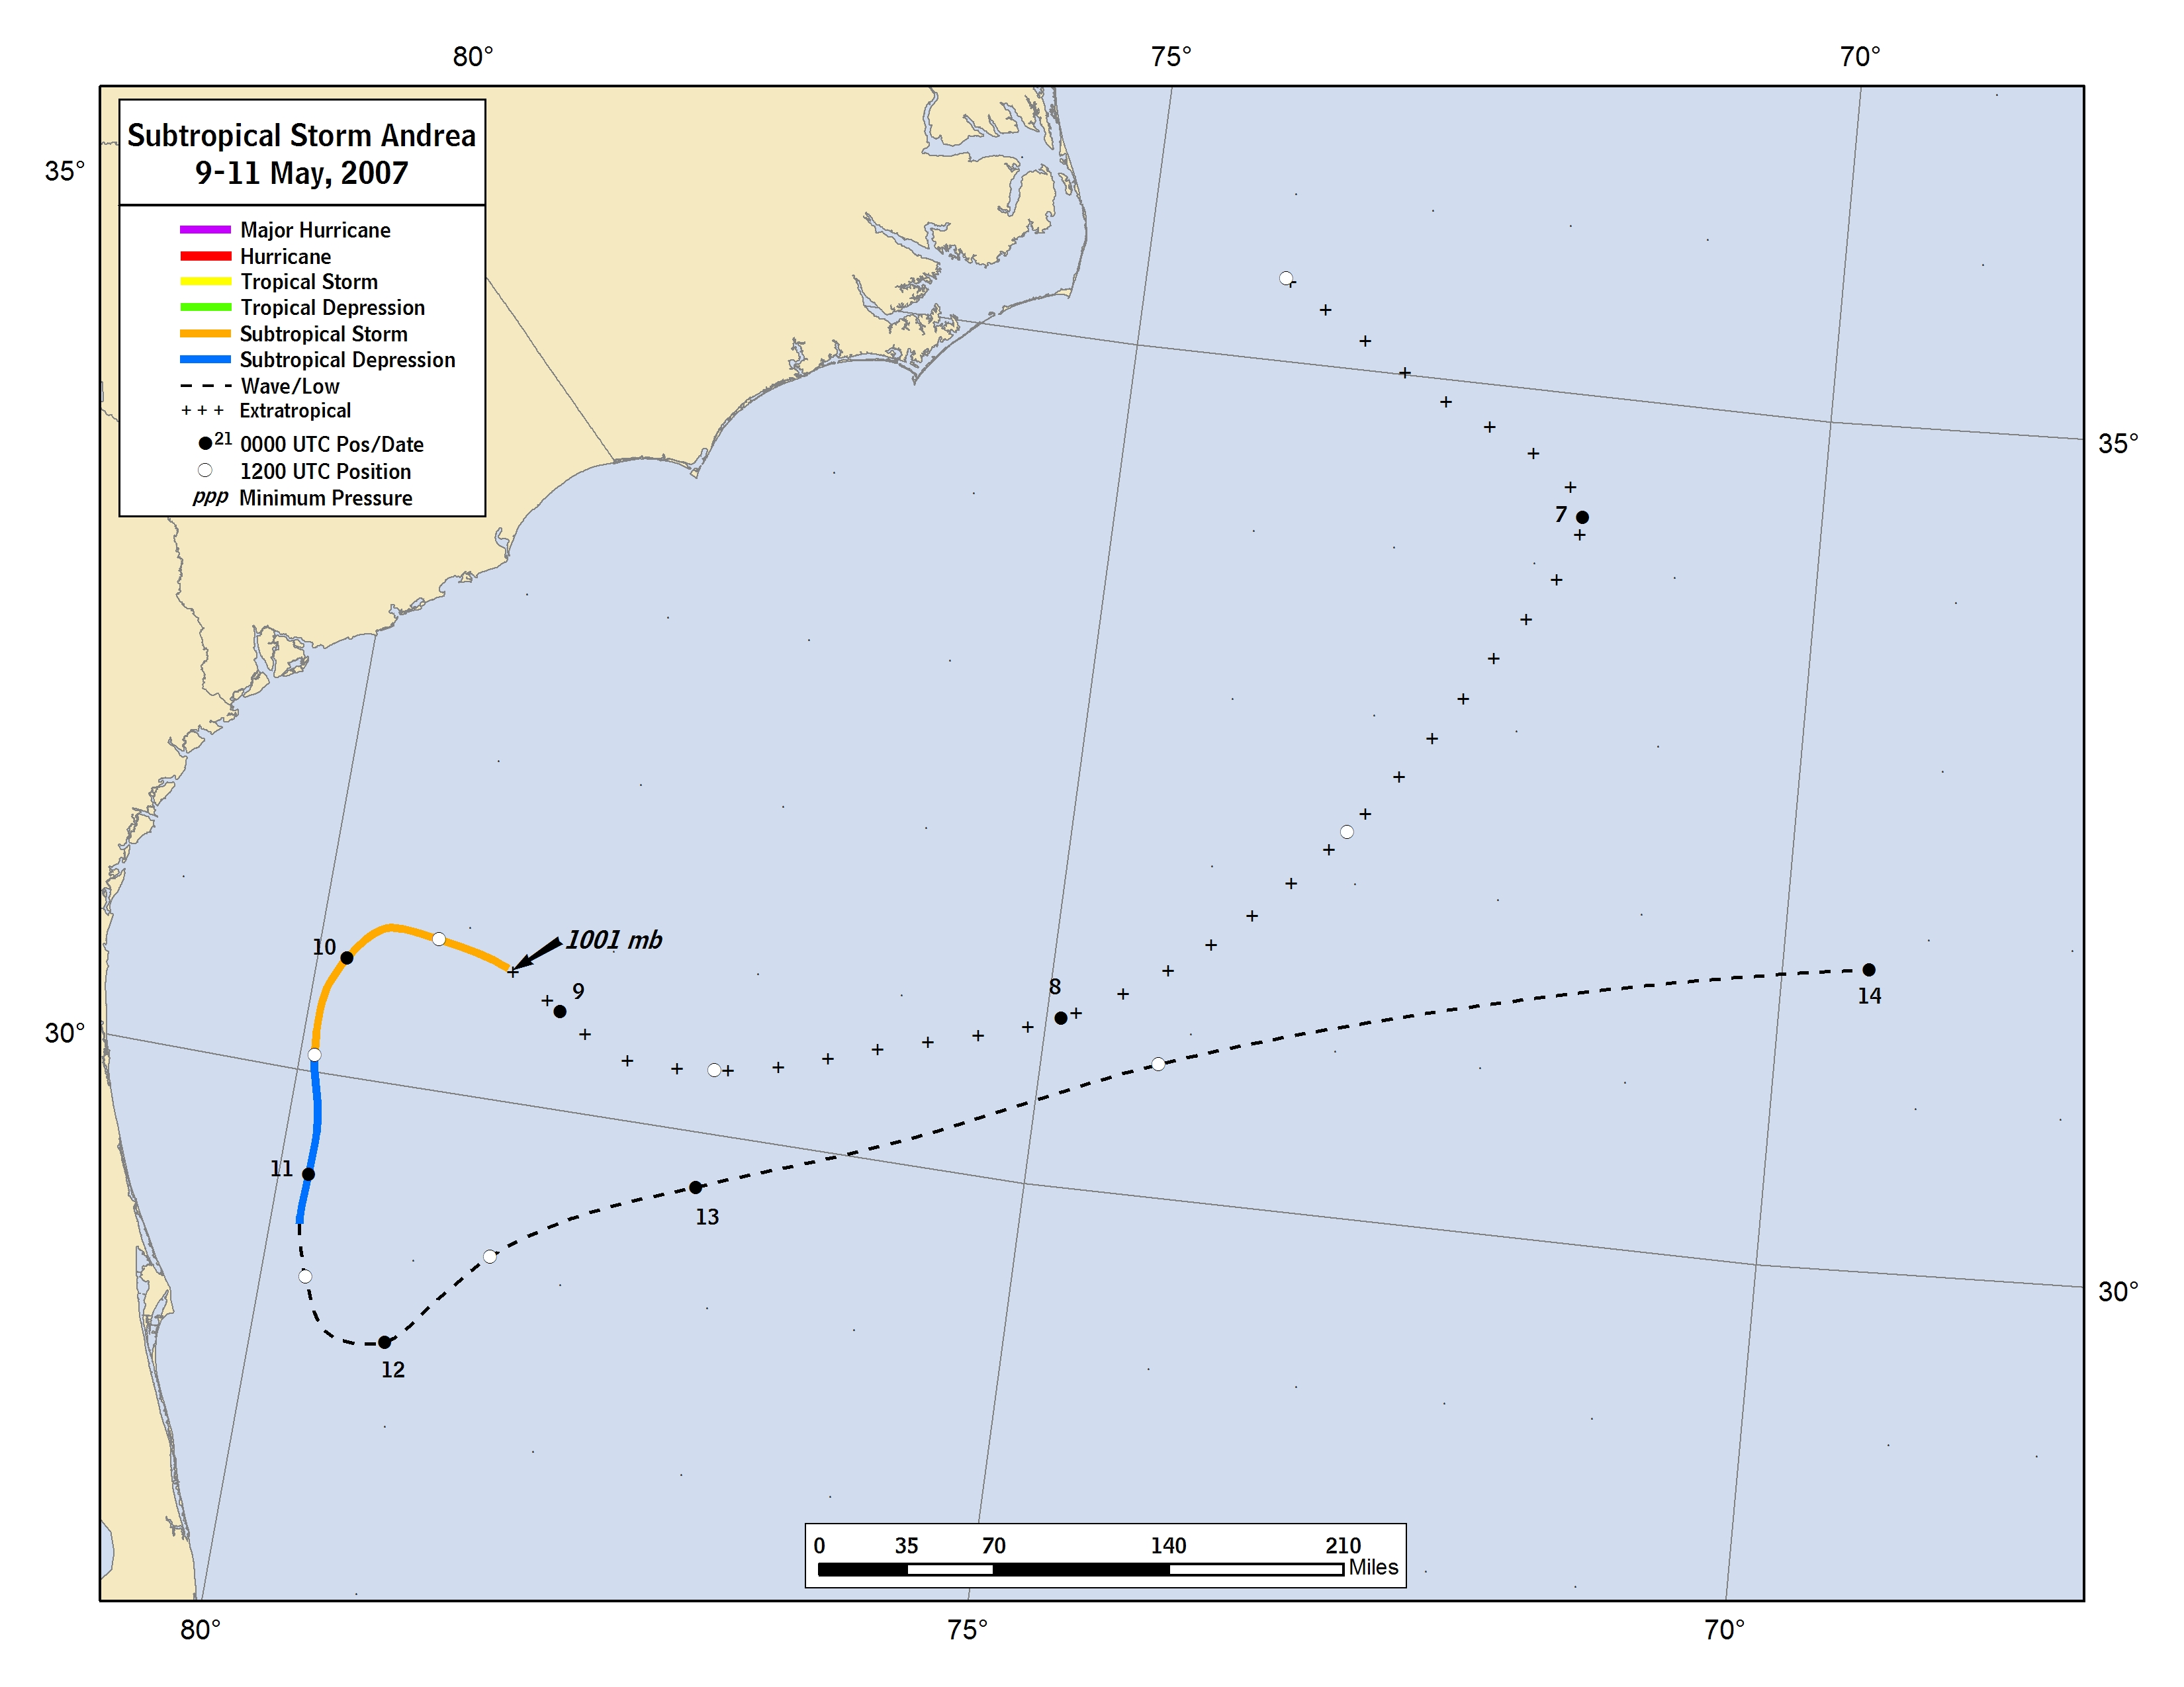
Figure 1. Best track positions for Subtropical Storm Andrea, 9-11 May 2007. Track during the extratropical stage is based partially on analyses from the Ocean Prediction Center.

Figure 2. Selected wind observations and best track maximum sustained surface wind speed curve for Subtropical Storm Andrea, 9-11 May 2007. Aircraft observations have been adjusted for elevation using 90%, 80%, and 80% reduction factors for observations from 700 mb, 850 mb, and 1500 ft, respectively. Estimates during the extratropical stage are based partially on analyses from the Ocean Prediction Center.

Figure 3. Selected pressure observations and best track minimum central pressure curve for Subtropical Storm Andrea 9-11 May 2007. Estimates during the extratropical stage are based partially on analyses from the Ocean Prediction Center.

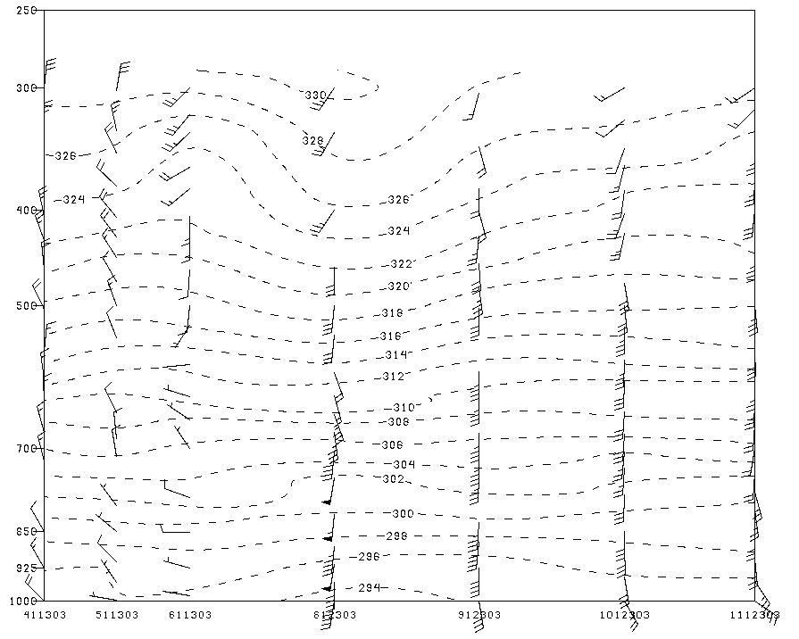
A

Figure 4a. Vertical cross section of wind and potential temperature obtained from dropwindsondes during Subtropical Storm Andrea on 9 May between 1111-1202 UTC.

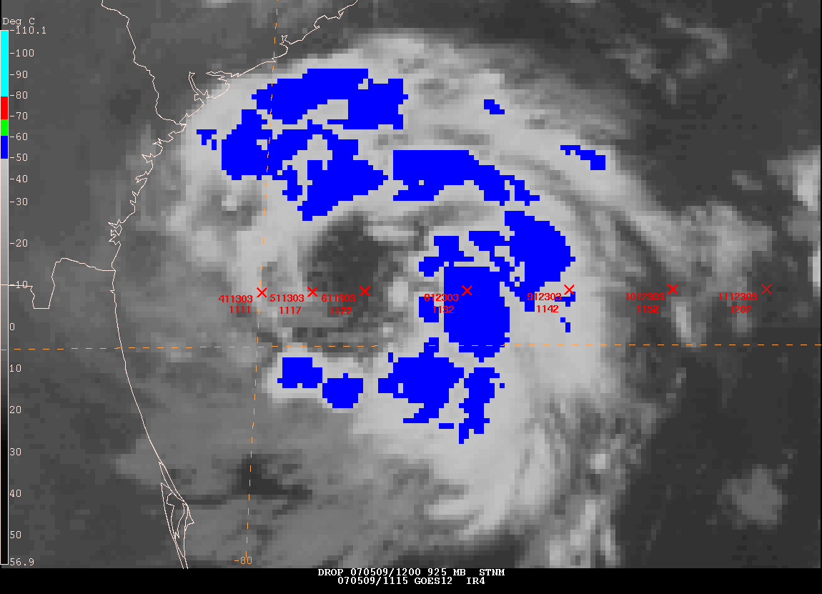
B

Figure 4b. GOES-East Satellite imagery at 1115 UTC 9 May indicating the location of the dropwindsondes (X) in proximity to the storm center, the drop id (6-digit number), and the time of the drop (4-digit number) in coordinated universal time (UTC).
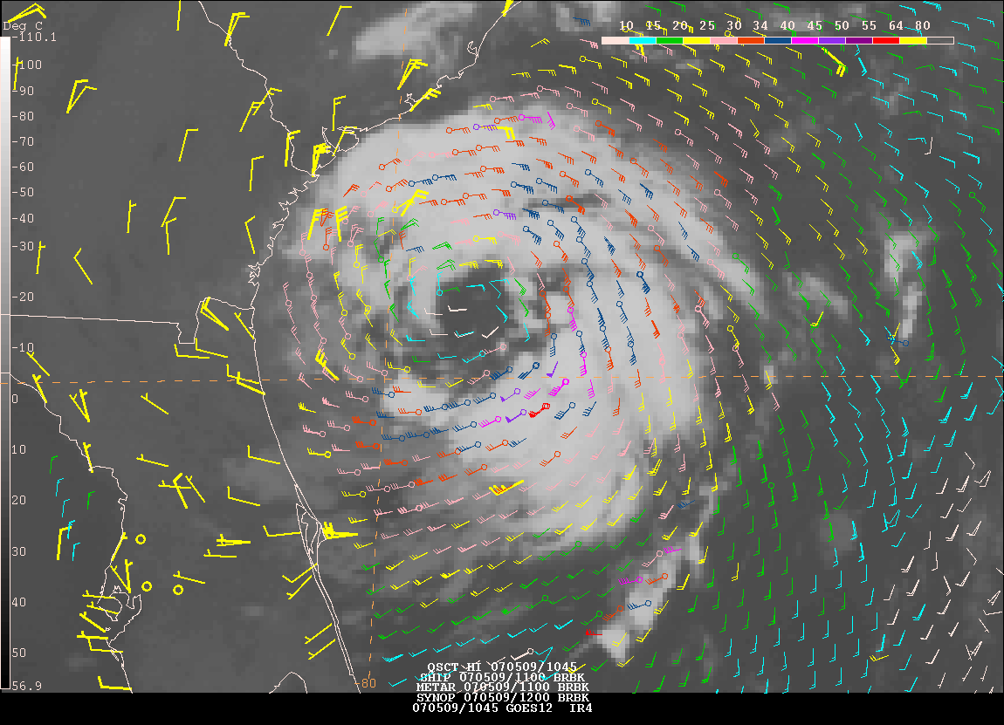
Figure 5. GOES-East Geostationary satellite imagery on 9 May at 1045 UTC along with ocean surface vector winds from QuikSCAT (equally spaced wind barbs), 1100 UTC metar surface data, 1100 UTC ship surface data, and 1200 UTC synoptic surface data.

