Furniture

Modern Grouping Furniture

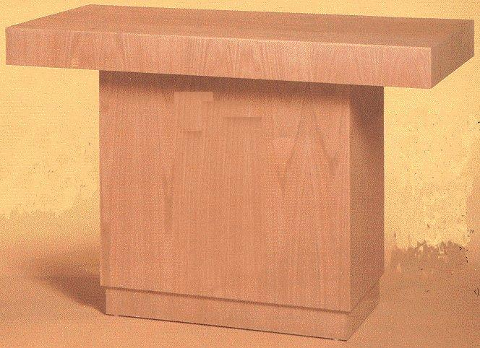
Altar, Modern Grouping
9925-01-459-3832 22051

Description: Constructed with a combination of sliced red oak plywood and solid red oak;
72" W X 40" H X 30" D; Weight 225 lbs.
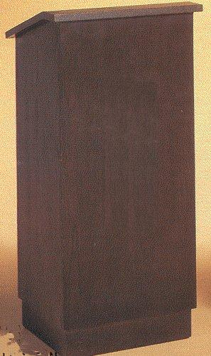

Lectern, Modern Grouping
9925-01-459-3782 22054
Description: Constructed with a combination of sliced red oak plywood and solid red oak; 1" W X 45" H X 20" D; Weight 125 lbs; Has extended shelf for lamp (lamp included) and microphone; Two inside shelves.

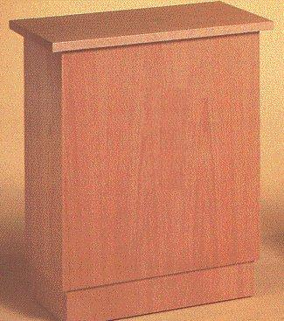

Offertory Table, Modern Grouping
9925-01-459-5534 22053
Description: Constructed with a combination of sliced red oak plywood and solid red oak;
25" W X 30"H X 16"D; Weight 75 lbs.; Open in back with one shelf.

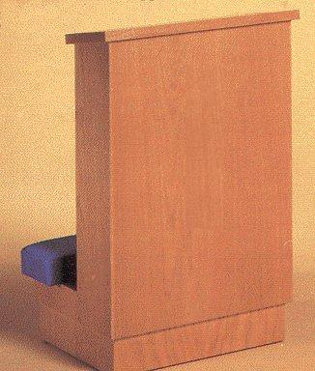
Prie Dieu, Modern Grouping
9925-01-459-3767 22050
Description: Constructed with veneer or solid oak; 22"W X 34" H X 18" D; Weight 70lbs; Upholstered kneeler

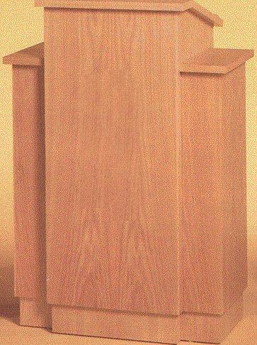

Pulpit, Modern Grouping
9925-01-459-3773 22052
Description: Constructed with a combination of sliced red oak plywood and solid red oak;
30" W X 45" H X 20" D; Weight 125 lbs.; Has extended shelf for lamp (lamp included) and microphone; Two inside shelves.

Gothic Furniture

The following furniture is Gothic in nature. Characteristics must included lines flowing up to pointed arch(es) and ribbed vaults. Relating to the style from the twelfth to mid-sixteenth century Europe.

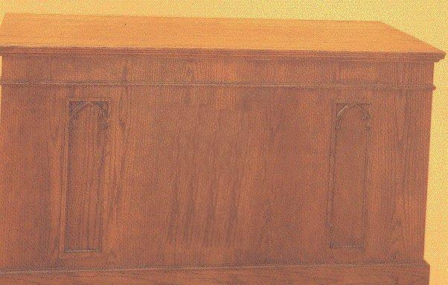
Altar, Gothic Traditional
9925-01-459-3803 22058
Description: Constructed with a combination of sliced red oak plywood and solid red oak;
72" W X 40" H X 33"D; Weight 325 lbs.
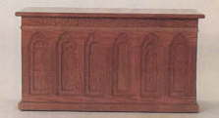

Communion Table, Gothic Traditional
9925-01-459-3827 22055
Description: Constructed with a combination of sliced red oak plywood and solid red oak;
60" W X 40" H X 32" D; Weight 300 lbs.; "This Do in Remembrance of Me" is carved on front.

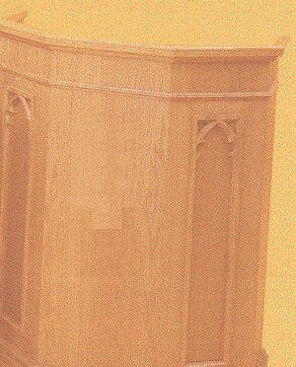
Lectern, Gothic Traditional
9925-01-459-3817 22056

Description: Constructed with a combination of sliced red oak plywood and solid red oak; 25"W X 45" H X 20" D; Weight 100 lbs.; Lamp included.

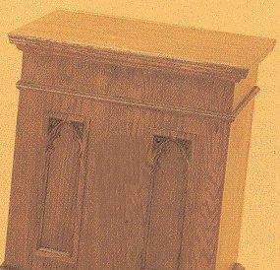
Offertory Table, Gothic Traditional
9925-01-459-3806 22059

Description: Constructed with a combination of sliced red oak plywood and solid red oak;
25" W X 30" H X 19" D; Weight 75 lbs.

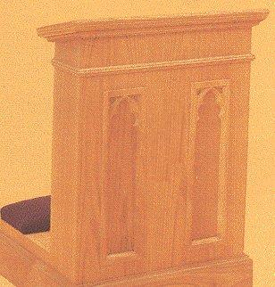
Prie Dieu, Gothic Traditional
9925-01-459-4097 22060

Description: Constructed with a combination of sliced red oak plywood and solid red oak;
23" W X 34" H X 23" D; Weight 75 lbs. upholstery.

Pulpit, Gothic Traditional
9925-01-459-3790 22057
Description: Constructed with a combination of sliced red oak plywood and solid red oak;
36" W X 45" H X 24" D; Weight 125 lbs; Lamp included.

Chairs, Pews, Kneelers

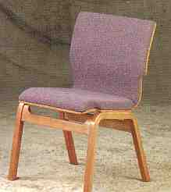
Chair, Interlocking
Quantity Ordered | NSN
1 - 20 | 9925-01-465-5723 25866
21 - 74 | 9925-01-465-5726 25867
75 - 299 | 9925-01-465-5729 25868
300 or more | 9925-01-465-5752 25869

Description: Includes an underseat bookrack and cupholder with radius interlocking.

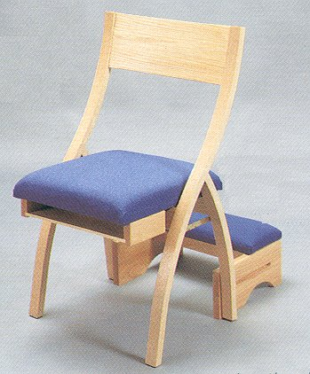

Chair, Folding with Prie Dieu
9925-01-459-3849 22067
Description: Constructed with a combination of sliced red oak plywood and solid red oak; Open 33" H X 21" W X 20" D; Weight 20 lbs.; Book rack under seat; Wood back.
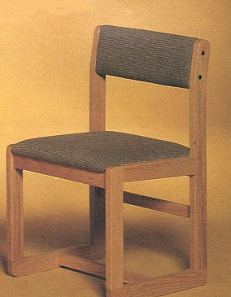
Chair, Non-Stacking, Armless
9925-01-459-3836 22069
Description: Constructed with a combination of sliced red oak plywood and solid red oak; 31"H X 21" W X 19" D; Weight 22 lbs.; Upholstered back and seat.
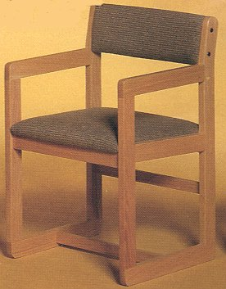
Chair, Non-Stacking with Arms
9925-01-459-3845 22068
Description: Constructed with a combination of sliced red oak plywood and solid red oak;
31” H X 21" W X 19" D; Weight 25 lbs.; Wood back.

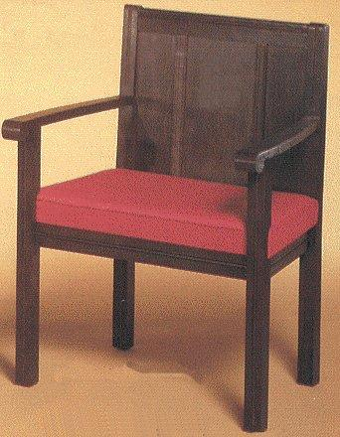
Chair, Sanctuary with Arms, Contemporary
9925-01-459-2077 22062
Description: Constructed with veneer or solid oak; 27" W X 36" H X 18" D; Weight 50 lbs.; Comes with cross carved in front back; Upholstered seat.

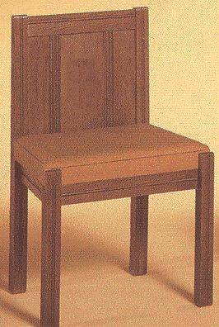
Chair, Sanctuary, Contemporary
9925-01-459-4133 22061

Description: Constructed with veneer or solid oak; 21" W X 34" H X 16" D; Weight 25 lbs.

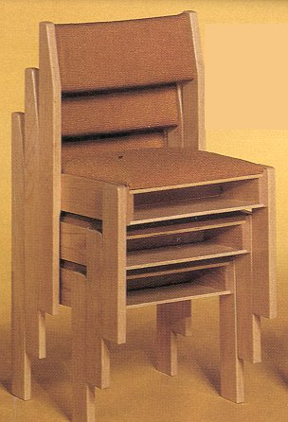
Chair, Stacking
9925-01-459-3859 22066
Description: Constructed with a combination of sliced red oak plywood and solid red oak;
33" H X 20" W X 18" D; Weight 25 lbs. Upholstered kneeler. Kneeler, upholstered back and seat.

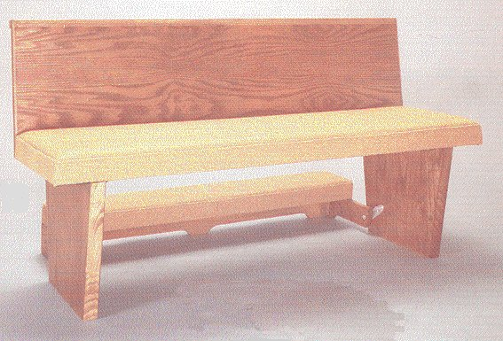
Pew
Constructed with a combination of sliced red oak plywood and solid red oak finished;34" H X 72" W X 21" D; 20 lbs. per foot.
Priced and sold by the foot.
Style | NSN
Plain Seat and Back | 9925-01-459-3762 22072
Upholstered Seat and Plain Back | 9925-01-459-3725 22073
Upholstered Seat and Back | 9925-01-459-3775 22074

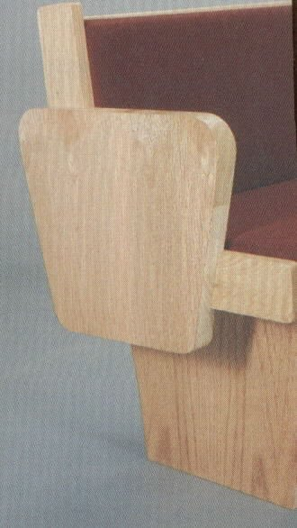
Pew End with Support
9925-01-460-1084 22029

Pew Kneeler
9925-01-459-5056 22075
Kneeler upholstered.

Hymn Boards and Pamphlet Racks

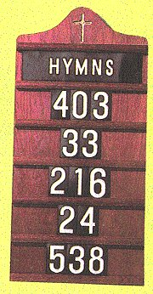
Board, Hymnal
Description: Durable oak laminated on both sides of ¾" Fibercore; Finished on both sides; Cross routed at top in gold gilding; Complete with slide "Hymns" and four sets of numerals 0-9; 11 ½" X 24" overall; Shipping weight 6 lbs. 12 ozs.; Rectangular shape with rounded top.
Board, Hymnal, Light Oak - 9925-01-459-4007 22098
Board, Hymnal, Dark Oak - 9925-01-459-3713 22099

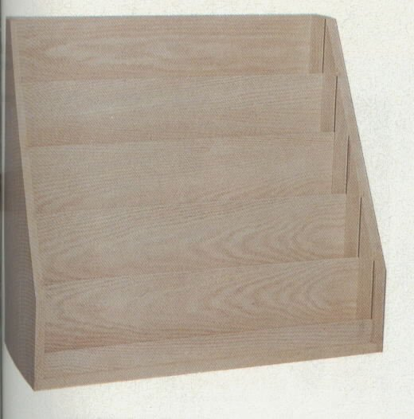
Rack, Pamphlet
9925-01-460-0222 21990
Description: Constructed with a combination of sliced red oak plywood and solid red oak

Miscellaneous Furniture

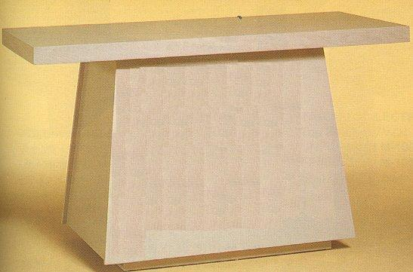
Altar
9925-01-459-5072 22065
Description: Constructed with a combination of veneer or solid oak finish;
40" H X 72" W X 30" D; 200 lbs
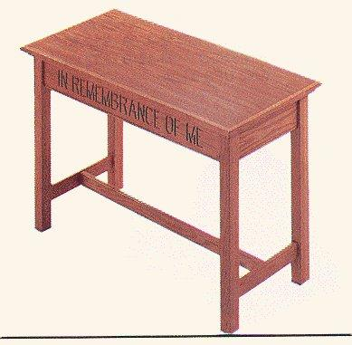
Communion Table, Traditional
9925-01-459-4052 22071
Description: "IN REMEMBRANCE OF ME" inscribed on front; 21" X 48" X 30" high; Shipping weight 65 lbs.
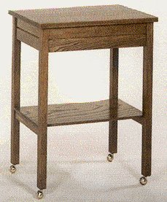
Table, Credence with Brass Casters
9925-01-459-5080 22064
Description: Top 24" W X 16" D X 30" H; Includes brass casters.

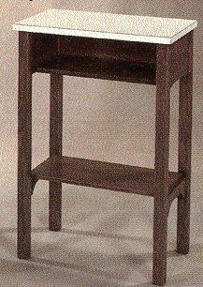
Table, Credence with Formica Top
9925-01-459-3998 22063
Description: Formica top; One shelf; Top 20" W X 13" D X 30" H

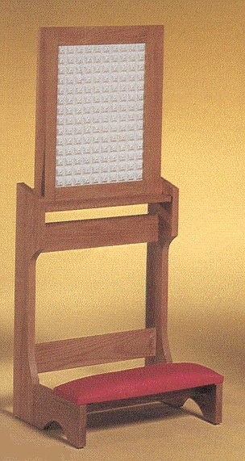
Prie Dieu with Stationary Screen
9925-01-459-3842 22070
Description: Constructed with a combination of sliced red oak plywood and solid red oak
52" H X 22" W; Weight 30 lbs.; Furnished with metal screen; Upholstered kneeler.

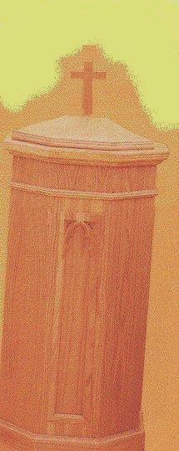

Font, Baptismal, Gothic Traditional
9925-01-459-5476 22077
Description: Constructed with a combination of sliced red oak plywood and solid red oak; Swivel top with Cross on top; 51" H X 21" D X 21" W; 75 lbs.

Individual Item Listing

Item | NSN/  PGC | U/I | Price | Description | Photo
Altar | 9925-01-459-5072  22065 | EA | $ 1,389.76 | Morgan #M-7036 | 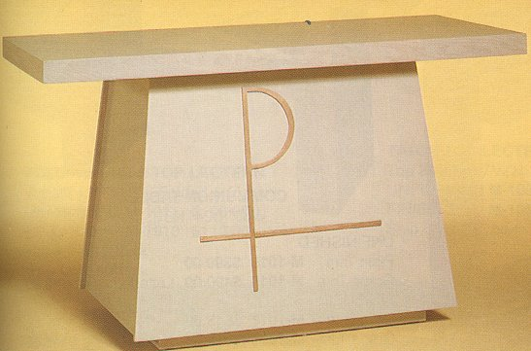
Altar, Gothic Traditional | 9925-01-459-3803  22058 | EA | $ 3,008.06 | Morgan #M-1272 | 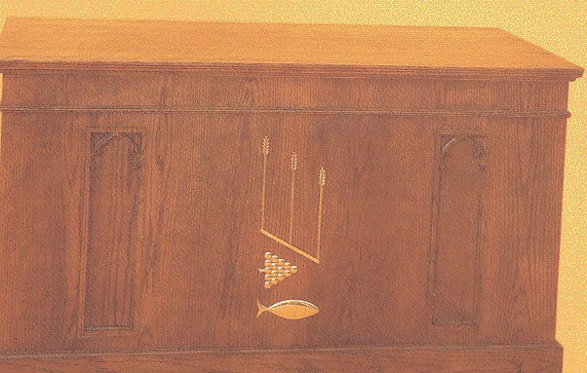
Altar, Modern Grouping | 9925-01-459-3832  22051 | EA | $ 1,958.21 | Morgan #M-8072 | 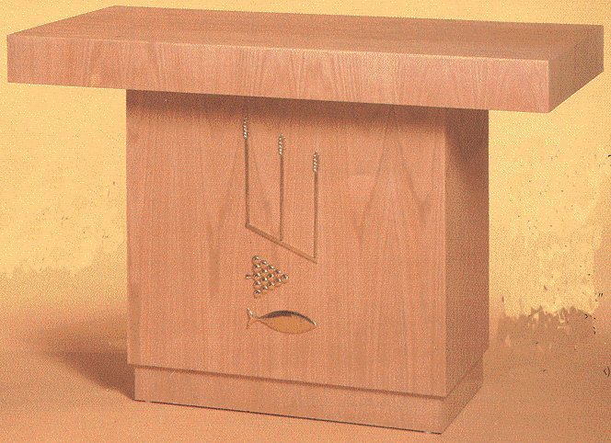
Board, Hymnal, Dark Oak | 9925-01-459-3713  22099 | EA | $ 60.04 | Hiwassee #1650 | 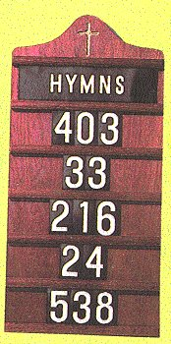
Board, Hymnal, Light Oak | 9925-01-459-4007  22098 | EA | $ 60.40 | Hiwassee #1650
Chair, Folding with Prie Dieu | 9925-01-459-3849  22067 | EA | $ 174.00 | Morgan #MP-214
Chair, Interlocking, 1-20 | 9925-01-465-5723  25866 | EA | $ 159.96 | Sauder Vantage Chair #8720; underseat bookrack and cupholder; radius interlock. Price applies to orders of 1-20 chairs. | 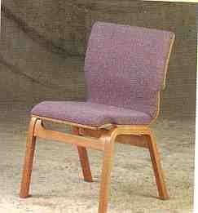
Chair, Interlocking, 21-74 | 9925-01-465-5726  25867 | EA | $ 138.11 | Sauder Vantage Chair #8720; underseat bookrack and cupholder; radius interlock. Price applies to orders of 21-74 chairs.
Chair, Interlocking, 300+ | 9925-01-465-5752  25869 | EA | $ 159.06 | Sauder Vantage Chair #8720; underseat bookrack and cupholder; radius interlock. Price applies to orders of 300+ chairs. | 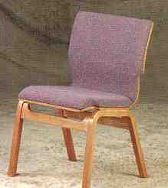
Chair, Interlocking, 75-299 | 9925-01-465-5729  25868 | EA | $ 130.54 | Sauder Vantage Chair #8720; underseat bookrack and cupholder; radius interlock. Price applies to orders of 75-299 chairs. | 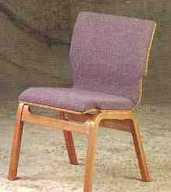
Chair, Non-Stacking Armless | 9925-01-459-3836  22069 | EA | $ 210.87 | Morgan #MP-103
Chair, Non-Stacking, Arms | 9925-01-459-3845  22068 | EA | $ 237.80 | Morgan #MP-102
Chair, Sanctuary w/ arms, Contemporary | 9925-01-459-2077  22062 | EA | $ 501.19 | Morgan #M-9000C | 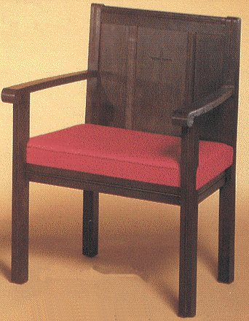
Chair, Sanctuary, Contemporary | 9925-01-459-4133  22061 | EA | $ 503.88 | Morgan #M-9000S | 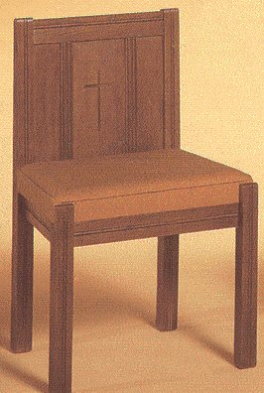
Chair, Stacking | 9925-01-459-3859  22066 | EA | $ 179.66 | Morgan #MP-101
Communion Table, Gothic Tr | 9925-01-459-3827  22055 | EA | $ 3,075.54 | Morgan #M-1206 | 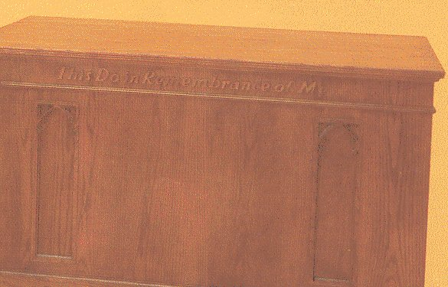
Communion Table, Trad | 9925-01-459-4052  22071 | EA | $ 618.26 | Hiwassee #501-48 | 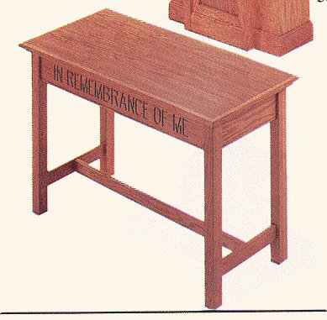
Font, Baptismal, Gothic Trad | 9925-01-459-5476  22077 | EA | $ 1,490.97 | Morgan #M-1209 | 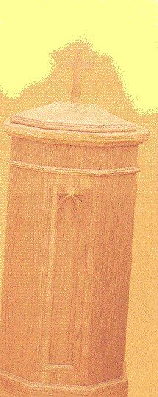
Lectern, Gothic Traditional | 9925-01-459-3817  22056 | EA | $ 1,357.11 | Morgan #M-1220 | 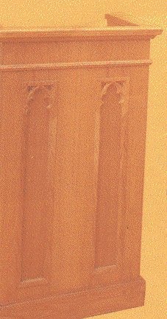
Lectern, Modern Grouping | 9925-01-459-3782  22054 | EA | $ 848.87 | Morgan #M-8020 | 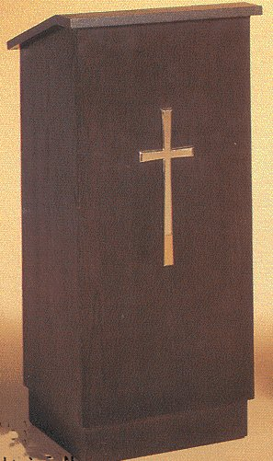
Offertory Table, Gothic Trad | 9925-01-459-3806  22059 | EA | $ 908.00 | Morgan #M-1240 | 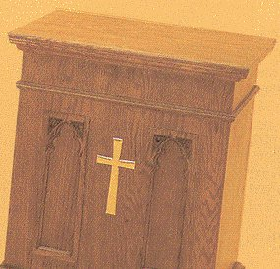
Offertory Table, Modern Gr | 9925-01-459-5534  22053 | EA | $ 625.77 | Morgan #M-8040 | 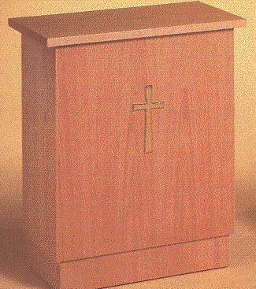
Pew End with Support | 9925-01-460-1084  22029 | EA | $ 225.41 | Morgan 8009
Pew Kneeler | 9925-01-459-5056  22075 | FT | $ 17.77 | Morgan MP-8006 upholstered - sold by the foot. | 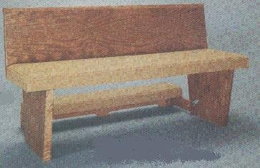
Pew, Plain Seat and Back | 9925-01-459-3762  22072 | FT | $ 35.09 | Morgan MP-8006 - sold by the foot.
Pew, Uph. Seat and Plain Back | 9925-01-459-3725  22073 | FT | $ 50.26 | Morgan MP-8006 - sold by the foot. | 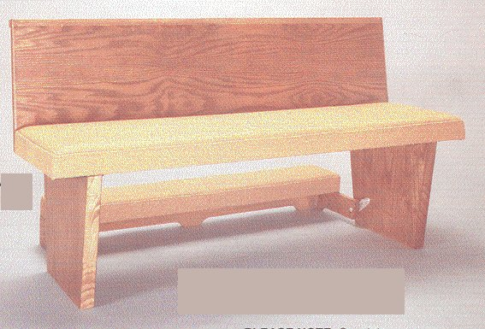
Pew, Uph. Seat and Uph. Back | 9925-01-459-3775  22074 | FT | $ 59.05 | Morgan MP-8006 - sold by the foot. | 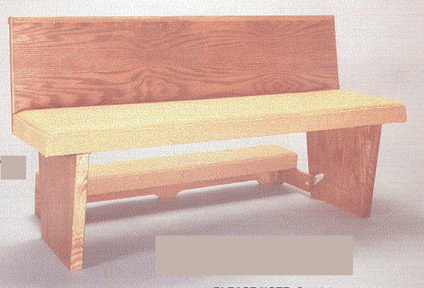
Prie Dieu, Gothic Traditional | 9925-01-459-4097  22060 | EA | $ 789.72 | Morgan #M-1210 | 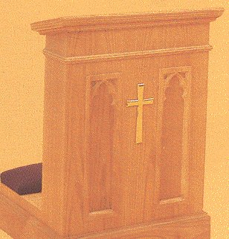
Prie Dieu, Modern Grouping | 9925-01-459-3767  22050 | EA | $ 491.91 | Morgan #M-8011 | 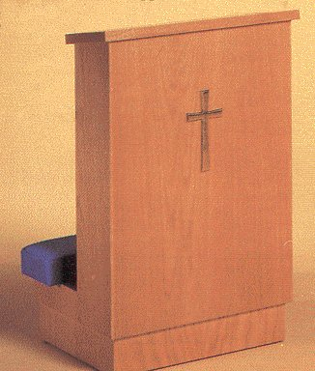
Prie Dieu, w/ Stationary Scr | 9925-01-459-3842  22070 | EA | $ 396.13 | Morgan #M-2450
Pulpit, Gothic Traditional | 9925-01-459-3790  22057 | EA | $ 2,163.98 | Morgan #M-1250 | 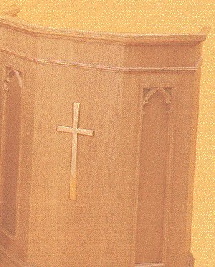
Pulpit, Modern Grouping | 9925-01-459-3773  22052 | EA | $ 1,578.04 | Morgan #M-8050 | 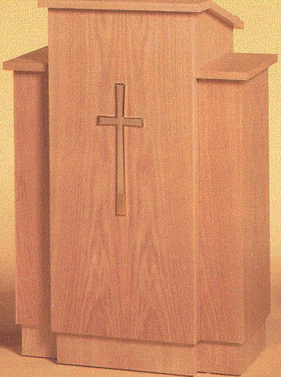
Rack, Pamphlet | 9925-01-460-0222  21990 | EA | $ 245.40 | Morgan #M-1047
Table, Credence, w/Br Cast | 9925-01-459-5080  22064 | EA | $ 366.97 | Woerner Narthex Furnishings#340
Table, Credence, w/Formica | 9925-01-459-3998  22063 | EA | $ 284.81 | Woerner Narthex Furnishings #341

