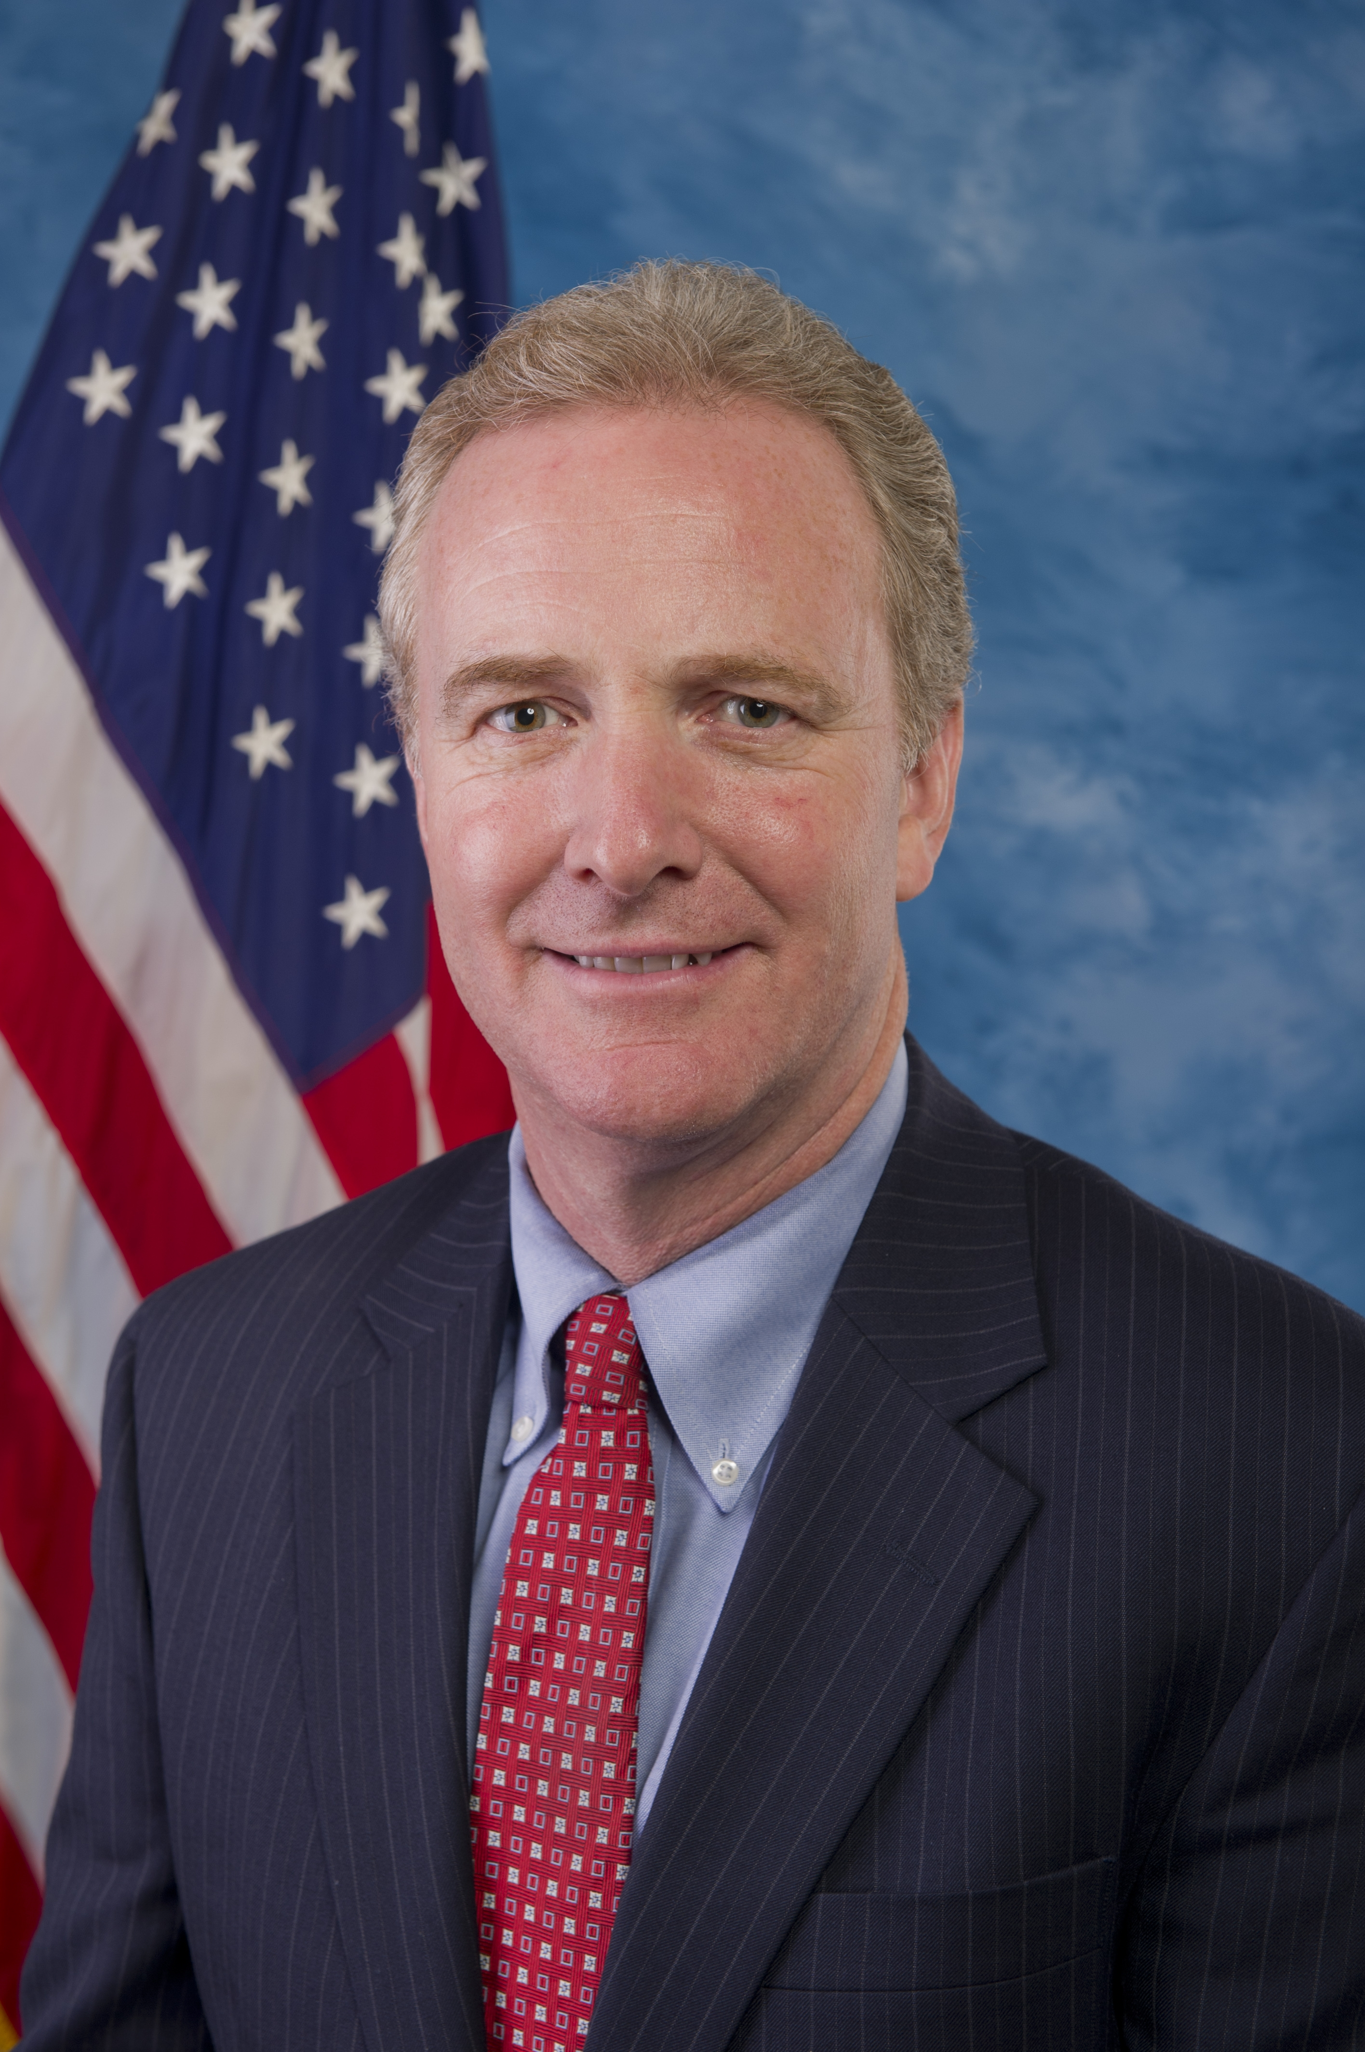
Congressman Chris Van Hollen was elected to Congress in 2002 in a high-profile
election that received national attention. He quickly earned a reputation as an active, engaged, and effective member of Congress, rising to become one of the youngest members of the Democratic leadership in 2008. In addition to representing the Eighth District of Maryland and serving in House leadership, Congressman Van Hollen was elected by his colleagues in 2010 to serve as the top Democrat on the House Budget Committee. In this position, he is working to advance policies that support job creation and economic growth, reduce the deficit, and put America on a path to long-term fiscal sustainability.

The Washington Post named Chris Van Hollen one of “10 members to watch in the 112th Congress.” Roll Call has noted that “Van Hollen gets near-universal respect from his colleagues for his intellectual firepower and combination of policy and political chops.”

Congressman Van Hollen is a tireless advocate for Maryland in Congress, and his leadership has helped to obtain funding for a wide range of critical investments in our community, including infrastructure, biotechnology and education; public transportation in the Washington National Capital area; and anti-gang initiatives. Congressman Van Hollen was recognized by Washingtonian Magazine as the ‘Best Metro Area Member of Congress’ in 2010 and as the ‘Best Local Elected Official’ by Bethesda Magazine in 2008.

Throughout his career, Congressman Van Hollen has been a champion of education, energy the environment, health care, and civil rights. He is a leader on cleaning up the Chesapeake Bay, and fought successfully to obtain a historic boost in federal funds for the Bay as part of the Farm Bill and to secure provisions in the Recovery Act that provided loan guarantees for renewable energy projects. He also played an integral role in the effort to pass comprehensive health care reform and fought to ensure that young adults receive expanded access to health insurance. He has been a staunch advocate for critical government reforms. He led the fight to pass far-reaching lobbying disclosure reform and has been a key supporter of whistleblower protections. A former professional staff member on the Senate Foreign Relations Committee, Congressman Van Hollen has a strong background in national security policy. He lived and studied abroad in South Asia and has remained active in issues related to U.S. foreign policy in that region and around the world.

Congressman Van Hollen has received numerous leadership awards for his legislative activities, including the Chesapeake Climate Action Network's "Climate Champion of the Year" award for his contribution to clean -energy policies; the "Community Health Superhero Award" from the National Association of Community Health Centers for his efforts on behalf of the uninsured and medically underserved Americans; the Montgomery County Chamber of Commerce’s “Legislator of the Year” award; Progressive Maryland’s “Champion of Working Families” award; the Maryland Executive Council for Educational Opportunities’ “Excellence in Educational Advocacy” award; and the Multiple Sclerosis Society’s “Representative of the Year” award.

Before his election to the U.S. House of Representatives, Congressman Van Hollen served 4 years in the Maryland General Assembly and 8 years in the Maryland Senate. His legislative record in Annapolis earned him the praise of The Washington Post, which called him “one of the most effective members of the Maryland legislature.” He is a graduate of Swarthmore College, the John F. Kennedy School of Government at Harvard University, and Georgetown University Law Center. He lives in Kensington, Maryland with his wife, Katherine, and their three children, Anna, Nicholas, and Alexander.

