TO:
FROM: {Green Purchasing Lead in Organization}
DATE:
RE: {Organization Name} to Only Purchase ENERGY STAR {product name or product category}
We are pleased to announce that as part of our continuing efforts to save energy, money and help protect the environment, {Organization Name} will only purchase ENERGY STAR qualified {product name or product category} as of {date}.* ENERGY STAR qualified products can save up to 50% of the energy used by standard products without costing more or sacrificing performance.
Please employ the following guidance:
- When purchasing {product name or product category} please:
  - Visit www.energystar.gov/products for a list of ENERGY STAR qualified products.
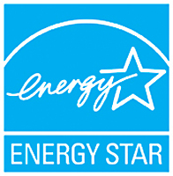
  - Look for the ENERGY STAR certification mark in product descriptions, product boxes, online catalogs, etc.

- When setting up a {services contract or purchasing agreement}, please include the following language:
The Vendor must provide products {or insert name of specific products of interest (i.e., computers, monitors, copiers)} that earn the ENERGY STAR and meet the ENERGY STAR specifications for energy efficiency. The vendor is encouraged to visit energystar.gov/products for complete product specifications and updated lists of qualifying products.
* {Mention any conditions where purchasing ENERGY STAR products is not required.}

