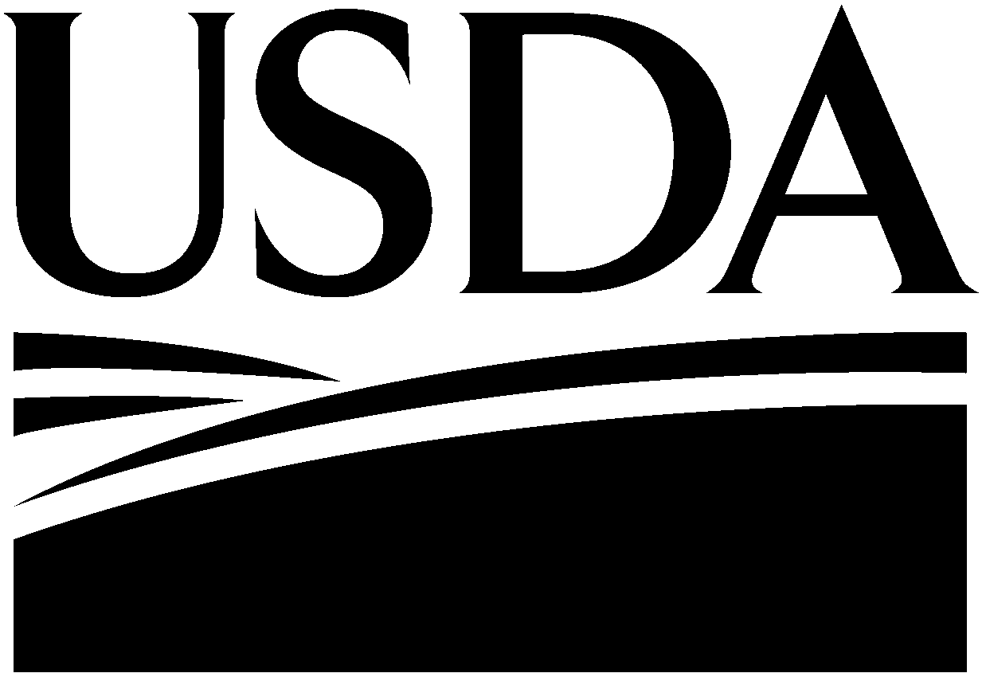

Oct. 29, 2009

Memo to Interested Parties

From: USDA

Subject: USDA provides update on 2009 pandemic H1N1 influenza testing fair pig samples

USDA’s National Veterinary Services Laboratories (NVSL) is providing an update on 2009 pandemic H1N1 influenza virus testing of additional pig samples collected at the Minnesota State Fair and the South Dakota State Fair. The samples were collected and submitted by the University of Minnesota and University of Iowa as part of a project funded by the U.S. Centers for Disease Control and Prevention (CDC).

USDA’s NVSL received 57 samples from pigs at the Minnesota State Fair as well as 45 samples from pigs at the South Dakota State Fair.

NVSL has confirmed that six Minnesota State Fair pig samples are for positive 2009 pandemic H1N1 influenza. This figure includes the initial positive sample announced on Oct. 19. Confirmatory testing continues on six additional samples that had preliminary H1N1 positive results.

There are no plans to conduct further testing on the original 102 samples.

The samples collected at the 2009 Minnesota State Fair and South Dakota State Fair were part of a University of Iowa and University of Minnesota cooperative agreement research project funded by the U.S. Centers for Disease Control and Prevention which documents influenza viruses where humans and pigs interact such as fairs.

USDA will post all future suspected 2009 pandemic H1N1 influenza detections on the Internet. USDA will maintain a list of all 2009 pandemic H1N1 influenza detections in swine at www.usda.gov/H1N1flu.

People cannot get this flu from eating pork or pork products. Pork is safe to eat. USDA continues to remind U.S. swine producers about the need for good hygiene, biosecurity and other practices that will reduce introducing and spreading of influenza viruses in their herd.

More information about USDA’s 2009 pandemic H1N1 efforts is available at www.usda.gov/H1N1flu.

#

USDA is an equal opportunity provider, employer and lender. To file a complaint of discrimination, write: USDA, Director, Office of Civil Rights, 1400 Independence Avenue, SW, Washington, DC 20250-9410 or call (800) 795-3272(voice), or (202) 720-6382 (TDD).

