Nanomaterials: Environmental Risks and Benefits

NATO Advanced Research Workshop

October 2007, Portugal

Recent advances in the design and potential applications of nanomaterials have led to a wide range of potential uses in conductors, pharmaceuticals, automobiles, and military applications due to unique properties (e.g., strength, low weight) related to their small size (1 to 100 nm). The understanding of the environmental effects and risks associated with nanotechnology is very limited and contradictory. However nanomaterials and their associated technology may hold promising opportunities for environmental remediation technologies, waste treatment, friction reduction, and energy conservation.

With 300 products in use today, what information do we have that suggests that nanomaterials may pose unacceptable risks to human and environmental health? How can any environmental health and safety impacts of nanomaterials be minimized through the manufacturing and product life-cycle through engineering and handling practices to minimize exposure and risks of future liability? How nanotechnology can be used to enable environmental benefits? The ARW workshop will focus on recent advances in nanotechnology that may have environmental implications (e.g., benefits and costs). The workshop has five primary purposes:

- Identify and describe what is known about the risks and approaches to assess the security and ecological risks of nanomaterials.
- Outline environmental applications in the context of pollution prevention, risk reduction, and remediation.
- Assess the suitability of multicriteria decision analysis for reconciliation of benefits and risks of nanotechnology.
- Direct future research in nanomaterial and environmental sciences to address the emerging issues associated with the nanotechnology field.
- Identify strategies for users in developing countries to best manage this emerging technology and its associated risks.

Participants will be organized into three working groups to address (i) environmental benefits of nanomaterial applications, (ii) human health and ecological nanomaterial risks, and (iii) environmental security and decision making. State of the science reviews by these working groups along with other materials discussed during the meeting will provide foundation for a book on Nanotechnology that will be published by Springer. This workshop will provide environmental scientists and government officials with a clear view of the trade-offs associated with the environmental impacts of nanotechnologies and will provide them with warning signs and decision tools for the environmental security aspects of its applications.

Organizing Committee
Jeffery A Steevens, U.S. Army Corps of Engineers, USA
Igor Linkov, Intertox Inc., USA
Boris Yatsalo, Obninsk State Technical University of Nuclear Power Engineering, RUSSIA
Mahmud Haraza, Atomic Energy Authority, EGYPT

Contact the ARW Organizers,
Dr. Jeffery Steevens at Jeffery.A.Steevens@us.army.mil
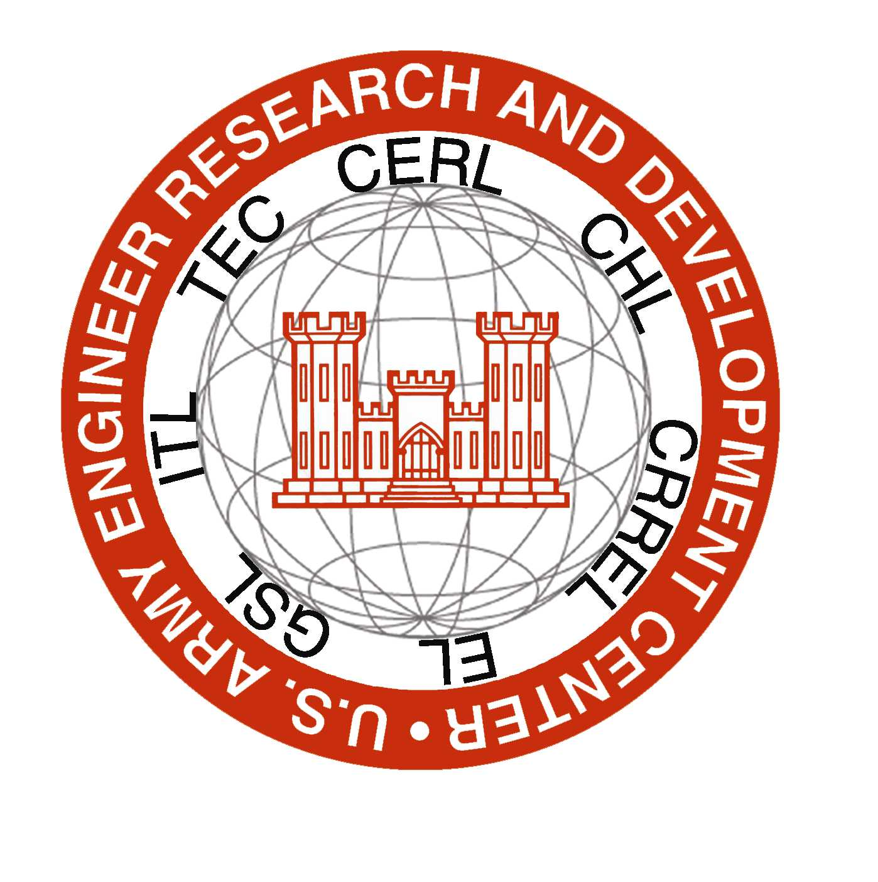
Dr. Igor Linkov, ilinkov@intertox.com
U.S. Army
Engineer Research and Development Center

