Tabletop Exercise #6

[This page intentionally left blank]

Table of Contents
CERT Drills and Exercises 1
What Is a Tabletop Exercise? 1
Exercise Overview 2
For Exercise Staff 3
Facilitator Guidelines 5
Appendix 11
Local map
Events and Evaluation Form for Facilitator(s) and Evaluator(s)
Facilitator/Evaluator Feedback Form
Participant Feedback Form

How to Use This Document
This document provides exercise Facilitators with all information and materials needed to plan, conduct, and evaluate an exercise. Do the following:
Read through the entire exercise and supporting materials.
Decide how to localize the scenario in a way that reflects likely challenges in your community and tests your CERT members’ skills and techniques.
Familiarize yourself with the flow of the exercise by thoroughly reviewing the Facilitator Guidelines. Use these guidelines to conduct the exercise.
Make copies of the supporting documents for participants. See the Appendix index for instructions.
Make copies of the Participant Feedback Form and ask participants to complete it after the exercise.
Complete the Facilitator/Evaluator Feedback Form after the exercise.

[This page is intentionally left blank]

CERT Drills and Exercises
The Community Emergency Response Team (CERT) Program educates ordinary people from all walks of life about disaster preparedness and weapons of mass destruction and trains them in basic disaster response skills, such as fire safety, light search and rescue, and disaster medical operation. Using the training, CERT members can assist others in their neighborhood or workplace following an event and can take a more active role in preparing their community.
The National CERT Program has developed a library of drills and exercises. These exercises have been designed in a ready-for-use format and include complete instructions, detailed lists of materials, and all supporting forms.
This document is used by the Facilitator(s) and supports the delivery of a tabletop exercise that can be customized to meet local needs.

What Is a Tabletop Exercise?
Tabletop exercises are table-based activities typically held in an informal setting and presented by the Facilitator. There is no hands-on practice or field work. This type of exercise is intended to generate discussion of various issues regarding a hypothetical, simulated emergency. Tabletops can be used to enhance general awareness, validate plans and procedures, rehearse concepts, and/or assess the types of systems needed to guide the prevention of, protection from, mitigation of, response to, and recovery from a defined incident.
Delivered in a low-stress environment, the tabletop exercise offers participants the opportunity to explore different ideas in the context of a real-world scenario. All participants should be encouraged to contribute to the discussion and be reminded they are making decisions in a “no-fault” environment.
Effective facilitation is critical to keeping participants focused on exercise objectives. The Facilitator may ask about the decisions made, including how a decision was reached or what implications a decision might have. The exercise ends either when all actions have been discussed or when the time limit is reached. Participant learning is reinforced and feedback is provided through a hot wash at the conclusion of the exercise.
For descriptions and other types of exercises for CERTs, please visit www.citizencorps.gov/cert and click on CERT Exercises.

Exercise Overview
“Tabletop Exercise #6”
Hazard: | Flood
Location: | Local town
Duration: | 40-60 minutes

Capabilities Exercised:
- Incident Command
- Communications
- Search procedures – exterior
- Scene management
- Sizeup

Exercise Objectives:
- Assess plans and protocols for communicating between the team and professional responders, between the CERT Command Post and the field, and between team members.
- Validate the decision-making process to prioritize incidents.
- Assess exterior search procedures.
- Evaluate the procedures for managing responses from the survivors in a disaster area.
- Validate CERT sizeup procedures.

Scenario:
A series of heavy storms has caused small stream flooding, with moderate damage to local roads, parks, and structures in low-lying areas. Water levels are rising slowly but steadily.

The Fire Department has asked that the team assemble at a local park to help with evacuations, sandbagging, and organizing volunteers.

For Exercise Staff

Exercise Synopsis:
This tabletop exercise gives the team the opportunity to:
- Discuss the process it would use to search for a missing child.
- Prioritize how to respond to a variety of requests.
- Respond to a variety of people at the scene of an emergency.
The focus of the exercise is on setting priorities and managing resources.
These activities are performed in the context of a scenario where heavy rains have caused flooding in a local neighborhood.
The team first discusses the process for setting up the Command Post and medical treatment area. Then the team develops an initial plan to respond to the situation. Once the initial plan is developed, the Facilitator pauses the exercise to discuss the plan.
While the team is implementing the plan, another emergency crops up to which it must respond. The Facilitator discusses how the team responds to the emergency.
The exercise ends either when all actions have been discussed or the time limit is reached. At the conclusion of the exercise, a hot wash helps participants review what they have learned and provides feedback on the exercise.

Exercise Materials and Staff:
- Facilitator (1 for each group of 7-10)
- Forms:
  - Local map, used during the exercise
  - Events and Evaluation Form for Facilitator(s) and Evaluator(s), used by the Facilitator(s) and Evaluator(s) during the exercise
  - Facilitator/Evaluator Feedback Form, completed after the exercise
  - Participant Feedback Form, completed after the exercise
Exercise Staff Roles:

Facilitator
The Facilitator will play three roles for this exercise.
First, the Facilitator will lead and guide the exercise by presenting information. This will keep the exercise moving forward and make sure the key decision points in the exercise are reached.
Second, the Facilitator will observe and coach. In this role, he or she will observe the group process and discussion. As the exercise unfolds, he or she may need to step in and help the team members clarify their decision making by asking questions about their thought process and the factors they considered in making choices. For example, if they placed a high priority on helping a victim who was probably dying, or if they decided to enter a building that was clearly too dangerous, work through their decision-making process so they realize the potential negative results of their decision.
The Facilitator may want to take notes on decisions made and actions taken so he or she can refer to them later. Use the Events and Evaluation Form for Facilitator(s) and Evaluator(s) to record notes.
Third, the Facilitator will conduct a hot wash (debrief). The purpose of the hot wash is to reinforce learning by helping participants evaluate their own decision making. It is a balance between:
- Asking participants why they made the choices they did and what they learned.
- Providing additional information and coaching.
Bear in mind that, although the Facilitator may have more experience and knowledge, participants will likely learn more if coached through their decision-making process than if they are told what they should have done.
During the hot wash and after the exercise, the Facilitator has additional responsibilities including collecting feedback on the exercise and how beneficial it was for CERT participants, and providing input to improve future CERT exercises.

Evaluator
The role of Evaluator is typically assumed by the Facilitator in a tabletop exercise. The primary responsibility of the Evaluator is to assess the exercise based on the events and expected actions listed on the Events and Evaluation Form for Facilitator(s) and Evaluator(s). The Evaluator typically has a passive role and does not interfere with the exercise unless he or she is also playing the role of Facilitator.

Facilitator Guidelines
Step | Action |  | What to Say/Do
1 | Prepare for the exercise. |  | - Make copies of the handouts in the Appendix. The Appendix index indicates how many copies are needed.  - Make copies of the one-page Exercise Overview for each participant.
2 | If necessary, organize the group into groups of 7-10. |  | Explain that each small group will go through the exercise together.
3 | Introduce the exercise to all participants. |  | Distribute the one-page Exercise Overview to all participants.  Explain that the purpose of the exercise is:  - To provide an opportunity to talk through the procedures the team would implement in response to a given scenario.  - To improve CERT’s operational performance by practicing and validating policies, plans, procedures, and training in the risk-free environment of an exercise.
4 | Review the goals of the exercise with all participants. |  | Explain the goals of the exercise.  - Assess plans and protocols for communicating between the team and professional responders, between the CERT Command Post and the field, and between team members.  - Validate the decision-making process to prioritize incidents.  - Assess exterior search procedures.  - Evaluate the procedures for managing responses from the survivors in a disaster area.  - Validate CERT sizeup procedures.
5 | Present the scenario to all participants. |  | - A series of heavy storms has caused small stream flooding, with moderate damage to local roads, parks, and structures in low-lying areas. Water levels are rising slowly but steadily.  - The Fire Department has asked that the team assemble at a local park to help with evacuations, sandbagging, and organizing volunteers.
6 | Hand out copies of the map to each participant. |  | - Explain that the team has gathered at the parking lot near the 1st St. entrance.  - There are sandbagging supplies available.  - There is a firefighter trying to organize a group of 10 volunteers when the team arrives.  - She asks that the team take over organizing the volunteers, help fill the sandbags and get them placed in front of the businesses on Pine St., and let the residents on Maple and Pine between 1st and 3rd Streets know that they need to evacuate their homes.  - After explaining the situation, she leaves saying she will check in as she is able.
7 | Provide initial instructions. |  | Ask the group how they would:  - Establish Incident Command.  - Choose the location for the Command Post.  - Keep emergency services updated on the status of the situation.  - Develop a plan to respond to the situation, including defined roles and assigned tasks.  Emphasize that all members of each small group will participate in the decision-making process. Each member should be prepared to make decisions as if he or she is the Incident Commander (IC), Team Leader, or other role of the Command Post Team.
8 |  | Pause and discuss the roles and tasks and provide feedback about the group’s decisions. | Consider the following in your discussion:  - Does the team have adequate resources to respond to all the Fire Department requests? If not, how did they respond?  - Which leadership positions were created? Why?  - Which requests received the highest priority? Why?
9 |  | Resume the exercise.
10 |  | Tell the team that a woman runs up. She is almost hysterical. She was dropping her husband off to help with the sandbagging. Her 5-year-old son has wandered away. She thinks he went into the park. She desperately needs help finding him. | Ask the team how they would respond to this new development.  Be sure to explore how Incident Command would communicate with teams in the field when prioritizing and assignments are shifted.
11 |  | Observe the discussion and decision-making process. | Coaching tips are provided in Step 15.
12 |  | Review the final plan with the team. Discuss the implications of their decisions as appropriate | Consider the following in your discussion:  - Were tasks prioritized correctly?  - Were adequate personnel assigned for each operation?  - Were team members performing tasks that they have the capability to achieve?  - How might the teams have communicated with the CERT IC?
13 |  | Terminate the exercise when the time has run out, or most of the small groups have developed a final plan of action.
14 |  | Conduct the hot wash with all participants and staff members. | - Since documentation is a key part of every CERT response, ask specific questions during the hot wash that would likely require the group to refer to documentation for answers. Questions might include:  - How were team members divided into functional teams?  - What actions were taken and by whom?  - Why were certain actions taken?  - When did they do this?  - What conditions did they find?  - What did you do next?  - What worked well and what did not?  - NOTE: Documentation may be done in a variety of ways – from structured forms, to notes on scrap cardboard, to writing on the back of a hand. The format isn’t important, but retaining the information is.
15 |  | Provide coaching to the participants as appropriate. | Coaching points you may want to bring up to the group if not already mentioned include:  - The two most important goals for team members are: Protect yourself first, and then do the greatest good for the greatest number of people. All other decisions flow from these two considerations.  - What factors were considered when assigning resources?  - Looking back, what might you do differently the next time you face a similar situation?
16 |  | Distribute the Participant Feedback Form to all participants. | Ask participants to complete the form.
17 | Distribute the Facilitator/Evaluator Feedback Form. |  | Ask all Facilitators/Evaluators to complete the form.

Appendix

[This page intentionally left blank]

Index of Forms and Materials
Local map (1 page): 1 copy per participant is distributed during the exercise
Events and Evaluation Form for Facilitator(s) and Evaluator(s) (2 pages): 1 copy per Facilitator and Evaluator is distributed before the exercise
Facilitator/Evaluator Feedback Form (1 page): 1 copy per Facilitator and Evaluator is distributed after the exercise
Participant Feedback Form (1 page): 1 copy per participant is distributed after the exercise

[This page intentionally left blank]
Local Map
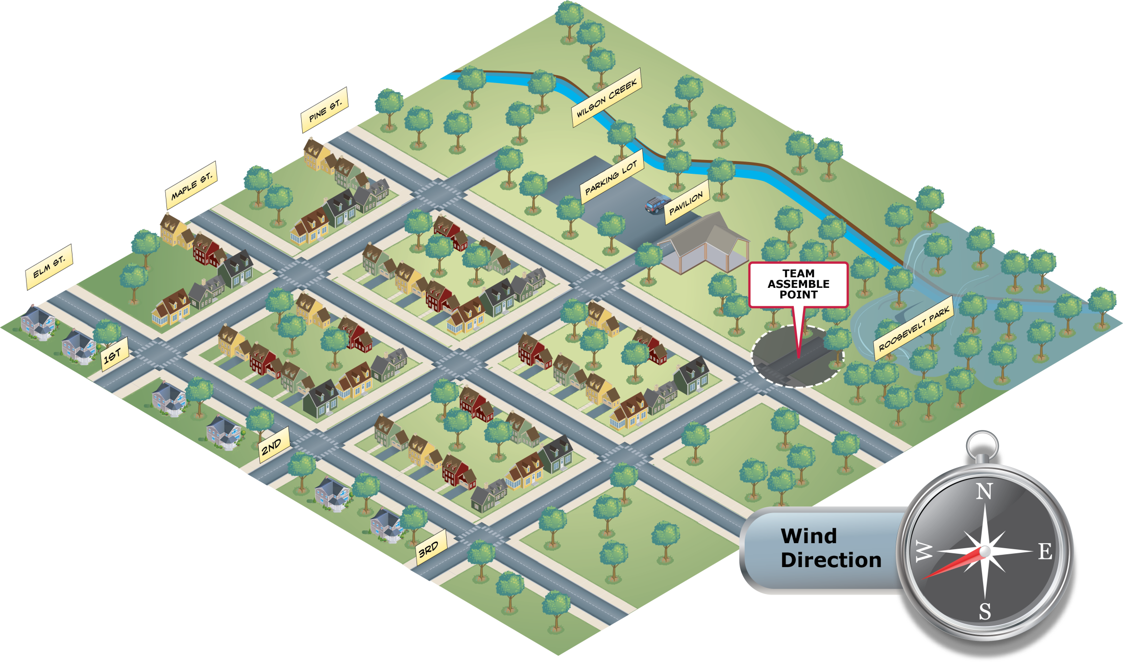

[This page intentionally left blank]

Events and Evaluation Form for Facilitator(s) and Evaluator(s)
Message/Event | Expected Action | Actual Observed  (To be filled in by Evaluators during the exercise)
Set up Command Post.  [ICS] | Command Post should be located in central, safe location.  Likely location is in parking lot pavilion. | Time completed: __________  Completion:  No ____ Yes ____ Partial ____  Notes:
Establish communications with emergency services.  [Communications] | IC contacts 9-1-1 or Fire Department and maintains periodic contact to keep them updated about incident status. | Time completed: __________  Completion:  No ____ Yes ____ Partial ____  Notes:
Assign leadership roles.  [ICS] | Assign IC, Logistics Team Leader, and Operations Section Chief. Medical treatment area Team Leader may not be needed. | Time completed: __________  Completion:  No ____ Yes ____ Partial ____  Notes:
Prioritize incidents and develop action plan.  [ICS] | Team correctly prioritizes incidents according to what team has the capability to perform. | Time completed: __________  Completion:  No ____ Yes ____ Partial ____  Notes:
Assign tasks.  [ICS, Scene Management] | Operations Section Chief assigns teams to:  - Coordinate sandbagging and assign volunteers after asking about special skills.  - Go to houses and warn residents to evacuate. | Time completed: __________  Completion:  No ____ Yes ____ Partial ____  Notes:
Address search process for 5-year-old.  [Exterior Search, Communications] | Withdraw teams from sandbagging and/or evacuation activities to conduct search.  Establish search pattern.  Set procedures for communicating with Incident Command. | Time completed: __________  Completion:  No ____ Yes ____ Partial ____  Notes:

Facilitator/Evaluator Feedback Form
Exercise Name: | Exercise Date:
Name (Optional): Role (Optional):
CERT/Organization:
- Please rate, on a scale of 1 to 5, your overall assessment of the exercise relative to the following statements, with 1 indicating strong disagreement with the statement and 5 indicating strong agreement.
Assessment Factor | Strongly  Disagree |  |  | Strongly Agree
The exercise was well structured and organized. | 1 | 2 | 3 |  | 4 | 5
The exercise scenario(s) was plausible and realistic. | 1 | 2 | 3 |  | 4 | 5
The Facilitator(s) was knowledgeable about the area of play and kept the exercise on target. | 1 | 2 | 3 |  | 4 | 5
The exercise documentation provided to assist in preparing for and participating in the exercise was useful. | 1 | 2 | 3 |  | 4 | 5
This exercise allowed the CERT to practice and improve priority capabilities. | 1 | 2 | 3 |  | 4 | 5
This exercise helped the CERT identify strengths and weaknesses in the execution of plans, protocols, and procedures. | 1 | 2 | 3 |  | 4 | 5
- Based on today’s exercise, list observed key strengths and/or areas that need improvement.
Strengths: _____________________________________________________________
Areas for improvement: ____________________________________________________
- Please provide recommendations on how this exercise or future exercises could be improved or enhanced.

[This page intentionally left blank]

Participant Feedback Form
Exercise Name: | Exercise Date:
Name (Optional):
CERT/Organization:
- Please rate, on a scale of 1 to 5, your overall assessment of the exercise relative to the statements provided below, with 1 indicating strong disagreement with the statement and 5 indicating strong agreement.
Assessment Factor | Strongly  Disagree |  |  | Strongly Agree
The exercise was well structured and organized. | 1 | 2 | 3 | 4 | 5
The exercise scenario(s) was plausible and realistic. | 1 | 2 | 3 | 4 | 5
The exercise documentation provided to assist in preparing for and participating in the exercise was useful. | 1 | 2 | 3 | 4 | 5
This exercise allowed me to practice and improve priority capabilities. | 1 | 2 | 3 | 4 | 5
This exercise helped my CERT identify strengths and weaknesses in the execution of plans, protocols, and procedures. | 1 | 2 | 3 | 4 | 5
After this exercise, I believe my CERT is better prepared to deal successfully with the scenario(s) that was exercised. | 1 | 2 | 3 | 4 | 5
- Based on today’s exercise, list observed key strengths and/or areas that need improvement.
Strengths: _____________________________________________________________
Areas for improvement: ____________________________________________________
- Please provide recommendations on how this exercise or future exercises could be improved or enhanced.

[This page intentionally left blank]

