Devolve—to hand down or delegate to another | Devolvement  Through devolvement of the Defense Environmental Restoration Account (DERA), DoD has handed down the previously centralized account structure for environmental restoration to each of the Military Departments. The program will continue to be executed the same as it was before devolvement; the only difference is that DoD now has five environmental restoration accounts instead of one.  How Does Devolvement Benefit the Program?
  Improves planning and budgeting -- integrates environmental restoration into the planning, programming, and budgeting system (PPBS) at the Military Department level, like most other military programs
  Improves accountability -- aligns accountability and responsibility with budgeting and funding control, bringing greater institutional checks and balances to bear
  Improves oversight -- provides increased financial and management scrutiny within the Military Departments and allows the Office of the Secretary of Defense (OSD) to focus on policy and oversight responsibilities

OSD Environmental Restoration, Defense (ER,D)
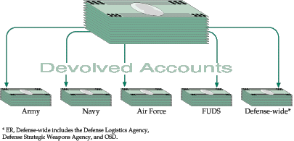

   | A copy of the Devolvement Report to Congress  is available on the World Wide Web at  http://www.dtic.mil/envirodod/devolve.html

How Will Stakeholders Benefit?
Increased military chain-of-command awareness of the environment and responsibility for environmental restoration
Better information and performance data will be available because of PPBS integration and enhanced oversight and reporting requirements

Understanding Defense Appropriations
Congress provides spending authority for specified purposes in several appropriations acts each year. One of those is the Defense Appropriations Act. All defense appropriations are considered in the context of national security objectives and reflect
a balance between providing sufficient funding to carry out essential defense activities and responding to the fiscal constraints and changing security requirements facing the nation.
Typical appropriations provided in the Defense Appropriation Act include: military personnel; operations and maintenance; procurement; and research, development, test, and evaluation.
The appropriation for environmental restoration is contained in the FY97 Defense Appropriations Act under Title II, Operations and Maintenance. Before devolvement, environmental restoration was listed as a single appropriation, entitled Environmental Restoration, Defense (ER,D). With devolvement, there are now five appropriations--ER, Army; ER FUDS; ER, Navy; ER, Air Force; and ER, Defense-wide.

