Army - Cleanup Status and Progress

The Army has a large and technically challenging environmental restoration program. Production base and training missions have created significant environmental cleanup requirements. For example, explosives contamination and unexploded ordnance stretch the technical capabilities of the DoD and private sector to address these problems. To date, the Army has identified 12,185 potentially contaminated sites at 1,185 installations, with 7,765 sites requiring no further action. Restoration activities are planned or underway at 4,420 sites. The Army has completed final remedial construction actions at 709 sites, with 84 requiring long-term operations. In addition, the Army has completed a total of 1,042 interim actions at 713 sites. The BRAC 1988, 1991, 1993, and 1995 lists included 87 Army installations and 53 stand-alone family housing areas that are being closed or realigned under BRAC laws. Approximately 267,000 acres are excess to DoD and the excess property is available at 62 installations. Army installations have formed 39 BRAC Cleanup Teams to support fast track cleanup. At all other locations, the Army has appointed a Fast Track Point of Contact. Local Redevelopment Authorities (LRA) have completed reuse plans at 16 BRAC installations and have initiated reuse plans at 28 additional installations. Restoration activities continue at BRAC installations. The Army has completed nearly all BRAC 1995 installations’ environmental baseline surveys. Regulatory concurrence on clean parcels at BRAC 1995 installations in accordance with the Community Environmental Response Facilitation Act (CERFA) is under way and scheduled for completion by the end of March 1997.

GOALS AND PRIORITIES
During FY96 the Army updated the total cost-to-complete for all remediation activities. The estimate is now $10.3 billion; $8.6 billion for Installation Restoration (IR) at operational installations and $1.7 billion for BRAC. The previous estimate in FY95 was $10.9 billion. With the reduction in the cost-to-complete, the Army now projects meeting DoD's goal of 50 percent reduction of high relative risk sites at operational installations by 2002 at current projected funding levels. Management costs are limited to 10 percent of the program.

DERA and BRAC Status
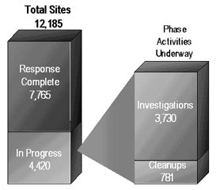

Property Available for Transfer
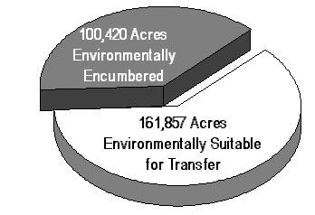
The Army achieved a major goal in FY96 by signing two Records of Decision (ROD) for Rocky Mountain Arsenal (RMA) in Colorado. The RMA cleanup is the most expensive and challenging of all Army cleanup requirements, representing 22 percent of the Army's $8.6 billion IR cost-to-complete. The RODs resulted from several years of partnering and dialogue with EPA Region 8, the State of Colorado, the Shell Oil Company, and several local interest groups.
The Army continues to make progress towards the plan of spending more IR funds on cleanup activities than on studies and administration. In FY96, the actual percentage of Army IR and BRAC environmental restoration funds expended on cleanup was 63 percent. The FY97 and FY98 plans are to achieve a percentage of cleanup expenditures of 71 and 77 percent, respectively. Prudent expenditures on site characterization studies can result in considerable cost avoidance or savings. For example, during FY96, the Army and regulatory agencies came to an agreement at Schofield Barracks, Hawaii that potentially will save up to $300 million in cleanup and $10 million in further studies.
The Army projects major increases in BRAC properties available for transfer in FY97, more than tripling the inventory of available acres. FY96 legislation allowing transfer of properties prior to all cleanup actions being taken will speed property transfer without reducing the government's responsibility for ensuring cleanup.
RELATIVE RISK IMPLEMENTATION
The Army continued to evaluate their sites for relative risk in FY96. A site's relative risk category (high, medium, or low) is a key factor in sequencing restoration activities for operational installations. Army guidance requires that 90 percent of IR funds address high relative risk sites. During FY96 the Army reduced the number of not evaluated IR sites at operational installations from 1,625 to 937. The Army's goal is to have all IR sites either evaluated or determined to not require evaluation by the end of FY97. The Army also implemented a quality assurance and quality control plan in FY96 to ensure all relative risk site evaluation data is credible and supportable. Software was provided directly to the Army installations in FY96 for the calculation and reporting of relative risk site evaluation data, greatly improving the quantity and quality of data received.
DERA and BRAC
Sites In Progress Relative Risk
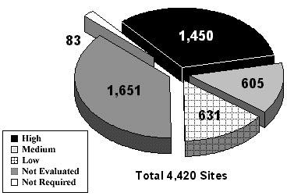
Although relative risk is not the primary factor in sequencing restoration activities for the Army's BRAC program, the Army does consider the site's relative risk category. Planned or proposed reuse is the most important criteria. The chart above for all Army sites includes BRAC sites. It reflects a larger proportion of unevaluated sites than described in the previous paragraph for Army active sites. This results from the number of BRAC not evaluated sites increasing considerably in FY96, due to the identification of new sites at BRAC 1995 installations.
ORGANIZATION AND MANAGEMENT INITIATIVES
AND IMPROVEMENTS
The devolvement of the Defense Environmental Restoration Account has had the desired effect. Army leadership, from installations to major commands and department headquarters, has taken a proactive role in the programming, budgeting, and execution of cleanup requirements at Army operational installations. The immediate result has been a better justified and more defensible Army environmental restoration program for FY97.
The Army fielded new software in FY96 to collect and manage site level data required for program management and reporting. The data received for FY96 restoration activities were more comprehensive and complete than previous data received. The Army continues to work with DoD and the other DoD Components to improve data collection and reporting capabilities.
Department of the Army
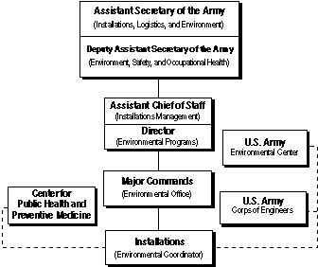
INFORMATION AND TECHNOLOGY TRANSFER
The Army completed a successful phytoremediation demonstration at Milan Army Ammunition Plant (AAP) in FY96. The Army constructed artificial wetlands, conducted field work, and confirmed successful uptake of explosives residuals in plant biomass. The resulting plant material is non-toxic, non-hazardous waste. The Army is continuing this demonstration as a full scale pilot project and plans a similar project at Iowa AAP.
The Umatilla Army Depot explosives-contaminated soil cleanup was completed in FY96, using a composting bioremediation technology that saved $2.6 million over incineration. The successful pilot-scale bioremediation study and technology demonstration investigated the treatment effectiveness of composting contaminated soils. The Army plans to use the technology at additional explosives contaminated sites at Milan AAP, Newport AAP, Savanna Depot Activity, and Tooele Army Depot.
OUTREACH
Jefferson Proving Ground in Indiana and Fort McClellan in Alabama initiated formal partnering agreements with EPA and their respective states in FY96. There is great potential to resolve regulatory conflicts at those locations. Early progress reports are good. A similar partnering agreement at Sierra Army Depot in California resulted in accelerating the leasing agreement by six months. Partnering on the Installation Action Plan at Fort Campbell with EPA and the States of Kentucky and Tennessee produced cost avoidances of at least $10 million. Fort Bliss' partnering efforts with the State of Texas produced a cost avoidance of $5.4 million due to reduced groundwater monitoring requirements. Iowa AAP's partnering efforts have the potential to result in savings of $23 million based on regulatory acceptance of phytoremediation and natural attenuation remedies.
Aggressive efforts to increase the number of Restoration Advisory Boards (RAB) at Army installations resulted in 23 new RABs, increasing the Army total number of RABs to 48. The Army also completed and published new RAB guidance during FY96, implementing the recommendations of the Federal Facilities Environmental Restoration Dialogue Committee to increase the participation of RABs in priority setting and program development.
In FY96, the Army obligated $416.3 million in environmental restoration funds, approximately 30 percent of the overall FY96 program for DoD. The Army’s environmental restoration funds will decrease to $338.8 million in FY97 and then increase to $377.3 million in FY98, according to current planning estimates. In FY96, approximately 60 percent of Army environmental restoration funds was spent on design work, interim or final cleanup actions, and operations and maintenance. That percentage is planned to increase to 71 percent in FY97 and decrease to 69 percent in FY98, according to current planning estimates.
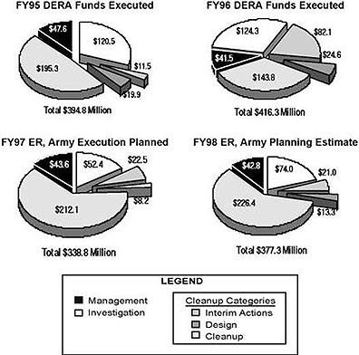

Of the 3,224 sites in progress at operational installations, 1,247 or about 39 percent, are categorized as high relative risk.  Of the 1,196 sites in progress at closing installations, 203, or about 17 percent, are categorized as high relative risk. | 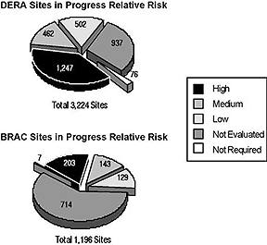
Of the 10,242 sites at Army operational installations that are funded by DERA, response is complete at 7,018. At 3,224 remaining sites, investigation, design, or cleanup actions are in progress.
The Army completed 123 interim actions in FY96, bringing the total number of interim actions completed at operational installations to 912 at 614 sites.
During FY96, the number of response complete site determinations based on cleanup activities at operational installations increased by 61 sites from FY95. The number of no further action or response complete site determinations based on appropriate investigations and analysis at operational installations increased by 287 sites from FY95.
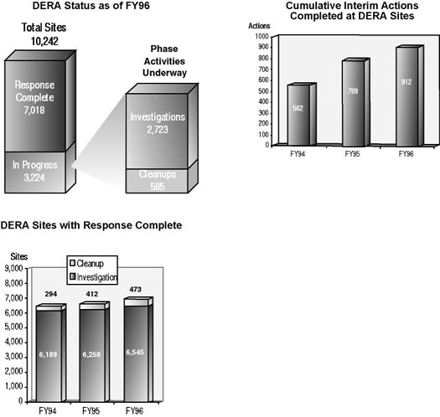
Of the 1,943 sites at Army BRAC installations, response is compete at 747. At 1,196 remaining sites, investigation, design, or cleanup actions are in progress.
In FY96, the Army completed 66 interim actions, bringing the total number of interim actions completed at BRAC installations to 130 at 99 sites.
During FY96, the number of response complete site determinations based on cleanup activities at BRAC installations increased by 74 sites from FY95. The number of no further action or response complete site determinations based on appropriate investigations and analysis at BRAC installations increased 113 sites from FY95.
