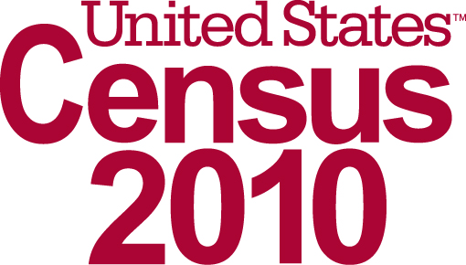
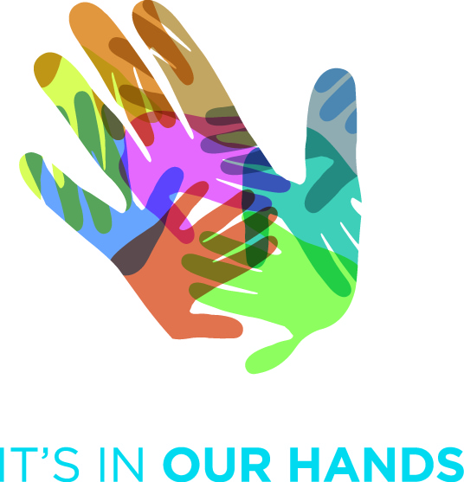
2010 Census Partnership Certificate

Signature
<<Name>>
<<Title>>
<<Organization Name>>
<<Date>>
Signature
<<Name>>
<<Title>>
U.S. Census Bureau
<<Date>>
<<Organization Name>>

commits to being an official partner of the 2010 Census, because of the importance of the census to the country and local communities.

The 2010 Census will affect political representation, the allocation of
billions of dollars in government funding and decisions on where to build
new roads, hospitals, schools and more.

D – XXXX (E)

