Toolkit for Faith-Based Organization Partners
Web Banners and Buttons

To raise awareness of the 2010 Census and encourage participation, leaders of faith-based organizations can post the following Web banners and buttons onto their organization’s Web site. To add these buttons or banners to your Web site, copy and paste either the code or the banner to your Web site.

This document is available with the Toolkit for Faith-Based Organization Partners at “Partner With Us” at 2010census.gov.

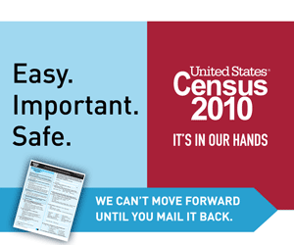
To post a clickable image that brings visitors to 2010census.gov, copy and paste the code below into the source of your Web page where you would like the image to appear.

<a href="http://2010.census.gov" target="_blank"><img src="http://2010.census.gov/partners/toolkits/banners/EasyImportantSafe_300x250.gif" width="300" height="250" border="0" alt="Easy Important Safe Banner Ad (300x250)" /></a>

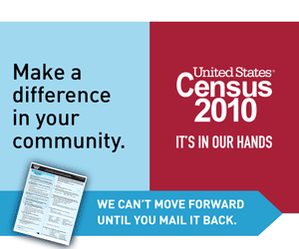
To post a clickable image that brings visitors to 2010census.gov, copy and paste the code below into the source of your Web page where you would like the image to appear.

<a href="http://2010.census.gov" target="_blank"><img src="http://2010.census.gov/partners/toolkits/banners/MakeaDifference_300x250.gif" width="300" height="250" border="0" alt="Make a Difference Banner Ad (300x250)" /></a>
Issued September 2009
Form D-3296

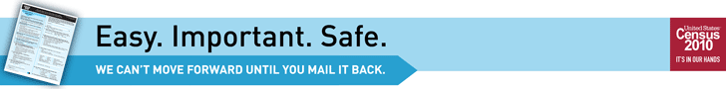
To post a clickable image that brings visitors to 2010census.gov, copy and paste the code below into the source of your Web page where you would like the image to appear.

<a href="http://2010.census.gov" target="_blank"><img src="http://2010.census.gov/partners/toolkits/banners/EasyImportantSafe_728x90.gif" width="728" height="90" border="0" alt="Easy Important Safe Banner Ad (728x90)" /></a>

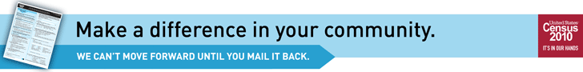

To post a clickable image that brings visitors to 2010census.gov, copy and paste the code below into the source of your Web page where you would like the image to appear.

<a href="http://2010.census.gov" target="_blank"><img src="http://2010.census.gov/partners/toolkits/banners/MakeaDifference_728x90.gif" width="728" height="90" border="0" alt="Make a Difference Banner Ad (728x90)" /></a>

To post a clickable image that brings visitors to 2010census.gov, copy and paste the code below into the source of your Web page where you would like the image to appear.

<a href="http://2010.census.gov" target="_blank"><img src="http://2010.census.gov/partners/toolkits/banners/Census_125x125.gif" width="125" height="125" border="0" alt="2010 Census Banner Ad" /></a>



Issued September 2009
Form D-3296

