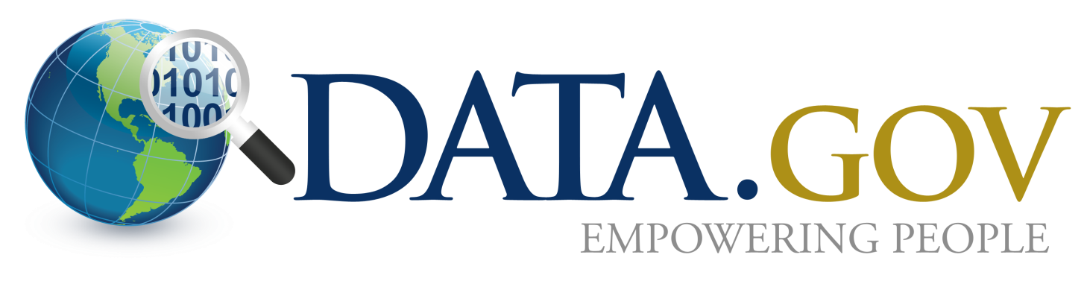
Data.gov is the flagship initiative under the President’s Open Government Directive, and supports the principles of Open Government: transparency, participation, and collaboration. Data.gov was launched on May 21, 2009 with 47 datasets, while today features nearly 450,000. With the new open source code version (OGPL), Data.Gov leads the expansion of open government data around the world.

Data.gov provides real results:
- Data.gov powered apps make life better—among many examples, health data have been used to improve or save lives; and public safety data has been used improve safety at home, on the road, or in the workplace.
- Proactive release of government data reduces the need for Freedom of Information Act (FOIA) requests, saving taxpayers time and money.
- Using the Open Government Platform (OGPL), the new open source code version of Data.gov makes it possible to have more cost effective and adaptable open government data sites.

Data.gov communities bring the data to life:
- Engages many community stakeholders--Business USA, Developer, Education, Energy, Ethics, Health, Law, Manufacturing, Ocean, Open Data, Restore the Gulf, Safety, and Semantic Web.
- Engages citizens, governments, researchers, and industries with forums, blogs, apps, and more.

FACTS & FIGURES

- Data.gov-led open government data and information movement, is sweeping the world:
  - 30 nations now have open government data sites
  - 34 states, 15 cities and tribes
- Data.gov catalog of datasets and apps continues to grow:
  - 445,162 datasets
  - 236 citizen apps, 1,248 government apps, 103 mobile apps
  - 157 interactive datasets on a cloud based service platform
- User traffic remains high:
  - 3.3 million visitors with over 16 thousand visitors in a high day
  - 2.9 million datasets downloaded
- Data.gov works across government and created the first all-agency working group:
  - 172 agencies and 270 Points of Contact
  - Hundreds trained in Data.gov Dataset Management System (DMS)
- Data.gov uses innovative technologies:
  - Open source Open Government Platform and code is now available at http://www.opengovplatform.org/ to enable governments around the world to launch their own open government data sites
  - Over 6.4 billion Resource Description Framework (RDF) triples to support semantic web
  - Interactive platform and dataset hosting enables real-time access to and analysis of cloud-hosted data
- Data.gov is recognized as an exemplar of innovation in government, having been honored with numerous awards from Government Computer News, ACT-IAC, CIO 100 and others.

