Maverick Landing, a redevelopment of the Boston Housing Authority’s Maverick Gardens public housing development, will bring 396 new rental units, 305 of which will be affordable, to East Boston. The Carlton Wharf Condominium Development is adjacent to Maverick Landing, on the harborfront.
“Maverick Landing is an important part of the revitalization of East Boston,” Mayor Menino said. “This development will ensure that affordable housing, both for renters and homeowners, will remain a part of the East Boston waterfront for years to come.”

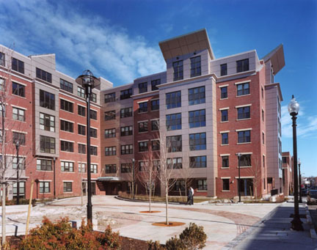
Replacing the old block shaped Maverick Gardens buildings are 316 townhouse-style units in 20 three-story low-rise structures and one six-story building at the adjoining Carlton Wharf site. Part of the on-site redevelopment includes the reconnection of the city street grid that was originally severed during the construction of Maverick Gardens in 1941. A new community center will be constructed which will include offices for the property management and Maverick Tenants Organization.
“Maverick Landing is yet another example of the transformative power the HOPE VI program has had on neighborhoods in Boston,” said Sandra Henriquez, BHA Administrator. “The new design of the development, will open it up to the surrounding neighborhood and integrate residents into the community.”

The redevelopment of Maverick is being done in phases. The first two phases are complete and being occupied, while phases three and four are under demolition. The BHA selected Trinity East Boston Development Limited Partnership (a collaboration between Trinity Financial and the East Boston Community Development Corporation) as developer. Trinity Carlton LLC, an affiliate of Trinity Financial, developed the Carlton Wharf Condominiums.
The new Maverick Landing Community is a mixed-income development with 77 percent of the units continuing to be affordable to households earning up to 60 percent of area median income and the remaining 23 percent as market rate rentals. The Carlton Wharf Condominiums will be affordable for working families and will be sold to households earning between 80% and 120% of area median income. The base price for a one-bedroom unit will be $141,000, $157,000 for a two-bedroom unit, and $172,000 for a three-bedroom unit.
The Maverick Gardens redevelopment was made possible when the Boston Housing Authority was awarded a $35 million grant from the United States Department of Housing and Urban Development (HUD) in 2001. In addition to the money from the HOPE VI grant from HUD, The BHA provided approximately $13.5 million in capital funds. The total project cost is about $121 million and funding sources include the City of Boston Department of Neighborhood Development and Neighborhood Housing Trust, Commonwealth of Massachusetts, Massachusetts Technology Collaborative, MassHousing, Apollo Housing Capital and Nationwide Insurance. The Carlton Wharf Condominiums received construction financing from Bank of America, as well as linkage funds through the Boston Redevelopment Authority.
Construction began in October 2003 and completion of the entire project is expected by the end of 2006.
"Across the country and here in Boston, we have seen HOPE VI developments transform aging, distressed public housing into beautiful, thriving mixed-income communities," said James Barnes, HUD's acting regional director. "Being awarded three highly competitive HOPE VI grants demonstrates this city's commitment to affordable housing."
The Maverick redevelopment includes a Community and Supportive Services Program (CSSP) which will be partially funded through the HOPE VI grant, but will also be provided through collaborations with community service providers. The CSSP will include individual case management, employment and computer training, adult learning, youth education and recreational programs for Maverick residents.

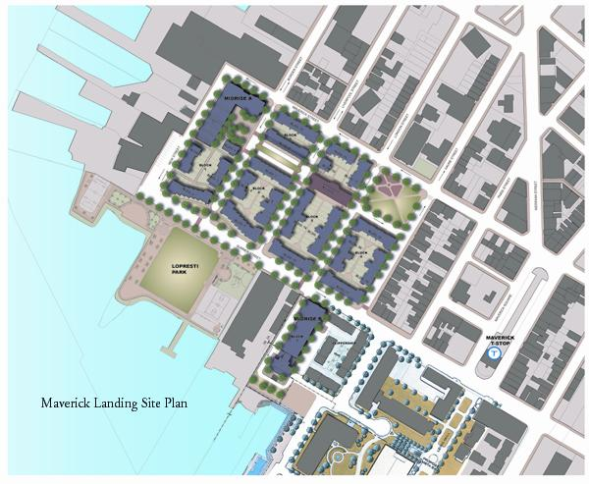
Residents will also have access to the Maverick Landing Homeownership Program, a loan-to-purchaser program that will assist 50 eligible households with subordinate financing to purchase their own homes.
A unique feature of the redevelopment is the green building initiative at the phase one mid-rise building. Made possible through a grant from the Massachusetts Technology Collaborative, the grant allowed the implementation of measures that produce valuable energy savings and new sources for renewable energy. Green building features include rooftop solar panels, energy efficient windows, insulation, appliances, flooring and more.
As part of the overall development, the first 100 feet of Harborwalk, with an historical interpretive marker, was installed on the Boston Harbor

Project Summary: Maverick Landing
OWNER/DEVELOPER
Trinity East Boston Development, LP, a partnership of Trinity Financial and East Boston Community Development Corporation
ARCHITECT
ICON Architecture, Inc.
LANDSCAPE ARCHITECT
Geller DeVellis, Inc.

CONTRACTORS
CWC Builders, Inc.
PROPERTY MANAGEMENT
Winn Residential
FUNDERS: | TYPE:
HUD HOPE VI | Grant
Trinity East Boston Development, LP | Investment
Massachusetts Technology Collaborative | Grant
DEVELOPMENT TYPE:
New construction townhouse and flat rental units.
RESIDENT PROFILE:
Low income 50% - 80% AMI, Section 8 voucher holders.
DENSITY: 88 units per acre

DEVELOPMENT PROFILE
Type | #/Units | Size (sf) | Rent
FLATS
1 BR | 23 | 690 | $1,295
2 BR | 19 | 860 | $1,595
3 BR | 15 | 1,217 | $1,950
DUPLEXES
2 BR | 13 | 968 | $1,700
3 BR | 1 | 1,125 | n/a
TRIPLEXES
3 BR | 5 | 1,244 | $1,895
4 BR | 5 | 1,452 | $2,150
Total | 150
Laundry: Community laundry
Courtyard/play: Common courtyard
Parking: 56 garage spaces
Total site area: 74,205sf (1.7 acres)
CONSTRUCTION TYPE
Steel and concrete structure clad in brick.
DEVELOPMENT COSTS:
Land cost: n/a; Constr. costs: $25,423,227; Other costs: n/a; Total development costs: $54,000,000 ($360,000/unit); Completed in 2005.
Maverick Landing is an example of partnerships at work. MTC, the Boston Housing Authority (BHA), Trinity Financial, Inc., and several other organizations helped to create 411 mixed-income housing units. A unique feature of the development is its focus on green building and energy efficiency elements, including efficient lighting, appliances, and structural elements and certification under the LEED Rating System, a national green building guideline. Through its Renewable Energy Trust grant, Maverick Landing features a 37 kilowatt solar array and a 75 kilowatt gas-fired cogenerator to provide a significant amount of the development’s electricity supply, as well as a solar hot water system. These elements were targeted following a feasibility study funded by MTC. Maverick Landing will serve to educate both the building industry and the community about the green building process, and serve as a model for future green affordable housing developments.

