Toolkit for Reaching American Indians and
Alaska Natives
Web Banners and Buttons

To raise awareness of the 2010 Census and encourage participation, organizations that serve American Indians or Alaska Natives can post the Web banners and buttons below to their official Web sites and blogs. To add these clickable buttons or banners to your Web site, copy and paste either the code or the banner to your Web site.

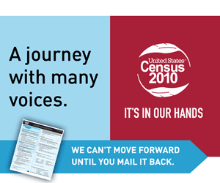
To post a clickable image that brings visitors to 2010census.gov, copy and paste the code below into the source of your web page where you would like the image to appear.

<a href="http://2010.census.gov" target="_blank"><img src="http://2010.census.gov/partners/toolkits/banners/EasyImportantSafe_Tribal_300x250.gif" width="300" height="250" border="0" alt="Easy Important Safe Banner Ad (300x250)" /></a>

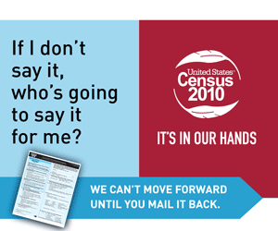
To post a clickable image that brings visitors to 2010census.gov, copy and paste the code below into the source of your web page where you would like the image to appear.

<a href="http://2010.census.gov" target="_blank"><img src="http://2010.census.gov/partners/toolkits/banners/MakeaDifference_Tribal_300x250.gif" width="300" height="250" border="0" alt="Make a Difference Banner Ad (300x250)" /></a>


To post a clickable image that brings visitors to 2010census.gov, copy and paste the code below into the source of your web page where you would like the image to appear.

<a href="http://2010.census.gov" target="_blank"><img src="http://2010.census.gov/partners/toolkits/banners/EasyImportantSafe_Tribal_728x90.gif" width="728" height="90" border="0" alt="Easy Important Safe Banner Ad (728x90)" /></a>



To post a clickable image that brings visitors to 2010census.gov, copy and paste the code below into the source of your web page where you would like the image to appear.

<a href="http://2010.census.gov" target="_blank"><img src="http://2010.census.gov/partners/toolkits/banners/MakeaDifference_Tribal_728x90.gif" width="728" height="90" border="0" alt="Make a Difference Banner Ad (728x90)" /></a>


To post a clickable image that brings visitors to 2010census.gov, copy and paste the code below into the source of your web page where you would like the image to appear.

<a href="http://2010.census.gov" target="_blank"><img src="http://2010.census.gov/partners/toolkits/banners/Census_Tribal_125x125.gif" width="125" height="125" border="0" alt="2010 Census Banner Ad" /></a>

