Training Coordinator Handbook

March 2010

Table of Contents

SECTION I-INTRODUCTION 3

INTRODUCTION 4
LEARNING AND DEVELOPMENT DIVISION: MISSION AND FUNCTIONS 4
L&DD CUSTOMER SATISFACTION CENTER 5
L&DD HUMAN RESOURCES (HR) SPECIALISTS 5
TRAINING COORDINATOR: ROLES & RESPONSIBILITIES 6

SECTION II-TRAINING AND TRAVEL PROCEDURES 7

SF-182 GUIDANCE 8
SF-182 FORM 9
INCOMPLETE SF-182s 23
LATE SUBMISSIONS 23
GROUP TRAINING 23
NO ACTION EMAIL 24
APPROVED TRAINING 24
TRAINING COORDINATOR MEETINGS 24
TRAINING NEEDS ASSESSMENT 25
TRAINING NOMINATIONS 25
TRAINING ATTENDANCE REQUIREMENTS 25-26
AFTER THE FACT TRAINING PROCEDURES 26
CANCELLATION & RESCHEDULING 26
FINANCE/BUDGET 26
TRAVEL ORDERS 27
TRAINING RECORDS 27
MY BIZ 27-28

SECTION III-TRAINING AND DEVELOPMENT OPPORTUNITIES 29

TRAINING AND DEVELOPMENT OPPORTUNITIES 30
ADVANCED MANAGEMENT PROGRAM (AMP) 30
ASPIRING LEADER PROGRAM 30
BROOKINGS EUROPEAN SEMINAR 30
CONGRESSIONAL FELLOWSHIP PROGRAM 30
*COUNCIL FOR EXCELLENACE IN GOVERNMENT FELLOWS PROGRAM (CEG) 30
DEFENSE ACQUISITION UNIVERSITY (DAU) 30
DOD SES APEX ORIENTATION 30
DEFENSE LEADERSHIP & MGMT PROGRAM (DLAMP) 30
DEFENSE POLICY SEMINAR (GWU/NSSP) 30
*DOD EXECUTIVE LEADERSHIP PROGRAM (ELDP) 30
EXECUTIVE COURSE ON NATIONAL & INTERNATIONAL SECURITY (GWU/NSSP) 30
EXECUTIVE LEADERSHIP PROGRAM (ELP) 30
EXECUTIVE POTENTIAL PROGRAM (EPP) 30
FEDERAL EXECUTIVE INSTITUTE (FEI) 31
INDUSTRIAL COLLEGE OF THE ARMED FORCES (ICAF) 31
INFORMATION RESOURCES MGMT COLLEGE (IRMC) 31
INFORMATION ASSURANCE SCHOLARSHIP PROGRAM (IASP) 31
*KEY EXECUTIVE PROGRAM, AMERICAN UNIV 31
*LEGISLATIVE FELLOWS PROGRAM 31
MANAGEMENT DEVELOPMENT CENTER COURSES (MDC) 31
NATIONAL WAR COLLEGE (NWC) 31
NEW LEADER PROGRAM 31
*OSD GRADUATE FELLOWSHIP 31
RETIREMENT SEMINAR 31
*SEMINAR XXI (MASSACHUSETTS INSTITUTE OF TECHNOLOGY) 32
SENIOR EXECUTIVE DEVELOPMENT PROGRAM 32
SENIOR MANAGER COURSE IN NATIONAL SECURITY 32
SES NEW MEMBER ORIENTATION (OPM) 32
REFERENCES 33

Section I – Introduction

Introduction

Welcome to the world of a Training Coordinator (TC)!

This handbook is developed by Washington Headquarters (WHS), Human Resources Directorate (HRD), Learning and Development Division (L&DD) to assist the TC. It addresses the issues and questions which arise regarding the training of employees and provides detailed procedures related to requesting, approving, funding, and documenting training.

The TC plays an important role in disseminating training information and assisting with the various processes involved in obtaining training for employees. Each TC has a vital role in the on-going and successful implementation of external training. This requires the review and knowledge of Administrative Instruction (AI) 40, Employee Learning and Development.

Thank you for your willingness to serve your organization as a TC.

Learning and Development Division: Mission and Functions

The mission of the L&DD is to systematically plan, implement and evaluate progressive and effective programs that train, educate, and develop the workforce to meet current and projected performance objectives essential to the serviced organizations.

L&DD prepares guidance and promulgates policy to provide leadership and direction in the development, implementation and execution of programs to maintain a high performing civilian and military workforce by:

- Supporting learning and development services for military and civilian personnel assigned to the serviced organizations.

- Determining or validating learning and development requirements and instituting management controls required to ensure compliance with applicable laws and regulations.

- Providing systematic and strategic advice to the DoD Component(s) leadership in all aspects of learning and development.

- Preparing, managing, and monitoring learning and development budget accounts for centrally funded OSD/WHS Long Term Training Programs including DoD executive development programs (e.g., APEX, the National Security Studies Program, the Defense Leadership and Management Program that require oversight for the Department of Defense).

L&DD Customer Satisfaction Center

- Customer Satisfaction Center (CSC):
  - Provides a central location for receipt and processing of all training requests.
  - Processes travel requested for training.
  - Updates a civilian employee’s training history record in the Defense Civilian Personnel System (DCPDS).
  - Provides status of training request to TCs.
  - Answers questions regarding training and travel procedures.

- Hours of Operation: Monday – Friday 8:30 a.m. to 5:00 p.m.

- Contact Information:
  - Phone Number: (703) 604-6852
  - Fax Number: (703) 601-2296
  - E-Mail: LDDCustomerSatisfactionCenter@whs.mil
  - Website: http://www.whs.mil/HRD/Civilian/CareerDevelopment/index.cfm

L&DD Human Resources (HR) Staff
- HR Staff:
  - Counsel employees regarding education and training development.
  - Determine appropriateness of training.
  - Register employees and pays training expenses.
  - Assist organizations in developing Competency Modeling Frameworks.
  - Function as project managers in Course Development.
  - Facilitate organizations by identifying training needs.
  - Coordinating Strategic Human Capital Management (i.e., Coaching, Mentoring, etc.)
  - Providing Learning Management System support and training.

Training Coordinator: Roles & Responsibilities

The following is an outline of specific duties that provides a clear understanding of how a TC can support employees to accomplish learning and development activities most efficiently and effectively working in partnership with L&DD. Each TC is responsible to:

Disseminate Training Opportunity Announcements (TOAs).
Maintain course catalogs (external) and TOAs as a reference for employees.
Assist employees in completing the Training Request Forms (SF-182) and direct employees to utilize the Defense Travel System (DTS). All training submissions should arrive at L&DD 21 days prior to beginning of a course of instruction.
Review and coordinate training requests for accuracy and completeness (e.g., additional information as required in TOAs or course catalogs, proper justification, supervisor’s signature, costs, and beginning and ending dates of a course, etc).
Determine if the request for a conference includes training.
Check nomination deadlines before submitting SF-182 to L&DD. If a request is past the deadline, return the SF-182 to the employee for new session dates.
Ascertain whether the travel and per diem costs will be out of training or mission funds. A DTS authorization,must be initiated for travel fund expenditures from trainings. This should be accomplished at the same time the SF-182 is submitted to L&DD.
Assist employees in submitting proper clearance information to schools when required.
Ensure that employees and/or supervisors who do not have an e-mail account receive timely enrollment or cancellation information and confirmation e-mails.
Serve as the point of contact for the employee and the L&DD, Human Resource Staff assigned to your organization.
Attend scheduled Action Officers (AO)/TC meetings and /or Quarterly TC meetings.
Determine that the training requested is appropriate for the employee’s occupational series, mission requirements, and meets training policy criteria for admission.
Validate and ensure the employee has initiated course registration, where applicable.
Notify employee to register for no cost training and college/university courses. Indicate registration on SF-182.
Ensure that ALL SF-182s are typed and scanned. Handwritten SF-182s will NOT be accepted.
Notify CSC of TC changes.
Contact L&DD to arrange a meeting between a new TC and L&DD staff members.
Requests should be sent one per email. The subject line should include the employee’s last name and document number in the subject line.

Section II- Training and Travel Procedures

SF-182 Guidance

All of sections A-C will be filled out as indicated by yellow highlights on the
following page, using the underlined links for code definitions, when necessary.

Section D Approvals 1a-e is mandatory, 2a-e is optional, and 3a-e is to be
left blank for the Learning and Development Division’s use. Section E is also optional.

Your document number (e.g., RFAT, DHAT, PFAT, DPAT) will be entered in
Section C4.

Questions may be directed to our Customer Satisfaction Center
LDDCustomersatisfactioncenter@whs.mil or (703) 604-6852.

SF-182 FORM
http://www.dtic.mil/whs/directives/infomgt/forms/formsprogram.htm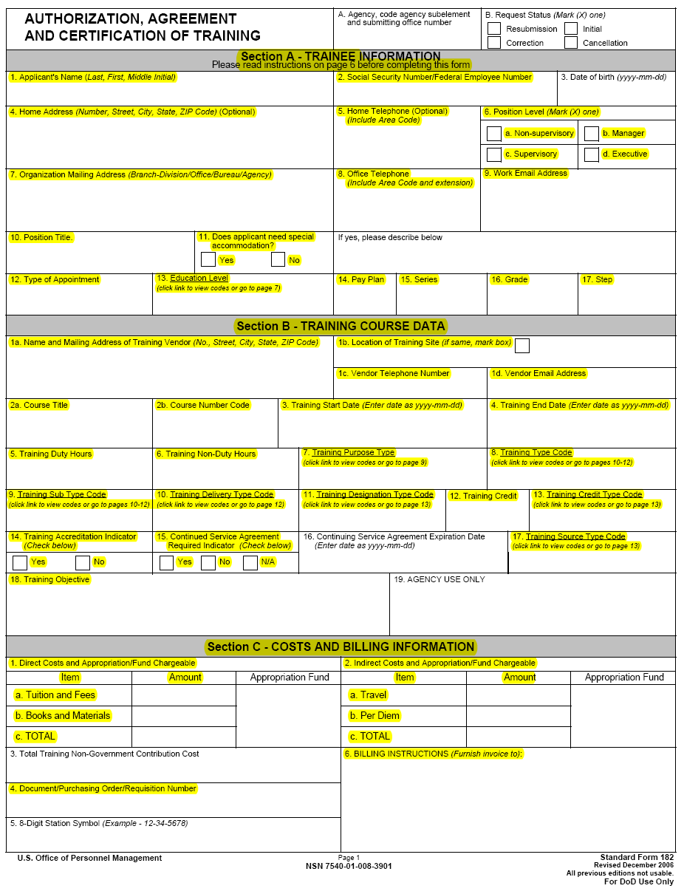
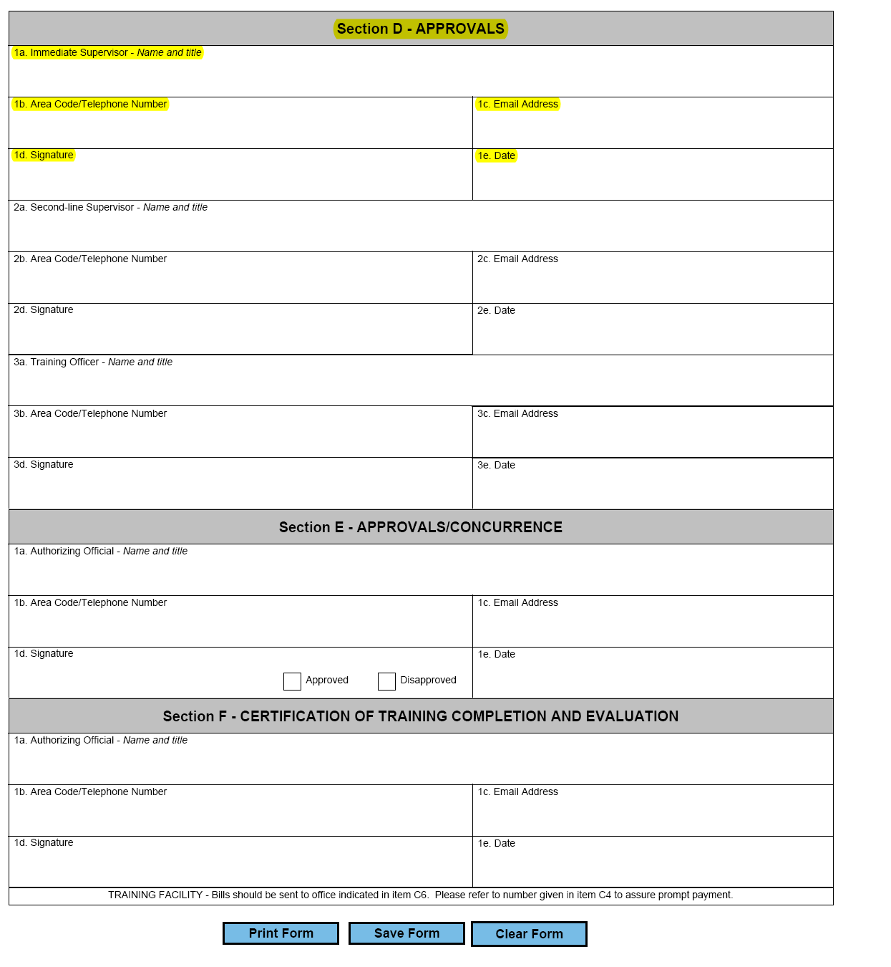

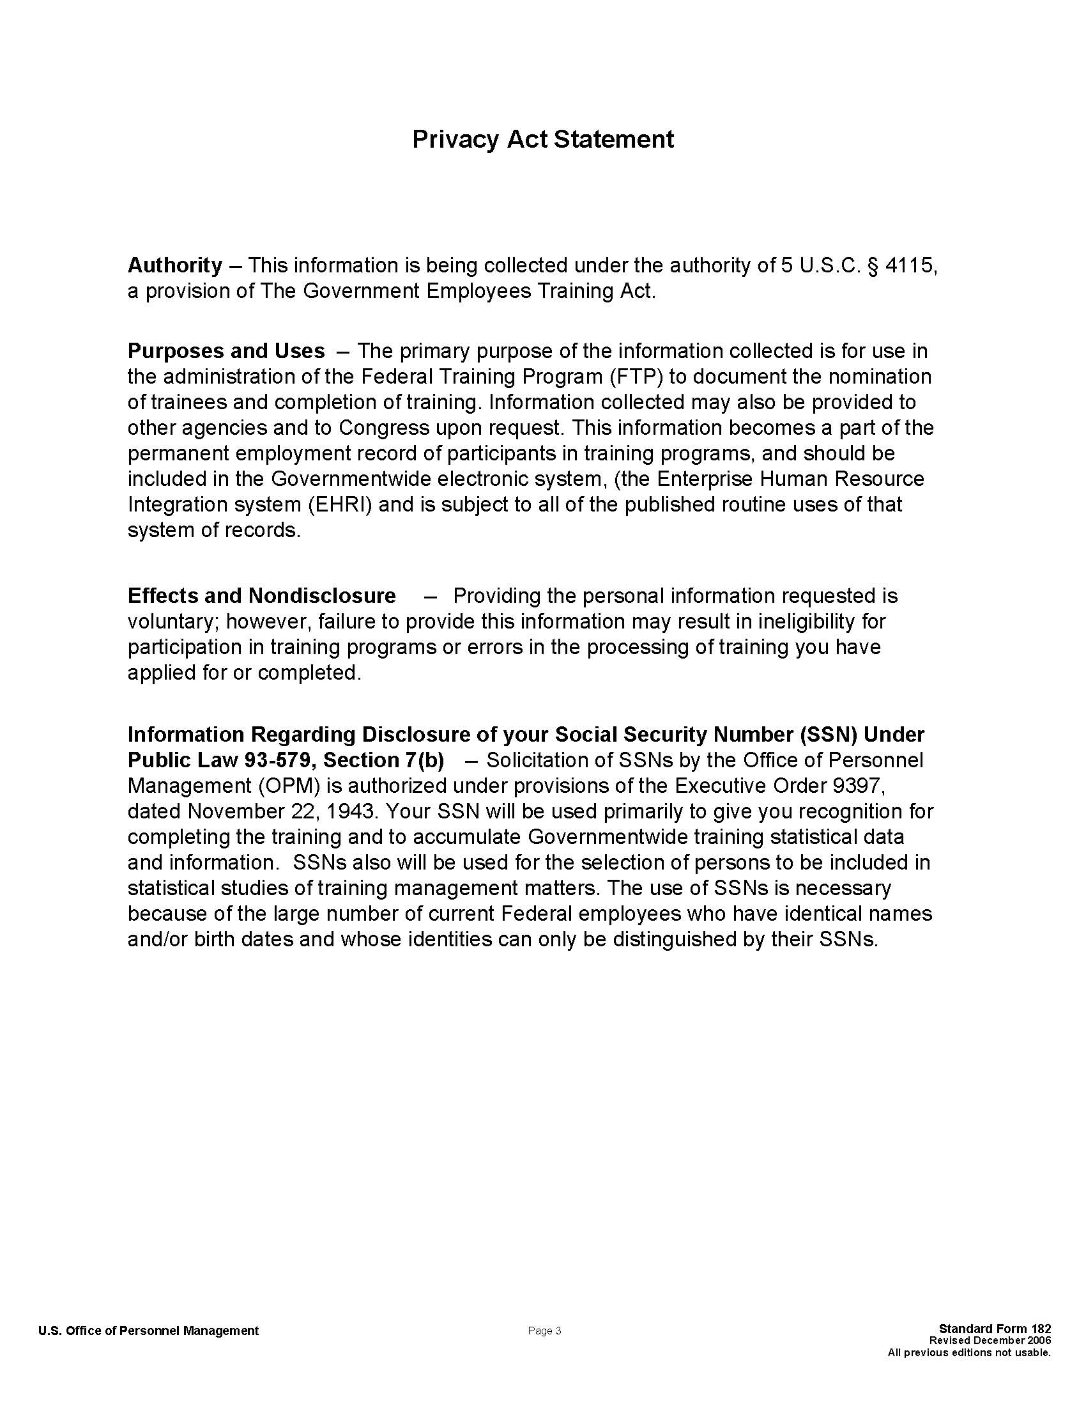

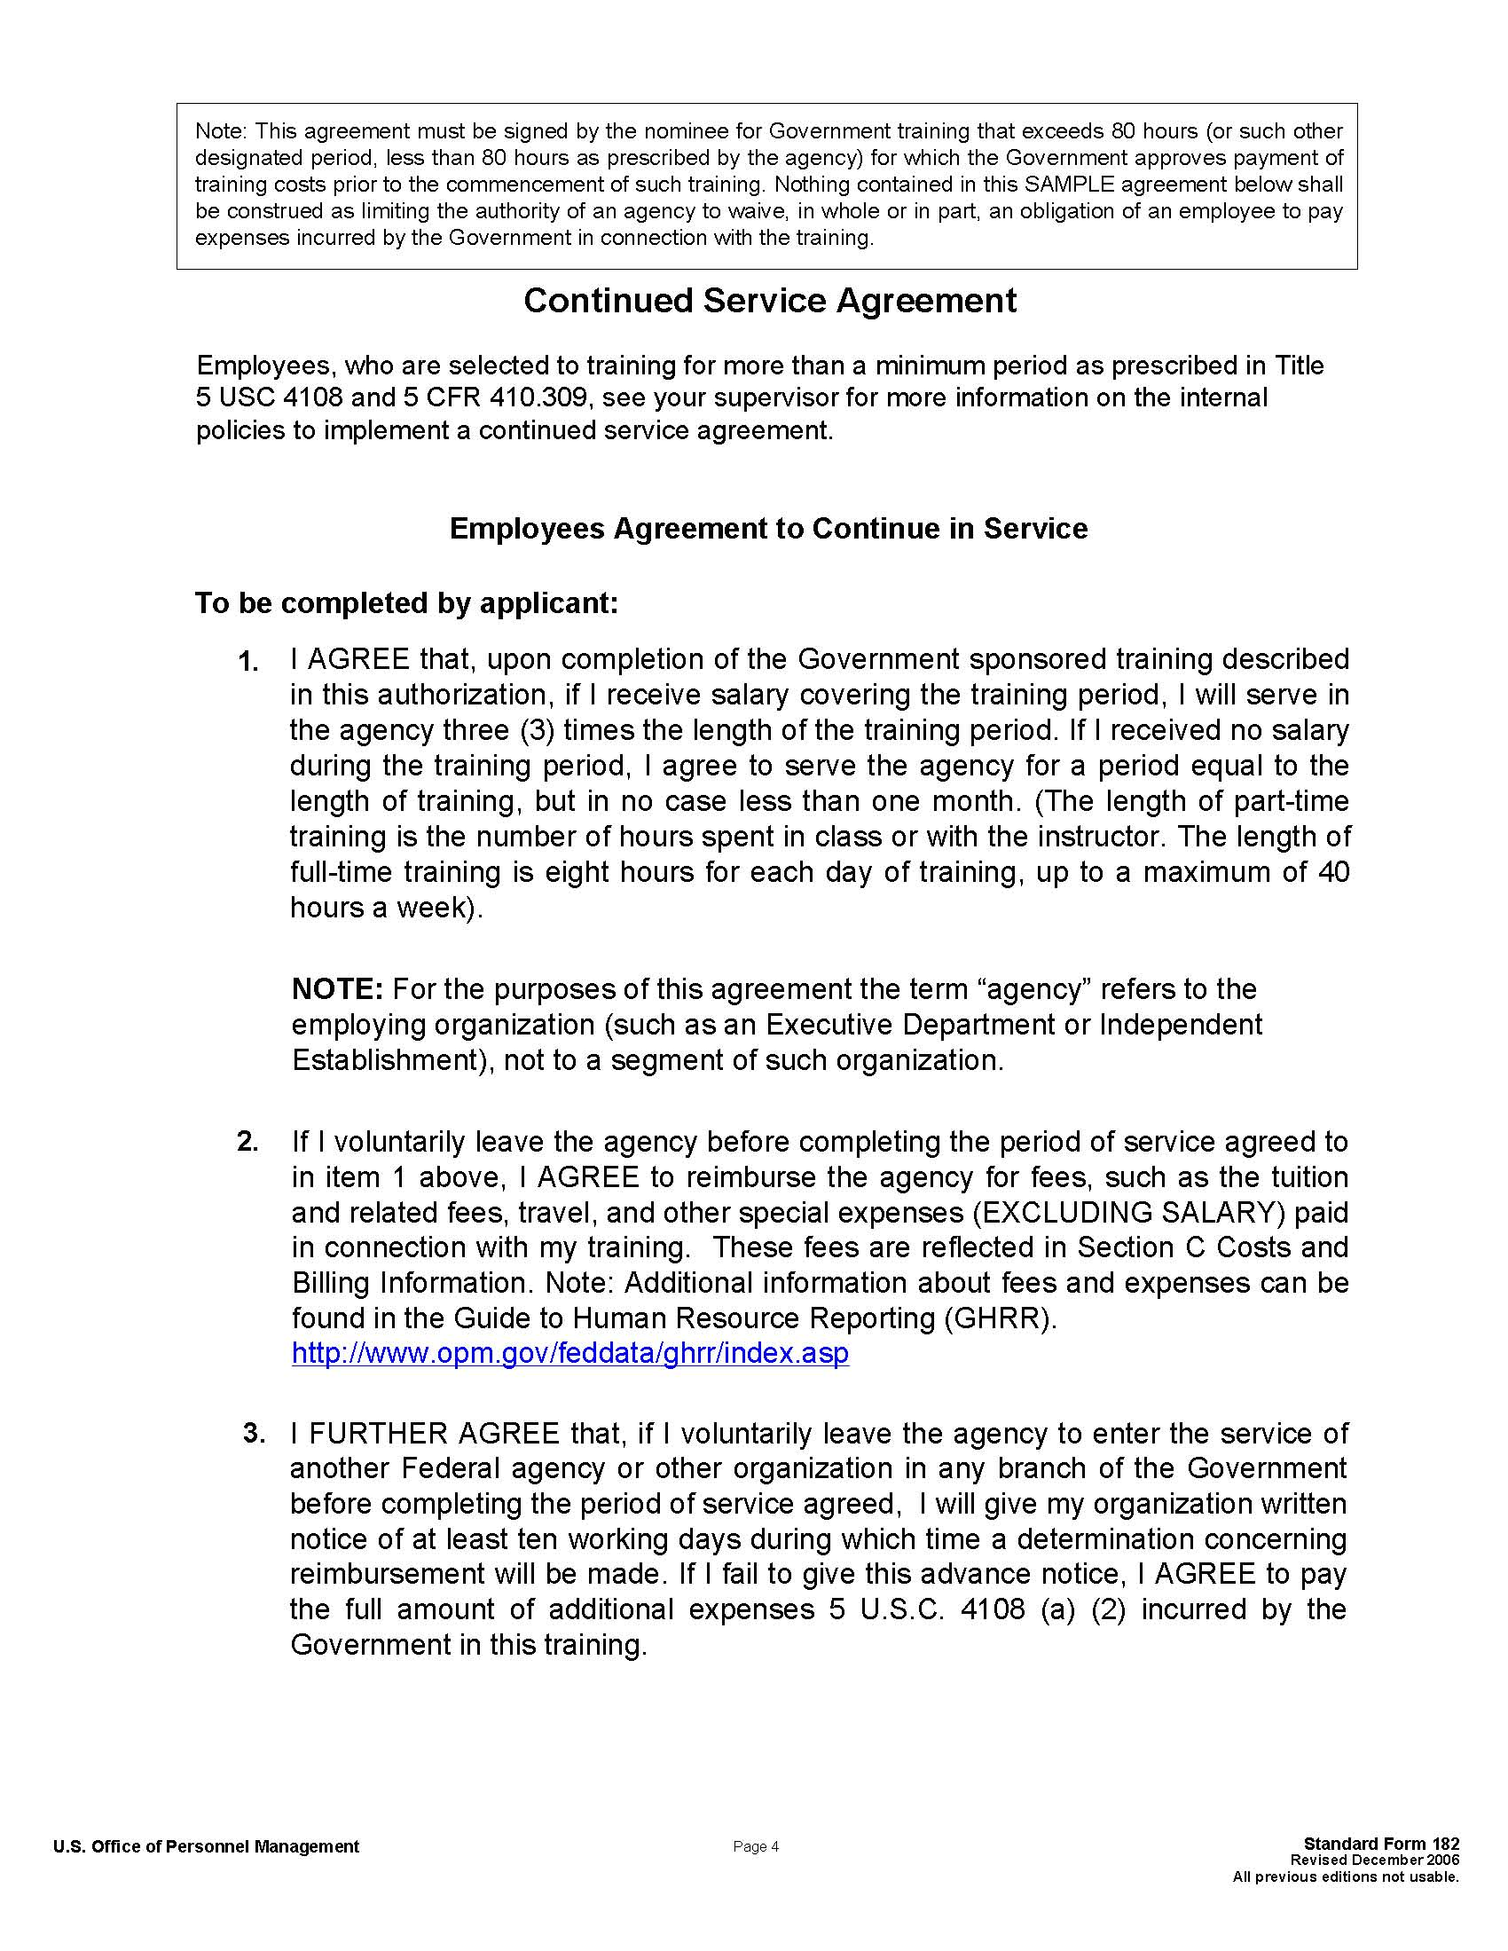

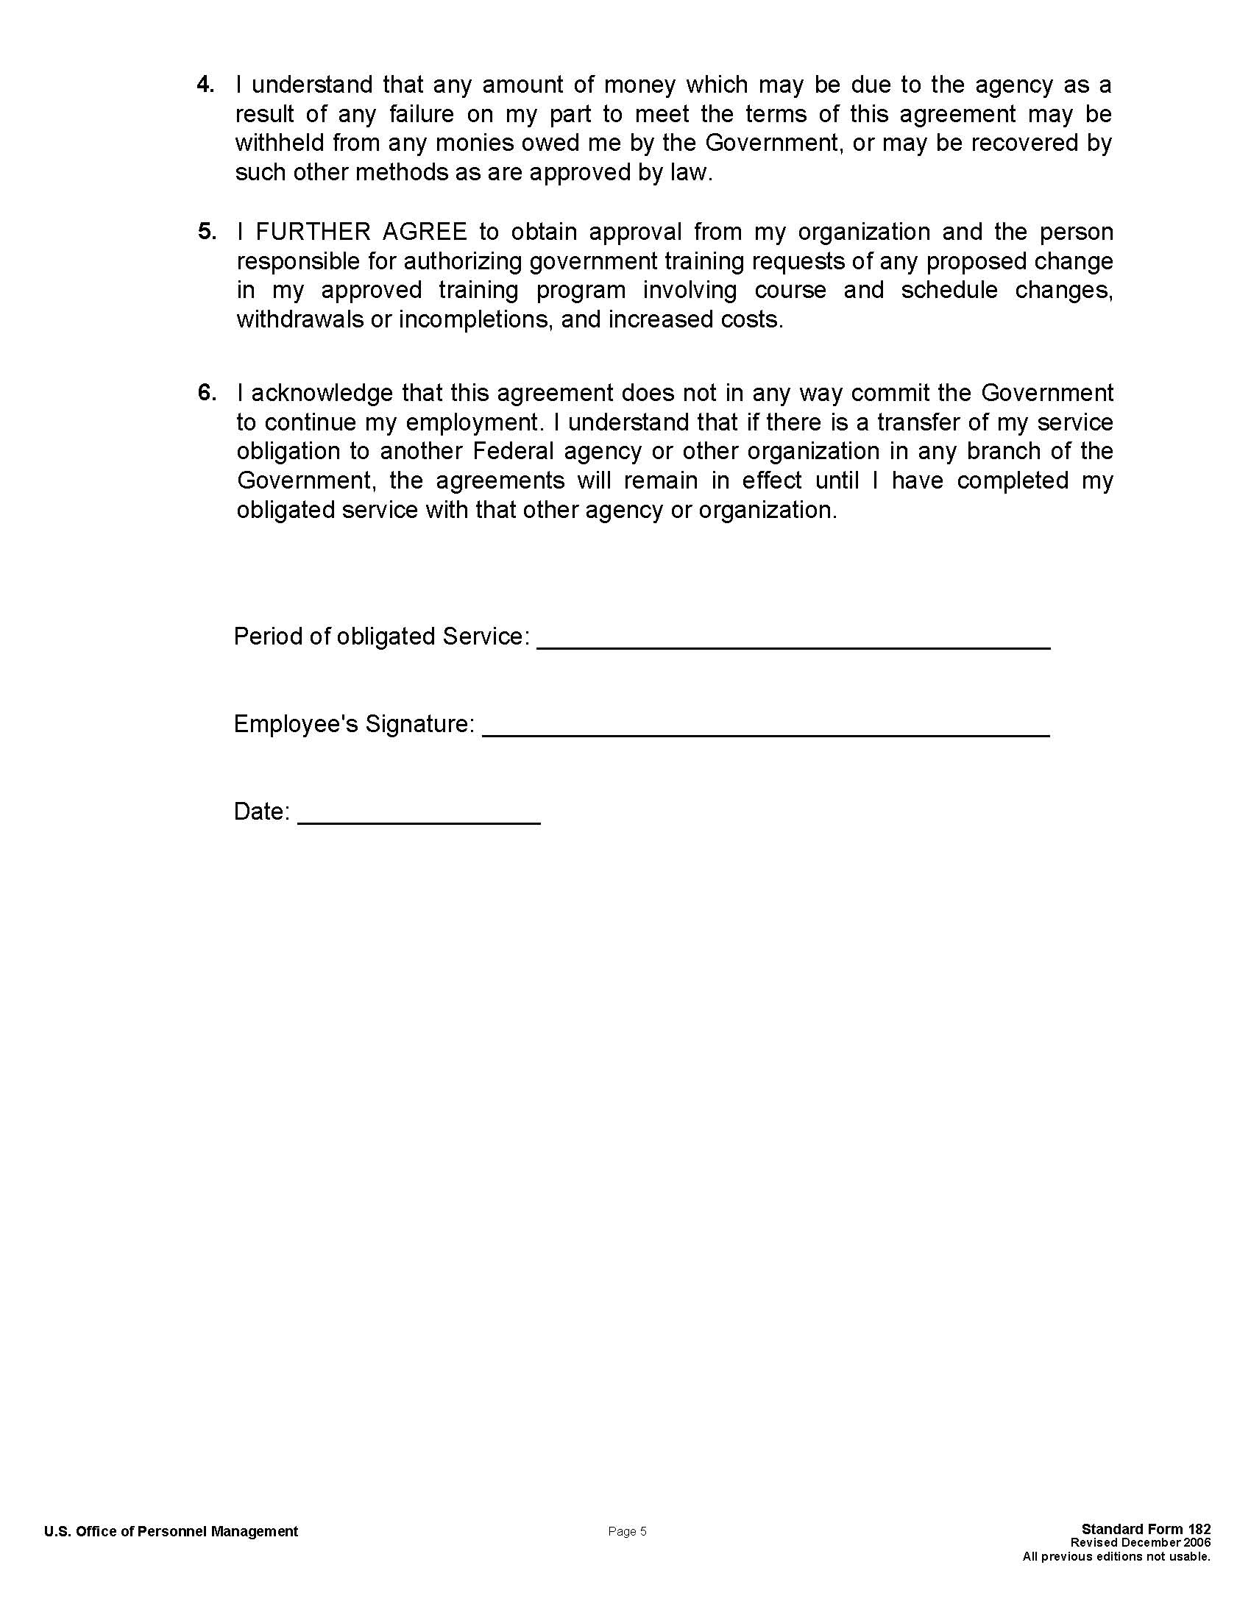

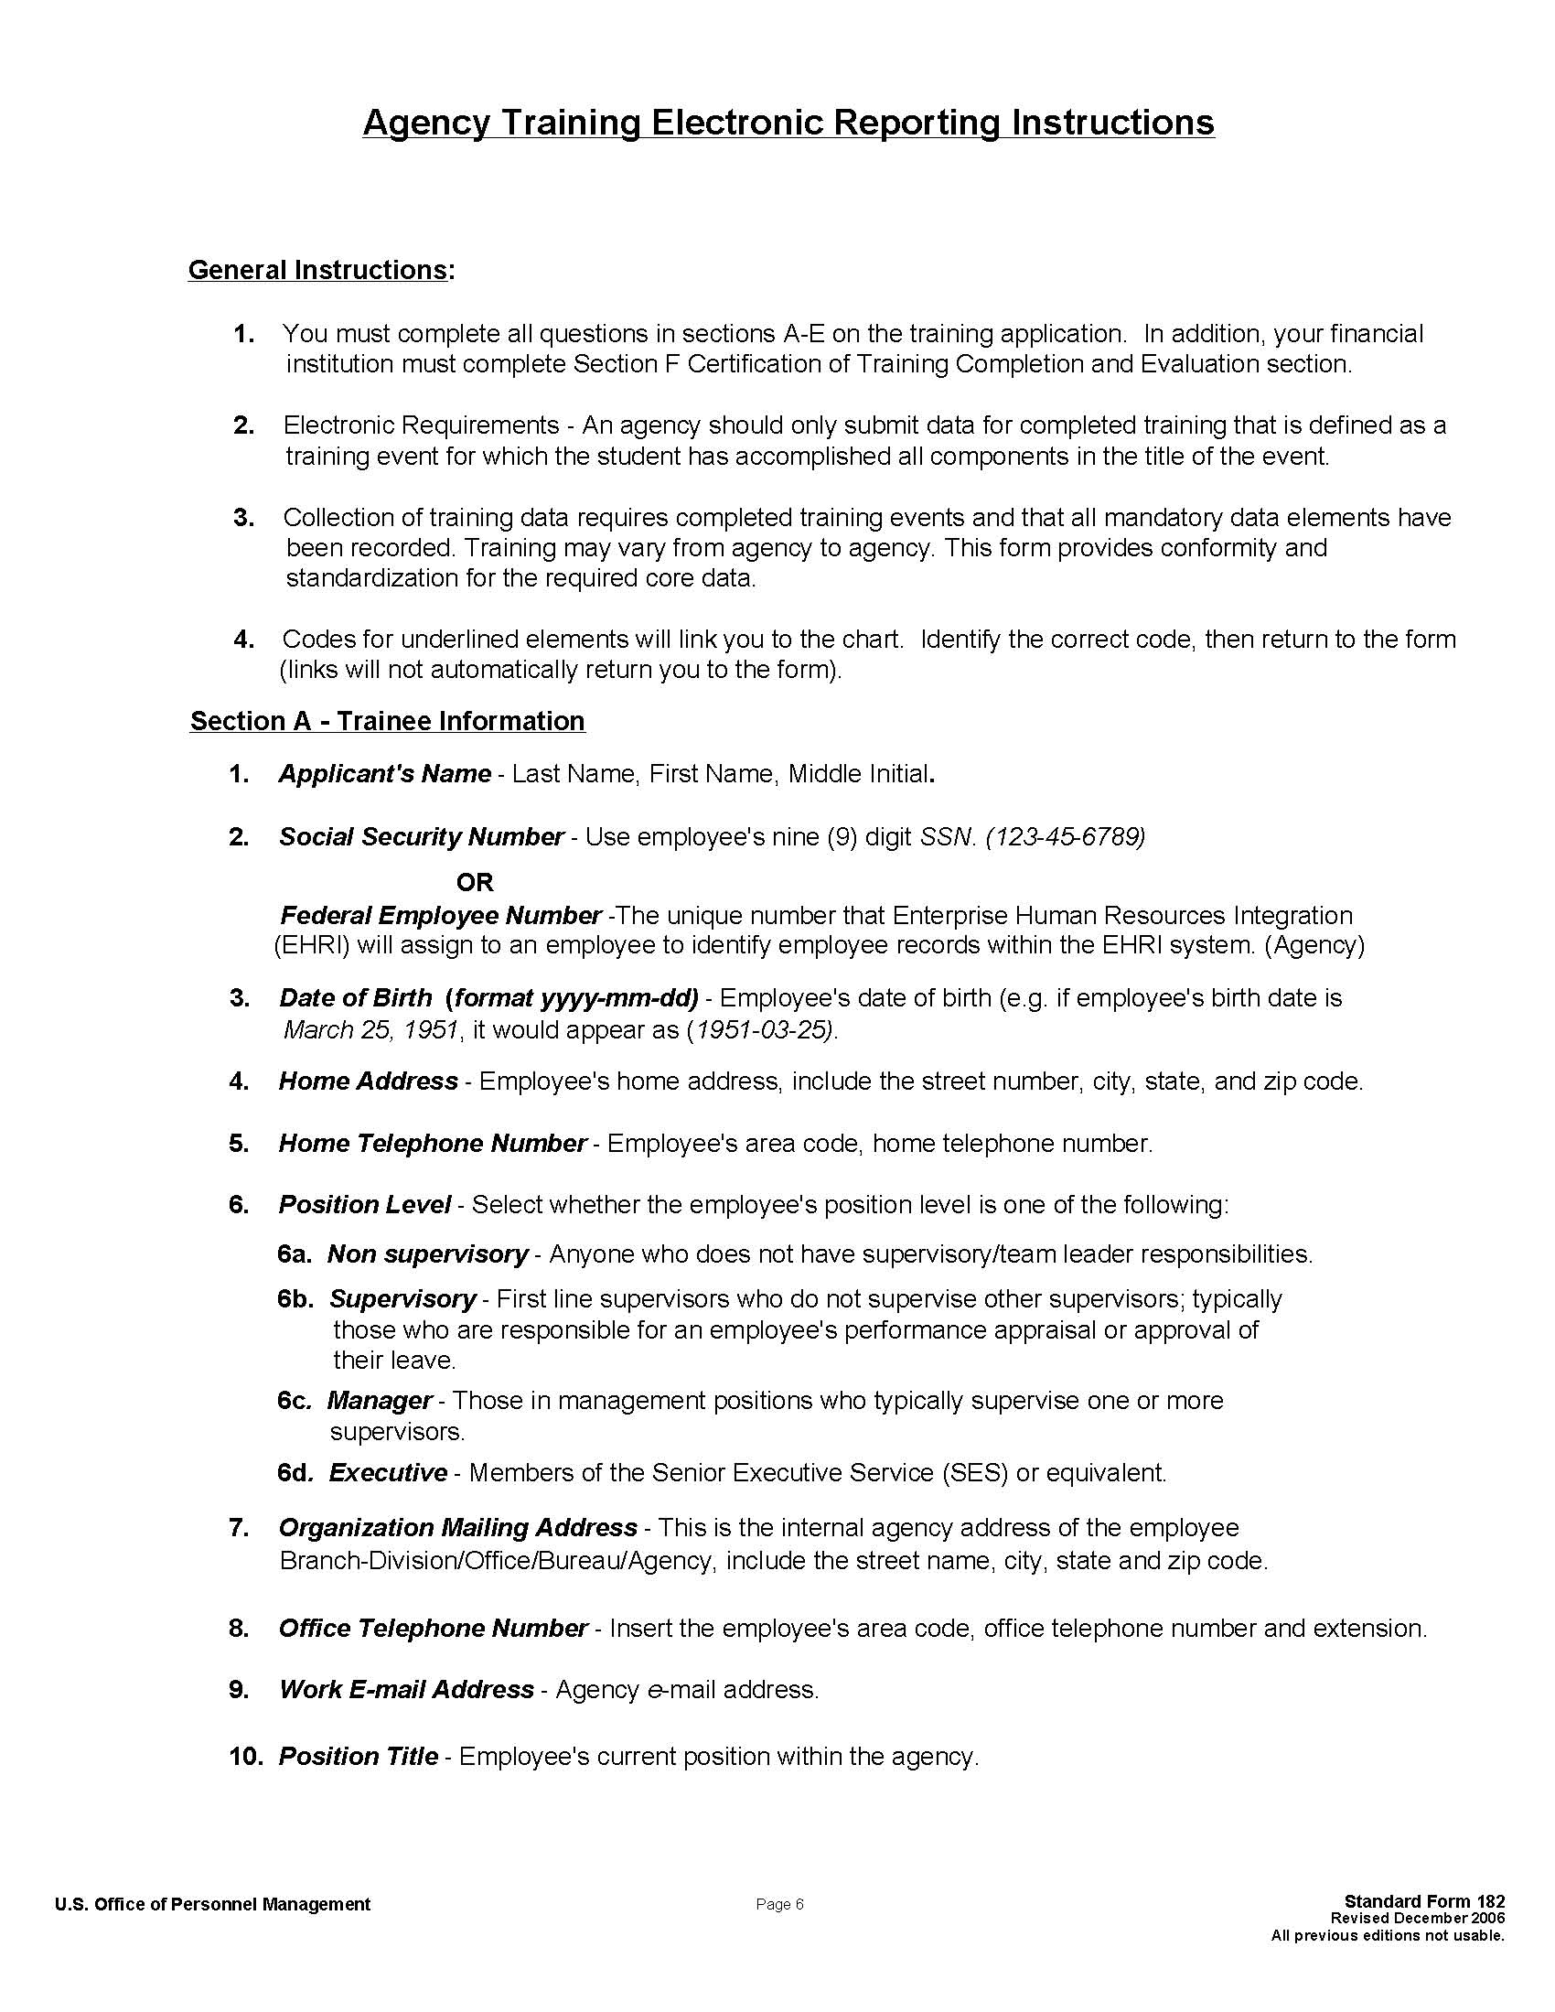

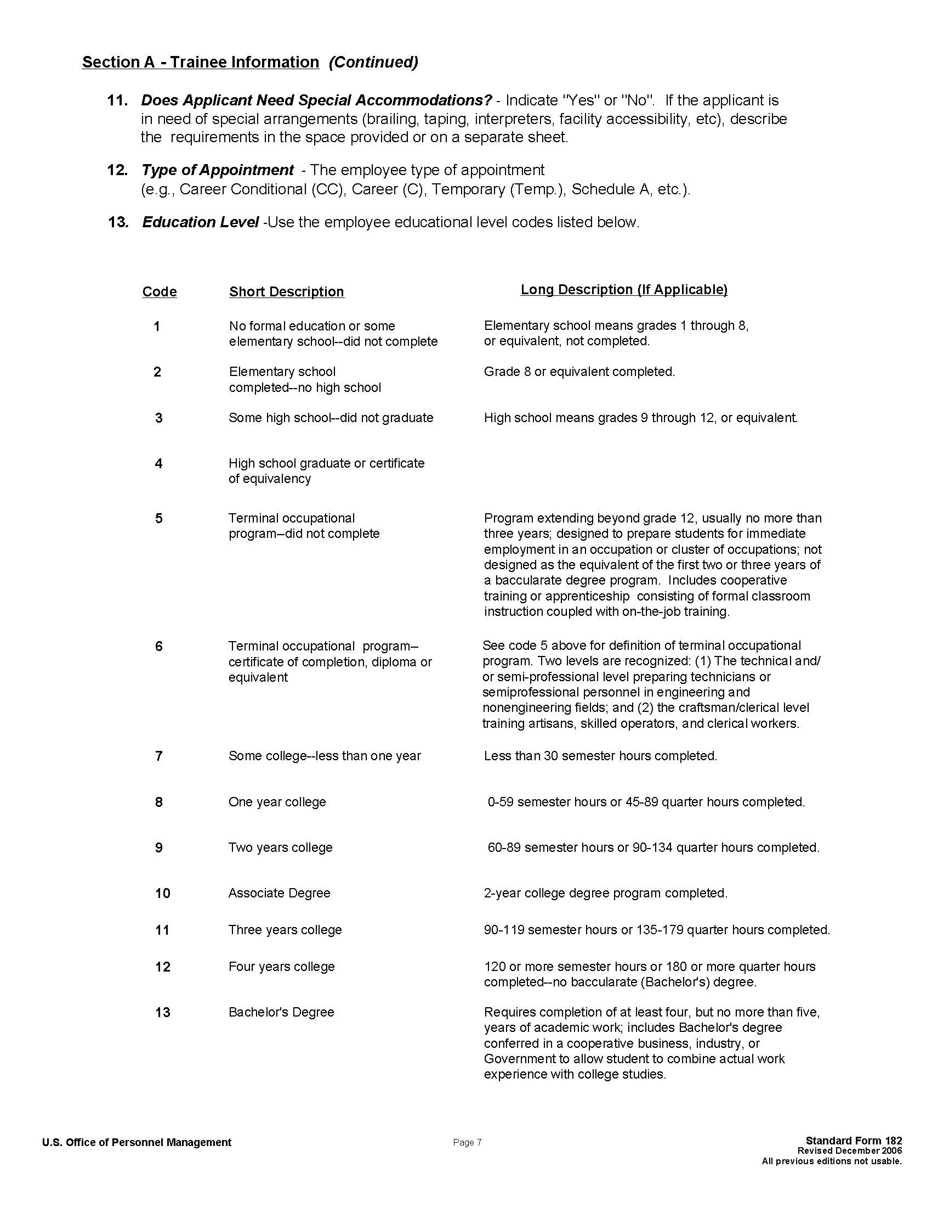

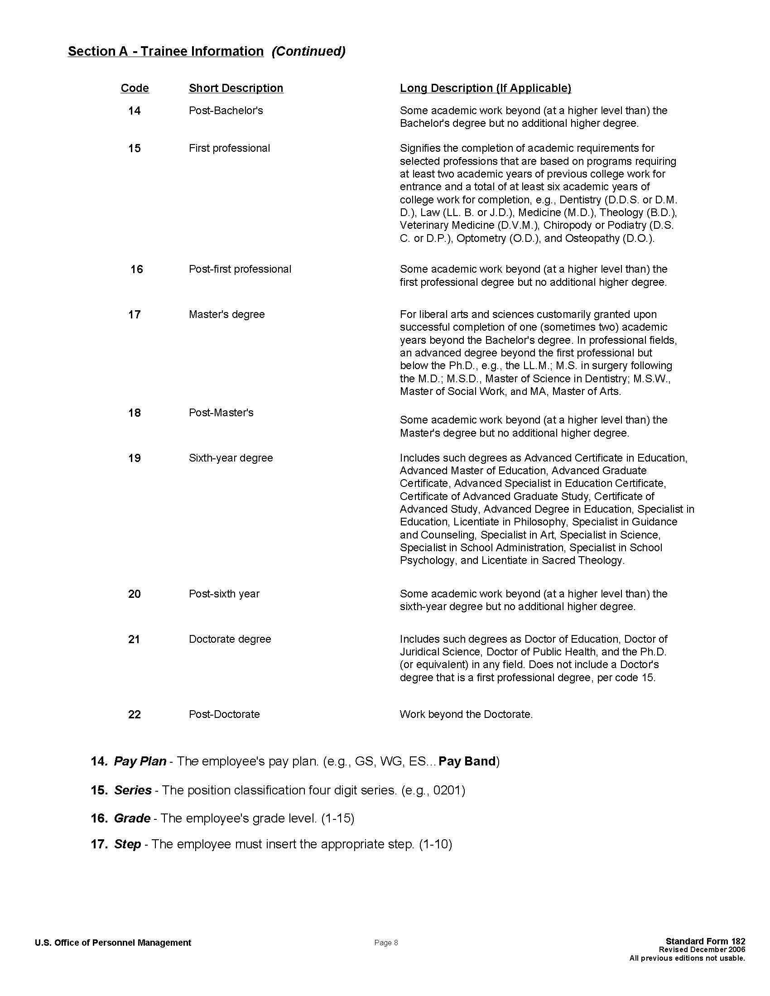

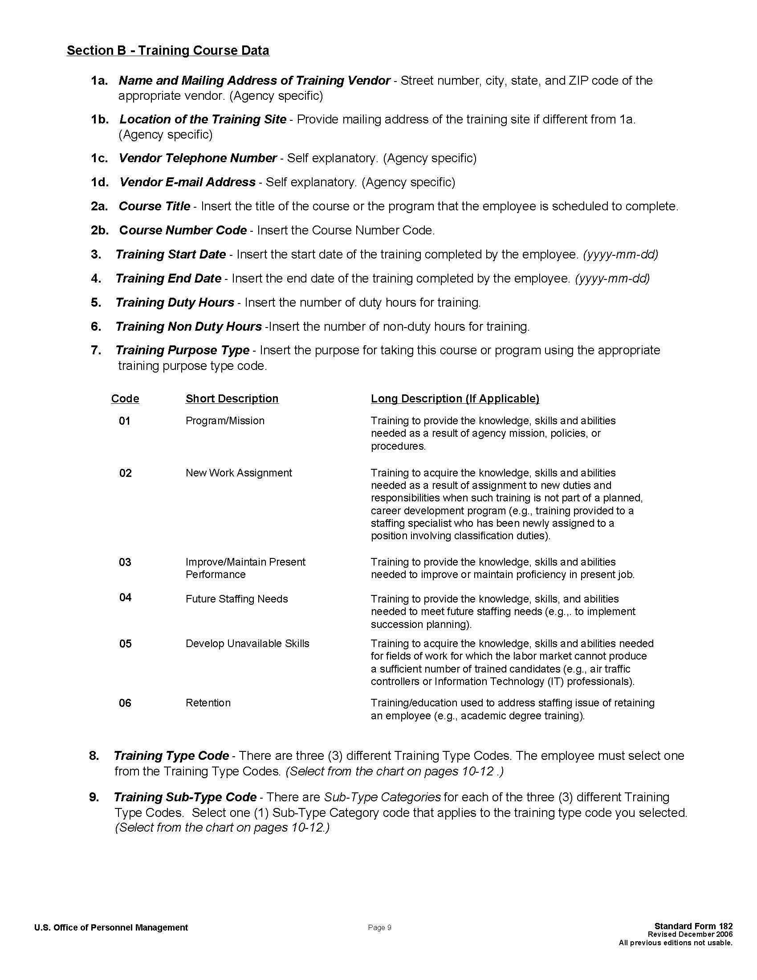

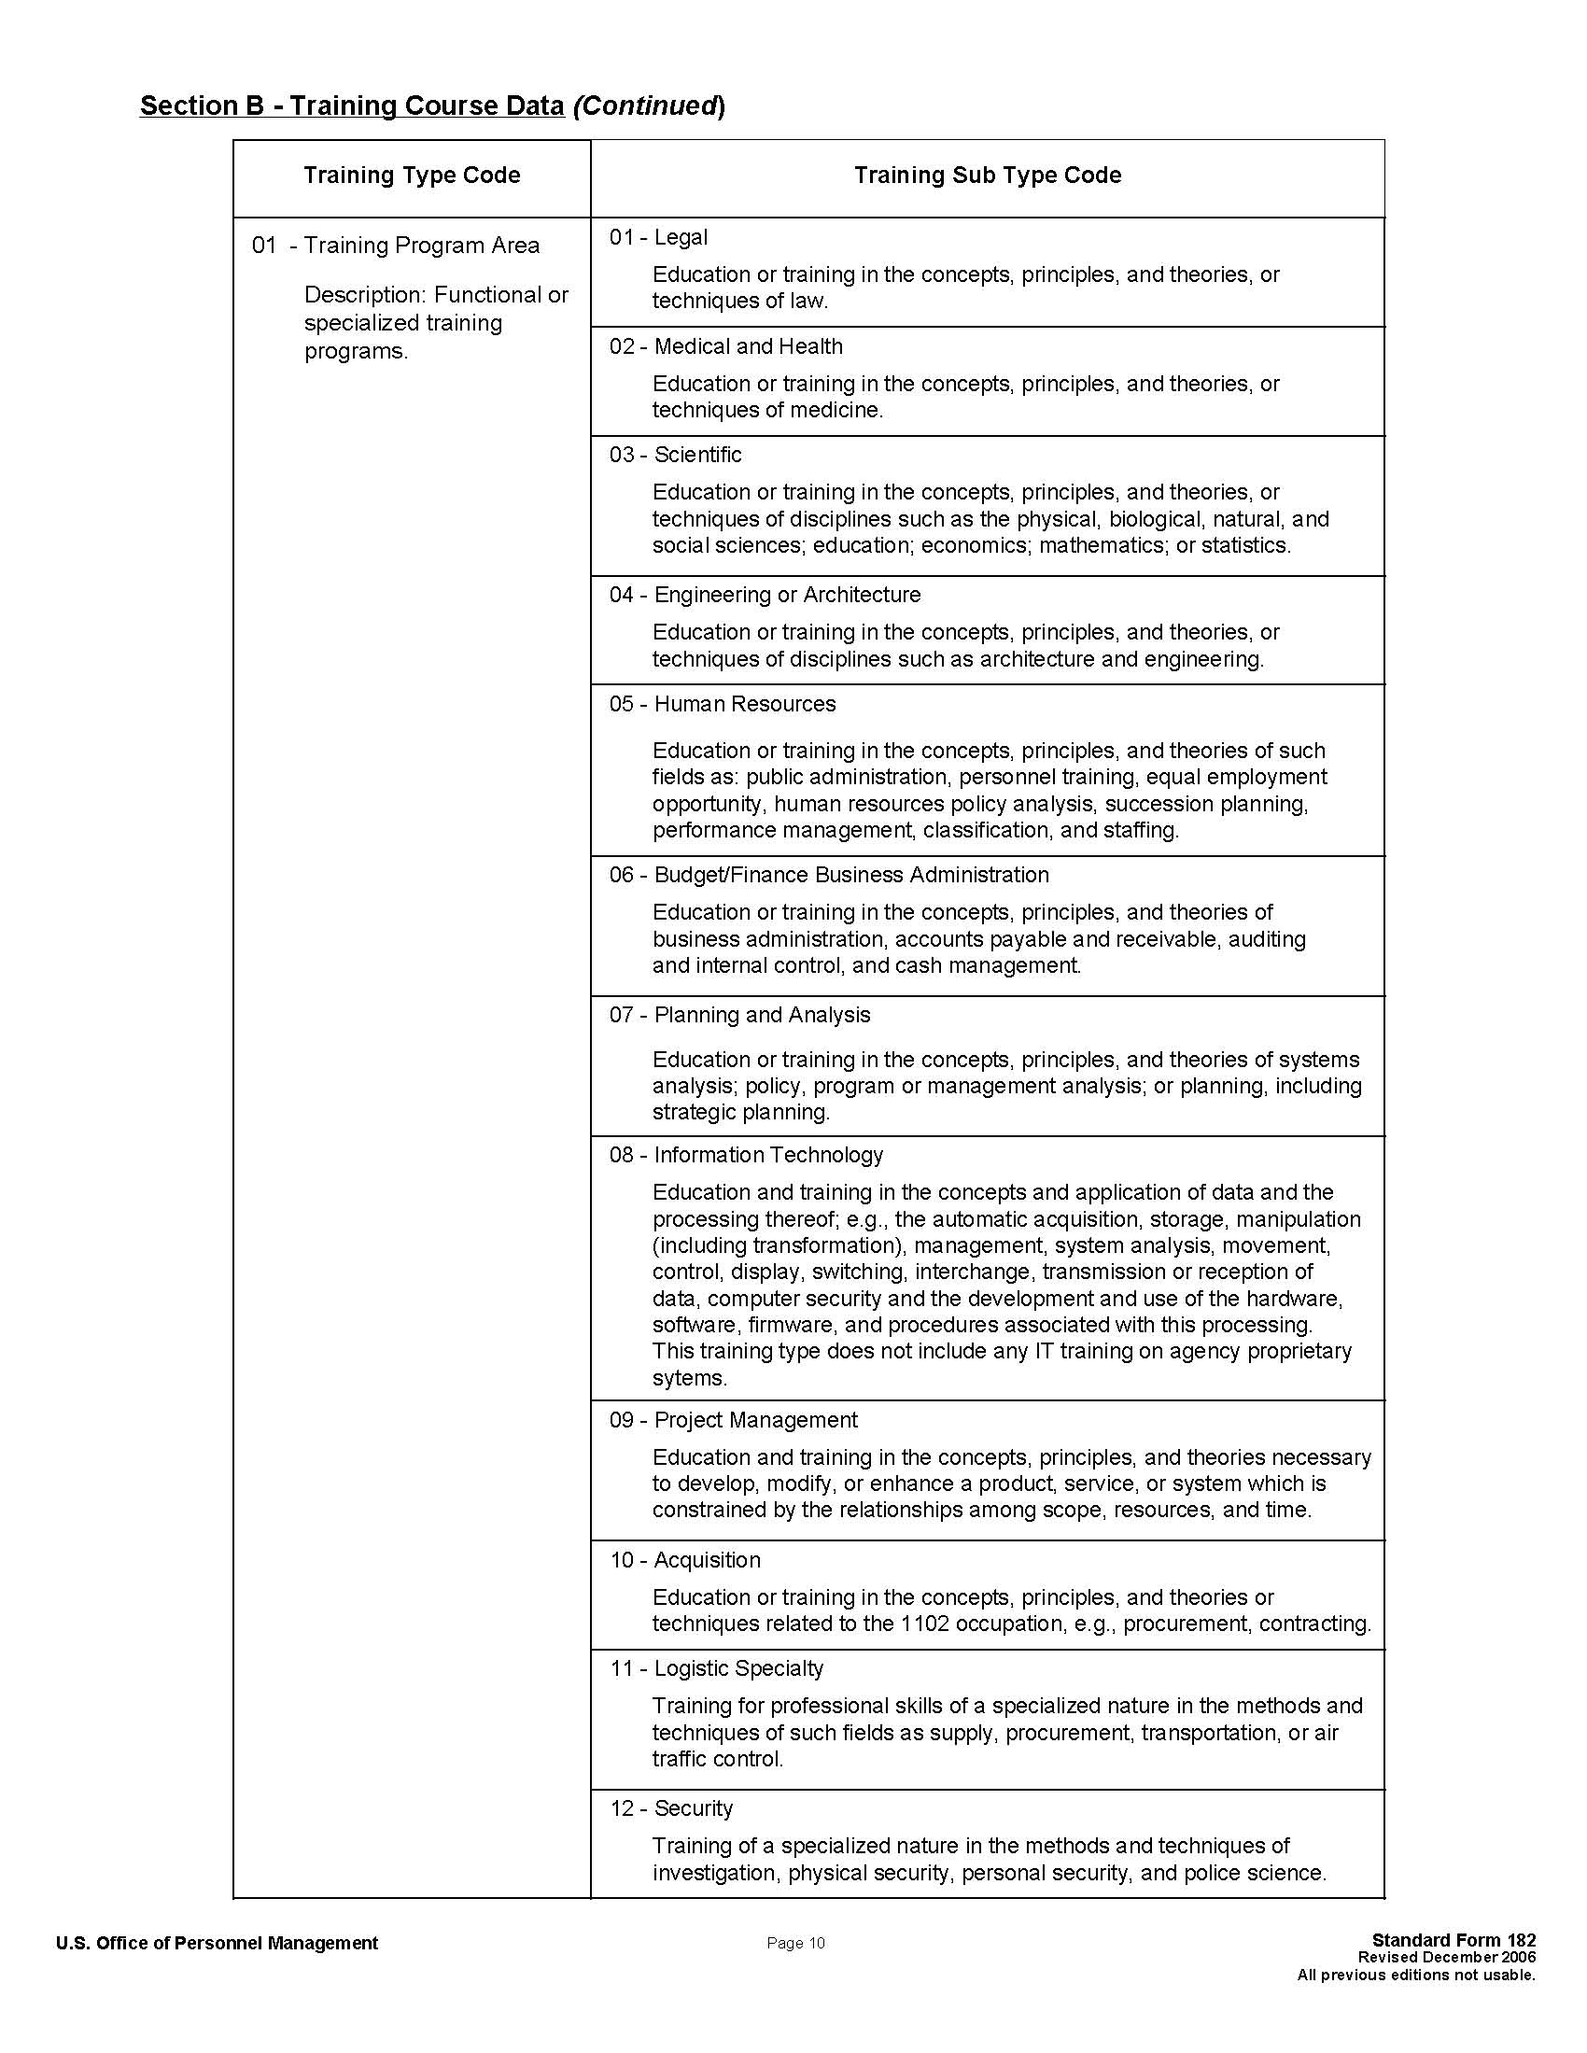

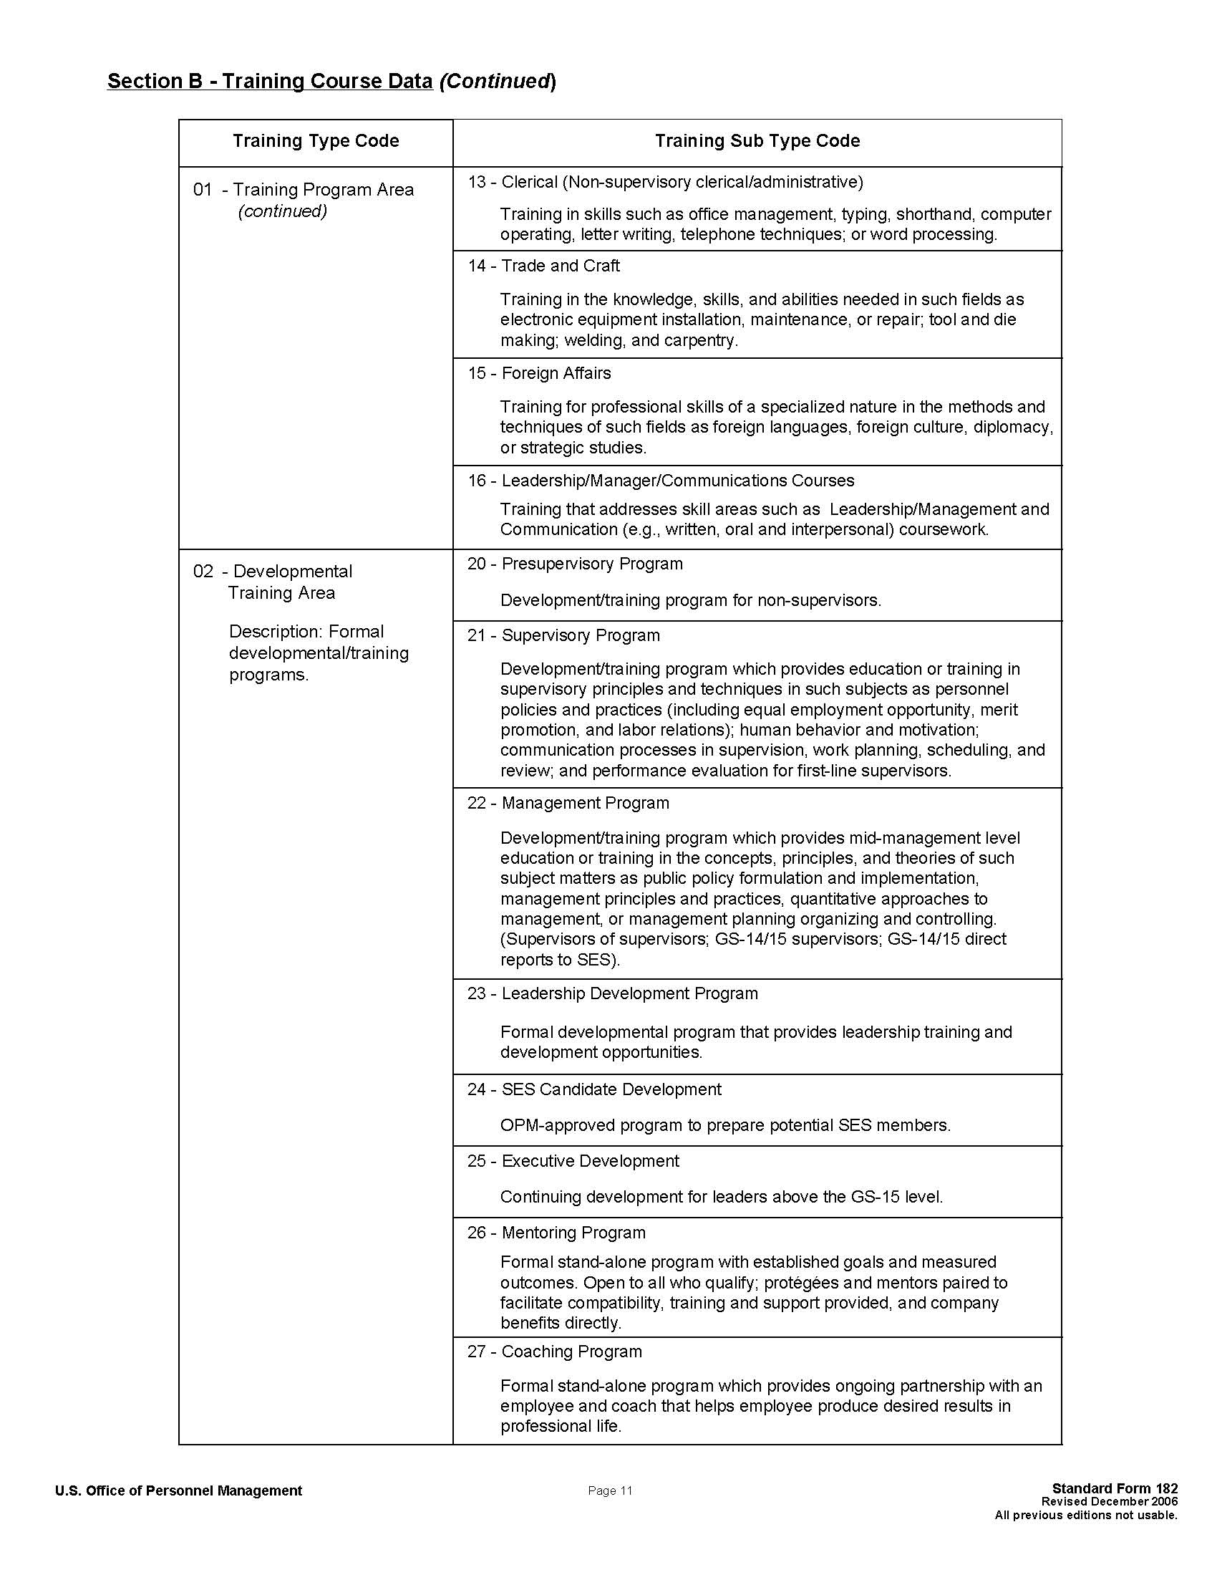

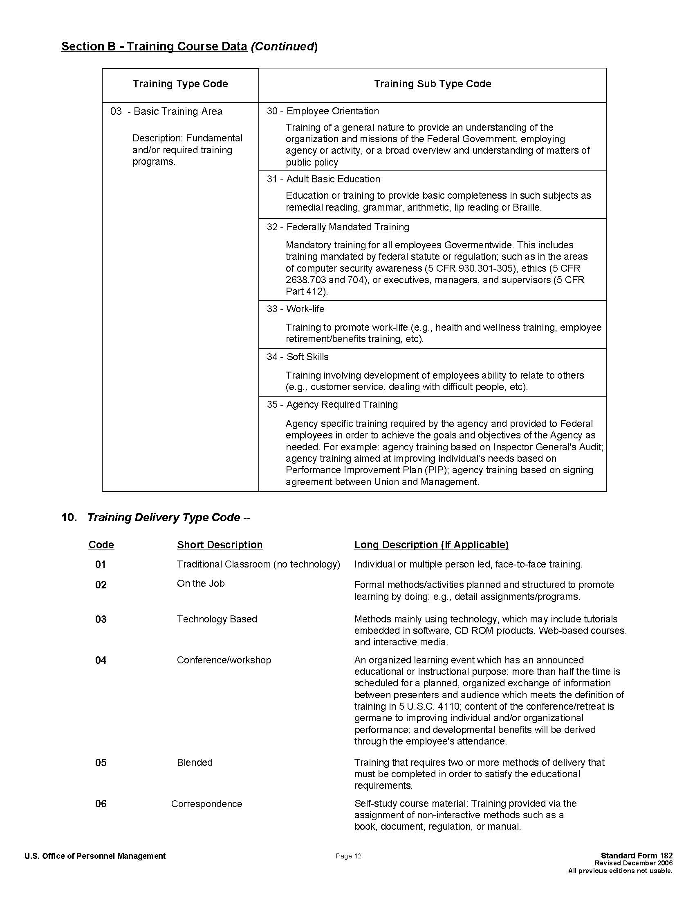

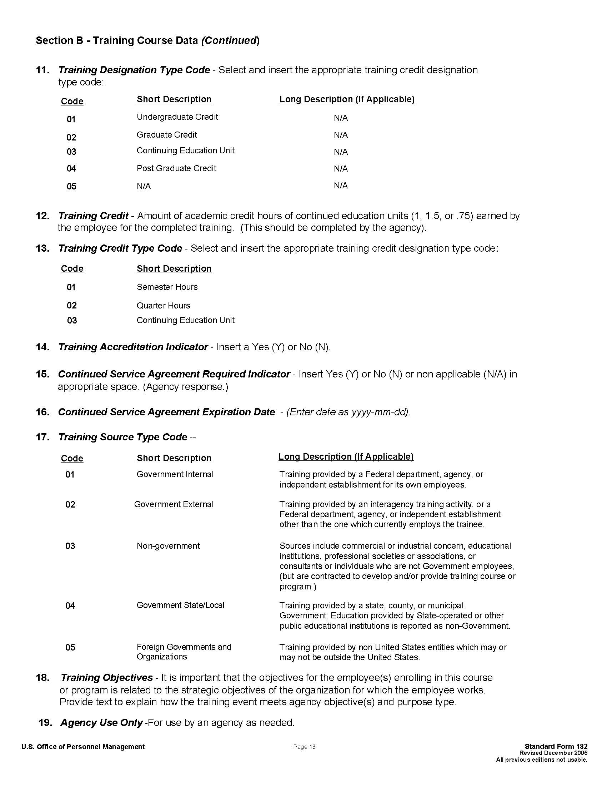

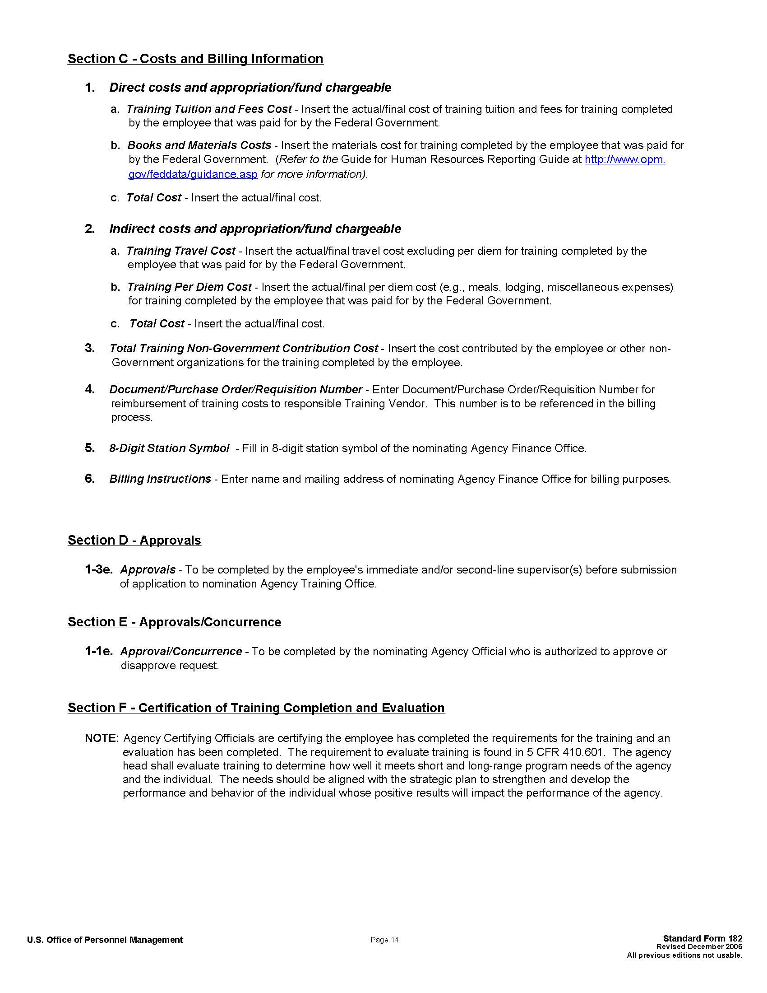

INCOMPLETE SF-182s

All incomplete/inaccurate training requests will be returned to the organization’s training coordinator for completion/correction. Refer to SF-182 example above with required fields highlighted in yellow.

LATE SUBMISSIONS

AI-40 training guidance stipulates requests must be submitted 21 calendar days prior to the beginning date of the course. L&DD will return SF-182's submitted less than 21 calendar days prior to the training unless a written justification accompanies the request signed by the immediate supervisor. Exceptions will be handled on a case by case basis and will be reported to the organizational Director.

GROUP TRAINING

Group training requests may be used when the course, date and vendor information on the request is the same. Home address is not required.
Write Group in Section A, block 1, and on top of the SF-182
All incoming group SF-182’s must have an attached list of the employee’s name, social security number, email, grade, series, pay plan, and cost per person.
The group should be assigned one document number with each employee assigned the document number plus (-X). (ex. DHAT-7-1000-1 thru 10, RFAT-7-4000-1 thru 29).
Travel orders for group training require that each employee have their own DD Form 1610 submitted for approval.

NO ACTION EMAIL

If an SF-182s is submitted with missing information the request will be returned and marked as a ‘No Action” email. The TC is responsible for returning the training request to the student for corrections. If the TC does not respond with the correct information, the request will not be processed.

Below is a sample of the No Action –Missing Information notification:

The Customer Satisfaction Center is returning this training request without action because it is missing the following:

-Vendor Contact Information such as phone number, website, or fax number
-PayPlan/Series/Grade is incomplete
-E-mail address for student
-Training Objective

Please resubmit the SF-182 with the appropriate and correct information for processing within 72 hours. If you have any further questions, please don't hesitate to contact us.

Thank you,

Customer Satisfaction Center
Learning & Development Division

Direct: (703) 604 -6852
Fax (703) 601 - 2296
Email: Lddcustomersatisfactioncenter@whs.mil

APPROVED TRAINING

Once the HR Specialist has approved the course, an approval letter will be sent to the TC and the student. This approval letter grants approval for the course only and does not grant approval for travel. Travel orders must be approved by Defense Travel System.

TRAINING COORDINATOR MEETINGS

Training coordinator meetings are hosted quarterly and are usually held at the Pentagon Conference Center. All TCs on the distribution list will receive an agenda and minutes for the meetings. The meetings provide an opportunity to obtain information or clarification on training issues as well as receive answers to questions and provide feedback. All TCs are encouraged to attend.

TRAINING NEEDS ASSESSMENT

The process used by supervisors and managers to identify training requirements should be done continuously. The following are some possible indicators that a training need exists.

Are there new equipment, systems, programs, or procedures being installed or slated for application in the near future?

Have inspection, evaluation, or audit reports highlighted conditions that may point to needed training?

Are significant changes in state-of-the-art technology being experienced within scientific and engineering disciplines?

Is there an individual employee performance problem that could be corrected through training?

Valid training needs must be prioritized with their relative importance to the organization. Needs are where organizations invest time, energy, and talent to meet the mission. Identify the nature and scope of training, critical functions, and any problems training might solve.

TRAINING NOMINATIONS
A SF Form 182 nominates civilians for training opportunities and is used for:
- Registering with the training vendor.
- Giving a school or paying agency information about the attendee.
- Providing the vendor with a billing copy.
- Obligating funds through the financial management office.
- Entering training attendance in the employee’s official personnel folder.
- Maintenance of training and budget records in the Employee Development and Training Office.
- Organizations should not register employees for training prior to the submission and approval of the SF Form 182 because only the Human Resources Specialist is authorized to obligate government training funds and your organizations, employee, or supervisor could be held liable for any costs incurred.

TRAINING ATTENDANCE REQUIREMENTS

When the supervisor signs the SF Form 182, he/she guarantees the employee will be available to attend the training. Subsequent substitutions or cancellations should only occur in emergency situations. Once the employee has a class confirmation, other duties and activities need to be rescheduled around the employee’s attendance at training, not vice versa. When an employee fails to attend a class, a no-show may be charged to your organization.

- Unsatisfactory Completion. In the event an employee fails to complete a course, the employee may be required to reimburse the government for the costs associated with the training.

- RESTRICTIONS ON NON-GOVERNMENT TRAINING AND EDUCATION. There are several limitations on training and education through non-government facilities.

- Academic Degree Restrictions. Training in a non-government facility may not be provided.

For the sole purpose of providing an employee an academic degree to qualify for their current position, or, for the sole purpose of obtaining an academic degree. This prohibition does not limit an organization’s authority to assign employees to training in non-government facilities when the purpose of the training is to develop, knowledge, skills, and abilities which will best qualify them to perform their official duties. If in the accomplishment of this training an employee receives an academic degree, this is considered an accidental by product of the training.
- Training for Promotion. The Government Employees Training Act prohibits training in non government facilities for the purpose of filling a position by promotion if there is another employee of equal ability and suitability who is fully qualified for the position and is available at or near where the duties are to be performed.

- Continued Service Agreements (CSA). Before an employee is assigned to training over 80 hours, the employee must agree in writing to continue with the agency for an appropriate time. Generally, the minimum period is three times the length the training. Note: An individual CSA can be established for longer periods of required service it is justified by the cost of the training or other factors; i.e., training is in a highly technical field or the training provides skills in a hard to fill job series.

AFTER THE FACT TRAINING PROCEDURES

Except for very rare or unusual circumstances, L&DD will not process any SF-182s after the training has commenced or has been completed. This includes payment of such training. Only with strong written justification by a Directorate head will L&DD consider this situation. Please note that by policy (AI-40) all training must be approved prior to class start date. Employees must be in receipt of an approval letter prior to attending training. Otherwise, the costs incurred may become the responsibility of the employee. As discussed in previous training coordinator meetings, employees may register and attend "no cost" with supervisory approval. A SF- 182 is still required to document the training in their training history file.

CANCELLATION & RESCHEDULING

Employees are responsible for canceling, rescheduling, or finding an approved substitute if they cannot attend the approved learning and development opportunity. The substitute is required to submit an approved SF-182. Employees who fail to attend or complete approved learning and development opportunities may be required to reimburse the government, less any refund or credit obtained.

FINANCE/BUDGET

The TC is responsible for tracking all costs related to learning and development activities and ensuring that the total costs do not exceed the distributed target for their component. Monthly, L&DD will send each TC a report listing all training requests that have been received by L&DD to date. It is the TC’s responsibility to review these reports and update their records when needed. If any discrepancies are noted, the TC must contact L&DD to reconcile the account.

TRAVEL ORDERS

If travel is required in support of training, TCs are responsible for ensuring employees know to go into the Defense Travel System (DTS) to process travel authorizations and vouchers. Additional information can be available from the DTS Help Desk at 703-601-6155/6154. For organizations that still process manual travel orders, the following examples shows you how to complete the order:

TRAINING RECORDS

WHS/L&DD updates a civilian employee's training history file in the Defense Civilian Personnel Data System (DCPDS).

For the organizations that submit SF-182’s for processing to WHS/L&DD, the employee’s training history file is updated in DCPDS the month following the course ending date. For this reason, it is imperative that any cancellations or non-attendance is immediately reported to the CSC.

For the organizations that process their own SF-182’s, WHS/L&DD is responsible for updating the employee’s training history in DCPDS. Organizations will be required to submit to L&DD an Excel file listing the employees who have completed training from the previous month. This spreadsheet is available from the CSC, lddcustomersatisfactioncenter@whs.mil (or as listed in the global as "RSS - LDD Customer Satisfaction Center"). It is imperative that the spreadsheet provided to L&DD is in the exact same format as the example. Any spreadsheets submitted not in the prescribed format will not be processed and be returned for correction. Reports are due no later than the 15th of each month to the CSC.

The data you submit will be available to OPM. It is important to verify the data on the Excel file for accuracy. In particular, any fields relating to costs or hours of training will be of interest to OPM. In addition, quarterly reports will be sent to each organization listing all the training records in DCPDS for your review. Report any discrepancies to the CSC.

MyBiz

Civilian Personnel Management Services (CPMS) is incorporating a feature that will show training history to Department of Defense (DoD) Civilians who are customers of the Learning and Development Division (L&DD) of Washington Headquarters Services (WHS).

By implementing this process it is realized that there may be possible gaps in customer’s training history displayed in MyBiz. Employees will be able to fill in their training history; however if and when problems arise and confirmation is needed, Training Coordinators and L&DD assist.

A mailbox has been created titled LDD.SelfService@whs.mil which WHS Training Coordinators and serviced population civilians can address questions.

Please verify that all of the following conditions have been met:
- The inquiry is from an organization L&DD services
- The training:
- was held more than 45 days prior to when the inquiry was received
- is no more than 5 years old
- fits the definition of training provided by CPMS
- is accompanied by a transcript, documented proof from the training institution or a supervisor’s certification.

If the training fits those descriptions, then L&DD shall update the DCPDS and will then be illustrated in MyBiz.

Section III- Training and Development Opportunities

TRAINING AND DEVELOPMENT OPPORTUNITIES
TITLE | Program Date(s) | 1556 due to L&DD | Grade  Equivalent to: | Tuition Cost  (Subject to change)
Advanced Management Program (AMP)  This IRMC program prepares managers to lead the emergence of gov't as a successful info age enterprise, capable of managing the complexity of info resources. Two 12-week courses per year. http://www.ndu.edu/irmc/pcs/pcs_amp.html | Sep-Dec & Jan-Apr | Jun/Oct | YA2-YC2 &above | NDU Funded
*Air Command & Staff College (ACSC)  An Intermediate professional military education school which prepares student to assume positions of higher responsibility. Student must have or have applied for a top secret security clearance and an SSBI. http://wwwacsc.au.af.mil/ | Aug-Jun | February | YA2 & above  Major equivalent | Air Force Funded (Tvl & Per Diem to be paid by owning organization)
*Air War College (AWC)  A 10 month graduate degree-granting program. Students must have an undergraduate bachelors degree & have or applied for a top secret security clearance and an SSBI. http://www.au.af.mil/au/awc/awchome.htm | Jul-May | February | YA3 & above | Air Force Funded (Tvl & Per Diem to be paid by owning organization)
Aspiring Leader Program  A six month part-time program that prepares federal employees for positions as team leaders, supervisors, and managers. The program strengthens basic competencies in managerial skills such as: oral & written communication, problem solving, & customer service. http://graduateschool.edu/ | Apr-Jun & Aug-Nov | July | YA1 & above | $2,758
Brookings European Seminar  An exchange program that takes a group of U.S. Gov't officials to Brussels, Belgium for a week-long seminar on the European governmental system and U.S. European relations. http://www.brook.edu/execed/programs_title.htm | October | August | YA3 & above | Varies
*Congressional Fellowship Program  A nine-month program sponsored by the American Political Science Assn which expands knowledge and awareness of Congress. Organizations with activity relating to foreign governments can nominate candidates for the eight-week Foreign Affairs Fellows section of the program. http://www.apsanet.org/content_3031.cfm?navID=41 | January | February | YA2-YC2 &above  With +2 yrs of service | $5,000 plus $2,600 for Foreign Affairs Seminar (if selected)
Defense Acquisition University (DAU)  Acquisition courses offered including internet courses.  http://www.dau.mil | Courses held throughout year | Varies | All | DAU Funded
DoD SES APEX Orientation Program  Covers issues and topics of common concern, regardless of Component affiliation. Two week program with visits to Commands. http://www.whs.mil/HRD/Civilian/Career Development/DODSponsoredPrograms/ApexOrientation.cfm or www.apexnet.org | Mar/Sep | Jan/Jul | SES | Centrally funded by WHS. Participants Organizations fund travel cost.
Defense Policy Seminar (GWU/NSSP)  Examines the psychology of decision making and crisis management. Curriculum is designed to strengthen leadership competency under conditions of intense pressure and stress. This 3 day program is held twice a year.  http://www.gwu.edu/~nssp/nssp_brochure.pdf | Jul/Dec | May/Oct | Senior SES & O-8 and above | Centrally Funded by Services & WHS
Defense Senior Leader Development Program (DSLDP)  Two year program designed for those who are currently leading high performing organizations & programs, who have the potential & motivation to take on more responsible senior leadership positions. http://www.cpms.osd.mil/lpdd/DSLDP/DSLDP_Program.aspx | Multi-year | July | Pay band 3 under the Standard Career Group in the National Security personnel System | Funded thru CPMS
*DoD Executive Leadership Dev Pgm (ELDP)  A year long program to gain a better understanding of DoD's mission.  http://www.cpms.osd.mil/lpdd/eldp_index.aspx | Oct-Sep | February | YA2 & above  YC1 & above | $6,000 + $20,000 for Travel
Executive Course on National & International Security (GWU/NSSP)  Designed to investigate issues such as: Military plans & actions, intelligence gathering, analysis; dissemination & sharing, and nation building from leadership & practical perspectives. A two week program held in early fall.  http://www.gwu.edu/~nssp/nssp_brochure.pdf | September | June | SES & O-7 and above | Centrally Funded by Services & WHS
Executive Leadership Program (ELP)  A year-long program structured around the OPM's Leadership Effective Framework (LEF), a model for effective leadership and managerial performance. http://graduateschool.edu/ | Apr-Feb  Sep-Jun | Mar/Aug | YA2 & above  YC1 & above | $4,275
Executive Potential Program (EPP)  A year long competency based leadership program based on OPM's Executive Core Qualifications (ECQs). http://graduateschool.edu/ | Apr-Apr | Feb | YA2 & above  YC1 & above | $6,392
Federal Executive Institute (FEI)  Leadership for a Democratic Society helps executives develop broad corporate viewpoints, understand their constitutional roles, & enhance essential skills.  http://www.leadership.opm.gov/programs/Executive-Leadership-Development/LDS/Index.aspx | Courses Held Throughout Year | Jun/Jul | YA3 & above | $18,375
*Industrial College of the Armed Forces (ICAF)  Prepares senior leadership/staff positions dealing with national security strategy and the resource component of national power. School year runs from Aug to Jun. http://www.ndu.edu/icaf | Aug-Jun | February | YA3 & above  YC3 & above | NDU Funded
Information Resources Mgmt College (IRMC)  Provides courses for Information Technology certificates.  http://www.ndu.edu/irmc | Crs Held Thoughout Year | Varies | YA2 & above  YC2 &above | NDU Funded
Information Assurance Scholarship Program (IASP)  This program is for disciplines and programs of study supported under the IASP. The program includes opportunities for DoD civilian and military to attend school either full or part-time to earn a degree. Students selected will receive full scholarships for tuition and selected books and fees. POC Mr. Ned Kieloch, 703-699-0116, ned.kieloch@osd.mil | Varies | January | Varies | Funded
*Key Executive Program, American Univ  A 20 month course that offers participants the perspectives and competencies necessary for effective performance in high level executive and managerial work. http://www.american.edu/spa/key/mpa.cfm | Sep-Sep | February | YA2 & above | $50,724
*Legislative Fellows Program  Open to Government managers who need in-depth understanding of the U.S. Congress and the legislative process. Twelve month or seven month sessions beginning Jan. http://www.brookings.edu/execed/fellowships.aspx; http://gai.georgetown.edu; http:graduateschool.edu. | Jan-Dec or Jan-Aug | February | YA2 & above | Varies per Vendor/12 month  Varies per Vendor//7 month
Management Development Center Courses (MDC)  Multiple seminars offered by OPM for managers & executives.  http://www.leadership.opm/gov | Courses held Throughout Year | September | YA2 & above  YC1 & above | Varies per class
*National War College (NWC)  Prepares students for planning and conducting global war plus making peacetime national security and strategy decisions. The program runs from Aug to Jun. http://www.ndu.edu/nwc/index.htm | Aug-Jun | February | YA3 & above  YC3 & above | $73,000
New Leader Program  A six month leadership development program designed to develop future public service leaders by providing assessment, experiential learning, and individual development opportunities. Provides solid training & develops basic leadership and team building skills. http://graduateschool.edu/ | Mar-Sep & Aug-Jan | Feb/Jun | YA1& YA2  YC1 | $3,220
*OSD Graduate Fellowship  An academic year of study at an accredited college or university. The purpose is to ensure DoD retains the most qualified workforce. Contact WHS/LDD. | Varies | February | YA2 & above  YC1 & above with +5 yrs service | $20,000
OSD Staff/Action Officer Course The objective of this course is to provide action officers with an understanding of how to create and coordinate actions effectively. http://www.whs.mil/HRD/Civilian/CareerDevelopment/ TrainingAndDevelopment/OSDStaffOrientationandStaffActionOfficerCourses.cfm | Bi-Monthly | 5 days prior to class start date | Various | OSD Funded
OSD Staff Orientation Course The objective of this course is to ensure new employees are given a basic introduction to the Office of the Secretary of Defense. http://www.whs.mil/HRD/Civilian/CareerDevelopment/TrainingAnd Development/OSDStaffOrientationandStaffActionOfficerCourses.cfm | Monthly | 5 days prior to class start date | Various | OSD Funded
Retirement Seminar  Two day Mid-Career Seminar for employees 10 to 15 years from retirement.  Three day Seminar for employees 5 to 10 years from retirement.  Course location: Polk Bldg, 2521 S. Clark St, Ste 4000, Arlington,VA  http://www.whs.mil/HRD/Civilian/CareerDevelopment/DODSponsoredPrograms/RetirementSeminars.cfm | Courses Held Throughout Year | Varies | All | Varies
*Seminar XXI (Massachusetts Institute of Technology)  Provides future leaders with analytic skills needed to understand other countries and foreign relations, and to explore policy issues critical to American interests through a variety of lenses. http://web.mit.edu/semxx | Sept-May | February | YA3 & above  YC3 & above | $9,400
Senior Executive Development Program  Seminar sponsored by GWU exposes participants to new ideas about leadership and strategic thinking and will enhance their potential for growth within the organization. Employees can choose the five week program which meets twice a week, or the two week program which is full time. http://www.gwu.edu/~cepl/federal/sed_intro.html | Apr-May (5 weeks) & Jun (2 week) | Mar/May | YA3 & above  YC3 & above | $5,000
Senior Manager Course in National Security  GWU/NSSP’s 4 week seminar conducted once a year. It involves interplay of policy and process in the complex defense environment.  http://www.gwu.edu/~nssp/nssp_brochure.pdf | June | April | YA3 & above  YC3 & above /O-6  & above | Centrally Funded by Services & WHS
SES New Member Orientation (OPM)  Provides an overview of executive branch priorities and an opportunity to interact with a broad range of policy makers. It covers the President's vision and values. http://www.opm.gov/ses | Courses held Throughout Year | Varies | SES | $495
*Centrally-funded Long Term Training programs for OSD/WHS

REFERENCES

DIRECTIVES

AI 40
http://www.dtic.mil/whs/directives/corres/html/040.htm
HANDBOOKS

OPM Handbook
http://www.opm.gov/hrd/lead/pubs/handbook/Training_policy_hndbk04.pdf

