ECOE Project DB Checklist / User Guide
Last Updated: 9/30/2006

General Comments:
- Be specific with Project Name
- Preference for bundled measures vs submittal of multiple projects for one site.
- When sending files that need to be attached to projects, please refer to the bldg# to assist in correctly identifying which project the file belongs to

Project Tab

____ Detailed project description!! Includes fixture counts and sizes (this can be in the form of attached scope, energy audit or study)

____ Attached supporting documentation is indicated in the description

____ Renewable Component drop-down box needs to be completed

ECM Tab

____ Individual Measures should be listed separately when feasible. Complete information should be added to this tab. The mmBTU savings for the project comes from this tab. ( Most often tab left incomplete!)

Financial Tab

____ Substantial Completion Date entered

____ BLCC Comparative Analysis Report (in html format) attached

____ BLCC Summary LCC Report (in html format) attached

____ BLCC Detailed LCC Report (in html format) attached

____ Other Supporting Info attached ( ie. Audit Reports, scope descriptions, savings backup)

Accessing and entering a project submission in the ECOE Project Database

The Project database is accessed via the GSA intranet by going to:

http://srwp-tatest
or
http://159.142.200.171

There you will be prompted to enter your user name and password. If you have not already received a username and password, please contact Karen Curran (508-543-7768).

Once you are logged in you will be at the "home" page of the database. In order to enter a new submission, you will click on the tab that says "Project Maintenance."

You will be taken to a query screen. In order to enter a new submission, please click on the button that says "Add New Project."

The next screen will look like this:

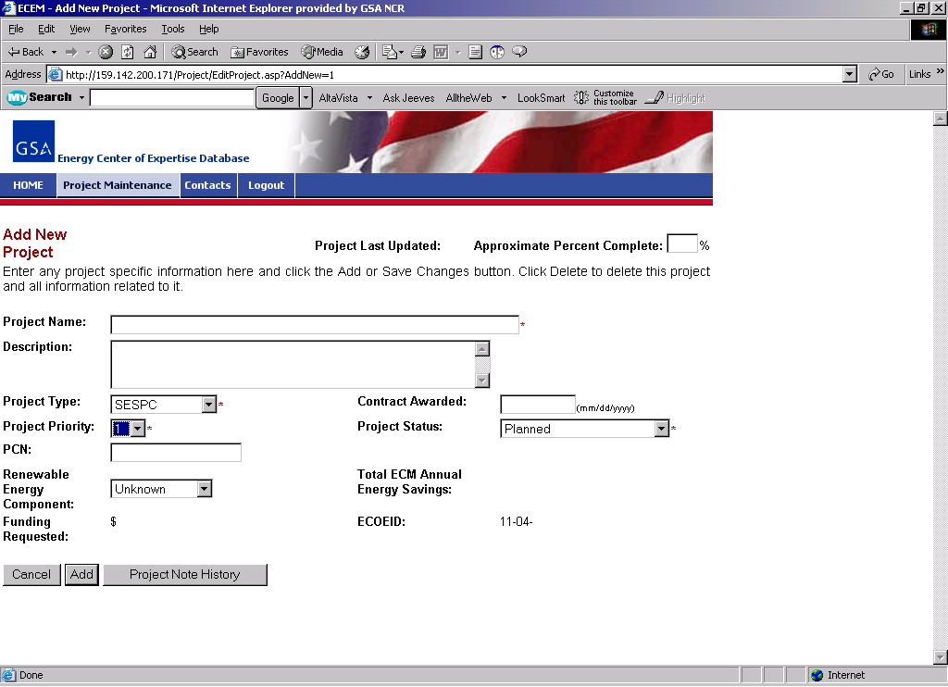

Since this is a new project, the percent complete and contract awarded date will not need entries. Please enter a descriptive project name and a brief description of the project.

Note that any fields with a red asterisk (*) next to them are required, and must be completed before proceeding.

You can select from a variety of options for the "type" of project -- i.e. Utility financed, fully-funded, etc. Since you are requesting B/A55 funds, you will most likely select fully-funded as the type. If you are planning to "buy-down" a utility-financed project, please select utility financed.

You will then need to assign a regional project priority -- a number from 1 (lowest priority) to 10 (highest priority).

For Project Status, please select "submission."

You will then indicate whether or not the project includes a renewable energy component. If it does not, please select "none."

Once the information is completed, click on the "Add" button.

You will then see a screen that includes the information you just entered with some new tabs across the top:

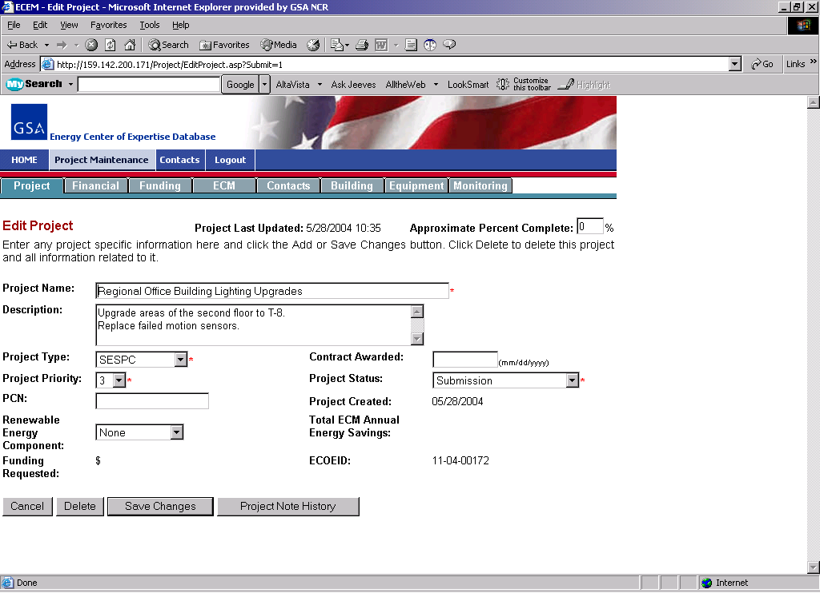

Once you have verified the entries (and clicked on "Save Changes" if you have made any changes), you can select the "Financial" tab in the light green-gray bar.

Financial Data

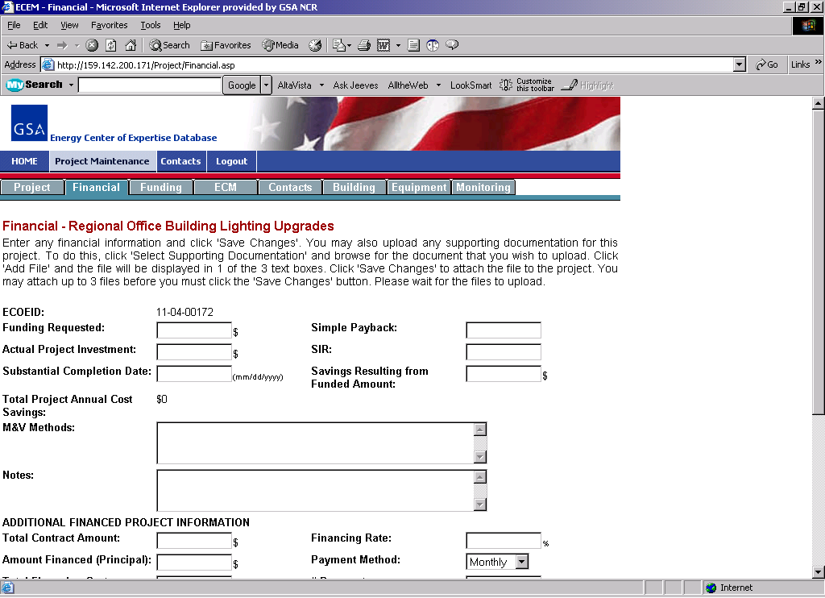

On this page, you will need to enter the following information: the total project cost in dollars of the Funding Requested, project Simple Payback, and project SIR fields.

In the case of a utility financed project with a funded component, you will need to enter a value in the Savings Resulting from Funded Amount field (please work with Karen or Steve on this). You will also need to complete the M&V description field, as well as the appropriate financed project information on this page.

Click on "Save Changes" once you have completed the necessary fields, and then select the "ECM" tab.

ECM Entry

On the "ECM" Tab, you will enter data specific to each of a project's ECMs at the top of the screen and click the "Add" button to save it to the list of ECMs for the project.

Please enter the estimated construction cost as the "Implementation Expense" for fully funded projects.

The Simple payback field will be automatically calculated based on other information in the form.

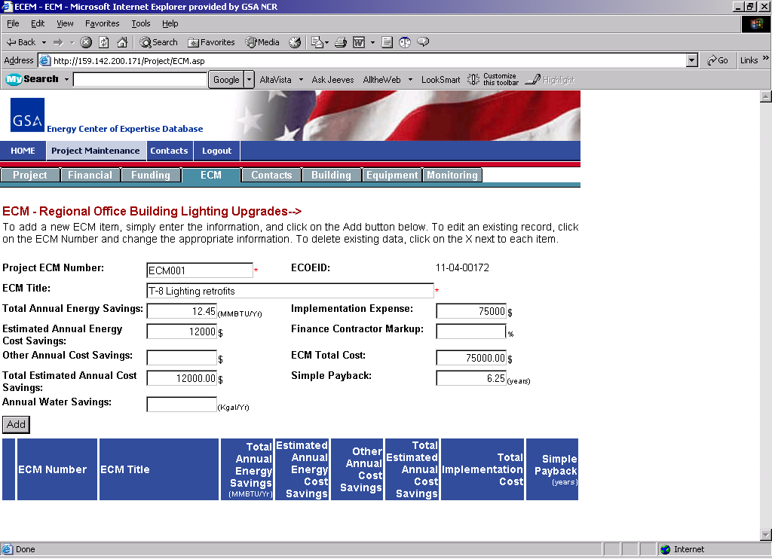

Once you have added the ECMs, they will show at the bottom of the page in the table:

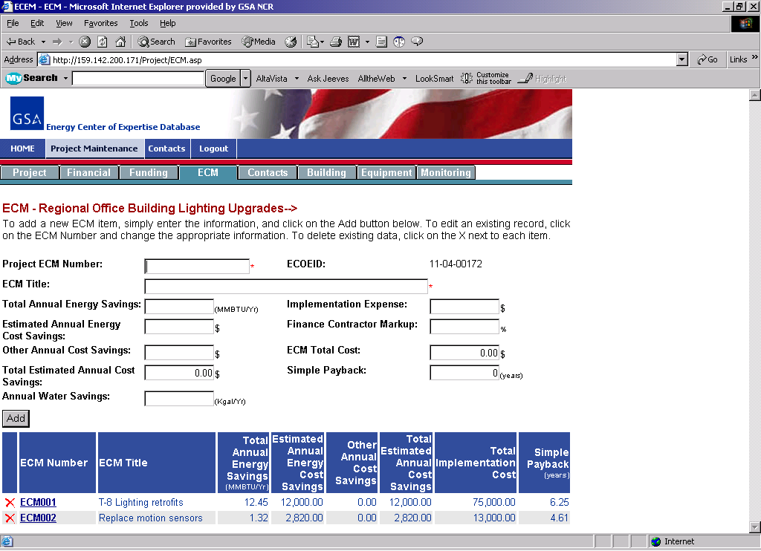

You can enter multiple ECMs for each project on this screen. To review or edit any ECM, select it by clicking on the ECM Number (bolded and underlined) from the table with the blue headings at the bottom of the screen.
Building Data

After you have completed entering information for the ECMs, click on the "building" tab to enter pertinent building data:

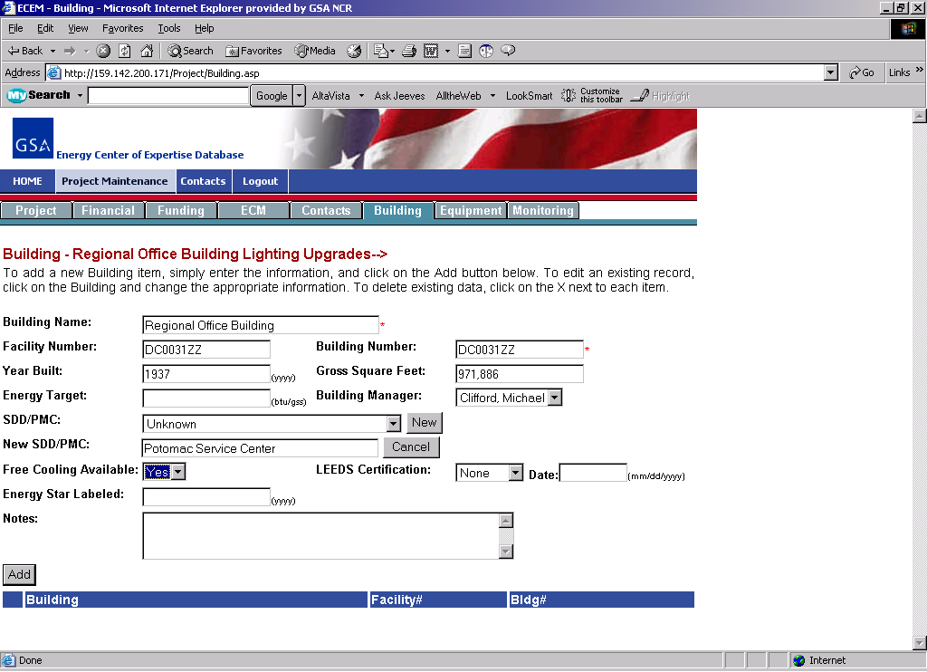

Click the "Add" button once you are done. While it's likely a project will be associated with only one building, there may be instances where multiple buildings will be involved. If there is more than one building for a project, you can enter it by following the same method.

Data for the "Funding" tab will be updated after the project is approved and information on "Equipment" tab should be entered at substantial completion.

The contacts tab is a resource for users to keep up with important associates throughout the project life. When you enter a project, you are automatically associated with the project as a contact.

