Intent to Award for 0040022476: G12PS00171

The US Geological Survey (USGS) has a requirement to acquire access to a best-practice research library under an enterprise subscription from the private and public sector, diagnostic tools designed to support our information collaboration and delivery environment, supplemental guidance on the business impacts of implementing different IT strategies, benchmarking data, training material, and moderated networking opportunities focused on Applications Strategy and Management.

The USGS is aware of no other source that can provide the above. Therefore, it intends to make an award to the Corporate Executive Board, unless it is contacted by any vendor who believes they obtained similar technical expertise and can provide the same service. Vendors are invited to contact the Contract Specialist, [kvultaggio@usgs.gov](mailto:kvultaggio@usgs.gov) no later than 12:00 PM EST, Monday, February 27, 2012 with an affirmative answer.

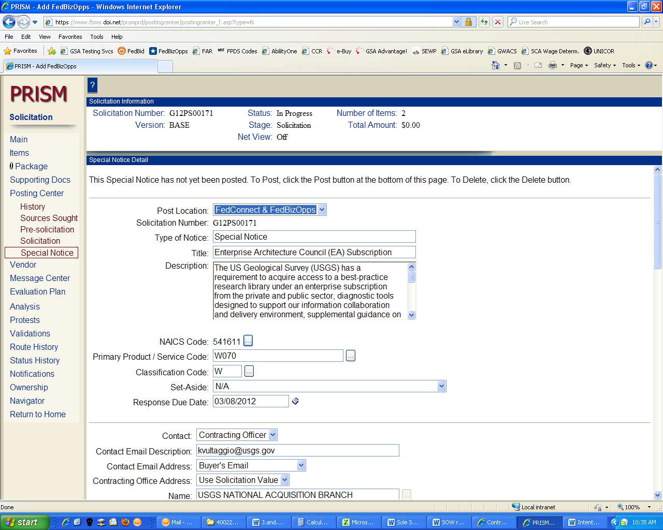

*The U.S. Geological Survey (USGS) considers employee signatures to be Personal Protected Information, and therefore all employee signatures have been redacted. By posting this document, the Contracting Officer attests all appropriate signatures have been obtained.*

SOLE SOURCE JUSTIFICATION STATES THE FOLLOWING PART:

**CEB** – Collaborative Research, best practices, benchmarking, tools, templates and diagnostics. Focus is on cross-functional business issues in the IT sector. CEB also offers the following unique diagnostic tools required by the Government to provide leverage, so that enterprise initiatives may be accomplished with existing staff.

* + Anatomy of World-Class Solutions Delivery:The Anatomy of World-Class Solutions Delivery measures the importance and maturity of 23 new or evolving competencies. The Council has an all new diagnostic which defines capabilities at each level of maturity based on the practical experiences of Applications groups.
  + Insight IQ Diagnostic:The Insight IQ Diagnostic benchmarks the organization's information management practices and knowledge worker analytic capabilities and helps to prioritize areas for improvement. The diagnostic builds on a rich dataset that spans a variety of organization sizes and industries, and includes responses from more than 6,000 knowledge workers globally.
  + Enterprise Architect Effectiveness Diagnostic: (Jan 30-March 9) The skills demanded of Enterprise Architects are changing and few Chief Architects know whether they have the right mix across their teams to meet this demand. This diagnostic provides a clear assessment of the USGS team's skills and domain expertise. The results will allow the Government to compare the team's perception of their effectiveness with that of the Chief Architect and to a benchmark of peers.

Also, as required by the Government, CEB subscription also offers Anatomy of a World-Class Enterprise Architecture Group: The Anatomy of a World-Class Enterprise Architecture Group measures the importance, ownership, and maturity of 15 critical and emerging EA activities.

The Library of Congress uses this vendor as a part of their FEDLINK program, which is a pre-vetted listing of vendors with whom other government agencies can procure services via special Interagency Agreements (IAs) for a fee. The FEDLINK program designates the CEB as a “Sole Source IDIQ” because there are no other vendors providing the same services. Information on the FEDLINK program can be found at: http://www.loc.gov/flicc/.