INTRODUCTION TO THE

AIRPORT IMPROVEMENT PROGRAM

Federal Aviation Administration
Eastern Region
Airports Division
November 2002

Introduction

The purpose of this pamphlet is to provide an overview of the Federal Grant in Aid program known as the Airport Improvement Program. It provides the legislative sources of authority for this grant program, as well as discussion of the fees used to generate the revenue for these grants, how the grant funds are disbursed, and the types of project work that is “eligible” to receive these funds.
For a more detailed treatment of the workings of this program, the reader is advised to consult the Eastern Region Airport Division Sponsor Guide, available at the FAA Offices listed at the end of this pamphlet.
The FAA Eastern Region Airports Offices, listed at the end of this pamphlet, have staffs of experts in all areas of airport development, and the administration of the Airport Improvement Program. For any specific questions on areas covered in this pamphlet, and to be sure of having the most current information, we encourage you to contact these offices.

Section I
Introduction To The Airport Improvement Program, (AIP)

Authorizing Legislation.

The AIP is authorized by Title 49 of the United States Code (U.S.C.), which is referred to as the “Act”. Previously, the AIP was authorized by the Airport and Airway Improvement Act of 1982 (P.L. 97-248, as amended), which was repealed in 1994, and the provisions were recodified as Title 49, United States Code. The Act’s broad objective is to assist in the development of a nationwide system of public-use airports adequate to meet the current projected growth of civil aviation. The Act provides funding for airport planning and development projects at airports included in the National Plan of Integrated Airport Systems (NPIAS). The Act also authorizes funds for noise compatibility planning and to carry out noise compatibility programs as set forth in the Aviation Safety and Noise Abatement Act of 1979 (P.L. 96-143).

Public Law 103-272 (July 5, 1994), Codification of Certain U.S. Transportation Laws at 49 U.S.C., repealed the Airport and Airway Improvement Act of 1982, as amended, and the Aviation Safety and Noise Abatement Act of 1979, as amended, and recodified them without substantive change as Title 49, U.S.C. Several notable name changes were contained in the recodification language. The term “enplanements” was replaced with the term “passenger boardings.” The codification also refers to passenger facility fees instead of passenger facility charges. These terms, when used in a discussion of legislative provisions and program objectives, are interchangeable.

The first Act was amended in 1994, 1996, 1999, 2000, 2001, and again in 2002, to change the annual authorizations for FY 1994 through FY 2003 as well as numerous other program changes.

Policy.
The highest aviation priority of the United States is the safe and secure operation of the airport and airway system. Other policy statements in enabling legislation address minimizing noise impacts on nearby communities; developing reliever airports; developing cargo–hub airports; developing transportation systems that use various modes of transportation; protecting and enhancing natural resources; reducing aircraft operation delays; converting former military air bases to civil use; and implementing a variety of other provisions to ensure a safe and efficient airport system.
In the administration of the AIP, the FAA supports this policy by giving the highest priority to projects that enhance the safety and security of our airport system. Other major policy objectives are advanced by assigning high priority in the award of AIP funds to projects that maintain current airport infrastructure and increase the capacity of facilities to accommodate growing passenger and cargo traffic. The United States aviation policies are strengthened by statutory provisions that direct specific funding resources to help minimize current and projected noise impacts; convert available former military air bases to civil use; preserve and enhance capacity, safety, and security at primary and reliever airports; and ensure continued funding availability to the small general aviation and nonhub commercial service airports. Discussion of these funding designations is provided in the sections that follow dealing with apportioned and discretionary funds.
Section 47103 of the Act requires the Secretary of Transportation to publish a national plan for the development of public–use airports in the United States. This plan, the NPIAS, lists development considered necessary to provide a safe, secure, efficient, and integrated airport system meeting the needs of civil aviation, national defense, and the U. S. Postal Service. An airport must be included in this plan to be eligible to receive a grant under the AIP. The latest published edition of the NPIAS, before the issuance of this order, covered 1998–2002. It was transmitted to Congress on March 12, 1999. That report identified 3,344 existing airports of significance to air transportation and included an estimated that $35.1 billion in AIP-eligible development that will be needed over the 5 year period of 1998-2002 to meet the needs of civil aviation.

Title 49, United States Code

Grant Authority.
Section 47104(a) of the Act authorizes the Administrator to make grants for airport planning and development in the United States, the Commonwealth of Puerto Rico, the Virgin Islands, American Samoa, the Commonwealth of the Northern Mariana Islands, and Guam. The grants assist the development of public-use airports served by air carriers, commuters and general aviation.

Revenue Sources.
The Airport and Airway Trust Fund, which was established by the Airport and Airway Revenue Act of 1970, provides the revenues used to fund AIP projects. The Trust Fund concept guarantees a stable funding source whereby users pay for the services they receive. In 1997, Congress enacted new taxes to fund the Trust Fund as shown in the following table 1:

Table 1 Aviation Taxes
Domestic Passenger Ticket Tax | 9% from Oct. 1, 1997 through Sept. 30, 1998  8% from Oct. 1, 1998 through Sept. 30, 1999  7.5% from Oct. 1, 1999 through Sept. 30, 2000
Passenger Flight Segment | $1.00 per segment for FY 1998  $2.00 per segment for FY 1999  $2.25 per segment for the remainder of CY 1999  $2.50 per segment during CY 2000  $2.75 per segment during CY 2001  $3.00 per segment during CY 2002  indexed to the Consumer Price Index (CPI) after 2002
Passenger Ticket Tax at Rural Airports | 7.5% passenger ticket tax without flight segment  component beginning Oct. 1, 1997
Waybill Domestic Freight and Mail | 6.25% of shipment cost
General Aviation Fuel Tax | 19.3¢ per gallon (gasoline)  21.8¢ per gallon (jet fuel)
Commercial Fuel Tax | 4.3¢ per gallon
International Departure/International  Arrival Tax | $12.00 per person international departure tax plus  $12.00 per person international arrival tax  indexed to CPI starting Jan. 1, 1999
Special rule: for flights between US  and Alaska or Hawaii | $6 departure tax on domestic flights to and from  Alaska and Hawaii  plus a portion of the passenger ticket tax.  This tax is indexed to CPI starting Jan. 1, 1999
Frequent Flyer Tax | 7.5% of value of ticket (approximately 2¢ per mile)  indexed to CPI after FY 1998

AIP Authorized Funding Levels.
The Act, as amended, authorizes the use of monies from the Airport and Airway Trust Fund to make grants under the AIP on an annual fiscal year basis. Figure 1 depicts the amounts (in millions) that were authorized and subsequently limited by appropriations acts for the AIP. As can readily be seen, appropriation limitations generally fall short of authorized levels.
Funds authorized but remaining after a fiscal year, due to appropriations limitations, carry forward to future fiscal years unless the Congress takes specific action to limit such amounts. During the annual appropriations process, Congress may also limit the funding that may be obligated for grants to an amount that differs from the annual authorization. (See Figure 1.) Rescissions may be enacted as a bookkeeping device reducing the authorized level to the amount limited by appropriations acts.

4. Types of Airports.
The only airports, or portions thereof, that are eligible for AIP funding are public use airports that serve civil aviation. The general definition for airports in legislation refers to any area of land or water used or intended to be used for the landing or taking off of aircraft and includes, within the five categories of airports listed below, special types of facilities like

Figure 1 Typical Correlation between Authorization and Appropriation Levels

seaplane bases, heliports and those facilities to accommodate tilt rotor aircraft. An airport includes an appurtenant area used or intended to be used for airport buildings, facilities, as well as rights of way together with those buildings and facilities. The statute further defines airports by categories that include commercial service, primary, cargo service, reliever, and general aviation airports. They are defined as follows:

Commercial Service Airports are publicly owned airports that have at least 2,500 passenger boardings each calendar year and receive scheduled passenger service. Passenger boardings refer to revenue passenger boardings on an aircraft in service in air commerce whether or not in scheduled service. The definition also includes passengers who continue on an aircraft in international flight that stops at an airport in any of the 50 States for a non-traffic purpose, such as refueling or aircraft maintenance rather than passenger activity. Passenger boardings at airports that receive scheduled passenger service are also referred to as Enplanements. A pilot program on airport privatization may apply to individual commercial service airports, in which case some private rather than public ownership provisions are allowed, and questions on it should be directed to AAS-400.

Nonprimary Commercial Service Airports are Commercial Service Airports that have at least 2,500 and no more than 10,000 passenger boardings each year.

Primary Airports are Commercial Service Airports that have more than 10,000 passenger boardings each year. Hub categories for Primary Airports are defined as a percentage of total passenger boardings in the most current calendar year ending before the start of the current fiscal year. For example, calendar year 1997 data are used for fiscal year 1999 since the fiscal year began 9 months after the end of that calendar year. Table 2 depicts the definition and formulae used for designating Primary Airports by Hub Type:
Table 2 Types of Airports
Airport classifications |  |  | Percentage of Annual  Passenger Boardings | Common Name
Commercial Service: publicly owned airports that have at least 2,500 passenger boardings each calendar year and receive scheduled passenger service §47102(7) | Primary: have more than 10,000 passenger boardings each year §47102(11) | Hub Type §41731(a)(3) | Large:  1% or more | Large Hub
 |  | Hub Type §41731(a)(3) | Medium:  At least 0.25%, but less than 1% | Medium Hub
 |  | Hub Type §41731(a)(3) | Small:  At least 0.05%, but less than 0.25% | Small Hub
 |  | Hub Type §41731(a)(3) | Nonhub:  More than 10,000, but less than 0.05% | Nonhub Primary
 | Nonprimary | Hub Type §41731(a)(3) | Nonhub:  More than 2,500, but less than 10,000 | Nonprimary Commercial Service
Other than Passenger Classes |  |  |  | Cargo Service
 |  |  |  | Reliever
 |  |  |  | General Aviation
Note: Nonhub Airports - Locations having less than 0.05 percent of the United States passengers, including any nonprimary commercial service airport, are statutorily defined as nonhub airports. For some purposes we separate the primary locations, although more than 100 nonprimary airports are currently defined as a commercial service airport in this category.

Cargo Service Airports are airports that, in addition to any other air transportation services that may be available, are served by aircraft providing air transportation of only cargo with a total annual landed weight of more than 100 million pounds. “Landed weight” means the weight of aircraft transporting only cargo in intrastate, interstate, and foreign air transportation. An airport may be both a commercial service and a cargo service airport.

Reliever Airports are airports designated by the FAA to relieve congestion at Commercial Service Airports and to provide improved general aviation access to the overall community. These may be publicly or privately-owned.

The Remaining Airports, while not specifically defined in Title 49 U.S.C., are referred to as General Aviation Airports and comprise the largest single group of airports in the U.S. airport system. This category also includes privately owned, public use airports that enplane 2500 or more passengers annually and receive scheduled airline service. The pilot program, authorized under 49 USC Section 47134, on airport privatization may affect individual general aviation airports, in which case some private rather than public ownership provisions are allowed.

Changes in Airport Classification.

(i) Primary Airports. Any apportioned funds earned by an airport whose classification has changed from primary to nonprimary commercial service airport will be available to that airport for the entire 3-year (4-year in the case of nonhub, primary airports) life of those apportionments regardless of any subsequent change in airport classification. Should a primary airport be inadvertently or erroneously classified as a nonprimary in the annual announcement of apportionment distribution, a sum equivalent to the earned apportionments may be made available to the airport from discretionary funds.

(ii) Reliever Airports. FAA Regions may designate airports as relievers (assuming they meet criteria for relievers as defined in the FAA NPIAS Order) at any time during the year.

(iii) Other Airports. A few airports change from general aviation to commercial and vice versa during a year. For funding classifications for these borderline airports, consult with your FAA office.

5. Distribution of Funds.
Statutory provisions require that AIP funds be apportioned by formula each year to specific airports or types of airports. Such funds are available to airports in the year they are first apportioned and they remain available for the two fiscal years (three fiscal years in the case of non-hub primary airports) immediately following. Among the recipients of apportioned funds are primary airports, cargo service airports, states (including non-primary apportionments when applicable) and insular areas, and Alaska Airports. Figure 2, at the end of this paragraph, depicts how the funds are divided between funding categories. See Paragraph 5e for limiting factors concerning apportionment of funds to nonprimary airports.

Primary Airports. Each primary airport apportionment is based upon the number of passenger boardings at the airport. If full funding is made available for obligation, the minimum amount apportioned to the sponsor of a primary airport is $650,000, and the maximum is $22,000,000, in accordance with 49 USC 47114(c)(1)(B). These funds are calculated as follows:
- $7.80 for each of the first 50,000 passenger boardings
- $5.20 for each of the next 50,000 passenger boardings
- $2.60 for each of the next 400,000 passenger boardings
- $0.65 for each of the next 500,000 passenger boardings
- $0.50 for each passenger boarding in excess of 1 million
Also, in any fiscal year in which the total amount made available under Section 48103 of Title 49 U.S.C. is $3,200,000,000 or more the amount to be apportioned to a sponsor shall be increased by doubling the amount that would otherwise be apportioned under the formula, the minimum apportionment to a sponsor under (a) above will be increased to $1,000,000 rather than $650,000, and the maximum apportionment to a sponsor under (a) above shall be increased to $26,000,000 rather than the $22,000,000.

Small Airport Fund. In 1990, legislation was enacted that allows public agencies controlling commercial service airports to charge enplaning passengers using the airport a $1, $2, or $3 passenger facility charge (PFC). Public agencies wishing to impose a PFC must apply to the FAA for such authority and meet certain requirements. The Wendell H. Ford Aviation Investment and Reform Act for the 21st Century (AIR 21) made provision for the imposition of a $4.00 or $4.50 PFC as described within Order 5500.1.
Section 47114(f) of Title 49 U.S.C. requires that AIP funds apportioned to a large, or medium, hub airport be reduced if a PFC is imposed at that airport. For a PFC of $3.00 or less the apportionment for a fiscal year is reduced by 50 percent of the forecast PFC revenue in that fiscal year, but not by more than 50 percent of the apportionments calculated for that fiscal year. In the case of a fee of more than $3.00, the apportionment for a fiscal year is reduced by 75 percent of the projected revenues from the fee in the fiscal year but not by more than 75 percent of the amount that otherwise would be apportioned. This reduction takes place in the fiscal year following the year in which the collection of the fee imposed under Section 40117 is begun.
The apportionments that are withheld as a result of PFC collections are distributed, in accordance with 49 USC 47116(b) as follows:
- 12.5 percent to the AIP discretionary fund; and
- 87.5 percent to the “small airport fund".
Of the 87.5 percent distributed to the small airport fund, one seventh (1/7) (12.5 percent of the total PFC-reduced apportionment funds) must be spent at small–hub primary airports, and the remaining divided as follows:

one–third (25 percent of the total PFC-reduced apportionment funds) is distributed to general aviation (including reliever) airports, and

the remaining two–thirds (50 percent of the total PFC-reduced apportionment funds) is distributed to nonhub commercial service airports.

Cargo Service Airports. Airports qualified as cargo service airports share the 3 percent of AIP apportionment made available to them in accordance with 49 USC 47114(c)(2). Cargo funds are apportioned to each cargo service airport in the same proportion as its proportion of landed weight of cargo aircraft to the total landed weight of cargo aircraft at all qualifying airports. No cargo service airport is entitled to more than 8 percent of the total amount apportioned to all-cargo service airports. Further, beginning in 1997, the Secretary is authorized to make a portion of the cargo funds available to airports not qualifying for these funds if the Secretary finds the non-qualifying airports will be served primarily by aircraft providing cargo-only air transportation. Cargo service apportionments may only be used at the airport for which the apportionment is made.

States/Insular Areas.

If AIP has funding available under $3.2 billion, a total of 18.5 percent of the annual amount made available for obligation is apportioned for use at nonprimary commercial service, general aviation, and reliever airports within the states and insular areas in accordance with 49 USC 47114(d). Of this 18.5 percent, 99.34 percent is apportioned for airports based on an area/population formula within the 50 States, the District of Columbia, and Puerto Rico, while the remaining 0.66 percent is apportioned for airports in the insular areas (Guam, American Samoa, the Commonwealth of the Northern Mariana Islands, and the U.S. Virgin Islands).

(ii) If AIP has funding available equal or more than $3.2 billion, 20 percent of the annual amount made available for obligation is apportioned for use at nonprimary commercial service, general aviation, and reliever airports within the States and insular areas. Of this, a direct apportionment will be made to nonprimary airports in accordance with Paragraph e. below. Of the funds remaining after deduction of the nonprimary apportionment, 99.38 percent is apportioned for airports based on an area/population formula within the 50 States, the District of Columbia, and Puerto Rico, while the remaining 0.62 percent is apportioned for airports in the insular areas (Guam, American Samoa, the Commonwealth of the Northern Mariana Islands, and the U.S. Virgin Islands).

Although the apportionment is designated for use in these political entities, the FAA has the responsibility for determining which airports should receive grants in jurisdictions not funded through the State Block Grant Program. Funds apportioned for use within the states and insular areas remain available for the fiscal year in which first authorized and the two fiscal years immediately following.

Nonprimary Airports. In the event that AIP is funded at $3.2 billion or more, a portion of the funds apportioned in Subparagraph d (2) is apportioned directly to sponsors of nonprimary airports. The formula for computing these apportionments is 20 percent of the 5-year cost of the need listed for a particular airport in the most recently published NPIAS with an overall cap of $150,000. Such apportionments are available for the year it is apportioned and two fiscal years thereafter. Further, unlike primary airport apportionments, these funds may only be used at the airport for which the apportionment is made and they may not be used to reimburse a sponsor for work prior to a grant except for the exceptions existing for land purchase, project formulation, and noise program implementation. Multi-year grants using anticipated apportionments are not allowed for non-primary airports.

Alaska Supplemental Funds. Funds are apportioned for certain Alaskan airports to ensure that Alaska receives at least as much as these airports were apportioned in FY 1980 under previous grant-in-aid legislation in accordance with 49 USC 47114(e).

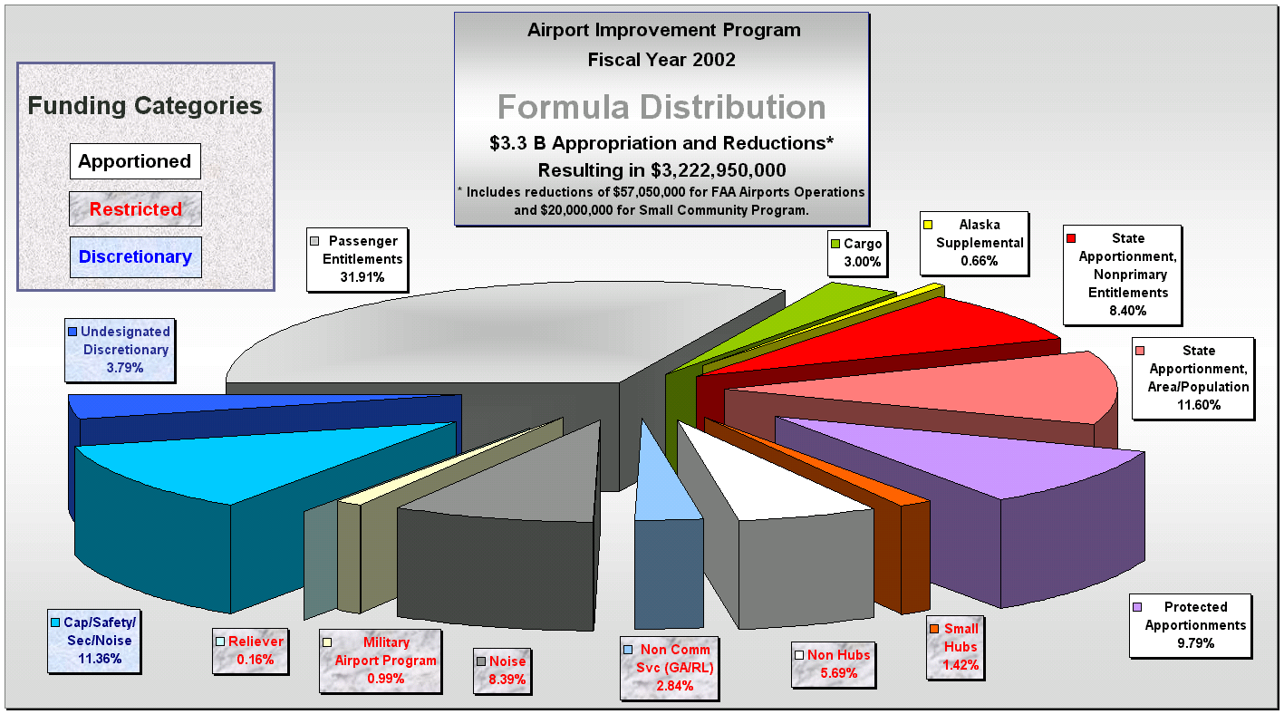
Discretionary. The remaining funds are discretionary funds. Discretionary funds are of two types. One type is discretionary set-aside funds, which are more fully described in Paragraph h. below. The other type consists of those funds remaining after the apportionments are made and the set-asides are accommodated. Of these remaining funds, 75 percent, known as capacity/safety/security/noise (C/S/S/N), is to be used for preserving and enhancing capacity, safety, security, and carrying out noise compatibility planning and programs at primary and reliever airports. The remaining 25 percent, known as remaining or pure discretionary, may be used for any eligible project at any airport.

Figure 2 Typical Percentage Distribution of AIP

Set Aside Funds. Portions of discretionary funds are set-asides designed to achieve specified funding minimums. A minimum amount of funding is directed to the following:

An amount equal to 34 percent of the discretionary fund is reserved for noise compatibility planning and implementing noise compatibility programs under Section 47501 et seq. of Title 49 U.S.C. (formerly the Aviation Safety and Noise Abatement Act of 1979). Such minimum can be met with apportioned or discretionary funds;

4 percent of the discretionary fund is used for the MAP; and

if AIP is funded at $3.2 billion or above, 0.66 percent of the discretionary fund is available for reliever airports with:

more than 75,000 annual operations;

a runway with a minimum usable landing distance of 5,000 feet;

a precision instrument landing procedure; and

at least 100 based aircraft.

Minimum Discretionary Fund. The Act states that, beginning in FY 1997, not less than $148 million plus an amount equal to payments from the discretionary funds for LOI’s issued prior to January 1, 1996, must be available as discretionary funds (C/S/S/N and Remaining) after all apportionments and set-asides are satisfied. If less than this amount remains, all apportionments (except for Alaska supplemental funds) and set-asides are to be reduced by the same percentage to ensure that this amount is available for discretionary grants.

Federal Share of Project Costs.

For large and medium hub primary airports, the Federal share is 75 percent (except for noise program implementation which is 80 percent). Large and medium hub airports are primary airports that enplane 0.25 percent or more of the total annual U.S. enplanements. Approximately 70 airports qualify as large and medium hub primary airports.

For all other airports, the Federal share is 90 percent.

The Federal share of costs associated with integrated airport system planning is 90 percent.
Note: There is an upward adjustment to these rates at some airports in Alaska, Arizona, California, Nevada, New Mexico, Oregon, Utah, and Washington due to the high percentage of Federally owned lands in these states.

Section 601 of P.L. 96-205 (United States Insular Areas of Appropriation Authorization) requires waiver of up to $100,000 of the sponsor's share of a grant issued after March 12, 1980, to American Samoa or the Northern Mariana Islands. Under this rule, a grant of up to $1 million at the 90% participation rate would require no contribution from the sponsor.

For block grants, the states have flexibility to fund individual airport projects using any United States Government share of allowable project costs that is not greater than 90%.

7. Maximum Allowable Grant Increases.

For Grants prior to December 30, 1987.

The United States maximum obligation under a grant agreement made prior to December 30, 1987, shall not be increased by more than 10 percent for development projects or, in the case of land acquisition, by more than 50 percent of the total increase in the allowable project costs attributable to the acquisition.

(ii) For terminal development, any grant increase may not exceed the 60% of entitlement funds for primary airports or the $200,000 discretionary funds for other commercial service airports.

For Grants on or after December 30, 1987, but before September 30, 1992. The United States maximum obligation under a grant agreement shall not be increased by more than 15 percent for both airport development projects and land acquisition.

For Grants after September 30, 1992. The United States maximum obligation under a grant agreement shall not be increased by more than 15 percent for both airport development projects and land acquisition at primary airports. For land acquisition at other than primary airports, the maximum obligation may be increased by either the 15 percent of the original grant or 25 percent of the increase in total allowable project costs based upon credible appraisals or court award, whichever is greater.

Planning elements of any grant cannot be increased.

Section II

Overview of the Grant Process
and Program Funding

A. The Grant Process.
Figure 3, below, represents the steps taken by the FAA and the sponsor for a typical AIP construction project. Not all of these steps are necessary for each project since requirements differ depending upon the work involved, the type of sponsor, project size, etc. The starting point within the project development stage is capital improvement planning, which should receive early attention to ensure the succeeding steps in the process work well. Except for the Congressional notification process and the approval of projects exceeding the dollar limits delegated to the regions, all actions shown for FAA are carried out in the regions and field offices. Details on requirements and procedures for each of the steps are found in FAA Eastern Region Sponsor Guide.

B. Mandatory Standards.
A sponsor is required to comply with all appropriate technical guidelines incorporated into identified advisory circulars, and these standards become mandatory for the project being funded. The list of the advisory circulars is published electronically on www.faa.gov/arp . Any guidance that needs to be specifically required for a project other than that identified in the FAA headquarters list of current advisory circulars should be added to the project as a special condition. Standards in effect on the date of allocation of AIP funds to a project apply to that project. Standards that become effective after the date of allocation may be applied to the project by mutual agreement between the FAA and the sponsor. As allowed in Section 47105(c) of the Act, where states have established and the Secretary has approved airport development standards at nonprimary, public-use airports (other than standards for safety of approaches) the applicable state standards shall be used. Any modification to the technical standards of the advisory circulars identified must be processed in accordance with the procedures of FAA Order 5300.1, “Approval Level of Modification of Airport Design Standards”.
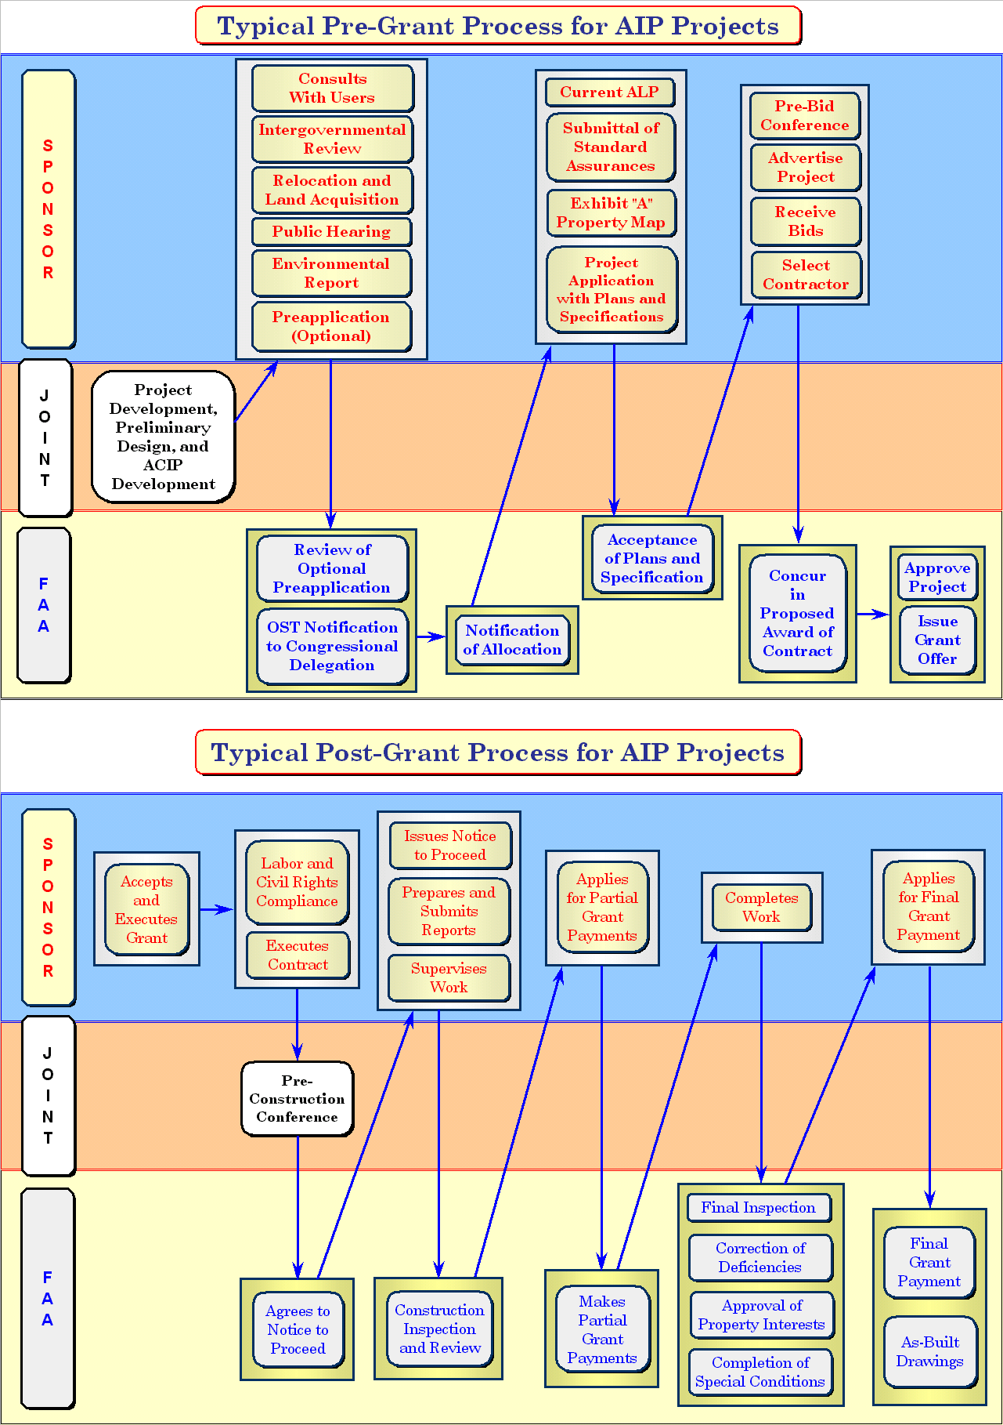

Figure 3 Typical Grant process

Section III. Sponsor Eligibility

General.
Eligibility to receive funds under the AIP is contingent upon the type of sponsor and the type of activity for which funds are sought. The different types of sponsors that are eligible to receive funds are:

Planning agencies;

Public agencies owning airports;

Certain public agencies not owning airports; and

Certain private airport owners/operators.
A state whether it owns an airport or not may sponsor development at airports within the state. If the state is not the owner of the airport, please contact your airport office regarding policies and conditions that apply.

Legal and Financial Responsibility.
Sponsors must:

Be legally, financially, and otherwise able to assume and carry out the certifications, representations, warranties, assurances, covenants and other obligations required of sponsors which are contained in the AIP project application and grant agreement forms; and

Have the authority to act as a sponsor. An opinion of the sponsor's attorney as to its legal authority to act as a sponsor and carry out its responsibilities under the grant agreement will be required when deemed necessary or desirable.

Cosponsor.
Any two or more public agencies desiring to participate in accomplishing a project may cosponsor a project provided such public agencies jointly or severally meet the requirements of Paragraph B.1. above.
1. The terms and conditions of the grant agreement will jointly and severally bind cosponsors unless their respective rights and obligations with respect to an approved AIP project are otherwise set forth in a written agreement. A true copy of such agreement must be incorporated in or made a part of the project application submitted to the FAA office in whose jurisdiction the airport is located. The agreement shall, as a minimum, set forth:

The responsibilities of each cosponsor to the other(s) with respect to the accomplishment of the proposed development, operation, and maintenance of the airport;

The obligations which each will assume to the United States; and

The names of the sponsor or sponsors who will accept receipt of and disburse grant payments.

A public agency that desires only to contribute funds to a sponsor need not become a sponsor or an agent of the sponsor. However, any funds contributed become funds of the sponsor(s) for purposes of the project.

Any other entity not meeting the requirements of Paragraph B. 1. may co-sponsor a development project only if an eligible sponsor co-signs the grant, and a written agreement must bind that sponsor to the terms and conditions of the grant.

Agents.
A public agency authorized by state or local law may act as an agent of the public agency that owns and operates the airport without participating financially in the project or becoming a sponsor. The terms and conditions of the agency and the agent's authority to act for the sponsor must be set forth in an agreement that is satisfactory to the Administrator, a true copy of which must be submitted for approval with the project application. Such agent may accept, on behalf of the sponsor, a grant only if that acceptance has been specifically authorized by resolution or ordinance of the sponsor's governing body and such authority is specifically spelled out in the agreement.

Planning Agencies.
A planning agency means any agency designated by the FAA Administrator which is authorized by the laws of the state or states (including the District of Columbia, the Commonwealth of Puerto Rico, the Virgin Islands, American Samoa, the Government of the Northern Mariana Islands, the Trust Territory of the Pacific Islands, and Guam) or political subdivisions concerned to engage in area wide planning for the areas in which the grant assistance is to be used.

Typical State Planning Agencies. Typical state agencies that are authorized by state law to engage in state airport system planning normally include planning offices, aeronautics commissions, and departments of transportation. In some cases, state law may authorize a system planning effort to be undertaken directly by the office of the governor. A legal opinion, supplied by the state agency applying for the grant and showing that state law permits the applicant to undertake the Federally assisted project, is a sufficient basis for determining eligibility. If the suitability of the applicant to undertake the effort is in question, the Administrator's designation of the planning agency will be based on:

Comments from the state Single Point of Contact (SPOC);

Comments from the governor; and

The capability of the applicant to undertake airport system planning in a comprehensive statewide planning framework.

Typical Metropolitan Planning Agencies. Typical planning agencies, which are authorized by state or local laws to engage in metropolitan area airport system planning, include Metropolitan Planning Organizations (MPO's), Councils of Government (COG's), Regional Planning Commissions, (RPC's) and other similarly organized agencies. In most cases, the planning agency will be in existence and have established boundaries. When it exists, the MPO designated by the governor shall be the sponsor or cosponsor for metropolitan and/or system planning projects. If the MPO is not capable of engaging in area wide planning for the area in which the grant assistance is to be used, a cosponsor agreement shall be worked out between a planning agency that has the capability to do area wide airport system planning and the MPO. This arrangement is needed to insure that airport planning is properly considered in the overall transportation planning process for the metropolitan area and vice versa.

Designation of Eligible Planning Agencies.
Eligible planning agencies may receive grants for system planning.

Designation. All sponsors for system planning projects must be designated by the FAA Administrator. This designation authority is delegated to the Airports Division Manager and is implicitly accomplished when a grant request is approved.

Conflicting Applications. Where more than one agency applies for a grant for the same or similar planning project, and where identification of the appropriate agency empowered to do the planning is not clear, the FAA will designate the eligible applicant based on which one is best equipped to do the planning. All parties should be requested to work through the FAA-designated grantees where they desire to conduct planning elements or activities.

Public Agencies Owning Airports

A public agency means a state, the District of Columbia, the Commonwealth of Puerto Rico, the Virgin Islands, American Samoa, the Government of the Northern Mariana Islands, the Trust Territory of the Pacific Islands, and Guam or any agency of them; a municipality or other political subdivisions; or a tax-supported organization; or an Indian tribe or pueblo:

Public agencies owning public-use airports are eligible to receive grants for:

Airport master planning;

Noise compatibility planning;

Noise program implementation projects; and

Airport development projects.

For systems planning projects, states may be requested to identify appropriate public agencies and airport sponsorship arrangements for airports within their jurisdictions.

Public Agencies not Owning Airports

See G. 1., above, for the meaning of public agency.

Public agencies not owning public-use airports are eligible for master planning (including site selection) grants for new airports, acquisition of existing airports, and noise program implementation projects if such projects are included in the noise compatibility program prepared by the local airport sponsor and approved by the FAA, except for noise insulation for buildings used for educational or medical purposes in the noise impact area surrounding a public airport.

The designation of eligible public agencies not owning public-use airports may be accomplished as part of airport planning. This designation needs special consideration before issuance of master plan grants to ensure proposals meet Federal requirements.

I. Private Airport Owners.

This may be an individual, a partnership, corporation, etc., that owns a public-use airport used or intended to be used for public purposes that is a reliever airport or an airport that has at least 2,500 passenger boardings each year and receives scheduled passenger aircraft service.

A privately-owned airport sponsor, as defined in a. above, is eligible for funding for:

Airport development projects;

Airport master planning;

Noise compatibility planning; and

Noise program implementation projects.

J. State Sponsorship of Airport Projects.

Section 47105(a)(1)(B) of the Act allows State sponsorship of development projects, including master planning, for one or more airports. This provision is subject to three statutory conditions:

The sponsor of each airport shall consent in writing to State sponsorship;

There shall be administrative merit and aeronautical benefit to the State sponsorship; and

An agreement acceptable to FAA shall exist to assure compliance with appropriate grant conditions and assurances.

This provision could reduce FAA and State/sponsor workload by combining many grants into one and could provide economies of scale where appropriate through sole State sponsorship rather than numerous sponsorships. For instance, equipment could be acquired in quantity at potentially lower cost, several small and similar construction projects could be combined, or related airport master or layout plans could be prepared.

To simplify and promote national uniformity in the grant program, the FAA has developed a standard agreement to be signed by the sponsor of each airport included in a State sponsored grant. The signed agreement(s) should be provided by the State to FAA with the pre-application package. This will satisfy requirements in the statute that airport sponsors consent in writing to State sponsorship of work at their airports and assure compliance with grant conditions and assurances. Should the State wish to retain one or all obligations, sufficient details should be spelled out as an addendum to the standard agreement in the form prescribed by Paragraph C. 1.

Field offices should encourage State sponsorship if they determine there are administrative merit and/or aeronautical benefit in issuing a single grant for a number of related projects. This determination must be referenced in the project folder.

Co-sponsorship of projects remains an alternative to this procedure if all parties believe this to be more efficient.

State block grants, as described in Chapter 10, Section 9, are an alternative to State sponsorship of airport projects. The block grant projects are restricted to States having been selected for the program. A block grant requires more capability within the State aviation agency. The main difference between the block grant and State sponsorship of airport project requirements under Section 47105(a)(1)(B) is responsibility for project selection. States select airport projects funded by the block grants. Under the State sponsorship provision, the FAA selects the projects. For the States that express interest in the block grant program prior to having been selected for such, regions should encourage its sponsorship of airport projects as a transition in the event that the State may be added to the program.

Section IV. Project Eligibility

General Project Eligibility Requirements

Your FAA Airports office should be consulted for project eligibility, but in general, no project grant application may be approved unless the FAA is satisfied that:

The project sponsorship requirements have been met;

The project is reasonably consistent with the plans of planning agencies for the development of the area in which the airport is located;

Sufficient funds are available for that portion of the project not paid for by the United States;

The project will be completed without undue delay;

The airport location is included in the current version of the NPIAS; and

The project involves more than $25,000 in AIP funds unless, in the judgment of the responsible Airports office, it would be in the best interest of the Government to award a grant of a lesser amount.

The Act allows the separate funding of projects for the preparation of plans and specifications, including field investigations incidental thereto. These will be funded only if they result in the complete preparation of plans and specifications for airport development work that has every expectation of beginning within two years. Projects involving only field investigations, such as pavement evaluation, will not be funded on a “stand alone” basis except in planning projects.

A current airport layout plan (ALP) that depicts the proposed project and which has FAA approval from the standpoint of safety, utility, and efficiency of the airport shall be required before a development project is approved. ALP’s may be funded as part of master planning. ALP’s may be funded retroactively upon grant approval as project formulation cost to add the work of the project onto the ALP and reflect actual conditions existing on the airport. If current design standards for the airport need to be reflected on the ALP, this work is eligible as project formulation cost. If an environmental assessment is needed for the project, the assessment is also eligible as project formulation cost.

B. Prohibitions

Legislative Determination. The Act specifically prohibits using AIP funds for decorative landscaping, the provision or installation of sculpture or works of art, and for the construction, alteration, or repair of:

Public parking facilities for passenger automobiles;

A hangar; or

Any part of an airport building, (with some exceptions).
The prohibitions contained in 1. a). and 1. b). do not apply to airports designated by the Secretary under the Military Airport Program (MAP). Not more than $7 million at each airport can be spent for parking lots, fuel farms, utilities, and hangars under the provisions of the Act. In addition, the prohibition against public parking facilities does not apply to non-revenue facilities at nonhub primary airports.

FAA Policy Determination. FAA will make a determination on the eligibility of unusual projects on a case-by-case basis and based on FAA's interpretation of the intent of Congress. The FAA Order which includes eligibility criteria can be found at http://www2.faa.gov/arp/financial/aip/aiphandbook.cfm

C. Environmental Requirements

All AIP projects, including projects for plans and specifications, require environmental processing prior to FAA approval. Every project will fall within one of the following categories:

Those requiring an environmental assessment and preparation of an environmental impact statement (EIS) or a finding of no significant impact (FONSI); or

Those that are categorically excluded.

Detailed guidance on the environmental process can be obtained at your FAA airports office.

D. Off Airport Work.
Work items must be located within the airport boundary to be eligible. The only exceptions to this requirement are:

Removal of obstructions;

Outfall drainage ditches. The correction of any damage resulting from construction of ditches is an eligible cost;

Relocation of roads and utilities constituting airport obstructions;

Relocation of roads and utilities to allow eligible airport development;

Installation or relocation of navigational aids (NAVAID’s), including markers;

Construction and installation of utilities;

Lighting and marking of obstructions;

Airport waste-water treatment plants;

Noise program implementation projects;

Environmental mitigation measures required as a condition of environmental approval (e.g., wetlands replacement); and

Aircraft Rescue and Fire Fighting Training Facility (Federal investment must be protected).
YOUR FAA OFFICES

Region: Eastern

Area Covered: New York, New Jersey, Pennsylvania, Delaware, Maryland, Virginia, West Virginia, and the District of Columbia.

Airports Division, AEA-600
1 Aviation Plaza
Jamaica, New York 11434
Phone: (718) 553-3330
FAX: (718) 995-5614

Airports District/Field Offices:

Area Covered: Pennsylvania, Delaware
Harrisburg Airports District Office
3905 Hartsdale Drive, Suite 508
Camp Hill, Pennsylvania 17011
Phone: (717) 730-2831
FAX: (717) 730-2838

Area Covered: West Virginia
Beckley Airports Field Office
176 Airport Circle
Beaver WV 25813-9350
Phone: (304) 252-6216
FAX: (304) 253-8028

Area Covered: Maryland, Virginia, District of Columbia
Washington Airports District Office
23723 Air Freight Ln.
Dulles, VA 20166
Phone: (703) 661-1357
FAX: (703) 661-1370

Area Covered: New York, New Jersey
New York Airports District Office
600 Old Country Road
Garden City, NY 11530
Phone: (516) 227-3800
FAX: (516) 227-3813

