Tsunamis

Instructor guidance | Content
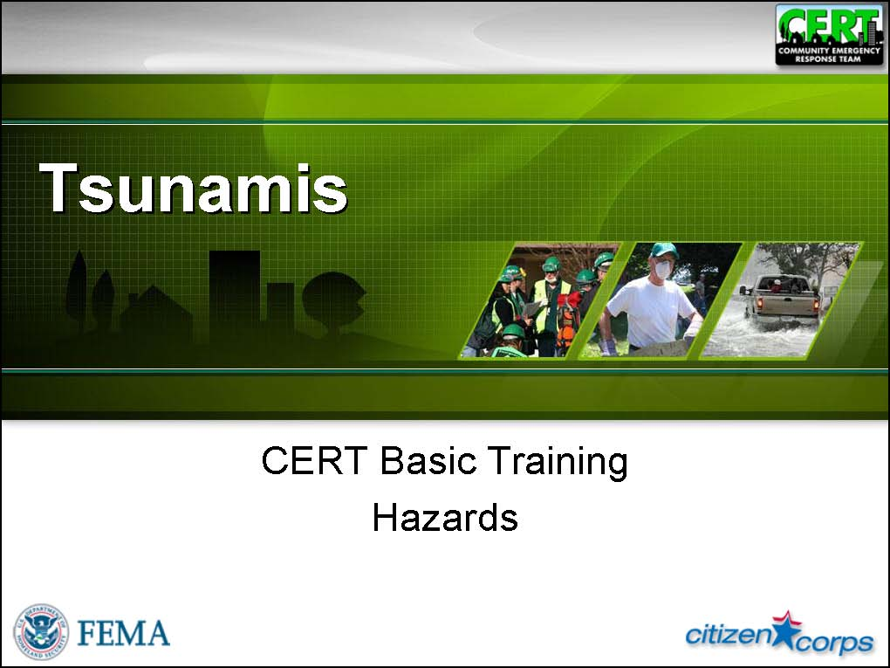  Display Slide Ts-0  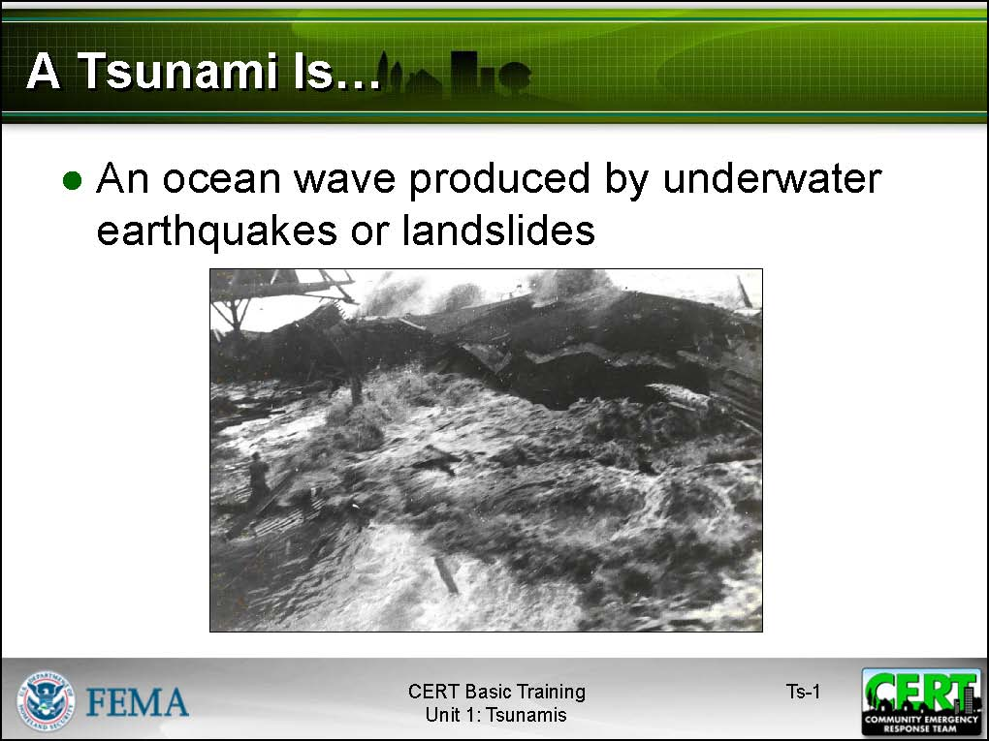  Display Slide Ts-1 | Tsunamis  Tell the participants that tsunamis are ocean waves that are produced by underwater earthquakes or landslides. The word is Japanese and means “harbor wave” because of the devastating effects that these waves have had on low-lying Japanese coastal communities. Tsunamis are often incorrectly referred to as tidal waves.
 | Risk Posed by Tsunamis
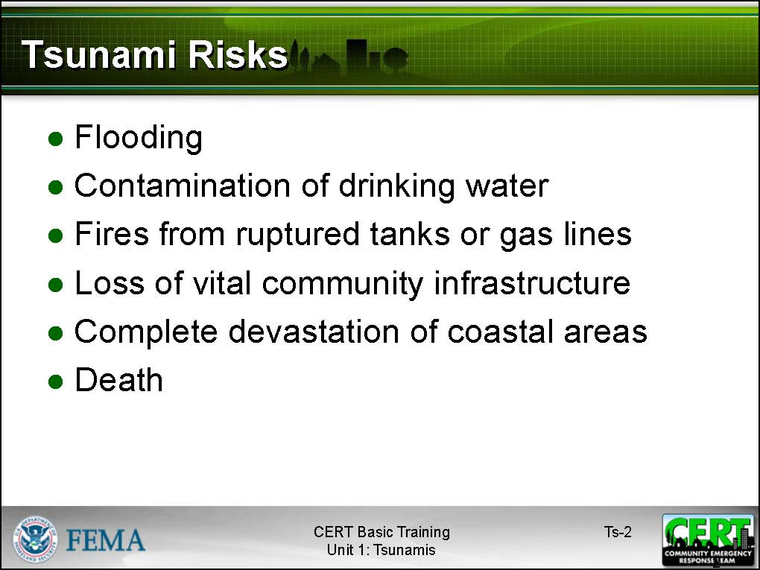  Display Slide Ts-2 | Explain that tsunamis pose the greatest risk to areas less than 25 feet above sea level and within one mile of the shoreline. They can cause:  - Flooding  - Contamination of drinking water  - Fires from ruptured tanks or gas lines  - Loss of vital community infrastructure  - Complete devastation of coastal areas  - Death  Stress that most deaths caused by tsunamis result from drowning.
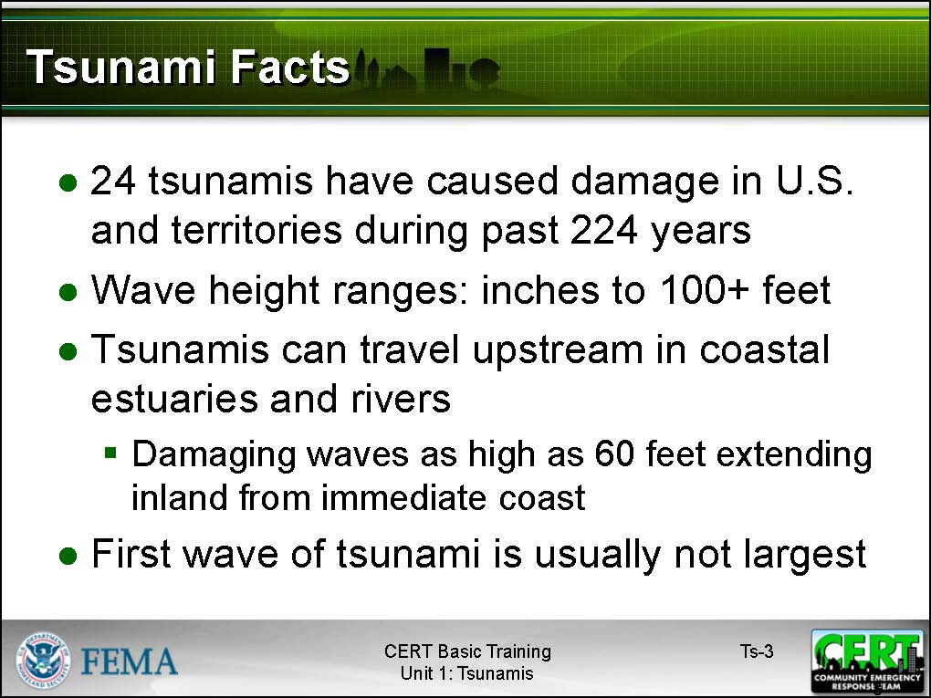  Display Slide Ts-3 | Tell the group that since 1945, six tsunamis have killed more than 350 people and caused 500 million dollars worth of property damage in Hawaii, Alaska, and the West Coast. In the United States and its territories 24 tsunamis have caused damage during the past 224 years.  Point out that the common scientific definition of tsunami wave height ranges between a few inches and about 100 feet (30 meters). Some tsunamis have produced wave heights of up to 200 feet (60 meters), for example, the 1964 Alaska subduction earthquake. Tsunamis can travel upstream in coastal estuaries and rivers, with damaging waves as high as sixty feet extending farther inland than the immediate coast. A tsunami can occur during any season of the year and at any time, day or night.
 | Explain that the first wave of a tsunami is usually not the largest in a series of waves, nor is it the most significant. One coastal community may experience no damaging waves, while another, not far away, may experience destructive deadly waves. Depending on a number of factors, some low-lying areas could experience severe inundation of water and debris several miles or more inland.
Tell the participants that tsunami warnings originate from two agencies:
- The West Coast/Alaska Tsunami Warning Center (WC/ATWC) is responsible for tsunami warnings for California, Oregon, Washington, British Columbia, and Alaska.
- The Pacific Tsunami Warning Center (PTWC) is responsible for providing warnings to international authorities, Hawaii, and U.S. territories within the Pacific basin.
Point out that the two Tsunami Warning Centers coordinate the information that is being disseminated.
 | Tsunami Preparedness
Allow the participants time to respond. | How can you prepare for a tsunami?
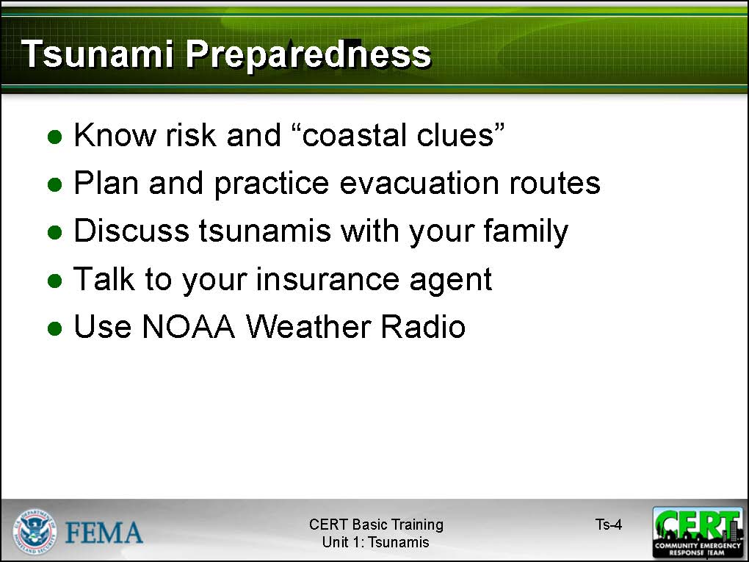  Display Slide Ts-4 | Summarize the discussion using the slide. Be sure to make the points listed below.  - Know the risk for tsunamis in the area. Know the height of your street above sea level and the distance of your street from the coast or other high-risk waters. Evacuation orders may be based on these numbers.  - Be aware of coastal clues. The waterline will withdraw and disappear out to sea, followed by a series of high waves reaching further and further inland. Remember that the series of tsunami waves won’t necessarily occur at regular intervals.
- Plan and practice evacuation routes. If possible, pick an area 100 feet or more above sea level, or go at least 2 miles inland, away from the coastline. You should be able to reach your safe location on foot within 15 minutes. Be able to follow your escape route at night and during inclement weather.
If you are visiting an area at risk from tsunamis, check with the hotel, motel, or campground operators for evacuation information.
- Discuss tsunamis with your family. Discussing tsunamis ahead of time will help reduce fear and anxiety and let everyone know how to respond. Review flood safety and preparedness measures with your family.
- Talk to your insurance agent. Homeowners’ policies do not cover flooding from a tsunami. Ask your agent about the National Flood Insurance Program (NFIP).
- Use a NOAA Weather Radio with a tone-alert feature to keep you informed of local watches and warnings.
Allow the participants time to respond. | How do you protect your property in case of a tsunami?
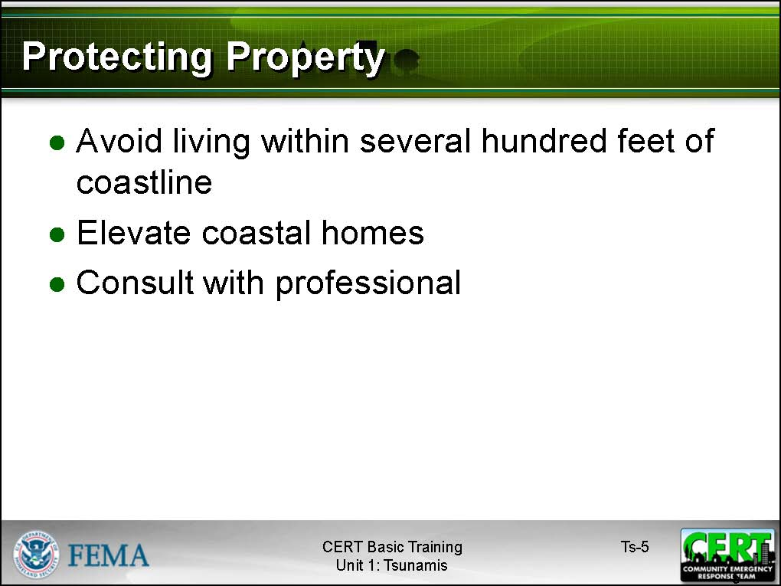  Display Slide Ts-5 | Suggest the following ways to protect property:  - Avoid building or living in buildings within several hundred feet of the coastline. These areas are most likely to experience damage from tsunamis, strong winds, or coastal storms.  - Elevate coastal homes. Most tsunami waves are less than 10 feet high.  - Consult with a professional for advice about ways to make your home more resistant to tsunami. Also, there may be ways to divert waves away from your property.
Allow the participants time to respond. | What do you do if you feel a strong coastal earthquake?
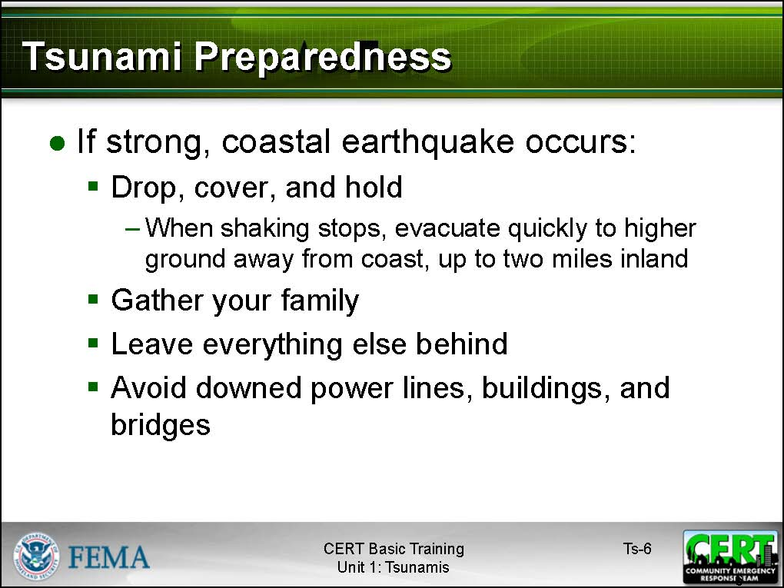  Display Slide Ts-6 | Use the slide to explain the actions that they should take. Be sure to emphasize the following points:  - Drop, cover, and hold. You should protect yourself from the earthquake first.  - When the shaking stops, gather your family members and evacuate quickly. Leave everything else behind. A tsunami could occur within minutes. Move quickly to higher ground away from the coast, up to two miles inland.  - Avoid downed power lines, and stay away from buildings and bridges from which heavy objects might fall during an aftershock.
Allow the group time to respond. | What should you do when you receive a Tsunami Warning?
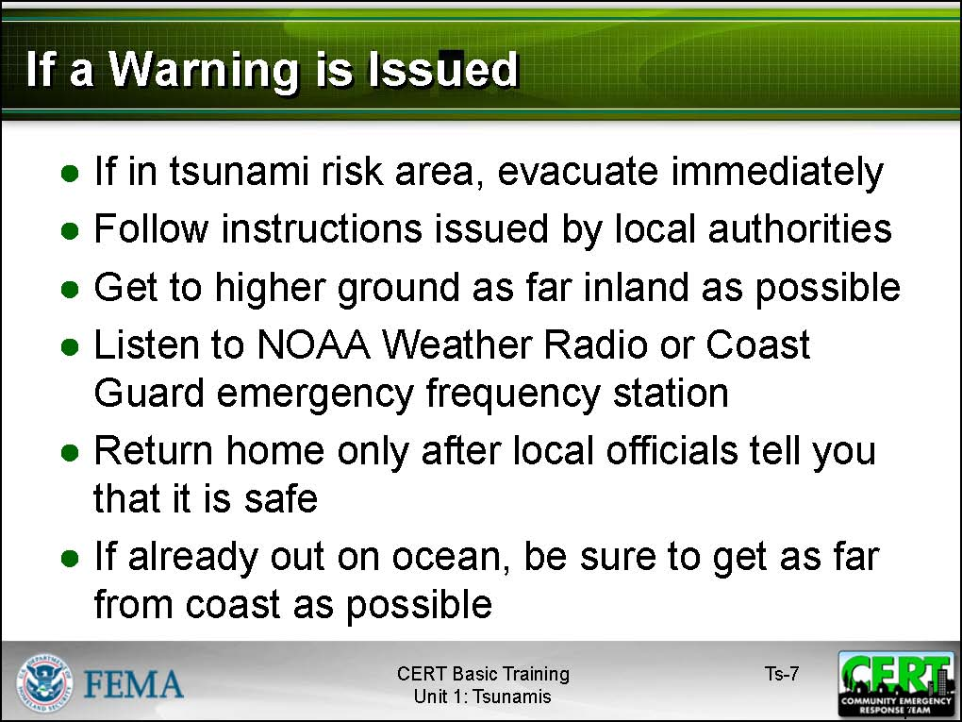  Display Slide Ts-7  Emphasize that watching a tsunami from the beach or cliffs can put people in grave danger. If a person can see the wave, he or she is too close to escape it. | Use the slide to summarize the discussion. Discuss the following actions:  - If you are in a tsunami risk area and you hear an official tsunami warning or detect signs of a tsunami, evacuate at once. A tsunami warning is issued when authorities are certain that a tsunami threat exists, and there may be little time to get out.  - Follow instructions issued by local authorities. Recommended evacuation routes may be different from the one you planned, or you may be advised to move to higher ground than you had planned.  - Get to higher ground as far inland as possible. Officials cannot reliably predict either the height or local effects of tsunamis.  - Listen to a NOAA Weather Radio or Coast Guard emergency frequency station for updated emergency information.  - Return home only after local officials tell you that it is safe. A tsunami is a series of waves that may continue for hours. Do not assume that after one wave, the danger is over. The next wave may be larger than the first one.  - If you are out on a boat when the warning is issued, move as far out from the coast as possible. This action could prevent the waves from carrying your craft inland where it is likely to sustain damage and the risk of fatality is great.
Explain that, following a tsunami, citizens should continue listening to a NOAA Weather Radio or Coast Guard emergency frequency station for updated emergency information and instructions. As with many other hazards, post-tsunami actions include:
- Avoiding fallen power lines or broken utility lines and immediately reporting those that you see
- Staying out of damaged areas until told that it is safe to enter. The risk of contamination and disease is very high
- Staying out of damaged buildings
- Using a flashlight to look for damage and fire hazards, and documenting damage for insurance purposes
- Turning off utilities, if necessary
- Reserving the telephone for emergencies
 | Does anyone have additional questions, comments, or concerns about tsunamis or tsunami preparedness and response?
PM, P. Ts-5 | Refer the participants to Tsunami Myths and Facts in the Participant Manual. Suggest that they review these myths and facts after the session.

Instructor guidance | Content
PM, P. Ts-5 | Tsunami Myths and Facts

Myth: | Tsunamis are giant walls of water.
Fact: | Tsunamis normally have the appearance of a fast-rising and receding flood. They can be similar to a tide cycle occurring over 10-60 minutes instead of 12 hours. Occasionally, tsunamis can form walls of water, known as tsunami bores, when the waves are high enough and the shoreline configuration is appropriate.
Myth: | Tsunamis are a single wave.
Fact: | Tsunamis are a series of waves. Often the initial wave is not the largest. The largest wave may occur several hours after the initial activity has started at a coastal location.
Myth: | Boats should seek protection of a bay or harbor during a tsunami.
Fact: | Tsunamis are often most destructive in bays and harbors. Tsunamis are least destructive in deep, open ocean waters. Boats already out to sea should travel as far out as possible to prevent being carried to shore.

